AMBA AHB
(ADVANCED MICROCONTROLER BUS ARCHITETURE. ADVANCED HIGH-PERFORMANCE BUS)
For high speed, high bandwidth communication
Examples cases processor to DDR
The AHB protocol defines the interactions between
1.Masters (Mangers): Whichever the component initiates the transaction for read or write
2.Slaves (Subordinates): Response to manager request includes memories, peripheral, and bridges to others buses
3.Interconnects
**nor component is permanent Master or Slave**
Features
Single clock-edge operation: operates synchronously on rising edge of clock
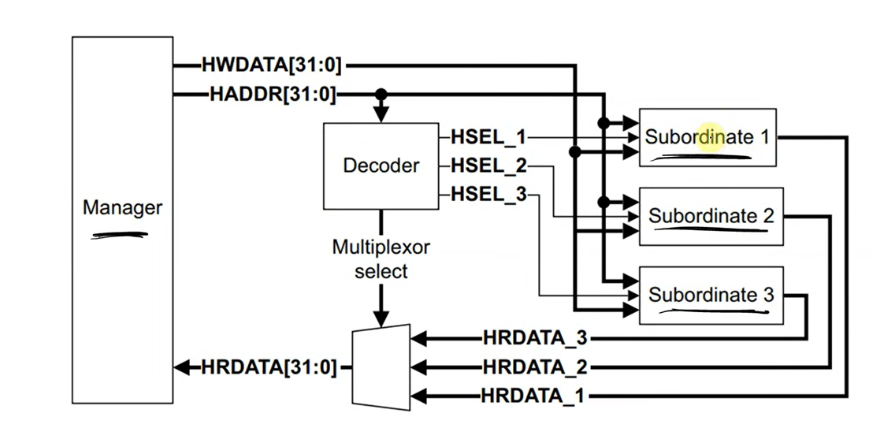
Burst transfer: AHB supports single and burst transfer, improving data throughput
AHB BLOCK DIAGRAM

***In AHB protocol all signals naming starts with letter H ***

Signals associated with Manger
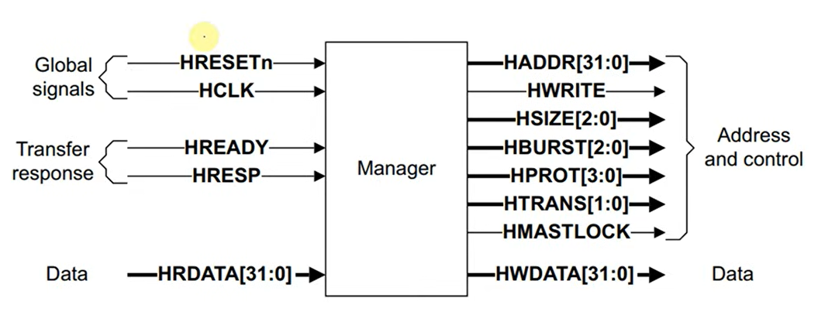

Global signals
- HRESETn → Active-low reset signal that initializes the bus/system.
- HCLK → Clock signal that synchronizes all AHB transfers

Transfer response
- HREADY → Indicates the slave is ready to complete the current transfer.
- HRESP → Shows transfer status (OKAY, ERROR, etc.).

Address & control signals
- HADDR[31:0] → Address bus specifying where the transfer occurs.
- HWRITE → Indicates write (1) or read (0) transfer.
- HSIZE[2:0] → Specifies transfer data size (byte, halfword, word, etc.).[size]
- HBURST[2:0] → Defines burst transfer type. HBURST will tell count of your packets[count]
- HPROT[3:0] → Protection/control info (privilege, cache, buffer, etc.).*-
- HTRANS[1:0] → Indicates transfer type (idle, busy, nonseq, seq)(00,01,10,11).
- HMASTLOCK → Locks bus for exclusive transfer sequence.*-

Data signals
- HWDATA[31:0] → Data bus carrying write data from master.
- HRDATA[31:0] → Data bus carrying read data from slave.

TRANSFERS in AHB PROTOCOL

Transfers consist of two phases(ideal case 2 CLK cycles)
1.ADDRESS: Last for a single HCLK cycles unless it is extended by previous bus transfer
All the control signal to be valid and valid address of the 1st packet is provided
2.DATA: Might require several HCLK cycles. Uses HREADY signal to control the number of clock cycles required to complete the transfer.

READ TRANSFER
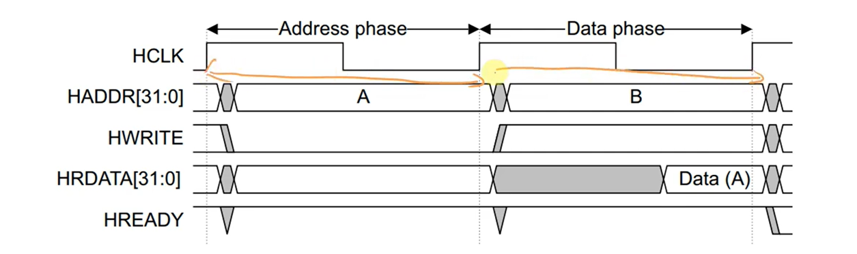
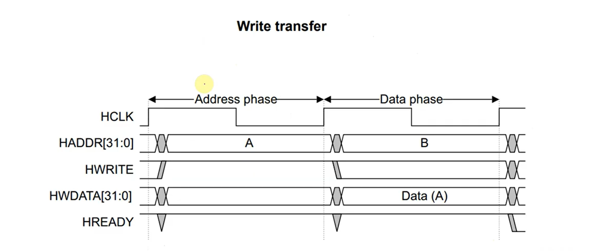
Simple Transfer with no wait states:
  - The master drives the control and address signals onto the bus after the rising edge of HCLK
  - The Slave then samples the address and control on next HCLK edge
  - After the slave has sampling it can drive HREADYOUT response, this result is sampled by the master on next 3rd HCLK edge

Transfers with WAIT States
READ TRANSFER WITH TWO WAIT STATES
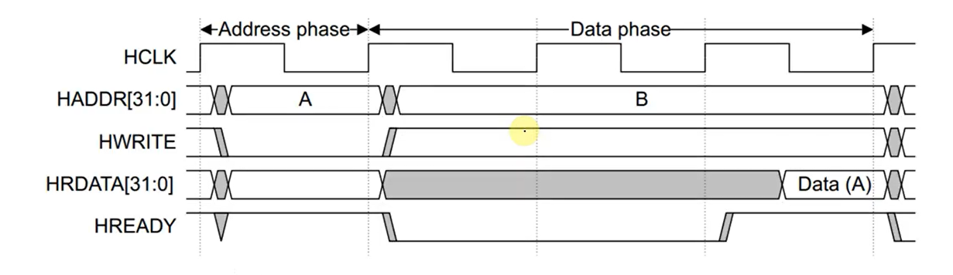
If HREADY = 0 the master is not going to change the phase from D phase to A phase until HREADY is 1

WRITE TRANSFER WITH ONE WAIT STATES
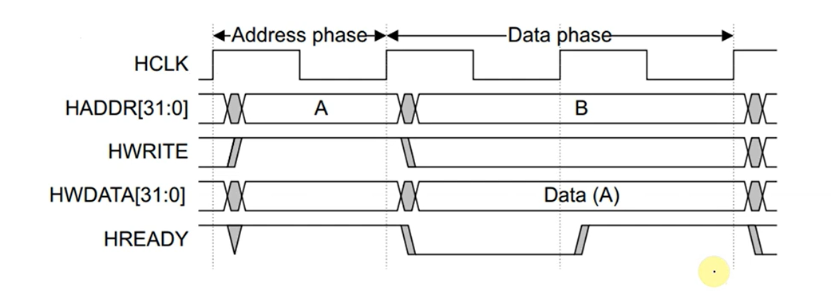

**the data is made constant unless the data phase is completed **

MULTIPLE TRANSFER

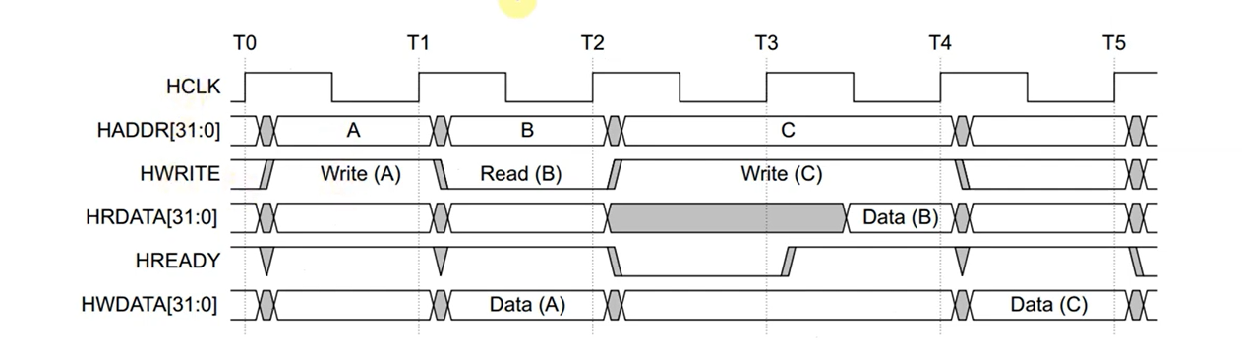
One packet is address phase is going to data phase of another packet

TRANSFER TYPES

HTRANS[1:0] | TYPE | FUNCTION
00 | IDLE | No data transfer is required  Master is idle  Subordinates must always provide 0 wait state OKAY response to IDLE transfer must ignore by subordinates
01 | BUSY | The slave will come to know master is busy  The busy transfer type enables manager to insert idle cycle in the middle of a burst . This transfer type indicates that the manager is continuing with a burst but next transfer cannot take place immediately  Subordinates must always provide a zero wait state OKAY response to BUSY transferand transfer must be ignored by the Subordinates
10 | Non-SEQ | First transfer of burst or single transfer  Address may not follow previous address sequence.  Starts any new transaction.
11 | SEQ | Remaining transfers in burstIndicates sequential burst transfer.Address follows predictable increment pattern.  Used in:  Incrementing bursts  Wrapping bursts
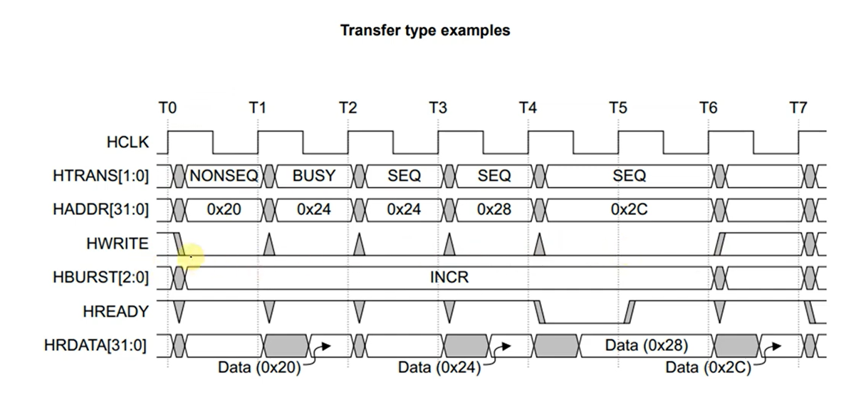

HSIZE
HSIZE is a 3-bit signal in the AHB protocol that specifies the size of the data transfer on the bus.
It tells the slave how many bytes are being transferred in each transaction.
HSIZE[2:0] | Transfer Size | Bytes
000 | Byte | 8 bits (1 byte)
001 | Halfword | 16 bits (2 bytes)
010 | Word | 32 bits (4 bytes)
011 | Doubleword | 64 bits (8 bytes)
100 | 128-bit | 16 bytes
101–111 | Reserved | Not used

Burst Operation
Burst operation means transferring multiple data items continuously in one bus request instead of single transfers. This improves speed and efficiency by reducing address/control overhead.
Types of Burst Transfers
Incrementing Burst (INCR)
Address continuously increments, no boundary limit.
- Address increases sequentially.
- No fixed burst length (can continue).
- 0x1000 → 0x1004 → 0x1008 → 0x100C
Wrapping Burst (WRAP)
Address increments but wraps within fixed boundary.
- Address wraps around boundary.
- Used in cache line accesses.
- 0x100C → 0x1000 → 0x1004 → 0x1008
- . For bursts, total boundary:
Burst boundary = Transfer size × Number of beats

HBURST[2:0] | Type | Description
000 | SINGLE | Single transfer
001 | INCR | Incrementing burst (undefined length)
010 | WRAP4 | 4-beat wrapping burst
011 | INCR4 | 4-beat incrementing burst
100 | WRAP8 | 8-beat wrapping burst
101 | INCR8 | 8-beat incrementing burst
110 | WRAP16 | 16-beat wrapping burst
111 | INCR16 | 16-beat incrementing burst

Example for INCR4
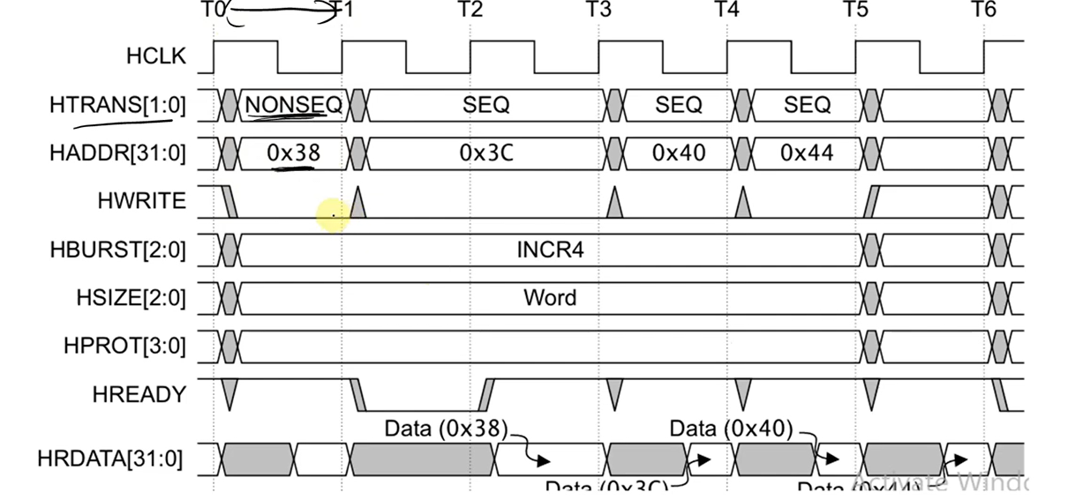

Example for WRAP 4

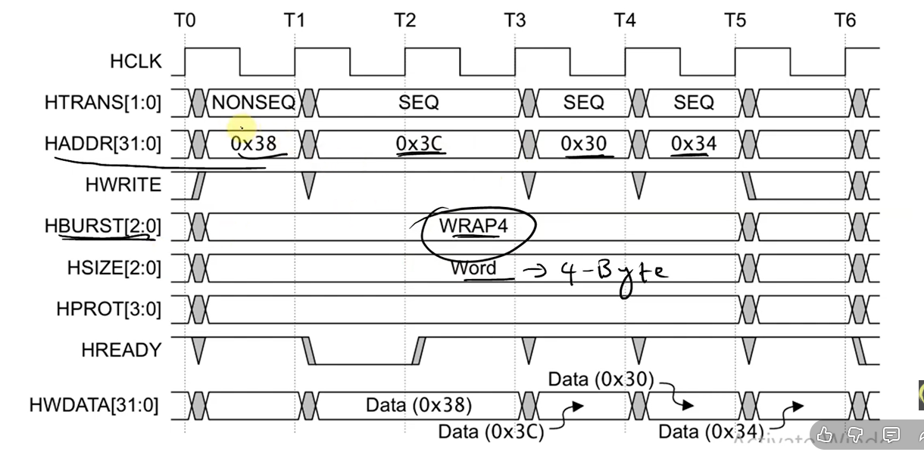

Subordinate (slave) response signals

HREADY → Indicates the subordinate is ready and the transfer can complete.
HRESP → Shows transfer result (OKAY, ERROR, RETRY, SPLIT).

1. HREADY (Ready Signal)
Purpose: Indicates whether the subordinate/slave has completed the current transfer.
How it works:
- HREADY = 1 → Transfer finished
  - Data valid for read.
  - Write accepted.
  - Next transfer can start.
- HREADY = 0 → Wait state
  - Slave needs more time.
  - Master must hold address/control stable.
2. HRESP (Response Signal)
Purpose: Shows status of the transfer.
/* In most modern AHB-Lite systems:Only OKAY and ERROR are used.*/
HRESP | Meaning | Explanation
00 | OKAY | Normal successful transfer
01 | ERROR | Transfer failed (invalid address etc.)
10 | RETRY | Slave asks master to retry later
11 | SPLIT | Slave temporarily busy (bus released)
Normal transfer:
HREADY = 1
HRESP = OKAY

Wait state:
HREADY = 0

Error response:
HREADY = 0, HRESP = ERROR → first cycle
HREADY = 1, HRESP = ERROR → second cycle
✔ Error response requires two cycles.

During an IDLE transfer
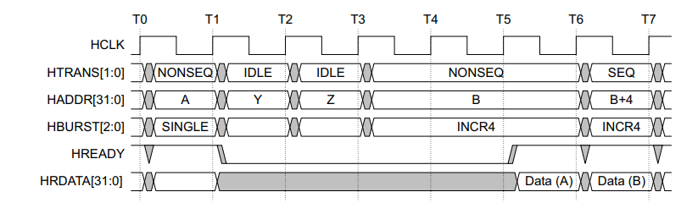
Address changes during a waited transfer, with an IDLE transfer

BUSY transfer, fixed-length burst
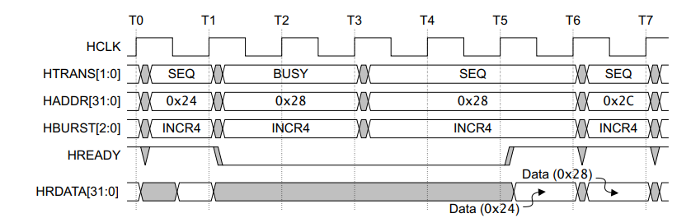
• AHB protocol, during fixed-length burst transfers (INCR4/8/16, WRAP4/8/16), a BUSY transfer can be inserted between burst beats.
• If HREADY = LOW (wait state), the Manager must keep control signals stable.
• When HTRANS changes from BUSY → SEQ, it must remain SEQ until HREADY = HIGH.
• BUSY transfers are not allowed in SINGLE bursts.
Control signals must stay constant during wait states in burst transfers.

BUSY transfer, undefined length burst
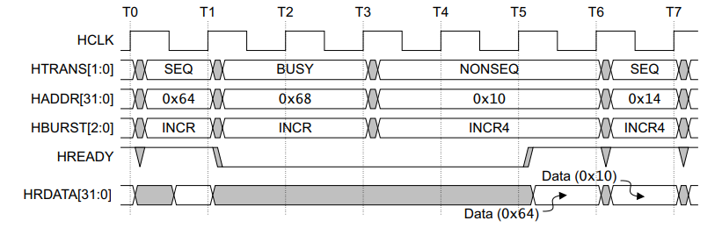
- AHB protocol, in an undefined-length burst (INCR), if HREADY = LOW, the Manager can change HTRANS from BUSY → SEQ, NONSEQ, or IDLE.
- SEQ → burst continues.
- NONSEQ or IDLE → current burst terminates and a new transfer/burst begins.
- While HREADY remains LOW, HTRANS must stay constant after the change.
Key point: In INCR bursts, BUSY can switch to any transfer type during wait states, but NONSEQ/IDLE ends the burst.

