

Qualification: ICT 50615 Diploma of Website Development Group 1B
Units: Web Design Cluster:
- ICTWEB505 – Develop complex web page layouts
- ICTWEB506 – Develop complex cascading style sheets
- CUAGRD504 – Create and manipulate graphics
Teacher: John Perry
Assessment Task: WD1 – Brochure Website
Due Date: 6 Aug 2021

Student Name: Jacob Turner
Student Number: 472891731

Part D
Screenshot of W3C HTML Validation
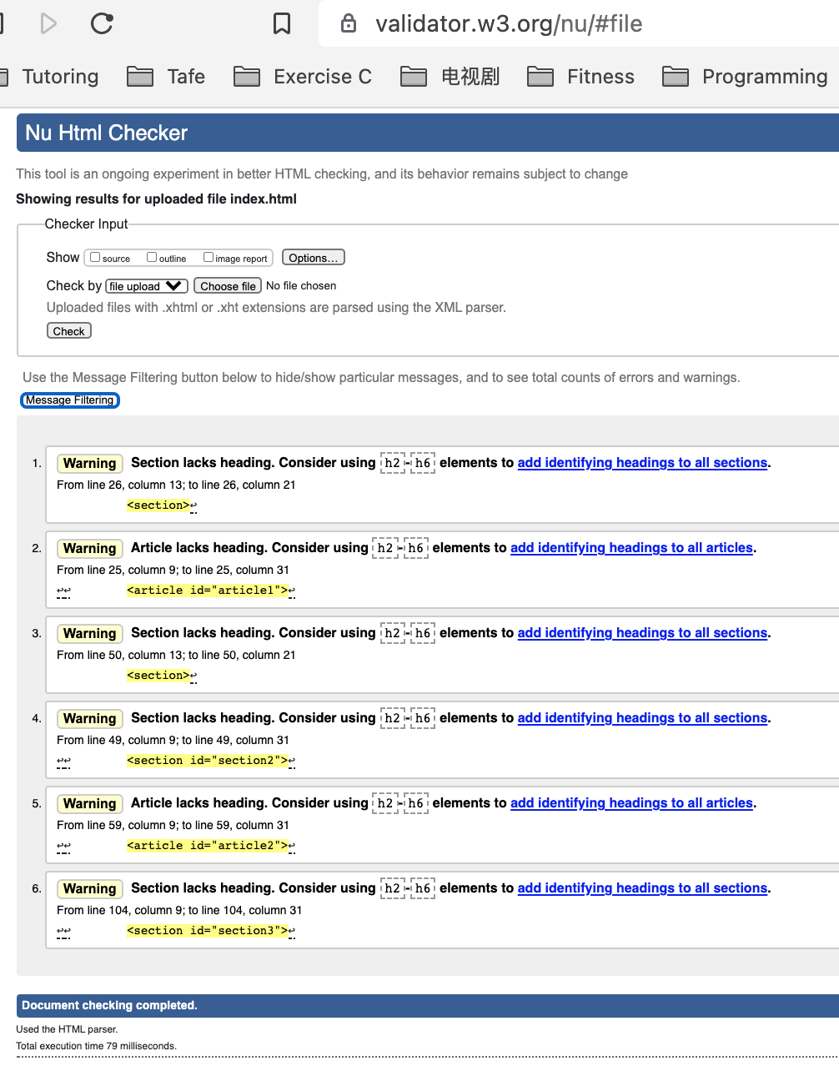

Screenshot of W3C CSS Validation
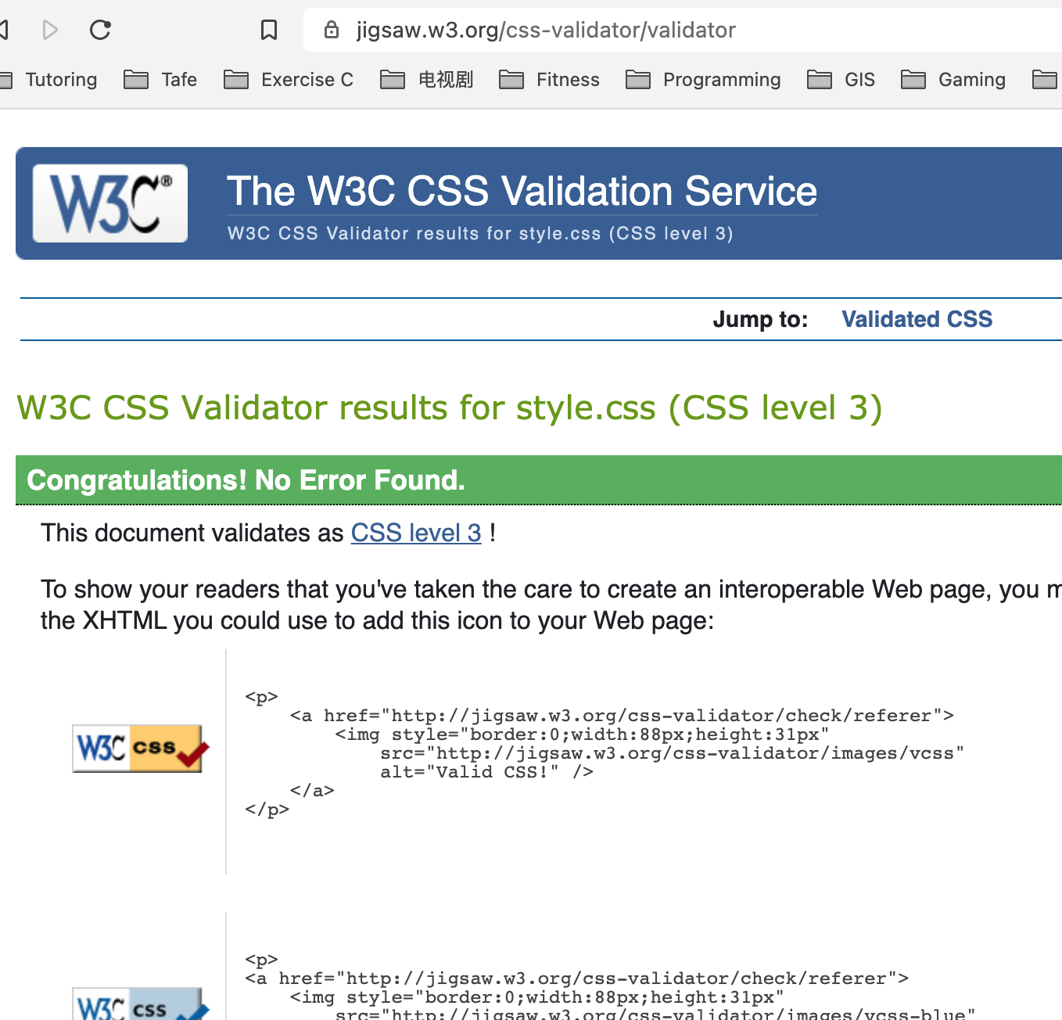

Cross-Browser Test
Chrome
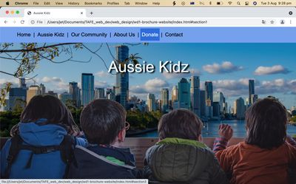

Firefox
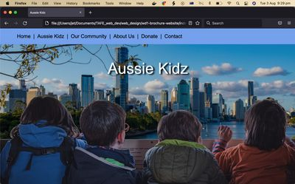
Safari
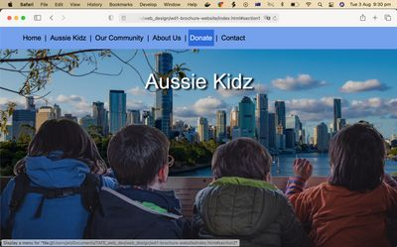

Part E
1. Describe how the images chosen meet the client brief.
The images chosen for the website mostly depict happy children. This is intentional and is intended to show the positive effect the Aussie Kidz charity has in the community. By supplying necessary equipment through grants, Aussie Kids directly improves the lives of disabled children and their families. The website aims to emphasise this point be design.
The background of the feature image has been replaced to depict children overlooking Brisbane city. Anyone in the Brisbane region can identify that the city in the image is Brisbane and recognise that the website – and the associated charity – are locally based.
The bricks used as a repeatable background in the third section of the website indicate that the main client base of Aussie Kids are based in the greater Brisbane metropolitan area.

2. How have your modified images better suited the web medium?
All of the photos in the Aussie Kidz website have been scaled to an appropriate size depending on their actual display size. This greatly reduces website loading times without noticeable deterioration in image quality. Background images have had a CSS overlay added to reduce contrast to enhance text readability.
The brick wall background has been edited to create smooth repeatable background. This was achieved by duplicating and flipping the image horizontally and merging the two images along side each other. By doing this the image will flow naturally when repeated in a background. In this way a smaller image can be loaded once then used to fill a much larger area through CSS.

3. What rationale was used when choosing the file format for each image?
The JPG file type was used for all images on the Aussie Kidz website. This choice was made due to JPG’s superior ability to display detailed photographs with good levels of compression. As there is no need for transparency in the images used on this site PNG files were deemed unnecessary. The smaller file size of JPG images allows the website load times to be minimised while maintaining a high level of quality.

4. Note source for all images including copyright and/or licence requirement(s).
All of the photos (edited and original) on the site were sourced from unsplash.com and fall under the Unsplash Licence which can be found at https://unsplash.com/license. Under this licence photos can be downloaded and used for free for both commercial and non-commercial purposes. No permission is required for any use case. Photos cannot be sold without significant modification and cannot be used to create a competing service to unsplash.com.

Below is a list of all photos used on the website with a direct link to the image:
Photographer | Direct Link
Brisbane Local Marketing | https://unsplash.com/photos/nHiPAtsZcCo
Xavi Cabrera | https://unsplash.com/photos/WXccb2JwgOU
elnaz asadi | https://unsplash.com/photos/a23rnyst3Ak
MI PHAM | https://unsplash.com/photos/FtZL0r4DZYk
Ben White | https://unsplash.com/photos/lVCHfXn3VME
Micah Tindell | https://unsplash.com/photos/fZEGoHBTz9A
Ryan Scott | https://unsplash.com/photos/Xc-gy4mRcDo
Katherine Hanlon | https://unsplash.com/photos/xaG8oaZD7ss

5. Sell your design to client (Teacher). Describe how it meets client objectives.
In designing this webpage a number of design choices were made which orient the webpage to meet the needs of your organisation. The imagery used throughout the webpage is designed to evoke positive emotional responses in the viewer and demonstrates the good your organisation does in the community. The top page shows that you are a Brisbane based organisation and are focused on improving the lives of local families. The next section highlights the achievements you have already accomplished and shows viewers that you are dedicated to providing effective community services. Specifically, I have highlighted the fact that you have already raised over $750,000 and 100% of donations have reached the children in need. In my opinion, his shows that your organisation is dedicated to achieving results.
Further down the page we find a powerful quote by a local stakeholder, a testament to the extent of your services in the community. The clean, simply design is compelling and draws attention to the important elements of the page. After this we find some detailed information about Aussie Kidz for those who want to know more. The following section gives the relevant details for supporters to donate to your organisation. The background image is bright and happy and alludes to the euphoria one feels when helping a child in need. The final section provides further points of contact for your organisation.
Overall, the design is clean and simple. It provides all the information necessary for someone to donate to your cause or contact you for more information. Looking at the webpage it is easy to see that your organisation is making a difference in local lives.

