Loomy Plugin to
IntelliJ IDEA
User's Guide

Table of Contents
Introduction 3
Installation 4
Installation Requirements 4
How to Install 4
Automatic Installation using the IntelliJ IDEA Plugin Manager 4
Manual Installation 4
Getting Started 5
Features 6
Tapestry View 6
Drag & Drop 8
Drag&Drop Components 8
Drag&Drop Pages 8
Drag&Drop Mixins 9
Safe Delete 9
Tapestry ToolWindow 10
Wizards 10
Tapestry Module Creation 11
New Component 14
New Page 14
New Mixin 15
Template Editing 16
Syntax Highlighting 16
Error Detection 17
Auto-Completion 18
Component Tags Auto-Completion 18
Component Parameters Auto-Completion 19
Parameters Values Auto-completion 19
Navigation 20
Between template and class 20
From tag to component class 20
From property value to associated method 20
To component documentation 20

Introduction
Congratulations on becoming a user of Loomy Plugin! You made an excellent choice and we hope you will enjoy all its capabilities.
Loomy for IntelliJ IDEA provides integration with the web development framework Apache Tapestry.

Installation
To install the plugin into IntelliJ IDEA, please complete the following procedures:

Installation Requirements
- Java RunTime Environment 1.5 or 1.6
- Operating System: Windows, Unix/Linux based system or Macintosh
- IntelliJ IDEA 6.0.X

How to Install
The download size of this Plugin is approximately 3.5 MB. The installation can be done in two ways:
- Automatic Installation using provided Plugin Manager.
- Manual Installation.

Automatic Installation using the IntelliJ IDEA Plugin Manager
- Open the Settings window (Main Menu -> Settings or press CTRL+ALT+S)
- Under IDE Settings select the Plugins option.
- Click the Available tag, to download the list of available plugins, then, search for the Loomy plugin in the list. Once you've found it, right click on it and select Download and install.

Manual Installation
- Download the plugin zip file.
- Shutdown IntelliJ IDEA.
- Extract the plugin zip file into your IntelliJ IDEA plugins directory. This directory is located in you user home directory inside “IntellijIdea60/config”.
- Start IntelliJ IDEA.

Getting Started
In order to get you started you'll need a valid license. If you don't already have a valid license you can get one here.
Once you do get a valid license you can install you two different ways:
- Copy the license text and paste it into the window that should show up when you start IntelliJ IDEA.
- Create a file called loomy.key with the license text in it and place the file in your IntelliJ IDEA config directory. This is located under you user home directory in “IntellijIdea60”.

That's it, your ready to go!!!!!

Of course the plugin won't do much unless you have a web module created with Tapestry support. You can find out how to do this in the xxxxxx section of this guide.

Features

Tapestry View
In this view you can browse your Tapestry application not in terms of classes and templates but in terms of pages, components, services, etc.
This view is available to every project that has at least one web module with Tapestry support.
It can be accessed like any other project view from the View as selection box.
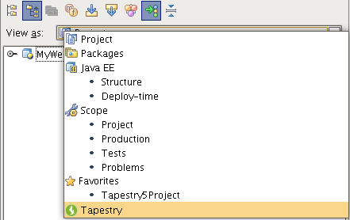

The view let's you browse your Tapestry modules in a tree structure that shows you all Tapestry elements like pages and components.

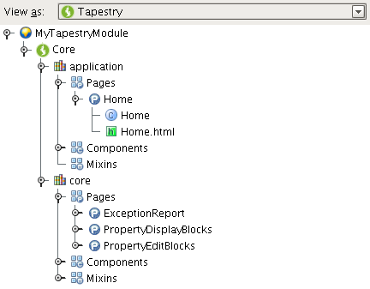

Each element in the Tapestry View has a different icon so that it's easy to identify the type of element:

Library |  | A Tapestry library.  By default you will have two library nodes, one for you application and other of the provided core library.
Page |  | A Tapestry page.  You can navigate to the page class or template from here.
Component |  | A Tapestry component.  You can navigate to the component class or template from here.
Mixin |  | A Tapestry mixin.  You can navigate to the mixin class from here.

The toolbar provides some additional functionality that will also help each user customize it's look&feel:
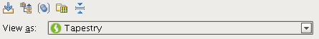

Autoscroll to Source |  | Single click on a element in the browser will load the corresponding source file in an editor panel.
Show From Base Package |  | Only Show Content From the Application Base Package
Group Element Files |  | Group Element Files Like it's Class and Template in a Parent Node.
Show Libraries |  | Show/Hide Tapestry Libraries.
Collapse All |  | Collapse all the elements.

Drag & Drop
In order to increase development speed and prevent errors the plugin allows you to use drag&drop operations to generate simple code but that would otherwise be more error prone and take time from the task at hand.

Drag&Drop Components
- Drop in Page or Component Template
This drop operation will result in a reference to the dropped component being inserted at the drop point with all required attributes set.
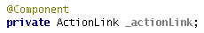
- Drop in Page or Component Class
This drop operation will result in the declaration of an embedded component in the target class.

Drag&Drop Pages
- Drop in Page or Component Template
This drop operation will result in a page link to the dropped page being inserted at the drop point.

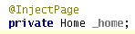
- Drop in Page, Component or Mixin Class
This drop operation will result in the injection of the dropped page in the target class.

Drag&Drop Mixins
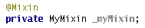
- Drop in Component Class
This drop operation will result in the declaration of the usage of an implementation mixin.

Safe Delete
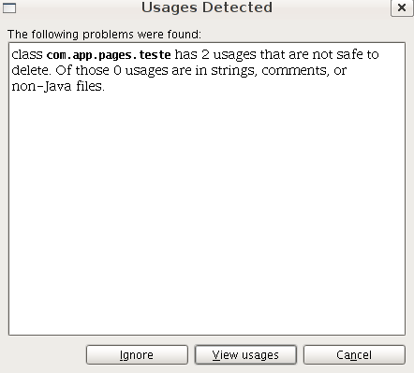
If you execute the delete action from the Tapestry View you'll see that Loomy will actually figure out what Tapestry elements you're trying to delete and it will aggregate all it's file into this operation. So if for example you try to delete a page, Loomy will delete the page class, template and it's resource bundle.
IntelliJ IDEA will then look for usages of all the resulting files and you'll be able to, as usual, go through with the operation or cancel it.

Tapestry ToolWindow
This toolwindow shows contextualized information about some Tapestry element. It currently has one tab but in future more will be added. For now, this toolwindow will show you the documentation of a Tapestry element.
The documentation is composed of (where applicable):
- General description
- List of required parameters and their description
- List of optional parameters and their description
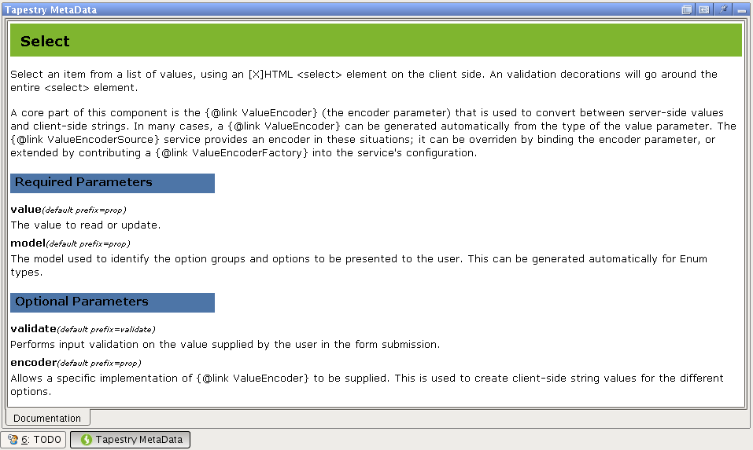

Wizards
This plugin provides additional wizards to help you deal with the most common tasks.

Tapestry Module Creation
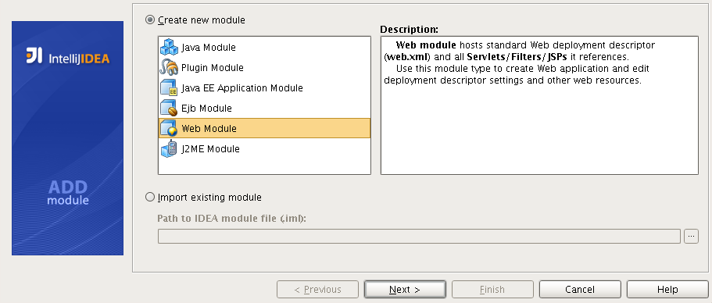
This wizard allows you to get a Tapestry project up and running quickly by providing special support for Tapestry in the new module wizard.
The generated web module will be a ready-to-run Tapestry web application with a sample Home page.
The general flow of the module creation process is similar to the described in the Creating Modules section. This subsection describes only features specific for the Tapestry Web Module creation.
At Step 1 select the Web Module item in the module list.
Steps 2 to 6 are the same as in the normal web module creation.
Step 7 is different. Here you need to specify that you want this web module to have Tapestry support.
Every step from here on is specific to Tapestry.
In Step 8 you need to specify Tapestry related information:
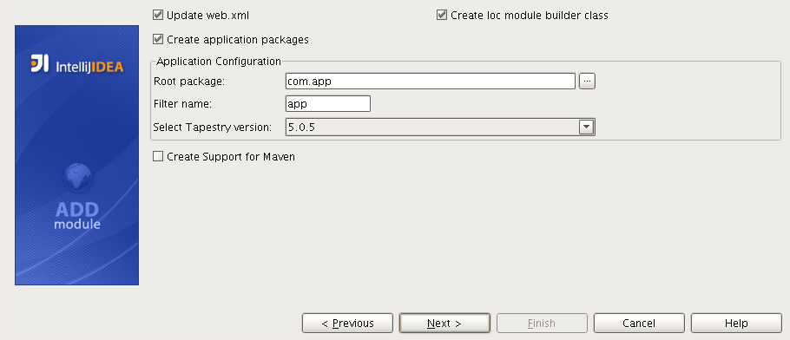
- Update web.xml
Check to update the main deployment descriptor(web.xml) with Tapestry specific configurations.
- Create Ioc module builder class
Check to generate a new module builder class.
- Create Ioc module builder class
Check to generate a new module builder class.
- Create application packages
Check to create the base packages for a Tapestry application.
- Root package
The application root package.
- Filter name
The name of the filter that will be configured in your web.xml.
- Tapestry version
The Tapestry version to use.
- Create Support for Maven
Check to generate a pom.xml file with basic project configuration.
In Step 9 you need to specify Maven related information:
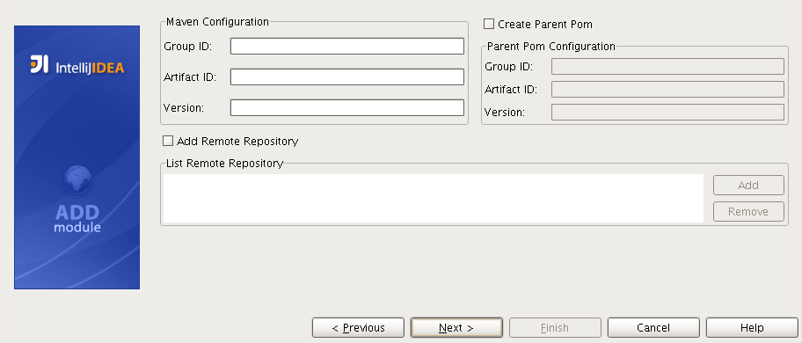
- Group ID
The group that this Maven project belongs to.
- Artifact ID
The artifact ID of this Maven project.
- Version
The version of this Maven project(optional).
- Create Parent Pom
Check to generate a parent pom section in your pom.xml.
- Parent Group ID
The parent pom group ID.
- Parent Artifact ID
The parent pom artifact ID.
- Version
The parent pom version.
- Add Remote Repository
Check to generate a remote repositories sections in your pom.xml file.
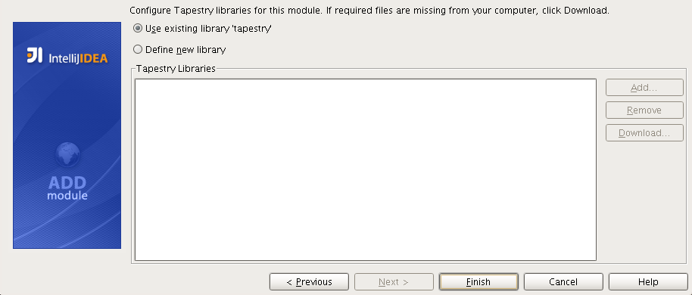
In Step 10 you can configure the Tapestry libraries.
Here you can add the Tapestry dependencies in three ways:
- Use existing library
If you have a configured library with the Tapestry jars you can select it to be used in this new module.
- Download jars
If you don't have any library created then you can let the plugin download the jars from a remote location and create the library for you.
- Add jars
If you already have the jars in you computer you can add select them and a new library will be created.

New Component
This wizard allows you to create a new component(class and template) in your Tapestry project.
- Select the destination component package.
- Right-click the node, point to New and click Tapestry Component.
- Enter the required information about the component.
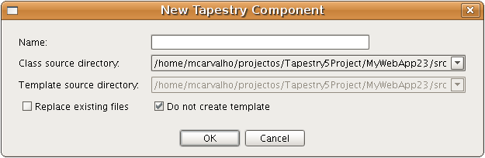
- Name
The component name. Can include "/" as path separators.
- Class source directory
The java source root to add the component class to.
- Class template directory
The web context root to add the component template to.
- Replace existing files
Check if you want to replace existing files with the ones that are create by this wizard.
- Do not create template
Allows the user to create a new element without a template.

New Page
This wizard allows you to create a new page(class and template) in your Tapestry project.
- Select the destination page package or web context folder.
- Right-click the node, point to New and click Tapestry Page.
- Enter the required information about the page.
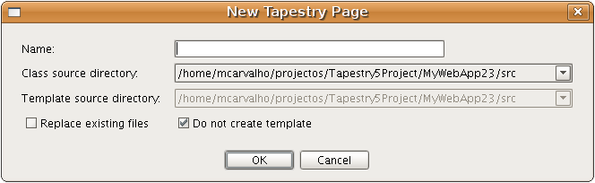
- Name
The page name. Can include "/" as path separators.
- Class source directory
The java source root to add the page class to.
- Class template directory
The web context root to add the page template to.
- Replace existing files
Check if you want to replace existing files with the ones that are create by this wizard.
- Do not create template
Allows the user to create a new element without a template.

New Mixin
This wizard allows you to create a new mixin in your Tapestry project.
- Select the destination mixin package.
- Right-click the node, point to New and click Tapestry Mixin.
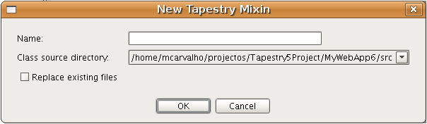
- Enter the required information about the mixin.

- Name
The mixin name. Can include "/" as path separators.
- Class source directory
The java source root to add the mixin class to.
- Replace existing files
Check if you want to replace existing files with the ones that are create by this wizard.

Template Editing
Loomy adds some additional features to the default HTML editor to allow faster and safer creation of Tapestry templates.

Syntax Highlighting
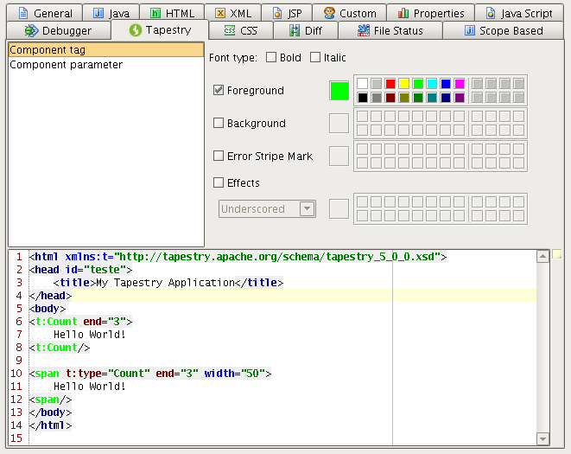
To configure the syntax highlighting feature you have to go to Colors & Fonts settings. In the Tapestry tab you can then choose the syntax coloring scheme that you prefer.
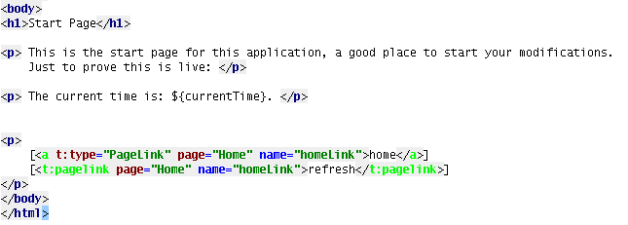
Once this is configured, you will be able to easily identify in your template what are normal tags and Tapestry tags:

Error Detection
There are several errors that are only found when the application is running. With Loomy it's possible to detect many of these errors without losing the time to run the application.
The plugin can detect the following errors:
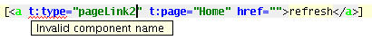
- Invalid component references

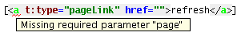
- Missing required parameters

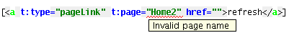
- Invalid page names
- Invalid property
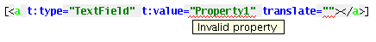

Auto-Completion
Auto-completion makes template editing much faster. Loomy extends this feature introducing lot's of Tapestry specific completions.

Component Tags Auto-Completion
When editing your template you can take advantage of the auto-completion feature to help you insert a component using both types of possible annotations for that:

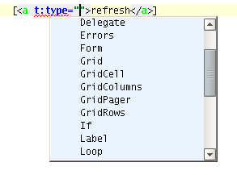
- Invisible Instrumentation
Just use the auto-completion feature on the t:type attribute value.
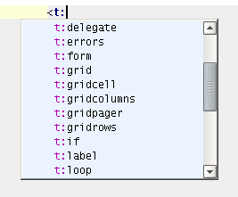
- Component Tag
Just use the auto-completion feature on the tag name where you want to insert the component.

Component Parameters Auto-Completion
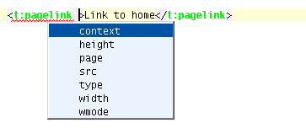
Component tags have additional parameters that don't conform to the HTML standard and so the default auto-completion won't help you. This plugin extends the auto-completion feature adding the Tapestry component parameters to the list of possible tag parameters.

Parameters Values Auto-completion
Auto-completion of property binding is available so you can save lot's of time navigating from template to class.

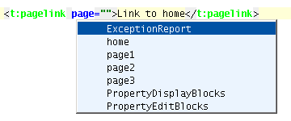
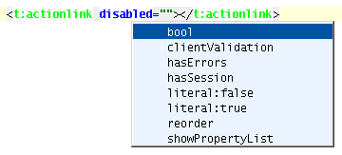
Page parameter of the PageLink component:
Boolean parameters:
Simple properties:
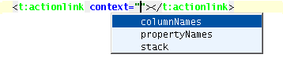

Composed properties:
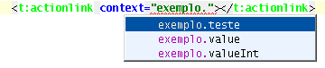

Navigation
Loomy allows easy navigation between several elements in your template are related content.

Between template and class
Probably the most used navigation. Loomy provides an action (CTRL+SHIFT+G by default) that allows you to navigate from a template to it's corresponding class and vice-versa.

From tag to component class
This navigation allows you to navigate from a component tag in your template to that component class. Just press CTRL+Click on the tag itself.

From property value to associated method
If you have bound a component parameter with a property you can now just press CTRL+Click on the parameter value in your template and you will navigate to the method that corresponds to the given property.

To component documentation
This navigation allows you to navigate from a component tag in your template to that component documentation displayed in the Tapestry ToolWindow. This action is associated by default to the key CTRL+Shift+D, so just use when the cursor is on a component tag and you'll see it's documentation.

