CSE 415 take-home final: Question 1

**Background**: The 2019 novel coronavirus, known officially as COVID-19, is a highly infectious disease that originated in Wuhan, China around December 2019, spreading to over 25 countries within the span of about 4 months.[1] As far as we know, the disease spreads quickly over time and space, due to many infected persons only showing mild or few symptoms, or not exhibiting physical symptoms at all, while the elderly, immunocompromised, very young children, and people with pre-existing health issues have the highest mortality rate.[2]

**Proposed initial state**: Similar to a state-space representation of climate change relating to variables such as earth albedo, we can treat the spread of this disease (on Earth as a whole) like an equation.[3] The initial state represents the instance the first human acquired COVID-19. Since the disease spreads over time, it is important to consider a “t” variable as time in months since the approximate start of the outbreak, therefore t = 0 at the initial state. The initial state should also include N, number of people infected, since future numbers of infected people are likely to grow exponentially from previous infection numbers. According to the World Health Organization Coronavirus Situation Report 46, “the number of secondary infections generated from one infected individual is understood to be between 2 and 2.5.”[4]

While the number of currently infected people is likely directly related to the future number of people infected by COVID-19, government action against COVID-19 and number of people who have developed an immunity against COVID-19 should be inversely related. This design choice is supported by scholars’ claims that strict “quarantine, social distancing, and isolation of infected populations can contain the epidemic”.[5] Therefore, we shall represent those two factors as G (level of government action around the world) and I (number of people with immunity).

An approximate equation could look something like this: Total Number of Infected after 1 month since N was observed = – (G + I2)

Python representation of initial state: INITIAL_STATE = infectedState(t=0, N=1, G=0, I=0)

**Operators:** A possible general action that can be taken in this state-space search is having the government of each country prioritize COVID-19 testing. An obstacle that has impeded doctors in the United States in their struggle to test for COVID-19 is red tape imposed by the U.S. Food and Drug Administration. Alex Greninger, the assistant director of virology at the University of Washington Medical Center, claims that getting the authorization to test was “complicated”.[6]

1. Invest _____ amount of money into COVID-19 testing.
   1. Pre-condition: government funds are greater than or equal to the proposed investment.
   2. State-transformation function: subtract proposed funds from government funds, add 1 to G in the state for every $10,000 spent
2. Implement government-mandated quarantines, successfully.
   1. Pre-condition: most citizens (>=99%) obey the quarantine, a majority of involved politicians/lawmakers, (opinions are weighted, >=65% approval) agree to imposed quarantines.
   2. State-transformation function: add 1 to G if successful, multiply number of infected (N) by 0.82 to reflect people in quarantine but recover or pass away.
3. Decrease requirements to acquire EUA for testing (Emergency Use Authorizations)
   1. Pre-condition: most politicians involved agree to lifting restrictions on EUA (weighted opinions, ex: FDA has more say in the law)
   2. State-transformation: add 1 to G if successful, multiply number of infected by 0.92, since early testing can prevent people from infecting others.
4. Distribute vaccines to every clinic in a country.
   1. Pre-conditions: vaccine exists.
   2. State-transformation: add 100 to G if successful, multiply number of infected by 0.2, not 0.0 because of people who are in situations where they cannot receive vaccines, or they are anti-vaccine. This is the best method to decrease infection rates.
      1. If the vaccine is not completely successful, (ex: only some people develop immunity), then add percentage of success to G.
5. Make all large public and private universities and schools online-only, successfully.
   1. Pre-conditions: local government agrees, most students agree (>=90%), Zoom (or any video-conference technology) exists and is accessible or free of cost, university administration agree.
   2. State-transformation: add 1 to G if successful, multiply N by 0.998. This doesn’t dramatically decrease N since students could still go to places with large crowds, travel overseas or out of state and get infected/pass on the infection.

**Goal State:** In Python, a goal state would look like: GOAL_STATE = state(t, N=0, G, I)

N would equal 0, indicating that there is no longer any existence of COVID-19 in humans. This could be in the context of humans successfully eradicating the virus through vaccination or isolation

**Cost Function:** A cost function that maps each operator application to a nonnegative value would be the number of years + amount of money needed to fulfill all pre-conditions of each operator. For example, the operator “make all large public and private universities online” requires extensive funding from an administration. Distributing video-conferencing technology potentially costs money and would cause a shortage of overall funds in the long-term and deter some school officials from having schools go online.

**Heuristic:** States leading to the existence of successful vaccines should have a lower heuristic value than states that do not. The search will follow paths that lead to vaccination, and thus reach the goal state quickly. The heuristic function could also add the shortest distance of the node to the goal to its heuristic value. The heuristic value itself would represent the time in number of years to reach the goal from the current node.

This heuristic’s admissibility is difficult to argue for since the search must consider costs of several operators as well as the heuristic function, so one would not know if the value is overestimating the true distance to the goal node.

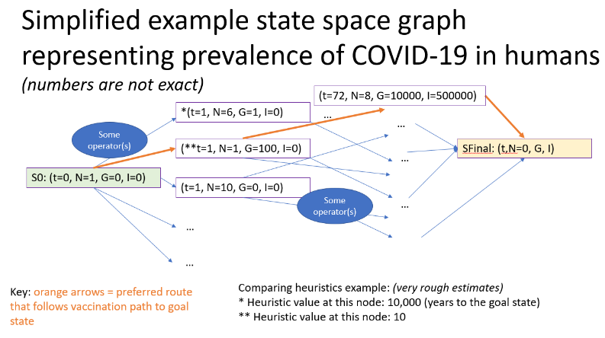

**Formulation Critique:** My formulation largely relies on all involved people working in a unified, cohesive effort to contain the outbreak, which is not always realistic given our very diverse planet. My formulation also assumes many things about how people interact with their government, and if that government even exists. For example, one country might spends billions of dollars fighting COVID-19, skewing G (level of positive government involvement against COVID-19) higher, when in reality, countries that do not have funding at all are causing the highest increase in N (future people infected). Furthermore, this formulation assumes that we are able track every single infected person in the world, which is impossible given that not everyone shows symptoms, and the added difficulty of possible reinfections.[7]

**Argument for this formulation:** I would argue that this formulation makes it easy for people who hear misinformation, act against recommendations to fight the virus, or are panicking to understand a possible solution to the virus, and thus cause better practices to defend against COVID-19.

**Question 2: Consider the HMM whose state space is {*N,M,V* }, and whose set of possible observations is {*Mary,Jane,Will,Spot,Can,See,Pat*}. The emission and transition probability distributions are given in the two tables below.**

(a) the probability of the most likely state sequence, given that the output sequence is the one shown: 0.0023*4/9=**0.001**

(b) trellis diagram:

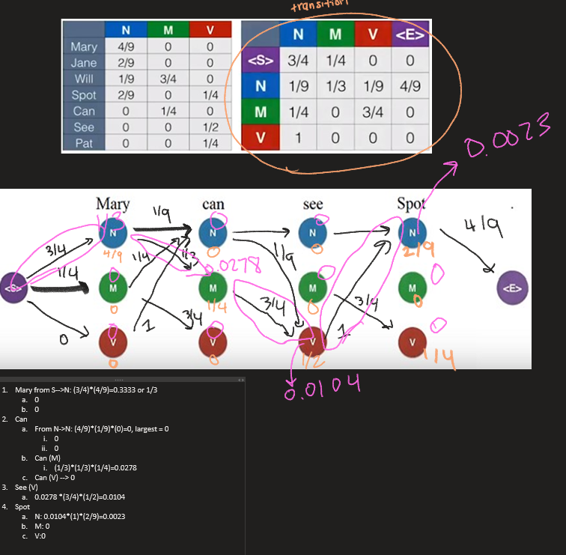



1. **Write answers of about 3-4 sentences for each subquestion.**

**Choose one of Asilomar Open AI principles 6-23. They are here:** [**https://futureoflife.org/ai-principles**](https://futureoflife.org/ai-principles)

1. paraphrase the description of the principle:

Designers of artificial intelligence must adhere to ethical design choices in their creations. The AI should not infringe upon any human’s rights or freedoms. And lastly, it should be created with consideration for all cultures and experiences.

1. identify and describe one challenge in being consistent with this principle:

It can be difficult for designers to consider all cultures when designing AI, especially if they are working in a company that values profit over morals. Also, the concept of “culture” is nebulous at times and may have conflicting interpretations among people. Oftentimes, creators of AI do not intend to violate human rights with their created technology, but the harmful side effects show up later when users interact with the product. For example, Google Photos may strive to help users easily find images or visually impaired people see images through image recognition, but the algorithm is currently riddled with biases against minorities.

1. identify and describe some way of achieving consistency with the principle:

To address the aforementioned problem, creators should detect bias in machine learning algorithms before deploying a product. To do this, companies should hire a more diverse population in order to gain understanding of how different people use their technology. Engineers should also make sure the training data is diverse and has no biases.

1. explain why this principle is important, in comparison to one of the other principles in the same group:

This principle is more important in comparison to “Capability Caution”, because addressing human rights in AI in general encompasses most of the other 15 Asilomar Open AI principles, while this principle only warns against assuming the future of AI, which might not have an immediately large impact on society. “Capability Caution” is important to consider as an engineer; having an open mind will bring about innovative creations in the future. However, “Human Values” will greatly impact everyone who uses the technology, not just the creator.

1. Xiao, Y., & Torok, M. E. (2020). Taking the right measures to control COVID-19. *The Lancet Infectious*

   *Diseases*. doi: 10.1016/s1473-3099(20)30152-3
2. People at Risk for Serious Illness from COVID-19. (2020, March 12). Retrieved March 13, 2020, from https://www.cdc.gov/coronavirus/2019-ncov/high-risk/high-risk-complications.html?CDC_AA_refVal=https://www.cdc.gov/coronavirus/2019-ncov/specific-groups/high-risk-complications.html
3. Tanimoto, S. *Applying Ai Methodology in Problem Solving* [Release 0.101 (Draft)]. Retrieved from https://courses.cs.washington.edu/courses/cse415/18wi/uwnetid/ApplyingAIInProblemSolving.pdf#page=25&zoom=100,96,202
4. World Health Organization. (2020). *Coronavirus disease 2019 (Covid-19) Situation* Report – 46 (pp. 2).
5. World Health Organization. (2020). Coronavirus disease 2019 (Covid-19) Situation Report – 44.
6. Khazan, O. (2020, March 13). The 4 Key Reasons the U.S. Is So Behind on Coronavirus Testing. The Atlantic. Retrieved from https://www.theatlantic.com/health/archive/2020/03/why-coronavirus-testing-us-so-delayed/607954/
7. Auwaerter, Paul. "Coronavirus." Johns Hopkins ABX Guide, The Johns Hopkins University, 2020. Johns Hopkins Guide, www.hopkinsguides.com/hopkins/view/Johns_Hopkins_ABX_Guide/540143/all/Coronavirus.