Jia-Jia Lin

CSE 415

January 7, 2020

Assignment 1, Part B: “Your Turing Test”

My major field of study is music composition. Typically, a person within this field will pursue a career in performance, composing, teaching, or scholarly research about music. For example, film score composers are in charge of writing soundtracks for movies. They may write sheet music by hand for a live orchestra to perform. The audio is then recorded and processed to fit scenes within the movie.

Parts of the job can be done by or made easier with the use of a computer. If one is composing music digitally, they may use soundfonts, or files that contain recorded samples from an instrument instead of hiring live musicians. Music notation software also exists, allowing composers to write music notes down electronically. There are programs that automatically create scores just from audio input. Technological advancements have even allowed for partially artificial intelligence-created songs.[1] Since the late twentieth century, the rise in popularity of electronic music and a shift against cultural norms have led to musicians using programs that can randomly generate lyrics to aid their creativity.[2] Recently, researchers at Google produced an algorithm, named NSynth, that can generate new sounds by reading the wave patterns of many music samples and combining their elements together.[3] Overall, computers have played a vital role in the modern music industry.

While the existence of artificially generated beats and lyrics are impressive, the computer or program itself has yet to create music, complete with voice, background instruments, and other nuanced elements that make a song “sound correct” to the average listener without being tuned and “fixed” by a composer. The average listener may be convinced that an artificially generated song is real but will be less convinced the longer they listen.

A good Turing test for an artificial composer would be to test whether an audience thinks that the generated song sounds like it was completely created by a person or not, and if that person is a real composer. The judges of the tests will consist of people who are able to listen to music and communicate with the person or computer. The artificially composed songs or “real” songs would be played in succession to the audience, and they would have to vote Real or Artificial for each one. The listeners may also describe how they felt about each song. Some specific questions that could be asked of the computer during the test are: “what were you thinking when you made this song?”, and “how did you create this?” Some affordances are particularly important in my field, such as comprehending human speech, understanding music notation and vocabulary, being able to tell apart musical pitches, and the ability to put together a song that sounds at least somewhat appealing to another listener. A particular “must-have” feature for a computer to exhibit in order to be considered “intelligent” within this field is the ability to gather data about music from source material online by itself and use it in a way that results in an original song that people would want to listen to and buy.

In the next ten years, artificially intelligence will certainly play an even bigger part to the process of music composition. Algorithms may be advanced enough to completely generate a song that becomes a popular hit. However, AI are not likely to replace composers in the near future. They will continue to be mostly used as a tool for composers to enhance their creativity in music creation. Based on my experience designing an agent related to my major field, one significant challenge in creating an agent that can pass the Turing test is implementing both the ability to understand and respond to human speech as a normal human composer would, and the ability to compose good music.

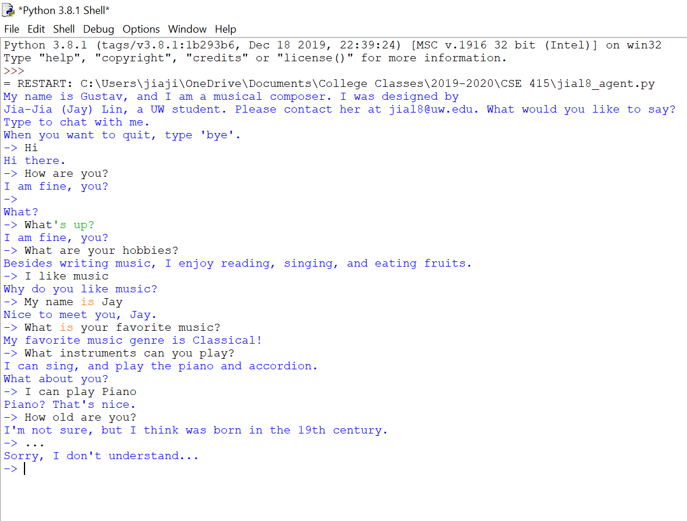Chatbot transcript:

1. <https://www.theverge.com/2018/8/31/17777008/artificial-intelligence-taryn-southern-amper-music>
2. <https://www.vice.com/en_us/article/xygxpn/the-verbasizer-was-david-bowies-1995-lyric-writing-mac-app>
3. <https://nsynthsuper.withgoogle.com/>