Jia-Jia (Jay) Lin

CSE 415A: Winter 2020

March 3rd, 2020

Assignment 6 Report

**CIFAR PLOTS**

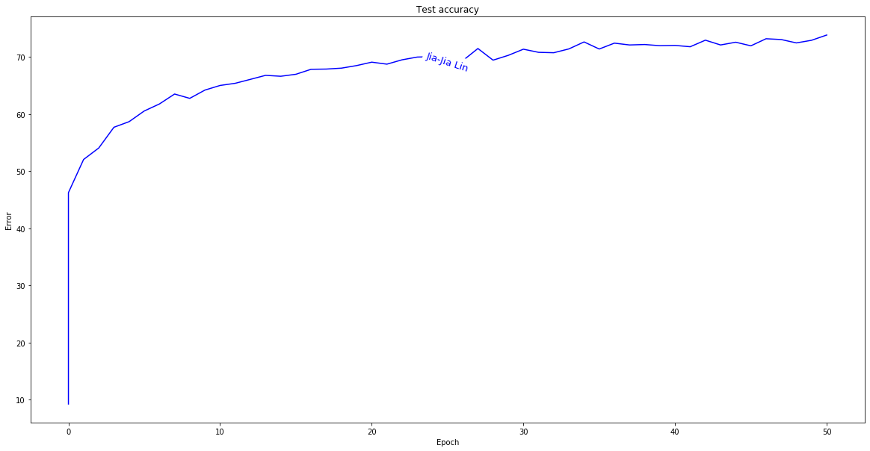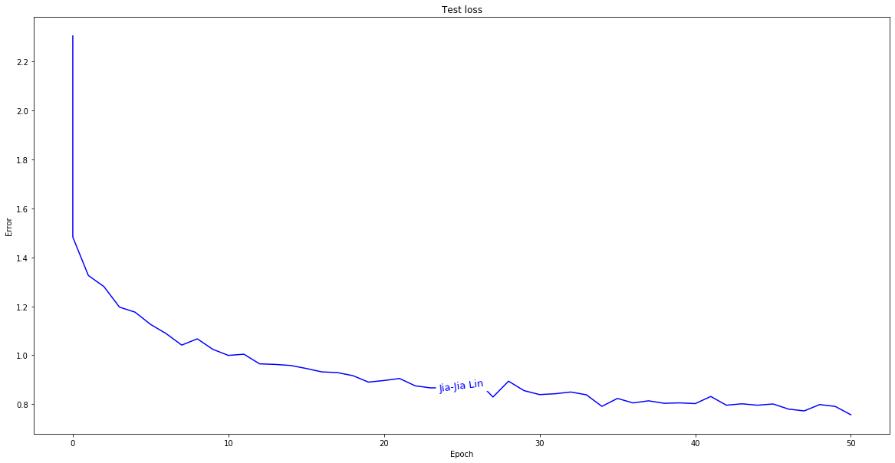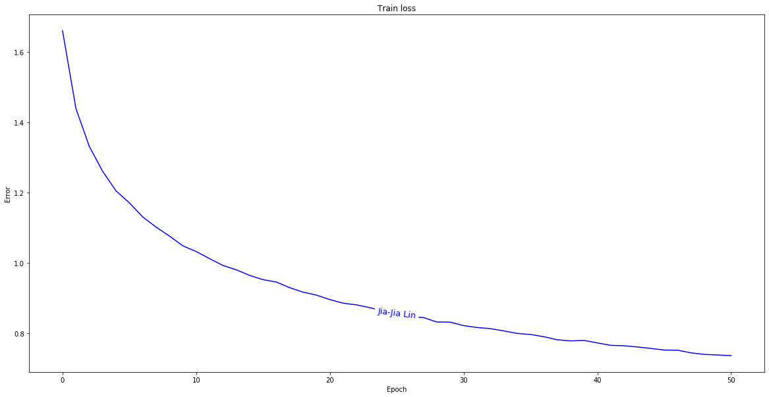

**External Images**



**Final Sentence:** Harry Potter, Voldemort, and Dumbledore walk into a bar. e was still staring at the door and the one of the corner of the corner of the corner of the corner of the corner of the corner of the corridor was still staring at the door and the one of the corner

**NLP plots**

