

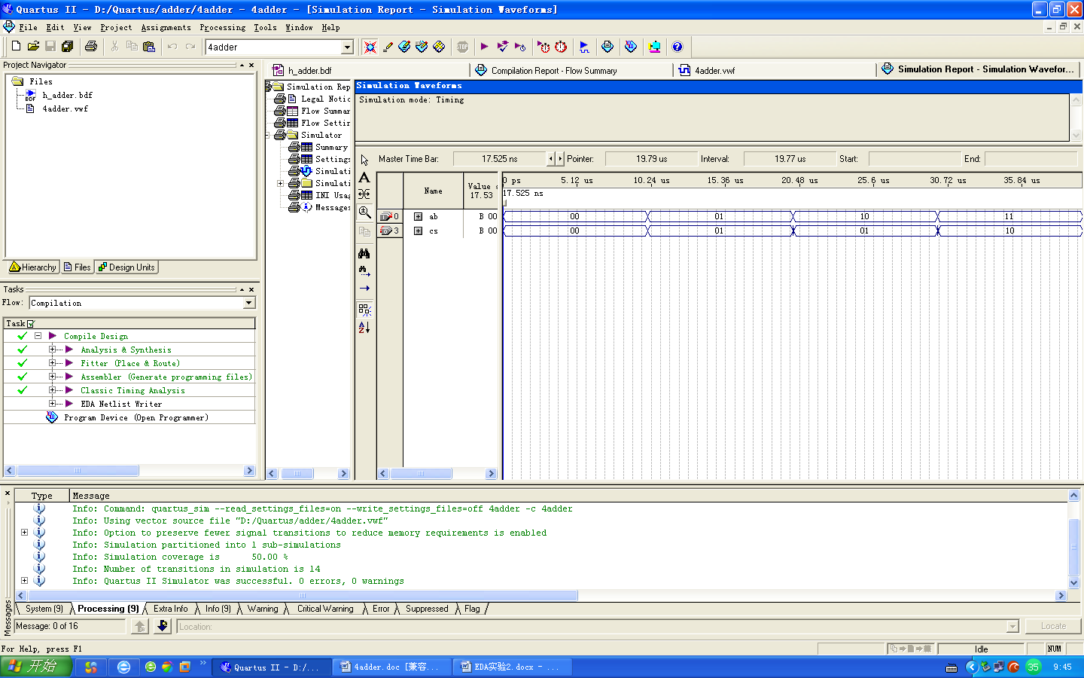



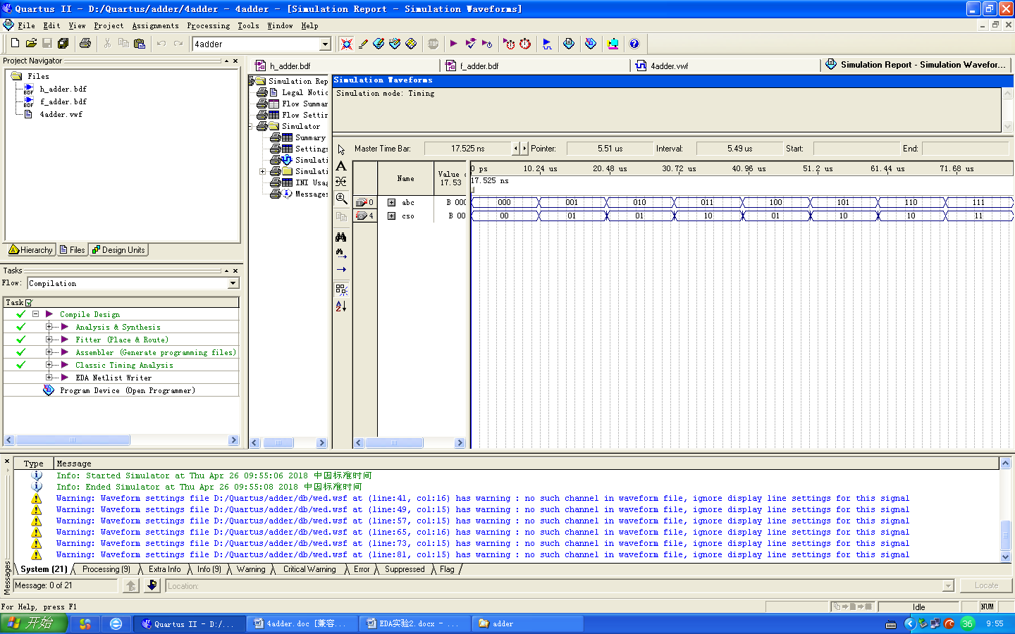



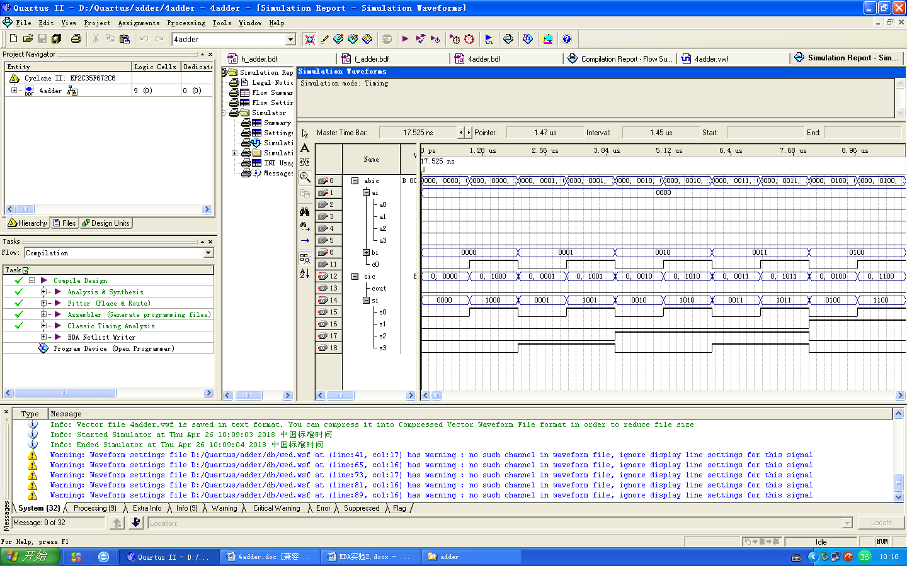

**顶层文件：**

LIBRARY IEEE;

USE IEEE.STD_LOGIC_1164.ALL;

USE work.h_adderp.all;

USE work.f_adderp.all;

ENTITY adderVHDL IS

PORT(a0, b0, c0, a1, b1, a2, b2, a3, b3: IN STD_LOGIC;

s0, s1, s2, s3, cout: OUT STD_LOGIC);

END adderVHDL;

ARCHITECTURE example OF adderVHDL IS

SIGNAL ss1, ss2, ss3, ss4, cc1, cc2, cc3, cc4: STD_LOGIC;

BEGIN

f1: f_adder PORT MAP(a0, b0, c0, ss1, cc1);

f2: f_adder PORT MAP(a1, b1, cc1, ss2, cc2);

f3: f_adder PORT MAP(a2, b2, cc2, ss3, cc3);

f4: f_adder PORT MAP(a3, b3, cc3, ss4, cc4);

s0 <= ss1;

s1 <= ss2;

s2 <= ss3;

s3 <= ss4;

cout <= cc4;

END example;

**h_adder文件：**

LIBRARY IEEE;

USE IEEE.STD_LOGIC_1164.ALL;

ENTITY h_adder IS

PORT(a, b: IN STD_LOGIC;

s, c: OUT STD_LOGIC);

END h_adder;

ARCHITECTURE example OF h_adder IS

BEGIN

s <= a XOR b;

c <= a AND b;

END example;

**h_adderp包文件：**

LIBRARY IEEE;

USE IEEE.STD_LOGIC_1164.ALL;

PACKAGE h_adderp IS

COMPONENT h_adder IS

PORT(a, b: IN STD_LOGIC;

s, c: OUT STD_LOGIC);

END COMPONENT h_adder;

END h_adderp;

**f_adder文件：**

LIBRARY IEEE;

USE IEEE.STD_LOGIC_1164.ALL;

USE work.h_adderp.all;

ENTITY f_adder IS

PORT(ai, bi, ci: IN STD_LOGIC;

so, co: OUT STD_LOGIC);

END f_adder;

ARCHITECTURE example OF f_adder IS

SIGNAL SZ1, CZ1, SZ2, CZ2: STD_LOGIC;

BEGIN

h1: h_adder PORT MAP(ai, bi, sz1, cz1);

h2: h_adder PORT MAP(sz1, ci, sz2, cz2);

so <= sz2;

co <= cz1 OR cz2;

END example;

**f_adderp包文件：**

LIBRARY IEEE;

USE IEEE.STD_LOGIC_1164.ALL;

USE work.h_adderp.all;

PACKAGE f_adderp IS

COMPONENT f_adder IS

PORT(ai, bi, ci: IN STD_LOGIC;

so, co: OUT STD_LOGIC);

END COMPONENT f_adder;

END f_adderp;

