

AMCS2123
Systems And Programming Concepts

Assignment
June 2026

Programme | : | Diploma in Computer Science
Tutorial Group | : | Group 2
Tutor Name | : | Chow Chi Sin
Date Submitted to Tutor | : | 31 August 2026

Team Members:
No | Student Name | Student ID
1. | Yong Jet Hong | 25WMD03550
2. | Lee Zhi Qian | 25WMD03339
3. | Michelle Eng Jia Qi | 25WMD03739
4. | Teo Kai Xuan | 25WMD03174

No. | Team Member | Task(s) Completed (in detailed including mention the programming and reporting tasks) | Overall Contribution (%)
1. | Yong Jet Hong | Programming:  Main module  Customer management module  Reporting:  Program Structure  Overall Structure Chart  Main Menu and Navigation  Module Integration and Data Sharing  Programming Concepts Applied  Individual Module - Customer Management  Achievement of Objectives | 25
2. | Lee Zhi Qian | Programming:  Room management module  Price management module  Reporting:  Selected Service Industry  Target Users  Major Functional Areas  Overall System Workflow  Individual Module - Room & Inventory Management  Summary of the System | 25
3. | Michelle Eng Jia Qi | Programming:  Payment & Billing module  Reporting module  Reporting:  Background of the System  Purpose of the Program  System Objectives  Scope of the System  Individual Module - Billing.Payment & Reporting  Overall System Performance | 25
4. | Teo Kai Xuan | Programming:  Room Booking module  Reporting:  Dynamic Price and Discount Management  Customer Check-In and Check-Out Management  Overall Benefits  Individual Module - Booking/Reservation & Schedule  Future Improvement | 25
Total |  |  | 100

Coursework Originality Declaration
We confirm that we have read and shall comply with all the terms and conditions of TAR University of Management and Technology plagiarism policy.
We declare that this assignment is free from all forms of plagiarism and for all intents and purposes is our own properly derived work.

Name | : | Yong Jet Hong | Lee Zhi Qian | Michelle Eng Jia Qi | Teo Kai Xuan
Photo | : |  |  |  | 
Signature | : |  |  | 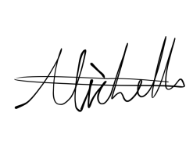 | 

Table of content
Table of content 5
1.0 Introduction 8
1.1 Background of the System 8
1.2 Purpose of the Program 8
1.3 System Objectives 9
1.4 Scope of the System 9
2.0 System Overview 10
2.1 Selected Service Industry 10
2.2 System Overview 10
2.3 System Users 11
2.4 Major Functional Areas 11
2.4.1 Customer Management 11
2.4.2 Room Management 11
2.4.3 Price Management 11
2.4.4 Room Booking 12
2.4.5 Reporting 12
2.5 Overall System Workflow 13
3.0 Overall Program Design 14
3.1 Program Structure 14
3.2 Main Menu and Navigation 16
3.4 Data Structures and Shared Data 17
3.5 Programming Concepts Applied 18
4.0 Additional Functionalities 19
4.1 Dynamic Price and Discount Management 19
4.2 Membership Reward and Upgrade 20
4.3 Customer Check-In and Check-Out Management 20
4.3 Overall Benefits 20
5.0 Program Testing and Outputs 21
5.1 Introduction Screen 21
5.2 Main Menu 21
5.3 Customer Management Entry 21
5.4 Room Management Entry 21
5.5 Room Booking Entry 21
5.6 Price Management Entry 21
5.7 Report Entry 21
5.8 Exit 21
6.0 Individual Module-Customer Management 22
6.1 Module Overview 22
6.2 Module Purpose 22
6.3 Functional Description 23
6.4 Data Structures 24
6.5 Functions 25
6.6 Input Validation 26
6.7 Module Interaction 27
6.8 Test Plan 28
Scenario 1-Add Valid Customer 28
Scenario 2-Invalid Customer Information 28
Scenario 3-Search/Edit/Delete Customer 28
7.0 Individual Module-Room & Inventory Management 29
7.1 Module Overview 29
7.2 Module Purpose 29
7.3 Functional Description 29
7.4 Data Structures 29
7.5 Functions 29
7.6 Input Validation 29
7.7 Module Interaction 29
7.8 Test Plan 29
Scenario 1-View Room Details 29
Scenario 2-View Available Rooms 29
Scenario 3-Edit Room Status 29
8.0 Individual Module-Booking/Reservation & Schedule 30
8.1 Module Overview 30
8.2 Module Purpose 30
8.3 Functional Description 31
8.4 Data Structures 32
8.5 Functions 33
8.6 Booking Validation 34
8.7 Payment Integration 35
8.8 Module Interaction 35
8.9 Test Plan 36
Scenario 1-Successful Room Booking and Payment 36
Scenario 2-Invalid Date / Invalid Input 36
Scenario 3-Cancel Booking / Check-In / Check-Out 36
9.0 Individual Module-Billing/Payment & Reporting 37
9.1 Module Overview 37
9.2 Module Purpose 37
9.3 Payment Functionality 38
9.4 Reporting Functionality 39
9.5 Data Structures 40
9.6 Functions 41
9.7 Validation 42
9.8 Interaction with Other Modules 43
9.9 Test Plan 44
Scenario 1: Successful Cash Payment 44
Scenario 2: Insufficient Cash 47
Scenario 3: Successful Premium Member Payment with Discount 51
Scenario 4: Generate Monthly, Yearly, Overall Reports 54
Scenario 5: Validation Testing Scenario 58
10.0 Conclusion 64
10.1 Summary of the System 64
10.2 Achievement of Objectives 64
10.3 Overall System Performance 64
10.4 Future Improvement 64

1.0 Introduction

1.1 Background of the System
The Hotel Reservation System is a menu-driven C++ application developed to support common hotel management and reservation activities. The system provides an organized way to manage customer records, hotel room information, room pricing, room reservations, payments, and management reports. By integrating these functions into one system, users can perform hotel-related operations through a structured and consistent interface.
The system is designed around several major functional areas, including Customer Management, Room Management, Price Management, Room Booking, Billing/Payment, and Reporting. The Customer Management function allows customer records to be added, edited, deleted, displayed, and searched. The Room Management function allows users to view room details, check available rooms, update room status, and search for specific rooms. The Price Management function allows room prices and membership discounts to be viewed and updated. The Room Booking function manages room selection, customer verification, booking dates, check-in, check-out, cancellation, searching, and booking records. The Billing/Payment function calculates booking charges, records successful payments, and generates receipts. The Reporting function generates summary information such as total bookings, total customers, completed payments, and total revenue.
The system also applies the programming concepts covered in the Systems and Programming Concepts course. These include modular program design, user-defined functions, arrays, vectors, structures, selection statements, repetition statements, input validation, string processing, calculations, and formatted output. The use of these concepts allows the system to divide its operations into manageable functions and provides a clear program structure.

1.2 Purpose of the Program
The purpose of the Hotel Reservation System is to provide a simple and organized computerized system for handling hotel reservation and management activities. The program allows users to manage customer and room information, process room bookings and payments, maintain room and pricing information, and obtain management statistics.
The system is also intended to reduce errors that may occur during manual processing by providing validation for important user inputs. For example, the system validates customer information such as names, IC numbers, and phone numbers, while the booking process validates room selection, customer identification, and booking dates. Payment processing also checks the payment amount before completing a transaction.
Overall, the program provides an integrated flow from customer registration and room selection to booking, payment, receipt generation, and management reporting.

1.3 System Objectives
- To provide a structured system for managing customer records.
- To manage hotel room information and room availability.
- To provide a centralized function for managing room prices and membership discounts.
- To allow users to create, cancel, search and display hotel reservations.
- To support customer check-in and check-out operations.
- To process payments and generate payment receipts.
- To generate management reports containing booking, customer, payment and revenue information based on month and year.
- To apply modular and well-structured C++ programming concepts in developing the system.
- To provide input validation and error handling to reduce invalid entries and prevent inappropriate program behaviour.

1.4 Scope of the System
The scope of the Hotel Reservation System covers the main operational functions required for managing hotel reservations. The system provides six main functional areas: Customer Management, Room Management, Price Management, Room Booking, Billing/Payment, and Reporting.
Customer Management covers adding new customers, displaying customer records, editing customer information, deleting customers, and searching for customers. Room Management covers viewing room details, viewing available rooms, editing room status, and searching for rooms. Price Management covers editing room prices, editing membership discounts, and displaying current room prices and discount rates.
Room Booking is responsible for the main reservation workflow. Users can select a room type, verify an existing customer, select an available room, enter check-in and check-out dates, confirm the booking, and proceed with payment. The booking module also supports cancellation, booking searches, booking record display, and guest check-in and check-out. Payment processing is integrated into the room booking process, and a receipt is generated after a successful payment.
The Reporting function provides a summary of the system's booking and payment information. The generated report includes the total number of bookings, total customers, completed payments, and total revenue. The report can be viewed by year or month.
The system is implemented as a console-based C++ application with a menu-driven interface. It uses arrays, vectors, structures, functions, selection and repetition statements, input validation, and formatted output to perform the required operations.

2.0 System Overview

2.1 Selected Service Industry
Selected Service Industry: Hotel Reservation System
The selected service industry for this project is the hotel reservation industry. The system is developed to support hotel related activities including customer management, room management, room pricing, reservations, payment processing, check-in and check-out, and management reporting.

2.2 System Overview
The Hotel Reservation System is a menu-driven C++ application that integrates several hotel management functions into one system. When the program starts, the system initializes the available hotel rooms and displays the main menu. Users can then select the required functional area and perform the corresponding operations.
The system consists of six main functional areas:
Functional Area | Main Functions
Customer Management | Add, delete, display, edit and search customer records
Room Management | View room details, available rooms, edit room status and search rooms
Price Management | Edit room prices, edit membership discounts and display pricing information
Room Booking | Book rooms, perform check-in/check-out, cancel bookings, search bookings and display booking records
Reporting | Generate and display booking, customer, payment and revenue summaries
The functional areas are integrated through shared data. Customer information is used during room booking and payment calculation, room information is used to determine the selected room and price, booking information is used during billing and payment processing, and booking and payment information are used to generate reports. This integration allows the different parts of the system to work together as a complete application. This assignment requires individual modules to interact correctly and share data within the overall system.

2.3 System Users
The primary users of this system is the hotel staff member responsible for carrying out hotel reservation and management operations. The users interact with the system through the menu-driven interface to manage customer records, room information, pricing, reservations, payments and reports.

2.4 Major Functional Areas

2.4.1 Customer Management
The Customer Management module manages customer records. Users can add new customers, display all customer records, edit existing customer information, delete customer records, and search for customers by Customer ID, IC number, or customer name.
The module also applies input validation. Customer names are checked to ensure that they contain valid characters, while IC numbers and phone numbers are checked for numeric input, appropriate length, and duplicate records. Customer IDs are generated automatically by the system.

2.4.2 Room Management
The Room Management module manages information for the hotel's rooms. The system initializes rooms with unique room IDs, room types, prices, and availability status. Users can view the details of rooms, display available rooms, search for a room, and update a room's availability status.
The system categorizes rooms into three room types: Single, Double, and Deluxe. Each room type is associated with a corresponding price, and the room status is updated when rooms are occupied or released.

2.4.3 Price Management
The Price Management module provides functions for managing room prices and membership discounts. Users can edit the price of Single, Double, and Deluxe rooms, as well as edit the discount rates for Regular, Premium, and VIP membership types. The system also provides functions for displaying the current room prices and discount rates.
The updated pricing information is used during payment calculation, allowing the system to apply the current room price and customer membership discount when calculating the total booking amount.

2.4.4 Room Booking
The Room Booking module manages the main hotel reservation workflow. Users can select a room type, verify a customer, select an available room, enter valid check-in and check-out dates, and confirm a reservation.
After the booking information is confirmed, the system processes the payment using the selected payment method. Once payment is successfully completed, the booking is recorded and the selected room is marked as unavailable.
The module also provides check-in and check-out operations, booking cancellation, booking search, and display of all booking records. During check-out, the room is marked as available again.

2.4.5 Billing/Payment
The Billing/Payment module calculates the total booking charge using the room type, number of nights, and applicable customer membership discount. It supports Cash, Credit Card, Debit Card, Online Banking, and E-Wallet payments. For cash payment, the system validates the amount received and calculates the change. After a confirmed payment, the system creates a payment record, marks the booking as paid, updates the customer's total spending, and displays a payment receipt.

2.4.6 Reporting
The Reporting module provides a summary of the current hotel reservation records. The system calculates and displays the total number of non-cancelled bookings, the number of unique customers associated with those bookings, the number of completed payments, and the total revenue generated from successful payments.

2.5 Overall System Workflow
The overall system workflow can be summarized as follows:
Customer Management
Main Menu
Hotel Reservation System
Room
Management
Price
Management
Room Booking
Report
Payment
Check-in/
Check-out
Receipt
Figure 2.5
The main interaction between the functional areas occurs through shared system data. Customer records are accessed during booking, room data are used for room selection and pricing, booking records are used for payment processing and payment and booking information are used to generate management reports.
The system therefore combines the individual functions into an integrated hotel reservation application rather than operating them as isolated modules. This supports the assignment requirement that the individual modules communicate correctly and that information is shared consistently throughout the complete system.

3.0 Overall Program Design
The Hotel Reservation System is designed as a modular, menu-driven C++ application. The program is divided into several functional modules to organize the different hotel management operations. Each module contains related functions that perform specific tasks, while shared data structures and global variables allow information to be accessed and updated across different modules.
The program begins execution from the main() function. Before displaying the main menu, the system initializes the hotel room records through the initializeRooms() function. The user can then access the main functional areas of the system: Customer Management, Room Management, Price Management, Room Booking, Billing/Payment, and Reporting.
The modular design improves the organization and readability of the program. Instead of placing all operations inside a single function, the system separates different operations into individual functions. For example, the Room Booking module contains separate functions for booking a room, checking in, checking out, cancelling a booking, searching for a booking, and displaying booking records.

3.1 Program Structure
The overall structure of the program is based on a hierarchical function design. The main() function acts as the starting point and controls the navigation to the main functional modules.
The six main modules are:
- Customer Management
- Room Management
- Price Management
- Room Booking
Billing/Payment
- Reporting
Each module contains additional functions responsible for specific operations. The functions interact through shared system data, including customer records, room records, booking records, payment records, room prices, and membership discount rates.
The overall program structure is illustrated below.

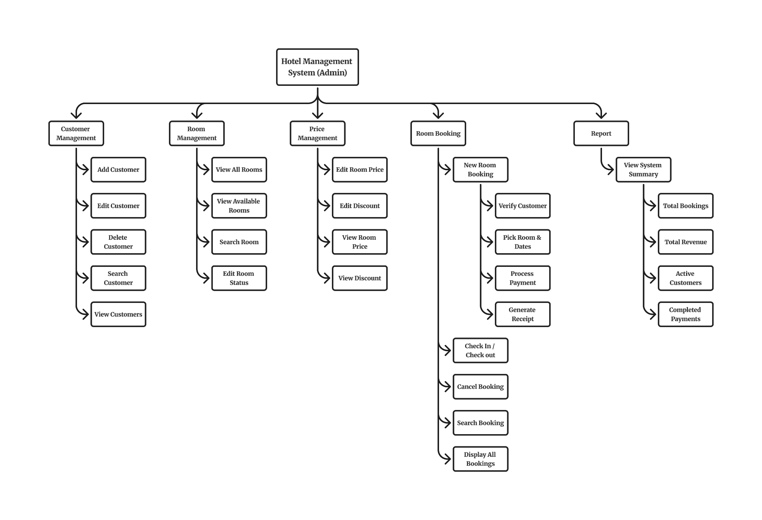
Figure 3.1 Overall Program Structure Chart

3.2 Main Menu and Navigation
Introduction/Main Screen → Main Menu → each menu option → module entry screen
When the program starts, the initializeRooms() function is executed to create and initialize the room records. The system then displays the main menu.
The main menu provides the following options:
1. Customer Management
2. Room Management
3. Price Management
4. Room Booking
5. Report
6. Exit
The user enters a menu choice, and the getMenuChoice() function validates whether the input is within the permitted range. If an invalid input is entered, the system displays an error message and prompts the user to enter another choice.
Based on the selected option, the system calls the corresponding module. After completing an operation, the user can return to the previous menu and continue using other functions. The program continues running until the user selects the Exit option.

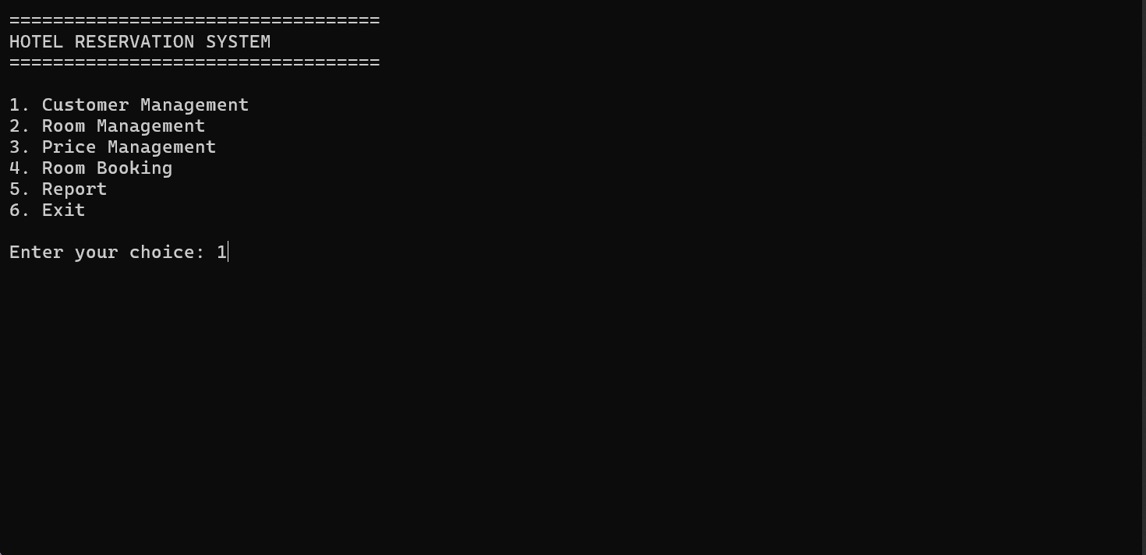
Figure 3.2 Main Menu Navigation

3.4 Data Structures and Shared Data
The system uses user-defined structures to store the main records required by the application. The primary data structures include Customer, Room, Booking, Payment, and Report.
Customer information is stored in the customers array, while hotel room information is stored in the rooms array. Booking information is stored in the bookings array. Payment and report information are stored using vectors.
The main shared data used by the system include:

Data | Purpose
customers | Stores customer records
rooms | Stores room information and availability status
bookings | Stores booking records
payments | Stores payment records
reports | Stores generated report records
singlePrice | Stores the price of a Single room
doublePrice | Stores the price of a Double room
deluxePrice | Stores the price of a Deluxe room
Membership discounts | Stores discount rates for different membership types
These shared data structures allow the different modules to interact with one another. For example, the Room Booking module accesses customer information to verify a customer and accesses room information to determine room availability. After a successful booking, the booking information can be used by the payment and reporting functions.
This shared-data approach allows the individual modules to operate as part of one integrated Hotel Reservation System.

3.5 Programming Concepts Applied
Functions
Pass-by-reference
Arrays
Vectors
Structures
Selection (if, else if, switch)
Repetition (while, for)
String processing
Input validation
Formatted output using iomanip
Date processing using tm, mktime, strftime
Regular expressions for date validation

4.0 Additional Functionalities
Besides the main functions of customer management, room management, room booking, payment, and reporting, the Hotel Reservation System also includes several additional functionalities to improve the usability, reliability, and efficiency of the system.

4.1 Dynamic Price and Discount Management
The system provides a Price Management module that allows users to manage room prices and membership discounts. Users can view and update the prices for Single, Double, and Deluxe rooms.
The system initially uses the following room prices:
- Single Room – RM120.00
- Double Room – RM180.00
- Deluxe Room – RM250.00
When a room price is updated, the system updates the prices of all rooms under the selected room type. The new price is then used for future booking and payment calculations.
The system also allows users to manage discounts for different membership types. The available membership categories are:
- VIP
- Premium
- Regular
The default discounts are:
- VIP – 20%
- Premium – 10%
- Regular – 0%
Users can enter a discount value between 0% and 100%, and confirmation is required before the changes are applied.
During the payment process, the system identifies the customer's membership type and automatically applies the corresponding discount when calculating the total payment amount. The calculation considers the room price, number of nights, and membership discount.

4.2 Membership Reward and Upgrade
The system tracks the total amount spent by each customer after a successful payment. The customer's total spending is updated whenever a payment is completed.
Based on the accumulated spending amount, the system automatically upgrades the customer's membership type. Customers who have spent RM500 or more are upgraded to Premium membership, while customers who have spent RM5000 or more are upgraded to VIP membership.
This functionality provides a simple reward mechanism that encourages customers to continue using the hotel's services. Higher membership levels can also receive different discount rates during future payments.

4.3 Customer Check-In and Check-Out Management
The system provides a check-in and check-out function to manage the customer's stay.
During check-in, the system verifies the booking ID and checks the current booking status. A booking cannot be checked in if it has been cancelled, is already checked in, or has already been completed. When the check-in is successful, the booking status is updated to Checked-In.
During check-out, the system ensures that the customer has already checked in before allowing the check-out process. After a successful check-out, the booking status is updated to Complete, and the corresponding room is automatically changed to Available.
This functionality helps maintain accurate booking and room availability records.

4.3 Overall Benefits

5.0 Program Testing and Outputs

5.1 Introduction Screen
When the program starts, the system displays an introduction screen identifying the course, assignment, and semester. This screen provides a clear starting point before the user enters the Hotel Reservation System.
Figure 5.1: Introduction screen.
[Insert screenshot of the introduction screen here]

5.2 Main Menu
After the introduction screen, the main menu provides access to Customer Management, Room Management, Price Management, Room Booking, Report, and Exit. The user enters a menu number to navigate to the selected function. Invalid menu input is rejected and the system prompts the user again.
Figure 5.2: Main menu.
[Insert screenshot of the main menu here]

5.3 Customer Management Entry
The Customer Management menu allows hotel staff to add, display, edit, delete, and search customer records. Customer ID, name, IC number, phone number, membership type, and total spending are maintained for later use by the booking and billing functions.
Figure 5.3: Customer Management menu.
[Insert screenshot of the Customer Management menu here]

5.4 Room Management Entry
The Room Management menu displays room information and availability. Staff can view all rooms, view available rooms, search for a room, and update a room status. Room data are used by the booking function to allocate an available room.
Figure 5.4: Room Management menu.
[Insert screenshot of the Room Management menu here]

5.5 Room Booking Entry
The Room Booking menu supports creating reservations, checking in guests, checking out guests, cancelling bookings, searching booking records, and displaying all bookings. During a new booking, the system verifies customer and room information, validates the stay dates, calculates the number of nights, and transfers the confirmed booking to the payment process.
Figure 5.5: Room Booking menu.
[Insert screenshot of the Room Booking menu here]

5.6 Price Management Entry
The Price Management menu allows staff to display and update room prices and membership discount rates. Changes to these values are used in subsequent booking and payment calculations, ensuring that the current price and eligible discount are applied.
Figure 5.6: Price Management menu.
[Insert screenshot of the Price Management menu here]

5.7 Report Entry
The Report menu provides three reporting options: Search by Month, Search by Year, and Overall Report. The generated report displays the total number of non-cancelled bookings, unique customers who have booking records, completed payments, and total revenue from successful payments.
Figure 5.7: Report menu and generated report.
[Insert screenshot of the Report menu and one generated report here]

5.8 Exit
When the user selects Exit from the main menu, the system displays an exit message and terminates the program safely. This completes the program flow without leaving the user in a menu loop.
Figure 5.8: Exit message.
[Insert screenshot of the exit message here]

6.0 Individual Module-Customer Management
Member:

6.1 Module Overview
The Customer Management serves as a core component of the Hotel Reservation System, responsible for creating, maintaining, searching, updating, and removing customer records. The module stores records sequentially in a fixed-size array (customers[MAX_CUSTOMER]) and automates identity management by generating unique, zero-padded Customer IDs (e.g., C001, C002). By centralizing customer identity and contact information, the module ensures that other sub-systems such as Room Booking and Billing & Payment can reliably reference valid customer records.

6.2 Module Purpose
The main objectives of the Customer Management Module are:
- Data Integrity: Enforce strict validation rules on customer credentials such as name format, IC number, and phone number to prevent corrupt or duplicate records.
- Uniqueness Assurance: Guarantee that no two customers share the same National IC or phone number.
- Streamlined Workflow: Standardize text formatting such as auto-capitalizing names into Title Case and automate ID allocation to eliminate manual input errors.
- Centralized Reference: Provide lookup and query services for room bookings, customer check-ins, and membership discount calculations.

6.3 Functional Description
- Add Customer
- Prompts the user sequentially for customer details: Name, IC Number, and Phone Number.
- Performs real-time field validation at each input step.
- Auto-formats the customer name to Title Case using capitalizeName().
- Automatically assigns a default member type ("Regular") and previews an auto-generated Customer ID before requesting confirmation to save the record.
- Display All Customers
- Iterates through the active customers array and renders a formatted ASCII table showing Customer ID, Name, IC Number, Phone Number, and Member Type.
- Handles empty database states gracefully with an informative message block.
- Search Customer
- Offers a sub-menu to search active customer profiles by Customer ID, IC Number, or Name.
- Performs exact matching for IDs (case-insensitive) and IC numbers, and substring matching (find() != string::npos) for customer names.
- Edit Customer
- Locates a target customer profile by ID and displays current details.
- Allows field-by-field updates (Name, IC, Phone) with full validation against duplicates and invalid formats.
- Previews the updated details and requires user confirmation before committing changes.
- Delete Customer
- Displays the active customer table, prompts for a target Customer ID, and shows full record details for verification.
- Upon user confirmation, deletes the record by shifting subsequent array elements to the left, clears the trailing slot, and decrements the global customerCount.
- Menu Navigation
- Controls the module loop using robust integer validation (getMenuChoice) to prevent infinite input loops or unexpected crashes.

6.4 Data Structures
The module uses the following structures:
struct Customer {
string customerID;
string name;
string phone;
string ic;
string memberType;
double totalSpent = 0.0;
};
The Customer structure stores each new customer details.
The following global storages and variables are used:
Customer customers[MAX_CUSTOMER] is a global static array holding up to 100 customer records.
int customerCount used to track the current number of active customer records.
int customerIDCounter will auto-increment the integer counter used to construct unique IDs.

6.5 Functions
Functions | Description
string capitalizeName (string name) | Converts input string to Title Case.
bool isValidName (const string& name) | Validates that a string contains only alphabetic characters and spaces.
bool isNumber (const string& input) | Checks if a string consists entirely of numeric digits.
bool checkDuplicateIC (const string& ic) | Checks if an IC number already exists in the customers array.
bool checkDuplicatePhone (const string& phone) | Checks if a phone number already exists in the customers array.
void generateCustomerID (Customer& c) | Generates a zero-padded string ID such as C001, assigns it to c, and increments customerIDCounter.
bool displayCustomerTable () | Displays formatted tabular list of all active customer profiles. Returns false if the array is empty.
void addCustomer() | Interactive workflow for registering a new customer record.
void searchCustomer() | Menu-driven utility to locate customers by ID, IC or Name.
void editCustomer() | Interactive workflow to modify existing customer record attributes.
void deleteCustomer() | Removes a customer record and shifts remaining elements to maintain array continuity.
void displayAllCustomer() | Wrapper function calling displayCustomerTable() with screen clearing and pause.
void customerManagement() | Module main menu control loop.

6.6 Input Validation
The module performs the following validation:
Input / Condition | Validation Performed
Customer name | Name must contain letters and spaces only. Invalid name displays "Invalid name! Name must contain letters and spaces only."
IC length | IC must contain exactly 12 digits. Otherwise, the system displays "IC must contain 12 digits!".
IC format | IC must consist of numbers only. Non-numeric input displays "IC must contain numbers only!".
Duplicate IC | If the entered IC already exists for another customer, the system displays "IC already exists!".
Phone length | Phone number must contain 10 or 11 digits. Otherwise, the system displays "Phone must contain 10 or 11 digits!".
Phone format | Phone number must consist of numbers only. Non-numeric input displays "Phone number must contain numbers only!".
Duplicate Phone | If the entered phone number already exists for another customer, the system displays "Phone number already exists!".
Customer lookup / ID | If the entered Customer ID or search query does not exist in the database, the system displays "Customer not found!".
Menu selection | Only choices within the specified range are accepted. Invalid choice displays "Invalid choice!".
Action Confirmation | Only y, Y, n, or N are accepted. Other input displays "Invalid input!" or "Invalid choice!".
Empty customer table | Displays "No customer records available!" when attempting to view or operate on an empty database.
Database capacity | Displays "No empty slot!" when attempting to add a new customer when the system reaches maximum capacity.

6.7 Module Interaction
The Customer Management module interacts with other modules as follows:
Module | Interaction
Main System | Receives user menu choices from the main application loop to navigate into customer management features.
Room Booking / Reservation | Provides customer ID lookup and returns customer details (name, IC, phone, member type) to verify guest identity during booking creation.
Billing & Payment | Supplies customer details (ID, name, member type, total spending) for invoice generation and membership discount calculation. Receives updated total spending and membership status updates after successful payments.
Reporting | Provides total customer count and profile data to generate management and customer activity reports.

6.8 Test Plan

Scenario 1-Add Valid Customer

Scenario 2-Invalid Customer Information

Scenario 3-Search/Edit/Delete Customer

7.0 Individual Module-Room & Inventory Management

7.1 Module Overview

7.2 Module Purpose

7.3 Functional Description

7.4 Data Structures

7.5 Functions

7.6 Input Validation

7.7 Module Interaction

7.8 Test Plan

Scenario 1-View Room Details

Scenario 2-View Available Rooms

Scenario 3-Edit Room Status

8.0 Individual Module-Booking/Reservation & Schedule

8.1 Module Overview
The Booking/Reservation & Schedule Module manages the reservation lifecycle within the Hotel Reservation System. It handles room selection, customer verification, calendar date processing, night calculations, guest check-in/check-out schedule transitions, and reservation cancellations. Additionally, it integrates directly with the Billing & Payment module, using an atomic transaction rollback mechanism that ensures room state updates occur only upon verified payment processing.

8.2 Module Purpose
The primary objectives of the Booking/Reservation & Schedule Module are:
- Scheduling Accuracy: Provide date parsing and leap-year validation to prevent invalid booking dates or impossible stays.
- Conflict Prevention: Prevent room double-bookings by tracking individual room availability statuses (available).
- Transactional Integrity: Enforce reservation rollback so that unpaid or cancelled booking attempts leave no orphaned records or locked room states.
- Occupancy Tracking: Provide real-time operational state tracking (Confirmed, Checked-In, Complete, Cancelled) for guest management.

8.3 Functional Description
- Book Room:
- Multi-step reservation wizard:
- Room Type Selection: Choose tier (Single, Double, Deluxe).
- Customer Verification: Verify existing Customer ID or launch registration workflow if not found.
- Room Allocation: Filter and select from currently available rooms of the chosen type.
- Date Entry & Validation: Accept check-in/check-out dates in flexible formats (YYYY/MM/DD, YYYY-MM-DD, DD/MM/YYYY, DD-MM-YYYY), validate chronological logic, and compute total nights stayed.
- Payment Processing: Transfer control to processPayment(). If payment succeeds, set room availability to false and commit the booking; if payment fails, roll back the reservation entry.
- Guest Check-In:
- Verifies booking ID status and transitions valid active bookings to Checked-In status (checkedIn = true).
- Prevents duplicate check-ins, check-ins on cancelled bookings, or check-ins on completed stays.
- Guest Check-Out:
- Updates checked-in bookings to Complete status (checkedOut = true).
- Automatically frees up the assigned room by marking rooms[r].available = true for future reservations.
- Cancel Booking:
- Prompts for confirmation to void an active booking.
- Updates booking status to Cancelled (cancelled = true) and immediately releases the reserved room (available = true).
- Search Booking:
- Provides lookups by Booking ID, Room ID, or Customer Name (substring search).
- Display Bookings:
- Renders an ASCII table displaying all stored booking schedules, room assignments, dates, and occupancy statuses.

8.4 Data Structures
struct Booking {
string bookingID;
string customerID;
string customerName;
string phone;
string roomNumber;
string roomType;
string checkedInDate;
string checkedOutDate;
string status;
int nights = 0;
bool checkedIn = false;
bool checkedOut = false;
bool cancelled = false;
bool isPaid = false;
};

struct Room {
string roomID;
string roomType;
double price = 0.0;
bool available = true;
};

The following Global Storage are used:
Booking bookings[MAX_BOOKINGS]: Global array storing up to 100 booking records.
Room rooms[MAX_ROOM]: Global array holding 100 initialized room inventory slots.
int bookingCount: Counter tracking total active and historical booking entries.

8.5 Functions
Functions | Descriptions
void initializeRooms() | Populates 100 room records (R001 - R100) across Single, Double, and Deluxe tiers.
bool parseDate (const string& input, tm& dateStruct) | Validates date format via regex, checks calendar logic (leap years, month, day) and outputs a structure.
string generateBookingID() | Constructs zero-padded string IDs (e.g., “B001”, “B002”) based on bookingCount.
void bookRoom() | Main reservation wizard for room type selection, guest verification, room allocation, date calculation, and payment triggering.
void checkedInBooking() | Updates active bookings to Checked-In status.
void checkedOutBooking() | Completes guest stays and releases assigned rooms back to available = true.
void checkInCheckOutMenu() | Sub-menu controller for managing check-in and check-out operations
void cancelBooking() | Voids active reservations and releases assigned rooms.
void searchBooking() | Searched booking records by Booking ID, Room ID, or Customer Name.
void viewBookings() | Displays all booking records in a structured ASCII table.
void roomBooking() | Module main menu control loop.

8.6 Booking Validation
The module performs the following validation:
Input / Condition | Validation Performed
Room selection choice | Only choices within the available room list range are accepted. Invalid choice displays “Invalid input or room choice!”.
Customer ID lookup | If the entered Customer ID is not found, prompts “Customer not found! Add new customer? (y/n)” to allow inline registration.
Date format & validity | Accepts YYYY/MM/DD, YYYY-MM-DD, DD/MM/YYYY, or DD-MM-YYYY formats. Invalid dates or values such as Feb 30 will display “Invalid Check-in date format or value!” or “Invalid Check-out date format or value!”.
Date chronology | Check-out date must be strictly after check-in date. Equal or earlier check-out dates display “Check-out must be after check-in!”.
Supported date range | Dates resulting in conversion errors display “Date is out of supporting range!”.
Booking confirmation | Only y, Y, n or N are accepted. Invalid input displays “Invalid choice! Enter y or n.”.
Check-in state rules | Disallows check-in for cancelled, already checked-in, or completed bookings, displaying appropriate status error messages.
Check-out state rules | Disallows check-out for cancelled, non-checked-in, or already completed bookings, displaying appropriate status error messages.
Cancellation state | Disallows cancelling an already cancelled booking, displaying “This booking has already been cancelled!”.
Storage capacity | Displays “Booking storage is full!” when bookingCount >= MAX_BOOKINGS.
Empty room list | Displays “No available room!” if all rooms of the selected type are occupied.

8.7 Payment Integration
The module connects reservation creation directly to payment processing:
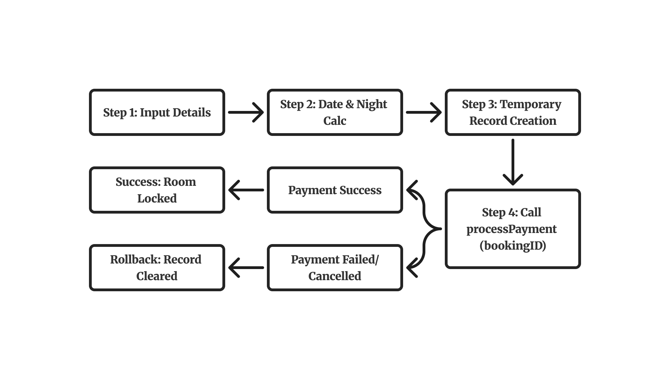
- Temporary Assignment: When the user confirms reservation parameters in bookRoom(), a new Booking struct is populated with status = “Confirmed” and appended to bookings[bookingCount].
- Payment Handoff: bookRoom() calls processPayment (new Booking.bookingID).
- Transaction Outcome Handling:
- On Payment Success (true): The assigned room’s availability is locked (rooms[room_Index].available = false), and success confirmation screen displays the generated Booking ID and Room ID.
- On Payment Failure/Cancellation (false): An atomic rollback occurs; bookingCount is decremented, the temporary booking array slot is reset (bookings[bookingCount] = Booking{}), and “Booking Cancelled!” is displayed without altering room availability.

8.8 Module Interaction
The Booking/Reservation & Schedule module interacts with other modules as follows:
Module | Interaction
Main System | Receives user menu selections from the main application loop to navigate reservation functions.
Customer Management | Queries customer records to verify guest IDs during booking. Launches addCustomer() if a guest profile is missing.
Room & Inventory Management | Reads initialized room pricing (singlePrice, doublePrice, deluxePrice) and updates room availability statuses (available = true/false) during booking and check-out.
Billing & Payment | Triggers processPayment() to execute transaction billing prior to confirming reservations. Updates isPaid flags upon successful payment.
Reporting | Provides booking counts, stay durations, cancellation records, and occupancy data for management reports.

8.9 Test Plan

Scenario 1-Successful Room Booking and Payment

Scenario 2-Invalid Date / Invalid Input

Scenario 3-Cancel Booking / Check-In / Check-Out

9.0 Individual Module-Billing/Payment & Reporting
Member: Michelle Eng Jia Qi

9.1 Module Overview
The Billing/Payment & Reporting module manages payment transactions and generates management reports for the hotel reservation system.
The payment component calculates the accommodation charge based on room type, number of nights, customer membership type, and discount rate. It supports Cash, Credit Card, Debit Card, Online Banking, and E-Wallet payments. After a successful transaction, the system records the payment, updates the booking payment status, updates the customer’s total spending, and displays a receipt.
The reporting component allows management to generate:
- Monthly reports for a selected month in the current year.
- Yearly reports for a selected year.
- Overall reports for all booking and payment records.
Each report displays the total bookings, total unique customers, completed payments, and total revenue.

9.2 Module Purpose
The main objectives of the Billing/Payment & Reporting Module are:
- Payment Accuracy: Calculate booking charges based on room type, number of nights, and applicable membership discounts to ensure customers are charged correctly.
- Payment Validation: Validate booking IDs, payment-method choices, cash amounts, and payment confirmation inputs to prevent invalid or insufficient payments.
- Transaction Recording: Generate payment IDs, store successful payment records, update booking payment status, and produce receipts for completed transactions.
- Membership Integration: Update customers’ accumulated spending after successful payment and automatically upgrade their membership level when the required spending threshold is reached.
- Financial Reporting: Generate monthly, yearly, and overall reports showing non-cancelled bookings, unique customers with bookings, completed payments, and total revenue.
- Management Support: Provide clear payment and revenue information to support hotel management in monitoring business performance.

9.3 Payment Functionality
The payment process starts when a booking ID is sent to the processPayment() function. The system searches for the booking and calculates the total amount payable.
The payment amount is calculated using the following formula:
Total Amount = Number of Nights × Room Price × (1 − Discount Rate)
The default room prices are shown below:
Room Type | Price per Night
Single | RM120.00
Double | RM180.00
Deluxe | RM250.00
The membership discounts are:
Membership Type | Discount
Normal / Regular | 0%
Premium | 10%
VIP | 20%
For Cash payment, the user enters the amount received. The system checks whether the cash amount is sufficient and calculates the change.
For Credit Card, Debit Card, Online Banking, and E-Wallet payments, the system automatically treats the amount paid as equal to the total amount due.
After the user confirms the payment using y or Y, the system:
- Generates a payment ID, for example P001.
- Saves the transaction in the payments vector.
- Sets the booking’s isPaid status to true.
- Updates the customer’s totalSpent.
- Updates membership to Premium when total spending reaches RM500.00.
- Updates membership to VIP when total spending reaches RM5,000.00.
- Displays a payment receipt.
The receipt displays the payment ID, booking ID, payment method, customer name, accumulated customer spending, total amount, cash paid, and change where applicable.

9.4 Reporting Functionality
The reporting function provides three report options:
Report Type | Description
Search by Month | Displays booking and payment statistics for the selected month in the current year.
Search by Year | Displays booking and payment statistics for a selected available year.
Overall Report | Displays booking and payment statistics for all records in the system.
The system reads the booking check-in date in YYYY-MM-DD format. A date is accepted for reporting only when it has the correct format and a valid month from 1 to 12.
For each report, the system calculates:
- Total non-cancelled bookings
- Total unique customers
- Number of completed payments
- Total revenue from successful payments
Only payments with paymentStatus = true are included in the completed payment count and total revenue.
The Total Customers value in the report does not represent all customers registered in the system. It counts only unique customers who have at least one non-cancelled booking record. Therefore, a customer who is added to Customer Management but has not made any booking will not be included in the report’s total customer count.

9.5 Data Structures
The module uses the following structures:
struct Payment {
string paymentId;
string bookingId;
string customerName;
string totalPoint;
double totalAmount = 0.0;
string paymentMethod;
bool paymentStatus = false;
double cashPaid = 0.0;
double change = 0.0;
};

struct Report {
int totalBookings;
double totalRevenue;
int totalCustomers;
int completedPayments;
};
The Payment structure stores each successful payment transaction. The Report structure stores the generated report statistics.
The following collections are used:
vector<Payment> payments;
vector<Report> reports;
Booking data is stored in the bookings array, while successful payment transactions and generated reports are stored in vectors.

9.6 Functions
Function | Description
double calculateTotalAmount(int bookingIndex) | Calculates the total room charge based on room type, nights, membership type, and discount rate.
bool processPayment(string bookingID) | Processes a payment for a valid booking ID and records the transaction after confirmation.
void generateReceipt() | Displays the receipt for the most recently recorded payment.
bool getBookingYearAndMonth(const Booking& booking, int& year, int& month) | Validates and extracts the year and month from a booking check-in date.
Report generateReport(const vector<Booking>& bookingRecords, const vector<Payment>& paymentRecords) | Calculates booking, customer, completed-payment, and revenue totals.
void displayReport(const Report& report, const string& title) | Displays a formatted report with a title.
void searchReportByMonth() | Generates a report for the selected month in the current year.
void searchReportByYear() | Generates a report for the selected year.
void displayOverallReport() | Generates a report using all booking and payment records.
void reporting() | Displays the report menu and directs the user to

9.7 Validation
The module performs the following validation:
Input / Condition | Validation Performed
Payment method | Only choices 1 to 6 are accepted. Invalid input displays “Invalid choice!”.
Cash amount | Non-numeric cash input displays “Invalid amount. Please enter a valid number.”
Insufficient cash | When cash paid is less than the total amount, the system displays an insufficient-cash message and requests a new amount.
Payment confirmation | Only y, Y, n, or N are accepted. Choosing n during confirmation returns the user to payment-method selection. Other input displays an error message.
Payment cancellation | Choosing option 6 cancels payment and returns the user to the room booking screen.
Report menu input | Only choices 1 to 4 are accepted. Invalid input displays “Invalid choice! Please enter a number from 1 to 4. ”
Monthly report input | Only choices 1 to 13 are accepted. Invalid input displays “Invalid choice! Please enter a number from 1 to 13. ”
Yearly report input | The selected year must be within the available booking-year range. Invalid input displays “Invalid year! Please enter a year within the displayed range. ”
Empty records | The monthly, yearly and overall reports display a message if no booking and payment records are available.

9.8 Interaction with Other Modules
The Billing/Payment & Reporting module interacts with other modules as follows:
Module | Interaction
Customer Management | Retrieves customer ID, name, membership type, and total spending. After a successful payment, it updates the customer’s total spending and membership type.
Room & Inventory Management | Uses room type and room price to calculate the booking charge.
Booking / Reservation & Schedule | Retrieves booking ID, room type, number of nights, check-in date, customer information, and cancellation status. It updates isPaid after successful payment.
Reporting | Uses booking records and payment records to generate monthly, yearly, and overall management reports.

9.9 Test Plan

Scenario 1: Successful Cash Payment
Scenario description:
A Normal customer has a Single room booking for two nights. The customer pays RM300.00 in cash for a total bill of RM240.00. The system should accept the payment, calculate the change, update payment records, and display a receipt.
Pre-condition:
Booking B001 exists with the following information:
Booking ID | Customer ID | Customer Name | Membership | Room Type | Nights | Check-in Date
B001 | C001 | Ali | Regular | Single | 2 | 2026-08-15
Test Data, Expected Outputs and Actual Outputs
Step | User Input / Action | Expected Result / Output | Actual Output
1 | Start payment for booking ID B001 | System displays customer name, room type, number of nights, and total amount. | System displays payment information for B001.
2 | Select payment method: 1 | System displays Cash Payment screen. | Cash Payment screen displayed.
3 | Enter cash paid: 300 | Total amount due = 2 × RM120.00 = RM240.00. Change = RM300.00 − RM240.00 = RM60.00. | Total due RM240.00 and change RM60.00 displayed.
4 | Confirm payment: y | Payment is recorded successfully. Payment ID is generated. Booking is marked as paid. | Payment record created and booking payment status updated.
5 | View receipt | Receipt displays payment ID, booking ID, Cash method, customer name, total amount RM240.00, cash paid RM300.00, and change RM60.00. | Receipt displayed correctly.

Expected Payment Record
Payment ID | Booking ID | Payment Method | Total Amount | Cash Paid | Change
P001 | B001 | Cash | RM240.00 | RM300.00 | RM60.00

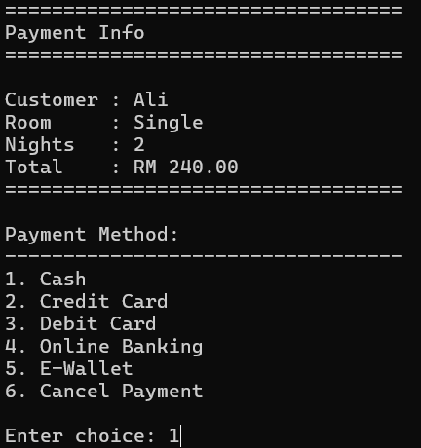
System displays payment info such as customer name, room type, number of nights, and total amount.
System displays payment method, user input 1-5 to select payment method or 6 to cancel payment

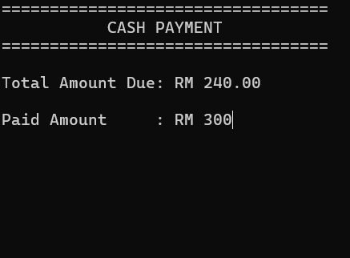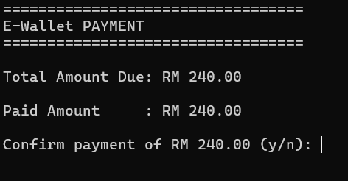
For cash payment, user need to input paid amount
Besides cash payment, other payment methods will directly display the paid amount same as the total amount due

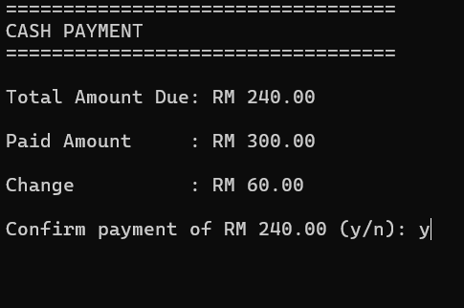
If the paid amount greater than the total amount due, system will calculates and displays the change, then ask user to confirm payment

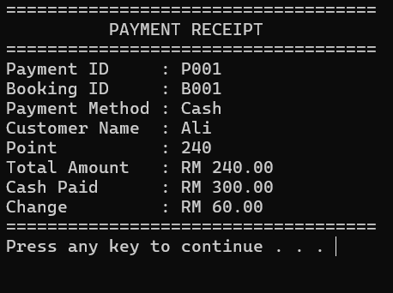
After confirming payment, system displays the payment receipt. Receipt displays payment ID, booking ID, payment method, customer name, point, total amount, cash paid, and change

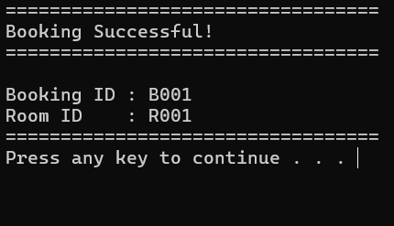
Booking successful message is displayed

Scenario 2: Insufficient Cash
Scenario description:
A customer attempts to pay less than the required amount. The system must reject the amount and request another cash amount. The user then returns to the payment menu and cancels the transaction. No payment record should be created.
Pre-condition:
Booking B002 exists with the following information:
Booking ID | Customer ID | Customer Name | Membership | Room Type | Nights | Check-in Date
B002 | C002 | Siti | Regular | Double | 1 | 2026-08-20
Test Data, Expected Outputs and Actual Outputs
Step | User Input / Action | Expected Result / Output | Actual Output
1 | Start payment for booking ID B002 | System displays booking payment information. Total amount = 1 × RM180.00 = RM180.00. | Payment information displayed with total RM180.00.
2 | Select payment method: 1 | System displays Cash Payment screen. | Cash Payment screen displayed.
3 | Enter cash paid: 100 | System displays “Insufficient cash. You need at least RM180.00”. It does not create a payment record. | Insufficient-cash message displayed.
4 | Enter cash paid again: 180 | System calculates change = RM0.00 and displays the confirmation screen. | Confirmation screen displayed with RM0.00 change.
5 | Confirm payment: n | System displays “Returning to payment method selection.” | System returns to payment-method menu.
6 | Select payment method: 6 | System displays “Payment cancelled.” No receipt or payment record is generated. | Payment cancelled successfully.

Expected Final Result
Item | Expected Result
Payment record for B002 | Not created
Booking B002 isPaid status | False
Receipt | Not displayed
System stability | System re-prompts correctly and does not crash

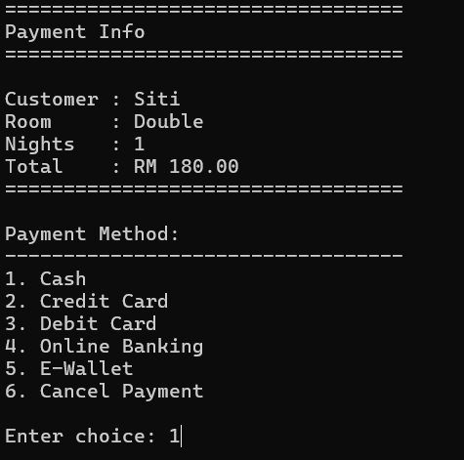
System displays payment info such as customer name, room type, number of nights, and total amount.
System displays payment method, user input 1-5 to select payment method or 6 to cancel payment

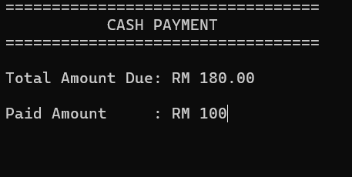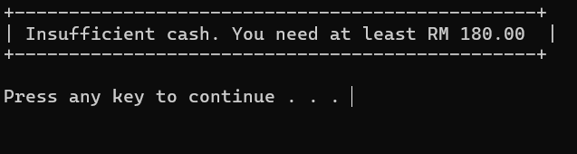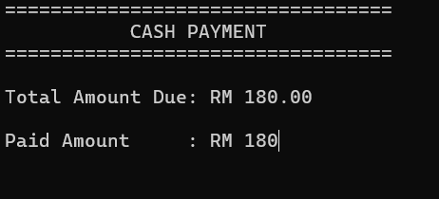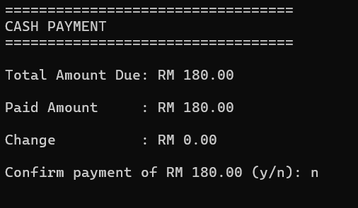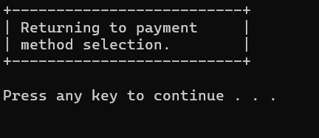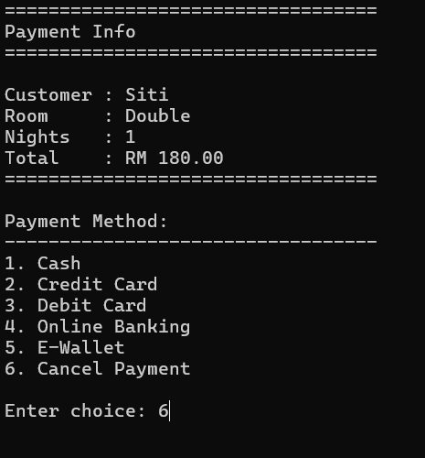
For cash payment, user need to input paid amount
If the paid amount less than the total amount due, system will displays error message
System will go back to cash payment screen and ask user to input the paid amount again
System displays the change and ask user to confirm payment
If the user choose not to confirm payment, system will displays a return message
System will go back to payment method screen and ask user to input again

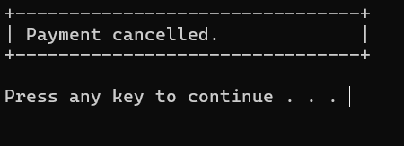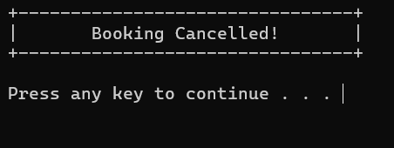
If the user choose 6 to cancel payment, system will displays a cancellation message
Since the payment is cancelled, the booking will also be cancelled and system will displays a cancellation message

Scenario 3: Successful Premium Member Payment with Discount
Scenario description:
A Premium member makes a payment for a Double room booking for three nights. The system must apply the 10% Premium member discount before processing the payment.
Pre-condition:
Booking B003 exists and the customer is already registered as a Premium member.
Booking ID | Customer ID | Customer Name | Membership | Room Type | Nights | Check-in Date
B003 | C003 | Kumar | Premium | Double | 3 | 2026-08-25
Test Data, Expected Outputs and Actual Outputs
Step | User Input / Action | Expected Result / Output | Actual Output
1 | Start payment for booking ID B003 | System displays customer, room type, nights, and calculated total amount. | Payment information displayed.
2 | Select payment method: 4 (Online Banking) | System displays Online Banking payment confirmation screen. | Online Banking payment screen displayed.
3 | Confirm payment: y | Payment is successfully recorded and a receipt is displayed. | Payment completed successfully.

Expected Discount Calculation
Description | Calculation
Original room charge | 3 nights × RM180.00
Premium discount | RM540.00 × 10%
Total amount payable | RM540.00 − RM54.00 = RM486.00
Change | Non-cash payment

Expected Payment Record
Payment ID | Booking ID | Payment Method | Total Amount | Cash Paid | Change | Payment Status
P003 | B003 | Online Banking | RM486.00 | RM486.00 | RM0.00 | True
Expected Receipt Information
Booking ID | Payment Method | Customer Name | Total Amount | Cash Paid | Change
B003 | Online Banking | Kumar | RM486.00 | RM486.00 | RM0.00
- Cash Paid and Change are not displayed because this is a non-cash payment.
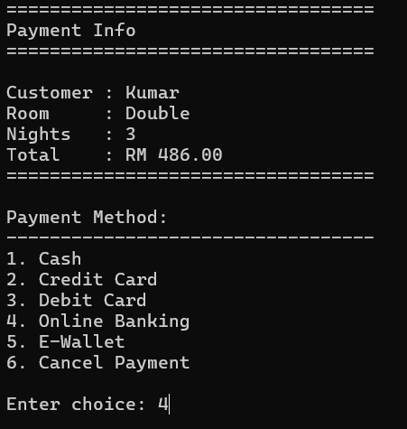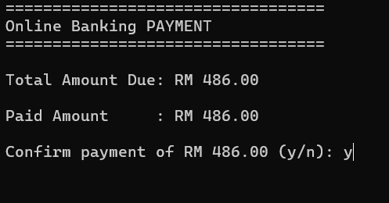
System displays payment info such as customer name, room type, number of nights, and total amount which is after applied discount
System displays payment method, user input 1-5 to select payment method or 6 to cancel payment
If the user choose 4 (Online Banking), system will directly displays the paid amount same as the total amount due and ask user to confirm payment
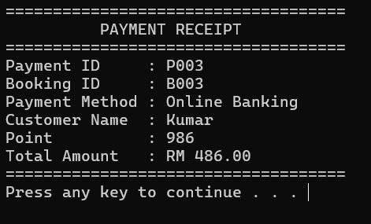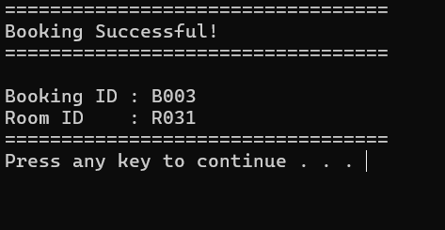
After confirming payment, system displays the payment receipt. Receipt displays payment ID, booking ID, payment method, customer name, total point and total amount
Booking successful message is displayed

Scenario 4: Generate Monthly, Yearly, Overall Reports
Scenario description:
The system contains booking and payment records from the previous scenarios. The user generates monthly, yearly, and overall reports to verify that total bookings, customers who have booked rooms before, completed payments, and revenue are calculated correctly.
Pre-condition:
The following records exist in the system.
Successful Booking Records
Booking ID | Customer ID | Customer Name | Check-in Date | Cancelled | Payment Status
B001 | C001 | Ali | 2026-08-15 | False | Paid
B002 | C003 | Kumar | 2026-08-20 | False | Paid
B003 | C003 | Kumar | 2026-08-25 | False | Paid
Successful Payment Records
Payment ID | Booking ID | Payment Method | Total Amount | Payment Status | Payment ID
P001 | B001 | Cash | RM240.00 | True | P001
P002 | B002 | E-Wallet | RM500.00 | True | P002
P002 | B003 | Online Banking | RM486.00 | True | P003
Expected Report Calculation
Item | Calculation | Expected Value
Total bookings | B001 + B002 + B003 | 3
Total customers | C001 + C003 | 2
Completed payments | P001 + P002 + P003 | 3
Total revenue | RM240.00 + RM500.00 + RM486.00 | RM1226.00
Expected Report Calculation
Step | User Input / Action | Expected Result / Output | Actual Output
1 | Select Report from the main menu. | Report menu with four options is displayed. | Report menu displayed.
2 | Select 1. Search by Month. | System displays the month selection menu for the current year. | Month menu displayed.
3 | Select 8. August. | System displays AUGUST 2026 REPORT. Total bookings = 3, total customers = 2, completed payments = 3, total revenue = RM1226.00. | August report displayed correctly.
4 | Select 2. Search by Year. | System displays the available booking-year range. | Available booking years displayed.
5 | Enter 2026. | System displays 2026 YEARLY REPORT with the same totals. | Yearly report displayed correctly.
6 | Select 3. Overall Report. | System displays OVERALL REPORT with the same totals. | Overall report displayed correctly.
Expected Report Output
Report Type | Total Bookings | Total Customers | Completed Payments | Total Revenue
August 2026 Report | 3 | 2 | 3 | RM1226.00
2026 Yearly Report | 3 | 2 | 3 | RM1226.00
Overall Report | 3 | 2 | 3 | RM1226.00

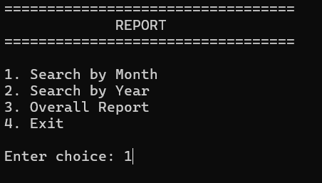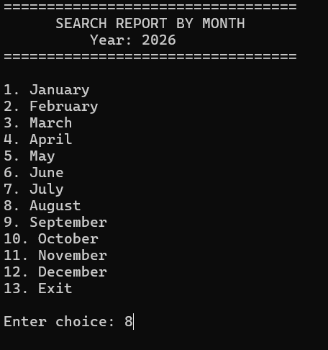
User can input 1 to view the monthly report, 2 to view the yearly report, and 3 to view the overall report
If user input 1 to view the monthly report, system will display month selection menu for the current year. User can input 1-12 to view the selected month report or 13 to exit.
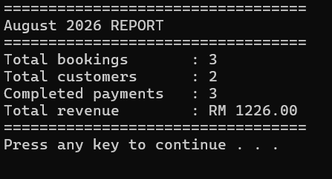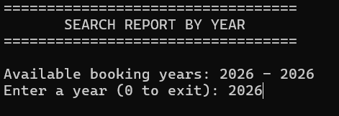
After user input the selected month, system will display the monthly report which contains total bookings, total customers, completed payments and total revenue
If user input 2 to view the yearly report, system will display the available booking years and ask user to input a year to view selected year report
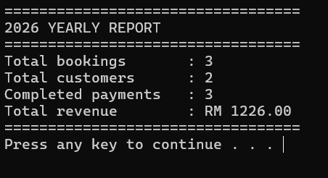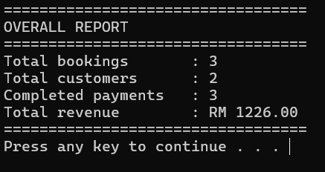
After user input the selected year, system will display the yearly report which contains total bookings, total customers, completed payments and total revenue
If user input 3 to view the overall report, system will directly display the overall report which contains total bookings, total customers, completed payments and total revenue

Scenario 5: Validation Testing Scenario
Scenario description:
This run tests invalid inputs in the Billing/Payment & Reporting module. The system should display an appropriate error message, re-prompt the user where applicable, and continue running without crashing.
Test Case | User Input / Action | Expected Result / Output | Actual Output
1 | At the payment-method menu, enter 9. | System displays Invalid choice! and re-displays the payment-method menu. | Error message displayed and user is re-prompted.
2 | At the payment-method menu, enter abc. | System displays Invalid choice! and re-displays the payment-method menu. | Error message displayed and user is re-prompted.
3 | Select Cash payment and enter abc as the cash amount. | System displays Invalid amount. Please enter a valid number. and requests a new amount. | Error message displayed and user is re-prompted.
4 | Select Cash payment and enter an amount lower than the total, for example total = RM360.00 and cash = RM200.00. | System displays Insufficient cash. You need at least RM360.00 and request a new amount. | Insufficient-cash message displayed.
5 | At payment confirmation, enter x. | System displays Invalid choice! Enter y or n. and requests confirmation again. | Error message displayed and user is re-prompted.
6 | At the payment-method menu, select 6. | System displays Payment cancelled. No payment record or receipt is generated. | Payment cancelled successfully.
7 | At the Report menu, enter 5. | System displays Invalid choice! Please enter a number from 1 to 4. | Error message displayed and report menu is shown again.
8 | At the Search by Month menu, enter 14. | System displays Invalid choice! Please enter a number from 1 to 13. | Error message displayed and month menu is shown again.

9 | At the Search by Year screen, enter a year outside the available range, for example 2025 when only 2026 is available. | System displays Invalid year! Please enter a year within the displayed range. | Error message displayed and user is re-prompted.
10 | Start the system with no booking records and no payment records. Select Report → 1. Search by Month. | System displays No booking records are available for a monthly report. No report is generated. | Error message displayed.
11 | Start the system with no booking records and no payment records. Select Report → 2. Search by Year. | System displays No booking dates are available for a yearly report. No report is generated. | Error message displayed.
12 | Start the system with no booking records and no payment records. Select Report → 3. Overall Report. | System displays No booking or payment records are available for reporting. No report is generated. | Error message displayed.
Expected Report Output
Validation Area | Result
Invalid payment menu input | Rejected
Non-numeric cash amount | Rejected
Insufficient cash | Rejected
Invalid payment confirmation input | Rejected
Payment cancellation | Processed correctly
Invalid report menu input | Rejected
Invalid month input | Rejected
Invalid year input | Rejected
Empty booking and payment records | Appropriate message displayed

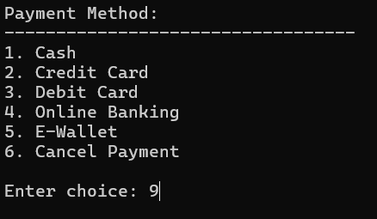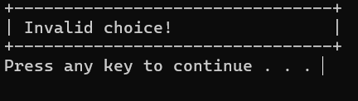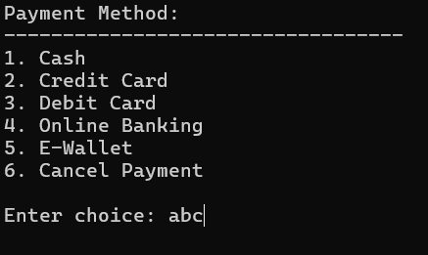
If the user input unaccepted number or non-numeric value, error message displayed and re-displays the payment-method menu
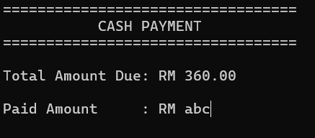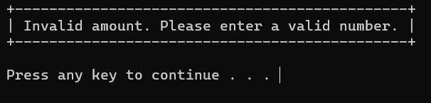
If the user input non-numeric cash, error message displayed and re-displays the payment-method menu
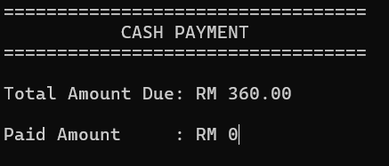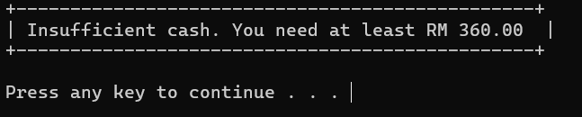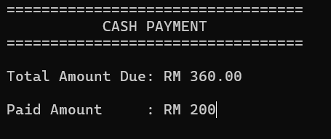
If the user input zero or an amount lower than the total, insufficient-cash message displayed and request a new amount
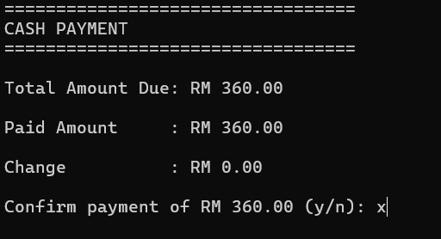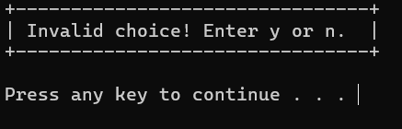
If the user input invalid choice, error message displayed and request confirmation again
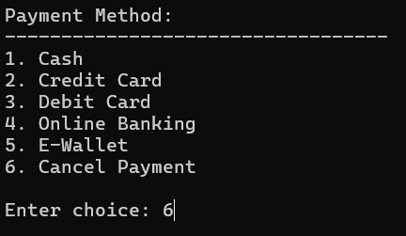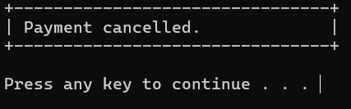
If the user choose 6 to cancel payment, system will displays a cancellation message
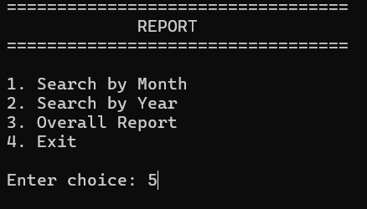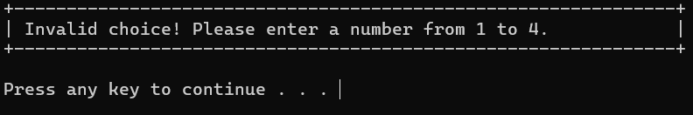
If the user input invalid choice, error message displayed and report menu is shown again
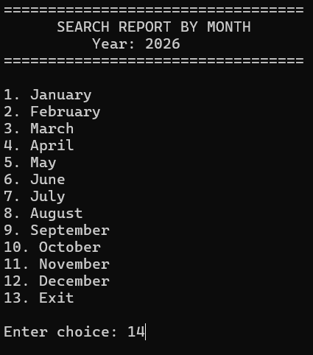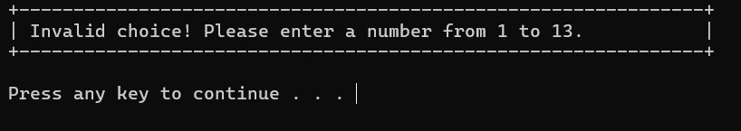
If the user input invalid choice, error message displayed and month menu is shown again
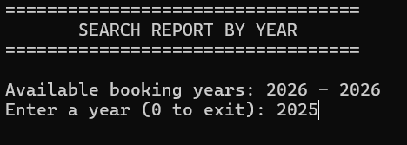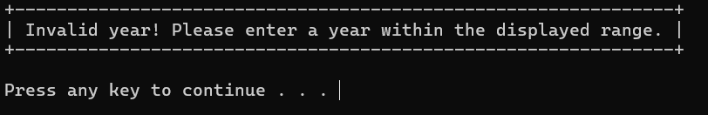
If the user input a year outside the available range, error message displayed and request a new valid year
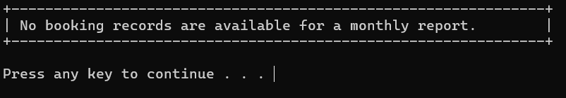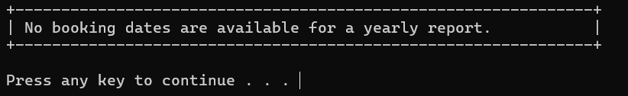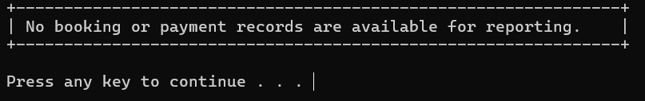
If the system with no booking records and no payment records, error message displayed

10.0 Conclusion

10.1 Summary of the System
The Hotel Reservation System is a console-based C++ application developed to support the main daily operations of a hotel. It integrates customer management, room and inventory management, price and discount management, booking and scheduling, billing and payment processing, and management reporting into one menu-driven system.
The system stores customer, room, booking, payment, and report information in shared data structures. This allows information created in one module to be used by other modules. For example, customer membership and room price data are used to calculate payment charges, while booking and payment records are used to generate management reports.

10.2 Achievement of Objectives
The main objectives of the system have been achieved:
Manage customer records with validation for important customer details.
Maintain room information, room availability, room prices, and membership discounts.
Create, search, cancel, check in, and check out hotel bookings.
Calculate booking charges, apply membership discounts, process payments, and generate receipts.
Generate monthly, yearly, and overall reports for booking and revenue monitoring.
Apply modular programming, structures, arrays, vectors, functions, validation, selection, repetition, and formatted output.

10.3 Overall System Performance
Overall, the system performs the intended hotel-reservation workflow in a structured manner. The menu-driven design makes the functions easy to access, while validation helps to reduce common input errors. The shared data structures allow the modules to communicate consistently, for example when payment updates a booking record and reporting uses the payment data to calculate revenue.
The system is suitable for demonstrating the required Systems and Programming Concepts in a small hotel environment. It provides clear console output, handles common invalid inputs without crashing, and gives staff an organised workflow from customer registration to reporting.

10.4 Future Improvement
The following improvements can be considered for future development:
Add file or database storage so that customer, booking, payment, and report records remain available after the program closes.
Add user login and role-based access control to protect staff functions and sensitive customer information.
Prevent a booking that has already been paid from being processed for payment again.
Add more report filters, such as custom date ranges, room-type revenue, occupancy rate, and exportable report files.
Develop a graphical user interface to improve usability for hotel staff.
Integrate a secure real-world payment gateway for card, online banking, and e-wallet transactions.

