**Aim:** Performing market basket analysis on online retailer using python.

**Description:**

First go through the data-set

Our data-set is on online retail, the snap-shot of our data-set

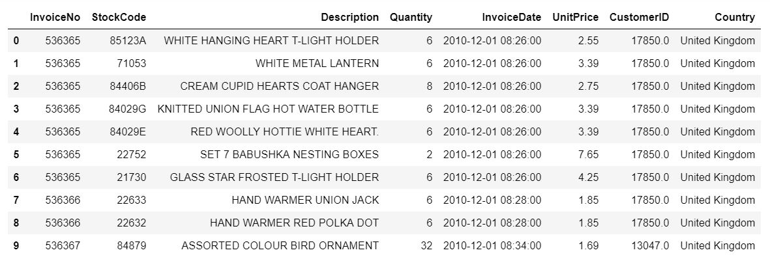

Now moving towards to analyzing of this data-set

Here we are using Market Basket Analysis,

Definition:

Market Basket Analysis (Association Analysis) is a mathematical modeling technique based upon the theory that if you buy a certain group of items, you are likely to buy another group of items.

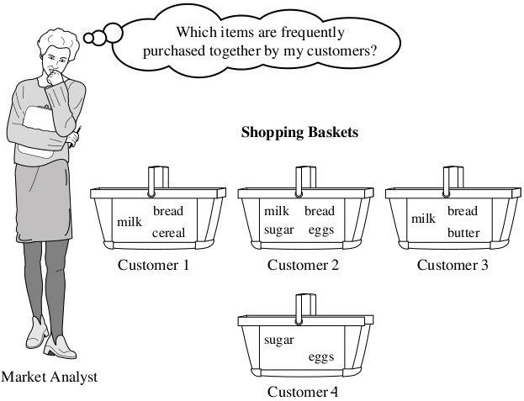

Association rules are normally written like this: {Diapers} -> {Beer} which means that there is a strong relationship between customers that purchased diapers and also purchased beer in the same transaction.

In the above example, the {Diaper} is the **antecedent** and the {Beer} is the **consequent**. Both antecedents and consequents can have multiple items. In other words, {Diaper, Gum} -> {Beer, Chips} is a valid rule.

**Support** is the relative frequency that the rules show up. In many instances, you may want to look for high support in order to make sure it is a useful relationship. However, there may be instances where a low support is useful if you are trying to find “hidden” relationships.

**Confidence** is a measure of the reliability of the rule. A confidence of .5 in the above example would mean that in 50% of the cases where Diaper and Gum were purchased, the purchase also included Beer and Chips. For product recommendation, a 50% confidence may be perfectly acceptable but in a medical situation, this level may not be high enough.

**Lift** is the ratio of the observed support to that expected if the two rules were independent. The basic rule of thumb is that a lift value close to 1 means the rules were completely independent. Lift values > 1 are generally more “interesting” and could be indicative of a useful rule pattern.

**Source Code with Output**

Step: 1 read the data-set

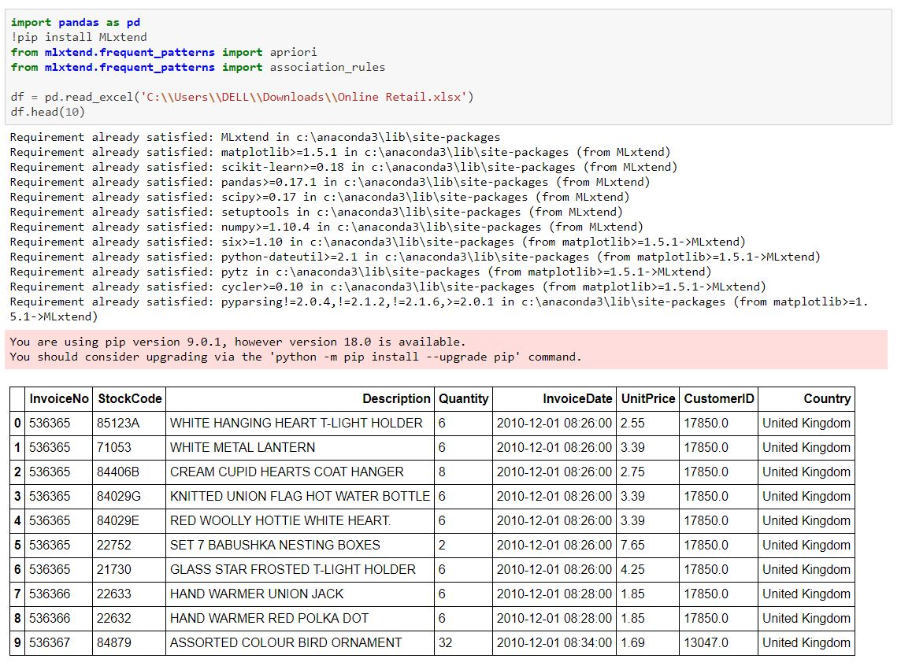

Step: 2 process the data from the description

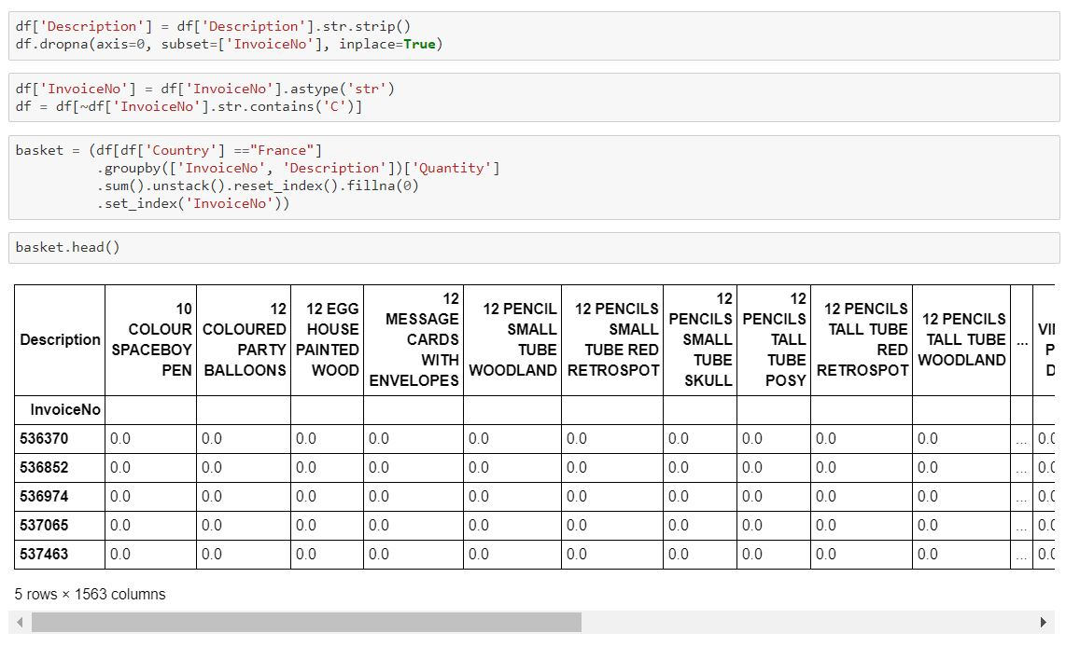

Step: 3 take out needed column

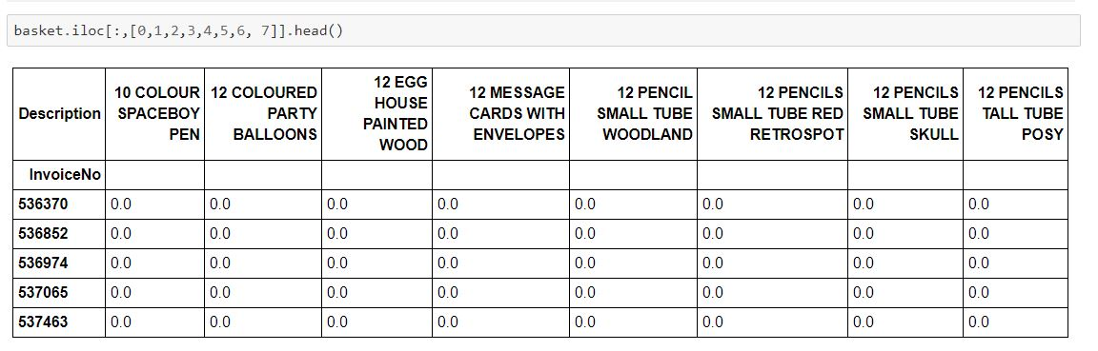

Step: 4 clean out data

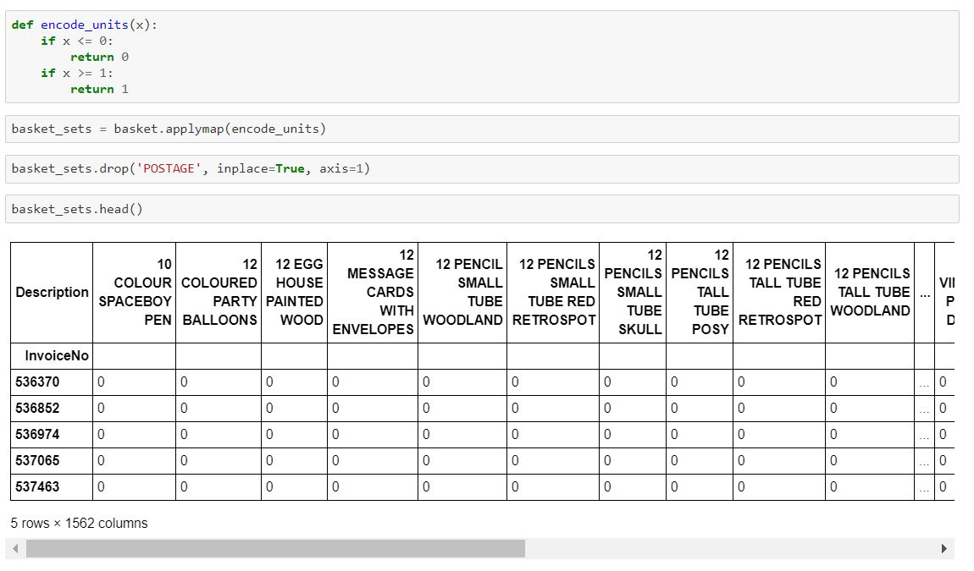

Step: 5 generate the rule

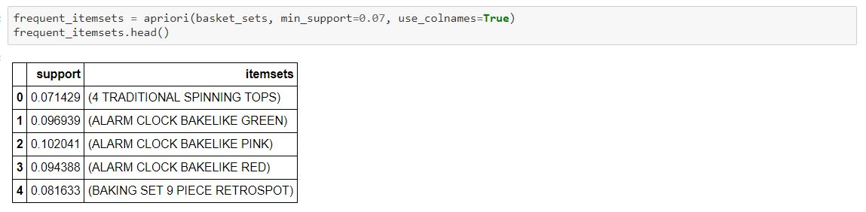

Step: 6 display the rules

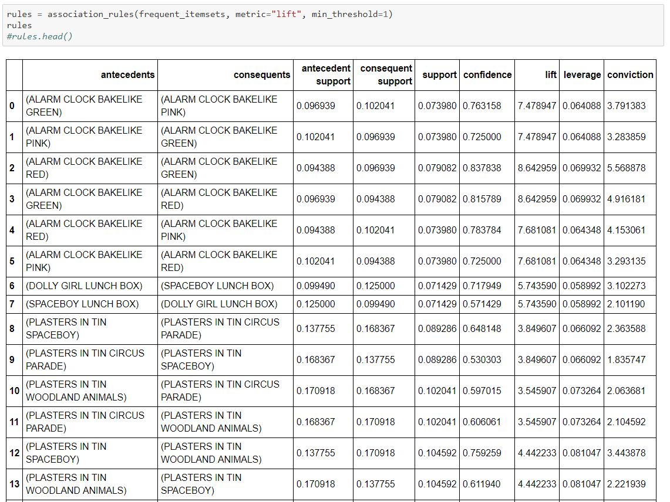

Step: 7 filter out rule

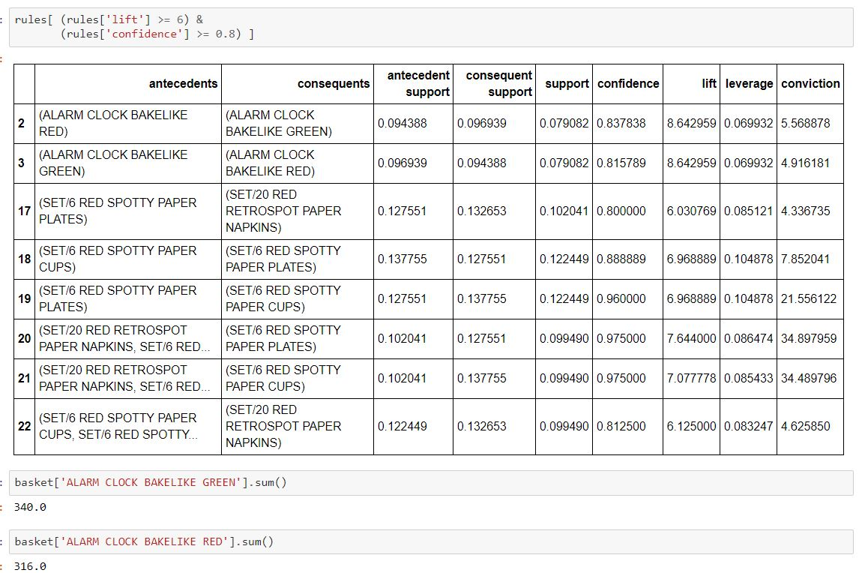

Step: 8 again do all this process for generate 2nd basket also generate its rules

