EXPERIMENT NO: 02

Installation of Metamask and testing of networks available on the Ethereum.

**Aim**: To Install of Metamask and testing of networks available on the Ethereum.

**Theory:**

**MetaMask** is just an Ethereum Browser and Ether wallet. It interacts with **Ethereum Dapps** and **Smart Contracts** without running a full Ethereum node. MetaMask add-on can be installed on Chrome, Firefox, Opera, and the new Brave browser.

First, let’s setup a MetaMask on Chrome browser. Open up a new Chrome browser window and navigate

to **https://chrome.google.com/webstore/detail/metamask/nkbihfbeogaeaoehlefnkodbefgpgknn** and then click on ‘**ADD TO CHROME**’ to install MetaMask plugin.

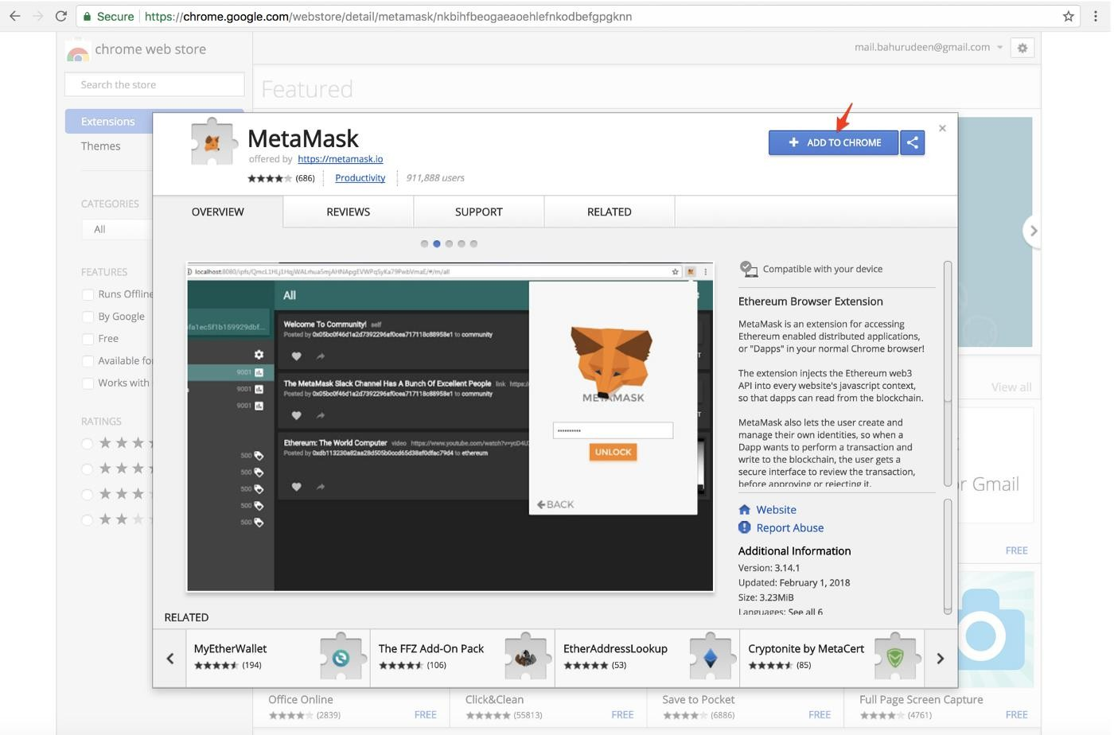

After installing, click on the MetaMask icon on the top right corner of the chrome browser. It will open up MetaMask UI, scroll all the way down and click **Accept** to agree MetaMask’s terms of use.

Then enter password, confirm password, and then click **Create** for a new Ethereum account. This account allows to send and receive Ether and also allows to deploy Smart Contracts.

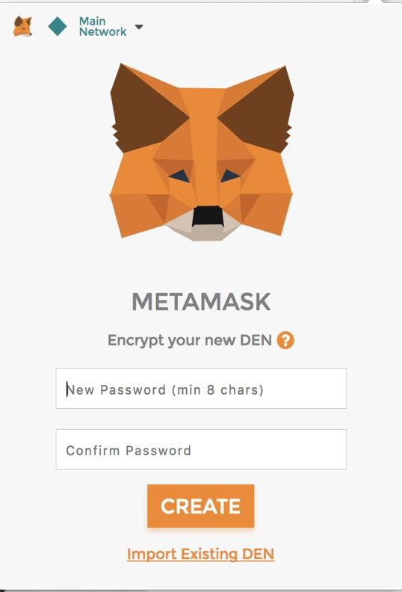

MetaMask will show up 12 words recovery key (**Seed**) as below.

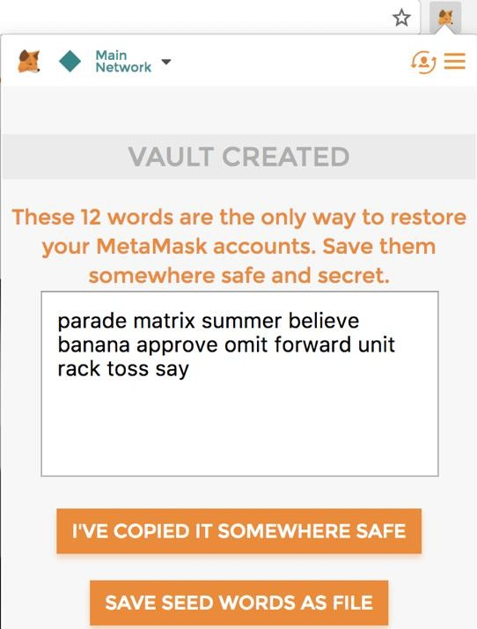

These 12 words are the only way to restore MetaMask accounts if you forget the password. It should be stored in a safe location. Then click on ‘**I’VE COPIED IT SOMEWHERE SAFE**’. The main screen of MetaMask will open as below.

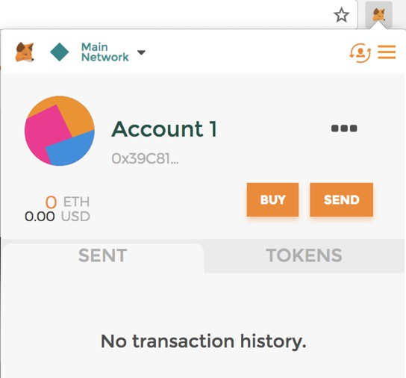

. In the upper left corner, click “**Main Network**” Then select “**Rinkeby Test Network**”

The Rinkeby Test Network is used to test the code and get free Ether to test Smart Contracts.

First we need to publish a new public post with Ethereum address. Open up MetaMask window, click on the 3 dots and then click on “**Copy Address to clipboard**” to get the **Account1** address.

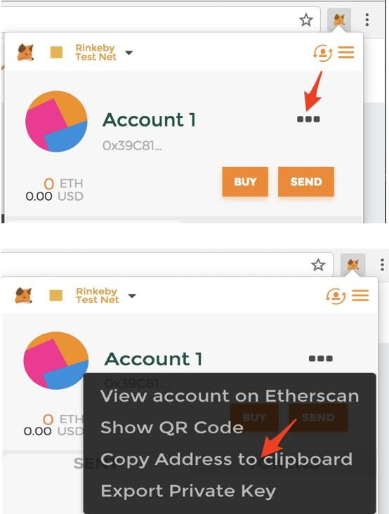

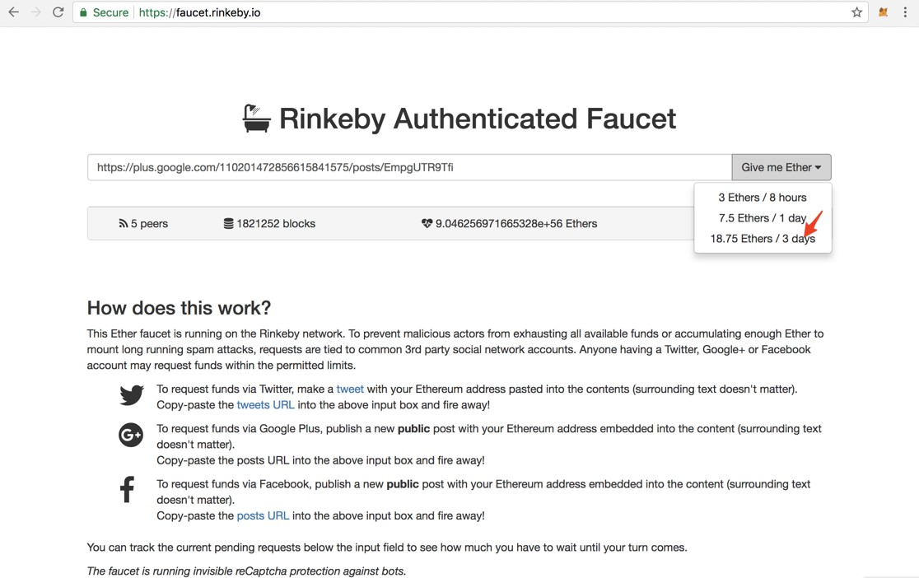Open up a new browser window and navigate to **https://faucet.rinkeby.io/** then paste the newly created post’s url on text area, and then select ‘**18.75 Ethers / 3 days**’. It takes some time for processing.

Open up MetaMask window and make sure that **18.750** ETH is added to **Account1**.

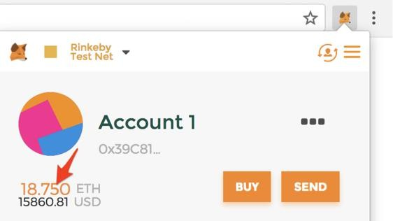

Let’s create an another account, click on **Account** menu and then click **Create Account** for another new account.

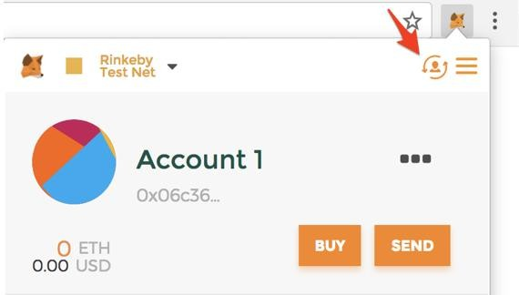

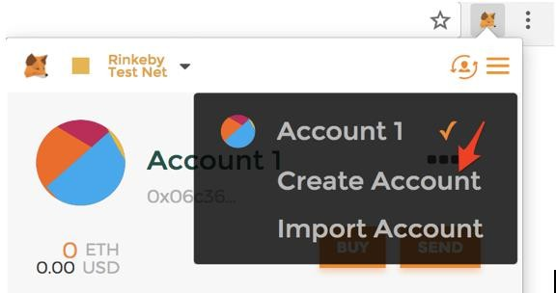

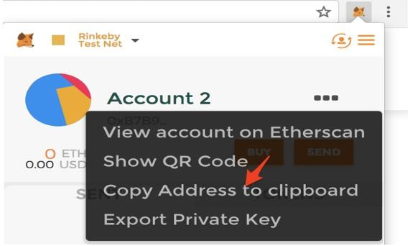Initially **Account2** has 0 ETH available balance. Let’s send **0.1** ETH to **Account2** from **Account1**. Copy **Account2** address to clipboard make sure **Account2** is selected.

Choose **Account1** from account menu, and then click **Send**.

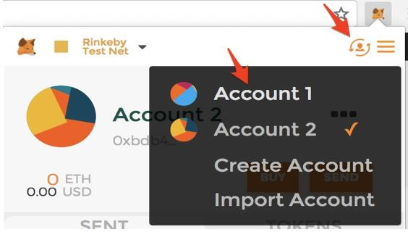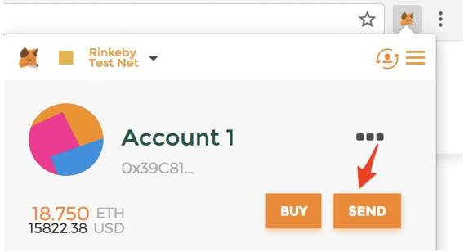

Paste **Account2** address in Recipient Address, then enter **0.1** Ether, and then click **Next**.

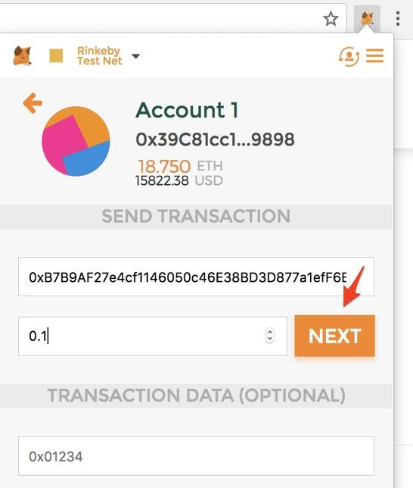

Then click **Submit** to confirm Transaction. It takes few seconds for processing.

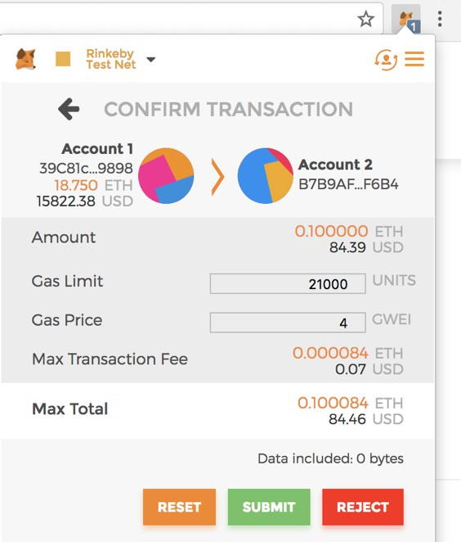

Choose **Account2** and make sure **0.1** Ether is added.

