**JELLA MARIE B CACERES BSIT-3C WEB DEVELOPMENT**

**Documentation for Controller: HomeController and DashboardController**

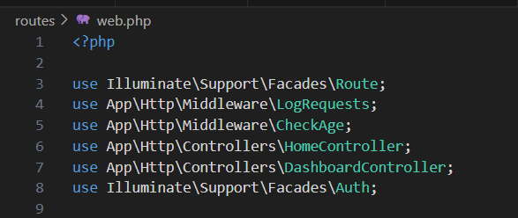In this project, controllers play a central role in handling requests for specific pages. Each controller has an index method, which is designated as the primary method for rendering content. This index method allows the controller to capture and use parameters from the URL to personalize the response, creating a more dynamic and user-friendly application experience.

**HomeController.php**

****The HomeController is responsible for rendering the homepage view. When a user makes a request to the homepage (for example, by navigating to a URL like /homepage/{username}), the application triggers the index method in HomeController. This method accepts the username parameter from the URL, allowing it to customize the homepage content based on the given username.

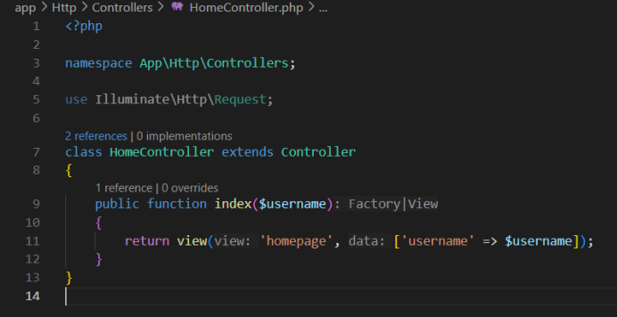

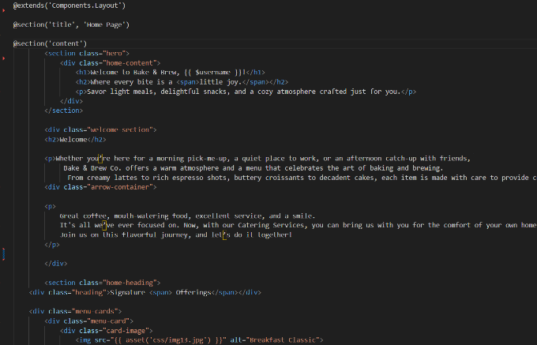

The Blade template extends a Layout component (likely a main layout file) and defines sections for the title and content. The controller, specifically HomeController, is responsible for routing requests to this view, making sure it’s properly displayed within the overall site layout.

**DashboardController.php**

The DashboardController is designed to handle requests related to the dashboard or menu view of the application. It functions similarly to HomeController, responding to requests through URLs like /menu/{username}. This route triggers the index method in DashboardController, which also takes a username parameter.

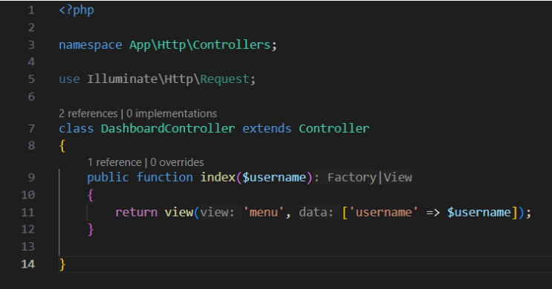

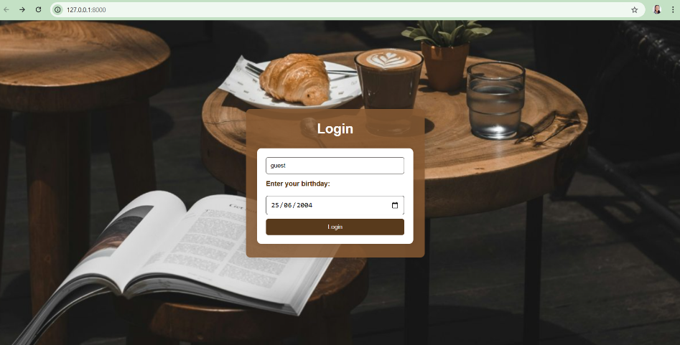**Web pages**

