**JELLA MARIE B. CACERES**

**BSIT- 3C**

**WEB DEVELOPMENT**

**DOCUMENTATION FOR POPULATING FROM A DATABASE**

**INTRODUCTION**

This documentation outlines the steps and processes involved in developing a web application that dynamically populates a menu page from a database. The project utilizes PHP, Laravel, and phpMyAdmin to manage the database and server-side logic. The primary goal is to connect a database, create models and controllers, seed sample data, and display the menu items on a web page.

1. **DATABASE CONNECTION**

* Using phpMyAdmin, a we created a database named ecommerce
* The .env file was updated with the database name to ensure the application connects to the correct database:



This configuration allows Laravel to interact with the ecommerce database for data retrieval and storage.

1. **CREATING THE MenuItem MODEL**

A model named MenuItem was created to represent the menu items stored in the database. This model allows us to define the structure and attributes of the menu items.



The MenuItem model is responsible for interacting with the menu_items table in the ecommerce database and retrieving menu data to display on the website.

1. **CREATING THE MenuController**

We Developed a MenuController to manage the logic for displaying the menu items. This controller handles the retrieval of data from the MenuItem model and passes it to the views. It ensures that menu items are fetched dynamically and rendered on the Menu page based on user requests.

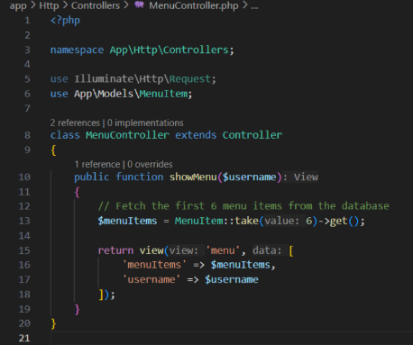

4. **Seeding the Database with MenuItemSeeder**

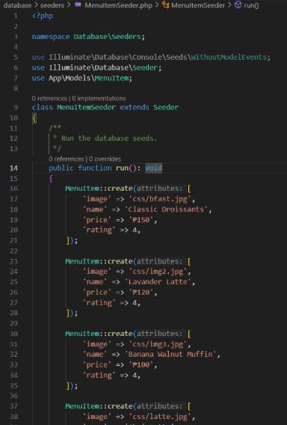To populate the menu_items table with sample data, we created a seeder named MenuItemSeeder. This seeder inserts six sample menu items with the following attributes:

* **Image Path:** The file path for each menu item’s image.
* **Name:** The name of the dish or product.
* **Price:** The cost of the item.
* **Rating:** The customer rating for each item.  
    
  After running the seeder, the database table in  
   ecommerce is populated with the sample data,  
   making it ready for display on the website.

**Command that runs the seeder:**

**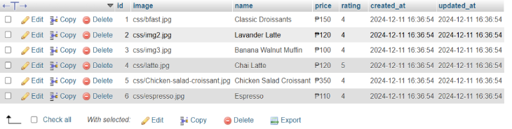  
Then this is what the database table shows:  
  
  
  
  
WEBSITE INTERFACE:**

**LOG IN PAGE  
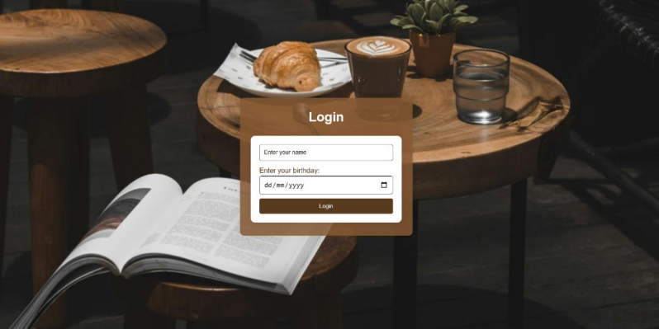  
  
  
  
  
  
  
  
  
  
  
  
  
  
  
  
  
  
  
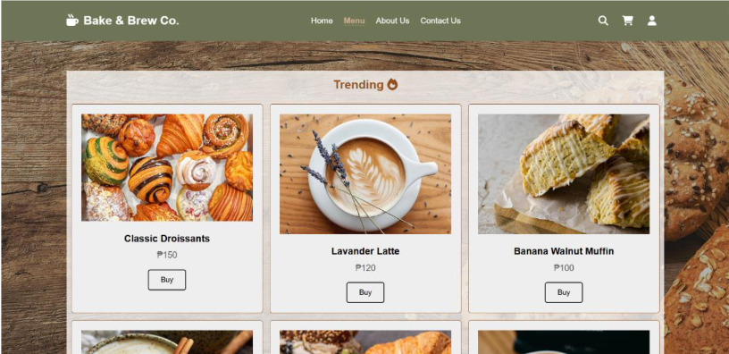MENU PAGE**