GAT ANDRES BONIFACIO HIGH SCHOOL

Nexora System Manual
Architecture, setup, deployment, recovery, modules, data, contracts, and operations
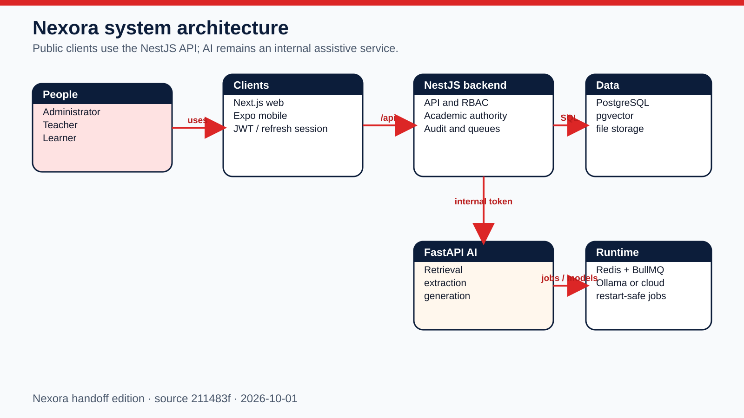
Locked evidence edition
Application snapshot 211483f07b901299b48ae42eda318c7448f1cbfd. Screens use synthetic documentation-only records; no production data or credentials are included.
Prepared 2026-10-01 · English edition · External-drive reference

How to use this book
Start here
Use Chapters 1-6 to run or recover the platform. Use the module and catalog chapters to trace ownership from a screen or incident to source, API, queue, table, and configuration.

Contents
Use search or the Navigation pane to jump to a numbered chapter. Catalog chapters continue across multiple indexed pages.
1. System at a glance
2. First run from an external drive
3. Local development
4. Security and request flow
5. Deployment and release
6. Backup, restore, and disaster recovery
7. Backend module catalog
8. Backend HTTP handler index
9. AI service handler index
10. Queue processors
11. Database catalog
12. Configuration reference
13. Client source catalogs
14. Incident checklist

1. System at a glance
Inventory locked to one commit
43 backend modules · 485 backend HTTP handlers · 63 AI handlers · 116 tables · 98 environment keys.
Public boundary: Next.js web and Expo mobile call the NestJS /api only.
Authority: Backend authentication, RBAC, academic policy, audit, and durable orchestration.
Assistive boundary: FastAPI AI receives internal shared-secret calls and returns drafts or retrieval output.
Durable state: PostgreSQL with pgvector, Redis/BullMQ, and configured file/object storage.

2. First run from an external drive
Important
Copy the package to a local SSD first. Containers, databases, node_modules, and Android builds should not run directly from a removable drive.
1. Install Git, Docker Desktop or Docker Engine with Compose, Node.js 22 LTS, and Python 3.11 or newer.
2. Open README-FIRST.txt and START-HERE.html. Confirm VERSION.txt names the intended snapshot.
3. Copy the source archive into a writable local folder. Keep the original external-drive copy unchanged.
4. Copy the supplied configuration templates. Replace placeholders with unique secrets and environment-specific URLs.
5. Run docker compose up -d --build from the source root. The six core services are postgres, redis, ollama, backend, ai-service, and frontend.
6. Run docker compose ps until required services are healthy. Check backend health and open the frontend over its documented URL.
7. Create or restore only authorized data. Run the role smoke checklist before a real onboarding or import.

Done when
All core health checks are green, the frontend loads over HTTPS or localhost, each role can sign in, and one read-only workflow succeeds without console or API failures.

3. Local development
Backend: Install from backend/package-lock.json, provide DATABASE_URL, REDIS_URL, JWT_SECRET, and JWT_REFRESH_SECRET, then use the backend development script.
Web: Install from next-frontend/package-lock.json, set the backend API URL, then run the Next.js development script.
Mobile: Install from mobile/package-lock.json, set EXPO_PUBLIC_API_URL, then run the Expo development build or install the supplied APK.
AI: Create a Python environment from ai-service requirements, configure database and the matching internal shared secret, then start FastAPI. Materialize the approved Ollama or cloud model separately.
Core rule: Web and mobile never call the AI service directly.

4. Security and request flow
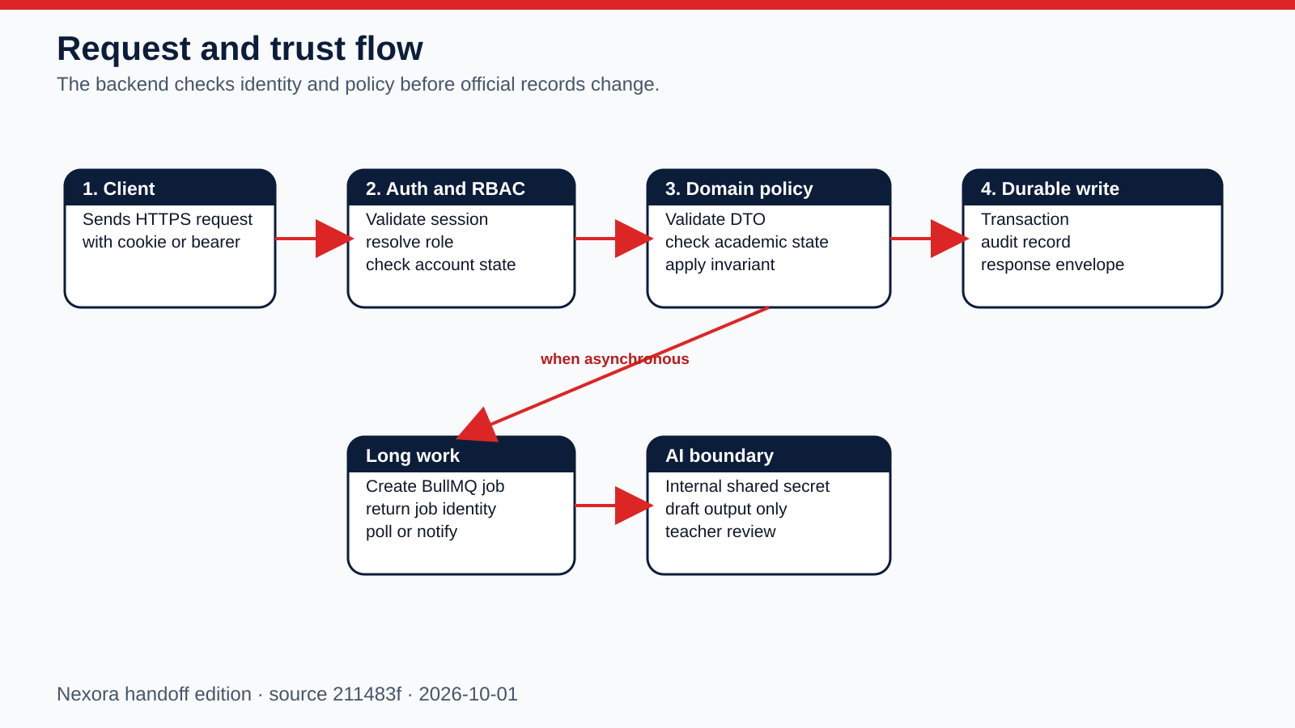
Safe operating rule
Treat a 403, academic-state blocker, maintenance gate, or impact-preview mismatch as a stop condition. Do not add force flags or bypass backend authority.

5. Deployment and release
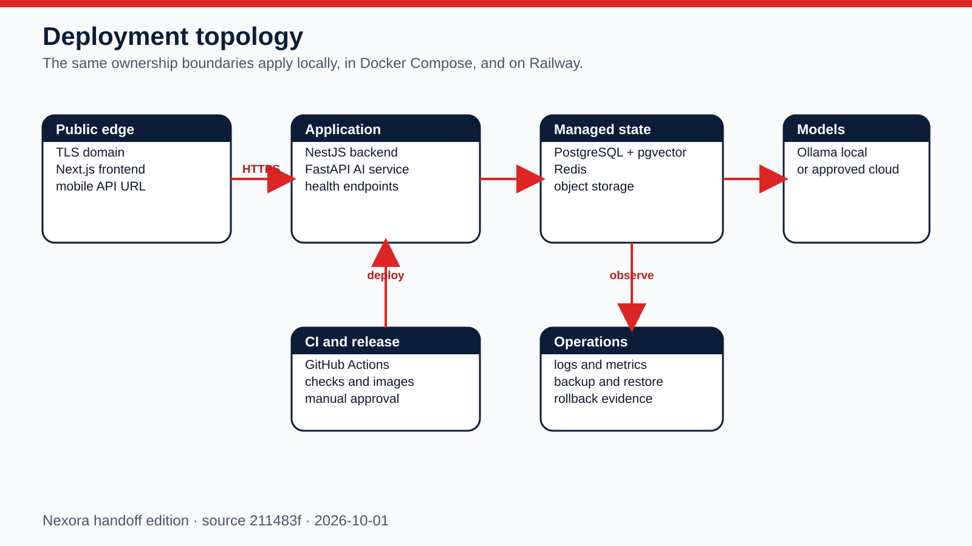
1. Choose the target environment and record its owner, domain, database, Redis, object storage, model runtime, and rollback target.
2. Configure secrets in Railway or the target secret store. Never reuse development credentials.
3. Deploy PostgreSQL/pgvector and Redis before backend workers. Keep the AI service private.
4. Deploy backend, run migrations once, verify health/readiness, then deploy the frontend with the public backend URL.
5. Build mobile with the production HTTPS API URL, publish the APK metadata and checksum, then verify the update policy endpoint.
6. Run role smoke tests and record the commit SHA, workflow run, deployed URLs, migration result, APK SHA-256, and rollback decision.
Railway definitions: backend/railway.json, next-frontend/railway.json, .github/workflows/railway-deploy.yml
Release workflows: .github/workflows/build-mobile-ios-sidestore.yml, .github/workflows/ci.yml, .github/workflows/docker-publish.yml, .github/workflows/railway-deploy.yml

6. Backup, restore, and disaster recovery
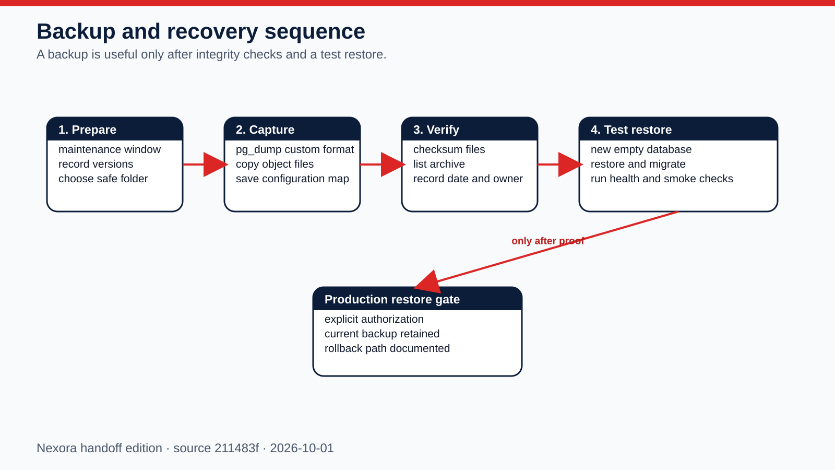
Recovery gate
Never overwrite production as a first restore attempt. Restore into a new empty target, run integrity checks and smoke tests, retain the current backup, and obtain explicit authorization before a production cutover.
Database: Use pg_dump custom format with the application quiesced or a documented consistency strategy. Record server version and checksum.
Files: Copy local uploads or object-storage objects with version and checksum evidence.
Configuration: Save a key-name map and ownership notes, not plaintext secrets in the handoff package.
Restore proof: Migrations, health, authentication, role access, one representative file, one queue job, and one audit read must pass.

7. Backend module catalog

Academic Grading
In plain English
Calculates and records official period and annual grading evidence, including revisions, remediation, and source selection.
Authority: NestJS backend. Web and mobile consume its public /api contract; the database is never a client API.
Inputs: Authenticated request or internal event, validated data, role/account state, academic policy, and existing durable records.
Outputs: Role-scoped response, audited transaction, notification, or durable job identity.
Source owner: backend/src/modules/academic-state/academic-grading.module.ts
Surface count: 3 controller files in this folder · 28 HTTP handlers
Failure path: Capture status code and request ID; check dependency health and backend log; inspect audit/job state; correct the cause before retrying.
Verification: Run a permitted read and a synthetic preview or write, confirm persistence, then repeat with a disallowed role to verify isolation.
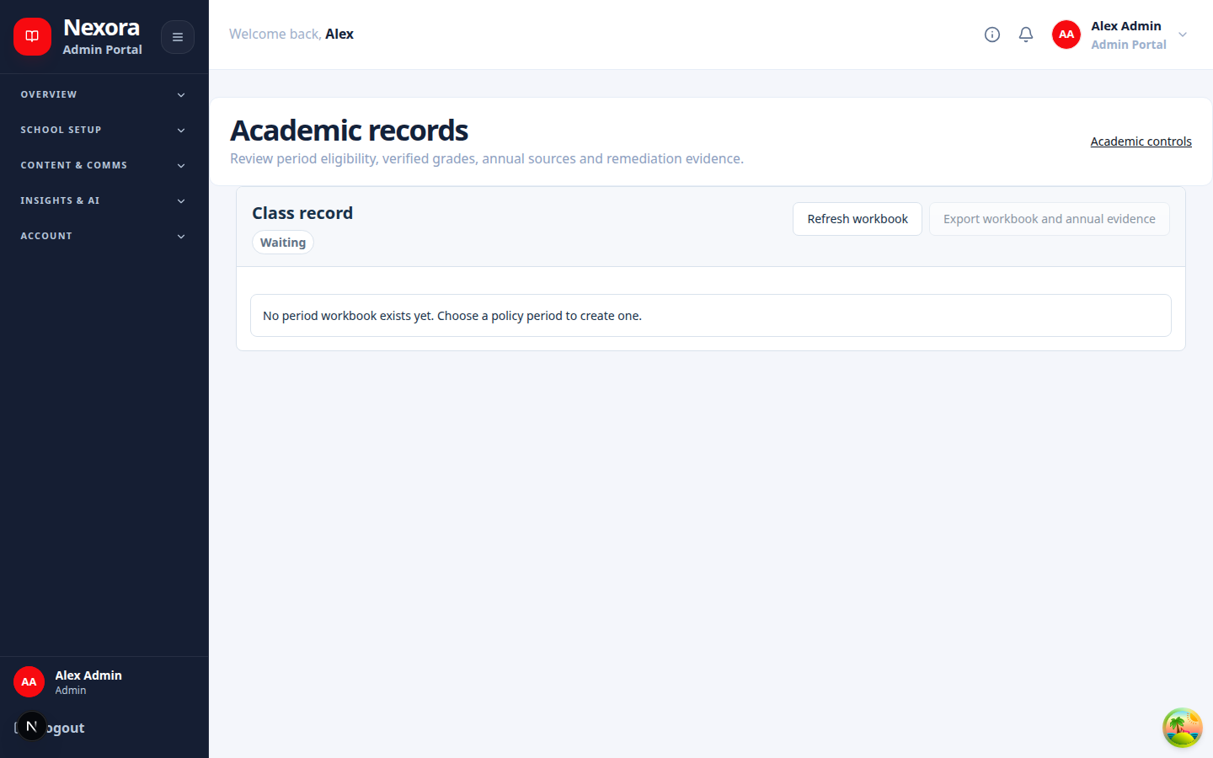
Related screen evidence: /dashboard/admin/academic-records/[classId]

Academic Policy
In plain English
Owns the school-year and grading-period rules that decide whether academic work may be prepared, edited, released, or finalized.
Authority: NestJS backend. Web and mobile consume its public /api contract; the database is never a client API.
Inputs: Authenticated request or internal event, validated data, role/account state, academic policy, and existing durable records.
Outputs: Role-scoped response, audited transaction, notification, or durable job identity.
Source owner: backend/src/modules/academic-state/academic-policy.module.ts
Surface count: 3 controller files in this folder · 28 HTTP handlers
Failure path: Capture status code and request ID; check dependency health and backend log; inspect audit/job state; correct the cause before retrying.
Verification: Run a permitted read and a synthetic preview or write, confirm persistence, then repeat with a disallowed role to verify isolation.
Related screen evidence: /dashboard/admin/academic-records/[classId]

Academic Readiness
In plain English
Evaluates learner and class evidence before release, completion, transition, or remediation decisions.
Authority: NestJS backend. Web and mobile consume its public /api contract; the database is never a client API.
Inputs: Authenticated request or internal event, validated data, role/account state, academic policy, and existing durable records.
Outputs: Role-scoped response, audited transaction, notification, or durable job identity.
Source owner: backend/src/modules/academic-state/academic-readiness.module.ts
Surface count: 3 controller files in this folder · 28 HTTP handlers
Failure path: Capture status code and request ID; check dependency health and backend log; inspect audit/job state; correct the cause before retrying.
Verification: Run a permitted read and a synthetic preview or write, confirm persistence, then repeat with a disallowed role to verify isolation.
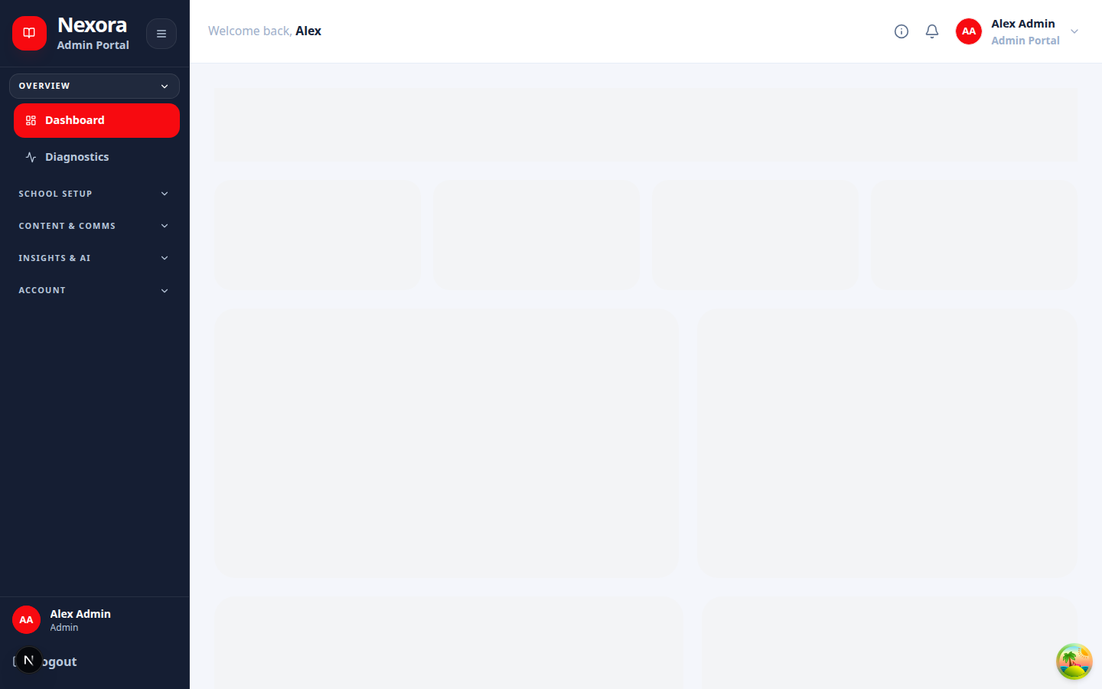
Related screen evidence: /dashboard/admin

Academic State
In plain English
Publishes the backend-authoritative current school year, period, lifecycle state, and related capability decisions.
Authority: NestJS backend. Web and mobile consume its public /api contract; the database is never a client API.
Inputs: Authenticated request or internal event, validated data, role/account state, academic policy, and existing durable records.
Outputs: Role-scoped response, audited transaction, notification, or durable job identity.
Source owner: backend/src/modules/academic-state/academic-state.module.ts
Surface count: 3 controller files in this folder · 28 HTTP handlers
Failure path: Capture status code and request ID; check dependency health and backend log; inspect audit/job state; correct the cause before retrying.
Verification: Run a permitted read and a synthetic preview or write, confirm persistence, then repeat with a disallowed role to verify isolation.
Related screen evidence: /dashboard/admin/academic-records/[classId]

Admin Demo Mode
In plain English
Provides a controlled demonstration state for administrators without turning demonstration behavior into production authority.
Authority: NestJS backend. Web and mobile consume its public /api contract; the database is never a client API.
Inputs: Authenticated request or internal event, validated data, role/account state, academic policy, and existing durable records.
Outputs: Role-scoped response, audited transaction, notification, or durable job identity.
Source owner: backend/src/modules/admin-demo-mode/admin-demo-mode.module.ts
Surface count: 1 controller files in this folder · 3 HTTP handlers
Failure path: Capture status code and request ID; check dependency health and backend log; inspect audit/job state; correct the cause before retrying.
Verification: Run a permitted read and a synthetic preview or write, confirm persistence, then repeat with a disallowed role to verify isolation.
Related screen evidence: /dashboard/admin

Admin Lifecycle
In plain English
Previews and executes governed archive, cleanup, and lifecycle actions while preserving impact and audit evidence.
Authority: NestJS backend. Web and mobile consume its public /api contract; the database is never a client API.
Inputs: Authenticated request or internal event, validated data, role/account state, academic policy, and existing durable records.
Outputs: Role-scoped response, audited transaction, notification, or durable job identity.
Source owner: backend/src/modules/admin-lifecycle/admin-lifecycle.module.ts
Surface count: 2 controller files in this folder · 21 HTTP handlers
Failure path: Capture status code and request ID; check dependency health and backend log; inspect audit/job state; correct the cause before retrying.
Verification: Run a permitted read and a synthetic preview or write, confirm persistence, then repeat with a disallowed role to verify isolation.
Related screen evidence: /dashboard/admin

Admin Maintenance
In plain English
Controls reauthenticated maintenance sessions and high-impact administrator operations.
Authority: NestJS backend. Web and mobile consume its public /api contract; the database is never a client API.
Inputs: Authenticated request or internal event, validated data, role/account state, academic policy, and existing durable records.
Outputs: Role-scoped response, audited transaction, notification, or durable job identity.
Source owner: backend/src/modules/admin-maintenance/admin-maintenance.module.ts
Surface count: 1 controller files in this folder · 3 HTTP handlers
Failure path: Capture status code and request ID; check dependency health and backend log; inspect audit/job state; correct the cause before retrying.
Verification: Run a permitted read and a synthetic preview or write, confirm persistence, then repeat with a disallowed role to verify isolation.
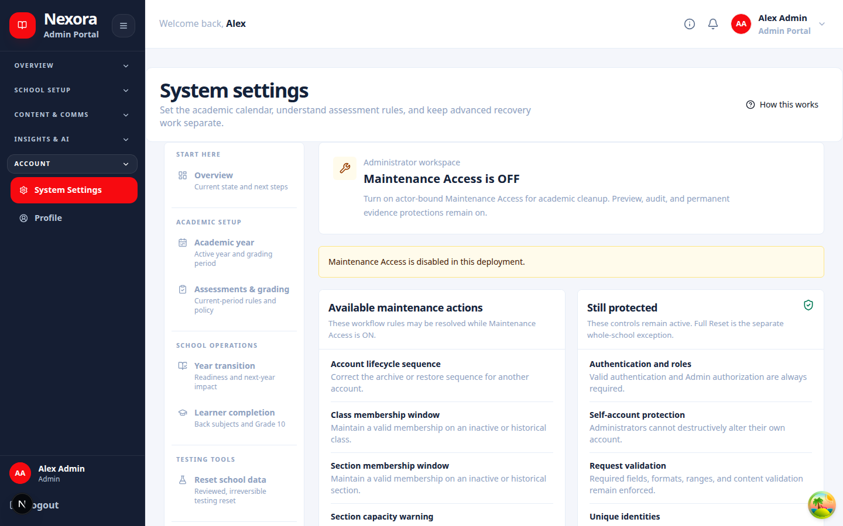
Related screen evidence: /dashboard/admin/system-settings/maintenance-access

Admin
In plain English
Aggregates administrator-facing capabilities, summaries, and management endpoints.
Authority: NestJS backend. Web and mobile consume its public /api contract; the database is never a client API.
Inputs: Authenticated request or internal event, validated data, role/account state, academic policy, and existing durable records.
Outputs: Role-scoped response, audited transaction, notification, or durable job identity.
Source owner: backend/src/modules/admin/admin.module.ts
Surface count: 1 controller files in this folder · 5 HTTP handlers
Failure path: Capture status code and request ID; check dependency health and backend log; inspect audit/job state; correct the cause before retrying.
Verification: Run a permitted read and a synthetic preview or write, confirm persistence, then repeat with a disallowed role to verify isolation.
Related screen evidence: /dashboard/admin

Ai Mentor
In plain English
Accepts authenticated AI-assistance requests, creates durable jobs where needed, and proxies only to the internal AI service.
Authority: NestJS backend. Web and mobile consume its public /api contract; the database is never a client API.
Inputs: Authenticated request or internal event, validated data, role/account state, academic policy, and existing durable records.
Outputs: Role-scoped response, audited transaction, notification, or durable job identity.
Source owner: backend/src/modules/ai-mentor/ai-mentor.module.ts
Surface count: 1 controller files in this folder · 46 HTTP handlers
Failure path: Capture status code and request ID; check dependency health and backend log; inspect audit/job state; correct the cause before retrying.
Verification: Run a permitted read and a synthetic preview or write, confirm persistence, then repeat with a disallowed role to verify isolation.
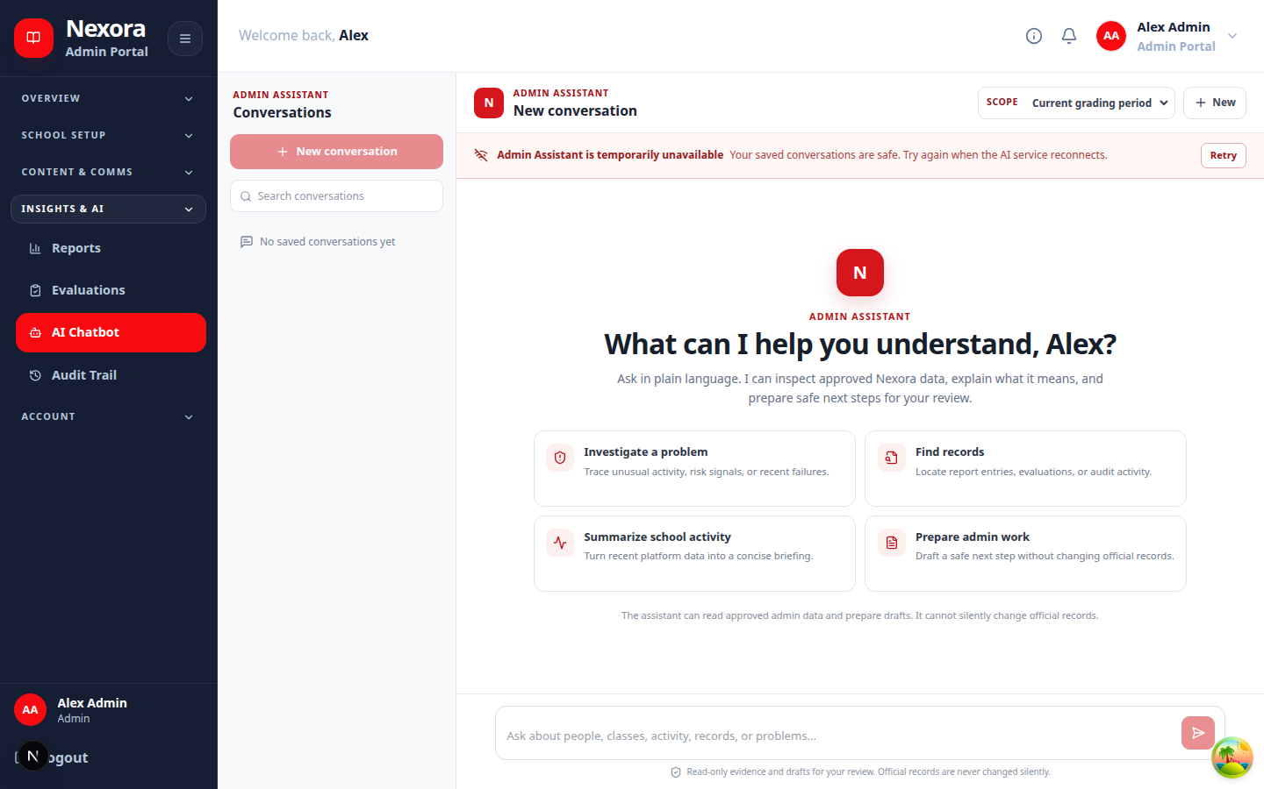
Related screen evidence: /dashboard/admin/chatbot

Analytics
In plain English
Builds role-scoped usage, learning, and operational summaries from authoritative backend data.
Authority: NestJS backend. Web and mobile consume its public /api contract; the database is never a client API.
Inputs: Authenticated request or internal event, validated data, role/account state, academic policy, and existing durable records.
Outputs: Role-scoped response, audited transaction, notification, or durable job identity.
Source owner: backend/src/modules/analytics/analytics.module.ts
Surface count: 1 controller files in this folder · 4 HTTP handlers
Failure path: Capture status code and request ID; check dependency health and backend log; inspect audit/job state; correct the cause before retrying.
Verification: Run a permitted read and a synthetic preview or write, confirm persistence, then repeat with a disallowed role to verify isolation.
Related screen evidence: /dashboard/admin

Announcements
In plain English
Creates, targets, schedules, publishes, and tracks school or class announcements.
Authority: NestJS backend. Web and mobile consume its public /api contract; the database is never a client API.
Inputs: Authenticated request or internal event, validated data, role/account state, academic policy, and existing durable records.
Outputs: Role-scoped response, audited transaction, notification, or durable job identity.
Source owner: backend/src/modules/announcements/announcements.module.ts
Surface count: 3 controller files in this folder · 8 HTTP handlers
Failure path: Capture status code and request ID; check dependency health and backend log; inspect audit/job state; correct the cause before retrying.
Verification: Run a permitted read and a synthetic preview or write, confirm persistence, then repeat with a disallowed role to verify isolation.
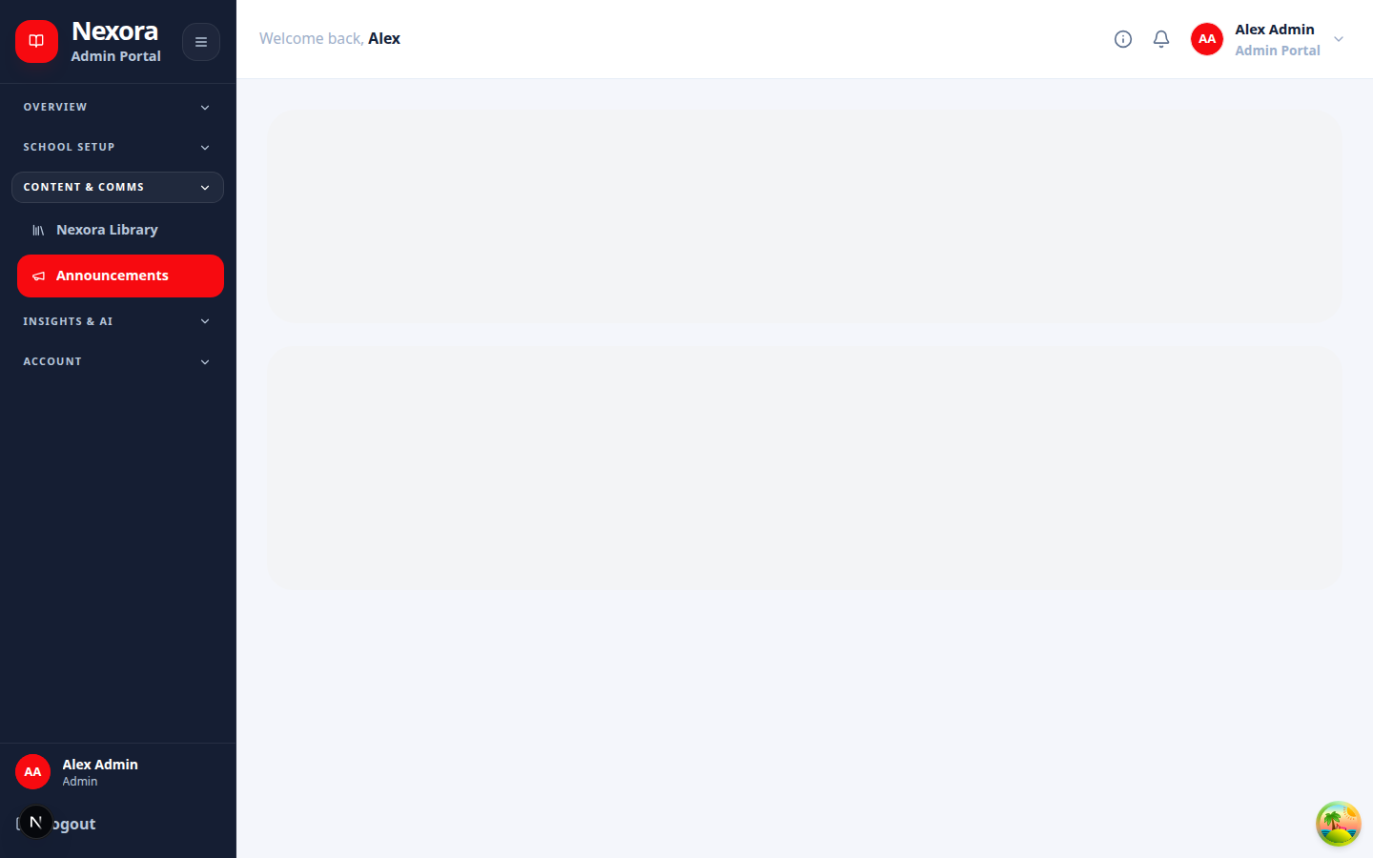
Related screen evidence: /dashboard/admin/announcements

App Version
In plain English
Publishes mobile build policy, update eligibility, download metadata, and integrity requirements.
Authority: NestJS backend. Web and mobile consume its public /api contract; the database is never a client API.
Inputs: Authenticated request or internal event, validated data, role/account state, academic policy, and existing durable records.
Outputs: Role-scoped response, audited transaction, notification, or durable job identity.
Source owner: backend/src/modules/app-version/app-version.module.ts
Surface count: 1 controller files in this folder · 2 HTTP handlers
Failure path: Capture status code and request ID; check dependency health and backend log; inspect audit/job state; correct the cause before retrying.
Verification: Run a permitted read and a synthetic preview or write, confirm persistence, then repeat with a disallowed role to verify isolation.
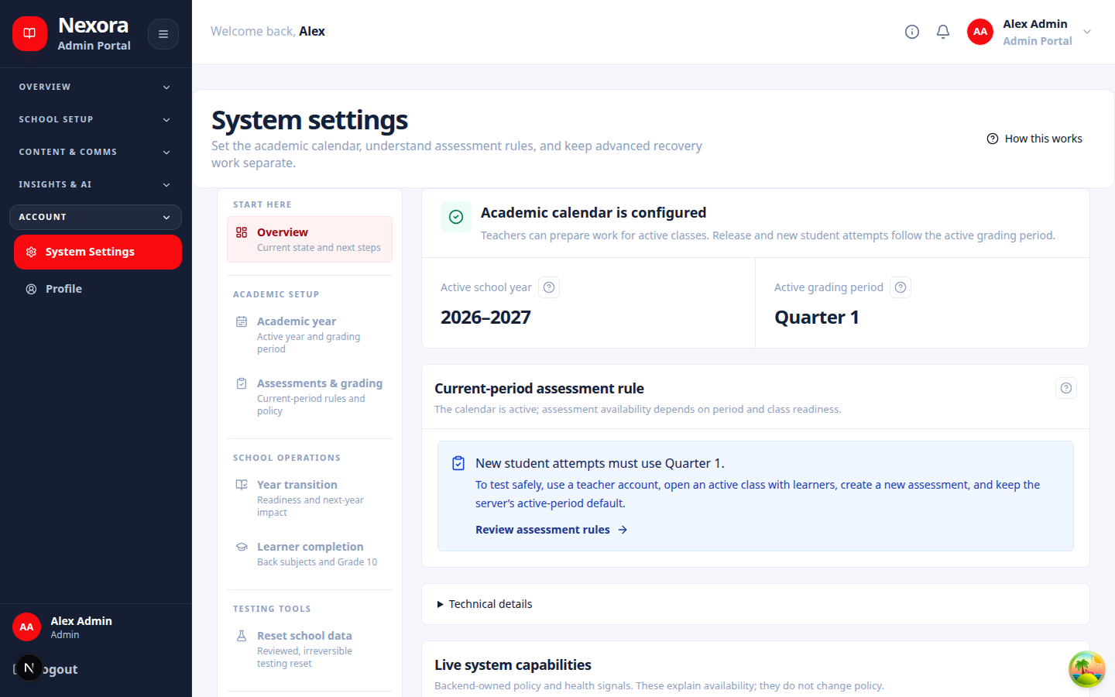
Related screen evidence: /dashboard/admin/system-settings

Assessments
In plain English
Owns assessment authoring, assignment, attempts, scoring, review, release, and result history.
Authority: NestJS backend. Web and mobile consume its public /api contract; the database is never a client API.
Inputs: Authenticated request or internal event, validated data, role/account state, academic policy, and existing durable records.
Outputs: Role-scoped response, audited transaction, notification, or durable job identity.
Source owner: backend/src/modules/assessments/assessments.module.ts
Surface count: 2 controller files in this folder · 41 HTTP handlers
Failure path: Capture status code and request ID; check dependency health and backend log; inspect audit/job state; correct the cause before retrying.
Verification: Run a permitted read and a synthetic preview or write, confirm persistence, then repeat with a disallowed role to verify isolation.
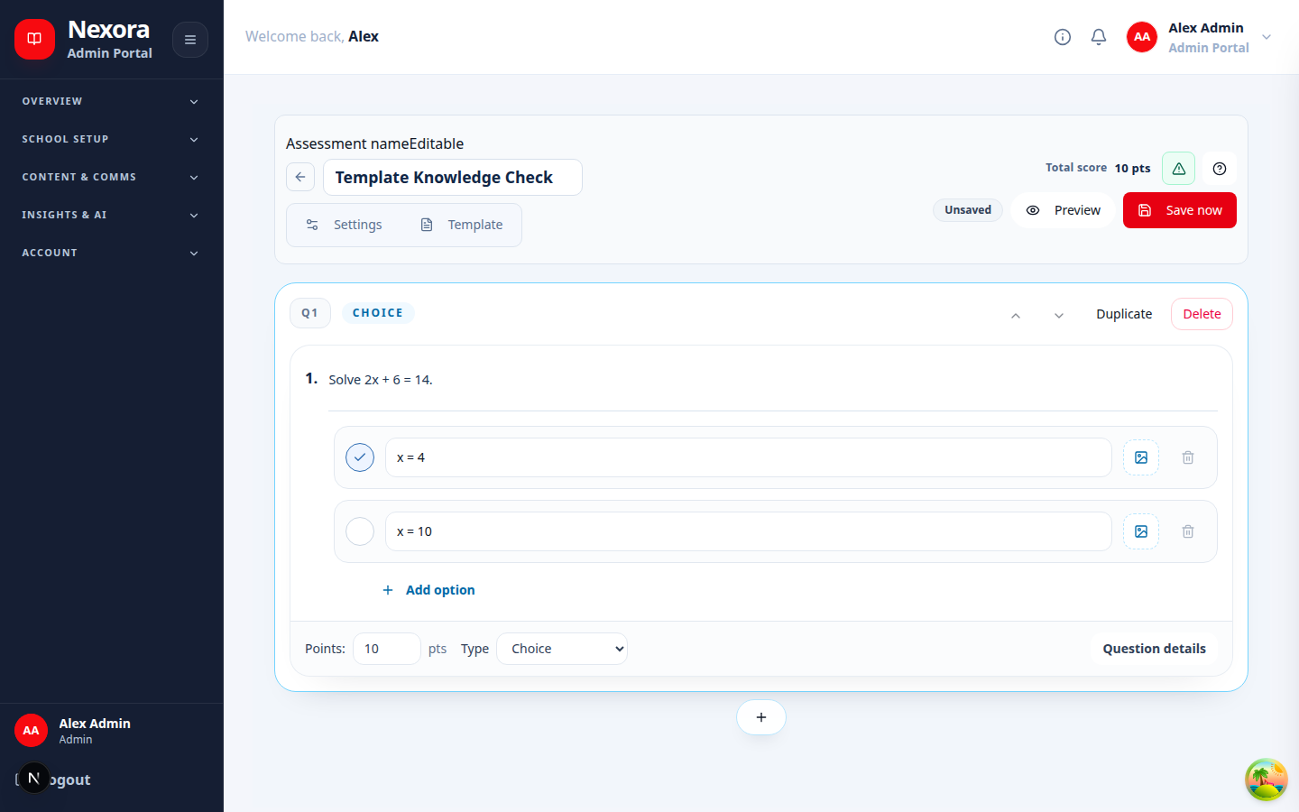
Related screen evidence: /dashboard/admin/class-templates/[id]/assessments/[assessmentKey]/edit

Audit
In plain English
Stores and retrieves immutable evidence of consequential actions and security-relevant events.
Authority: NestJS backend. Web and mobile consume its public /api contract; the database is never a client API.
Inputs: Authenticated request or internal event, validated data, role/account state, academic policy, and existing durable records.
Outputs: Role-scoped response, audited transaction, notification, or durable job identity.
Source owner: backend/src/modules/audit/audit.module.ts
Surface count: 0 controller files in this folder · 0 HTTP handlers
Failure path: Capture status code and request ID; check dependency health and backend log; inspect audit/job state; correct the cause before retrying.
Verification: Run a permitted read and a synthetic preview or write, confirm persistence, then repeat with a disallowed role to verify isolation.
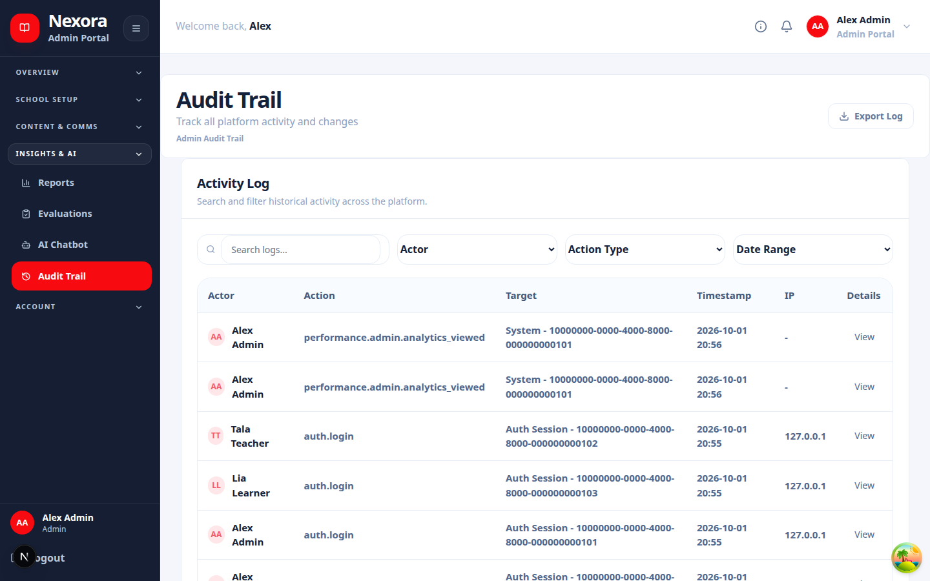
Related screen evidence: /dashboard/admin/audit

Auth
In plain English
Validates credentials, issues and rotates sessions, applies account-state rules, and supports secure recovery.
Authority: NestJS backend. Web and mobile consume its public /api contract; the database is never a client API.
Inputs: Authenticated request or internal event, validated data, role/account state, academic policy, and existing durable records.
Outputs: Role-scoped response, audited transaction, notification, or durable job identity.
Source owner: backend/src/modules/auth/auth.module.ts
Surface count: 1 controller files in this folder · 15 HTTP handlers
Failure path: Capture status code and request ID; check dependency health and backend log; inspect audit/job state; correct the cause before retrying.
Verification: Run a permitted read and a synthetic preview or write, confirm persistence, then repeat with a disallowed role to verify isolation.
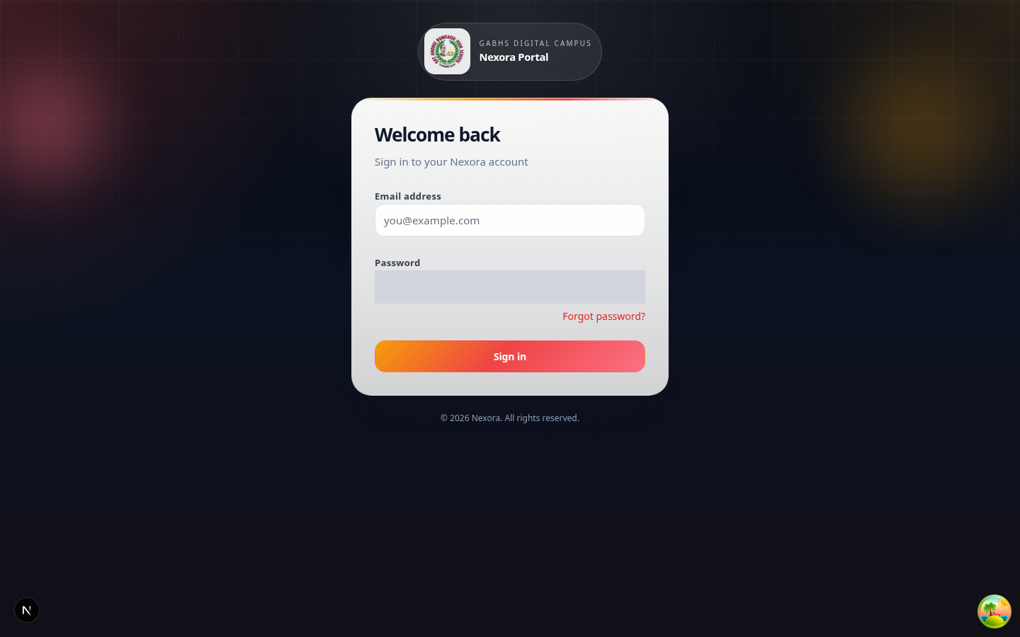
Related screen evidence: /login

Class Record
In plain English
Maintains the official class workbook, score evidence, exceptions, calculations, and release readiness.
Authority: NestJS backend. Web and mobile consume its public /api contract; the database is never a client API.
Inputs: Authenticated request or internal event, validated data, role/account state, academic policy, and existing durable records.
Outputs: Role-scoped response, audited transaction, notification, or durable job identity.
Source owner: backend/src/modules/class-record/class-record.module.ts
Surface count: 1 controller files in this folder · 30 HTTP handlers
Failure path: Capture status code and request ID; check dependency health and backend log; inspect audit/job state; correct the cause before retrying.
Verification: Run a permitted read and a synthetic preview or write, confirm persistence, then repeat with a disallowed role to verify isolation.
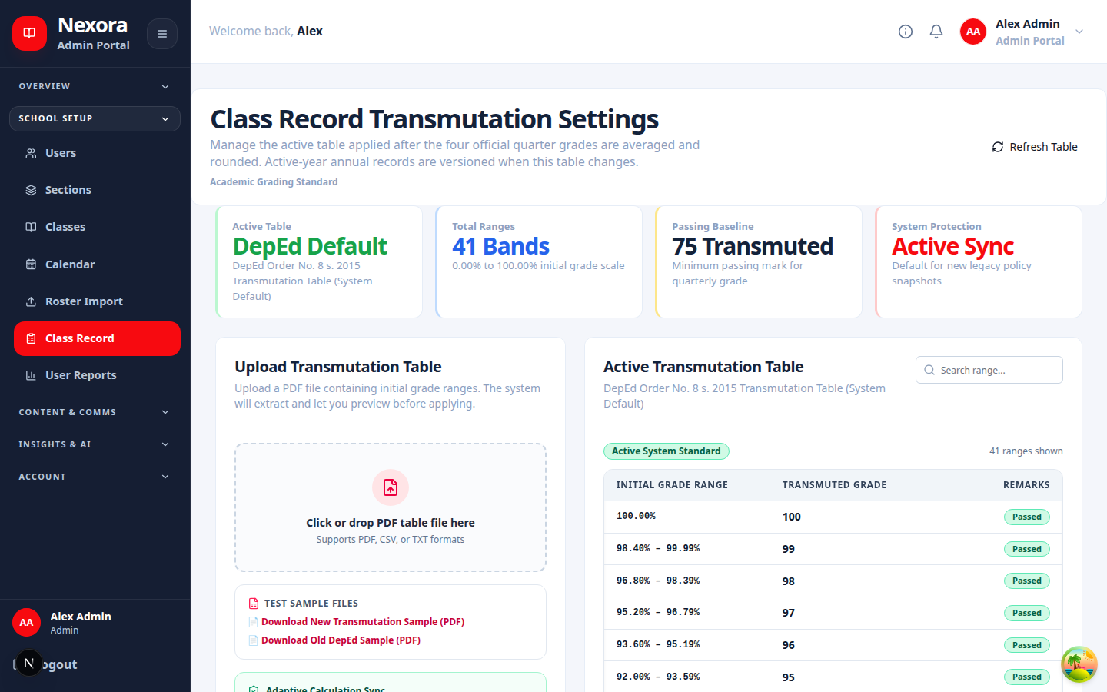
Related screen evidence: /dashboard/admin/class-record

Class Templates
In plain English
Lets authorized staff prepare reusable class structures and import or export template definitions.
Authority: NestJS backend. Web and mobile consume its public /api contract; the database is never a client API.
Inputs: Authenticated request or internal event, validated data, role/account state, academic policy, and existing durable records.
Outputs: Role-scoped response, audited transaction, notification, or durable job identity.
Source owner: backend/src/modules/class-templates/class-templates.module.ts
Surface count: 1 controller files in this folder · 14 HTTP handlers
Failure path: Capture status code and request ID; check dependency health and backend log; inspect audit/job state; correct the cause before retrying.
Verification: Run a permitted read and a synthetic preview or write, confirm persistence, then repeat with a disallowed role to verify isolation.
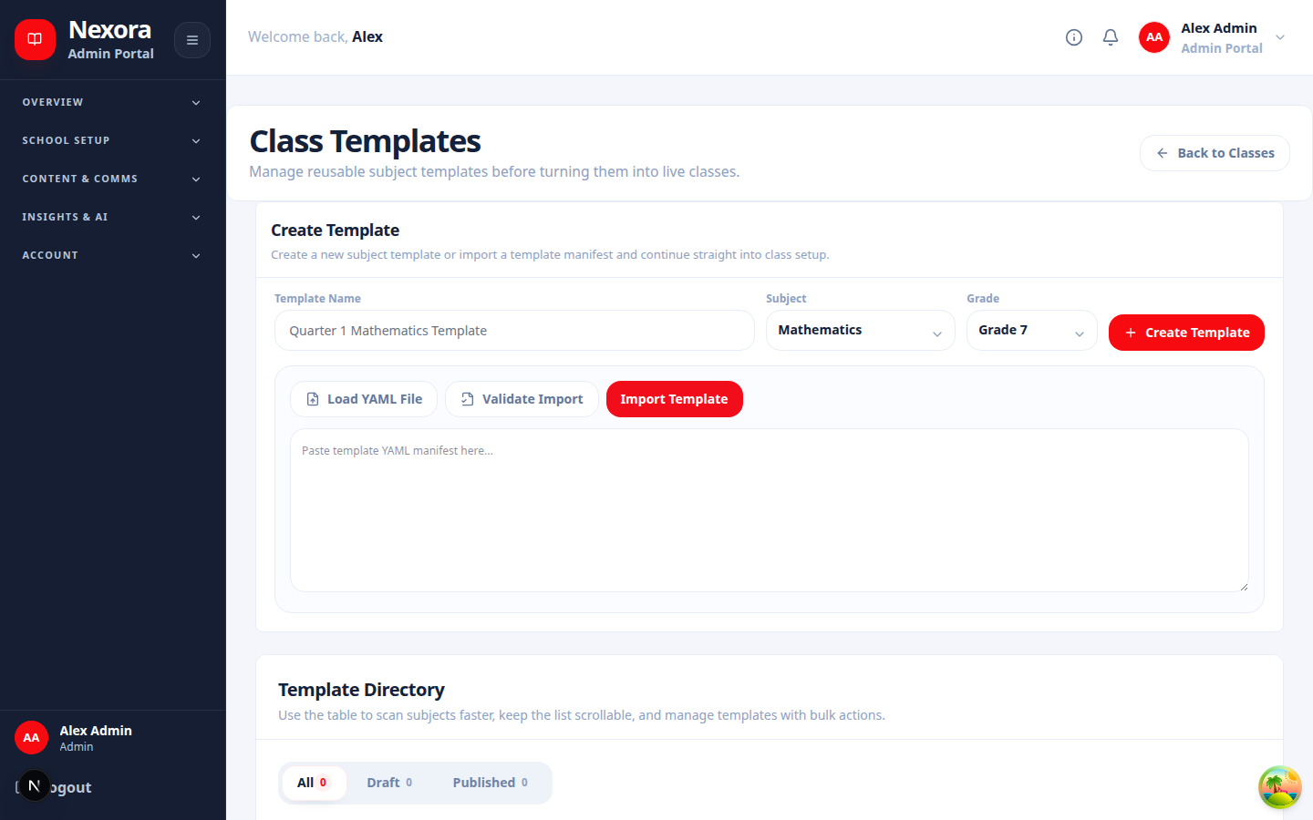
Related screen evidence: /dashboard/admin/class-templates

Classes
In plain English
Owns class identity, membership, teacher assignment, status, and class-level views.
Authority: NestJS backend. Web and mobile consume its public /api contract; the database is never a client API.
Inputs: Authenticated request or internal event, validated data, role/account state, academic policy, and existing durable records.
Outputs: Role-scoped response, audited transaction, notification, or durable job identity.
Source owner: backend/src/modules/classes/classes.module.ts
Surface count: 1 controller files in this folder · 29 HTTP handlers
Failure path: Capture status code and request ID; check dependency health and backend log; inspect audit/job state; correct the cause before retrying.
Verification: Run a permitted read and a synthetic preview or write, confirm persistence, then repeat with a disallowed role to verify isolation.
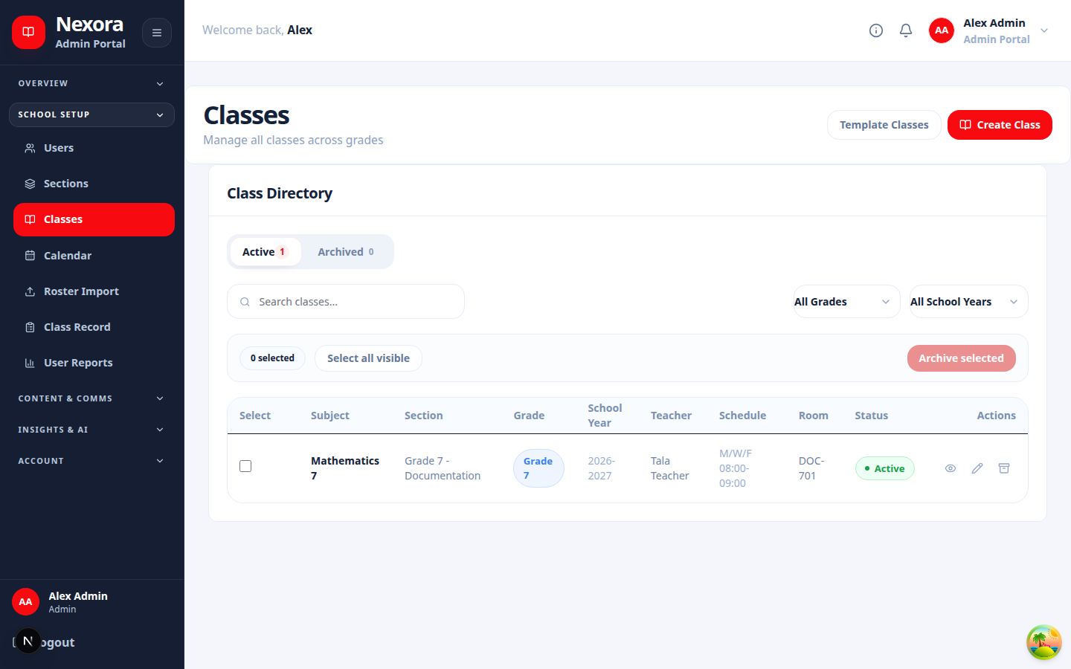
Related screen evidence: /dashboard/admin/classes

Content Modules
In plain English
Organizes course modules, ordering, publication state, and lesson relationships.
Authority: NestJS backend. Web and mobile consume its public /api contract; the database is never a client API.
Inputs: Authenticated request or internal event, validated data, role/account state, academic policy, and existing durable records.
Outputs: Role-scoped response, audited transaction, notification, or durable job identity.
Source owner: backend/src/modules/content-modules/content-modules.module.ts
Surface count: 1 controller files in this folder · 20 HTTP handlers
Failure path: Capture status code and request ID; check dependency health and backend log; inspect audit/job state; correct the cause before retrying.
Verification: Run a permitted read and a synthetic preview or write, confirm persistence, then repeat with a disallowed role to verify isolation.
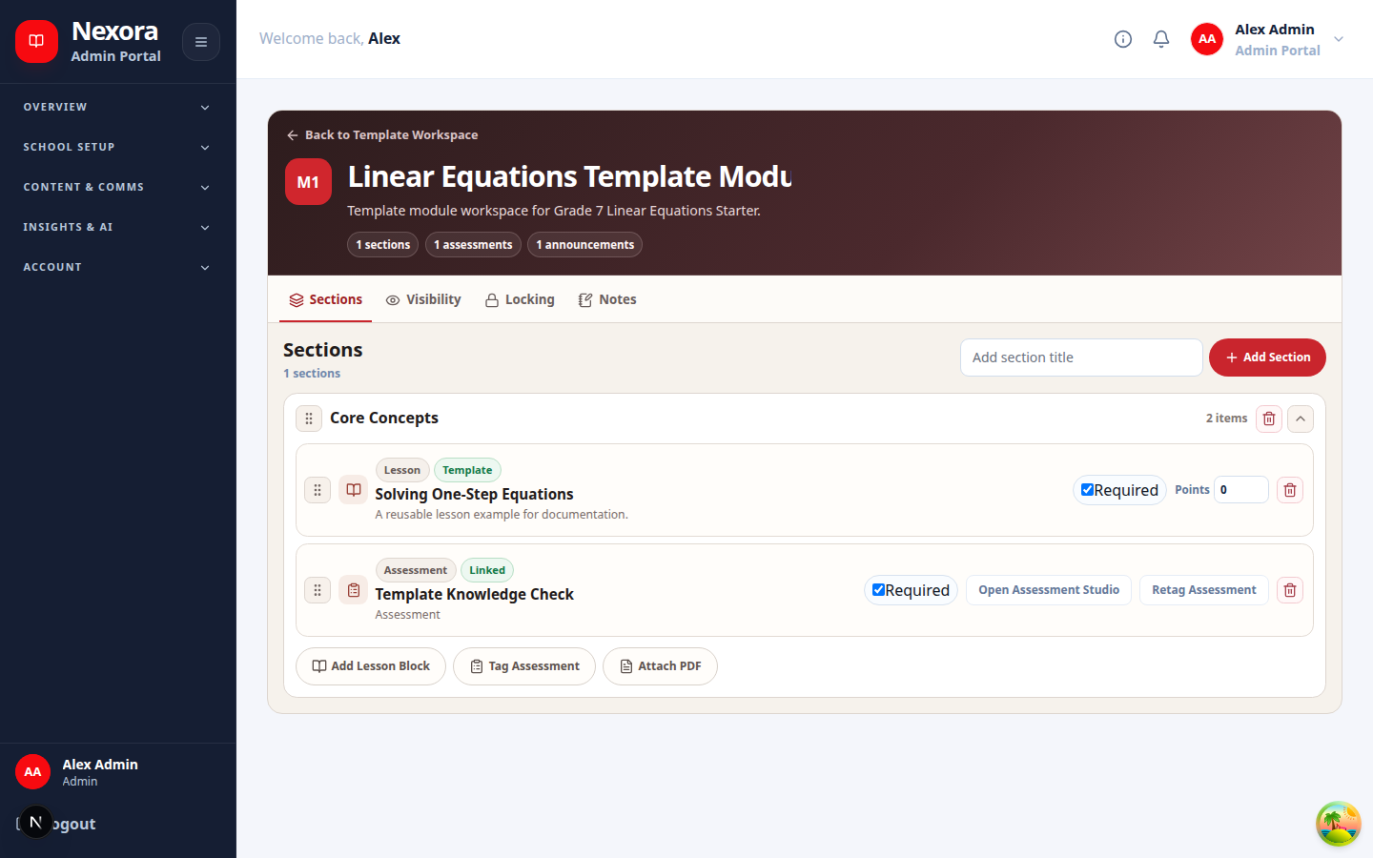
Related screen evidence: /dashboard/admin/class-templates/[id]/modules/[moduleKey]

Discussion Board
In plain English
Runs moderated class discussions, comments, attachments, reactions, reports, and publication state.
Authority: NestJS backend. Web and mobile consume its public /api contract; the database is never a client API.
Inputs: Authenticated request or internal event, validated data, role/account state, academic policy, and existing durable records.
Outputs: Role-scoped response, audited transaction, notification, or durable job identity.
Source owner: backend/src/modules/discussion-board/discussion-board.module.ts
Surface count: 1 controller files in this folder · 19 HTTP handlers
Failure path: Capture status code and request ID; check dependency health and backend log; inspect audit/job state; correct the cause before retrying.
Verification: Run a permitted read and a synthetic preview or write, confirm persistence, then repeat with a disallowed role to verify isolation.
Related screen evidence: /dashboard/admin

File Upload
In plain English
Validates uploaded teaching files, records ownership, and schedules extraction or indexing work.
Authority: NestJS backend. Web and mobile consume its public /api contract; the database is never a client API.
Inputs: Authenticated request or internal event, validated data, role/account state, academic policy, and existing durable records.
Outputs: Role-scoped response, audited transaction, notification, or durable job identity.
Source owner: backend/src/modules/file-upload/file-upload.module.ts
Surface count: 2 controller files in this folder · 14 HTTP handlers
Failure path: Capture status code and request ID; check dependency health and backend log; inspect audit/job state; correct the cause before retrying.
Verification: Run a permitted read and a synthetic preview or write, confirm persistence, then repeat with a disallowed role to verify isolation.
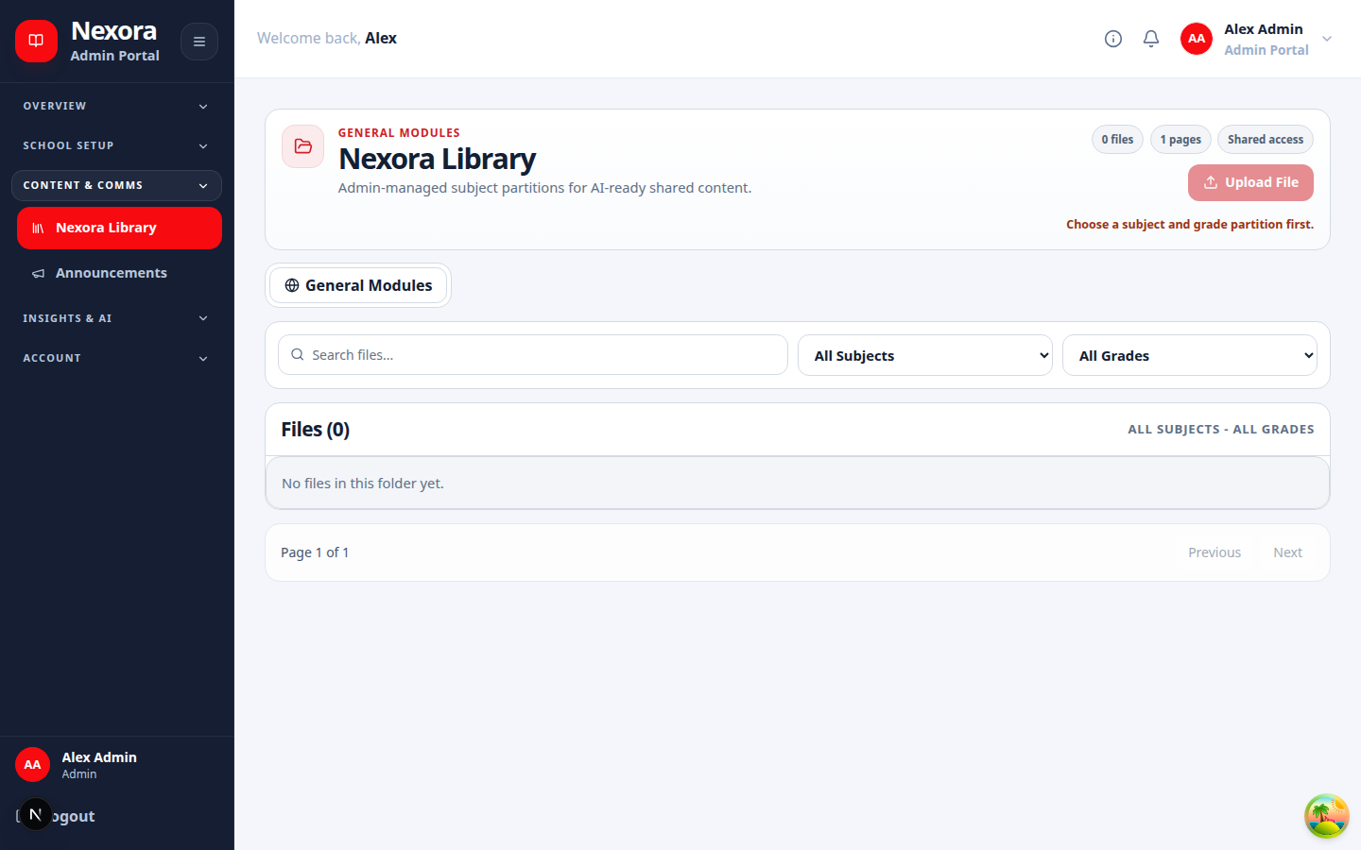
Related screen evidence: /dashboard/admin/library

Storage
In plain English
Provides the storage-driver boundary for local files or S3-compatible object storage.
Authority: NestJS backend. Web and mobile consume its public /api contract; the database is never a client API.
Inputs: Authenticated request or internal event, validated data, role/account state, academic policy, and existing durable records.
Outputs: Role-scoped response, audited transaction, notification, or durable job identity.
Source owner: backend/src/modules/file-upload/storage/storage.module.ts
Surface count: 0 controller files in this folder · 0 HTTP handlers
Failure path: Capture status code and request ID; check dependency health and backend log; inspect audit/job state; correct the cause before retrying.
Verification: Run a permitted read and a synthetic preview or write, confirm persistence, then repeat with a disallowed role to verify isolation.
Related screen evidence: /dashboard/admin/library

Health
In plain English
Reports liveness, readiness, dependency status, and operational diagnostics.
Authority: NestJS backend. Web and mobile consume its public /api contract; the database is never a client API.
Inputs: Authenticated request or internal event, validated data, role/account state, academic policy, and existing durable records.
Outputs: Role-scoped response, audited transaction, notification, or durable job identity.
Source owner: backend/src/modules/health/health.module.ts
Surface count: 2 controller files in this folder · 4 HTTP handlers
Failure path: Capture status code and request ID; check dependency health and backend log; inspect audit/job state; correct the cause before retrying.
Verification: Run a permitted read and a synthetic preview or write, confirm persistence, then repeat with a disallowed role to verify isolation.
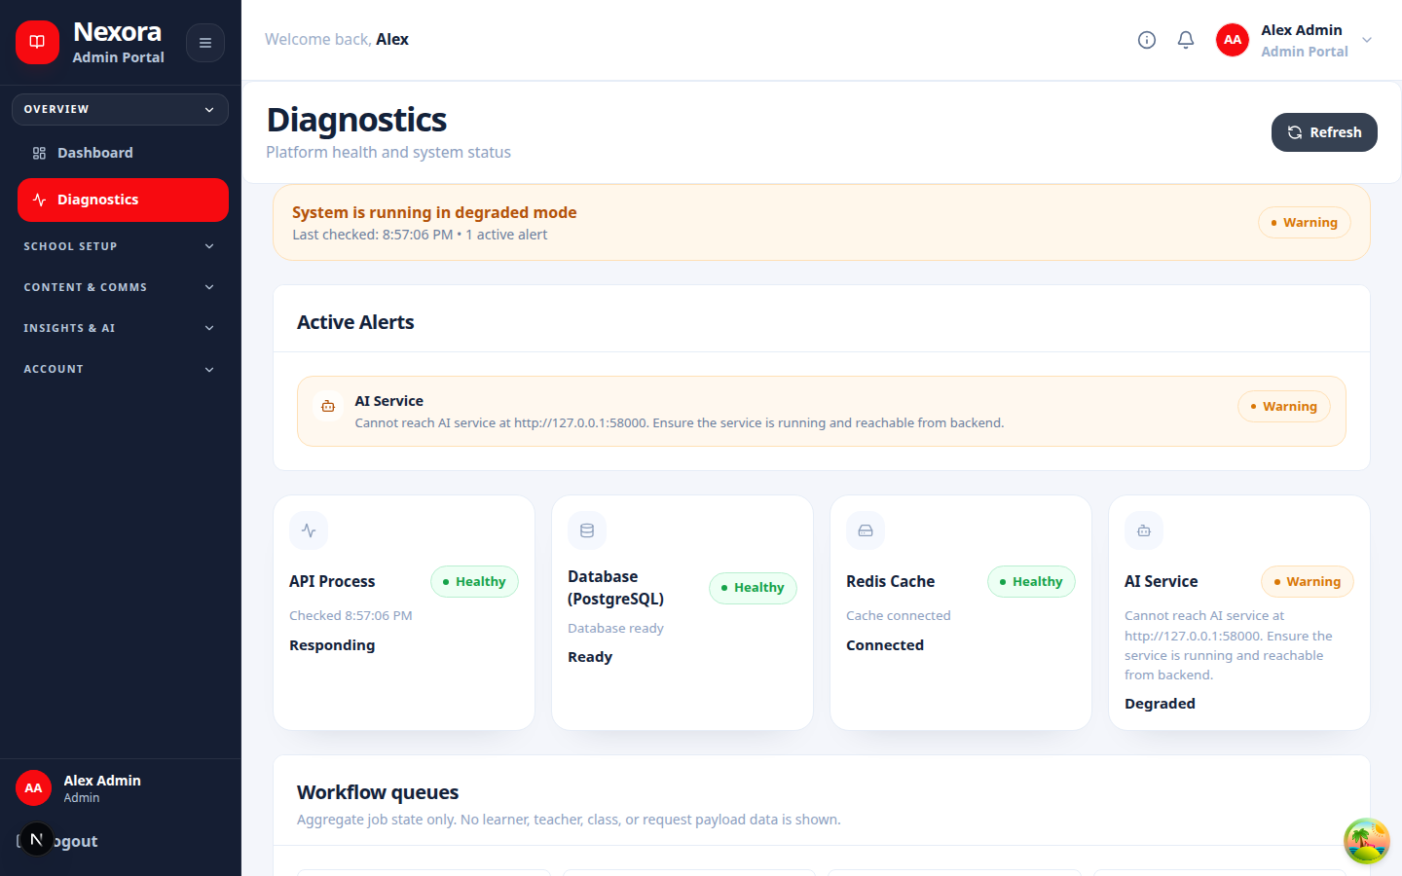
Related screen evidence: /dashboard/admin/diagnostics

Ja
In plain English
Coordinates JA guidance, review, learner support, and AI-assisted study interactions.
Authority: NestJS backend. Web and mobile consume its public /api contract; the database is never a client API.
Inputs: Authenticated request or internal event, validated data, role/account state, academic policy, and existing durable records.
Outputs: Role-scoped response, audited transaction, notification, or durable job identity.
Source owner: backend/src/modules/ja/ja.module.ts
Surface count: 2 controller files in this folder · 19 HTTP handlers
Failure path: Capture status code and request ID; check dependency health and backend log; inspect audit/job state; correct the cause before retrying.
Verification: Run a permitted read and a synthetic preview or write, confirm persistence, then repeat with a disallowed role to verify isolation.
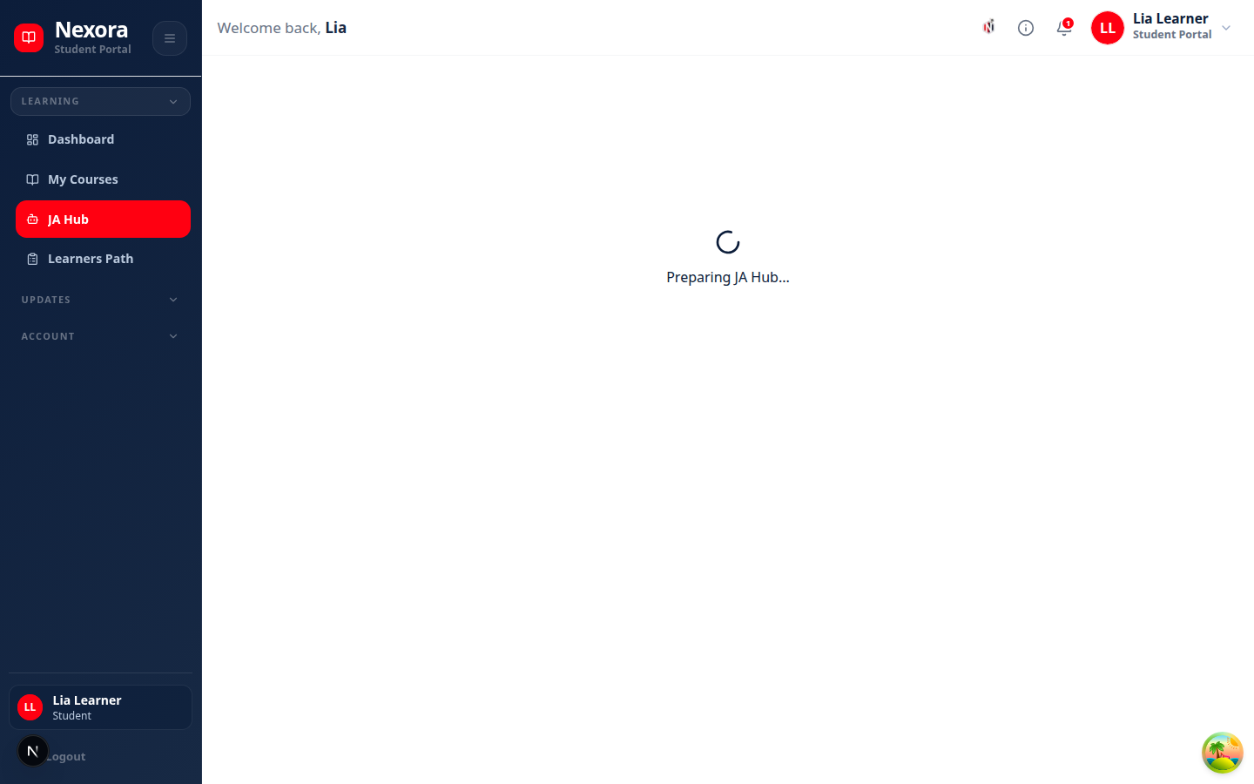
Related screen evidence: /dashboard/student/ja

Lessons
In plain English
Owns lesson content, publication, preview access, completion evidence, and delivery metadata.
Authority: NestJS backend. Web and mobile consume its public /api contract; the database is never a client API.
Inputs: Authenticated request or internal event, validated data, role/account state, academic policy, and existing durable records.
Outputs: Role-scoped response, audited transaction, notification, or durable job identity.
Source owner: backend/src/modules/lessons/lessons.module.ts
Surface count: 1 controller files in this folder · 25 HTTP handlers
Failure path: Capture status code and request ID; check dependency health and backend log; inspect audit/job state; correct the cause before retrying.
Verification: Run a permitted read and a synthetic preview or write, confirm persistence, then repeat with a disallowed role to verify isolation.
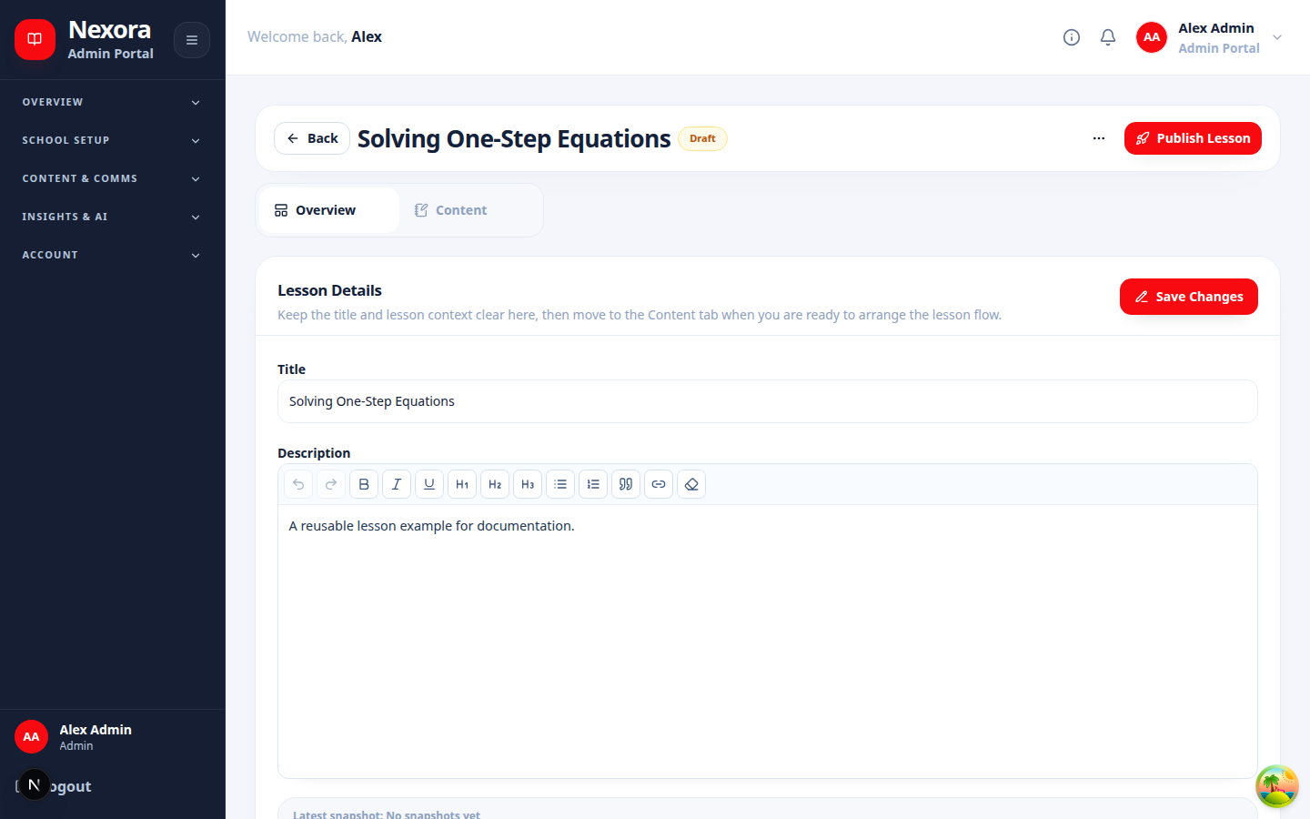
Related screen evidence: /dashboard/admin/class-templates/[id]/lessons/[lessonKey]/edit

Lxp
In plain English
Builds personalized learning paths and learner-facing experience data from approved content and evidence.
Authority: NestJS backend. Web and mobile consume its public /api contract; the database is never a client API.
Inputs: Authenticated request or internal event, validated data, role/account state, academic policy, and existing durable records.
Outputs: Role-scoped response, audited transaction, notification, or durable job identity.
Source owner: backend/src/modules/lxp/lxp.module.ts
Surface count: 1 controller files in this folder · 32 HTTP handlers
Failure path: Capture status code and request ID; check dependency health and backend log; inspect audit/job state; correct the cause before retrying.
Verification: Run a permitted read and a synthetic preview or write, confirm persistence, then repeat with a disallowed role to verify isolation.
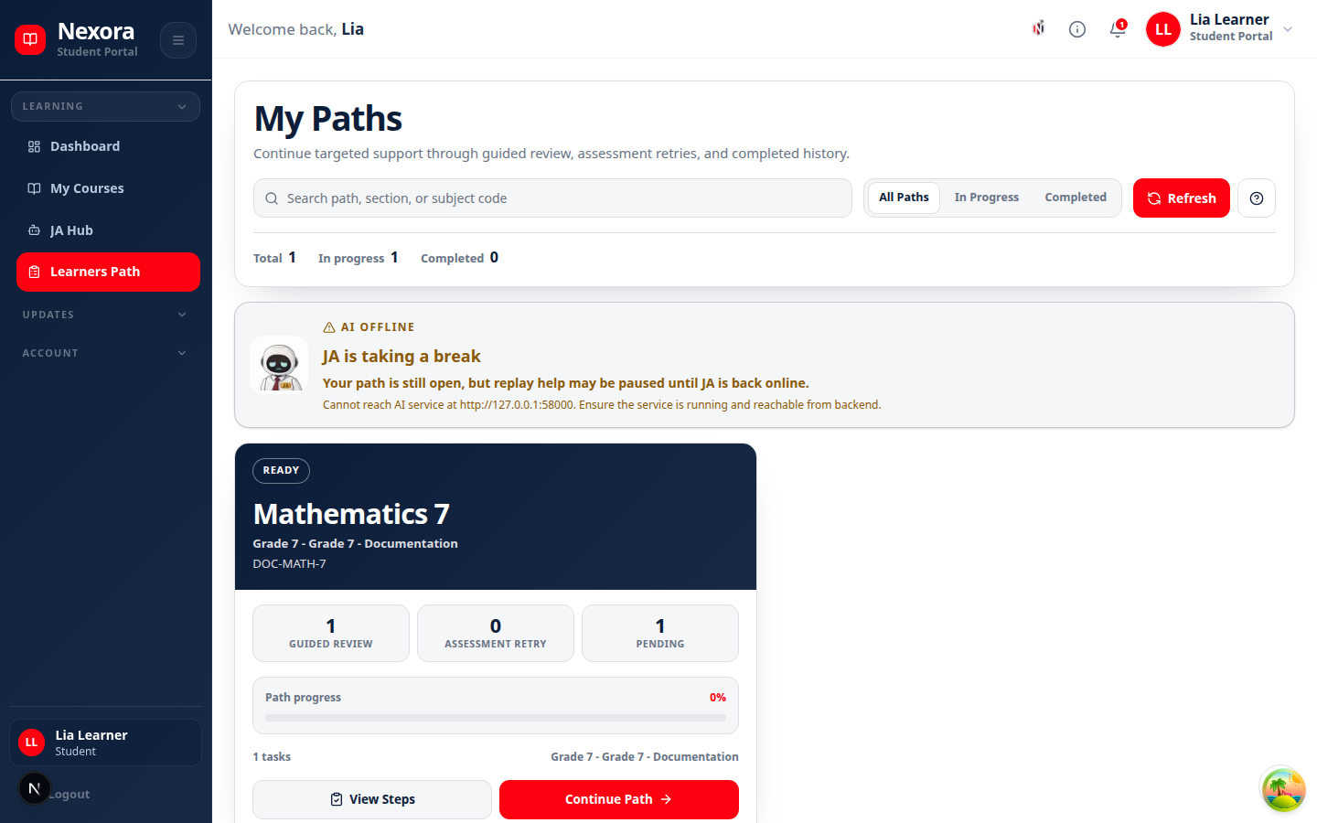
Related screen evidence: /dashboard/student/lxp

Mail
In plain English
Sends account, recovery, verification, and workflow email through the configured mail transport.
Authority: NestJS backend. Web and mobile consume its public /api contract; the database is never a client API.
Inputs: Authenticated request or internal event, validated data, role/account state, academic policy, and existing durable records.
Outputs: Role-scoped response, audited transaction, notification, or durable job identity.
Source owner: backend/src/modules/mail/mail.module.ts
Surface count: 0 controller files in this folder · 0 HTTP handlers
Failure path: Capture status code and request ID; check dependency health and backend log; inspect audit/job state; correct the cause before retrying.
Verification: Run a permitted read and a synthetic preview or write, confirm persistence, then repeat with a disallowed role to verify isolation.
Related screen evidence: /dashboard/admin/system-settings

Mobile Workspace
In plain English
Returns compact, role-specific mobile dashboard, calendar, and library projections.
Authority: NestJS backend. Web and mobile consume its public /api contract; the database is never a client API.
Inputs: Authenticated request or internal event, validated data, role/account state, academic policy, and existing durable records.
Outputs: Role-scoped response, audited transaction, notification, or durable job identity.
Source owner: backend/src/modules/mobile-workspace/mobile-workspace.module.ts
Surface count: 1 controller files in this folder · 5 HTTP handlers
Failure path: Capture status code and request ID; check dependency health and backend log; inspect audit/job state; correct the cause before retrying.
Verification: Run a permitted read and a synthetic preview or write, confirm persistence, then repeat with a disallowed role to verify isolation.
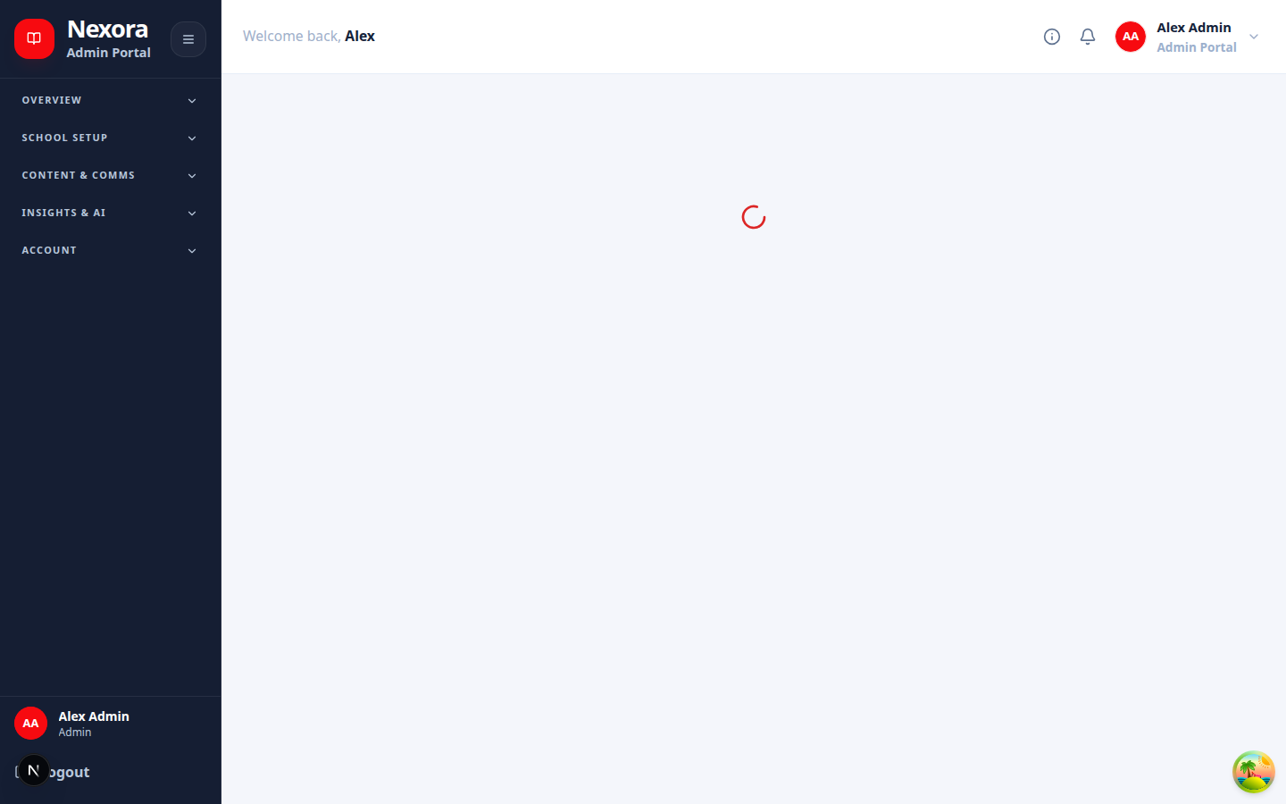
Related screen evidence: /dashboard

Notifications
In plain English
Creates in-app notifications and safely fans out push or workflow alerts.
Authority: NestJS backend. Web and mobile consume its public /api contract; the database is never a client API.
Inputs: Authenticated request or internal event, validated data, role/account state, academic policy, and existing durable records.
Outputs: Role-scoped response, audited transaction, notification, or durable job identity.
Source owner: backend/src/modules/notifications/notifications.module.ts
Surface count: 1 controller files in this folder · 8 HTTP handlers
Failure path: Capture status code and request ID; check dependency health and backend log; inspect audit/job state; correct the cause before retrying.
Verification: Run a permitted read and a synthetic preview or write, confirm persistence, then repeat with a disallowed role to verify isolation.
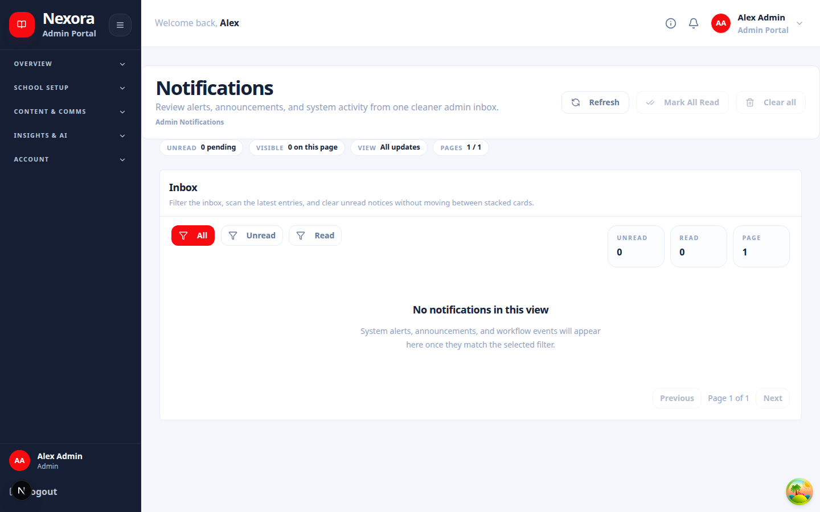
Related screen evidence: /dashboard/notifications

Otp
In plain English
Issues and validates short-lived verification codes with rate and expiry controls.
Authority: NestJS backend. Web and mobile consume its public /api contract; the database is never a client API.
Inputs: Authenticated request or internal event, validated data, role/account state, academic policy, and existing durable records.
Outputs: Role-scoped response, audited transaction, notification, or durable job identity.
Source owner: backend/src/modules/otp/otp.module.ts
Surface count: 1 controller files in this folder · 2 HTTP handlers
Failure path: Capture status code and request ID; check dependency health and backend log; inspect audit/job state; correct the cause before retrying.
Verification: Run a permitted read and a synthetic preview or write, confirm persistence, then repeat with a disallowed role to verify isolation.
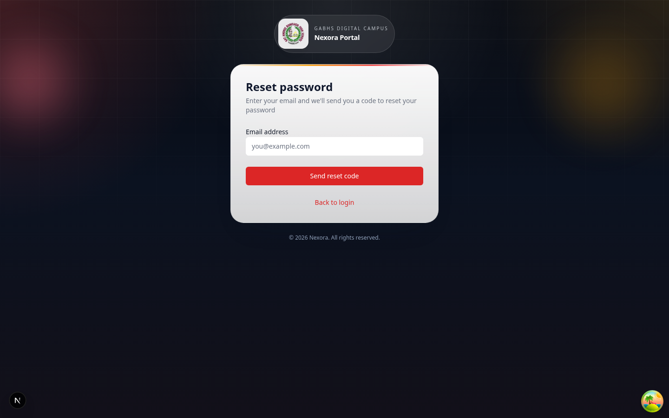
Related screen evidence: /forgot-password

Performance
In plain English
Computes learner performance signals, intervention candidates, and restart-safe recomputation jobs.
Authority: NestJS backend. Web and mobile consume its public /api contract; the database is never a client API.
Inputs: Authenticated request or internal event, validated data, role/account state, academic policy, and existing durable records.
Outputs: Role-scoped response, audited transaction, notification, or durable job identity.
Source owner: backend/src/modules/performance/performance.module.ts
Surface count: 1 controller files in this folder · 11 HTTP handlers
Failure path: Capture status code and request ID; check dependency health and backend log; inspect audit/job state; correct the cause before retrying.
Verification: Run a permitted read and a synthetic preview or write, confirm persistence, then repeat with a disallowed role to verify isolation.
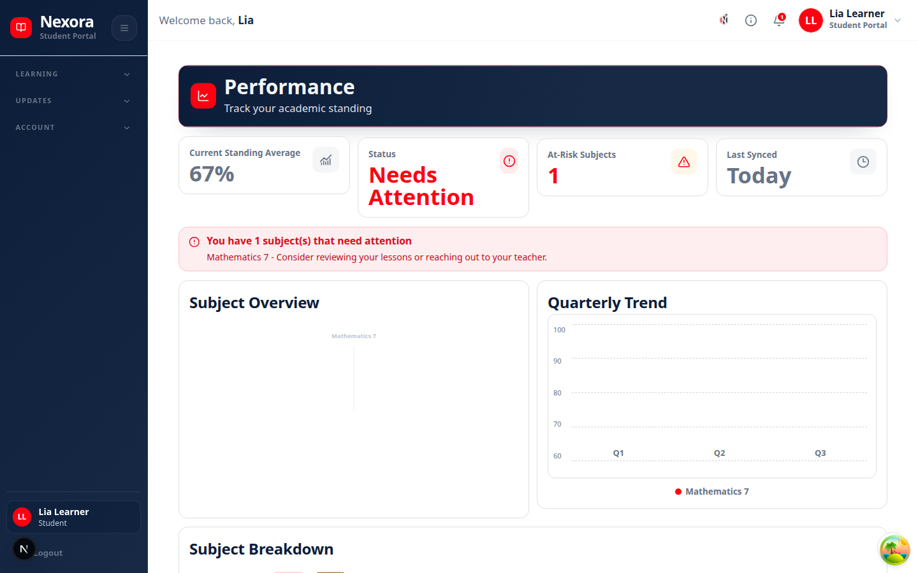
Related screen evidence: /dashboard/student/performance

Profiles
In plain English
Owns user profile completion, personal data, and role-safe self-service updates.
Authority: NestJS backend. Web and mobile consume its public /api contract; the database is never a client API.
Inputs: Authenticated request or internal event, validated data, role/account state, academic policy, and existing durable records.
Outputs: Role-scoped response, audited transaction, notification, or durable job identity.
Source owner: backend/src/modules/profiles/profiles.module.ts
Surface count: 1 controller files in this folder · 9 HTTP handlers
Failure path: Capture status code and request ID; check dependency health and backend log; inspect audit/job state; correct the cause before retrying.
Verification: Run a permitted read and a synthetic preview or write, confirm persistence, then repeat with a disallowed role to verify isolation.
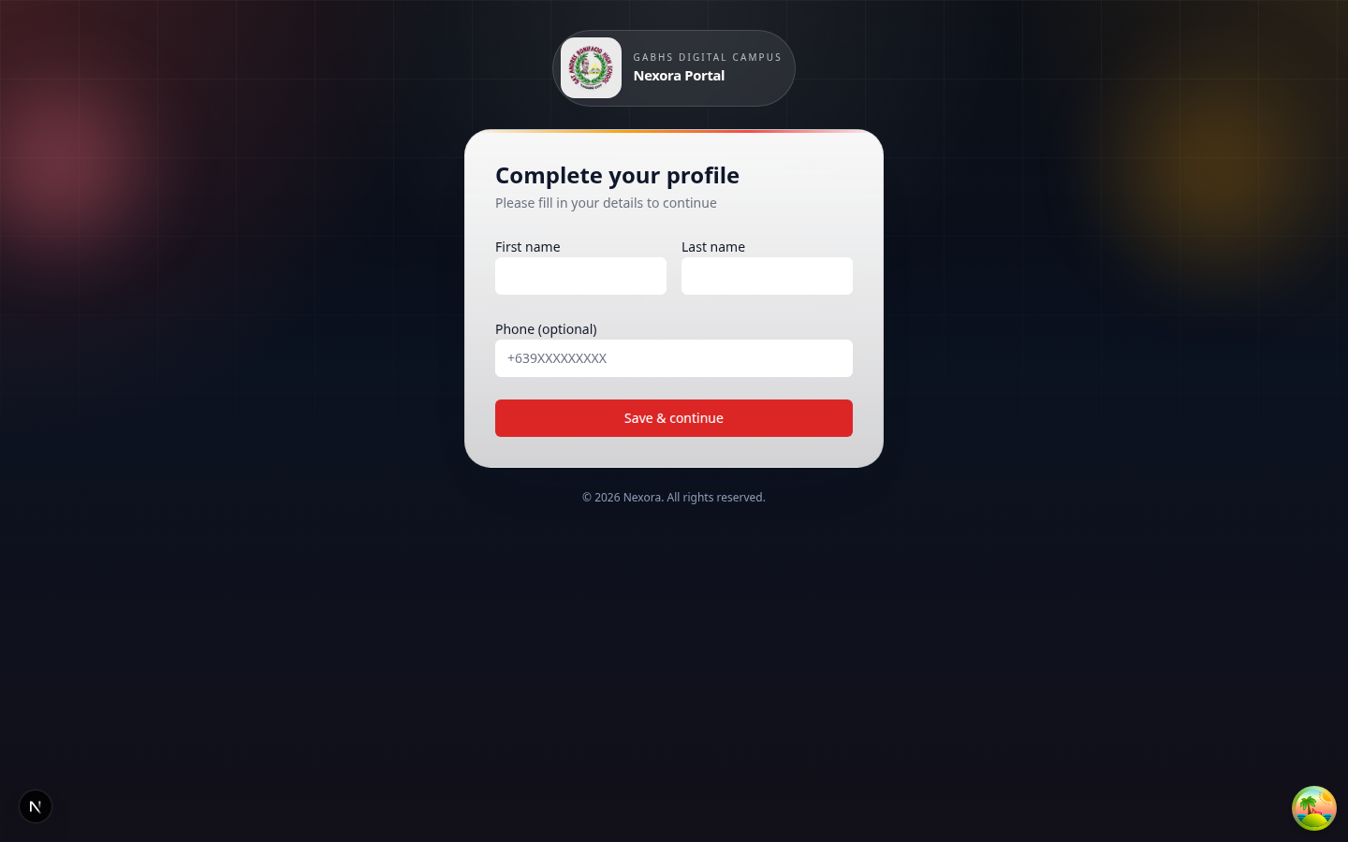
Related screen evidence: /complete-profile

Rag
In plain English
Coordinates retrieval indexing and source-grounded context used by assistive AI flows.
Authority: NestJS backend. Web and mobile consume its public /api contract; the database is never a client API.
Inputs: Authenticated request or internal event, validated data, role/account state, academic policy, and existing durable records.
Outputs: Role-scoped response, audited transaction, notification, or durable job identity.
Source owner: backend/src/modules/rag/rag.module.ts
Surface count: 0 controller files in this folder · 0 HTTP handlers
Failure path: Capture status code and request ID; check dependency health and backend log; inspect audit/job state; correct the cause before retrying.
Verification: Run a permitted read and a synthetic preview or write, confirm persistence, then repeat with a disallowed role to verify isolation.
Related screen evidence: /dashboard/admin/library

Reports
In plain English
Builds authorized operational and academic reports for review or export.
Authority: NestJS backend. Web and mobile consume its public /api contract; the database is never a client API.
Inputs: Authenticated request or internal event, validated data, role/account state, academic policy, and existing durable records.
Outputs: Role-scoped response, audited transaction, notification, or durable job identity.
Source owner: backend/src/modules/reports/reports.module.ts
Surface count: 1 controller files in this folder · 6 HTTP handlers
Failure path: Capture status code and request ID; check dependency health and backend log; inspect audit/job state; correct the cause before retrying.
Verification: Run a permitted read and a synthetic preview or write, confirm persistence, then repeat with a disallowed role to verify isolation.
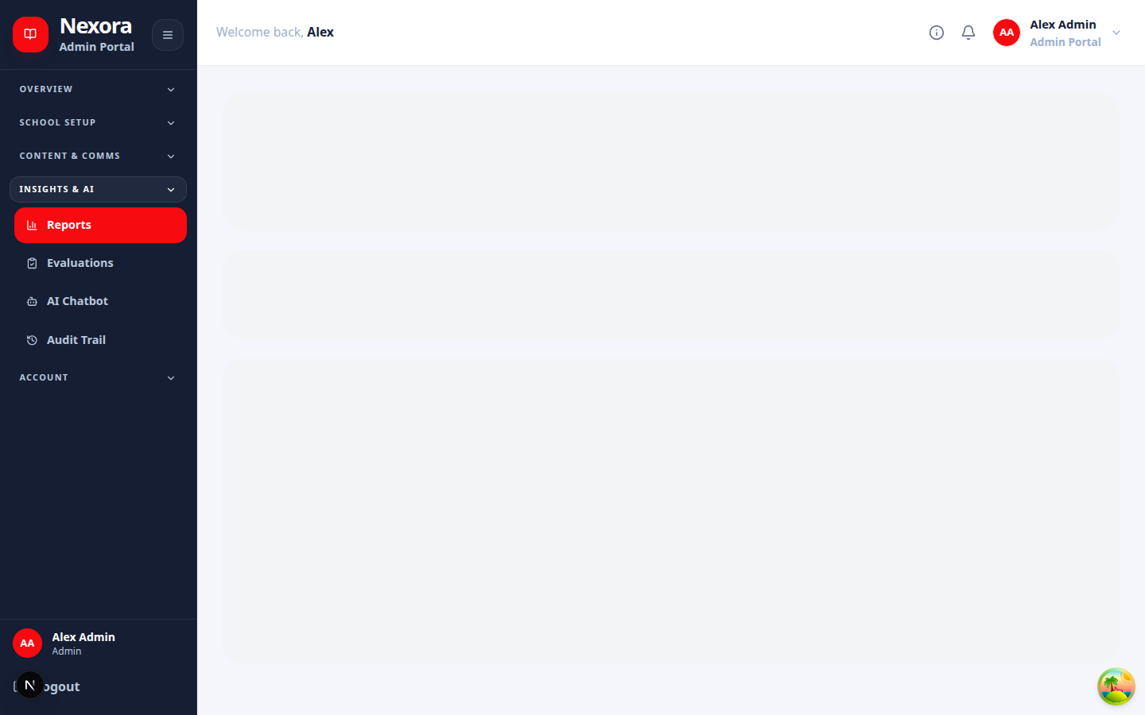
Related screen evidence: /dashboard/admin/reports

Roles
In plain English
Defines and resolves role records used by backend authorization.
Authority: NestJS backend. Web and mobile consume its public /api contract; the database is never a client API.
Inputs: Authenticated request or internal event, validated data, role/account state, academic policy, and existing durable records.
Outputs: Role-scoped response, audited transaction, notification, or durable job identity.
Source owner: backend/src/modules/roles/roles.module.ts
Surface count: 0 controller files in this folder · 0 HTTP handlers
Failure path: Capture status code and request ID; check dependency health and backend log; inspect audit/job state; correct the cause before retrying.
Verification: Run a permitted read and a synthetic preview or write, confirm persistence, then repeat with a disallowed role to verify isolation.
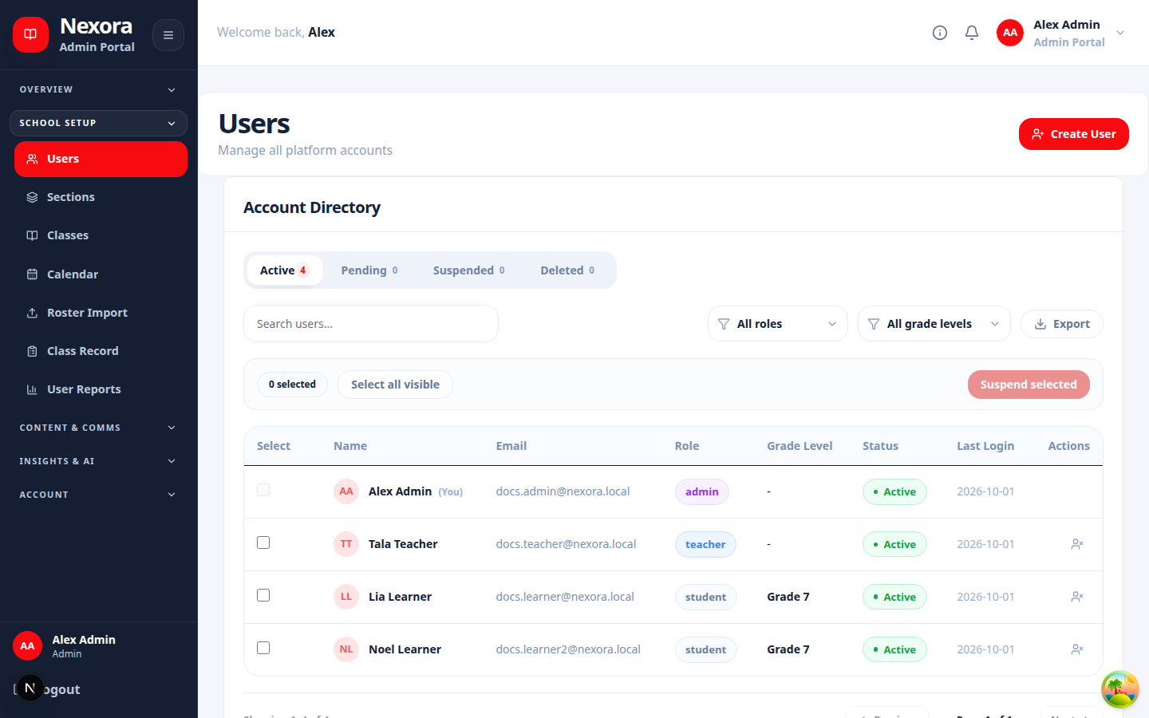
Related screen evidence: /dashboard/admin/users

Roster Import
In plain English
Validates roster files, previews impact, and performs controlled account or enrollment imports.
Authority: NestJS backend. Web and mobile consume its public /api contract; the database is never a client API.
Inputs: Authenticated request or internal event, validated data, role/account state, academic policy, and existing durable records.
Outputs: Role-scoped response, audited transaction, notification, or durable job identity.
Source owner: backend/src/modules/roster-import/roster-import.module.ts
Surface count: 1 controller files in this folder · 4 HTTP handlers
Failure path: Capture status code and request ID; check dependency health and backend log; inspect audit/job state; correct the cause before retrying.
Verification: Run a permitted read and a synthetic preview or write, confirm persistence, then repeat with a disallowed role to verify isolation.
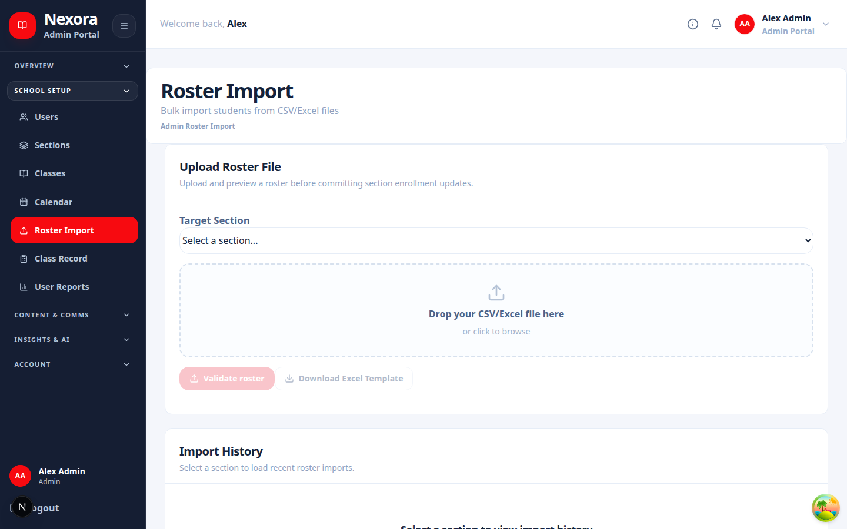
Related screen evidence: /dashboard/admin/roster-import

School Events
In plain English
Stores and delivers school calendar events and role-scoped schedules.
Authority: NestJS backend. Web and mobile consume its public /api contract; the database is never a client API.
Inputs: Authenticated request or internal event, validated data, role/account state, academic policy, and existing durable records.
Outputs: Role-scoped response, audited transaction, notification, or durable job identity.
Source owner: backend/src/modules/school-events/school-events.module.ts
Surface count: 1 controller files in this folder · 4 HTTP handlers
Failure path: Capture status code and request ID; check dependency health and backend log; inspect audit/job state; correct the cause before retrying.
Verification: Run a permitted read and a synthetic preview or write, confirm persistence, then repeat with a disallowed role to verify isolation.
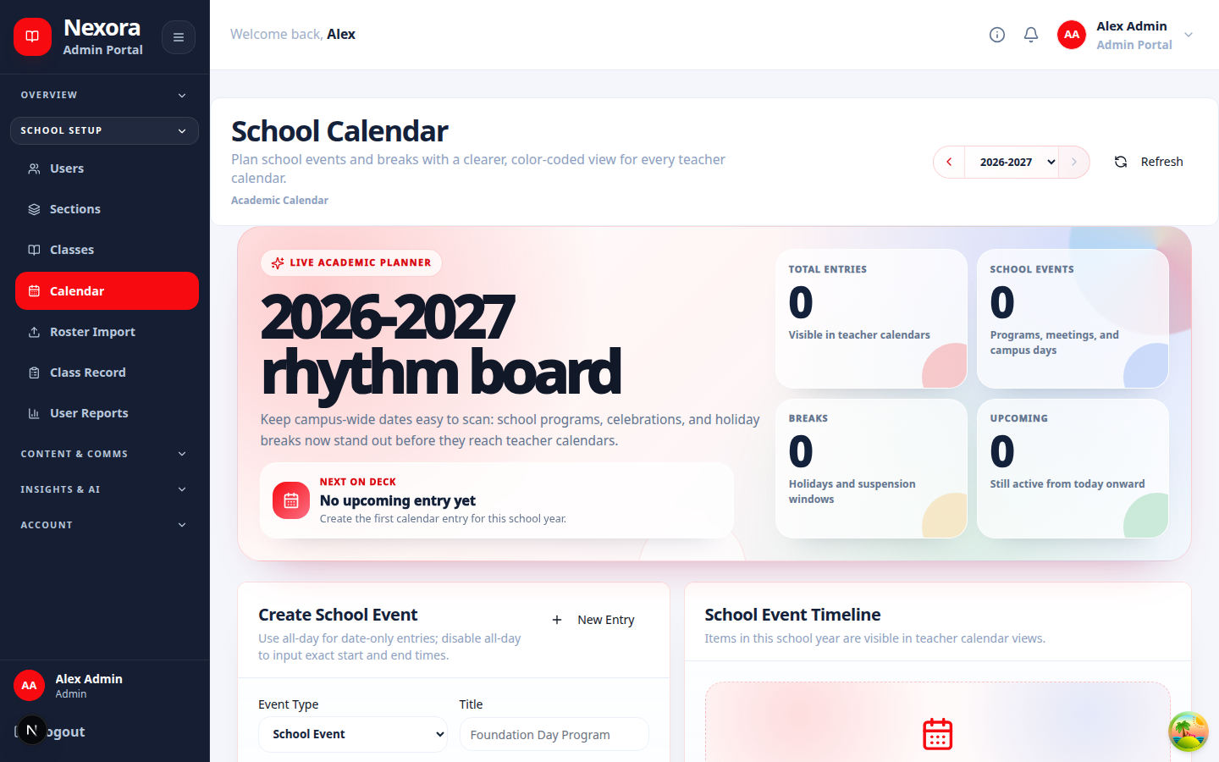
Related screen evidence: /dashboard/admin/calendar

Sections
In plain English
Owns section identity, membership, advisers, schedules, and class relationships.
Authority: NestJS backend. Web and mobile consume its public /api contract; the database is never a client API.
Inputs: Authenticated request or internal event, validated data, role/account state, academic policy, and existing durable records.
Outputs: Role-scoped response, audited transaction, notification, or durable job identity.
Source owner: backend/src/modules/sections/sections.module.ts
Surface count: 1 controller files in this folder · 26 HTTP handlers
Failure path: Capture status code and request ID; check dependency health and backend log; inspect audit/job state; correct the cause before retrying.
Verification: Run a permitted read and a synthetic preview or write, confirm persistence, then repeat with a disallowed role to verify isolation.
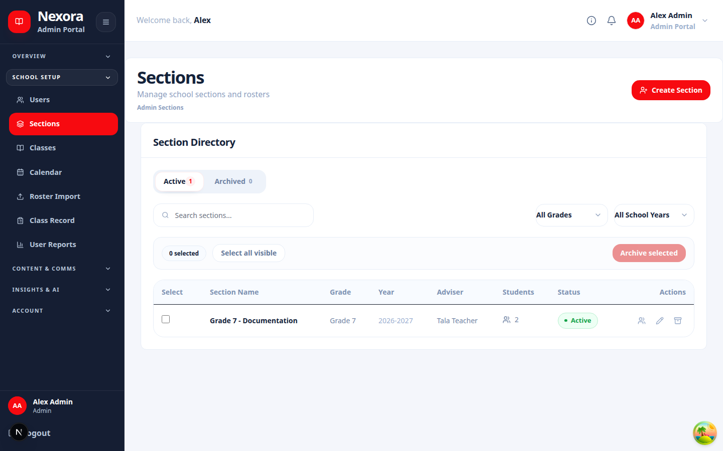
Related screen evidence: /dashboard/admin/sections

System Capabilities
In plain English
Consolidates backend-owned feature availability and dependency readiness for clients.
Authority: NestJS backend. Web and mobile consume its public /api contract; the database is never a client API.
Inputs: Authenticated request or internal event, validated data, role/account state, academic policy, and existing durable records.
Outputs: Role-scoped response, audited transaction, notification, or durable job identity.
Source owner: backend/src/modules/system-capabilities/system-capabilities.module.ts
Surface count: 1 controller files in this folder · 1 HTTP handlers
Failure path: Capture status code and request ID; check dependency health and backend log; inspect audit/job state; correct the cause before retrying.
Verification: Run a permitted read and a synthetic preview or write, confirm persistence, then repeat with a disallowed role to verify isolation.
Related screen evidence: /dashboard/admin/diagnostics

System Reset
In plain English
Previews and coordinates protected reset workflows with allowlists, reauthentication, queues, and audit evidence.
Authority: NestJS backend. Web and mobile consume its public /api contract; the database is never a client API.
Inputs: Authenticated request or internal event, validated data, role/account state, academic policy, and existing durable records.
Outputs: Role-scoped response, audited transaction, notification, or durable job identity.
Source owner: backend/src/modules/system-reset/system-reset.module.ts
Surface count: 1 controller files in this folder · 6 HTTP handlers
Failure path: Capture status code and request ID; check dependency health and backend log; inspect audit/job state; correct the cause before retrying.
Verification: Run a permitted read and a synthetic preview or write, confirm persistence, then repeat with a disallowed role to verify isolation.
Related screen evidence: /dashboard/admin

Teacher Profiles
In plain English
Stores teacher-specific professional profile data and assignments.
Authority: NestJS backend. Web and mobile consume its public /api contract; the database is never a client API.
Inputs: Authenticated request or internal event, validated data, role/account state, academic policy, and existing durable records.
Outputs: Role-scoped response, audited transaction, notification, or durable job identity.
Source owner: backend/src/modules/teacher-profiles/teacher-profiles.module.ts
Surface count: 1 controller files in this folder · 4 HTTP handlers
Failure path: Capture status code and request ID; check dependency health and backend log; inspect audit/job state; correct the cause before retrying.
Verification: Run a permitted read and a synthetic preview or write, confirm persistence, then repeat with a disallowed role to verify isolation.
Related screen evidence: /complete-profile

Teacher
In plain English
Provides teacher dashboard, class, learner, and workflow projections.
Authority: NestJS backend. Web and mobile consume its public /api contract; the database is never a client API.
Inputs: Authenticated request or internal event, validated data, role/account state, academic policy, and existing durable records.
Outputs: Role-scoped response, audited transaction, notification, or durable job identity.
Source owner: backend/src/modules/teacher/teacher.module.ts
Surface count: 1 controller files in this folder · 3 HTTP handlers
Failure path: Capture status code and request ID; check dependency health and backend log; inspect audit/job state; correct the cause before retrying.
Verification: Run a permitted read and a synthetic preview or write, confirm persistence, then repeat with a disallowed role to verify isolation.
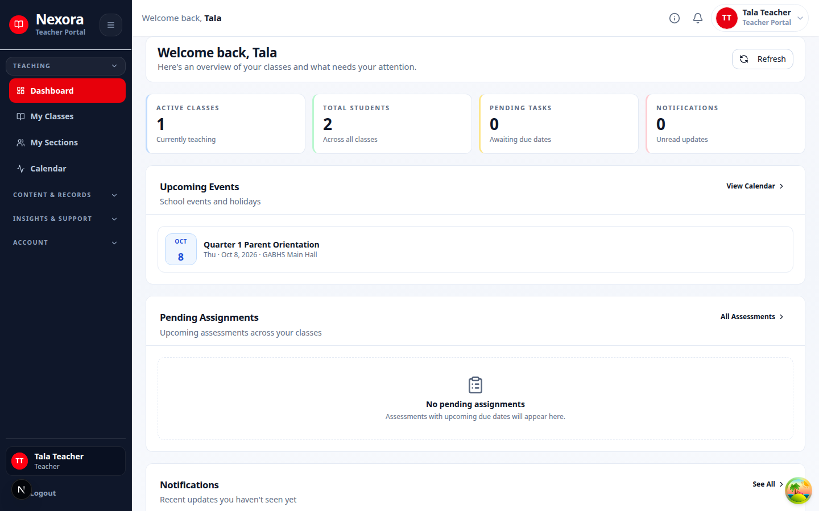
Related screen evidence: /dashboard/teacher

Users
In plain English
Creates, reads, updates, archives, and searches user accounts under role and lifecycle policy.
Authority: NestJS backend. Web and mobile consume its public /api contract; the database is never a client API.
Inputs: Authenticated request or internal event, validated data, role/account state, academic policy, and existing durable records.
Outputs: Role-scoped response, audited transaction, notification, or durable job identity.
Source owner: backend/src/modules/users/users.module.ts
Surface count: 1 controller files in this folder · 13 HTTP handlers
Failure path: Capture status code and request ID; check dependency health and backend log; inspect audit/job state; correct the cause before retrying.
Verification: Run a permitted read and a synthetic preview or write, confirm persistence, then repeat with a disallowed role to verify isolation.
Related screen evidence: /dashboard/admin/users

8. Backend HTTP handler index

backend/src/modules/academic-state/academic-grading.controller.ts
Method | Source line
POST | 32
POST | 49
POST | 66
GET | 83
POST | 91
GET | 103
POST | 119
POST | 136

backend/src/modules/academic-state/academic-repair.controller.ts
Method | Source line
GET | 38
POST | 46
POST | 61
POST | 78
POST | 90
POST | 107
POST | 124
POST | 141
POST | 158
POST | 175
POST | 184
POST | 193

backend/src/modules/academic-state/academic-state.controller.ts
Method | Source line
GET | 28
GET | 38
GET | 48
POST | 64
GET | 77
GET | 87
POST | 100
POST | 113

backend/src/modules/admin-demo-mode/admin-demo-mode.controller.ts
Method | Source line
GET | 42
POST | 48
POST | 56

backend/src/modules/admin-lifecycle/admin-lifecycle.controller.ts
Method | Source line
POST | 38
POST | 47
POST | 59
POST | 68
POST | 80
POST | 89
POST | 101
POST | 110
GET | 122

backend/src/modules/admin-lifecycle/admin-maintenance-lifecycle.controller.ts
Method | Source line
POST | 40
POST | 52
POST | 66
POST | 75
POST | 89
POST | 101
POST | 115
POST | 124
POST | 138
POST | 150
POST | 162
GET | 174

backend/src/modules/admin-maintenance/admin-maintenance.controller.ts
Method | Source line
GET | 21
POST | 30
DELETE | 42

backend/src/modules/admin/admin.controller.ts
Method | Source line
GET | 18
GET | 29
GET | 40
GET | 62
GET | 76

backend/src/modules/ai-mentor/ai-mentor.controller.ts
Method | Source line
POST | 963
POST | 976
GET | 997
PATCH | 1012
GET | 1091
POST | 1163
GET | 1231
POST | 1298
POST | 1352
GET | 1409
POST | 1435
POST | 1587
GET | 1671
GET | 1734
GET | 1802
PATCH | 1873
POST | 1925
POST | 1972
POST | 2079
POST | 2127
DELETE | 2208
GET | 2252
POST | 2273
GET | 2285
GET | 2295
PATCH | 2309
DELETE | 2324
POST | 2338
POST | 2367
POST | 2414
POST | 2446
POST | 2491
PATCH | 2536
PATCH | 2562
GET | 2586
PATCH | 2595
POST | 2616
POST | 2640
POST | 2676
POST | 2712
GET | 2747
GET | 2763
GET | 2844
DELETE | 2986
GET | 3028
POST | 3041

backend/src/modules/analytics/analytics.controller.ts
Method | Source line
GET | 15
GET | 29
GET | 43
GET | 56

backend/src/modules/announcements/admin-announcements.controller.ts
Method | Source line
GET | 18

backend/src/modules/announcements/announcements.controller.ts
Method | Source line
POST | 43
GET | 63
GET | 83
PATCH | 104
PATCH | 125
DELETE | 150

backend/src/modules/announcements/teacher-announcements.controller.ts
Method | Source line
GET | 18

backend/src/modules/app-version/app-version.controller.ts
Method | Source line
GET | 28
POST | 47

backend/src/modules/assessments/assessments-public.controller.ts
Method | Source line
GET | 18

backend/src/modules/assessments/assessments.controller.ts
Method | Source line
GET | 102
POST | 139
GET | 152
PUT | 165
GET | 183
GET | 230
POST | 254
PUT | 277
PATCH | 297
DELETE | 321
POST | 337
PUT | 360
DELETE | 384
POST | 400
POST | 449
GET | 502
POST | 519
POST | 569
DELETE | 616
GET | 639
GET | 667
GET | 692
POST | 723
GET | 742
GET | 762
PATCH | 777
POST | 801
POST | 820
PUT | 875
POST | 895
GET | 918
GET | 945
GET | 969
GET | 992
GET | 1014
GET | 1040
POST | 1062
POST | 1083
POST | 1099
POST | 1122

backend/src/modules/auth/auth.controller.ts
Method | Source line
POST | 103
POST | 137
POST | 170
POST | 209
POST | 243
POST | 268
POST | 287
POST | 316
POST | 333
POST | 348
GET | 373
POST | 390
POST | 418
POST | 442
PATCH | 469

backend/src/modules/class-record/class-record.controller.ts
Method | Source line
GET | 47
GET | 54
POST | 61
POST | 76
POST | 92
POST | 107
GET | 121
GET | 135
GET | 151
POST | 167
POST | 183
PATCH | 203
POST | 219
POST | 235
GET | 251
GET | 268
POST | 281
GET | 295
POST | 312
GET | 329
POST | 343
POST | 357
GET | 373
GET | 392
GET | 406
GET | 423
GET | 441
GET | 457
GET | 471
GET | 485

backend/src/modules/class-templates/class-templates.controller.ts
Method | Source line
GET | 68
GET | 82
POST | 95
GET | 106
PATCH | 113
DELETE | 129
POST | 140
GET | 156
PUT | 163
POST | 179
GET | 223
GET | 236
POST | 243
POST | 256

backend/src/modules/classes/classes.controller.ts
Method | Source line
GET | 85
GET | 117
GET | 160
GET | 191
GET | 208
GET | 224
GET | 251
PUT | 271
GET | 293
PUT | 312
GET | 336
POST | 356
PUT | 401
PATCH | 422
POST | 443
PUT | 481
POST | 497
DELETE | 520
DELETE | 535
PATCH | 550
PATCH | 567
GET | 584
GET | 601
GET | 626
GET | 651
GET | 706
POST | 724
DELETE | 751
GET | 777

backend/src/modules/content-modules/content-modules.controller.ts
Method | Source line
GET | 82
GET | 103
POST | 125
PATCH | 141
PATCH | 162
DELETE | 183
PUT | 199
POST | 221
PATCH | 242
DELETE | 263
PUT | 282
POST | 304
PATCH | 325
PATCH | 346
DELETE | 367
GET | 383
PUT | 425
PUT | 447
POST | 469
GET | 505

backend/src/modules/discussion-board/discussion-board.controller.ts
Method | Source line
POST | 138
POST | 165
POST | 194
GET | 216
GET | 235
PATCH | 256
POST | 279
POST | 300
POST | 321
DELETE | 342
POST | 363
DELETE | 387
POST | 410
PUT | 435
DELETE | 460
GET | 483
GET | 503
GET | 523
GET | 545

backend/src/modules/file-upload/file-upload.controller.ts
Method | Source line
POST | 107
GET | 152
GET | 172
POST | 188
PATCH | 206
DELETE | 226
GET | 241
GET | 253
PATCH | 271
GET | 291
POST | 328
POST | 339
DELETE | 357

backend/src/modules/file-upload/internal-uploads.controller.ts
Method | Source line
GET | 37

backend/src/modules/health/health.controller.ts
Method | Source line
GET | 12
GET | 28
GET | 37

backend/src/modules/health/workflow-diagnostics.controller.ts
Method | Source line
GET | 14

backend/src/modules/ja/ja-hub.controller.ts
Method | Source line
GET | 39
GET | 54
GET | 69
POST | 84
GET | 99
POST | 115
GET | 131
POST | 146
GET | 161
POST | 176
POST | 197
POST | 213

backend/src/modules/ja/ja.controller.ts
Method | Source line
GET | 34
POST | 49
GET | 64
POST | 79
POST | 100
POST | 123
DELETE | 143

backend/src/modules/lessons/lessons.controller.ts
Method | Source line
GET | 62
GET | 109
GET | 122
GET | 144
POST | 161
PUT | 184
PUT | 208
GET | 224
POST | 244
GET | 265
POST | 285
GET | 303
GET | 315
POST | 333
PUT | 358
POST | 386
PUT | 411
DELETE | 437
POST | 453
PUT | 477
DELETE | 502
PUT | 523
POST | 547
GET | 568
GET | 588

backend/src/modules/lxp/lxp.controller.ts
Method | Source line
GET | 37
GET | 46
GET | 57
GET | 67
POST | 77
GET | 92
POST | 107
PATCH | 124
POST | 141
GET | 158
GET | 173
POST | 184
GET | 194
GET | 204
GET | 217
POST | 226
POST | 237
POST | 248
POST | 258
GET | 268
GET | 278
GET | 291
POST | 301
GET | 311
GET | 321
POST | 330
POST | 345
GET | 358
PATCH | 371
POST | 386
POST | 401
GET | 416

backend/src/modules/mobile-workspace/mobile-workspace.controller.ts
Method | Source line
GET | 15
GET | 25
GET | 35
GET | 45
GET | 58

backend/src/modules/notifications/notifications.controller.ts
Method | Source line
PUT | 41
DELETE | 64
GET | 86
GET | 110
PATCH | 124
PATCH | 139
DELETE | 152
DELETE | 163

backend/src/modules/otp/otp.controller.ts
Method | Source line
POST | 21
POST | 38

backend/src/modules/performance/performance.controller.ts
Method | Source line
POST | 23
GET | 37
GET | 51
GET | 65
GET | 79
POST | 95
GET | 111
GET | 125
GET | 139
GET | 153
GET | 165

backend/src/modules/profiles/profiles.controller.ts
Method | Source line
GET | 49
GET | 59
GET | 69
GET | 90
GET | 112
GET | 128
POST | 148
PUT | 169
POST | 196

backend/src/modules/reports/reports.controller.ts
Method | Source line
GET | 100
GET | 126
GET | 152
GET | 178
GET | 205
GET | 231

backend/src/modules/roster-import/roster-import.controller.ts
Method | Source line
POST | 88
POST | 118
GET | 142
PATCH | 165

backend/src/modules/school-events/school-events.controller.ts
Method | Source line
GET | 32
POST | 40
PATCH | 51
DELETE | 63

backend/src/modules/sections/sections.controller.ts
Method | Source line
GET | 84
GET | 119
GET | 136
GET | 145
POST | 155
POST | 177
POST | 190
POST | 203
GET | 220
POST | 235
PUT | 258
PATCH | 279
POST | 300
DELETE | 338
POST | 356
PATCH | 375
PATCH | 395
PUT | 419
GET | 441
GET | 456
POST | 525
DELETE | 550
DELETE | 571
GET | 590
GET | 616
GET | 632

backend/src/modules/system-capabilities/system-capabilities.controller.ts
Method | Source line
GET | 10

backend/src/modules/system-reset/system-reset.controller.ts
Method | Source line
GET | 35
GET | 42
POST | 49
POST | 60
GET | 72
GET | 87

backend/src/modules/teacher-profiles/teacher-profiles.controller.ts
Method | Source line
GET | 51
GET | 58
PUT | 73
POST | 98

backend/src/modules/teacher/teacher.controller.ts
Method | Source line
GET | 18
GET | 35
GET | 52

backend/src/modules/users/users.controller.ts
Method | Source line
GET | 35
GET | 69
GET | 93
POST | 106
PUT | 124
POST | 144
DELETE | 159
PATCH | 177
PATCH | 190
DELETE | 204
GET | 217
DELETE | 239
POST | 247

backend/src/monitoring/metrics.controller.ts
Method | Source line
GET | 30

9. AI service handler index

ai-service/app/main.py
Method | Source line
POST | 2418
POST | 2542
POST | 2668
GET | 2694
POST | 2708
GET | 2730
POST | 2744
GET | 2773
POST | 2787
GET | 2814
POST | 2828
GET | 2848
POST | 2862
POST | 2886
GET | 2915
GET | 2949
GET | 2954
GET | 2968
POST | 2985
GET | 3135
GET | 3171
GET | 3216
POST | 3247
POST | 3273
POST | 3291
DELETE | 3309
POST | 3323
POST | 3340
GET | 3936
GET | 3989
GET | 4054
PATCH | 4099
POST | 4304
POST | 4344
POST | 4841
POST | 4872
DELETE | 4923
GET | 4964
GET | 4985
GET | 5013
PATCH | 5046
DELETE | 5080
POST | 5114
POST | 5172
POST | 5244
POST | 5304
POST | 5372
POST | 5497
POST | 5619
PATCH | 5725
PATCH | 5767
POST | 5809
POST | 5828
POST | 5845
POST | 5882
GET | 5896
GET | 5926
DELETE | 5975
POST | 6022
POST | 6047

ai-service/app/routers/extractions.py
Method | Source line
POST | 150
POST | 183
POST | 314

10. Queue processors

Admin Erasure Cleanup
Source: backend/src/modules/admin-lifecycle/admin-erasure-cleanup.processor.ts
Operating rule: Jobs are backend-owned, retryable where safe, observable, and must preserve their durable identity across restarts.

Ai Generation
Source: backend/src/modules/ai-mentor/processors/ai-generation.processor.ts
Operating rule: Jobs are backend-owned, retryable where safe, observable, and must preserve their durable identity across restarts.

Discussion Board
Source: backend/src/modules/discussion-board/discussion-board.processor.ts
Operating rule: Jobs are backend-owned, retryable where safe, observable, and must preserve their durable identity across restarts.

Library Indexing
Source: backend/src/modules/file-upload/processors/library-indexing.processor.ts
Operating rule: Jobs are backend-owned, retryable where safe, observable, and must preserve their durable identity across restarts.

Announcement Fan Out
Source: backend/src/modules/notifications/processors/announcement-fan-out.processor.ts
Operating rule: Jobs are backend-owned, retryable where safe, observable, and must preserve their durable identity across restarts.

Assessment Notification
Source: backend/src/modules/notifications/processors/assessment-notification.processor.ts
Operating rule: Jobs are backend-owned, retryable where safe, observable, and must preserve their durable identity across restarts.

Push Notification
Source: backend/src/modules/notifications/processors/push-notification.processor.ts
Operating rule: Jobs are backend-owned, retryable where safe, observable, and must preserve their durable identity across restarts.

Performance Recompute
Source: backend/src/modules/performance/performance-recompute.processor.ts
Operating rule: Jobs are backend-owned, retryable where safe, observable, and must preserve their durable identity across restarts.

Rag Indexing
Source: backend/src/modules/rag/processors/rag-indexing.processor.ts
Operating rule: Jobs are backend-owned, retryable where safe, observable, and must preserve their durable identity across restarts.

11. Database catalog

Tables 1-14
Table | Schema source
academic_legacy_grade_evidence | backend/src/drizzle/schema/academic-grading.schema.ts:42
academic_year_policies | backend/src/drizzle/schema/academic-grading.schema.ts:68
class_record_participants | backend/src/drizzle/schema/academic-grading.schema.ts:77
academic_period_grade_revisions | backend/src/drizzle/schema/academic-grading.schema.ts:116
academic_external_period_grades | backend/src/drizzle/schema/academic-grading.schema.ts:165
academic_annual_source_selections | backend/src/drizzle/schema/academic-grading.schema.ts:205
subject_annual_grades | backend/src/drizzle/schema/academic-grading.schema.ts:239
academic_remediation_results | backend/src/drizzle/schema/academic-grading.schema.ts:290
academic_back_subjects | backend/src/drizzle/schema/academic-grading.schema.ts:324
academic_back_subject_events | backend/src/drizzle/schema/academic-grading.schema.ts:380
academic_student_year_outcomes | backend/src/drizzle/schema/academic-grading.schema.ts:399
academic_reminder_runs | backend/src/drizzle/schema/academic-grading.schema.ts:426
academic_student_completions | backend/src/drizzle/schema/academic-grading.schema.ts:449
academic_system_states | backend/src/drizzle/schema/academic-state.schema.ts:11

Tables 15-28
Table | Schema source
admin_demo_mode_states | backend/src/drizzle/schema/admin-demo-mode.schema.ts:15
admin_lifecycle_operations | backend/src/drizzle/schema/admin-lifecycle.schema.ts:64
admin_erasure_operations | backend/src/drizzle/schema/admin-lifecycle.schema.ts:123
admin_erasure_items | backend/src/drizzle/schema/admin-lifecycle.schema.ts:188
enrollment_lifecycle_events | backend/src/drizzle/schema/admin-lifecycle.schema.ts:235
admin_maintenance_sessions | backend/src/drizzle/schema/admin-maintenance.schema.ts:28
ai_interaction_logs | backend/src/drizzle/schema/ai-mentor.schema.ts:44
extracted_modules | backend/src/drizzle/schema/ai-mentor.schema.ts:97
announcements | backend/src/drizzle/schema/announcements-notifications.schema.ts:38
notifications | backend/src/drizzle/schema/announcements-notifications.schema.ts:88
notification_devices | backend/src/drizzle/schema/announcements-notifications.schema.ts:133
app_versions | backend/src/drizzle/schema/app-version.schema.ts:11
assessment_editor_receipts | backend/src/drizzle/schema/assessment-editor.schema.ts:11
roles | backend/src/drizzle/schema/base.schema.ts:148

Tables 29-42
Table | Schema source
users | backend/src/drizzle/schema/base.schema.ts:157
user_roles | backend/src/drizzle/schema/base.schema.ts:184
audit_logs | backend/src/drizzle/schema/base.schema.ts:203
grade_score_repair_evidence | backend/src/drizzle/schema/base.schema.ts:224
sections | backend/src/drizzle/schema/base.schema.ts:251
classes | backend/src/drizzle/schema/base.schema.ts:285
class_schedules | backend/src/drizzle/schema/base.schema.ts:341
student_profiles | backend/src/drizzle/schema/base.schema.ts:360
teacher_profiles | backend/src/drizzle/schema/base.schema.ts:394
enrollments | backend/src/drizzle/schema/base.schema.ts:422
lessons | backend/src/drizzle/schema/base.schema.ts:453
lesson_content_blocks | backend/src/drizzle/schema/base.schema.ts:492
lesson_completions | backend/src/drizzle/schema/base.schema.ts:517
lesson_versions | backend/src/drizzle/schema/base.schema.ts:542

Tables 43-56
Table | Schema source
assessments | backend/src/drizzle/schema/base.schema.ts:567
assessment_questions | backend/src/drizzle/schema/base.schema.ts:621
assessment_question_options | backend/src/drizzle/schema/base.schema.ts:648
assessment_attempts | backend/src/drizzle/schema/base.schema.ts:669
assessment_responses | backend/src/drizzle/schema/base.schema.ts:753
archived_users | backend/src/drizzle/schema/base.schema.ts:790
class_modules | backend/src/drizzle/schema/base.schema.ts:812
module_sections | backend/src/drizzle/schema/base.schema.ts:852
module_items | backend/src/drizzle/schema/base.schema.ts:874
module_grading_scale_entries | backend/src/drizzle/schema/base.schema.ts:924
uploaded_files | backend/src/drizzle/schema/base.schema.ts:1237
class_visibility_preferences | backend/src/drizzle/schema/base.schema.ts:1302
student_class_presentation_preferences | backend/src/drizzle/schema/base.schema.ts:1325
student_course_view_preferences | backend/src/drizzle/schema/base.schema.ts:1355

Tables 57-70
Table | Schema source
section_visibility_preferences | backend/src/drizzle/schema/base.schema.ts:1374
library_folders | backend/src/drizzle/schema/base.schema.ts:1399
pending_roster | backend/src/drizzle/schema/base.schema.ts:1515
class_records | backend/src/drizzle/schema/class-record.schema.ts:44
class_record_categories | backend/src/drizzle/schema/class-record.schema.ts:85
class_record_items | backend/src/drizzle/schema/class-record.schema.ts:116
class_record_scores | backend/src/drizzle/schema/class-record.schema.ts:153
class_record_final_grades | backend/src/drizzle/schema/class-record.schema.ts:197
class_templates | backend/src/drizzle/schema/class-templates.schema.ts:32
class_template_modules | backend/src/drizzle/schema/class-templates.schema.ts:61
class_template_module_sections | backend/src/drizzle/schema/class-templates.schema.ts:91
class_template_assessments | backend/src/drizzle/schema/class-templates.schema.ts:112
class_template_lessons | backend/src/drizzle/schema/class-templates.schema.ts:137
class_template_lesson_blocks | backend/src/drizzle/schema/class-templates.schema.ts:158

Tables 71-84
Table | Schema source
class_template_assessment_questions | backend/src/drizzle/schema/class-templates.schema.ts:180
class_template_assessment_question_options | backend/src/drizzle/schema/class-templates.schema.ts:205
class_template_engine_chunks | backend/src/drizzle/schema/class-templates.schema.ts:228
class_template_module_items | backend/src/drizzle/schema/class-templates.schema.ts:255
class_template_announcements | backend/src/drizzle/schema/class-templates.schema.ts:290
discussion_threads | backend/src/drizzle/schema/discussion-board.schema.ts:34
discussion_thread_attachments | backend/src/drizzle/schema/discussion-board.schema.ts:69
discussion_comments | backend/src/drizzle/schema/discussion-board.schema.ts:92
discussion_comment_attachments | backend/src/drizzle/schema/discussion-board.schema.ts:119
discussion_comment_reactions | backend/src/drizzle/schema/discussion-board.schema.ts:142
ja_sessions | backend/src/drizzle/schema/ja.schema.ts:54
ja_session_items | backend/src/drizzle/schema/ja.schema.ts:90
ja_session_responses | backend/src/drizzle/schema/ja.schema.ts:117
ja_session_events | backend/src/drizzle/schema/ja.schema.ts:138

Tables 85-98
Table | Schema source
ja_progress | backend/src/drizzle/schema/ja.schema.ts:157
ja_xp_ledger | backend/src/drizzle/schema/ja.schema.ts:179
ja_threads | backend/src/drizzle/schema/ja.schema.ts:211
ja_thread_messages | backend/src/drizzle/schema/ja.schema.ts:239
ja_guardrail_events | backend/src/drizzle/schema/ja.schema.ts:261
intervention_cases | backend/src/drizzle/schema/lxp.schema.ts:92
intervention_assignments | backend/src/drizzle/schema/lxp.schema.ts:132
lxp_generated_remedial_lessons | backend/src/drizzle/schema/lxp.schema.ts:178
lxp_generated_guided_assessments | backend/src/drizzle/schema/lxp.schema.ts:222
lxp_generated_guided_assessment_attempts | backend/src/drizzle/schema/lxp.schema.ts:272
lxp_progress | backend/src/drizzle/schema/lxp.schema.ts:328
system_evaluations | backend/src/drizzle/schema/lxp.schema.ts:350
system_evaluation_campaigns | backend/src/drizzle/schema/lxp.schema.ts:382
system_evaluation_assignments | backend/src/drizzle/schema/lxp.schema.ts:417

Tables 99-112
Table | Schema source
class_ai_policies | backend/src/drizzle/schema/lxp.schema.ts:454
teacher_evaluation_windows | backend/src/drizzle/schema/lxp.schema.ts:480
teacher_evaluation_submissions | backend/src/drizzle/schema/lxp.schema.ts:522
otp_verifications | backend/src/drizzle/schema/otp.schema.ts:21
performance_snapshots | backend/src/drizzle/schema/performance.schema.ts:16
performance_logs | backend/src/drizzle/schema/performance.schema.ts:75
content_chunks | backend/src/drizzle/schema/rag.schema.ts:65
content_chunk_embeddings | backend/src/drizzle/schema/rag.schema.ts:122
student_concept_mastery | backend/src/drizzle/schema/rag.schema.ts:139
ai_generation_jobs | backend/src/drizzle/schema/rag.schema.ts:165
ai_generation_outputs | backend/src/drizzle/schema/rag.schema.ts:189
refresh_tokens | backend/src/drizzle/schema/refresh-tokens.schema.ts:12
school_events | backend/src/drizzle/schema/school-events.schema.ts:16
system_reset_state | backend/src/drizzle/schema/system-reset.schema.ts:12

Tables 113-116
Table | Schema source
system_reset_operations | backend/src/drizzle/schema/system-reset.schema.ts:23
system_reset_evidence | backend/src/drizzle/schema/system-reset.schema.ts:52
system_reset_instances | backend/src/drizzle/schema/system-reset.schema.ts:65
transmutation_tables | backend/src/drizzle/schema/transmutation.schema.ts:18

Enums 1-16
Enum | Schema source
ai_session_type | backend/src/drizzle/schema/ai-mentor.schema.ts:20
extraction_status | backend/src/drizzle/schema/ai-mentor.schema.ts:28
notification_type | backend/src/drizzle/schema/announcements-notifications.schema.ts:22
account_status | backend/src/drizzle/schema/base.schema.ts:24
content_type | backend/src/drizzle/schema/base.schema.ts:31
assessment_type | backend/src/drizzle/schema/base.schema.ts:38
rubric_parse_status | backend/src/drizzle/schema/base.schema.ts:45
class_record_category | backend/src/drizzle/schema/base.schema.ts:52
grading_period | backend/src/drizzle/schema/base.schema.ts:58
enrollment_status | backend/src/drizzle/schema/base.schema.ts:65
grade_level | backend/src/drizzle/schema/base.schema.ts:71
lesson_content_type | backend/src/drizzle/schema/base.schema.ts:73
lesson_version_type | backend/src/drizzle/schema/base.schema.ts:82
question_type | backend/src/drizzle/schema/base.schema.ts:88
feedback_level | backend/src/drizzle/schema/base.schema.ts:97
file_scope | backend/src/drizzle/schema/base.schema.ts:103

Enums 17-32
Enum | Schema source
library_subject_key | backend/src/drizzle/schema/base.schema.ts:104
library_index_status | backend/src/drizzle/schema/base.schema.ts:114
library_file_kind | backend/src/drizzle/schema/base.schema.ts:121
module_item_type | backend/src/drizzle/schema/base.schema.ts:129
student_presentation_mode | backend/src/drizzle/schema/base.schema.ts:134
student_course_view_mode | backend/src/drizzle/schema/base.schema.ts:139
class_record_status | backend/src/drizzle/schema/class-record.schema.ts:25
class_record_remarks | backend/src/drizzle/schema/class-record.schema.ts:31
class_template_status | backend/src/drizzle/schema/class-templates.schema.ts:21
class_template_item_type | backend/src/drizzle/schema/class-templates.schema.ts:26
discussion_thread_status | backend/src/drizzle/schema/discussion-board.schema.ts:16
discussion_reaction_type | backend/src/drizzle/schema/discussion-board.schema.ts:23
discussion_attachment_type | backend/src/drizzle/schema/discussion-board.schema.ts:29
ja_session_mode | backend/src/drizzle/schema/ja.schema.ts:17
ja_session_status | backend/src/drizzle/schema/ja.schema.ts:21
ja_reward_state | backend/src/drizzle/schema/ja.schema.ts:26

Enums 33-48
Enum | Schema source
ja_session_event_type | backend/src/drizzle/schema/ja.schema.ts:30
ja_xp_event_type | backend/src/drizzle/schema/ja.schema.ts:38
ja_thread_status | backend/src/drizzle/schema/ja.schema.ts:41
ja_thread_message_role | backend/src/drizzle/schema/ja.schema.ts:45
ja_guardrail_event_type | backend/src/drizzle/schema/ja.schema.ts:50
intervention_case_status | backend/src/drizzle/schema/lxp.schema.ts:24
lxp_assignment_type | backend/src/drizzle/schema/lxp.schema.ts:31
lxp_generated_artifact_status | backend/src/drizzle/schema/lxp.schema.ts:38
lxp_guided_attempt_status | backend/src/drizzle/schema/lxp.schema.ts:43
system_evaluation_target | backend/src/drizzle/schema/lxp.schema.ts:48
system_evaluation_form_type | backend/src/drizzle/schema/lxp.schema.ts:56
system_evaluation_audience_role | backend/src/drizzle/schema/lxp.schema.ts:61
system_evaluation_campaign_status | backend/src/drizzle/schema/lxp.schema.ts:66
system_evaluation_assignment_status | backend/src/drizzle/schema/lxp.schema.ts:71
teacher_evaluation_type | backend/src/drizzle/schema/lxp.schema.ts:76
teacher_evaluation_window_status | backend/src/drizzle/schema/lxp.schema.ts:82

Enums 49-55
Enum | Schema source
ai_policy_source_scope | backend/src/drizzle/schema/lxp.schema.ts:87
otp_purpose | backend/src/drizzle/schema/otp.schema.ts:15
content_source_type | backend/src/drizzle/schema/rag.schema.ts:32
ai_generation_job_type | backend/src/drizzle/schema/rag.schema.ts:39
ai_generation_output_type | backend/src/drizzle/schema/rag.schema.ts:48
ai_generation_status | backend/src/drizzle/schema/rag.schema.ts:55
school_event_type | backend/src/drizzle/schema/school-events.schema.ts:11

Migrations 1-18
0000_baseline_nexora.sql
0001_mixed_morgan_stark.sql
0002_small_photon.sql
0003_enable_pgvector.sql
0004_add_notification_metadata.sql
0005_add_transmutation_tables.sql
0006_clammy_micromacro.sql
0007_add_assessment_missing_columns.sql
0008_far_patch.sql
0009_add_student_graduation_status.sql
0010_repair_legacy_assessment_ai_columns.sql
0011_academic_period_lifecycle.sql
0012_academic_back_subject_evidence.sql
0013_academic_back_subject_term_limit.sql
0014_academic_legacy_evidence.sql
0015_academic_grade10_completion.sql
0016_assessment_editor.sql
0017_grade_score_invariants.sql

Migrations 19-36
0018_governed_admin_lifecycle.sql
0019_academic_lifecycle_notification.sql
0020_lifecycle_audit_link.sql
0021_admin_demo_mode.sql
0022_system_reset.sql
0023_system_reset_fences.sql
0024_system_reset_participants.sql
0025_system_reset_storage_generation.sql
0026_system_reset_participant_retirement.sql
0027_admin_maintenance_gateway.sql
0028_admin_authority_cascade_erasure.sql
0029_repair_legacy_class_record_teacher_constraint.sql
0030_admin_maintenance_switch_mode.sql
0031_retire_archived_teacher_notifications.sql
0032_user_notification_dismissal.sql
0033_class_record_excused_with_score.sql
0034_platform_neutral_app_artifacts.sql
0035_notification_devices.sql

Migrations 37-37
0036_mobile_release_reset_compatibility.sql

12. Configuration reference

Configuration keys 1-9
Key | Purpose and source
ADMIN_CASCADE_ERASE_ENABLED | High-impact administrator feature flag or safety control. Enable only with the documented preview and audit workflow. Sources: .env.compose.example, backend/.env.example
ADMIN_LIFECYCLE_ENABLED | High-impact administrator feature flag or safety control. Enable only with the documented preview and audit workflow. Sources: .env.compose.example, backend/.env.example
ADMIN_MAINTENANCE_ENABLED | High-impact administrator feature flag or safety control. Enable only with the documented preview and audit workflow. Sources: .env.compose.example, backend/.env.example
AI_CLOUD_FALLBACK_API_KEY | Secret credential. Generate a unique value, store it outside source control, and rotate it after exposure. Sources: ai-service/.env.example
AI_CLOUD_FALLBACK_BASE_URL | AI runtime, model, retrieval, or timeout setting. The backend remains the public boundary. Sources: ai-service/.env.example
AI_CLOUD_FALLBACK_ENABLED | AI runtime, model, retrieval, or timeout setting. The backend remains the public boundary. Sources: ai-service/.env.example
AI_CLOUD_FALLBACK_MODEL | AI runtime, model, retrieval, or timeout setting. The backend remains the public boundary. Sources: ai-service/.env.example
AI_CLOUD_FALLBACK_PROVIDER | AI runtime, model, retrieval, or timeout setting. The backend remains the public boundary. Sources: ai-service/.env.example
AI_DATABASE_URL | Database connection or database setting. Keep backend and AI database targets aligned with the intended environment. Sources: .env.compose.example

Configuration keys 10-18
Key | Purpose and source
AI_DEGRADED_ALLOWED | AI runtime, model, retrieval, or timeout setting. The backend remains the public boundary. Sources: ai-service/.env.example, backend/.env.example
AI_EXTRACTION_BG_MAX_CONCURRENCY | AI runtime, model, retrieval, or timeout setting. The backend remains the public boundary. Sources: ai-service/.env.example
AI_RUNTIME_MODE | AI runtime, model, retrieval, or timeout setting. The backend remains the public boundary. Sources: ai-service/.env.example
AI_SERVICE_PORT | AI runtime, model, retrieval, or timeout setting. The backend remains the public boundary. Sources: .env.compose.example
AI_SERVICE_SHARED_SECRET | Secret credential. Generate a unique value, store it outside source control, and rotate it after exposure. Sources: .env.compose.example, ai-service/.env.example, backend/.env.example
AI_SERVICE_TIMEOUT_CHAT_MS | AI runtime, model, retrieval, or timeout setting. The backend remains the public boundary. Sources: backend/.env.example
AI_SERVICE_TIMEOUT_EXTRACTION_MS | AI runtime, model, retrieval, or timeout setting. The backend remains the public boundary. Sources: backend/.env.example
AI_SERVICE_TIMEOUT_INDEXING_MS | AI runtime, model, retrieval, or timeout setting. The backend remains the public boundary. Sources: backend/.env.example
AI_SERVICE_TIMEOUT_INTERNAL_EXTRACTION_MS | AI runtime, model, retrieval, or timeout setting. The backend remains the public boundary. Sources: backend/.env.example

Configuration keys 19-27
Key | Purpose and source
AI_SERVICE_TIMEOUT_INTERNAL_INTERVENTION_MS | AI runtime, model, retrieval, or timeout setting. The backend remains the public boundary. Sources: backend/.env.example
AI_SERVICE_TIMEOUT_INTERNAL_QUIZ_MS | AI runtime, model, retrieval, or timeout setting. The backend remains the public boundary. Sources: backend/.env.example
AI_SERVICE_TIMEOUT_LESSON_PLAN_MS | AI runtime, model, retrieval, or timeout setting. The backend remains the public boundary. Sources: backend/.env.example
AI_SERVICE_TIMEOUT_QUIZ_MS | AI runtime, model, retrieval, or timeout setting. The backend remains the public boundary. Sources: backend/.env.example
AI_SERVICE_TIMEOUT_TUTOR_START_MS | AI runtime, model, retrieval, or timeout setting. The backend remains the public boundary. Sources: backend/.env.example
AI_SERVICE_URL | AI runtime, model, retrieval, or timeout setting. The backend remains the public boundary. Sources: backend/.env.example
AI_TEACHER_BG_MAX_CONCURRENCY | AI runtime, model, retrieval, or timeout setting. The backend remains the public boundary. Sources: ai-service/.env.example
AI_TUTOR_MAX_INFLIGHT | AI runtime, model, retrieval, or timeout setting. The backend remains the public boundary. Sources: ai-service/.env.example
AI_TUTOR_REJECT_STATUS | AI runtime, model, retrieval, or timeout setting. The backend remains the public boundary. Sources: ai-service/.env.example

Configuration keys 28-36
Key | Purpose and source
AI_TUTOR_RETRY_AFTER_S | AI runtime, model, retrieval, or timeout setting. The backend remains the public boundary. Sources: ai-service/.env.example
BACKEND_DATABASE_URL | Database connection or database setting. Keep backend and AI database targets aligned with the intended environment. Sources: .env.compose.example
BACKEND_INTERNAL_URL | Public URL, browser origin, or client build-time setting. Confirm HTTPS and allowed origins in production. Sources: ai-service/.env.example
BACKEND_PUBLIC_URL | Public URL, browser origin, or client build-time setting. Confirm HTTPS and allowed origins in production. Sources: backend/.env.example
COOKIE_DOMAIN | Public URL, browser origin, or client build-time setting. Confirm HTTPS and allowed origins in production. Sources: backend/.env.example
CORS_ALLOWED_ORIGINS | Public URL, browser origin, or client build-time setting. Confirm HTTPS and allowed origins in production. Sources: backend/.env.example
DATABASE_URL | Database connection or database setting. Keep backend and AI database targets aligned with the intended environment. Sources: ai-service/.env.example, backend/.env.example
DB_CONNECT_TIMEOUT_MS | Database connection or database setting. Keep backend and AI database targets aligned with the intended environment. Sources: backend/.env.example
DB_IDLE_TIMEOUT_MS | Database connection or database setting. Keep backend and AI database targets aligned with the intended environment. Sources: backend/.env.example

Configuration keys 37-45
Key | Purpose and source
DB_POOL_MAX | Database connection or database setting. Keep backend and AI database targets aligned with the intended environment. Sources: backend/.env.example
EMAIL_FROM | Email or verification delivery setting. Test delivery before onboarding real users. Sources: backend/.env.example
EMAIL_PASSWORD | Secret credential. Generate a unique value, store it outside source control, and rotate it after exposure. Sources: backend/.env.example
EMAIL_SERVICE | Email or verification delivery setting. Test delivery before onboarding real users. Sources: backend/.env.example
EMAIL_USER | Email or verification delivery setting. Test delivery before onboarding real users. Sources: backend/.env.example
EXPO_PUBLIC_API_URL | Public URL, browser origin, or client build-time setting. Confirm HTTPS and allowed origins in production. Sources: mobile/.env.example
FRONTEND_PORT | Public URL, browser origin, or client build-time setting. Confirm HTTPS and allowed origins in production. Sources: .env.compose.example
FRONTEND_URL | Public URL, browser origin, or client build-time setting. Confirm HTTPS and allowed origins in production. Sources: backend/.env.example
GF_SMTP_ENABLED | Email or verification delivery setting. Test delivery before onboarding real users. Sources: .env.compose.example

Configuration keys 46-54
Key | Purpose and source
GF_SMTP_FROM_ADDRESS | Email or verification delivery setting. Test delivery before onboarding real users. Sources: .env.compose.example
GF_SMTP_HOST | Email or verification delivery setting. Test delivery before onboarding real users. Sources: .env.compose.example
GF_SMTP_PASSWORD | Secret credential. Generate a unique value, store it outside source control, and rotate it after exposure. Sources: .env.compose.example
GF_SMTP_USER | Email or verification delivery setting. Test delivery before onboarding real users. Sources: .env.compose.example
GRAFANA_ADMIN_PASSWORD | Secret credential. Generate a unique value, store it outside source control, and rotate it after exposure. Sources: .env.compose.example
GRAFANA_ADMIN_USER | High-impact administrator feature flag or safety control. Enable only with the documented preview and audit workflow. Sources: .env.compose.example
GRAFANA_ALERT_EMAIL | Email or verification delivery setting. Test delivery before onboarding real users. Sources: .env.compose.example
GRAFANA_ALERTING_ENABLED | Observability setting for logs, metrics, or traces. It is optional for core Compose unless stated otherwise. Sources: .env.compose.example
GRAFANA_PORT | Observability setting for logs, metrics, or traces. It is optional for core Compose unless stated otherwise. Sources: .env.compose.example

Configuration keys 55-63
Key | Purpose and source
JWT_ACCESS_EXPIRY | Runtime configuration. Keep the value environment-specific and document who owns it. Sources: backend/.env.example
JWT_REFRESH_EXPIRY | Runtime configuration. Keep the value environment-specific and document who owns it. Sources: backend/.env.example
JWT_REFRESH_SECRET | Secret credential. Generate a unique value, store it outside source control, and rotate it after exposure. Sources: .env.compose.example, backend/.env.example
JWT_SECRET | Secret credential. Generate a unique value, store it outside source control, and rotate it after exposure. Sources: .env.compose.example, backend/.env.example
LESSON_PREVIEW_SECRET | Secret credential. Generate a unique value, store it outside source control, and rotate it after exposure. Sources: .env.compose.example, backend/.env.example
LOG_LEVEL | Observability setting for logs, metrics, or traces. It is optional for core Compose unless stated otherwise. Sources: ai-service/.env.example
LOKI_HOST | Observability setting for logs, metrics, or traces. It is optional for core Compose unless stated otherwise. Sources: .env.compose.example, backend/.env.example
LOKI_PORT | Observability setting for logs, metrics, or traces. It is optional for core Compose unless stated otherwise. Sources: .env.compose.example
MAX_RAW_TEXT | Runtime configuration. Keep the value environment-specific and document who owns it. Sources: ai-service/.env.example

Configuration keys 64-72
Key | Purpose and source
MOBILE_URL | Public URL, browser origin, or client build-time setting. Confirm HTTPS and allowed origins in production. Sources: backend/.env.example
NEXT_FRONTEND_URL | Public URL, browser origin, or client build-time setting. Confirm HTTPS and allowed origins in production. Sources: backend/.env.example
NODE_ENV | Runtime configuration. Keep the value environment-specific and document who owns it. Sources: backend/.env.example
OLLAMA_BASE_URL | AI runtime, model, retrieval, or timeout setting. The backend remains the public boundary. Sources: ai-service/.env.example, backend/.env.example
OLLAMA_EMBED_MODEL | AI runtime, model, retrieval, or timeout setting. The backend remains the public boundary. Sources: .env.compose.example, ai-service/.env.example
OLLAMA_KEEP_ALIVE | AI runtime, model, retrieval, or timeout setting. The backend remains the public boundary. Sources: ai-service/.env.example
OLLAMA_TEXT_MODEL | AI runtime, model, retrieval, or timeout setting. The backend remains the public boundary. Sources: .env.compose.example, ai-service/.env.example, backend/.env.example
OLLAMA_TIMEOUT_CHAT_S | AI runtime, model, retrieval, or timeout setting. The backend remains the public boundary. Sources: ai-service/.env.example
OLLAMA_TIMEOUT_EXTRACTION_S | AI runtime, model, retrieval, or timeout setting. The backend remains the public boundary. Sources: ai-service/.env.example

Configuration keys 73-81
Key | Purpose and source
OLLAMA_VISION_MODEL | AI runtime, model, retrieval, or timeout setting. The backend remains the public boundary. Sources: .env.compose.example, ai-service/.env.example, backend/.env.example
OPENROUTER_EMBEDDING_MODEL | AI runtime, model, retrieval, or timeout setting. The backend remains the public boundary. Sources: ai-service/.env.example
OPENROUTER_HTTP_REFERER | Runtime configuration. Keep the value environment-specific and document who owns it. Sources: ai-service/.env.example
OPENROUTER_VISION_MODEL | AI runtime, model, retrieval, or timeout setting. The backend remains the public boundary. Sources: ai-service/.env.example
OPENROUTER_X_TITLE | Runtime configuration. Keep the value environment-specific and document who owns it. Sources: ai-service/.env.example
OTEL_EXPORTER_OTLP_ENDPOINT | Observability setting for logs, metrics, or traces. It is optional for core Compose unless stated otherwise. Sources: .env.compose.example, backend/.env.example
OTP_PEPPER | Email or verification delivery setting. Test delivery before onboarding real users. Sources: .env.compose.example, backend/.env.example
PORT | Runtime configuration. Keep the value environment-specific and document who owns it. Sources: backend/.env.example
POSTGRES_HOST_PORT | Runtime configuration. Keep the value environment-specific and document who owns it. Sources: .env.compose.example

Configuration keys 82-90
Key | Purpose and source
POSTGRES_PASSWORD | Secret credential. Generate a unique value, store it outside source control, and rotate it after exposure. Sources: .env.compose.example
PROMETHEUS_PORT | Observability setting for logs, metrics, or traces. It is optional for core Compose unless stated otherwise. Sources: .env.compose.example
REDIS_HOST_PORT | Redis or background-job setting. Required for restart-safe asynchronous work. Sources: .env.compose.example
REDIS_URL | Redis or background-job setting. Required for restart-safe asynchronous work. Sources: backend/.env.example
RETRIEVAL_AGGREGATE_TIMEOUT_SECONDS | Runtime configuration. Keep the value environment-specific and document who owns it. Sources: ai-service/.env.example
RUN_DB_MIGRATIONS | Database connection or database setting. Keep backend and AI database targets aligned with the intended environment. Sources: .env.compose.example
RUN_DB_SEED | Database connection or database setting. Keep backend and AI database targets aligned with the intended environment. Sources: .env.compose.example
SYSTEM_RESET_BACKEND_TOPOLOGY | High-impact administrator feature flag or safety control. Enable only with the documented preview and audit workflow. Sources: .env.compose.example, backend/.env.example
SYSTEM_RESET_ENABLED | High-impact administrator feature flag or safety control. Enable only with the documented preview and audit workflow. Sources: .env.compose.example, backend/.env.example

Configuration keys 91-98
Key | Purpose and source
SYSTEM_RESET_ENVIRONMENT | High-impact administrator feature flag or safety control. Enable only with the documented preview and audit workflow. Sources: .env.compose.example, backend/.env.example
SYSTEM_RESET_REDIS_OWNERSHIP | Redis or background-job setting. Required for restart-safe asynchronous work. Sources: .env.compose.example, backend/.env.example
SYSTEM_RESET_STORAGE_ID | File/object-storage setting. Required when the selected storage driver uses S3-compatible storage. Sources: .env.compose.example, backend/.env.example
SYSTEM_RESET_STORAGE_OWNERSHIP | File/object-storage setting. Required when the selected storage driver uses S3-compatible storage. Sources: .env.compose.example, backend/.env.example
TEMPO_OTLP_HTTP_PORT | Observability setting for logs, metrics, or traces. It is optional for core Compose unless stated otherwise. Sources: .env.compose.example
TEMPO_PORT | Observability setting for logs, metrics, or traces. It is optional for core Compose unless stated otherwise. Sources: .env.compose.example
TRUST_PROXY_HOPS | Runtime configuration. Keep the value environment-specific and document who owns it. Sources: backend/.env.example
UPLOAD_DIR | Runtime configuration. Keep the value environment-specific and document who owns it. Sources: ai-service/.env.example

13. Client source catalogs

Web pages 1-14
Route | Source
/ | next-frontend/app/page.tsx
/complete-profile | next-frontend/app/(auth)/complete-profile/page.tsx
/dashboard | next-frontend/app/(dashboard)/dashboard/page.tsx
/dashboard/admin | next-frontend/app/(dashboard)/dashboard/admin/page.tsx
/dashboard/admin/academic-records/[classId] | next-frontend/app/(dashboard)/dashboard/admin/academic-records/[classId]/page.tsx
/dashboard/admin/access-students | next-frontend/app/(dashboard)/dashboard/admin/access-students/page.tsx
/dashboard/admin/announcements | next-frontend/app/(dashboard)/dashboard/admin/announcements/page.tsx
/dashboard/admin/audit | next-frontend/app/(dashboard)/dashboard/admin/audit/page.tsx
/dashboard/admin/calendar | next-frontend/app/(dashboard)/dashboard/admin/calendar/page.tsx
/dashboard/admin/chatbot | next-frontend/app/(dashboard)/dashboard/admin/chatbot/page.tsx
/dashboard/admin/class-record | next-frontend/app/(dashboard)/dashboard/admin/class-record/page.tsx
/dashboard/admin/class-templates | next-frontend/app/(dashboard)/dashboard/admin/class-templates/page.tsx
/dashboard/admin/class-templates/[id] | next-frontend/app/(dashboard)/dashboard/admin/class-templates/[id]/page.tsx
/dashboard/admin/class-templates/[id]/announcements/[announcementKey]/edit | next-frontend/app/(dashboard)/dashboard/admin/class-templates/[id]/announcements/[announcementKey]/edit/page.tsx

Web pages 15-28
Route | Source
/dashboard/admin/class-templates/[id]/announcements/new | next-frontend/app/(dashboard)/dashboard/admin/class-templates/[id]/announcements/new/page.tsx
/dashboard/admin/class-templates/[id]/assessments/[assessmentKey]/edit | next-frontend/app/(dashboard)/dashboard/admin/class-templates/[id]/assessments/[assessmentKey]/edit/page.tsx
/dashboard/admin/class-templates/[id]/lessons/[lessonKey]/edit | next-frontend/app/(dashboard)/dashboard/admin/class-templates/[id]/lessons/[lessonKey]/edit/page.tsx
/dashboard/admin/class-templates/[id]/modules/[moduleKey] | next-frontend/app/(dashboard)/dashboard/admin/class-templates/[id]/modules/[moduleKey]/page.tsx
/dashboard/admin/classes | next-frontend/app/(dashboard)/dashboard/admin/classes/page.tsx
/dashboard/admin/classes/[id] | next-frontend/app/(dashboard)/dashboard/admin/classes/[id]/page.tsx
/dashboard/admin/classes/[id]/edit | next-frontend/app/(dashboard)/dashboard/admin/classes/[id]/edit/page.tsx
/dashboard/admin/classes/[id]/students/add | next-frontend/app/(dashboard)/dashboard/admin/classes/[id]/students/add/page.tsx
/dashboard/admin/classes/new | next-frontend/app/(dashboard)/dashboard/admin/classes/new/page.tsx
/dashboard/admin/diagnostics | next-frontend/app/(dashboard)/dashboard/admin/diagnostics/page.tsx
/dashboard/admin/evaluations | next-frontend/app/(dashboard)/dashboard/admin/evaluations/page.tsx
/dashboard/admin/library | next-frontend/app/(dashboard)/dashboard/admin/library/page.tsx
/dashboard/admin/profile | next-frontend/app/(dashboard)/dashboard/admin/profile/page.tsx
/dashboard/admin/reports | next-frontend/app/(dashboard)/dashboard/admin/reports/page.tsx

Web pages 29-42
Route | Source
/dashboard/admin/roster-import | next-frontend/app/(dashboard)/dashboard/admin/roster-import/page.tsx
/dashboard/admin/sections | next-frontend/app/(dashboard)/dashboard/admin/sections/page.tsx
/dashboard/admin/sections/[id]/edit | next-frontend/app/(dashboard)/dashboard/admin/sections/[id]/edit/page.tsx
/dashboard/admin/sections/[id]/roster | next-frontend/app/(dashboard)/dashboard/admin/sections/[id]/roster/page.tsx
/dashboard/admin/sections/[id]/students | next-frontend/app/(dashboard)/dashboard/admin/sections/[id]/students/page.tsx
/dashboard/admin/sections/[id]/students/add | next-frontend/app/(dashboard)/dashboard/admin/sections/[id]/students/add/page.tsx
/dashboard/admin/sections/new | next-frontend/app/(dashboard)/dashboard/admin/sections/new/page.tsx
/dashboard/admin/system-settings | next-frontend/app/(dashboard)/dashboard/admin/system-settings/page.tsx
/dashboard/admin/system-settings/academic-year | next-frontend/app/(dashboard)/dashboard/admin/system-settings/academic-year/page.tsx
/dashboard/admin/system-settings/assessments-grading | next-frontend/app/(dashboard)/dashboard/admin/system-settings/assessments-grading/page.tsx
/dashboard/admin/system-settings/audit-recovery | next-frontend/app/(dashboard)/dashboard/admin/system-settings/audit-recovery/page.tsx
/dashboard/admin/system-settings/demo-mode | next-frontend/app/(dashboard)/dashboard/admin/system-settings/demo-mode/page.tsx
/dashboard/admin/system-settings/learner-completion | next-frontend/app/(dashboard)/dashboard/admin/system-settings/learner-completion/page.tsx
/dashboard/admin/system-settings/maintenance-access | next-frontend/app/(dashboard)/dashboard/admin/system-settings/maintenance-access/page.tsx

Web pages 43-56
Route | Source
/dashboard/admin/system-settings/reset-school-data | next-frontend/app/(dashboard)/dashboard/admin/system-settings/reset-school-data/page.tsx
/dashboard/admin/system-settings/year-transition | next-frontend/app/(dashboard)/dashboard/admin/system-settings/year-transition/page.tsx
/dashboard/admin/user-reports | next-frontend/app/(dashboard)/dashboard/admin/user-reports/page.tsx
/dashboard/admin/users | next-frontend/app/(dashboard)/dashboard/admin/users/page.tsx
/dashboard/admin/users/[id] | next-frontend/app/(dashboard)/dashboard/admin/users/[id]/page.tsx
/dashboard/admin/users/create | next-frontend/app/(dashboard)/dashboard/admin/users/create/page.tsx
/dashboard/library | next-frontend/app/(dashboard)/dashboard/library/page.tsx
/dashboard/notifications | next-frontend/app/(dashboard)/dashboard/notifications/page.tsx
/dashboard/profile | next-frontend/app/(dashboard)/dashboard/profile/page.tsx
/dashboard/student | next-frontend/app/(dashboard)/dashboard/student/page.tsx
/dashboard/student/announcements | next-frontend/app/(dashboard)/dashboard/student/announcements/page.tsx
/dashboard/student/assessment-history | next-frontend/app/(dashboard)/dashboard/student/assessment-history/page.tsx
/dashboard/student/assessments | next-frontend/app/(dashboard)/dashboard/student/assessments/page.tsx
/dashboard/student/assessments/[id] | next-frontend/app/(dashboard)/dashboard/student/assessments/[id]/page.tsx

Web pages 57-70
Route | Source
/dashboard/student/assessments/[id]/results/[attemptId] | next-frontend/app/(dashboard)/dashboard/student/assessments/[id]/results/[attemptId]/page.tsx
/dashboard/student/assessments/[id]/take | next-frontend/app/(dashboard)/dashboard/student/assessments/[id]/take/page.tsx
/dashboard/student/calendar | next-frontend/app/(dashboard)/dashboard/student/calendar/page.tsx
/dashboard/student/chatbot | next-frontend/app/(dashboard)/dashboard/student/chatbot/page.tsx
/dashboard/student/classes | next-frontend/app/(dashboard)/dashboard/student/classes/page.tsx
/dashboard/student/classes/[id] | next-frontend/app/(dashboard)/dashboard/student/classes/[id]/page.tsx
/dashboard/student/classes/[id]/modules/[moduleId] | next-frontend/app/(dashboard)/dashboard/student/classes/[id]/modules/[moduleId]/page.tsx
/dashboard/student/courses | next-frontend/app/(dashboard)/dashboard/student/courses/page.tsx
/dashboard/student/evaluations | next-frontend/app/(dashboard)/dashboard/student/evaluations/page.tsx
/dashboard/student/ja | next-frontend/app/(dashboard)/dashboard/student/ja/page.tsx
/dashboard/student/lessons | next-frontend/app/(dashboard)/dashboard/student/lessons/page.tsx
/dashboard/student/lessons/[id] | next-frontend/app/(dashboard)/dashboard/student/lessons/[id]/page.tsx
/dashboard/student/lxp | next-frontend/app/(dashboard)/dashboard/student/lxp/page.tsx
/dashboard/student/lxp/[classId] | next-frontend/app/(dashboard)/dashboard/student/lxp/[classId]/page.tsx

Web pages 71-84
Route | Source
/dashboard/student/lxp/[classId]/generated-lessons/[assignmentId] | next-frontend/app/(dashboard)/dashboard/student/lxp/[classId]/generated-lessons/[assignmentId]/page.tsx
/dashboard/student/lxp/[classId]/guided-assessment/[assignmentId] | next-frontend/app/(dashboard)/dashboard/student/lxp/[classId]/guided-assessment/[assignmentId]/page.tsx
/dashboard/student/performance | next-frontend/app/(dashboard)/dashboard/student/performance/page.tsx
/dashboard/student/profile | next-frontend/app/(dashboard)/dashboard/student/profile/page.tsx
/dashboard/student/transcript | next-frontend/app/(dashboard)/dashboard/student/transcript/page.tsx
/dashboard/teacher | next-frontend/app/(dashboard)/dashboard/teacher/page.tsx
/dashboard/teacher/announcements | next-frontend/app/(dashboard)/dashboard/teacher/announcements/page.tsx
/dashboard/teacher/assessments | next-frontend/app/(dashboard)/dashboard/teacher/assessments/page.tsx
/dashboard/teacher/assessments/[id] | next-frontend/app/(dashboard)/dashboard/teacher/assessments/[id]/page.tsx
/dashboard/teacher/assessments/[id]/edit | next-frontend/app/(dashboard)/dashboard/teacher/assessments/[id]/edit/page.tsx
/dashboard/teacher/assessments/[id]/results/[attemptId] | next-frontend/app/(dashboard)/dashboard/teacher/assessments/[id]/results/[attemptId]/page.tsx
/dashboard/teacher/calendar | next-frontend/app/(dashboard)/dashboard/teacher/calendar/page.tsx
/dashboard/teacher/class-record | next-frontend/app/(dashboard)/dashboard/teacher/class-record/page.tsx
/dashboard/teacher/classes | next-frontend/app/(dashboard)/dashboard/teacher/classes/page.tsx

Web pages 85-98
Route | Source
/dashboard/teacher/classes/[id] | next-frontend/app/(dashboard)/dashboard/teacher/classes/[id]/page.tsx
/dashboard/teacher/classes/[id]/ai-draft | next-frontend/app/(dashboard)/dashboard/teacher/classes/[id]/ai-draft/page.tsx
/dashboard/teacher/classes/[id]/modules/[moduleId] | next-frontend/app/(dashboard)/dashboard/teacher/classes/[id]/modules/[moduleId]/page.tsx
/dashboard/teacher/classes/[id]/modules/[moduleId]/files/[fileId] | next-frontend/app/(dashboard)/dashboard/teacher/classes/[id]/modules/[moduleId]/files/[fileId]/page.tsx
/dashboard/teacher/classes/[id]/students/[studentId] | next-frontend/app/(dashboard)/dashboard/teacher/classes/[id]/students/[studentId]/page.tsx
/dashboard/teacher/classes/[id]/students/add | next-frontend/app/(dashboard)/dashboard/teacher/classes/[id]/students/add/page.tsx
/dashboard/teacher/dashboard | next-frontend/app/(dashboard)/dashboard/teacher/dashboard/page.tsx
/dashboard/teacher/evaluations | next-frontend/app/(dashboard)/dashboard/teacher/evaluations/page.tsx
/dashboard/teacher/extractions/[id] | next-frontend/app/(dashboard)/dashboard/teacher/extractions/[id]/page.tsx
/dashboard/teacher/interventions | next-frontend/app/(dashboard)/dashboard/teacher/interventions/page.tsx
/dashboard/teacher/interventions/[caseId] | next-frontend/app/(dashboard)/dashboard/teacher/interventions/[caseId]/page.tsx
/dashboard/teacher/lessons | next-frontend/app/(dashboard)/dashboard/teacher/lessons/page.tsx
/dashboard/teacher/lessons/[id]/edit | next-frontend/app/(dashboard)/dashboard/teacher/lessons/[id]/edit/page.tsx
/dashboard/teacher/lessons/[id]/view | next-frontend/app/(dashboard)/dashboard/teacher/lessons/[id]/view/page.tsx

Web pages 99-112
Route | Source
/dashboard/teacher/library | next-frontend/app/(dashboard)/dashboard/teacher/library/page.tsx
/dashboard/teacher/modules | next-frontend/app/(dashboard)/dashboard/teacher/modules/page.tsx
/dashboard/teacher/performance | next-frontend/app/(dashboard)/dashboard/teacher/performance/page.tsx
/dashboard/teacher/profile | next-frontend/app/(dashboard)/dashboard/teacher/profile/page.tsx
/dashboard/teacher/reports | next-frontend/app/(dashboard)/dashboard/teacher/reports/page.tsx
/dashboard/teacher/sections | next-frontend/app/(dashboard)/dashboard/teacher/sections/page.tsx
/dashboard/teacher/sections/[id]/roster | next-frontend/app/(dashboard)/dashboard/teacher/sections/[id]/roster/page.tsx
/dashboard/teacher/sections/[id]/students/[studentId] | next-frontend/app/(dashboard)/dashboard/teacher/sections/[id]/students/[studentId]/page.tsx
/dashboard/teacher/sections/[id]/students/add | next-frontend/app/(dashboard)/dashboard/teacher/sections/[id]/students/add/page.tsx
/forgot-password | next-frontend/app/(auth)/forgot-password/page.tsx
/lesson-preview/[token] | next-frontend/app/lesson-preview/[token]/page.tsx
/login | next-frontend/app/(auth)/login/page.tsx
/reset-password | next-frontend/app/(auth)/reset-password/page.tsx
/set-initial-password | next-frontend/app/(auth)/set-initial-password/page.tsx

Web pages 113-114
Route | Source
/system-maintenance | next-frontend/app/system-maintenance/page.tsx
/verify-email | next-frontend/app/(auth)/verify-email/page.tsx

Mobile screens 1-18
mobile/src/screens/AdminAcademicScreen.tsx
mobile/src/screens/AdminAcademicYearSettingsScreen.tsx
mobile/src/screens/AdminAnnouncementsScreen.tsx
mobile/src/screens/AdminAssessmentsGradingSettingsScreen.tsx
mobile/src/screens/AdminAssessmentsScreen.tsx
mobile/src/screens/AdminAuditRecoverySettingsScreen.tsx
mobile/src/screens/AdminAuditScreen.tsx
mobile/src/screens/AdminCalendarScreen.tsx
mobile/src/screens/AdminChatbotScreen.tsx
mobile/src/screens/AdminClassRecordScreen.tsx
mobile/src/screens/AdminClassesScreen.tsx
mobile/src/screens/AdminClassesWorkspaceScreen.tsx
mobile/src/screens/AdminCreateUserScreen.tsx
mobile/src/screens/AdminDiagnosticsScreen.tsx
mobile/src/screens/AdminEvaluationsScreen.tsx
mobile/src/screens/AdminHomeScreen.tsx
mobile/src/screens/AdminLearnerCompletionSettingsScreen.tsx
mobile/src/screens/AdminLibraryScreen.tsx

Mobile screens 19-36
mobile/src/screens/AdminLifecycleReviewScreen.tsx
mobile/src/screens/AdminMaintenanceSettingsScreen.tsx
mobile/src/screens/AdminProfileScreen.tsx
mobile/src/screens/AdminReportsScreen.tsx
mobile/src/screens/AdminRosterScreen.tsx
mobile/src/screens/AdminSectionDetailScreen.tsx
mobile/src/screens/AdminSectionsScreen.tsx
mobile/src/screens/AdminSettingsOverviewScreen.tsx
mobile/src/screens/AdminStudentReadinessScreen.tsx
mobile/src/screens/AdminSystemResetScreen.tsx
mobile/src/screens/AdminTemplateDetailScreen.tsx
mobile/src/screens/AdminTemplatesScreen.tsx
mobile/src/screens/AdminToolsScreen.tsx
mobile/src/screens/AdminUserDetailScreen.tsx
mobile/src/screens/AdminUserReportsScreen.tsx
mobile/src/screens/AdminUsersScreen.tsx
mobile/src/screens/AdminYearTransitionSettingsScreen.tsx
mobile/src/screens/AnnouncementsScreen.tsx

Mobile screens 37-54
mobile/src/screens/AssessmentDetailScreen.tsx
mobile/src/screens/AssessmentHistoryScreen.tsx
mobile/src/screens/AssessmentResultsScreen.tsx
mobile/src/screens/AssessmentTakeScreen.tsx
mobile/src/screens/AssessmentsScreen.tsx
mobile/src/screens/CalendarScreen.tsx
mobile/src/screens/ClassDetailScreen.tsx
mobile/src/screens/CompleteProfileScreen.tsx
mobile/src/screens/CoursesScreen.tsx
mobile/src/screens/DashboardScreen.tsx
mobile/src/screens/ForgotPasswordScreen.tsx
mobile/src/screens/JaScreen.tsx
mobile/src/screens/LessonDetailScreen.tsx
mobile/src/screens/LessonsScreen.tsx
mobile/src/screens/LoginScreen.tsx
mobile/src/screens/ModuleDetailScreen.tsx
mobile/src/screens/NotificationsInboxScreen.tsx
mobile/src/screens/PerformanceScreen.tsx

Mobile screens 55-72
mobile/src/screens/ProfileScreen.tsx
mobile/src/screens/ResetPasswordScreen.tsx
mobile/src/screens/SetInitialPasswordScreen.tsx
mobile/src/screens/StudentEvaluationsScreen.tsx
mobile/src/screens/StudentGeneratedLessonScreen.tsx
mobile/src/screens/StudentGuidedAssessmentScreen.tsx
mobile/src/screens/StudentJaReviewAssessmentScreen.tsx
mobile/src/screens/SubjectLessonsScreen.tsx
mobile/src/screens/SystemResetProgressGate.tsx
mobile/src/screens/TeacherAiDraftScreen.tsx
mobile/src/screens/TeacherAnnouncementsScreen.tsx
mobile/src/screens/TeacherAssessmentDetailScreen.tsx
mobile/src/screens/TeacherAssessmentEditorScreen.tsx
mobile/src/screens/TeacherAssessmentReviewScreen.tsx
mobile/src/screens/TeacherAssessmentsScreen.tsx
mobile/src/screens/TeacherCalendarScreen.tsx
mobile/src/screens/TeacherClassDetailScreen.tsx
mobile/src/screens/TeacherClassRecordScreen.tsx

Mobile screens 73-90
mobile/src/screens/TeacherClassesScreen.tsx
mobile/src/screens/TeacherCreateAssessmentScreen.tsx
mobile/src/screens/TeacherCreateModuleScreen.tsx
mobile/src/screens/TeacherDeepParityScreens.tsx
mobile/src/screens/TeacherEvaluationsScreen.tsx
mobile/src/screens/TeacherExtractionDetailScreen.tsx
mobile/src/screens/TeacherHomeScreen.tsx
mobile/src/screens/TeacherInterventionsScreen.tsx
mobile/src/screens/TeacherLessonDetailScreen.tsx
mobile/src/screens/TeacherLessonEditorScreen.tsx
mobile/src/screens/TeacherLessonsScreen.tsx
mobile/src/screens/TeacherLibraryScreen.tsx
mobile/src/screens/TeacherModuleDetailScreen.tsx
mobile/src/screens/TeacherMoreScreen.tsx
mobile/src/screens/TeacherPerformanceScreen.tsx
mobile/src/screens/TeacherProfileScreen.tsx
mobile/src/screens/TeacherReportsScreen.tsx
mobile/src/screens/TeacherSectionDetailScreen.tsx

Mobile screens 91-100
mobile/src/screens/TeacherSectionsScreen.tsx
mobile/src/screens/TranscriptScreen.tsx
mobile/src/screens/VerifyEmailScreen.tsx
mobile/src/screens/student-announcements/StudentAnnouncementsView.tsx
mobile/src/screens/student-assessments/StudentAssessmentsView.tsx
mobile/src/screens/student-classes/StudentClassCard.tsx
mobile/src/screens/student-classes/StudentClassesView.tsx
mobile/src/screens/student-home/StudentHomeView.tsx
mobile/src/screens/teacher-ai-draft/TeacherAiDraftReviewPanel.tsx
mobile/src/screens/teacher-assessments/TeacherAiJobsPanel.tsx

14. Incident checklist
1. Record time, environment, user role, route, visible message, request ID, and current commit/build.
2. Check frontend/mobile connectivity, backend health, PostgreSQL, Redis, AI readiness, and storage in that order.
3. Determine whether the failure is permission, policy, validation, dependency, data integrity, or code.
4. Preserve logs and audit/job identifiers. Do not delete evidence to make a retry pass.
5. Apply the smallest safe correction in a non-production target, run the relevant smoke path, then document rollback.
Stop condition
If data scope, authorization, backup integrity, or rollback safety is uncertain, stop and escalate. Do not improvise a production mutation.

