**COMPUTERIZED BOOKING SYSTEM FOR**

**SUSING AND RUFIN’S FARM EVENTS PLACE**

**Capstone Project Proposal**

**Presented to the Faculty of the**

**Information and Communications Technology Program**

**STI College Tarlac**

**In Partial Fulfillment**

**of the Requirements for the Degree**

**Bachelor of Science in Information Technology**

**Christine Joy C. Bagayas**

**Joshua Jetro M. Damaso**

**Reniel A. Duldulao**

**Rouie John D. Dizon**

**2025**

**ENDORSEMENT FORM FOR PROPOSAL DEFENSE**

**TITLE OF RESEARCH: COMPUTERIZED BOOKING SYSTEM FOR SUSING AND**   **RUFIN’S FARM EVENTS PLACE**

**NAME OF PROPONENTS:**  **Bagayas, Christine Joy C.**

**Damaso, Joshua Jetro M.**

**Duldulao, Reniel A.**

**Dizon, Rouie John D.**

In Partial Fulfillment of the Requirements

for the degree of Bachelor of Science in Information Technology

has been examined and is recommended for Proposal Defense.

**ENDORSED BY:**

**Mr. Alvin M. Ramilo**

Capstone Project Adviser

**APPROVED FOR PROPOSAL DEFENSE:**

**Mr. Isagani F. Almeron**

Capstone Project Coordinator

**NOTED BY:**

**Ms. Nita L. Ventura**

Program Head

**2025**

**ABSTRACT**

Title of research: **Computerized Booking System for Susing and Rufin’s Farm**   **Events Place**

Researchers: **Bagayas, Christine Joy C.**

**Damaso, Joshua Jetro**

**Duldulao, Reniel A.**

**Dizon, Rouie John D.**

Degree: **Bachelor of Science in Information Technology**

Date of Completion:

Key words: **Booking System**

This capstone project focuses on designing and implementing a browser-based booking system for Susing and Rufin’s Farm Events Place, a local events venue in Gerona, Tarlac. At present, the business manages reservations, payments, and client records through manual processes, such as handwritten contracts, physical calendars, and paper-based documentation. These methods often lead to scheduling conflicts, and difficulties in tracking real-time availability, especially during high-demand periods.

The proposed system addresses these challenges by introducing a digital platform with integrated modules for user account management, enabling role-based access for owner, managers, and front-desk staff. It includes a real-time venue availability checker to prevent double bookings and streamline scheduling. Additionally, the system features a client profile module to centralize booking histories, payment records, and contract details, as well as an inventory tracker for monitoring catering equipment and resources. billing and reporting tools are also incorporated to enhance financial transparency and operational oversight.

Developed using Next.js and TypeScript the system prioritizes user-friendliness, data security, and scalability while adhering to the venue’s existing policies and workflows. By replacing manual processes with a structured digital solution, the project aims to reduce administrative burdens, minimize errors, and improve customer service efficiency, all while preserving the venue’s personalized approach to event management.

This project highlights the potential of tailored technology solutions to optimize operations in small-to-medium event businesses, demonstrating how digital transformation can support local enterprises in achieving greater accuracy, productivity, and client satisfaction.

**TABLE OF CONTENT**

**Content**  **Page**

**Title Page**  **i**

**Endorsement Form for Oral Defense**  **ii**

**Abstract**  **iii**

**Table of Contents**  **v**

**List of Figures**  **vi**

**List of Tables**  **vii**

**Introduction**

**Project Context 1**

**Purpose and Description of the Project 21**

**Objectives of the Study 22**

**Scope and Limitations 25**

**Review of Related Literature/Systems 36**

**Methodology**

**Technical Background**  **45**

**Requirements Analysis**   **55**

**Requirements Documentation**   **58**

**Design of Software, System, Product, and/or Processes**  **62**

**References**  **65**

**Appendices**

**Resource Persons**  **68**

**Personal Technical Vitae**  **69**

**LIST OF FIGURES**

**Figures** **Page**

**Figure 1. Front view of Susing and Rufin’s Farm Events Place 2**

**Figure 2. Front desk of Susing and Rufin’s Farm Events Place 3**

**Figure 3. Catering Packages 5**

**Figure 4. Full Blast Package for Grand Pavilion 6**

**Figure 5. Regular Package for Grand Pavilion 7**

**Figure 6. Mini Pavilion Package 8**

**Figure 7. Floating Pavilion Package 9**

**Figure 8. Pool Area Inclusions 10**

**Figure 9. Susing and Rufin’s Farm Events Place Checklist 12  
 and Contract**

**Figure 10. Official Receipt of Susing and Rufin’s Farm Events**    
**Place**  **13**

**Figure 11. Susing and Rufin’s Farm Events Place Calendar for**   
**all their bookings**  **14**

**Figure 12. Agile Methodology Model (Telkom University, n.d.). 62**

**LIST OF TABLES**

**Tables** **Page**

**Table 1: Gantt Chart**   **50**

**Table 2: Developer**  **53**

**Table 3: User**  **53**

**Table 4: Features**  **58**

**INTRODUCTION**

**Project Context**

Technology stands as a fundamental pillar of modern advancement, shaping nearly every aspect of contemporary life. It facilitates improvements in communication, access to information, and operational efficiency across industries. Its continuous evolution fuels growth, sustainability, and digital empowerment, making it a vital force in global progress (Research FDI, 2023).

Within the broad scope of technological advancement, Information Technology (IT) plays an essential role in reshaping how individuals and organizations function. IT innovations have enabled smarter decision-making, enhanced connectivity, and greater productivity. Information technology has revolutionized business processes, allowing for streamlined operations and improved service delivery through digital tools and platforms.

One of the sectors most significantly transformed by IT is the events booking industry. Through browser-based platforms, both event organizers and attendees benefit from enhanced convenience and efficiency. These digital solutions support functions such as real-time event search and booking, secure payment processing, personalized user accounts, and instant confirmations. Key features include secure employee authentication and dynamic venue and accommodation management with live availability checks, flexible booking modifications and cancellations, as well as detailed booking status tracking and financial oversight. Data analytics derived from these systems further enable actionable insights for better management and customer engagement. This digital transformation has not only optimized operational workflows but also significantly enhanced user satisfaction, engagement, and strengthened the overall security and reliability of the booking experience (The Event Company, 2023).

Susing and Rufin’s Farm Events Place serves as a compelling example of how technological advancements can be practically and effectively applied to optimize operations, enhance customer experiences, and support sustainable business growth. Susing and Rufin’s Farm Events Place is a growing enterprise located in Gerona, Tarlac, and operated by Yolli Verandia Espe (YVE). A photo of the Susing and Rufin’s Farm

Events Place site is shown in Figure 1. Front view of Susing and Rufin’s Farm Events Place.

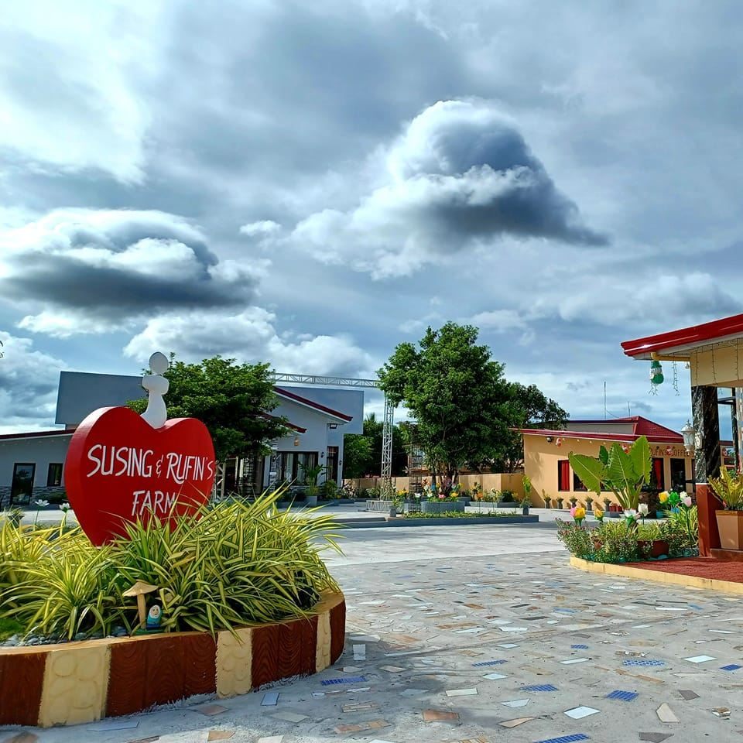*Figure 1. Front view of Susing and Rufin’s Farm Events Place*

Originally established as a private venue for family use, the property evolved in response to increasing interest and demand within the community. Officially launched to the public on December 3, 2022, it now exemplifies the integration of event management and hospitality services at the local business level. A photo of the venue’s front desk area is shown in Figure 2. Front desk of Susing and Rufin’s Farm Events Place, which serves as the main reception for clients.

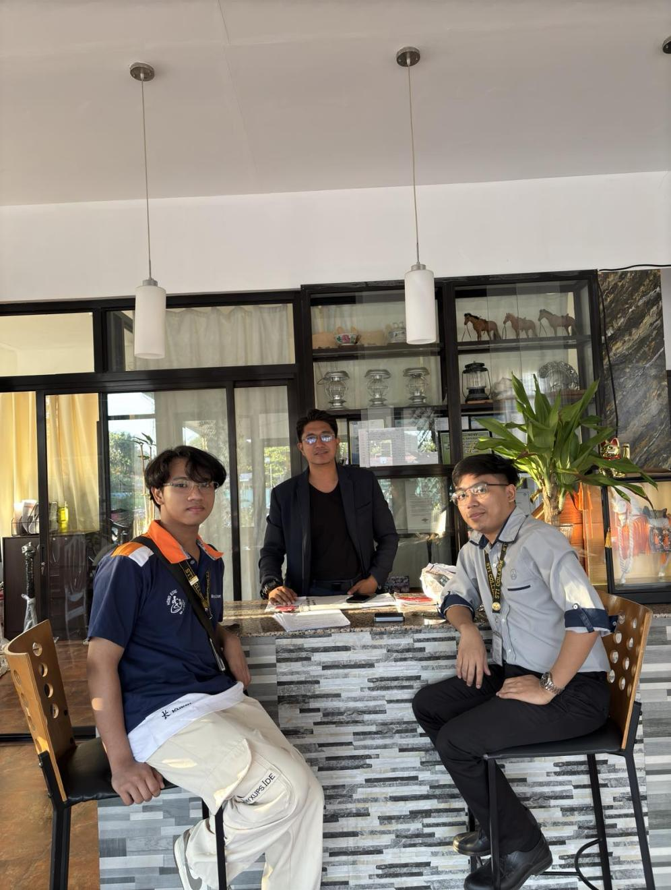

*Figure 2. Front desk of Susing and Rufin’s Farm Events Place*

The business was created to meet a wide range of community needs, offering spaces for various gatherings such as weddings, birthdays, reunions, church functions, and other events while also providing accommodation services. The demand at Susing and Rufin’s Farm Events Place continues to grow, with weekends consistently booked and peak seasons occurring during November and December. Events commonly take place every Friday, Saturday, and Sunday, while weekdays have fewer events, but the venue remains operational. On average, the venue handles between 20 to 40 inquiries and bookings per month, with this number varying depending on the season. These bookings encompass a wide range of events and customer inquiries, contributing to a steady flow of activity throughout the month

The venue includes a variety of event spaces: a Grand Pavilion with a 200-guest capacity, a Mini Pavilion with a 100-guest capacity, three (3) Floating Pavilions each accommodating 30–40 guests, and a Pool Area suitable for up to 60 attendees. These are available through flexible package options. In addition to venue packages, catering services are also offered with multiple package options to suit different event needs and budgets. A photo of the catering packages is shown in Figure 3. Catering Packages, which illustrate the food and menu options offered.

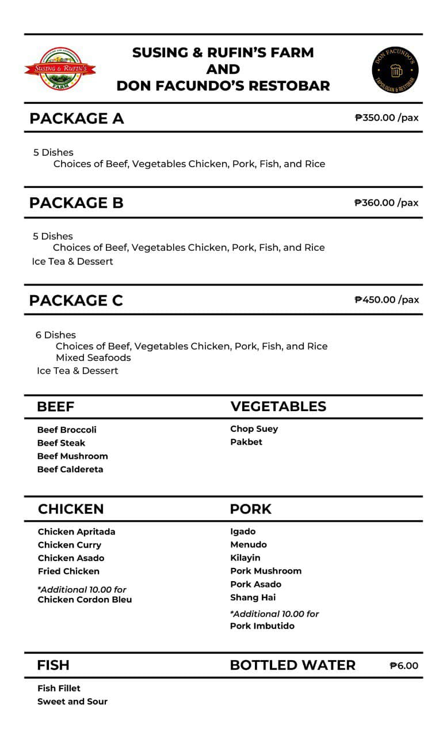

*Figure 3. Catering Packages*

For the Grand Pavilion, three packages are offered: the “Full Blast” package, which includes venue, food, and decoration for ₱65,000. A photo of the Grand Pavilion’s Full Blast package is shown in Figure 4. Full Blast Package for Grand Pavilion.

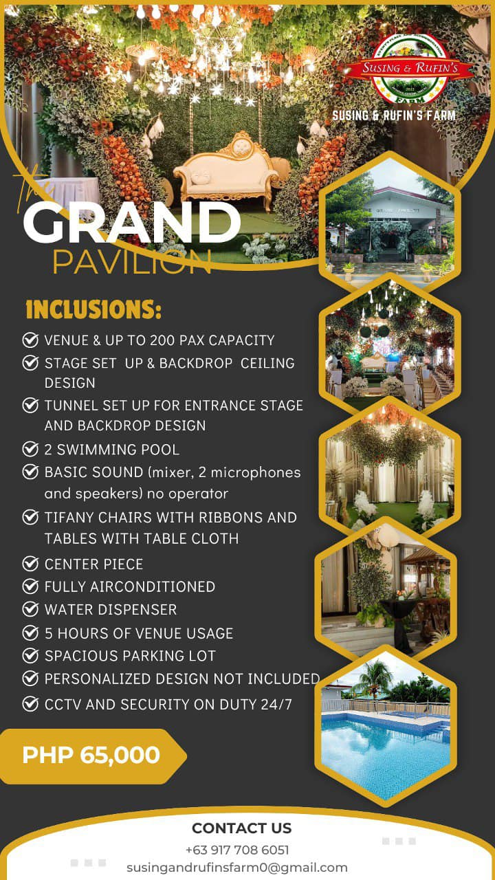

*Figure 4. Full Blast Package for Grand Pavilion*

A Regular package without styling for ₱45,000 and an Empty venue-only option at ₱35,000. A photo of the Grand Pavilion’s Regular package is shown in Figure 5. Regular Package for Grand Pavilion.

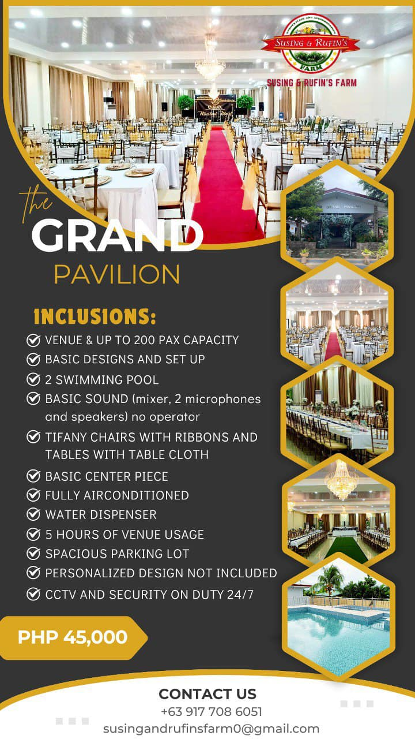

*Figure 5. Regular Package for Grand Pavilion*

The Mini Pavilion, which is popular for more budget-conscious events, has a fixed price of ₱25,000 which includes styling, chairs, and tables—removing these items does not lower the cost. A photo of the Mini Pavilion package is shown in Figure 6. Mini Pavilion Package.

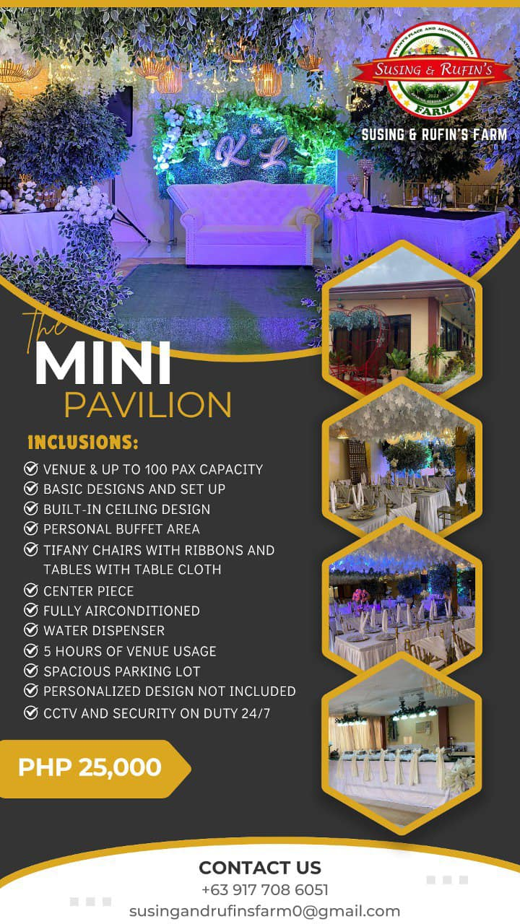

*Figure 6. Mini Pavilion Package*

The Floating Pavilions are set in the middle of a pond and vary in capacity: 30 to 40 pax. A photo of Floating Pavilion package is shown in Figure 7. Floating Pavilion Package.

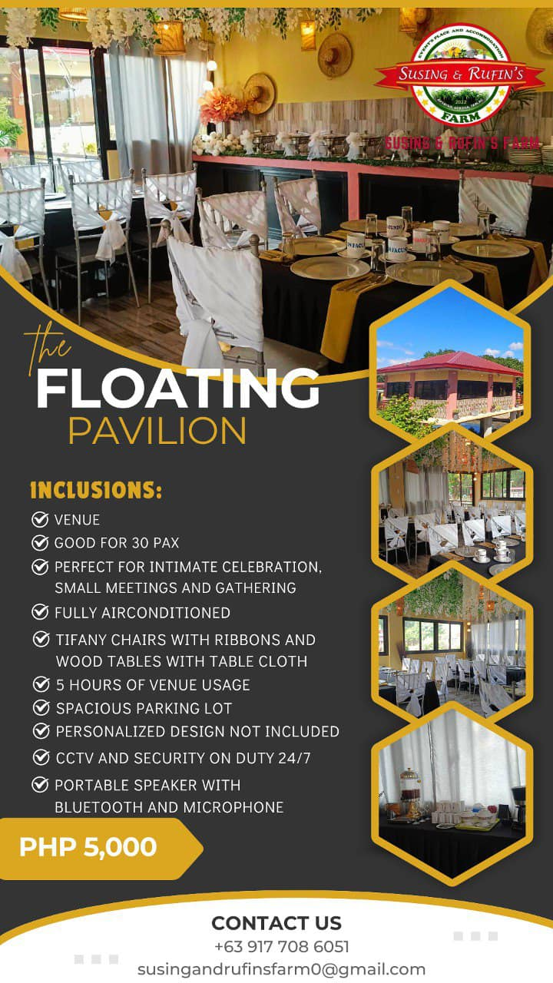

*Figure 7. Floating Pavilion Package*

While the Pool Area is enclosed with a roof and accommodates up to 60 people. A photo of inclusion in Pool Area is shown in Figure 8. Pool Area Inclusions.



*Figure 8. Pool Area Inclusions*

Renowned for its capacity to host multiple events simultaneously— especially on weekends — the business requires careful coordination of bookings, staff, and resources. As such, the integration of digital solutions is essential to efficiently manage the complex logistics of high-volume, multi-event operations while ensuring a high level of customer satisfaction.

Client Inquiry and Booking Procedure—Susing and Rufin’s Farm Events Place:

* Clients may inquire and book through three channels:
* Walk-ins
* Social Media messaging through Facebook Messenger.
* Calls and SMS
* On-Site Meeting and Finalization
* A face-to-face meeting with staff follows to finalize the booking details.
* Staff conduct a venue walk-through with the client.
* Package offerings, inclusions, and customization options are discussed on-site.
* Booking Confirmation
* All agreements are documented using printed contracts, which include the event date, services availed, and payment terms, while the information is manually recorded in handwritten form. A photo of the contract is shown in Figure 9. Susing and Rufin’s Farm Events Place Checklist and Contract
* Upon contract signing, clients receive both a copy of the signed contract and a receipt of their down payment, ensuring proper documentation for both parties.

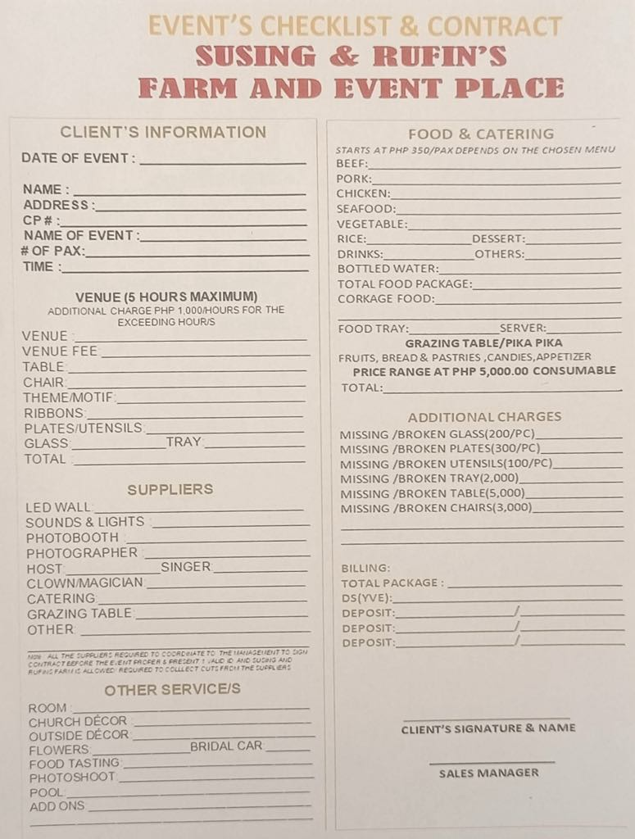

*Figure 9. Susing and Rufin’s Farm Events Place Checklist and Contract*



* Payment
* Clients pay the required deposit to secure booking.
* Payment can be made in full or in installments.
* The remaining balance must be fully settled before the event.
* Methods of payment:
* Cash
* Bank Transfer
* The official receipt is issued for every transaction. A photo of the official receipt is shown in Figure 10. Official Receipt of Susing and Rufin’s Farm Events Place.

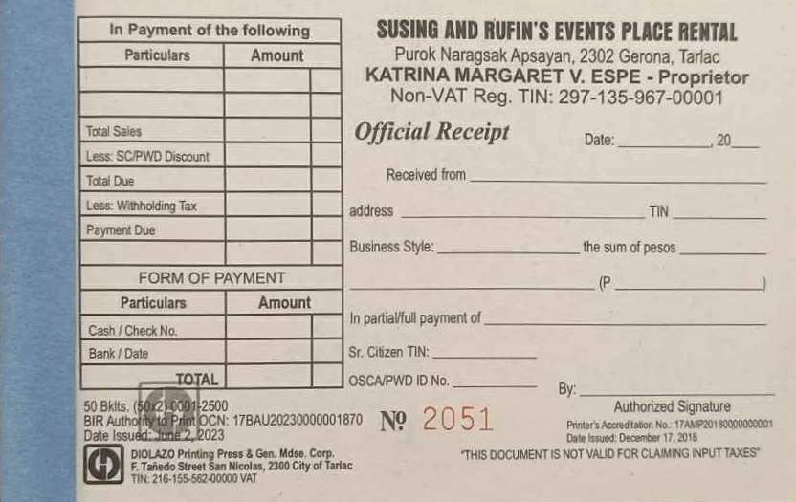  
*Figure 10. Official Receipt of Susing and Rufin’s Farm Events Place*

The contracts are stored in folders for each client, containing all their documents such as copies of receipts, request letters, and notes for proper documentation. A desk calendar is used to track reservations without having to dig through the contracts, with event dates, client names, and pavilion assignments. A photo of the calendar is shown in Figure 11. Susing and Rufin’s Farm Events Place Calendar for all their bookings

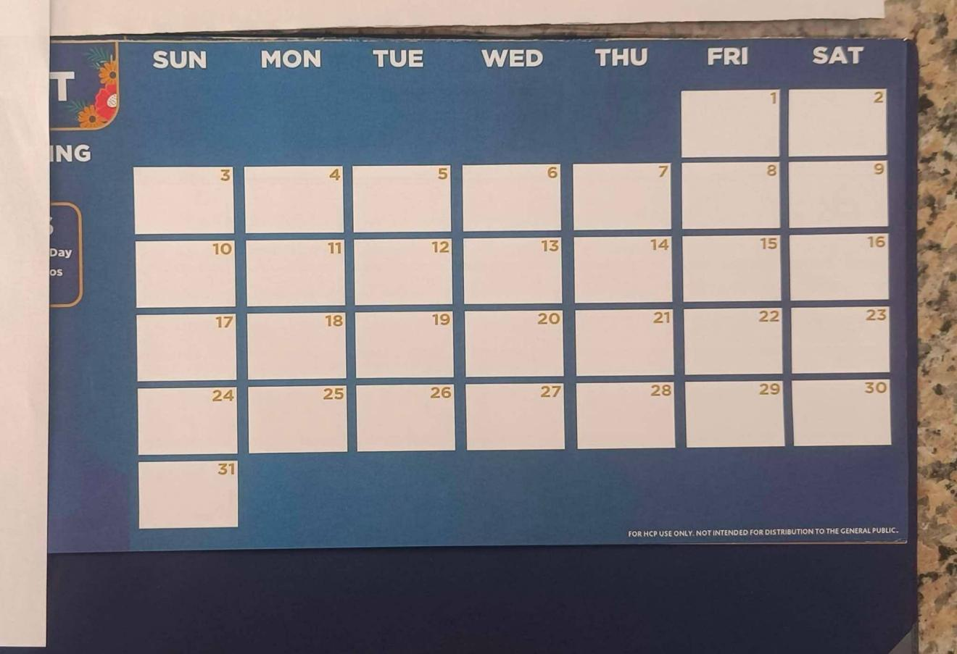

*Figure 11. Susing and Rufin’s Farm Events Place Calendar for all their bookings*

The calendar is used to help prevent scheduling conflicts. Booking summaries are shared in internal group chats to keep the team notified and up to date.

All client records and service and venue arrangements and assignments are written in physical documents. The sales manager consolidates and monitors bookings; the reliance on manual logging for critical operations presents challenges in data retrieval, accuracy, and efficiency, especially during high-demand periods. Nonetheless, the staff ensures each event is personalized and well-prepared. Using a manually coordinated system that has been carefully managed to date, even as they express interest in eventually moving toward a more digitized and accessible booking system.



**Policies of** **Susing and Rufin’s Farm Events Place**

* **Reservation and Scheduling System**
* All bookings are currently recorded by pen-and-paper method—in a centralized, physical calendar, which serves as the central booking reference for the business. This main calendar is maintained onsite and updated regularly by the management and staff to reflect new reservations, changes, and cancellations. The contracts list full event details. Clients who wish to reschedule must choose from available dates.
* The venue maintains a strict policy of allowing only one event per pavilion per day to ensure quality service and avoid scheduling conflicts between events.
* **Double Booking Policy**
* Bookings are managed by the sales manager, and if double bookings occur, priority is given to the client who paid first. Affected clients are offered free venue use or an alternative pavilion.
* **Booking and Cancellation Policy**
* To confirm an event reservation at Susing and Rufin’s Farm Events Place, clients are required to pay a ₱5,000 down payment. This payment serves as both a booking fee and date lock, ensuring that the selected event date is exclusively reserved for the client. All bookings follow a strict first-come, first-served policy.

The ₱5,000 down payment is generally non-refundable. However, in exceptional and valid reasons (such as a death in the family or miscarriage), a refund may be considered at the sole discretion of the owner.

* Date changes are allowed only if the new preferred date is available.
* For remote bookings with down payment submissions, administrative approval is required to ensure all booking details are accurate, payment is confirmed, and reservations are properly recorded in the system.
* For clients who cannot be physically present, the business coordinates through assigned representatives or coordinators who handle venue inspections, planning approvals, and contract signings. Documents are shared via email and signed using secure digital platforms when necessary, ensuring all agreements are clear with terms that protect both parties.
* **Customization and Decorations**
* Basic garden-style decorations are included in packages. Clients requesting personalized themes must supply the decoration or coordinate with recommended stylists. Other themes (e.g., safari) are handled by third-party decorators.
* **Business Tie-Ups**
* Trusted third-party partners (e.g., makeup artists, stylists) are endorsed. The business may receive a cut or referral fee when working with external vendors not personally connected to the owner.
* **Discounts**
* Discounts are given to senior citizens and Persons with Disabilities (PWDs), provided they present valid IDs or supporting documents. Repeat customers may also receive discounts, subject to the owner’s approval. These discounts typically apply to venue fees and not to food packages.
* **Contract Signing & Final Package Agreement**
* Once booking and customization details are agreed upon, both parties sign a contract outlining the full scope of services. This protects the client and the business. Contracts include all event details, selected packages, payment schedules, and additional services.
* **Payment Method and Terms**
* Payments can be made via cash or bank transfer through Philippine National Bank (PNB), providing options for domestic and overseas clients. Installment payments are allowed; however, the remaining balance must be settled at least one day before the event. Any request for payment extensions after the event requires approval from the management. Regardless of the channel used to book, all clients will receive an official receipt.
* No penalties are imposed for payments made one day after the event.
* **Catering Service Policy**
* Clients can choose between buffet or plated service, and menus are customizable beyond the standard package for an additional cost. Catering packages include basic event essentials such as staff, tables, chairs, and utensils. A non-refundable down payment is required to confirm bookings, and discounts may be given when both catering and venue are booked together. Dietary restrictions and allergies are accommodated, and no extra fees are charged for rush or last-minute bookings if feasible.
* **Catering Guidelines**
* Catering is provided by Susing & Rufin’s Farm Events Place, with the menu aligned to the packages the client avails. Clients are allowed to bring their own food, and Susing & Rufin’s Farm Events Place will provide food warmers and utensils. If clients use venue utensils, they must hire venue waiters as well. Clients are also given the opportunity to attend a food tasting session prior to their event to ensure the menu meets their preferences and expectations. Food complaints are taken seriously, and management may offer replacements, refunds, or freebies if quality issues arise.
* No corkage fees are charged for clients bringing outside food.
* Extra tables and chairs can be requested during events to accommodate additional guests.
* Food-related changes, guest count adjustments, and allergy accommodations can be requested up to one week before the event.
* **Event Changes and Add-ons Requests**
* Last-minute client requests are honored when feasible but may result in additional fees. Extra guests beyond the agreed headcount are charged unless waived by management.
* **Refunds and Price Adjustments**
* Refunds for canceled events depend on the reason and timing. If issues arise (e.g., incorrect food), management may offer compensation such as fee

waivers, freebies, or adjusted pricing.

* **Venue and Resource Use Policy**
* Each pavilion is equipped with its own chairs, tables, and utensils. Utensils rented from the venue must be used with their waiters to ensure care. If utensils are lost or broken by clients, they are charged accordingly. Staff are

liable for missing items due to negligence.

* **Safety, Cleanliness, and Maintenance**
* Inventory checks are done before and after events. Damaged or missing items are recorded and replaced. Events are prepared the day before to ensure everything is in good condition.
* **Customer Feedback and Service Commitment**
* Client feedback is gathered via social media, word-of-mouth, and direct comments. All issues are addressed professionally, even during events.

At Susing and Rufin’s Farm Events Place—the team employs highly personalized booking and record-keeping, dedicating significant time to addressing inquiries, meticulously documenting event details, and reviewing contracts to ensure each event is tailored to the unique needs of every client.

However, there is an opportunity to further enhance efficiency while maintaining this personalized service. Transitioning to a digital booking system would centralize availability, improve the scheduling process, and provide real-time updates, which would help the booking process to effectively attain accurate information. This shift would allow the owner, managers, and front desk staff to focus even more on providing exceptional client experiences, as they would spend less time on administrative tasks such as handwritten logging of bookings, cross-checking calendar entries, confirming availability, and tracking payments. In turn, the administration will have more time to focus on event planning based on client preferences, conducting thorough venue walkthroughs, and ensuring food service quality.

The challenges faced by Susing and Rufin’s Farm Events Place underscore the need for a more efficient and integrated booking solution. A browser-based system could help to solve these issues by digitizing the process, centralizing data, and reducing errors through automated data entry and validation. This could enhance accuracy, minimize disruptions, and optimize overall operations.

Equipped with the knowledge and skills in web development, database management, and system analysis to design and implement a tailored browser-based booking system. This proposed system aims to analyze the current manual process and create a platform that meets the specific needs of the venue. It is designed to provide a more organized, efficient, and user-friendly way to handle reservations and bookings, this proposed system will analyze the current manual process and create a platform that meets the specific needs of the venue.

The proposed system will centralize venue availability, manage reservations from multiple channels (walk-ins, phone calls, online inquiries), and organize event details in one digital space. The system will simplify operations, reduce human errors, and improve overall efficiency. This project offers a targeted technological solution to the current manual booking system at Susing and Rufin’s Farm Events Place.

**Purpose and Description of the Project**

The purpose of this capstone project is to develop a browser-based booking system specifically designed for Susing and Rufin’s Farm Events Place. The main function of the system is to help the business manage bookings. This will allow the staff to view venue availability, manage client reservations, track payments, and access event details—all in one place and in real time.

This project is specifically tailored to the needs and processes of Susing and Rufin’s Farm Events Place. Unlike general booking systems, this solution is based on how the business currently operates, with how the system fits their policies, such as allowing the modification of one’s contract, cancellation, refunds, providing the ability to accept changes and client requests anytime the management approves, and having the option to give discounts, ensuring that it meets their exact requirements. The system will also allow for better coordination among staff members and provide more accurate records of reservations, payments, and client preferences.

The proposed system will support tasks such as recording event packages, tracking payment status, and storing event-related documents. It is intended to assist staff in organizing client details, schedules, and bookings in a format that is easy to access when needed. Finally, the project is highly relevant not only to the business but also to the community it serves. Events are a big part of people’s lives and helping Susing and Rufin’s Farm Events Place deliver better service through a system that benefits both the owner and staff. This system supports the growth of a local business while showcasing how technology can make traditional manual operations such as the scheduling and creation of bookings, record keeping, limited monitoring access of schedules and booking details, tracking and managing of transactions, and the storage and archiving of documents more effective and organized.

**Objectives of the Study**



**General Objective**

The primary objective of this capstone project is to design and develop a user-friendly and efficient browser-based booking system for Susing and Rufin’s Farm Events Place. This system is intended to support and enhance the existing booking management process by providing designated staff members, particularly those responsible for managing bookings, with a reliable digital tool to carry out their tasks more effectively. It aims to enhance their booking processes, minimize errors and improve the overall experience for designated staff members.

**Specific Objectives**

* **To design and develop a module that manages user accounts.**

This module will implement secure access based on user-level permission, allowing managers, owner, and front desk staff of Susing and Rufin’s Farm Events Place to use the system according to their roles. It will ensure that only authorized personnel can access it, with role-based controls defining their specific permissions within the system, including secure creation, editing, and deactivation of users. This is crucial for maintaining data security and accountability within the booking process.

* **To design and develop a module that enables selecting and customizing event packages.**

This module will allow staff to select and customize event packages based on the client’s specific needs, including catering options, decoration themes, and additional services when creating bookings. It will enhance client satisfaction by enabling staff to provide tailored solutions based on client preferences.

* **To design and develop client profile modules.**

This module allows the staff members to create client profiles where they can track client information, record the client's basic information, bookings, payment history, documents (e.g., contracts, receipts, and IDs), and any applicable discounts. It also enables staff to access client booking and record history easily, supporting more efficient management. The goal is to enable staff to efficiently manage and access comprehensive client information, booking records, and payment history in one centralized module for better client service and operational efficiency.

* **To design and develop a module that will track inventory of catering equipment.**

This module will track inventory, such as chairs, tables, utensils, plates, and catering equipment. It will enable staff to check in and check out resources, manage availability, and ensure that no items are missing or broken. If one of the resources (e.g., chairs, tables, utensils, plates, and other catering supplies) came back broken or missing after an event, it will be noted in the module as a report. The purpose of this module is to efficiently track and manage the availability, usage, and condition of catering equipment to ensure accountability and prevent loss or damage.

* **To design and develop a module that handles billing transactions.**

This module will digitize the current payment tracking process by creating a system that records all payment transactions related to bookings. It will track the required down payments, manage payment installments, and monitor final payments due before events. The system will generate reports, maintain payment histories, and provide notifications for upcoming payment deadlines. This will optimize financial record-keeping and provide transparency for both staff and clients regarding payment status. The module is important for ensuring financial accountability and improving the efficiency of the venue's payment processes.

* **To design and develop a module that will generate reports.**

This module will provide key reports on bookings, revenue, and event trends, helping management make data-driven decisions. it will offer a breakdown of event type distribution, showing which events (e.g., weddings, conferences, parties) are most frequently booked.

**Scope and Limitation**

**Scope**

**Log In page**

The user will enter their employee number and their password, and it will continue to the dashboard depending on the account user-level access.

**System-Wide Features (Shared Across All Roles)**

These features are accessible to all authorized users based on their role permissions:

**Managers Access Management**

**Secure User Account Management**

Creation of managers and front desk accounts with the necessary credentials and privileges, as well as the deletion and modification of user accounts.

**Login Status**

Display which office employees are currently logged into the system.

**User Activity Logging**

Tracks and logs user activities within the system, ensuring full transparency. This includes actions like user creation, modification, and cancellation of bookings, with timestamps and user identification. This log provides accountability for every action taken within the system.

**Booking Access**

All authorized users can access booking functionalities based on their role permissions:

**Creation of Bookings**

Allows the managers to create bookings. When clicking the "Add Booking" button, filling out a form with customer information, event details, and booking requirements to create a new reservation in the system.

**Modification**

Allows the managers to modify created bookings in the

system and automatically recording the user activity.

**Cancellation**

Allows the managers to cancel bookings and automatically record the user activity.

**Front Desk Staff Access Management**

**Booking Access**

**Creation of Bookings**

Allows the front desk to create bookings. When clicking the "Add Booking" button, fill out a form with customer information, event details, and booking requirements to create a new reservation in the system.

**Modification**

Allows the front desk to modify created bookings in the

system and automatically recording the user activity.

**Cancellation**

Allows the front desk to cancel bookings and automatically record the user activity.

**Owner Management Module**

**Secure User Account Management**

Creation of manager and front desk accounts with the necessary credentials and privileges and the deletion of user accounts.

**Login Status**

Display which office employees are currently logged into the system.

**Booking Access**

**Creation of Bookings**

Allows the owner to create bookings. When clicking the "Add Booking" button, filling out a form with customer information, event details, and booking requirements to create a new reservation in the system.

**Modification**

Allows the owner to modify created bookings in the

system and automatically recording the user activity.

**Cancellation**

Allows the owner to cancel bookings and automatically record the user activity.

**User Activity Logging**

Tracks and logs user activities within the system, ensuring full transparency. This includes actions like user creation, modification, and cancellation of bookings, with timestamps and user identification. This log provides accountability for every action taken within the system.

**Discount Feature (Exclusive to Owner)**

The owner can

**Booking Management**

**Booking Form Interface**

Provides a user-friendly digital form for office employees to record all necessary booking details.

**Inputting in Client’s Information**

Enables staff to input the client’s information (e.g., name, address, contact number).

**Date and Time Selection**

Enables precise specification of booking start and end dates and times.

**Event Type**

Allows categorization of the booking (e.g., wedding, corporate event, family gathering) through a dropdown or custom input.

**Venue Selection**

Allows staff to choose from a predefined list of available venues (Grand Pavilion, Mini Pavilion, Floating Pavilions, Pool Area) and catering packages.

**Number of Attendees/Guests**

Records the exact number of people the booking is for.

**Catering**

Can allow staff to tailor event services to each client's preferences from menu selection, enhancing client satisfaction.

**Third Party Services (Basic Information Only)**

Enables staff to input third-party service provider information for reference purposes, The system does not manage third-party contracts, payments, or service agreements.

**Special Requests**

Captures client’s specific needs or preferences.

**Confirmation of Booking**

Officially records the booking in the system

**Real-time Availability Checker**

Automatically verifies if the selected venue is available during the requested dates and times.

**Prevents Double-Booking**

Ensures that the system will not allow overlapping bookings for the same resource.

**Detects Overlapping Bookings and Displays Warnings**

Alerts staff if a booking attempt conflicts with an existing reservation

**Booking Status Tracker**

Enables staff to monitor the current stage of each booking

**Track Status**

Provides clearly defined status labels such as *Pending* (initial request received), *Confirmed* (reservation secured), *Cancelled* (booking voided), and *Completed* (event finished).

**Calendar Coordination**

Seamlessly connects the booking form and saved bookings with the availability calendar.

**Automatically updates with the Availability Calendar**

Ensures that new and modified bookings are immediately reflected in the visual schedule.

**Booking List table**

Presents an overview of all the bookings in a structured, searchable format.

**Searchable and Sortable List**

Allows staff to easily find specific bookings based on various criteria (e.g., event type, client name, date).

**Filtering**

Includes a search and filter function that enables users to filter by venue, date and time, or booking status for more precise results.

**View Booking Details**

Displays key information such as status, date, venue, and client contact.

**Cancel Functionality**

Provides the ability to void or cancel existing booking

**Cancel Bookings with Reason Logging**

Requires staff to provide a reason for cancellation, aiding in record-keeping and analysis.

**Search and filter function for bookings**

**Filters**

Allow staff to narrow down the displayed bookings based on specific criteria.

**Filter by Venue, Date and time, or Booking Status**

Enables focused views of the schedule.

**Catering Inventory Management**

**Master Inventory List**

A digital list of all items, with key details like name, quantity, and category

**Resource Check-In/Check-Out**

Allows staff to manage resources (e.g., chairs, tables, utensils) by tracking through a master list when items are taken out for use (checked out) and when they are returned (checked in). This ensures proper inventory management and resource tracking.

**Damage and Missing Reporting**

Staff can report damaged or missing items when checking in resources.

**Financial Management**

**Payment Tracker**

Enables the recording and monitoring of billing transactions related to bookings.

**Enter and Update Payments**

Enables staff to input and track payments.

**View Payment History and Deadlines**

Provides a record of all payments made and any outstanding amounts with due dates.

**Transaction Reference Records**

Records a unique reference number for each booking transaction that can be used for record-keeping and payment tracking.

**Activity Logging**

**User Actions Logs**

The system will track and record users' actions, such as creation, updates, deletions, and access to sensitive data for transparency and security auditing.

**Timestamped Entries**

Each action will be logged with details including user ID, time and date, and specific changes made to ensure traceability.

**Accountability and Oversight**

Logging functions will support accountability by allowing to review and investigate all critical user interactions within the system.

**Limitations**

* **Limited Room Management**

The system only records the number of rooms booked as part of the booking package. It does not manage room reservations, track specific room numbers, room types, or room availability status.

* **Third Party Service Management**

The system does not manage contracts, payments, or service agreements with third-party vendors. Only basic information can be recorded for reference.

* **Non-Tracked Items**

Appliances (e.g., speakers, air conditioners, microphones) and decorations are excluded from the scope of inventory management.

* **Exclusion of Client Expenses for Third Party**

Only internal booking-related payments are recorded. Expenses incurred by clients outside the system such as payments to third-party vendors, transportation, or external rentals are not included.

* **Room Count Tracking**

Records the number of rooms included in booking packages for reference purposes only. Does not manage room assignments or detailed accommodation logistics.

* **No Official Receipt Generation**

The system does not generate official receipts for transactions. Instead, only a reference number will be recorded and provided as proof of transaction.

**Review of Related Literature/Studies/Systems**

This review of related literature and systems explores various digital platforms focused on event booking and management. The purpose of the review is to gain insights into the design, functionality, and limitations of existing systems—both local and international—that can inform the development of a browser-based event system for Susing and Rufin’s Farm Events Place. The literature is categorized into foreign and local sources, critically examined in terms of features, technologies, and relevance to the proposed project. Through this review, the researcher's aim is to identify best practices and gaps to justify and refine the proposed system.

**Foreign**

**Online Event Management System**   
**(Deshpande, Lahori, Sarowar, & Sahu, 2025)**

This study revolves around the exploration of an Online Event Management System (OEMS) as a comprehensive digital solution designed to transform and streamline the entire lifecycle of event planning, execution, and analysis. The study emphasizes how OEMS address the complexities traditionally associated with event management by offering a centralized, user-friendly, and customizable platform. It highlights key features such as event registration, ticketing, attendee engagement tools, vendor coordination, marketing integration, and post-event analytics. Additionally, the study underscores the system’s adaptability to various event formats, including in-person, virtual, and hybrid, which is increasingly important in today’s dynamic and diverse event landscape. OEMS also supports sustainability efforts through digital ticketing and virtual attendance, and it ensures data security and compliance with privacy regulations. By integrating advanced technologies like AI, machine learning, and VR/AR, the system enhances personalization and creates immersive experiences. Overall, the study presents OEMS as a vital tool for modern event organizers seeking to improve efficiency, foster collaboration, and deliver impactful and inclusive event experiences.

This study explores an Online Event Management System (OEMS) that offers a centralized, user-friendly digital platform to manage the full lifecycle of event planning—from registration and ticketing to post-event analytics. Key features include attendee engagement, vendor coordination, and hybrid event support using AI, VR/AR, and machine learning. The system also prioritizes data security and sustainability through virtual attendance options.

The Online Event Management System is a strong model of scalability and technological integration; it is designed for large-scale events the incorporation of immersive technologies and engagement tools provides useful concepts for scalability and user experience design in the proposed system. This showcases similarities with the proposed system in that both focus on streamlining event management processes through digital solutions and emphasize user-friendly interfaces and customization options to enhance user experience. However, the differences lie in the OEMS's incorporation of advanced technologies like AI and VR/AR for enhanced personalization, which may not be a primary focus of the proposed system, and its support for various event formats, while the proposed system is tailored specifically for Susing and Rufin’s Farm Events Place, focusing on physical events.

**Event Management System**   
**(Seelapareddy, 2023)**

This study revolves around the development and functionality of a web-based Event Management System designed to streamline the interaction between administrators, event organizers, and customers. The system allows users to view, book, and manage events taking place in specific localities, with a centralized database maintaining detailed records of all user types and transactions. Built using Java (Spring MVC framework), HTML, CSS, Bootstrap, and MySQL, and deployed on a Tomcat server, the system ensures secure payment processing and data handling. The application features user authentication, role-based access (admin, organizer, customer), personalized event recommendations using Apache Mahout, and feedback mechanisms. Administrators can manage content, event organizers can publish and monitor event bookings, and customers can explore, book, and provide feedback on events. By offering an integrated platform with secure and real-time access, the system enhances communication and engagement between stakeholders in the events industry, promoting a more efficient, user-friendly, and interactive event booking experience.

This web-based system streamlines interactions among administrators, organizers, and clients through features such as role-based access, secure payment processing, and personalized recommendations. Developed using Java, MySQL, and Bootstrap, the platform allows real-time access and feedback collection, fostering interactive user engagement.

The clear modular structure of this system aligns well with the need for user role segregation (admin, client, service provider). Although its tech stack may be complex for a smaller business context, its focus on usability, feedback, and secure access directly informs features of the proposed system.

**A study on allocation rules in booking systems**   
**(Huang, Liu, & Zhang, 2023)**

This study introduces a novel experimental framework to empirically assess and compare different types of efficiency losses in booking systems that allocate scarce goods or services using queue-based, lottery-based, or hybrid mechanisms. The researchers simulate real-world conditions by creating a real-effort lab experiment in which participants must simultaneously manage two tasks: booking an appointment slot and completing a production task (counting white dots in shaded squares). The experiment features two booking stages and incorporates different system designs: solo-track queue, solo-track lottery, and a dual-track hybrid system where participants choose their preferred method. In the queue system, participants invest substantial time in booking, often regardless of their valuation, resulting in high opportunity costs and strategic efficiency loss. Conversely, the lottery system minimizes time costs and enhances productive efficiency, with participants allocating more time to the production task. Contrary to common belief, the study finds that allocative efficiency is not necessarily higher in the queue system, as individuals' queuing behavior is not always aligned with their private valuations due to heterogeneous opportunity costs of time. To address practical concerns about fairness and transparency in pure lotteries, the authors design a dual-track system, which allows participants to choose between queue or lottery mechanisms. Most participants prefer the lottery track, confirming theoretical predictions that this approach leads to better overall efficiency and payoffs, even when both tracks offer equal chances of securing a slot. The dual-track design also improves allocative efficiency by attracting high-valuation participants to the queue track. The study distinguishes itself from previous work on queue systems and matching markets by focusing on quantifying efficiency losses specifically allocative, strategic, and behavioral (productivity-related) losses rather than just queue dynamics or scalper behavior. The findings emphasize that lottery-based systems not only ensure fairness but can outperform queue-based systems in total efficiency, particularly by eliminating the unproductive time cost associated with queuing. This insight has wide-reaching implications for public service allocation, education, event ticketing, and any market where time and fairness are critical factors.

This study compares efficiency in booking mechanisms (queue-based, lottery-based, and hybrid systems) and shows that lottery-based systems can outperform traditional queues by reducing wasted effort and increasing fairness. The experiment found that many users’ booking behaviors are misaligned with their actual valuations due to differing time constraints. This study highlights similarities with the proposed system in its emphasis on the importance of efficiency in booking processes and the potential benefits of insights on fairness and efficiency in booking mechanisms, particularly during high-demand periods. However, the differences are evident in that the study focuses on theoretical frameworks and experimental results regarding booking mechanisms, while the proposed system is a practical application designed for a specific venue, and it does not incorporate lottery-based mechanisms, focusing instead on a first-come, first-served policy.

**Online Event Booking and Management System**   
**(Gigool, Gonsalves, & Correia, 2021)**

This study presents the development and implementation of a web-based event management system designed to streamline and centralize the coordination, booking, and administration of events and their associated services. The system addresses challenges in the current manual or semi-automated approaches by providing an all-in-one platform where users—including individuals and corporations can organize, book, and manage events such as music festivals, conferences, weddings, and college functions. Their proposed system enhances usability, accessibility, and data security through authenticated user access and online booking features. It also offers personalized experiences like event recommendations via newsletters, event sorting by category or booking deadline, and account features for managing profiles, bookings, and ticketing. The system overcomes the limitations of the existing systems, which lack proper user tracking, secure registration, and real-time help, and are prone to data mismanagement and inefficiency. In contrast, their proposed system introduces a modern UI/UX, integration with social media, a dashboard for event browsing, and functionality for viewing and booking both paid and free events. Additionally, organizers can list their services, including sound, decoration, catering, venue booking, and more, thereby enabling users to find all necessary event services in one platform. The study contributes to literature by demonstrating how digitized event management platforms can reduce operational complexities, improve user satisfaction, and increase the efficiency of event planning and execution for both clients and service providers. It also adds value to the field by enabling data-driven service coordination and offering scalable solutions for hotels, clubs, organizations, and event companies.

This web-based system supports booking for multiple event types (e.g., weddings, festivals) and integrates user authentication, category-based sorting, and event dashboards. Organizers can also list services like sound, decoration, and catering, creating a one-stop platform for clients.

This study is directly relevant, showcasing how multi-service coordination can be integrated within a single interface, and it shares similarities with the proposed system in its aim to centralize event management and booking processes, enhancing usability and accessibility while emphasizing user authentication and data security. However, the differences are that the study's system supports a broader range of event types and services, while the proposed system is specifically tailored for Susing and Rufin’s Farm Events Place, which may not be included in the proposed system's initial scope.

**Online Events Booking and Reservation System**   
**(Ganiyu, Egwuche, & Adekunle, 2024)**

This study focuses on the development and implementation of an online event booking management system designed to facilitate seamless interaction between clients and event managers. The system aims to overcome the limitations of traditional offline booking methods, which are often time-consuming, costly, and reliant on physical presence and paperwork. By leveraging web-based technologies such as Bootstrap, MySQL, and PHP, the system provides a flexible and accessible platform that enables remote clients to view event packages, make reservations, and manage bookings efficiently. The literature highlights the critical role of effective event management in coordinating diverse tasks such as budgeting, scheduling, vendor coordination, and logistics, all of which require professional handling to ensure successful events. Moreover, studies emphasize the growing economic and social significance of events; while pointing out the challenges associated with manual booking systems, such as limited availability and administrative burden. Online booking systems are thus recognized for their ability to maximize registration, enhance professionalism, reduce workload, and expand business reach globally. Their proposed system addresses these needs by streamlining the booking process and enabling event managers to better coordinate multiple events with minimal conflicts.

This system is developed to digitize traditional offline bookings using PHP, MySQL, and Bootstrap. It enables remote clients to view and reserve event packages efficiently, addressing the administrative burden of manual methods. The literature also emphasizes the social and economic impact of efficient event coordination.

The approach used here closely matches the project’s core goals: minimizing in-person paperwork and centralizing event coordination. This will improve accessibility in the context.

**Local**

**Evaluating the Event Industry for a Computerized Event Supplier Management System**   
**(Galay & Encarnacion, 2024).**

This study proposes the development of a web-based event supplier management system to address common challenges in coordinating diverse event suppliers. The traditional methods often suffer from fragmented communication, manual data handling, scheduling conflicts, and mismanagement of supplier information, leading to inefficiencies, delays, and budget overruns. The system is designed to simplify coordination among event stakeholders through features such as real-time updates, automated communication, centralized data storage, and a user-friendly interface. The study specifically assesses the needs of event suppliers and professionals in Surigao City, revealing that while communication issues with clients are generally manageable, limitations in venue availability, scheduling, and managing last-minute changes remain significant hurdles. Findings show that 100% of planners emphasize the need for better collaboration among suppliers, and 90% highlight the importance of an accessible booking system. Additionally, 60% believe that real-time synchronization and local customization would enhance operational efficiency. By integrating these insights, their proposed system aims to reduce administrative burdens, minimize miscommunication, and improve supplier coordination, ultimately leading to smoother events and greater client satisfaction. This initiative not only seeks to automate routine supplier tasks but also intends to optimize resource allocation, ensuring a seamless event planning process tailored to local industry dynamics.

Focused on event supplier coordination, this system seeks to eliminate fragmented communication and reduce mismanagement. The study found that 90% of event planners in Surigao City needed real-time synchronization for efficient operations.

This system highlights the importance of backend coordination, which is often overlooked. For Susing and Rufin’s Farm Events Place, this insight supports the inclusion of a module that helps manage catering, decoration, and venue setup through centralized dashboards.

**Events Management Practices and Performance of Selected HEIs in National Capital Region: Inputs for Sustainable Business Generating Projects**   
**(Buenaventura & Soriano, 2023)**

The study explores the events management practices of selected higher education institutions (HEIs) in the National Capital Region (NCR), with a particular focus on how these practices contribute to sustainable business-generating projects. As events have become increasingly important tools for HEIs to engage with students, faculty, stakeholders, and the broader community, effective planning and execution are critical. These events not only foster institutional reputation but also create opportunities for skill development, revenue generation, and stakeholder collaboration. Using a quantitative research method, the study gathered data from HEI administrators and event organizers through surveys to assess current practices and performance. To evaluate these practices comprehensively, the study employed Thompson’s Model, which includes five core dimensions: market, technical, business model, management model, and economic/financial. Each dimension offers insights into how institutions understand market needs, handle logistics and technology, create unique value propositions, structure internal management for event support, and manage financial aspects like budgeting and return on investment. Additionally, the research considered performance indicators such as information gathering, selling activity, relationship building, exhibition image, and extension services. By applying theories related to marketing, stakeholder engagement, branding, and organizational structure, the study provides a framework for assessing the efficiency and impact of events. Overall, the research aims to bridge gaps in knowledge surrounding events management in HEIs and support institutions in optimizing event-related strategies to drive sustainability and institutional growth.

This study examines how events function as sustainable business projects in educational institutions, using Thompson’s Model (market, technical, business model, etc.) to assess practices. The study provides metrics for performance evaluation in event planning.

Although the context is academic the evaluation framework presented here can inform how we measure the effectiveness of the system—particularly in terms of user engagement, financial outcomes, and service reliability.

**Synthesis**

Across both local and foreign studies, one consistent theme is the shift from manual processes to centralized, digital platforms. Systems reviewed commonly offer features such as real-time booking, secure login, user-role management, and service coordination.

While international systems showcase advanced capabilities like hybrid event support and AI-based personalization, these often exceed the needs or capabilities of small to medium-sized venues. Conversely, local studies offer practical, scalable solutions that better fit the needs of Susing and Rufin’s Farm Events Place, though they may lack certain user experience refinements seen in global platforms.

Therefore, the proposed system will blend the efficiency and reliability of local systems with the customer-centric design of foreign platforms, while filling key gaps: supplier coordination and venue-specific scheduling. This project not only enhances digital transformation but also ensures that event planning is efficient, reliable, and tailored to the specific needs of the venue and its clients.

**METHODOLOGY**

**Technical background**

* **Overview of Current Technologies to be Used in the System**

This section outlines the key technologies that will be utilized in the development of the browser-based booking system.

**Code Editor**

* **Visual Studio Code (VSCode)** – A lightweight but powerful code editor developed by Microsoft, offering extensive extensions, debugging support, and integration with Git. It is the primary editor used during development.
* **WebStorm** – A commercial IDE by JetBrains tailored for JavaScript and TypeScript development. It offers advanced code intelligence, refactoring tools, and deep framework integration.

**Programming Languages**

* **TypeScript** – A strongly typed superset of JavaScript that brings static typing, interfaces, and tooling enhancements. It enables developers to write more reliable and scalable code, making it ideal for larger applications.
* **JavaScript** – A dynamic scripting language used to create interactive behavior on websites. It is the core language running both the frontend (React) and backend (Node.js) of the system.

**Database**

* **SQLite** – A lightweight, file-based relational database used during development and testing for its simplicity and zero-configuration setup.
* **PostgreSQL** – A powerful, open-source object-relational database system intended for use in production. It provides strong data integrity, performance, and advanced features like JSON support and full-text search.
* **MySQL** – An alternative relational database option considered for production, known for its speed, reliability, and wide adoption.

**Backend Technologies**

* **Node.js** – A JavaScript runtime built on Chrome's V8 engine, used to run JavaScript on the server side. It enables fast, scalable network applications and serves as the backend engine of the system.
* **Prisma ORM** – A modern Object-Relational Mapping (ORM) tool for Node.js and TypeScript. It simplifies database access, migrations, and data modeling with auto-generated, type-safe queries.
* **Philippines Library** – A specialized library that provides a complete list of Philippine towns, cities, provinces, and regions. It is used to populate and manage location-based data in the system.

**Frontend Technologies**

* **React** – A popular JavaScript library for building dynamic and responsive user interfaces using reusable components. It is the foundation of the system's frontend.
* **Next.js** – A full-stack React framework that enables server-side rendering (SSR), static site generation (SSG), routing, and API handling. It serves as the primary framework used to build the frontend application.
* **Tailwind CSS** – A utility-first CSS framework that allows rapid UI development by composing styles directly in markup. It ensures a consistent and efficient styling approach across the application.
* **Shadcn UI** – A component library built on top of Radix UI and styled with Tailwind CSS. It provides ready-made, accessible UI components with customization capabilities.
* **Radix UI** – A set of low-level, accessible, unstyled UI components for React. It enables developers to build custom-styled interfaces with high accessibility standards.
* **Lucide Icons** – An open-source icon library offering consistent and modern SVG-based icons for use in user interfaces.
* **TanStack Query (React Query)** – A powerful data-fetching and state management library for React. It handles caching, synchronization, and background updates for server state.
* **TanStack Table** – A headless utility for building powerful and customizable data tables and grids in React applications.
* **Zod** – A TypeScript-first schema validation library used to validate form inputs and API responses, ensuring data correctness.
* **React Hook Form** – A lightweight library for managing form state, validation, and submission logic in React.
* **date-fns** – A modern JavaScript date utility library offering fast, modular functions for date manipulation and formatting.

**Development Tools**

* **GitHub** – A cloud-based version control and collaboration platform that allows teams to manage code repositories, track issues, and collaborate efficiently.
* **Figma** – A browser-based UI/UX design and prototyping tool used to design and test the application's user interface before implementation.
* **Prettier** – An opinionated code formatter that enforces consistent coding style and formatting across the codebase.
* **ESLint** – A static code analysis tool for identifying and fixing problematic patterns in JavaScript and TypeScript code, promoting code quality and consistency.

**Calendar of Activities - Capstone project 1**

* **Week 4 of January**

During the fourth week of January, members were assigned to their respective capstone groups, and then the group began searching for a client and developing a proposed title for the project.

* **Week 1 of February**

During the first week of February, proposed titles were reviewed with the adviser, and a final title was selected. Upon confirming that the project would be browser-based, the group began researching suitable tools and technologies for development.

* **Week 2 of February**

During the second week of February, the title was finalized, and the group worked on creating the questionnaires for the interview of the client. This was followed by consultations and revisions to improve the quality and clarity of the questionnaires.

* **Week 3 of February**

During the third week of February, the group conducted their first interview and worked on transcribing the interview for documentation and analysis.

* **Week 4 of February**

During the fourth week of February, the group focused on learning the basics of the software that would be used for developing the browser-based project.

* **Week 1 of March**

During the first week of March, the group spent time practicing and applying their newly acquired skills with the development software.

* **Week 2 of March**

During the second week of March, the group had a consultation to review their Transcript of Interview, followed by a period of revising it based on the feedback received.

* **Week 3 of March**

During the third week of March, the group primarily concentrated on developing the project context and worked on drafting the key sections of Chapter 1, such as the Purpose and Description of the Project, Objectives, and Scope and Limitations of the Study.

* **Week 4 of March**

During the fourth week of March, the group held consultations and revised Chapter 1 of the project.

* **Week 1 of April**

During the first week of April, the group brainstormed and finalized the questionnaires for the second interview, then held a consultation to review the revised Chapter 1 alongside the interview questions for a second interview.

* **Week 2 of April**

During the second week of April, the group conducted the second interview and transcribed it on the same day.

* **Week 3 of April**

During the third week of April, the team began working on Chapter 2, incorporated information from the second interview, revised Chapter 1, and attended a consultation for further guidance.

* **Week 4 of April**

During the fourth week of April, the group revised the objectives section to better align with the client’s needs and continued working on and refining Chapter 2 and participated in another consultation for additional feedback.

* **Week 1 of May**

During the first week of May, the group focused on finalization of the project documentation and began creating the wireframe for the project.

* **Week 2 of May**

During the second week of May, the group focused on finalizing the wireframe for the project.

The Gantt chart presents the summary of activities. Listed are the activities, and opposite them are their duration or periods of execution.

**Gantt Chart of Activities— Capstone Project 1**

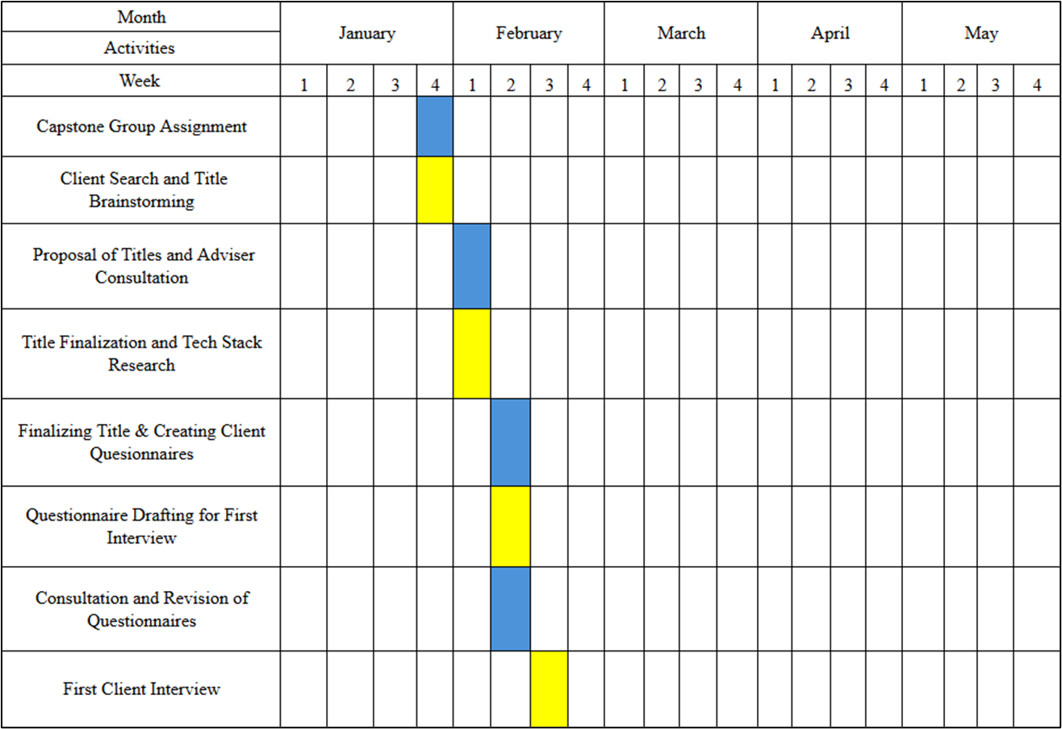

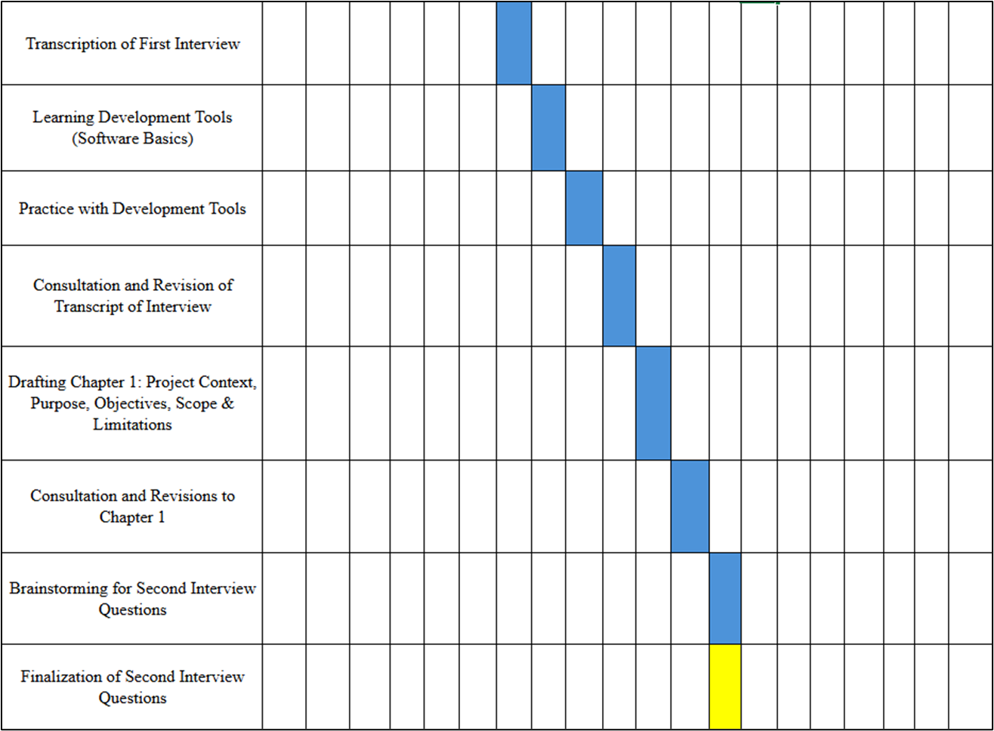

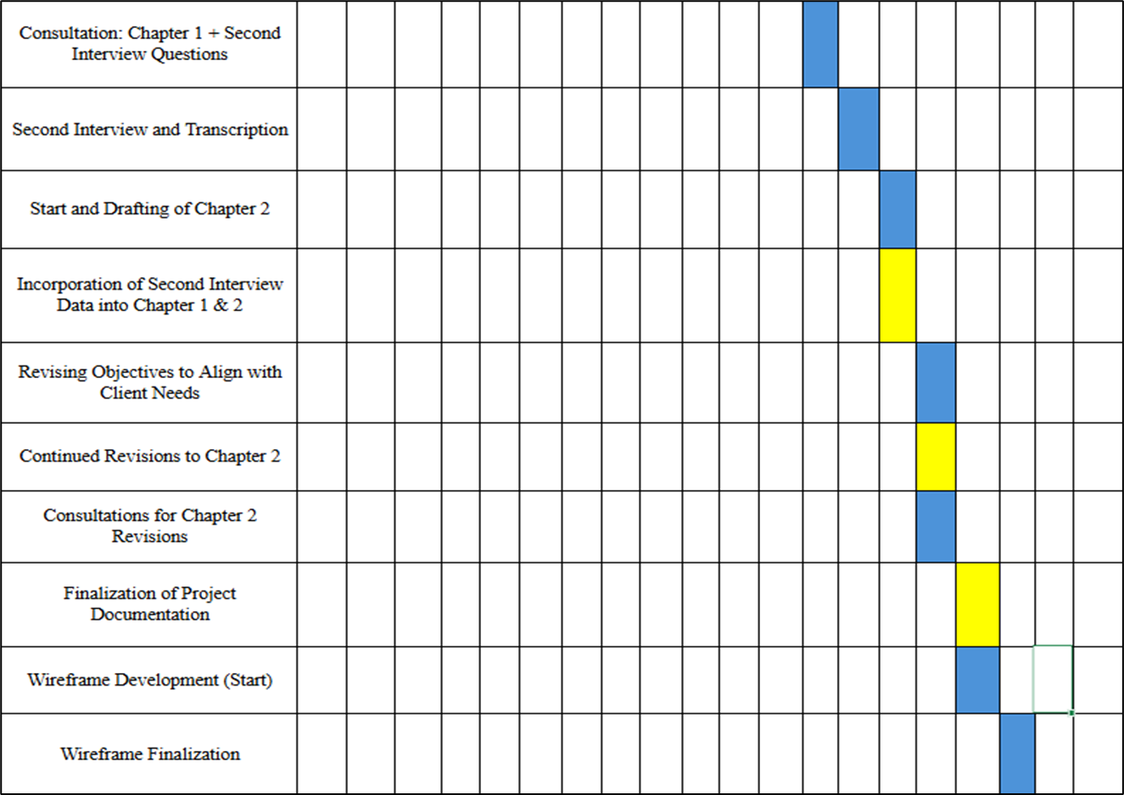

**Resources**

**Hardware**

|  |  |  |
| --- | --- | --- |
| Developer | | |
| **Hardware** | **Minimum Requirements** | **Description** |
| Processor | Intel Core i5 or AMD Ryzen 5 | Modern multi-core processors (4+ cores) are recommended to handle WebStorm and VSCode and running Next.js and its components. |
| Motherboard | Gigabyte GA-H61M, MSI B460M PRO-VDH, ASRock A320M, MSI B450M PRO-VDH MAX | The motherboard should support the required Intel or AMD processors, RAM, and storage configuration. |
| RAM | 8 GB or more | At least 8 GB of RAM to run WebStorm and VSCode smoothly alongside development tools, especially when handling large projects. |
| Storage | HDD or SSD with at least 5 GB free space | SSD storage is recommended for faster file reads/writes, improving IDE responsiveness and application builds. |
| Operating System | Windows 10/11, macOS, or Linux | WebStorm and VSCode is cross-platform, so it supports Windows, macOS, and Linux. |

|  |  |  |
| --- | --- | --- |
| User | | |
| **Hardware** | **Minimum Requirements** | **Description** |
| Processor | Intel Core i3, Core 2 Duo series, AMD's Athlon X2, Ryzen 3 series | Dual-core processors that offer basic multitasking capabilities. Suitable for general computing and light development tasks. |
| Motherboard | Gigabyte GA-H61M, ASRock A320M | Both are budget-friendly motherboards with good compatibility for Intel and AMD processors, respectively. |
| RAM | 4 GB DDR3 | 2-4GB of RAM is usually sufficient for basic browsing and running lightweight applications such as opening and operating the browser application |
| Storage | HDD or SSD (120gb minimum) | Storage capacity depends on the user's needs. SSDs are recommended for faster boot times and system responsiveness. |
| Operating System | Microsoft’s Windows 11 | The latest version of Windows, designed with modern features, enhanced security, and better performance. |

**Software for user developer**

* WebStorm and VSCode - The IDE used to develop the browser-based application itself.
* Internet Browser – To access the listed components, and to view and manage the browser-based application.

## **Requirements Analysis**

The proposed Browser-based Resort Management System should provide the following computing solutions to address the needs of the client, Susing and Rufin’s Farm Events Place:

**Who – The people involved**

* **Owner**

The business owner who has full system access and exclusive privileges such as granting discounts. The Owner can view and manage all aspects of bookings, packages, inventory, and financial reports.

* **Managers**

Staff members who assist in overseeing operations. Managers can create and manage bookings, coordinate events, manage user accounts, and access most system features.

* **Front Desk Staff**

Users who handle day-to-day booking operations. Front Desk staff can create bookings, check availability, update booking information, and assist clients with their reservations.

* **Researcher/Developers**

The team is responsible for designing and developing the browser-based booking system. They will ensure the system meets the client’s needs, is user-friendly, and provides a seamless booking experience for staff.

**• What – Business Activity**

* **Current state**

The current process for handling bookings is mostly manual. Clients inquire through walk-ins, social media (primarily Facebook, Messenger), or phone calls. These inquiries are managed using handwritten contracts and a physical calendar to track bookings. This manual process leads to slow response times, double bookings, and difficulty tracking events, payments, and client information.

* **Issues**

There’s a risk of missed bookings and confusion during peak seasons. Manual entry of data into notebooks and the physical calendar also reduces the overall efficiency and increases the chance of human error.

**Where – The current environment**

* **The venue setting**

The venue accommodates both walk-in and pre-booked clients. The lack of a centralized system means that everything, from checking availability to logging bookings and confirming event details, is handled through physical documentation and informal communication like group chats.

**When – Timing**

* **Peak seasons or weekends**

The resort experiences high demand during weekends and peak seasons. As multiple clients inquire and book during these times, the reliance on manual systems increases the risk of mistakes, including double bookings or conflicting schedules.

**How – The procedures involved**

* **Current procedures**

Bookings and inquiries are handled manually via text messages, calls, or walk-ins. Availability is checked by reviewing a physical calendar or notebook. Once a booking is confirmed, a handwritten contract is created, and payment records are manually logged.

* **Challenges**

The process is time-consuming and requires significant manual effort. Tracking client information, bookings, payments, and contracts manually makes it difficult to generate reports, track payments, or keep up with real-time booking updates.

* **Proposed solution:**

The browser-based system will automate availability checks, store client information digitally, and centralize bookings into one platform. This will eliminate manual logging, improve data accuracy, and enable staff to access real-time information from any device.

**Requirements Documentation**

|  |  |
| --- | --- |
| **Feature** | **Description** |
| Login | Users enter their employee number to log in. Access to dashboards and functionalities depends on account roles (Front Desk Staff, Managers, Owner). |
| Booking Access (Front Desk Staff/Managers/Owner) | Front Desk Staff, Managers, and Owner can create, modify, and cancel bookings. |
| Booking Form Interface | A digital form for recording booking details including client information, dates, event type, venue, guests, catering, Third party, and special requests. |
| Real-Time Availability Check | Checks venue availability to prevent double-booking and warns about overlaps. |
| Booking Status Tracker | Tracks booking status: Pending, Confirmed, Cancelled, Completed. |
| Calendar Coordination | Integrates with the availability calendar for real-time updates of bookings. |
| Booking List Table | A searchable and sortable list of all bookings with detailed information. |
| Cancellation | Allows the front desk to cancel bookings and automatically record the user activity. |
| Search and Filter Bookings | Filters bookings by venue, date, time, or status. |
| User Activity Logging | Logs all user activities with timestamps and user IDs to ensure accountability. |
| Secure User Account Management | Managers and Owners can create/delete user accounts with specific privileges. |
| Login Status | Displays logged-in office employees. |
| Discount Feature (Owner Only) | Only the Owner can grant, and add predefined discounts based on booking or client status. |
| Inventory Tracking | Maintains a master list of items including name, quantity, condition, and category. |
| Resource Check-In/Check-Out | Tracks when items are taken out and returned. |
| Damage and Missing Reporting | Staff can report damaged or missing items. |
| File Maintenance | Managers can create, update, and delete menu items and booking statuses. |
| Billing | Managers manage menu pricing and generate receipts. |
| Financial Management | Tracks payments, balances, payment history, and deadlines. transaction reference numbers for each payment. |
| Reports | Generates summaries of revenue and expenses with options for daily, weekly, and monthly reports. |

**System Navigation Structure (User Role-Based Access)**

**Owner**

**1. Header Section**

* **Add Booking**
* **Manage**

**2. Sidebar Navigation**

* **Home**
* **Bookings**
* **Clients**
* **Event Types**
* **Pavilion**
* **Rooms**
* **Inventory**
* **Employee**
* **Roles**
* **Additional Charges**
* **Discounts**
* **Payment Method**
* **Report**
* **Settings**
* **Notifications Icon**

**Managers**

**1. Header Section**

* **Add Booking**
* **Manage**

**2. Sidebar Navigation**

* **Home**
* **Bookings**
* **Clients**
* **Event Types**
* **Pavilion**
* **Rooms**
* **Inventory**
* **Employee**
* **Roles**
* **Additional Charges**
* **Discounts**
* **Payment Method**
* **Report**
* **Settings**
* **Notifications Icon**

**Front Desk Staff**

**1. Header Section**

* **Add Booking**
* **Manage**

**2. Sidebar Navigation**

* **Home**
* **Bookings**
* **Clients**
* **Event Types**
* **Pavilion**
* **Rooms**
* **Inventory**
* **Additional Charges**
* **Discounts**
* **Payment Method**
* **Settings**
* **Notifications Icon**

**Design of Software, System, Product, and/or Processes**

For the development of the Computerized Booking System for Susing and Rufin’s Farm Events Place, the Agile methodology will be employed. Agile is known for its iterative and incremental approach, allowing for flexibility in responding to changes and frequent feedback. This methodology is particularly suitable for projects that require ongoing adjustments based on user needs and evolving requirements.

Agile software development is structured around repeated cycles of planning, development, testing, and review. This iterative process ensures that the system improves continuously, with each cycle adding new features or refining existing ones. The Agile approach promotes close collaboration, adaptability, and user feedback, all of which contribute to ensuring the system meets user expectations.

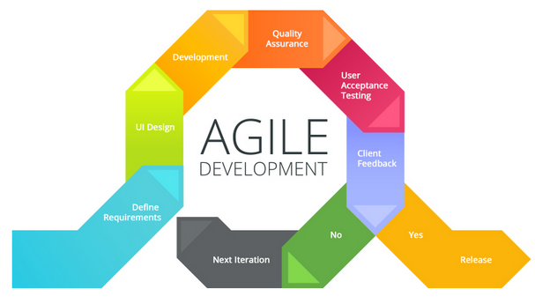*Figure 12. Agile Methodology Model (Telkom University, n.d.).*

#### **Phases of the Agile Development Process**

The Agile development process can be broken down into several key phases, each contributing to the creation and refinement of the booking system:

1. **Concept/Inception**

The initial phase focuses on defining the project goals, understanding the scope of the booking system, and gathering high-level requirements. This stage includes identifying the key functionalities needed for the system, along with a general understanding of the user needs and business objectives.

1. **Iteration/Incremental Planning**

Following the conceptual phase, the system will be developed in a series of sprints, typically lasting 2-4 weeks. During each sprint, specific features are prioritized and developed. Detailed planning is conducted for each sprint to allocate resources and set clear objectives. This planning ensures that the development process remains focused on delivering the most important functionalities first.

1. **Design and Development**

The design and development phase involve creating the system’s architecture and user interface (UI) designs, along with the actual coding of the prioritized features. The system’s UI will be designed to provide an intuitive user experience, and the back-end code will be developed to ensure smooth operation. Since Agile emphasizes flexibility, design changes and improvements can be made throughout the development process.

1. **Testing and Review**

After each sprint, the system will undergo comprehensive testing. This includes functional testing to verify that the system works as expected and user acceptance testing (UAT) to ensure the system meets the needs of its users. Regular reviews by stakeholders will also ensure the system aligns with project goals and user requirements.

1. **Feedback and Refinement**

Feedback from both stakeholders and end users will be collected after each iteration. This feedback will be analyzed to identify areas for improvement, and any necessary changes will be incorporated into the system during the next sprint. The iterative nature of Agile ensures that the system evolves according to user needs and that the final product reflects the most up-to-date requirements.

1. **Deployment**

Once the system has reached a functional state through several iterations, it will be deployed for use. This phase may also include live testing and monitoring to ensure that the system performs well in a real-world environment. Any issues discovered during deployment will be addressed in subsequent iterations.

1. **Maintenance**

Following deployment, the system will enter a maintenance phase, where it will continue to evolve through ongoing feedback and updates. Agile’s iterative process allows for the continued addition of features and the resolution of issues even after the system is live.

By adopting the Agile methodology, the development of the Computerized Booking System for Susing and Rufin’s Farm Events Place will remain adaptable and responsive to user needs. Agile’s iterative and feedback-driven approach ensures that the system can be continuously improved and updated, providing long-term flexibility and user satisfaction.

**REFERENCES**

*View of events management practices and performance of selected HEIs in national capital Region: Inputs for Sustainable business generating Projects*. (n.d.). <https://journal.formosapublisher.org/index.php/eajmr/article/view/8403/9019?fbclid=IwY2xjawKVUbhleHRuA2FlbQIxMABicmlkETFiOGVmRlhtQTFSU3ZwZElFAR5wmKgpJhMUTqFgS7W0jTMfvDE3W8Pb_77_SB_nOeMXOVdJsqbLsSHwKglzrw_aem_8O2bhE1OAP7r76bCHNfwNw>

Deshpande, P. M., Lahori, P. S., Sarowar, C. A., & Sahu, A. S. (2025). *Online event management system*. *International Journal of Research Publication and Reviews*, 6(3), 2378-2383. <https://ijrpr.com/uploads/V6ISSUE3/IJRPR39871.pdf>

Seelapareddy, H. V. (2023). *Event management system* (Capstone Project). Governors State University. <https://opus.govst.edu/cgi/viewcontent.cgi?article=1629&context=capstones>

Buenaventura, J. P. G., & Soriano, E. E. (2024). Events management practices and performance of selected HEIs in the National Capital Region: Inputs for sustainable business generating projects. *East Asian Journal of Multidisciplinary Research, 3*(3), 1389-1474. <https://www.irjet.net/archives/V8/i8/IRJET-V8I8464.pdf>

Ganiyu, M., Egwuche, O. S., & Adekunle, K. O. (2023). Online events booking and reservation system. *ResearchGate*. <https://www.researchgate.net/publication/383272017_Online_Events_Booking_and_Reservation_System>

Huang, L., Liu, T. X., & Zhang, J. (2023). Born to wait? A study on allocation rules in booking systems. *CeDEx Discussion Paper Series, 2023*(04). The University of Nottingham, Centre for Decision Research and Experimental Economics. <https://www.econstor.eu/bitstream/10419/284279/1/cedex-discussion-paper-2023-04.pdf>

Capuno, M. I., Benigno, J. F., Reyes, R. G., & Tojino, K. C. M. W. (2021). iReserve: An online event reservation for Lipa City Cultural with SMS notification. *Journal of Public Affairs and International Relations, 43*(1). <https://www.researchgate.net/publication/360174742_iReserve_An_Online_Event_Reservation_for_Lipa_City_Cultural_with_SMS_Notification>

Galay, J. L., & Encarnacion, R. (2024). Evaluating the event industry for a web-based event supplier management system. *International Journal of Advanced Research in Science, Communication and Technology (IJARSCT), 4*(3). <https://doi.org/10.48175/IJARSCT-18906>

Reyes, F. M., Abdulgani, M. A., Aliuden, M. F. M., Mantikayan, J. M., Guiamalon, T. S., Dilna, S. G., Mohamad, H. A., & Nawal, S. Z. D. (2022). Event management system with SMS notification for Mindanao People’s Care Foundation, Inc. *Psych Educ, 2*(11). <https://doi.org/10.5281/zenodo.6983883>

ResearchFDI. (2024, December 13). How technology is changing the landscape of economic development - *ResearchFDI*. <https://researchfdi.com/how-technology-is-changing-the-landscape-of-economic-development/>

*The Role of Technology in Event Planning: Trends and best practices*. (n.d.). <https://www.theeventcompany.com/news/technology-in-event-planning-trends-and-best-practices>

**Relevant Software.** (2020). *Agile software development lifecycle phases explained*. Relevant Software. Retrieved from <https://relevant.software/blog/agile-software-development-lifecycle-phases-explained/>

**APPENDICES**

**APPENDIX A. RESOURCE PERSONS**

**APPENDIX B. PERSONAL TECHNICAL VITAE**



ROUIE JOHN DIZON

**Address: Buno, Matatalaib Tarlac City**

**Email address: dizonrouie@gmail.com**

**Contact number: 09502953276**

EDUCATIONAL BACKGROUND

Level Year Name of School/Institution

Tertiary 2022-Present STI College Tarlac

Senior High School 2020-2022 AMA College Tarlac

High School 2016-2020 Matatalaib High School

Elementary 2010-2016 Matatalaib Buno Elementary School

PROFESSIONAL OR VOLUNTEER EXPERIENCE

Inclusive Dates Nature of Experience/ Name of Company or  
 Job Title Organization

2019-2020 Red Cross Youth Member Red Cross Youth

TRAININGS, SEMINARS, OR WORKSHOPS ATTENDED

Inclusive Dates Title of Training, Seminar, or Workshop

2018-2019 Student Leadership Training



JOSHUA JETRO M. DAMASO

**Address: Poblacion #1 Gerona, Tarlac**

**Email address: jetropapa@gmail.com**

**Contact number: 09157579017**

EDUCATIONAL BACKGROUND

Level Year Name of School/Institution

Tertiary 2022-Present STI College Tarlac

Tertiary 2020-2021 Holy Angels University

Senior High School 2018-2019 College of the Holy Spirit   
 Tarlac

High School 2014-2018 College of the Holy Spirit  
 Tarlac

Elementary 2008-2014 College of the Holy Spirit  
 Tarlac

PROFESSIONAL OR VOLUNTEER EXPERIENCE

Inclusive Dates Nature of Experience/ Name of Company or  
 Job Title Organization

2018-2020 Freelance Events Photo Freelance  
 & Videographer

2019 Work Immersion One FM Tarlac



CHRISTINE JOY C. BAGAYAS

**Sta. Maria, Camiling, Tarlac**

**yxnbgys@gmail.com**

**09152692924**

EDUCATIONAL BACKGROUND

Level Year Name of School/Institution

Tertiary 2022-Present STI College Tarlac

Senior High School 2020-2022 Glori Dei Montessori College

High School 2016-2020 Santa Ignacia Catholic School of Tarlac

Elementary 2010-2016 Meri Life Learning Academy

PROFESSIONAL OR VOLUNTEER EXPERIENCE

Inclusive Dates Nature of Experience/ Name of Company or  
 Job Title Organization

2022 Work Immersion Glori Dei Montessori College

2019 Organized an Earthquake Santa Ignacia Catholic Drill and First Aid Seminar School of Tarlac



RENIEL A. DULDULAO

**Address: Balite, Pura, Tarlac**

**Email address: duldulaoreniel@gmail.com**

**Contact number: 09075653294**

EDUCATIONAL BACKGROUND

Level Year Name of School/Institution

Tertiary 2022-Present STI College Tarlac

Senior High School 2020-2022 St. Rose Catholic School

High School 2016-2020 St. Rose Catholic School

Elementary 2010-2016 Dapdap Elementary School