1. Why do you think EE’s should know trig? Explain and expand your answer.

Trig is useful for understanding circuits as it helps with bode plots and frequency response graphs. Also learning trig helps with problem solving skills and allows for better understanding of the world.

1. Without using your calculators or your cell phones, or any information sheet do the following

Use the identities to solve each case. Need to show your work clearly

**sin(a+b)=sin(a)cos(b)+cos(a)sin(b) and cos(a+b)=cos(a)cos(b)-sin(a)sin(b)**

You need to show your detailed work, not just the answer….Please note

sin()

Sin(pi) = 0

Sin(pi/2) = 1

cos(pi/2) = 0

cos(pi) = -1

0 + -1(1)

sin()

sin(-pi/2) = -1

cos(-pi/2) = 0

cos(pi/4) = sin(pi/4) = sqr(2)/2

-1(sqr(2)/2) + 0 (sqr(2)/2)

cos(

cos 90 = 0

cos -135 = -sqrt(2)/2

sin 90 = 1

sin -135 = -sqrt(2)/2

0 (-sqrt(2)/2) - (-sqrt(2)/2)(1)

cos()

cos pi = -1

cos -5pi/2 =0

sin pi = 0

sin -5pi/2 = 0

0

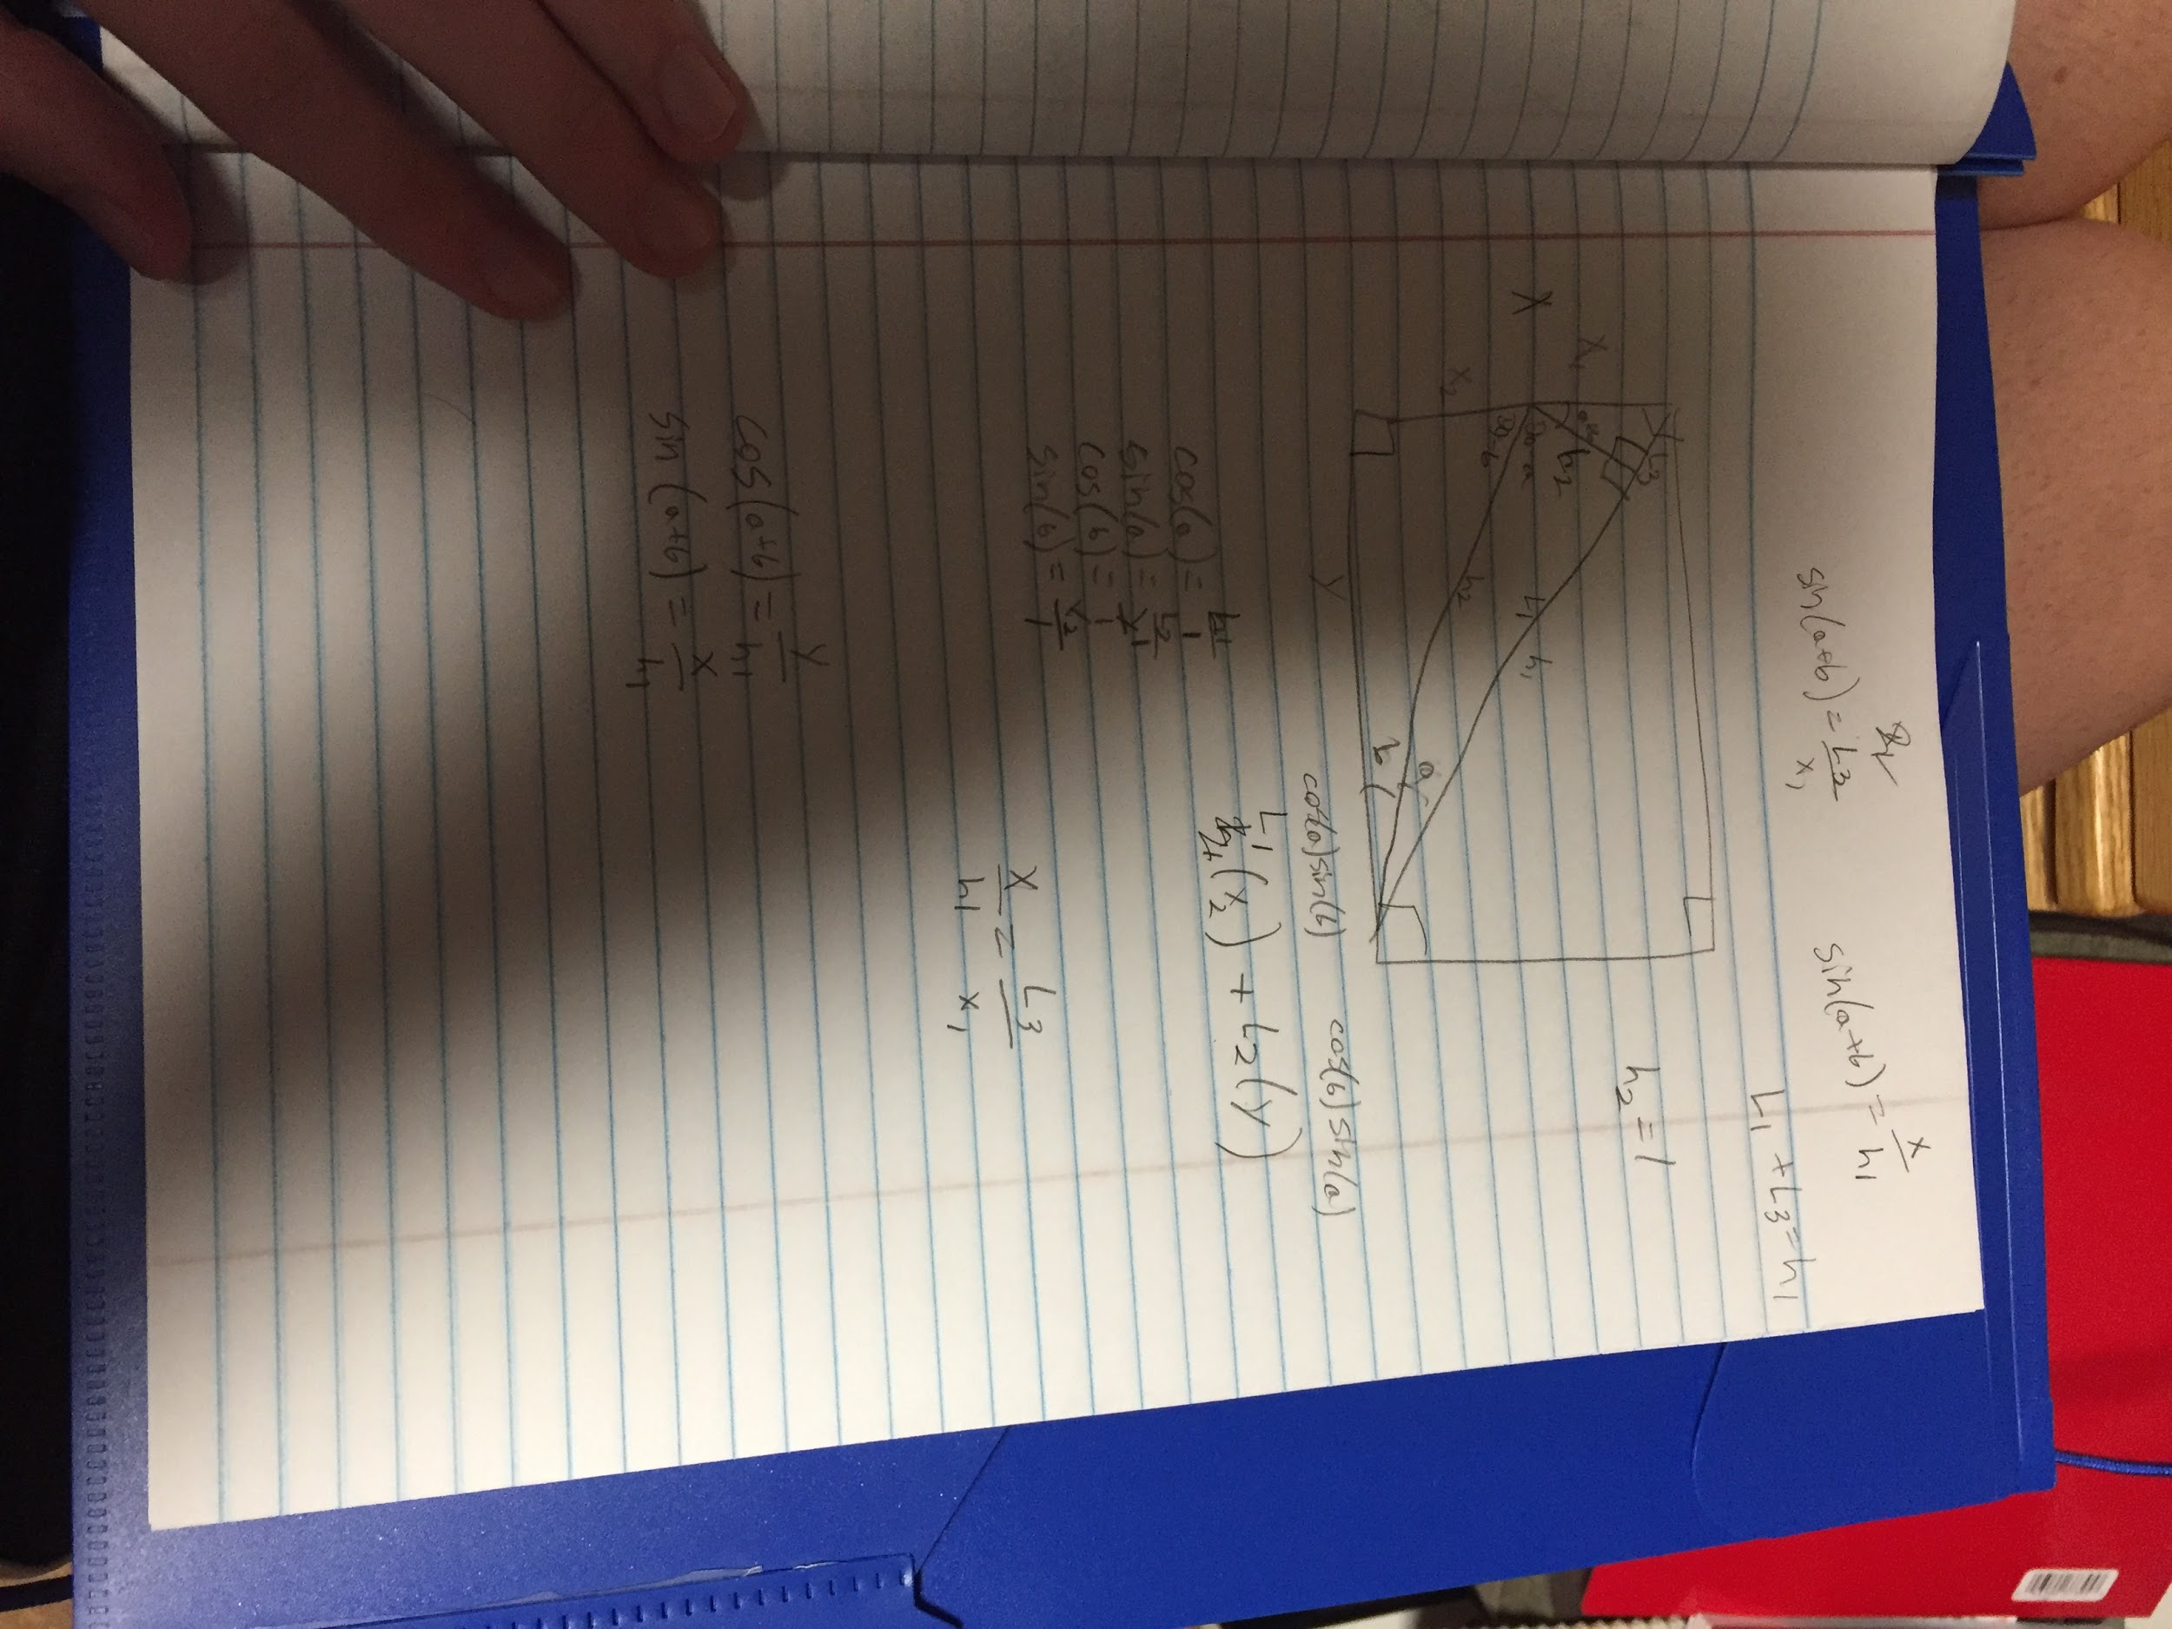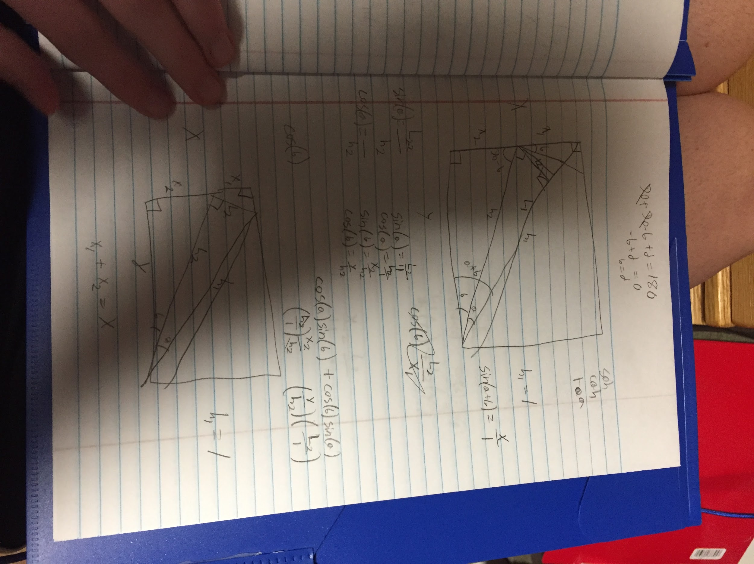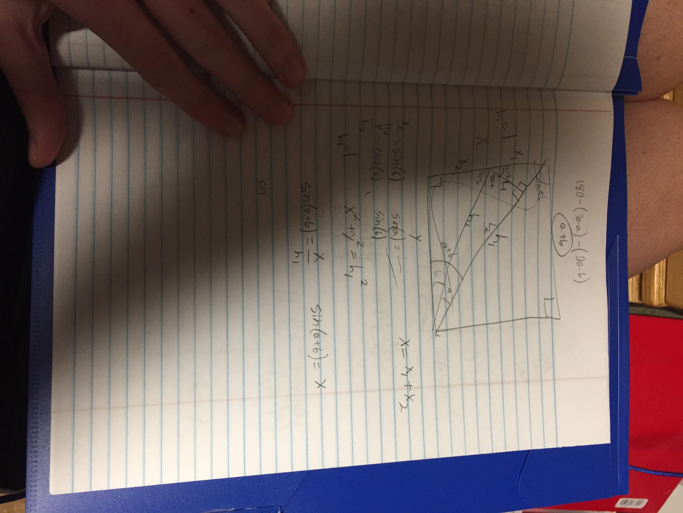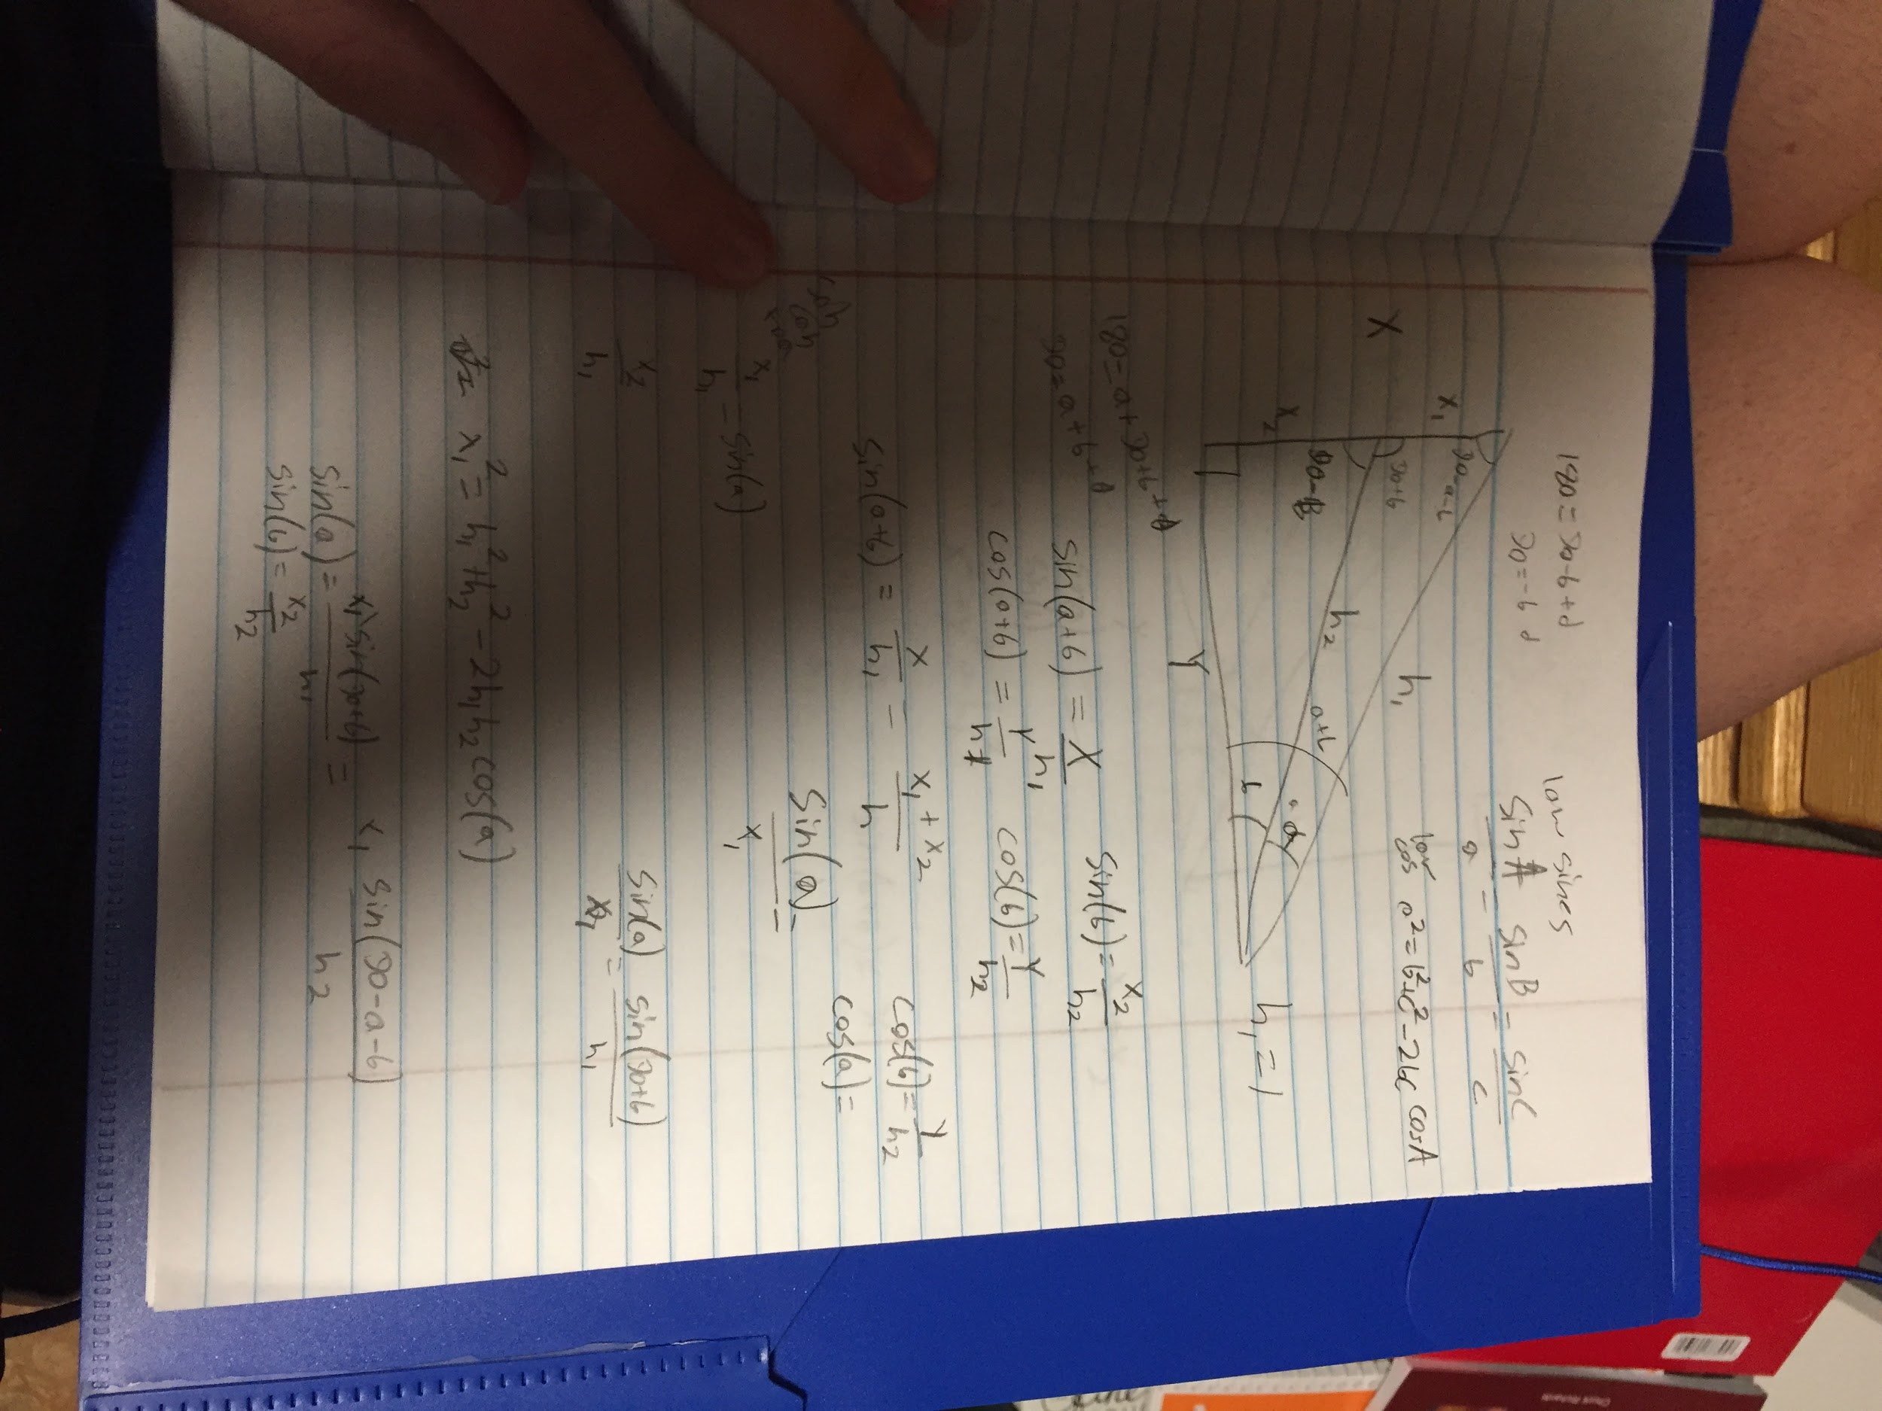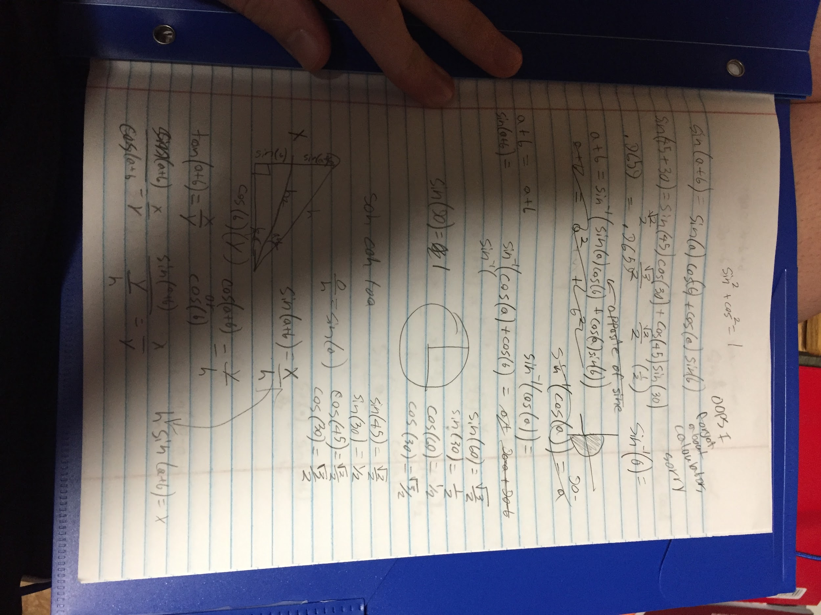

I sort of misunderstood the question because google would not load the equations. I tried finding the proof instead.

1. **Think, do, and explain:** If John finishes a job in 30 minutes, and Stacy finishes the same in 20, and Jack doe it in 60minutes. How long would they take if they work together? Show your work, clearly

10 minutes

1/20 t + 1/30 t + 1/60 t = 1

I guess if it is a linear job then stacey works 1 job /20 min and so on and so forth with everyone else. They only do one job so it adds to one.