
FACULTY OF ARTIFICIAL INTELLIGENCE AND ENGINEERING

Trimester October/November 2025 (Term 2530)

ARR6153 Mobile Robots and Drones

Project Report
Autonomous Differential Drive Wheeled Robot

Student Name: JET SAW JUN JIE
Student ID: 1231303401
Programme: B.Sc. (Hons.) Intelligent Robotics
1. Introduction
Wheeled mobile robots represent one of the most prevalent categories in robotics due to their straightforward mechanical architecture, effective locomotion on planar surfaces, and straightforward controllability. These robotic systems find extensive applications across diverse domains including industrial automation, infrastructure inspection, academic instruction, and scientific research.
This project encompasses the comprehensive design, construction, and implementation of a compact autonomous differential drive mobile robot with capabilities for planar locomotion and autonomous obstacle avoidance. The development process integrated fundamental theoretical concepts covered in coursework, encompassing direct current motor control principles, pulse-width modulation techniques, rotary encoder feedback mechanisms, proportional-integral-derivative closed-loop velocity regulation, multi-sensor fusion, and differential drive kinematic modelling.
The primary objectives of this engineering endeavour are to design, fabricate, and validate a compact wheeled robotic platform capable of the following functionalities:
- Execute autonomous locomotion on planar surfaces
- Regulate wheel velocities utilising pulse-width modulation and closed-loop proportional-integral-derivative control
- Identify and circumvent obstacles through onboard sensor perception
- Exhibit differential drive kinematic characteristics via independent wheel actuation
The robotic system is engineered to function within predetermined constraints regarding physical dimensions, mass properties, and electrical power consumption, whilst ensuring consistent and dependable locomotion performance.

2. Planning, Gantt Chart, and Budget Information
2.1 Project Planning
The robotic platform was developed following a systematic engineering methodology. Each functional subsystem was implemented and rigorously evaluated in isolation prior to comprehensive system integration. This incremental approach substantially reduced debugging complexity, mitigated integration-related risks, and enhanced the overall reliability of the complete system.
The principal developmental phases comprised:
- Motor driver characterisation and fundamental motion control implementation
- Rotary encoder integration and wheel velocity measurement
- Manual velocity regulation through serial communication interface
- Implementation of closed-loop proportional-integral-derivative velocity control
- Multi-sensor integration for obstacle perception
- Development of behavioural decision logic
- Wireless communication establishment via Bluetooth protocol
- Comprehensive system testing and validation

2.2 Budget Information
Table 2.1 presents a comprehensive breakdown of the total project expenditure, encompassing actuators, sensing elements, electronic components, and power supply subsystems. Cost-effective, commercially available components were deliberately selected to ensure economic feasibility without compromising functional requirements.
Component | Quantity | Estimated Cost
Arduino Uno | 1 | RM18.00
DC Gear Motors with Encoders | 2 | RM70.00
L298N Motor Driver | 1 | RM5.90
Ultrasonic Sensor | 1 | RM3.30
IR Sensors | 2 | RM50.00
Bluetooth Module | 1 | RM14.90
Li-Po Battery (7.4 V) | 1 | RM19.90
Chassis and Wheels | - | RM19.50
Total |  | RM201.50
Table 2.1 Project Budget Breakdown.
3. Methodology
The robotic system was developed through an incremental progression, commencing with fundamental motor actuation, followed by sensor integration, velocity regulation, and wireless communication capabilities. Each functional subsystem underwent individual validation prior to advancement to subsequent developmental stages.
3.1 Motor Actuation and Basic Motion
The initial developmental phase concentrated on establishing fundamental motor operation. The direct current gear motors were interfaced with an L298N dual H-bridge motor driver module, enabling bidirectional motor rotation through pulse-width modulation signal regulation and directional control pin configuration.
3.2 Encoder Integration
During the second phase, incremental rotary encoders were integrated to quantify wheel angular velocity. Encoder pulse transitions were enumerated by the Arduino microcontroller to derive real-time velocity feedback. This feedback mechanism is essential for implementing closed-loop velocity regulation and achieving precise differential drive locomotion.
3.3 Manual Speed Control via User Input
Serial communication protocols were subsequently implemented to enable manual velocity adjustment by the operator. User-specified velocity setpoints were transmitted to the control unit, facilitating verification of encoder feedback accuracy and motor dynamic response characteristics.
3.4 PID Speed Control
To minimise velocity discrepancies between the left and right wheels and achieve precise straight-line locomotion, a closed-loop proportional-integral-derivative velocity controller was implemented for each individual motor. Rotary encoder feedback was utilised to compute velocity error signals, and the PID controller dynamically adjusted the pulse-width modulation duty cycle to compensate for mechanical asymmetries, frictional variations, and load fluctuations. This approach substantially enhanced locomotion stability and trajectory accuracy compared to open-loop control methodologies.The PID parameters were empirically tuned utilising an iterative experimental approach. The proportional gain was initially increased to establish a stable dynamic response. The integral gain was subsequently adjusted to eliminate steady-state velocity error, followed by the application of a modest derivative gain to attenuate oscillations and enhance response smoothness. This systematic tuning procedure yielded improved velocity synchronisation between the two wheels and substantially reduced trajectory deviation during straight-line locomotion.$e(t)K_{p}K_{i}K_{d}$
3.5 Sensor Integration
Infrared and ultrasonic ranging sensors were integrated to enable obstacle perception capabilities. Each sensor modality was processed through dedicated software functions to accommodate variations in sensing range and temporal response characteristics. The utilisation of multiple complementary sensors enhanced detection reliability across diverse environmental conditions.

3.6 Wireless Communication
An HC-05 Bluetooth communication module was incorporated to establish wireless data exchange between the robotic platform and external computing devices. This capability enabled remote command and monitoring functionality without requiring physical USB tethering, thereby enhancing operational convenience during testing procedures and demonstration scenarios.

4. Detailed Design
4.1 Mechanical Design
The robotic platform employs a differential drive kinematic configuration featuring two independently actuated drive wheels mounted on opposing sides of the chassis, complemented by a passive caster wheel for static stability. This architectural arrangement enables the robot to execute forward and reverse translation, directional turning, and in-place rotation through independent regulation of each wheel's velocity and rotational direction.
TT-type direct current gear motors were selected based on their compact form factor, economic viability, and suitability for small-scale mobile robotic applications. Each motor incorporates an integrated incremental encoder, providing essential feedback for velocity measurement and distance estimation. The chassis was engineered to securely accommodate all mechanical and electronic subsystems whilst maintaining a low centre of mass to enhance dynamic stability during locomotion and directional changes.

4.2 Electrical and Electronic Design
The robotic system is governed by an Arduino Uno microcontroller serving as the primary computational and control unit. This device acquires sensor data, executes control algorithms, and generates appropriate command signals for the actuation subsystem. The motors are controlled through an L298N dual H-bridge driver module, enabling bidirectional actuation of the direct current motors. Infrared and ultrasonic sensors facilitate obstacle detection capabilities. Motor encoder pulse trains are processed by the Arduino microcontroller to derive accurate velocity feedback. Wireless communication functionality is provided by an HC-05 Bluetooth module, permitting remote command and telemetry monitoring of the robotic platform.
The system is energised by a 7.4 volt lithium polymer battery, which delivers adequate current capacity for both the actuation and control electronic subsystems. The motor driver module provides electrical isolation between the high-current motor power circuit and the low-power control signal circuitry, thereby protecting the microcontroller and enhancing overall system reliability. Figure 4.1 illustrates the comprehensive electrical architecture, emphasising power distribution pathways and control signal routing.
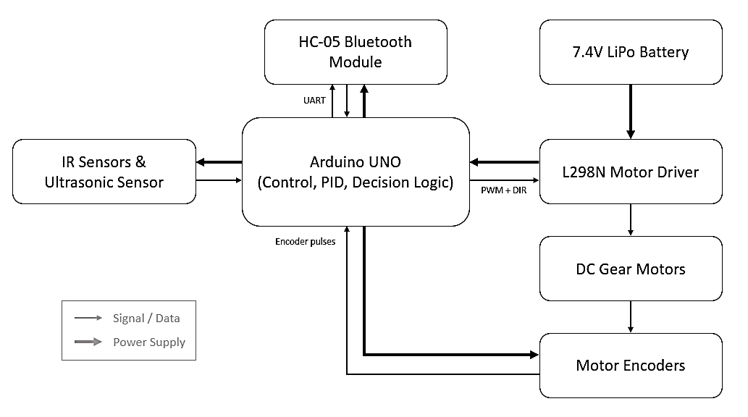
Figure 4.1 Overall System Block Diagram.

4.4 Software Design
The robotic firmware is architected employing a modular software design paradigm, with distinct functional modules dedicated to motor control, sensor data processing, communication protocols, and behavioural decision logic. This organisational structure enhances code comprehensibility, facilitates debugging procedures, and enables more straightforward future enhancement and maintenance.
The primary program execution loop continuously monitors the current operational mode, acquires sensor measurements, computes control output signals, and updates motor command values. Two distinct operational modes have been implemented:
- Manual mode: The operator exercises direct control over the robotic platform through serial or Bluetooth command interfaces.
- Autonomous mode: The robot executes self-directed navigation utilising sensor-derived environmental feedback.
Wheel velocities are quantified using encoder feedback signals processed by the microcontroller. A closed-loop proportional-integral-derivative controller is implemented for each individual wheel to regulate velocity and minimise discrepancies between the left and right motor speeds.

5. Results
5.1 Robot Prototype
Figures 5.1 through 5.3 present the frontal, lateral, and superior views of the completed robotic platform respectively. These visualisations emphasise the spatial arrangement of principal components, including the TT direct current gear motors, motor encoders, infrared and ultrasonic sensors, Arduino control board, L298N motor driver module, HC-05 Bluetooth communication module, and lithium polymer battery.
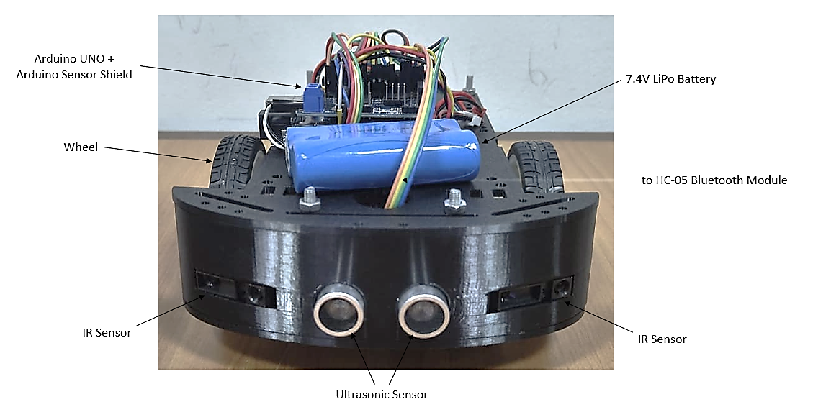
Figure 5.1 Front View of the Robot.
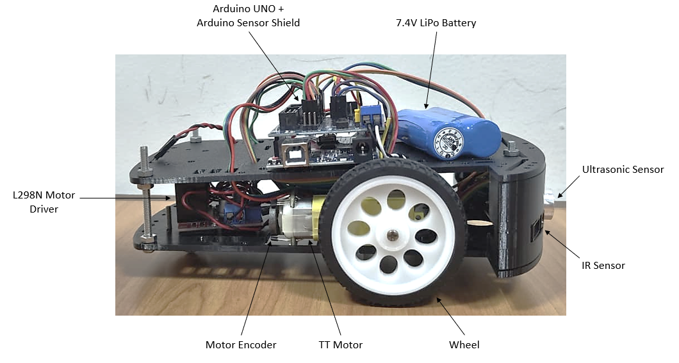
Figure 5.2 Side View of the Robot.
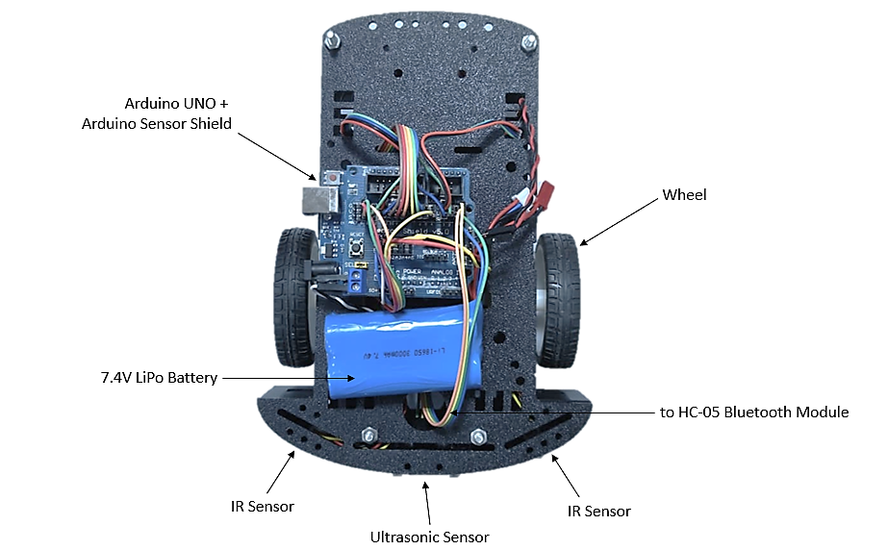
Figure 5.3 Top View of the Robot.
5.2 Motor Speed Control Results
In the absence of proportional-integral-derivative control, the robotic platform exhibited significant velocity disparities between the left and right wheels, resulting in lateral drift during attempted straight-line locomotion. Following the implementation of PID control utilising encoder feedback, wheel velocities were precisely synchronised, yielding stable straight-line movement with substantially attenuated drift characteristics.
5.3 Obstacle Avoidance Results
The infrared and ultrasonic sensors successfully identified obstacles positioned anteriorly, left-anteriorly, and right-anteriorly relative to the robotic platform. Based upon sensor measurement data, the robot executed appropriate evasive manoeuvres including left turns, right turns, and U-turn rotations. These results demonstrated reliable autonomous navigation capabilities within a controlled experimental environment.
5.4 Distance Measurement Results
The distance traversed by the robotic platform was estimated utilising encoder-based odometric calculations. The measurement results demonstrated consistency across repeated experimental trials, with minor discrepancies attributable to wheel slippage and surface irregularities. Collectively, the odometric data provided adequate information for fundamental locomotion analysis and performance evaluation.
6. Discussion
During experimental evaluation, the robotic platform encountered several technical challenges, including velocity discrepancies between the left and right motors, sensor measurement noise, and minor inaccuracies in time-dependent turning manoeuvres. The velocity mismatch was successfully mitigated through the application of encoder feedback and proportional-integral-derivative control, which substantially enhanced straight-line locomotion performance. Sensor noise was attenuated through optimisation of detection thresholds and utilisation of redundant multi-sensor configurations. Time-based turning operations introduced minor angular errors attributable to wheel slippage and surface frictional variations; however, the overall navigation performance remained reliable for the intended operational environment. The modular software architecture significantly simplified debugging procedures and subsystem integration. Potential future enhancements include implementation of sensor fusion algorithms, improved odometric accuracy through gyroscopic integration, and application of systematic PID parameter tuning methodologies.

7. Conclusion
This project successfully accomplished the design, construction, and validation of an autonomous differential drive wheeled robotic platform within the specified constraints regarding physical dimensions, mass properties, and electrical power consumption. The realised system demonstrates capabilities for autonomous locomotion, wheel velocity regulation through closed-loop proportional-integral-derivative control, obstacle detection and avoidance, and distance estimation through encoder-based odometry.
This project provided valuable practical experience in mobile robotic system design, control engineering, and multi-subsystem integration, underscoring the critical importance of controller parameter tuning, sensor calibration procedures, and systematic experimental validation methodologies.

8. Appendix
#include "SoftwareSerial.h"
SoftwareSerial BTserial(0, 1); // RX(D0), TX(D1)

const byte encoder1pinA = 2;
const byte encoder1pinB = 11;
const byte encoder2pinA = 3;
const byte encoder2pinB = 12;
volatile byte encoder1PinALast;
volatile byte encoder2PinALast;

bool isTurning1 = false; // Flag to check if in "U-turn mode"
bool isTurning2 = false; // Flag to check if in "Left turn mode"
bool isTurning3 = false; // Flag to check if in "Right turn mode"
unsigned long turnStartTime = 0; // To store when the turn started
const int turnDuration1 = 3800; // Time in ms to complete 180 degrees
const int turnDuration2 = 1000; // Time in ms to complete 45 degrees

float constant_W1 = 0.0;
float constant_W2 = 0.0;
int AutoManual = 0;

int setSpeed1 = 0;
int setSpeed2 = 0;
float gf_setW1 = 0.0;
float gf_setW2 = 0.0;

float gf_PIDErrorSum1 = 0.0;
float gf_PIDErrorSum2 = 0.0;
float f_w1Error_old = 0.0;
float f_w2Error_old = 0.0;
float gf_Kd = 0.5;
float gf_Ki = 1.2;
float gf_Kp = 2.0;

#define trigPin 13 // Ultrasonic sensor
#define echoPin 4 // Ultrasonic sensor
unsigned int front_distance_mm;
unsigned int left_distance_mm;
unsigned int right_distance_mm;

volatile int gn_duration1 = 0;
volatile int gn_duration2 = 0;

float distance = 0.0; // Distance traveled

void setup()
{
Serial.begin(9600); // Initialize the serial port
BTserial.begin(9600); // For Bluetooth module

pinMode(5, OUTPUT);
pinMode(6, OUTPUT);
pinMode(7, OUTPUT);
pinMode(8, OUTPUT);
pinMode(9, OUTPUT);
pinMode(10, OUTPUT);
pinMode(trigPin, OUTPUT); // Ultrasonic sensor
pinMode(echoPin, INPUT); // Ultrasonic sensor

pinMode(encoder1pinA, INPUT_PULLUP);
pinMode(encoder1pinB, INPUT_PULLUP);
pinMode(encoder2pinA, INPUT_PULLUP);
pinMode(encoder2pinB, INPUT_PULLUP);

encoder1PinALast = digitalRead(encoder1pinA);
encoder2PinALast = digitalRead(encoder2pinA);

attachInterrupt(digitalPinToInterrupt(encoder1pinA), wheelSpeed1, CHANGE);
attachInterrupt(digitalPinToInterrupt(encoder2pinA), wheelSpeed2, CHANGE);
}

void loop()
{
float f_w1, f_w2, f_w1Error, f_w2Error;
float f_PIDout1, f_PIDout2;

right_distance_mm = unReadIRSensor1(A0); // Read the input pin
left_distance_mm = unReadIRSensor2(A1); // Read the input pin
front_distance_mm = ReadUltrasonicSensor(trigPin, echoPin);

char bytRead;

if (Serial.available() > 0)
{
bytRead = Serial.read();
}

if (bytRead == 'm') // Manual mode
{
AutoManual = 1;
distance = 0.00;
gf_setW1 = 0.00;
gf_setW2 = 0.00;
}
else if (bytRead == 'a') // Auto mode
{
AutoManual = 0;
distance = 0.00;
gf_setW1 = 0.00; // No movement before command 's'
gf_setW2 = 0.00; // No movement before command 's'
constant_W1 = 0.0; // No movement before command 's'
constant_W2 = 0.0; // No movement before command 's'
}

if (AutoManual == 0) // Auto mode
{
if (bytRead == 's') // Start moving around
{
constant_W1 = 0.4; // Random constant rps
constant_W2 = 0.4; // Random constant rps
}

if (isTurning1 == true) // U-Turn
{
if (millis() - turnStartTime >= turnDuration1) // Check if the time is up
{
isTurning1 = false; // Turn finished
gf_setW1 = 0.0; // Stop
gf_setW2 = 0.0;
}
else // Turning on spot
{
gf_setW1 = 0.3;
gf_setW2 = -0.3;
}
}

else if (isTurning2 == true) // Left Turn (Obstacle at right)
{
if (millis() - turnStartTime >= turnDuration2) // Check if the time is up
{
isTurning2 = false; // Turn finished
gf_setW1 = 0.0; // Stop
gf_setW2 = 0.0;
}
else // Turning on spot
{
gf_setW1 = 0.3;
gf_setW2 = -0.3;
}
}

else if (isTurning3 == true) // Right Turn (Obstacle at left)
{
if (millis() - turnStartTime >= turnDuration2) // Check if the time is up
{
isTurning3 = false; // Turn finished
gf_setW1 = 0.0; // Stop
gf_setW2 = 0.0;
}
else // Turning on spot
{
gf_setW1 = -0.3;
gf_setW2 = 0.3;
}
}

else if (isTurning1 == 0 && isTurning2 == 0 && isTurning3 == 0 && front_distance_mm <= 150) // Object detected in front
{
isTurning1 = true; // Start the turning sequence
turnStartTime = millis(); // Record the current time
}

else if (isTurning1 == 0 && isTurning2 == 0 && isTurning3 == 0 && left_distance_mm <= 100) // Object detected at the left side
{
isTurning3 = true; // Start the turning sequence
turnStartTime = millis(); // Record the current time
}

else if (isTurning1 == 0 && isTurning2 == 0 && isTurning3 == 0 && right_distance_mm <= 100) // Object detected at the right side
{
isTurning2 = true; // Start the turning sequence
turnStartTime = millis(); // Record the current time
}

else // No obstacle.
{
gf_setW1 = constant_W1;
gf_setW2 = constant_W2;
}
}

else if (AutoManual == 1) // Manual mode
{
if (bytRead == '6') // Turn right
gf_setW2 += 0.15;
else if (bytRead == '2') // Slow down or move backward
{
gf_setW1 -= 0.15;
gf_setW2 -= 0.15;
}
else if (bytRead == '4') // Turn left
gf_setW1 += 0.15;
else if (bytRead == '5') // Stop
{
gf_setW1 = 0.00;
gf_setW2 = 0.00;
}
else if (bytRead == '8') // Move forward
{
gf_setW1 += 0.15;
gf_setW2 += 0.15;
}
if (front_distance_mm <= 100 || left_distance_mm <= 100 || right_distance_mm <= 100)
{
gf_setW1 = 0.0;
gf_setW2 = 0.0;
}
}

noInterrupts();
// Pulse1
f_w1 = (gn_duration1/960.0)*10.0;
gn_duration1 = 0;

// Pulse2
f_w2 = (gn_duration2/960.0)*10.0;
gn_duration2 = 0;
interrupts();

f_w1Error = gf_setW1 - f_w1;
f_w2Error = gf_setW2 - f_w2;

gf_PIDErrorSum1 = gf_Ki*f_w1Error + gf_PIDErrorSum1;
gf_PIDErrorSum2 = gf_Ki*f_w2Error + gf_PIDErrorSum2;
f_PIDout1 = gf_Kp*f_w1Error + gf_Kd*(f_w1Error - f_w1Error_old) + gf_PIDErrorSum1;
f_PIDout2 = gf_Kp*f_w2Error + gf_Kd*(f_w2Error - f_w2Error_old) + gf_PIDErrorSum2;
setSpeed1 = f_PIDout1*960.0/10.0;
setSpeed2 = f_PIDout2*960.0/10.0;

f_w1Error_old = f_w1Error;
f_w2Error_old = f_w2Error;

SetMotor1(setSpeed1);
SetMotor2(setSpeed2);

if (AutoManual == 0)
{
Serial.print(left_distance_mm); // Obstacle distance
Serial.print("; ");

Serial.print(right_distance_mm); // Obstacle distance
Serial.print("; ");

Serial.print(front_distance_mm); // Obstacle distance
Serial.print("; ");
}

/* Serial.print(f_w1);
Serial.print(" ");
Serial.println(f_w2); */

float d1 = fabs(f_w1) * 0.1 * 2.0 * PI * 0.03;
float d2 = fabs(f_w2) * 0.1 * 2.0 * PI * 0.03;

float d = (d1 + d2) / 2.0; // Robot traveled distance
distance += d;
Serial.print(distance);
Serial.println("m");

delay(100);
}

void wheelSpeed1()
{
byte Lstate = digitalRead(encoder1pinA);
if((encoder1PinALast == LOW) && Lstate==HIGH)
{
byte Bstate = digitalRead(encoder1pinB);
if(Bstate == LOW)
{
gn_duration1--; // Forward
}
else
{
gn_duration1++; // Reverse
}
}
encoder1PinALast = Lstate;
}

void wheelSpeed2()
{
byte Lstate = digitalRead(encoder2pinA);
if((encoder2PinALast == LOW) && Lstate==HIGH)
{
byte Bstate = digitalRead(encoder2pinB);
if(Bstate == LOW)
{
gn_duration2--; // Forward
}
else
{
gn_duration2++; // Reverse
}
}
encoder2PinALast = Lstate;
}

void SetMotor1(int nSpeed)
{
if (nSpeed >= 0)
{
analogWrite(5, nSpeed);
digitalWrite(7, LOW);
digitalWrite(8, HIGH);
}
else // nSpeed is negative.
{
analogWrite(5, -nSpeed);
digitalWrite(7, HIGH);
digitalWrite(8, LOW);
}
}

void SetMotor2(int nSpeed)
{
if (nSpeed >= 0)
{
analogWrite(6, nSpeed);
digitalWrite(9, LOW);
digitalWrite(10, HIGH);
}
else // nSpeed is negative.
{
analogWrite(6, -nSpeed);
digitalWrite(9, HIGH);
digitalWrite(10, LOW);
}
}

unsigned int unReadIRSensor1(unsigned int unPin) // 10cm - 80cm
{
if (unPin < A0 || unPin > A5) {
return 0; // Return 0 to indicate invalid pin
}

int value = analogRead(unPin); // Read Sensor
float volts = value * 0.0048828125; // Convert to Voltage
if (volts < 0.1)
volts = 0.1; // Prevent math explosion

unsigned int distance_mm = 262.22 * pow(volts, -1.299);

// Limit the range (100mm - 8000mm)
if (distance_mm < 100) {
distance_mm = 100;
}
else if (distance_mm > 8000) {
distance_mm = 8000;
}

return distance_mm;
}

unsigned int unReadIRSensor2(unsigned int unPin) // 4cm - 30cm
{
if (unPin < A0 || unPin > A5) {
return 0; // Return 0 to indicate invalid pin
}

int value = analogRead(unPin); // Read Sensor
float volts = value * 0.0048828125; // Convert to Voltage
if (volts < 0.1)
volts = 0.1; // Prevent math explosion

unsigned int distance_mm = 123.99 * pow(volts, -1.061);

// Limit the range (40mm - 300mm)
if (distance_mm < 40) {
distance_mm = 40;
}
else if (distance_mm > 300) {
distance_mm = 300;
}

return distance_mm;
}

unsigned int ReadUltrasonicSensor(byte trig, byte echo)
{
unsigned long duration, distance;

digitalWrite(trig, LOW);
delayMicroseconds(2);
digitalWrite(trig, HIGH);
delayMicroseconds(10);
digitalWrite(trig, LOW);

duration = pulseIn(echo, HIGH, 25000);
if (duration == 0)
duration = 8000; // Assume no obstacle

distance = duration*0.1718;

return distance;
}

