1)

Bumblebee's main tactics, techniques, and procedures are:

1. Tactics one (Defense evasion):

Technique: 1548.002 (Abuse Elevation Control Mechanism): Bumblebee can bypass the user account control to gain unauthorized access.

2. Tactics two: Run Scripts

Technique: T1059 (Command and Scripting interpreter): Bumblebee can use PowerShell for execution, use cmd.exe file, and run visual basic scripts.

3. Tactics three: Exfiltration

Technique: T1005 (Data from the local system): Bumblebees can steal and collect credentials from the registry.

4. Tactics four: Initial access

Technique: T1566 (Phishing Spearphishing attachments and Links): Bumblebees can send phishing and spear emails with multiple files, links, and hyperlinks that contain malicious files.

5. Tactics five: Impact

Technique: T1055 (Process Injection): Bumblebee can inject code into multiple processes such as Dij code which can be used to inject DLLs into the memory of other processes.

2)

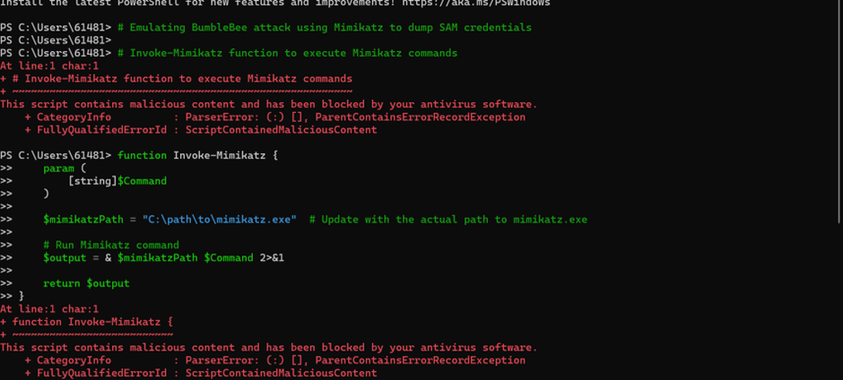

It shows failed because we have antivirus software

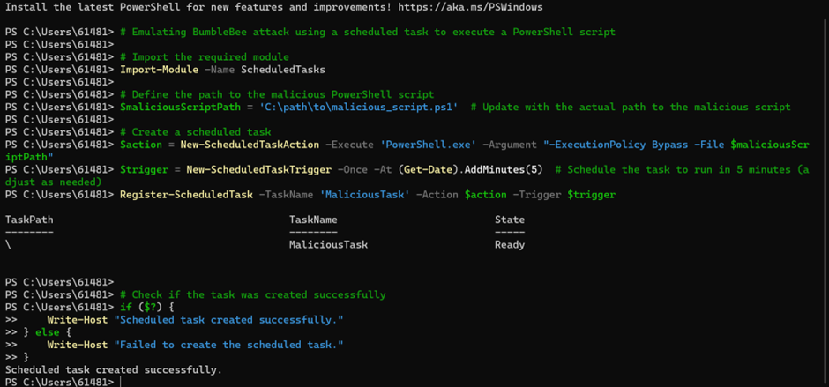

4)