Integrated Live Monitoring Demo
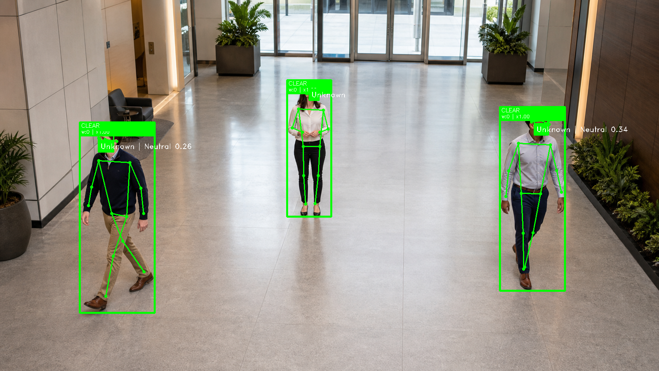
Figure 1. Actual application output from a staged synthetic lobby image.
Document status | Internal overview
Solution stage | Working demonstration build
Document purpose | Manager briefing
Prepared | June 01, 2026
Internal discussion document. This is a demonstration build for controlled review.

1. Executive Overview
Integrated Live Monitoring is a local computer-vision demonstration that organizes visible activity into simple overlays for a human operator. It can track multiple people at the same time and draw body landmarks for each visible person.
The current activity example counts repeated raised-hand waves. It is a transparent demonstration rule used to test tracking and operator clarity. It is not an operational policy or a conclusion about a person.

What The Demonstration Shows
- Multiple people can be tracked independently in the same frame.
- Body landmarks and review tiers are displayed directly on the video.
- The current demonstration processes frames locally.
- Photos, videos, USB cameras, and stream URLs can be used as inputs.
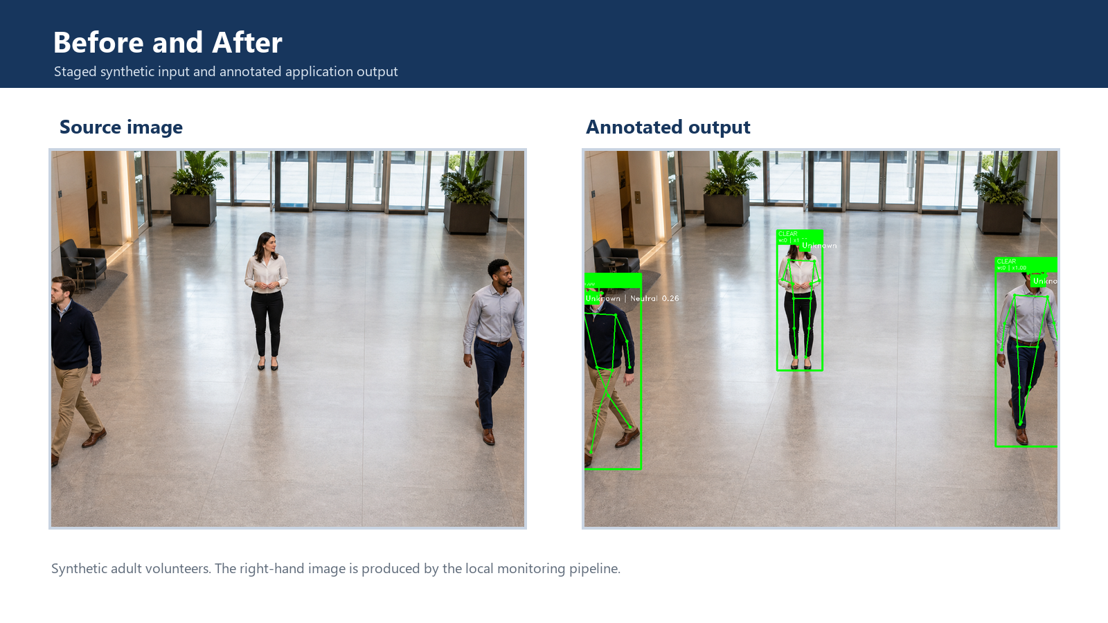
Figure 2. Staged synthetic input and annotated local-pipeline output.

At A Glance
Question | Current Answer
Is there a working demonstration? | Yes. It runs locally and supports multi-person pose tracking.
Does it support facial recognition? | Yes, optionally. It can compare visible faces against manually enrolled volunteer photos.
Is it ready for operational use? | No. Validation, governance, security controls, and an operator interface are still required.
What still needs evaluation? | Tracking stability, performance, operator clarity, camera reliability, and governance fit.

2. Current Build

Multi-Person Tracking
Each visible person receives a separate tracking ID, skeleton overlay, wave counter, and review tier while they remain in frame. One person's activity does not alter another person's state.
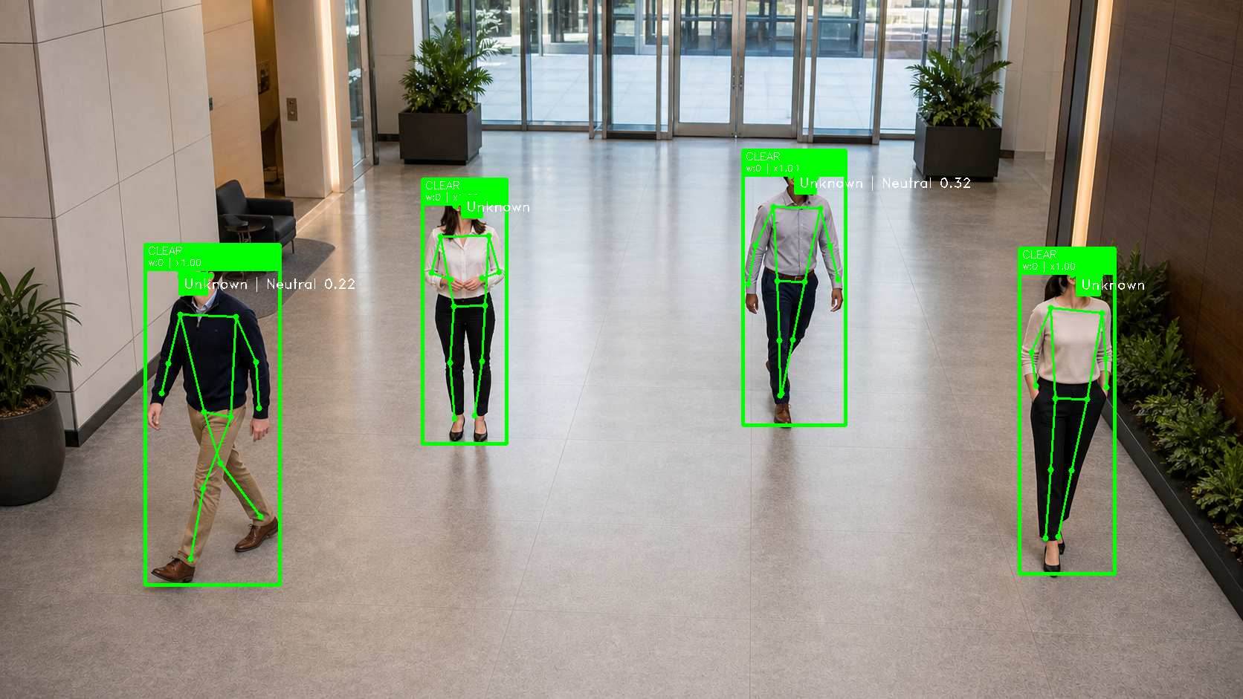
Figure 3. Actual application output showing four independently tracked people.

Operator-Facing Indicators
Indicator | Meaning
CLEAR | No repeated activity above the configured allowance
MONITOR | Some repeated activity is visible
REVIEW | Repeated activity merits operator attention
HIGH | Higher repeated activity count

The visible tier is a review aid. It does not determine intent, risk, or wrongdoing.

Optional Facial Recognition
The build includes optional facial recognition. It can compare a visible face against manually captured volunteer enrollment photos and display a matching label. Without enrollment images, it continues in anonymous mode. Facial recognition is not required for the core multi-person tracking workflow.
The separate expression estimate is experimental and should remain disabled or limited to controlled evaluation until its value is reviewed.

How It Works
- Receive frames from a camera, photo, video, or stream URL.
- Detect visible people and estimate body landmarks.
- Maintain a separate short-lived state for each tracked person.
- Apply the transparent repeated-wave demonstration rule.
- Draw the annotated feed for human review.
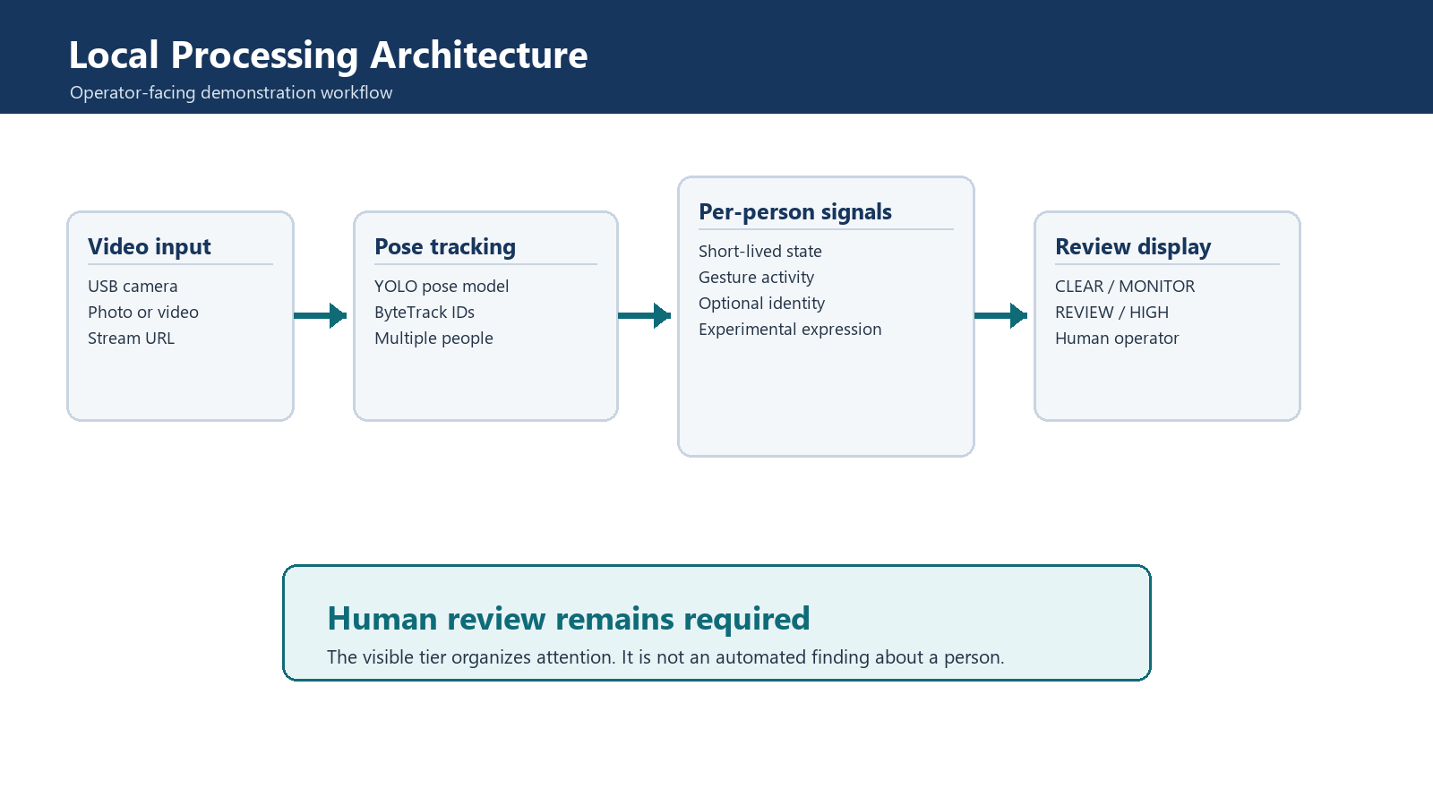
Figure 4. Local processing architecture and human-review boundary.

3. Evaluation Considerations
A limited internal evaluation would focus on technical feasibility and operator usefulness. It should use volunteers and approved staged recordings, not customer footage or operational decision-making.

Evaluation Focus
Area | Question
Tracking quality | Does each visible person retain a stable independent state?
Performance | Does the build remain responsive on the intended laptop?
Operator clarity | Can a reviewer understand why a tier changed?
Camera compatibility | Can the selected USB camera and fallback clips be used reliably?
Governance fit | Which capabilities, if any, are appropriate for further evaluation?

Current Limitations
- Accuracy has not been formally measured across lighting, camera placement, viewpoints, or demographic groups.
- Live performance depends on workstation hardware and the number of visible people.
- Enrollment images do not yet have enterprise access controls, retention rules, or audit logs.
- The OpenCV window is a demonstration view, not a supported operator dashboard.
- Privacy, security, legal, accessibility, procurement, and model-license reviews are still required.
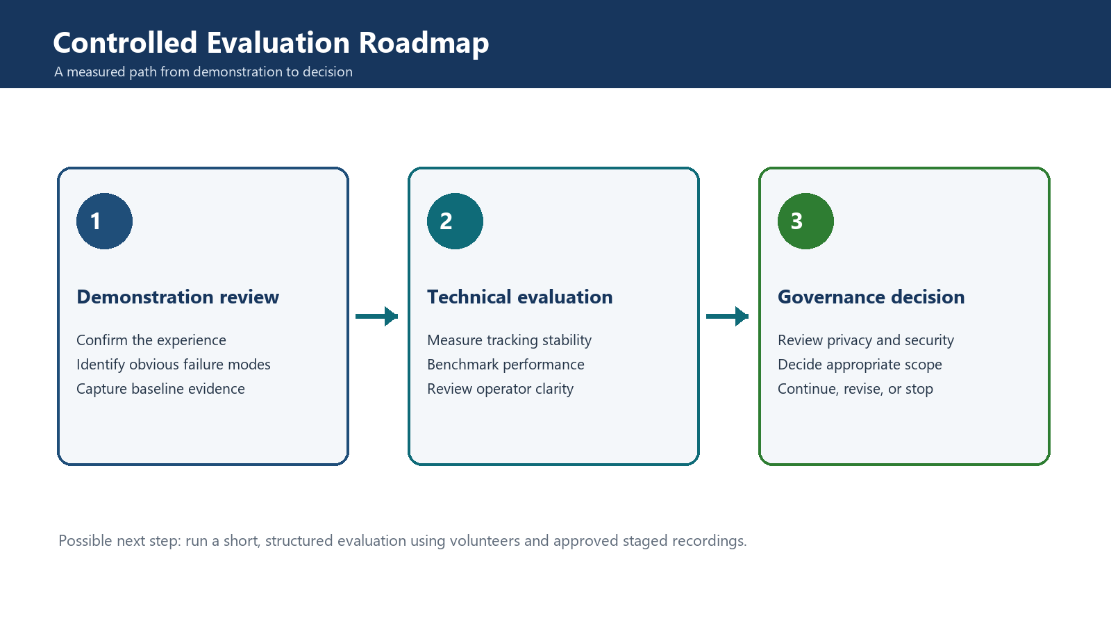
Figure 5. A possible three-phase controlled-evaluation roadmap.
Possible Next Step
If there is interest in continuing the concept, run a small time-boxed evaluation using approved staged footage or volunteers. Capture performance, operator feedback, and governance requirements, then decide whether to continue, revise, or stop.

4. Technical Follow-Up
This section is included for technical readers who want a quick view of the implementation. Detailed setup notes and engineering backlog items remain in the separate technical reference.
Component | Technology | Purpose
Input and display | OpenCV | Read sources and render the annotated view
Multi-person pose | Ultralytics YOLO Pose | Detect people and estimate body landmarks
Tracking | ByteTrack | Maintain short-lived person IDs between frames
Gesture rule | Python state machine | Count repeated raised-hand waves
Optional facial recognition | OpenCV YuNet and SFace | Match manually enrolled volunteers

The OpenCV YuNet and SFace facial-recognition path replaces the earlier dlib dependency. This is easier to install on Windows and remains portable across Windows, Linux, and macOS through opencv-contrib-python.

Selected Code Excerpts
Independent state for every tracked person (src/detection.py)
@dataclass
class PersonRuntime:
"""State that must stay isolated for each tracked person."""
wave_monitor: Any
review_monitor: Any
cached_emotion: Any = None
last_seen_frame: int = 0
Why it matters: Each person keeps an isolated short-lived state, preventing one person's activity from changing another person's review tier.
Windows-friendly OpenCV facial-recognition stack (src/identity.py)
def __init__(
self,
detector_model_path: Path = DEFAULT_DETECTOR_MODEL_PATH,
recognizer_model_path: Path = DEFAULT_RECOGNIZER_MODEL_PATH,
cosine_threshold: float = COSINE_MATCH_THRESHOLD,
) -> None:
ensure_model(detector_model_path, DEFAULT_DETECTOR_MODEL_URL)
ensure_model(recognizer_model_path, DEFAULT_RECOGNIZER_MODEL_URL)
self.cosine_threshold = cosine_threshold
self.detector = cv2.FaceDetectorYN_create(
str(detector_model_path),
"",
(320, 320),
0.8,
0.3,
5000,
)
self.recognizer = cv2.FaceRecognizerSF_create(str(recognizer_model_path), "")
Why it matters: OpenCV YuNet and SFace replace the earlier dlib installation path for optional facial recognition.

Demo Reference
External USB camera
.\.venv\Scripts\python.exe src\main.py --detect --source 1
Why it matters: Use source 2 if Windows assigns the USB camera a different index.
Recorded fallback video
.\.venv\Scripts\python.exe src\main.py --detect --source "C:\path\to\demo-video.mp4"
Why it matters: Keep a short approved staged recording available for demonstrations.

