Threat-Adaptive Interdiction of Taiwan's Crude Oil Supply
Research proposal | MA289-27-1 Independent Study | Cadet Dennis Pezan | Advisor: LTC Matthew Webb | 30 September 2026
PURPOSE
This project tests whether LTC Webb's threat-adaptive RL interdiction agent, built on Ukrainian/Russian rail, still finds sound attacker strategies on a structurally different network: the sea delivery of crude oil to Taiwan's refineries. Research question: given one effort budget spread across different kinds of action, which sea lanes does an attacker act on to minimize crude reaching Taiwan, and are they distant chokepoints or Taiwan’s own approaches?
WHY THIS NETWORK
Taiwan imports nearly all of its crude: in 2025, 61% from Persian Gulf producers through Hormuz, 27% from the U.S. Gulf Coast, 8% from Oman (EIA, 2026). Every barrel must pass a few named straits, so the open ocean reduces to a finite, closed graph. The structure is real: Hormuz has been largely closed since February 2026, and Taiwan reportedly rerouted through the Saudi Red Sea port of Yanbu, a route this network contains.
THE NETWORK
- Size: 55 nodes, 78 edges (59 interdictable), vs. 70 and 125 for Ukraine; loads into env_TA.py unchanged (Figure 1).
- Sources and sinks: four origin regions weighted by EIA import shares; three ports by refinery capacity (Kaohsiung 670, Mailiao 540, Shalung 200 kb/d). Demand: 11.9 VLCC loads a month (783 kb/d ÷ 2 million barrels a load).
- Structure: each strait or canal is an edge from entrance to exit; a node at every junction; every interdictable lane has a checked alternative (for Hormuz, the two bypass pipelines).
- Geometry: real sea lanes (scgraph marnet); 12 nm offshore near Taiwan, the territorial-sea limit; no lane crosses land (Figure 2).
HOW INTERDICTION WORKS
The attacker spends one effort budget. Each edge carries the one action that fits where it is, with an effort cost and a probability p that it shuts the edge (the expected share of the month closed), which is the per-edge cost and probability env_TA.py already uses. p is anchored on real disruptions; costs are ordinal, by legal threshold and distance from PRC bases.
Action | Where it is allowed | Cost | p | What p is anchored on
Cyber on a canal or port | Panama, Suez route, the 3 port entries | 1 | 0.10 | Nagoya, DP World port shutdowns, 2023 (~3 days)
Cyber on an open strait | Hormuz, Malacca, Sunda, Lombok, Sulu, Miyako | 1 | 0.05 | GPS jamming in Hormuz, 2025: traffic kept moving
Quarantine / blockade | Taiwan approaches (two variants) | 2 / 4 | 0.80 / 0.95 | CSIS quarantine scenarios; Hormuz 2026 (~95% drop)
Proxy disruption | Bab el-Mandeb | 2 | 0.60 | Houthi campaign since 2023: traffic down 50–67%
Kinetic (naval) | South China Sea only | 3 | 0.90 | CSIS "Lights Out?" blockade wargames (2025)
Economic pressure | The four supplier arcs | 3 | 0.20 | Sanctions work in 34% of 116 cases (Hufbauer et al.)
Naval presence (carrier) | Indian Ocean, western Pacific | 4 | 0.20 | Assumed; between Tanker War 2% and Houthis 60%
The other 19 edges (e.g. the Atlantic, Indonesian archipelagic waters) cannot be interdicted, each with a stated reason.
METHOD AND DELIVERABLES
- Baselines (exact min-cut, greedy). First result: counting p, the cheapest full cut is a five-lane cordon on Taiwan’s west coast (effort 12.5), where all three crude ports sit; ignoring p would pick three port cyber attacks instead.
- Agent evaluation on MIT SuperCloud (LTC Webb): zero-sum and canalize; quarantine and blockade variants.
- Transfer test: the rail-trained agent on this network, no retraining. If it transfers, it learned interdiction rather than a map; if not, that is a result.
Products: effort–flow frontier (budget vs. crude delivered, for min-cut, greedy and the agent); map of where the agent acts by budget; transfer result; poster.
ASSUMPTIONS AND LIMITS
Keeps LTC Webb's framework: two players (Stackelberg), full information, zero-sum, one round. Adds: supplier upper bounds (highest share found); one month, one commodity, no stock drawdown; no escorts; ordinal costs and an assumed carrier p, both swept for sensitivity; transit time does not reduce monthly flow; strait and canal capacities set to Taiwan's share of Northeast Asian imports (Lombok and Sulu fleet-limited). Unclassified sources only; a proof of concept, not a targeting model.
DECISIONS REQUESTED
- Stochastic outcomes? The training code runs stochastic; the meeting notes say deterministic. The effort budget needs p below 1.
- Evaluation inputs? Use the sourced capacities, costs and p when testing on this network (_update_capacity_constraints_from_dict).
- Supplier arcs? May economic pressure make the super-source arcs interdictable? The Ukraine network does not.
Key sources: EIA, Taiwan Country Analysis Brief (April 2026); IMF PortWatch; Natural Earth; scgraph / searoute-py; CSIS quarantine and blockade studies; UNGA Res. 3314 (1974); Hufbauer, Schott and Elliott (1990); Wood (1993); Cormican, Morton and Wood (1998); Webb and Caplice (2025). Full list, data and code in the project repository.
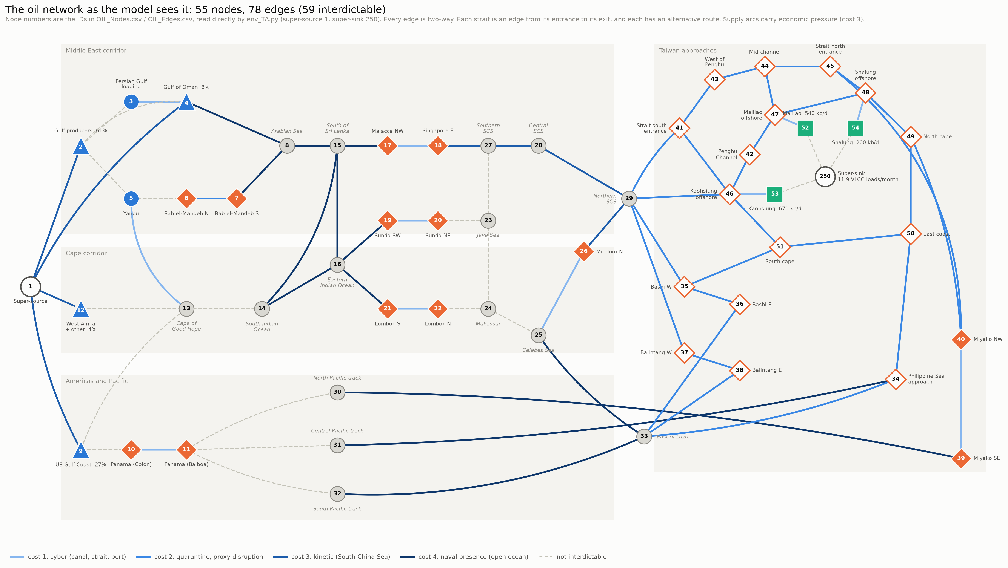
Figure 1. The network as the model sees it: 55 nodes and 78 edges, numbered with the IDs env_TA.py reads. Left to right follows the voyage; the Taiwan approaches are on the right, with the super-sink (demand, 11.9 VLCC loads a month) inside the ring. Edge shade is the effort cost of the action available there; grey dashed edges cannot be interdicted.
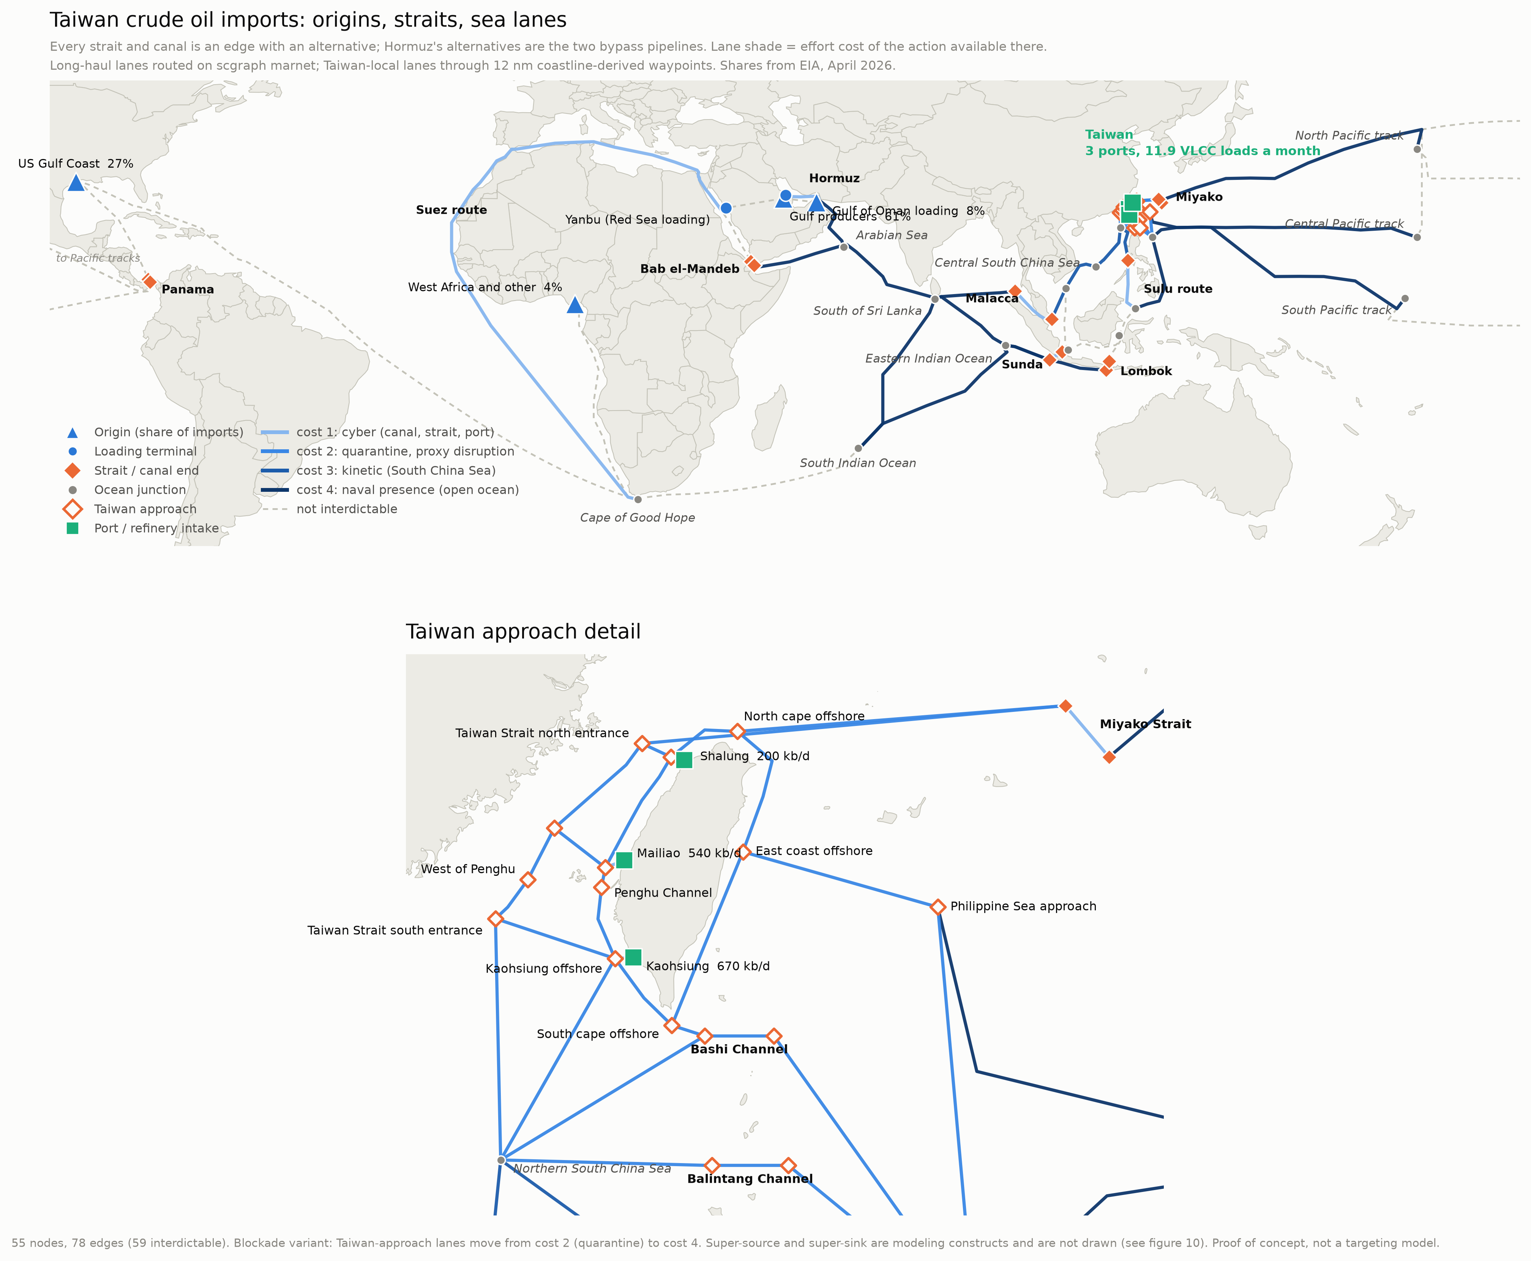
Figure 2. The same network on the map. Every lane follows its routed sea lane; Taiwan-local lanes run on waypoints 12 nm offshore. All three crude ports are on the west coast, which is why the cheapest full cut is a cordon there.

