BiTZ – Biodiversity in transition zones

# Purpose and patterns

The model’s specific purpose(s). • The patterns used as criteria for evaluating the model’s suitability for its purpose

* Wild bees are at thread in an agricultural landscape
* Prediction of impacts of TZ
* To analyse the impact and importance of flowering strips, e.g. areas with an increased nesting and resource pool, for bee diversity, we developed a meta community model.
* The model can be adapted to other species in agricultural landscapes
* Patterns? Use qualitative but testable patterns

# Entities, state variables and scales

* Spatial units: landscape consisting of cells; populations of different functional types
* Dynamic or static variables; type; range
* Spatial and temporal scale

Table 1: Parameters and state variables within BiTZ.

|  |  |  |  |  |  |
| --- | --- | --- | --- | --- | --- |
| Entity | Parameter | Type | Range | Description | Units |
| Environment | NameFtFile | Txt-file |  | Txt file with the definition of the functional types; including all trait parameters |  |
| NameLandscapePatchFile | Asc-file |  | Grid file of the underlying landscape with single patch IDs |  |
| NamePatchDefFile | Txt-file |  | Txt file with the definition of each single patch; including different parameters such as land use class, size, etc. |  |
| NameNestSuitabilityFile  NameForageSuitabilityFile | Txt-file |  | Txt file with the FT specific land use suitabilities for nesting and resources |  |
| t_max | Int | Min. 1 | Maximal time steps simulated | Years |
| y_max, x_max | Int | 100-500 | Dimension of the underlying landscape | 10 m |
| nb_LU | Int | Min. 2 or 3 | Number of land use classes |  |
| TZ_width | Int |  | Width of a transition zone | 10 m |
| TZ_percentage | Double | 0.0-1.0 | Percentage of borders with transition zone |  |
| size_order | String, | “ascending” or “descending” | order in which transition zones are selected depending on patch size |  |
| Max_search_attempts | Double | Min. 1 | Maximal number of search attempts to find the best suitable patch |  |
| Nrep | Int | Min. 1 | Number of repetitions |  |
| MC | int |  | Number of the current MC run |  |
| SimNb | int | Min. 1 | Number of the simulation |  |
| Landscape | x, y | int | 0-x/y_max | x, y coordinate of the cell |  |
| LU_id | Int | 0-nb_LU | Land use class identifier |  |
| pa_id | int |  | Patch identifier |  |
| TZ | bool |  | Cell is defined as transition zone |  |
| TZ_pot | bool |  | Cell is a potential transition zone cell |  |
| FT_pop_List | List |  | List of all FT populations in the cell |  |
| FT_pop_size | List |  | List of the FT population sizes in the cell |  |
| PID_def | Struct |  | Stores information of patch |  |
| PID | Int |  | Patch ID |  |
| Type | String |  | Land use class |  |
| Area | Double |  | Area |  |
| Nb_bordercells | int |  | Number of cells bordering a forest or grassland patch |  |
| Functional type | FtLinkList | List |  | List of all FT |  |
| FT_type | string |  | Type identifier |  |
| FT_ID | int |  | Type identifier |  |
| R | double | >0.0 | Growth rate |  |
| b | double |  | Density compensation effect |  |
| c | int | 0-nb. FTs | Interspecific competitive strength |  |
| trans_effect_nest | Double |  | Effect of transition zone on nesting suitability |  |
| trans_effect_res | double |  | Effect of transition zone on resource suitability |  |
| mu | double |  | Amount of dispersing individuals |  |
| omega | double |  | Densitiy dependent effect on dispersal |  |
| dist_eff | double |  | Susceptibility for disturbances |  |
| dispsd | double |  | Standard deviation of dispersal distance | 10 m |
| dispmean | double |  | Mean dispersal distance | 10 m |
| LU_suitability_nest | double | 0-1 | Map of land use suitabilities for nesting |  |
| LU_suitability_forage | double | 0-1 | Map of land use suitabilities for resource uptake |  |
| Population | cell | Shared pointer of class CCell |  | Link to the cell in which the population is (incl. all cell parameters) |  |
| Traits | Shared pointer of class FT_traits |  | Link to the list of traits of the FT |  |
| xcoord, ycoord | int |  | x, y coordinates of the population |  |
| nestCap | int |  | Nest capacity of the current cell for the specific FT |  |
| MaxNestSuitability | double |  | Maximal nest suitability in the dispersal distance radius |  |
| resCap | double |  | Resource uptake for the FT in the specific cell (sum of all resources in dispersal range) |  |
| Trans_effect_res | double | 0-1 | Copy of the FT trait trans_effect_res |  |
| Trans_effect_nest | double | 0-1 | Copy of the FT trait trans_effect_nest |  |
| Pt | Int |  | Current population size |  |
| Pt1 | Int |  | New population size |  |
| Emmigrants | Int |  | Number of emmigrants |  |
| Immigrants | int |  | Number of immigrants |  |

# Process overview and scheduling

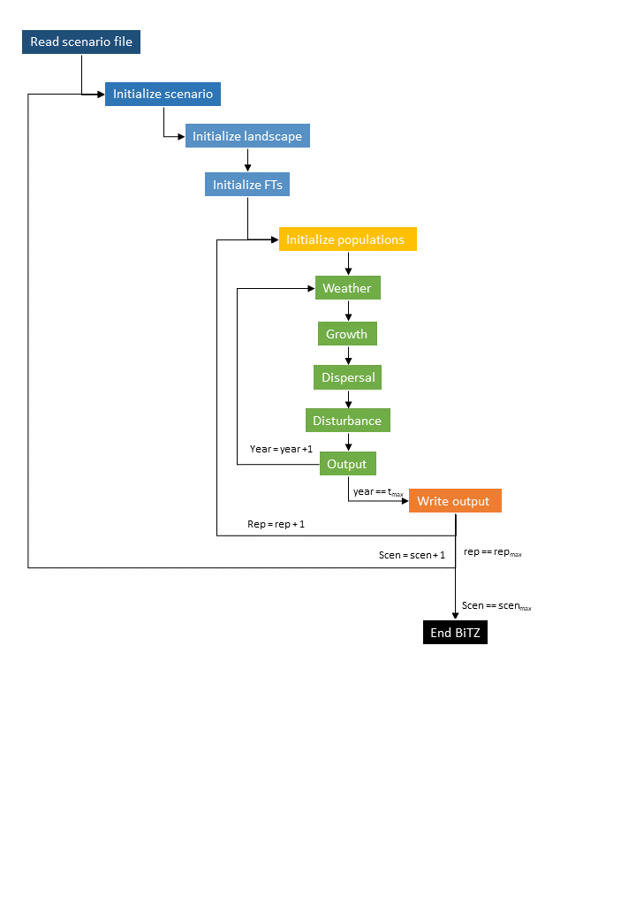

Figure 1: Flowchart of one BiTZ simulation including all single processes

* Which entity execute which process that changes which state variables and the order in which the entities execute the process 🡪 include also the updates

# Design concepts

## Basic principles

* population growth is based on a logarithmic growth function by maynard-smith and slatkin
  + A interspecific competition factor was integrated to account for interactions between different FTs (e.g. competition for resources and nesting sites)
* Dispersal is simulated on an individual basis
* Landscape level disturbances
* Trait and parameter assumptions classification of species

## Emergence

Which key model results or outputs are modeled as emerging from the adaptive decisions and behaviors of agents? These results are expected to vary in complex and perhaps unpredictable ways when particular characteristics of the agents or their environment change. • For those emergent results, the agent behaviors and characteristics and environment variables that results emerge from. • The model results that are modeled not as emergent but as relatively imposed by model rules. These results are relatively predictable and independent of agent behavior. • For the imposed results, the model mechanisms or rules that impose them. • The rationale for deciding which model results are more vs. less emergent.

## Adaptation

* Dispersal search for suitable nesting site

## Objectives

## Learning

n.a.

## Prediction

Directed dispersal

## Sensing

Directed dispersal

## Interaction

Interspecific competition integrated in the growth function

## Stochasticity

Wheather, dispersal, disturbance

## Collectives

n.a.

## Observation

How information is collected and analyzed

# Initialisation

## Scenarios

* Scenario file includes: Simulation number, NameFtFile, NameLandscapePatchFile, NamePatchDefFile, NameNestSuitabilityFile, NameForageSuitabilityFile, Number of repetitions, maximal time steps simulated, dimensions of the underlying landscape (x_max, y_max), Number of land use classes, Transition zone width, Percentage of borders with transition zones Probability of disturbances

## Landscape

The model needs two files to create the underlying landscape: 1) a raster file which contains the information of the patches in the landscape (distribution of patch IDs in the landscape) and 2) a patch definition file which contains the specific definition of each patch. Both files can be generated with the program FragStats if a rastered landscape file with information on the land use class of each raster cell exists. FragStats creates a patch_ID file, where, connected raster cells of the same land use classes are grouped to patches with a specific identifier. The landscape is analysed on the patch scale and parameters such as the patch area or patch perimeter are calculated. The patch definitions are stored in a txt file to be imported in the model.

First the patch defin

* Read the patch definition file and store it in a structure
* Read the landscape file and add the information of each patch id based on the patch definition file
* Define potential transition zone cells in the landscape: for all arable patches: for each cell within the patch: if one of the neighbouring cells is a forest or grassland cell, it is marked as a potential transition zone cell; the number of potential transition zone cells are summerized for each patch
* Select transition zone cells: depending on the determined size order parameter, arable patches are ordered according to their size. Starting with the first patch (either smallest or largest), potential transition zone cells are randomly selected and all arable cells within the range of the determined TZ_width are marked as TZ cell.; As soon as all potential TZ cells are selected for the specific patch, the next smaller/taller patch is selected.

## Functional types

* Read FT definition file
* Read nest suitability file
* Read forage suitability file

## Populations

* 1000 populations are initialised per FT
* Wherever a population is initialized on the grid:
  + Transition zone effects are set
  + Nest capacity is set (574 x (suitability + trans effect nest))
    - Maximal nest capacity is based on Potts & Willmer 1997 (data on Halictus rubicundus in UK)
  + Maximal nest capacity within the dispersal range is set
  + Resource capacity in the cell is set: sum of all resource suitability’s in the dispersal distance; for transition zone cells, trans effect res is added additionally
* Initial population size is a random start size of 1-10 individuals multiplied by the nest capacity/max. nest capacity of the certain patch for the specific FT

# Input data

* Input files are: simulation parameters, landscape, patch, FT: Traits, suitability nest + res

# Submodels

## Foraging range

* In each year, the foraging range of each population is updated
* Each cell includes the information which FT population is able to forage in this cell and how big this population is. If several populations of the same FT can forage in this cell, population sizes are summed up.

## Weather

* Stochastic impact for good and bad years:
  + Eps=normal distributed variable with a mean of 0.0 and a standard deviation of 0.15
  + Weather_year= 1+eps;

## Growth

* For each cell, the growth of each population is calculated after each other.
* Resource capacity is calculated: How much resources will the population gather considering the interspecific competiton?
  + Within the foraging range of the population:
    - In each cell the competition with other FTs is calculated; only FTs with the same flying period are considered
    - 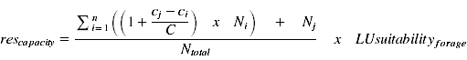
    - The resource capacities for each cell within the foraging range are summed up and divided by the number of foraging cells to calculate the mean resource capacity
* Growth is based on the Maynard-Smith and Slatkin function; modified by Jeltsch et al.:
* 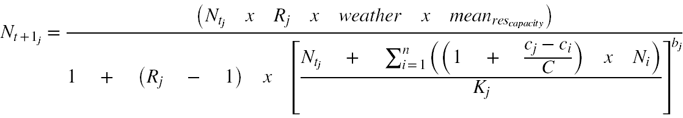
* Ntj: current population size of the FT population in the cell
* Rj: growth rate of FT
* Weather: weather impact factor
* Resource capacity: sum of all resource suitability values within the dispersal distance of the FT
* C:sum of the competition values of FTs in the cell with the same flying period
* Cj: competition value of the FT
* Ci: competition value of another FT within the cell; Ni: current population size of that FT population in the cell
* Kj: nest capacity of the FT population in the current cell
* Only FTs with the same flying periods are considered for interspecific competition;
* The new population sizes are stored in a temporary variable and updated after the growth of all FT populations on the grid is completed

## Dispersal

* Fraction of dispersing individuals is determined by the amount of dispersing individuals, and a density dependent impact of the carrying capacity, current population size, and the impact factor omega; maximal 90% of the population is dispersing
* 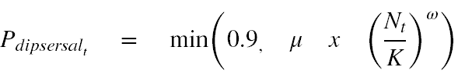
* Direction of dispersal:
* 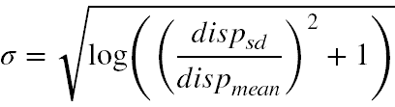dispersal distance:
* Each emigrating individual is searching for the most suitable patch for nesting in the dispersal kernel; with increasing number of attempts, the probability is increasing, that it decides to take a less suitable patch:
  + Probability to take a less suitable patch = tries/maximal search attempts * LU_suitability for nesting of the current cell/maximal land use suitability for nesting in the dispersal distance
* Only if the new population size is below the nesting capacity for that FT in the chosen cell, the individual is immigrating.
* All emigrating individuals, that were not able to find a suitable patch in the designated number of search attempts, are assumed to either die or have left the landscape

## Disturbances

* In each year, a number of arable and grassland patches are selected, which are being disturbed by soil managements. For arable patches: 90% of the patches are disturbed each year; for grasslands: 30% of the patches are disturbed
* Patches being disturbed are stored in a vector; for each of these patches: FT populations located in a cell of that patch are suffering a trait specific reduction in population size (nests being disturbed); trait depend on nesting site characteristics: soil nesting bees suffer more than cavity nesting bees
* For the other land use classes: urban, forest, bare: The probability of a cell being disturbed is 0.5, 0.1 and 0.5 respectively. E.g. these processes are not considered patch wise, but locally for each cell!; reduction of population sizes is still trait specific

## Management options