BiTZ – Biodiversity in transition zones

# Purpose and patterns

The model ‘Biodiversity in Transition Zones’ (BiTZ) was developed to analyse the impact and importance of flowering strips as transition zones within agricultural landscapes. The first version of the model is adapted to solitary bees but is still broad enough to be adapted to other mobile species in agricultural landscapes. Solitary bee species are classified into different functional types to cover for several similar species which are assumed to behave similar to abiotic and biotic conditions due to their trait characteristics. The model simulates bee populations within a realistic agricultural landscape. It accounts not only for intraspecific competition (e.g. density dependence) but also for interspecific competition.

The model is written in C++, the code is open source and published as a GitHub repository.

# Entities, state variables and scales

Table 1 summarizes the model parameters and state variables of BiTZ. The model simulates species population dynamics in agricultural landscapes while accounting for interspecific interactions. The landscape is designed as a grid of *x_max*\**y_max* grid cells. A grid cell represents the spatial unit of the landscape. The model parameter cell_scale defines the scale (in m) of the spatial unit. Each grid cell belongs to a specific patch (*pa_id*) of a specific land use class (*LU_id*). One patch consists of neighbouring cells (direct neighbours, 4 cell rule) with the same land use class. Each cell stores the information on the patch (identifier, area, and number of border cells to patches of other land use classes), being a potential and/or realized transition zone cell (see later).

A grid cell can comprise populations of several functional types of solitary bee species. The solitary bee species are classified into functional types according to 5 different trait characteristics (see Table 2). The state of each population is characterized by its location (*xcoord*, *ycoord*, cell characteristics), nesting site capacity *nestCap*, maximal nesting site suitability within the dispersal distance *MaxNestSuitability*, the transition zone effect on the nesting site suitability *trans_effect_nest* and resource availability *trans_effect_res*, the current and next population size *Pt* and *Pt1*, the number of immigrants and the number of immigrants. In addition, each population within a cell has a link to the trait characteristics of the functional type.

One timestep in the model represents one year. The total number of simulated years is determined by the model parameter *t_max*.

Table 1: Parameters and state variables within BiTZ.

|  |  |  |  |  |  |
| --- | --- | --- | --- | --- | --- |
| **Entity** | **Parameter** | **Type** | **Range** | **Description** | **Units** |
| **Environment** | *t_max* | Int | Min. 1 | Maximal time steps simulated | Years |
| *y_max, x_max* | Int | 100-500 | Dimension of the underlying landscape | cells |
| *nb_LU* | Int | Min. 2 or 3 | Number of land use classes |  |
| *Cell_scale* | int |  | Scale of one grid cell | m |
| **Cell** | *x, y* | int | 0-x/y_max | x, y coordinate of the cell |  |
| *LU_id* | Int | 0-nb_LU | Land use class identifier |  |
| *pa_id* | int |  | Patch identifier |  |
| *TZ* | bool |  | Cell is defined as transition zone |  |
| *TZ_pot* | bool |  | Cell is a potential transition zone cell |  |
| *FT_pop_List* | List |  | List of all FT populations in the cell |  |
| *FT_pop_size* | List |  | List of the FT population sizes in the cell |  |
| *PID_def* | Struct |  | Stores information of patch |  |
| *PID* | Int |  | Patch ID |  |
| *Type* | String |  | Land use class |  |
| *Area* | Double |  | Area |  |
| *Nb_bordercells* | int |  | Number of cells bordering a forest or grassland patch |  |
| **Population** | *cell* | Shared pointer of class CCell |  | Link to the cell in which the population is (incl. all cell parameters) |  |
| *Traits* | Shared pointer of class FT_traits |  | Link to the list of traits of the FT |  |
| *xcoord, ycoord* | int |  | x, y coordinates of the population |  |
| *nestCap* | int |  | Nest capacity of the current cell for the specific FT |  |
| *MaxNestSuitability* | double |  | Maximal nest suitability in the dispersal distance radius |  |
| *Trans_effect_res* | double | 0-1 | Copy of the FT trait trans_effect_res |  |
| *Trans_effect_nest* | double | 0-1 | Copy of the FT trait trans_effect_nest |  |
| *Pt* | Int |  | Current population size |  |
| *Pt1* | Int |  | New population size |  |
| *Emmigrants* | Int |  | Number of emmigrants |  |
| *Immigrants* | int |  | Number of immigrants |  |

Table 2: Classification of the functional types according to the trait characteristics

|  |  |  |  |  |  |  |  |  |
| --- | --- | --- | --- | --- | --- | --- | --- | --- |
| **Parameter** | **Based on trait** | | **Model parameter value** | | | | | |
| **Growth rate** | Foraging distance | Parasite | ***r*** | | | | | |
|  | long | y | 2.5 | | | | | |
|  | long | n | 3 | | | | | |
|  | medium | y | 3.5 | | | | | |
|  | medium | n | 4 | | | | | |
|  | short | y | 4.5 | | | | | |
|  | short | n | 5 | | | | | |
| **Competition effect** | Diet breadth | Foraging distance | ***c*** | | | | | |
|  | long | polylectic | 0 | | | | | |
|  | long | oligolectic | 1 | | | | | |
|  | medium | polylectic | 2 | | | | | |
|  | medium | oligolectic | 3 | | | | | |
|  | short | polylectic | 4 | | | | | |
|  | short | oligolectic | 5 | | | | | |
| **Land use suitability**  ***for foraging*** | Diet breadth | Flying periods | ***LU_suitability_forage*** | | | | | |
| bare | arable | forest | grassland | urban | water |
|  | Oligolectic | 1 | 0 | 0.4 | 0.4 | 1 | 0.4 | 0 |
|  | Polylectic | 1 | 0 | 0.7 | 0.6 | 1 | 0.6 | 0 |
|  | Oligolectic | 2 | 0 | 0.6 | 0.6 | 1.5 | 0.6 | 0 |
|  | Polylectic | 2 | 0 | 1.05 | 0.9 | 1.5 | 0.9 | 0 |
| **Land use suitability**  ***for nesting*** | Nesting preference | | ***LU_suitability_nest*** | | | | | |
| bare | arable | forest | grassland | urban | water |
|  | cavity | | 0 | 0.1 | 1 | 0.3 | 0.7 | 0 |
|  | soil | | 1 | 0.3 | 0.1 | 0.7 | 0.1 | 0 |
| **Dispersal distance** | Foraging distance | | ***dispmean*** | ***dispsd*** | | | | |
|  | long | | 600 | 60 | | | | |
|  | medium | | 300 | 30 | | | | |
|  | short | | 100 | 10 | | | | |
| **Flying periods** | Flying period | | ***flying_period*** | | | | | |
|  | First half of the year | | 1 | | | | | |
|  | Second half of the year | | 2 | | | | | |
|  | Two times a year | | 3 | | | | | |
| **Disturbance impact** | Nesting preference | | ***dist_eff*** | | | | | |
|  | cavity | | 0.3 | | | | | |
|  | soil | | 0.9 | | | | | |

# Process overview and scheduling

The schedule of the simulated processes is shown in Figure 1. First, the model reads the scenario file, which includes information about all input file names, the number of repetitions to be simulated, the maximal time, grid size (*x_max* and *y_max*), the number of land use classes, the width of a transition zone, the amount of realized transition zones, the size order for arable patches to include transition zones (either ascending or descending order), the number of tries to search for the best suitable patch while dispersing and the scaling of one grid cell. Afterwards, the landscape is generated including the calculation of potential and finally realized transition zone cells and the functional types of solitary bees are introduced and are randomly distributed in the landscape with a random start population size. Afterwards, each process is called every year until the number of years to be simulated is complete. The weather is updated at the beginning of each timestep. The foraging ranges and the competition effect during resource uptake is updated for each FT population in the landscape. In the following, the growth of each population is calculated with population sizes being updated only after growth is calculated for each population in each grid cell. Individual dispersal is again calculated for each population in each grid cell and only afterwards the immigrants and emigrants are added/subtracted to the population size. Disturbance is depending on the land use class and either calculated per patch or per grid cell. Population sizes are updated directly. A patch-scale output is stored after each year, a cell-scale output is stored every 10th year and in the last year.

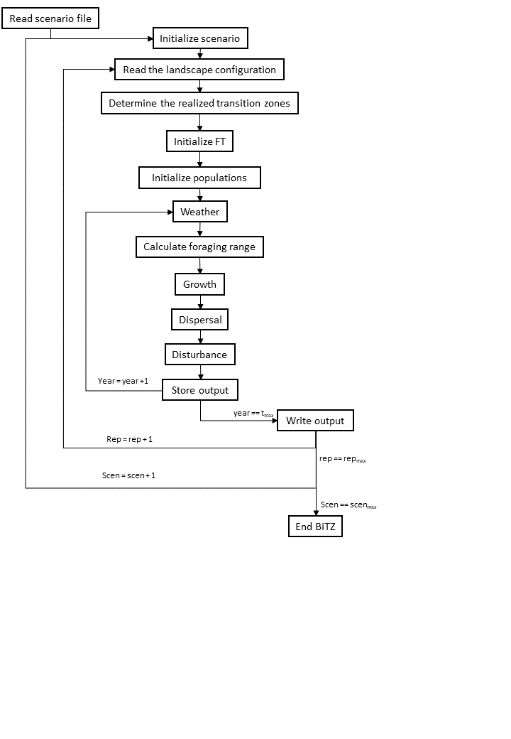

Figure 1: Flowchart of the simulation model BiTZ including all single processes

# Design concepts

## Basic principles

*Growth*. The population growth is based on a logarithmic growth function by Maynard-Smith and Slatkin which was adapted by Jeltsch et al to account for interspecific competition for nesting sites. Additionally, we have included the competition for resources: Each population has a specific foraging range in which it competes for resources with other functional types, whose foraging range overlap in space and time. Based on the competitive pressure, the acquired resources can be either increased or decreased. This has a direct impact on the population growth.

*Dispersal*. In contrast to all other processes happening on population level, the dispersal is calculated on an individual basis. Dispersing individuals try to find the best suitable cell.

*Disturbances*. Disturbances occur either on patch level if the land use class is agriculturally used or on cell level if not.

*Functional type classification*. Solitary bee species found in the agricultural area of the Uckermark region are translated into functional types according to their trait characteristics of their intertegular distance/foraging range, diet breadth, flying period, nesting preference and their parasite status (whether it is known that it is parasite by other bee species) (Table 2). The functional type approach was chosen to cover for several solitary bee species with similar trait characteristics which show consistent behaviour to environmental conditions.

## Emergence

Community dynamics emerge from the interaction/competition between different functional types for nesting sites and resources.

## Adaptation

Dispersing individuals are searching for the most suitable nesting site. However, with increasing number of search attempts, the probability for choosing a less suitable site increases.

## Objectives

n.a.

## Learning

n.a.

## Prediction

Dispersing individuals will search for the most suitable cell.

## Sensing

Dispersing individuals know the maximal potential nesting site suitability within their dispersal range.

## Interaction

Interspecific competition for nesting site and resource uptake is accounted for in the growth function

## Stochasticity

Weather, dispersal, and disturbance processes include stochasticity.

## Collectives

n.a.

## Observation

We used a list of solitary bee species that were found in insect traps within the Uckermark region. Based on this species list, the functional types were created. The trait data was gathered using different peer-reviewed studies and expert knowledges.

# Initialisation

## Scenarios

The scenario file defines the general parameters of the model environment. It includes the number of the specific simulation, the name of all input files, the number of repetition, the maximal timesteps, the dimensions of the underlying landscape, the number of different land use classes, the transition zone width and amount of realized transition zones, the order in which the arable patches are selected to have realized transition zones, the dispersal tries of individuals to find the best suitable patch and the scaling of the landscape.

## Landscape

The model needs two files to create the underlying landscape: 1) a raster file which contains the information of the patches in the landscape (distribution of patch IDs in the landscape) and 2) a patch definition file which contains the specific definition of each patch. Both files can be generated with the program FragStats with a rastered landscape file with information on the land use class of each raster cell. FragStats creates a patch_ID file, where connected raster cells of the same land use classes are grouped to patches with a specific identifier. The landscape is analysed on the patch scale and parameters such as the patch area are calculated. The patch definitions are stored in a txt file to be imported in the model.

After the patch definition file and the landscape file is read into the model, the potential transition zones of each arable patch are calculated. The code goes through each cell of an arable patch and marks it as a potential transition zone cell if one of the neighbouring cells is a forest or grassland cell. The number of potential transition zone cells are summerized for each patch. Afterwards, the realized transition zone cells are defined: Depending on the determined size order parameter, the arable patches are ordered according to their area either descending or ascending. The model then starts with the first arable patch (either the smallest or the largest one) and potential transition zone cells of this patch are randomly selected and all arable cells within the range of the determined transition zone width (TZ_width) are marked as realized transition zone cells. As soon as all potential transition zone cells of the specific arable patch are selected, the next smaller/taller patch is selected. This is repeated until the defined amount of realized transition zone cells is reached.

## Functional types

To initialize the functional types in the landscape, the model needs 3 different input files: the FT definition file, the file containing the nest suitability of each land use class for each FT and the file containing the resource availability in each land use class for each FT.

## Populations

After the model has the information of all FTs to be initialized in the landscape, 1000 populations are initialised for each FT: In a randomly selected cell, a random population size of 1-100 individuals is defined. Afterwards the cell specific (land use class specific) parameters, are defined: the transition zone effects for nest suitability and resource availability, the nest capacity including the transition zone effect (Potts & Willmer 1997 (data on Halictus rubicundus in UK)), and the maximal nest capacity within the dispersal range.

# Input data

The input files are the simulation file, the landscape patch ID file, the patch definition file, the FT definition file and the nest suitability and resource availability files.

# Submodels

## Weather

The weather is updated at the beginning of each year. It is simulated as stochastic impact on the population growth function. The weather variable eps is normal distributed with a mean of 0 and a standard deviation of 0.15. The impact on the growth function is 1+eps.

## Foraging range

Each year, the foraging range of each population is updated. Afterwards, each cell includes the information which FT population can forage in this cell and how big this population is. If several populations of the same FT can forage in this cell, population sizes are summed up.

## Growth

For each cell and each FT population in the cell, the growth is calculated one after the other. The resulting new population size is stored in the variable *Pt1* and the population sizes are only updated after the growth of each population is finished.

In a first step, the resource availability, or resource uptake, is calculated considering interspecific competition for resources in each cell within the foraging range of the FT population. In each cell within this range, the competition with other FTs, which foraging ranges are overlapping with this specific cell, are calculated. Only FTs with the same flying period are considered:

Equation 1

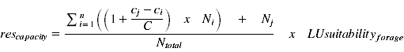

The mean of the resource capacities within the foraging range is calculated and integrated in the growth function.

The actual growth function is based on Maynard-Smith and Slatkin () ; modified by Jeltsch et al. ():

Equation 2

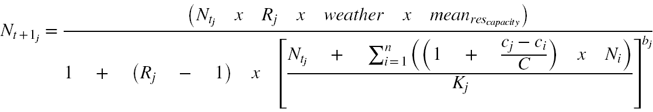

With *Ntj*: the current population size of the FT population *j* in the cell, *Rj*: the growth rate of the FT *j*, Weather: the weather impact factor, *meanrescapacity*: mean resource capacity considering interspecific competition, *C*: the sum of the competition values of FTs in the cell with the same flying period, *Cj*: competition value of FT *j*, *Ci*: competition value of FT *i* within the cell; *Ni*: current population size of FT *i* in the cell, *Kj*: nest capacity of the FT population *j* in the current cell. Only FTs with the same flying periods are considered for interspecific competition for nesting sites. The new population sizes are stored in the variable *Pt1* and are updated after the growth of all FT populations on the grid is completed.

## Dispersal

The fraction of dispersing individuals of a population *Pdispersal* is determined by the carrying capacity *K*, the current population size *Nt*, and the impact factor *ω*; maximal 90% of the population is dispersing.

Equation 3

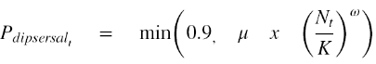

Each dispersing individual has the information about the best suitable nesting site within their dispersal distance. It tries to find a cell with this maximal nesting site suitability by randomly searching within its dispersal range.

Dispersal direction α is calculated with

Equation 4

The dispersal distance *d* is determined by the dispersal mean *dispmean* and standard deviation *dispsd* and calculated with

Equation 5

with

Equation 6



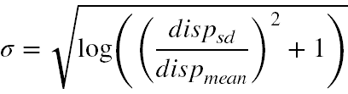and

Equation 7

However, the individuals have a maximal number of search attempts (*max_search_attempts*). With higher number of search attempts, the probability of choosing a less suitable cell is increasing. The probability to take a less suitable patch is

$${prob}_{less}= \frac{search attempt}{maximal search attempts}*\frac{Nesting suitability current cell}{maximal nesting suitability in dispersal range}$$

Only if the population size is below the nesting capacity for that FT in the chosen cell, the individual is immigrating. All emigrating individuals, that were not able to find a suitable patch in the designated number of search attempts, are assumed to either die or have left the landscape.

## Disturbances

The implementation of disturbances differs between land use classes. For agriculturally managed land use classes, arable and grassland, disturbances occur for a whole patch. In arable patches, disturbances occur every year. Grassland patches have a probability of 80% to be disturbed in a year. In forest, bare and urban land use classes, each cell has a probability to be disturbed: For the bare land use class the probability is 70%, for urban land use class the probability is 70%, and for forest land use class the probability is 30%. If a cell is disturbed the FT populations located in this cell are suffering a trait specific reduction in population size simulating a nest disturbance. This trait depends on nesting site characteristics: soil nesting bees suffer more than cavity nesting bees.

In cells of a realized transition zone, no disturbance takes place.