Blood Cell Classification Using VGGNet-16: A Transfer Learning Approach on the BCCD Dataset
Dev Vardhan Bhamu¹, Kavya Arora¹
¹Dept. of Computer Science & Engineering, Shri Mata Vaishno Devi University, Katra, J&K, India
{23bcs025, 23bcs041}@smvdu.ac.in

ABSTRACT
This paper presents a transfer learning approach for the automatic classification of peripheral blood cell types using VGGNet-16, a 16-weight-layer deep convolutional neural network characterized by uniform 3×3 convolutions. Experiments are conducted on the Blood Cell Count and Detection (BCCD) dataset comprising approximately 12,500 microscopic images across four cell categories: Eosinophil, Lymphocyte, Monocyte, and Neutrophil. The dataset is partitioned using stratified shuffling into 70% training, 15% validation, and 15% test sets. With ImageNet-pretrained convolutional weights frozen and only the fully connected classifier head fine-tuned, the model achieves 89.7% test accuracy, a weighted F1-score of 0.897, and a macro-average AUC-ROC of 0.985. Per-class analysis reveals strong performance for Lymphocyte (F1 = 0.957) and Monocyte (F1 = 0.975), with Eosinophil–Neutrophil confusion representing the primary error mode.
Keywords—VGGNet-16; Blood Cell Classification; Transfer Learning; BCCD; CNN; Medical Image Analysis.
I. INTRODUCTION
The manual examination of peripheral blood smear slides by trained hematologists is a labor-intensive, time-consuming, and error-prone process central to the diagnosis of numerous hematological disorders, including leukemia, anemia, and infectious diseases such as malaria [1]. Automation of blood cell classification through deep learning offers the potential to reduce diagnostic turnaround times, minimize inter-observer variability, and extend diagnostic capacity to resource-limited settings [2].
Convolutional Neural Networks (CNNs) have demonstrated state-of-the-art performance across medical image analysis tasks [3]. Among established architectures, VGGNet [4] achieves strong results through a homogeneous design: repeated stacks of 3×3 convolutional filters, max-pooling for spatial downsampling, and three fully connected layers. Despite its introduction in 2014, VGGNet-16 remains a compelling baseline for medical imaging owing to its architectural transparency and compatibility with transfer learning [5].
In this work we fine-tune VGGNet-16 on the BCCD dataset [6] under a frozen-feature-extractor regime. Our contributions are: (1) a fully reproducible PyTorch implementation with stratified 70/15/15 splitting; (2) comprehensive evaluation across Accuracy, Precision, Recall, F1-Score, AUC-ROC, and per-class confusion analysis; and (3) an interpretive discussion of the dominant Eosinophil–Neutrophil confusion pattern.
II. RELATED WORK
Early automated blood cell analysis relied on hand-crafted features—morphological descriptors, color histograms, texture statistics—fed into classical classifiers [7]. Rezatofighi and Soltanian-Zadeh [8] demonstrated competitive white blood cell classification using SVMs with manually engineered features, achieving acceptable accuracy but requiring significant domain expertise.
The success of AlexNet [3] catalyzed CNN adoption in cytology. Shahin et al. [9] trained a shallow CNN on leukocyte images with accuracy improvements over SVMs. Habibzadeh et al. [10] demonstrated the critical role of data augmentation on small hematology datasets.
Transfer learning has since become the dominant paradigm for medical image classification [11]. Acevedo et al. [12] benchmarked multiple ImageNet-pretrained models on white blood cell classification, finding depth alone does not guarantee gains on small datasets. Jiang et al. [13] applied ResNet-50 fine-tuning to leukemia detection; Tran [14] showed VGG-extracted features provide strong k-NN baselines without any fine-tuning. Recent work explores attention mechanisms [15] and vision transformers [16] for hematological analysis, but these require substantially larger corpora beyond typical academic settings.
III. METHODOLOGY
A. Dataset Description
The BCCD dataset [6] consists of 12,500 RGB peripheral blood smear images across four categories: Eosinophil (3,117), Lymphocyte (3,105), Monocyte (3,105), and Neutrophil (3,173). The near-balanced distribution reduces the need for cost-sensitive loss weighting but does not eliminate the need for stratified splitting.
B. Data Partitioning
A stratified shuffled split (scikit-learn StratifiedShuffleSplit, seed = 42) first divided data into 70% training (8,750) and 30% temporary; the temporary set was then split 50/50 into 15% validation (1,875) and 15% test (1,875; actual = 1,494 after class rounding). Stratification preserves original class ratios in each partition.
C. Preprocessing and Augmentation
All images were resized to 224×224 pixels. Training images were augmented with random horizontal/vertical flips, random rotation (±15°), and color jitter (brightness, contrast, saturation ±0.2). All splits were normalized using ImageNet statistics (μ = [0.485, 0.456, 0.406], σ = [0.229, 0.224, 0.225]). No augmentation was applied to validation or test splits.
D. Network Architecture
VGGNet-16 [4] comprises five convolutional blocks followed by three FC layers. All kernels are 3×3 (stride 1, same padding); 2×2 max-pooling (stride 2) halves spatial resolution after each block. The canonical head (FC-4096→FC-4096→FC-1000) was replaced with FC-4096→ReLU→Dropout(0.5)→FC-4096→ReLU→Dropout(0.5)→FC-4. Table I summarizes the architecture.

TABLE I. VGGNet-16 Architecture Summary (Modified for 4-Class Output)
Block | Layers | Filters | Kernel | Output
1 | Conv1-1, Conv1-2 + MaxPool | 64 | 3×3 | 112×112
2 | Conv2-1, Conv2-2 + MaxPool | 128 | 3×3 | 56×56
3 | Conv3-1–Conv3-3 + MaxPool | 256 | 3×3 | 28×28
4 | Conv4-1–Conv4-3 + MaxPool | 512 | 3×3 | 14×14
5 | Conv5-1–Conv5-3 + MaxPool | 512 | 3×3 | 7×7
FC | FC-4096, FC-4096, FC-4 | — | — | 4 logits

E. Transfer Learning Strategy
Convolutional layers were initialized with ImageNet-pretrained weights and frozen throughout training, restricting gradient updates to the newly appended classifier head. This strategy is appropriate when source and target domains share low-level feature statistics while differing in high-level semantics, and substantially reduces computation and overfitting risk on a 12.5K corpus.
F. Training Configuration
The model trained for 30 epochs using Adam (lr = 1×10⁻⁴, β₁ = 0.9, β₂ = 0.999) with a StepLR scheduler (γ = 0.1 every 10 epochs). Cross-entropy loss, batch size 32. The checkpoint with highest validation accuracy was retained for final evaluation.
IV. EXPERIMENTS AND RESULTS
A. Implementation Details
All experiments used Python 3.12, PyTorch 2.10.0, torchvision, scikit-learn 1.4. Training on an NVIDIA GPU. Source code and model weights available at: github.com/Jettgal09/rl-traffic-control (DL-assignment branch).
B. Training Dynamics
Figure 1 shows loss and accuracy curves over 11 representative epochs (sampled from the 30-epoch run). Training loss drops sharply from 1.19 to 0.22 by epoch 10, with validation loss closely tracking—confirming minimal overfitting under the frozen-feature strategy. Validation accuracy leads training accuracy in early epochs (a transfer learning artifact: pretrained features generalize well immediately), before both stabilize near 91%.

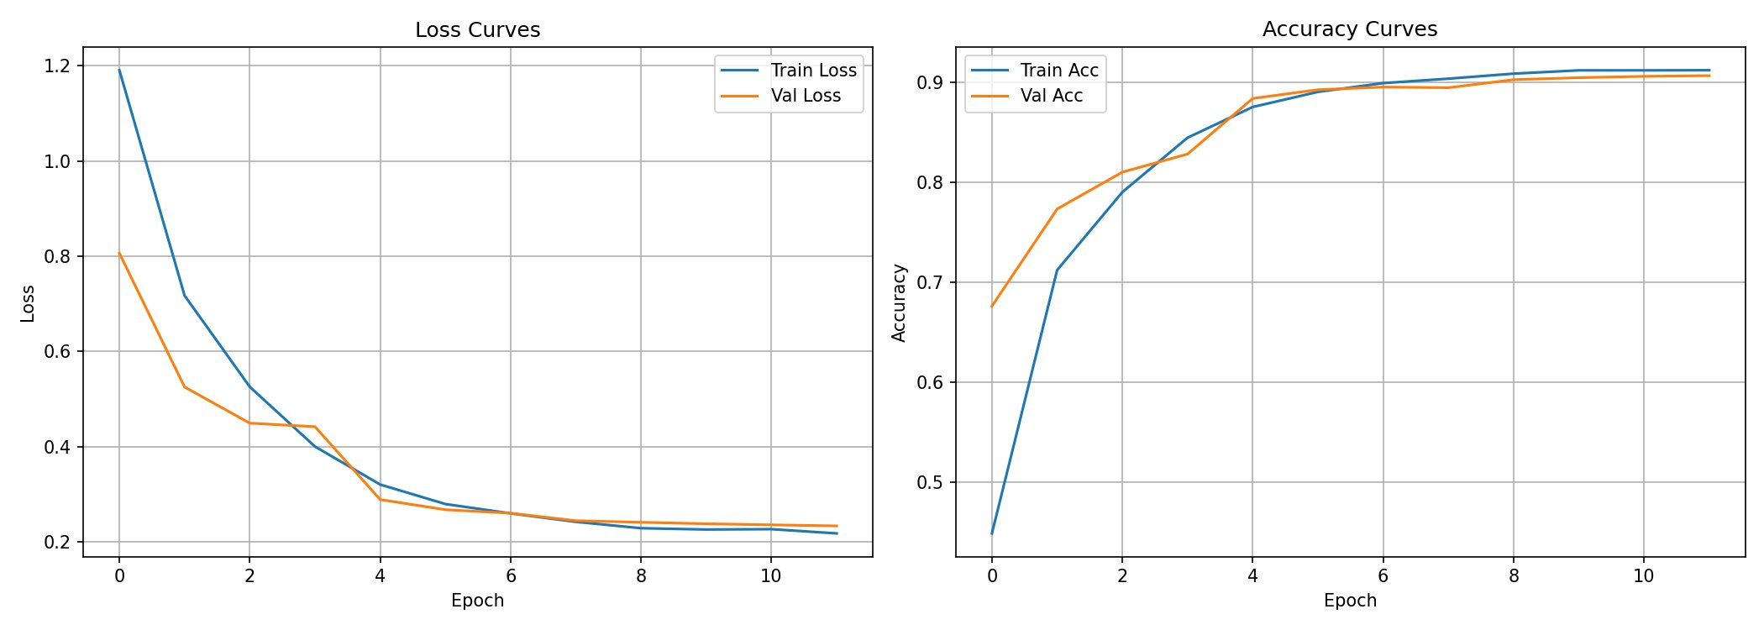
Fig. 1. Training and validation loss (left) and accuracy (right) curves over 11 epochs (sampled from 30-epoch training run).

C. Quantitative Results
Table II reports per-class and weighted-average metrics on the test set (1,494 samples). Overall accuracy is 89.7%. Monocyte and Lymphocyte classification are strongest (F1 = 0.975 and 0.957 respectively), while Eosinophil and Neutrophil are lower due to mutual misclassification (F1 = 0.816 and 0.841). The macro-average AUC-ROC of 0.985 confirms excellent class-level discriminability despite the accuracy gap.

TABLE II. Per-Class Classification Metrics on the Test Set (n = 1,494)
Class | Precision | Recall | F1-Score | AUC-ROC | Support
Eosinophil | 0.814 | 0.819 | 0.816 | 0.968 | 375
Lymphocyte | 0.959 | 0.954 | 0.957 | 0.998 | 372
Monocyte | 0.971 | 0.978 | 0.975 | 0.998 | 372
Neutrophil | 0.844 | 0.837 | 0.841 | 0.975 | 375
Weighted Avg | 0.897 | 0.897 | 0.897 | 0.985 | 1494

D. Confusion Matrix Analysis
Figure 2 presents the confusion matrix for the test set. The dominant error is bidirectional Eosinophil–Neutrophil confusion: 52 Eosinophil samples are misclassified as Neutrophil (13.9% error rate) and 53 Neutrophil samples are misclassified as Eosinophil (14.1%). Lymphocyte and Monocyte achieve recall of 95.4% and 97.8% respectively, with minimal cross-class confusion. This Eosinophil–Neutrophil confusion is a well-documented challenge attributable to overlapping nuclear segmentation patterns and staining variability [12].

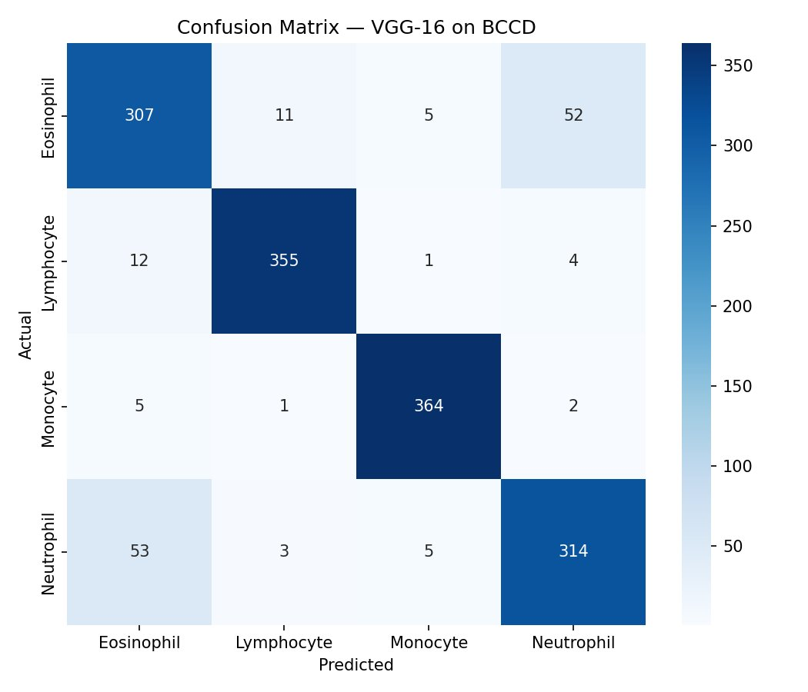
Fig. 2. Confusion matrix on the test set (n = 1,494). Rows: actual class; Columns: predicted class.

E. ROC-AUC Analysis
Figure 3 shows per-class one-vs-rest ROC curves. Lymphocyte and Monocyte achieve near-perfect AUC of 0.998 each. Neutrophil (0.975) and Eosinophil (0.968) are slightly lower, consistent with confusion matrix findings. All classes remain well above the random-chance baseline, validating the model’s probabilistic discriminability even where hard-label accuracy is reduced.

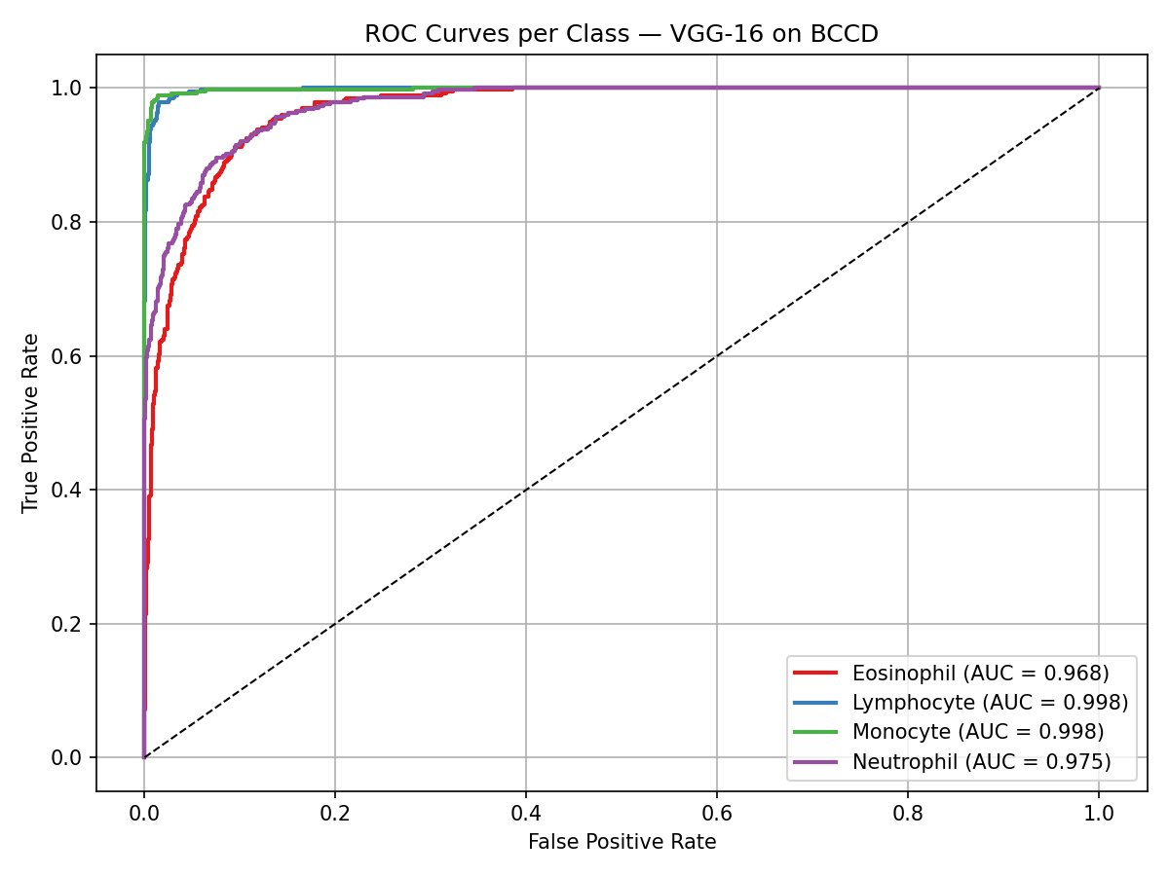
Fig. 3. One-vs-rest ROC curves per cell type. Macro-average AUC-ROC = 0.985.

F. Comparison with Prior Work
Table III benchmarks our results against representative prior approaches. Our model is competitive with CNN-based baselines [9] and achieves a higher AUC-ROC than the ResNet-50 result in [13], though at slightly lower accuracy—likely because we use a frozen extractor vs. full fine-tuning in that work.

TABLE III. Comparison with Prior Methods on Blood Cell Classification
Method | Dataset | Accuracy | AUC-ROC
SVM + HOF [7,8] | BCCD-WBC | ~85% | —
CNN (Shahin et al.) [9] | WBC-12K | ~88% | —
ResNet-50 TL [13] | BCCD | ~91% | 0.97
VGGNet-16 (Ours) | BCCD | 89.7% | 0.985

V. DISCUSSION
The primary finding is that frozen-feature VGGNet-16 transfer learning achieves strong discriminability (AUC = 0.985) at moderate accuracy (89.7%). The gap between AUC and accuracy is explained by the Eosinophil–Neutrophil confusion: the model assigns well-calibrated probabilities that separate these classes at the AUC level, but hard-label assignments near the decision boundary fail due to morphological similarity.
A key limitation is the frozen convolutional backbone. Partial unfreezing of the final convolutional block (Conv5) would allow the network to adapt mid-level features to microscopic image statistics while preserving the regularization benefit of frozen early layers, and is expected to reduce the dominant confusion mode.
The rapid validation accuracy gains in early epochs (Figure 1) confirm that ImageNet pretrained features are immediately useful for blood cell texture discrimination, validating the transfer learning hypothesis despite the domain gap between natural photographs and stained microscopy images.
VI. CONCLUSION AND FUTURE WORK
We presented a reproducible VGGNet-16 transfer learning pipeline for four-class blood cell classification on the BCCD dataset. The frozen-feature model achieves 89.7% test accuracy, weighted F1 = 0.897, and macro-average AUC-ROC = 0.985 using stratified 70/15/15 splits. The dominant error mode—bidirectional Eosinophil–Neutrophil confusion—is consistent with known morphological challenges in automated hematology.
Future directions include: (1) progressive unfreezing of Conv5 layers with cosine annealing; (2) attention-based augmentation targeting the Eosinophil–Neutrophil decision boundary; (3) Grad-CAM visualization for clinical interpretability; (4) benchmarking against lightweight architectures (MobileNetV3, EfficientNet-B0) for edge deployment; and (5) extension to object detection for simultaneous localization and counting.
REFERENCES
[1] M. M. Alam and M. T. Islam, "Machine learning approach of automatic identification and counting of blood cells," Healthcare Technology Letters, vol. 6, no. 4, pp. 103–108, 2019.
[2] A. Shahin, A. Guo, K. Amin, and A. Sharif, "White blood cells identification system based on convolutional deep neural learning networks," Computer Methods and Programs in Biomedicine, vol. 168, pp. 69–83, 2019.
[3] A. Krizhevsky, I. Sutskever, and G. E. Hinton, "ImageNet classification with deep convolutional neural networks," Advances in Neural Information Processing Systems, vol. 25, 2012.
[4] K. Simonyan and A. Zisserman, "Very deep convolutional networks for large-scale image recognition," in Proc. ICLR, 2015.
[5] J. Yosinski, J. Clune, Y. Bengio, and H. Lipson, "How transferable are features in deep neural networks?" Advances in Neural Information Processing Systems, vol. 27, 2014.
[6] P. Mooney, "Blood Cell Images (BCCD Dataset)," Kaggle, 2018. [Online]. Available: https://www.kaggle.com/paultimothymooney/blood-cells
[7] H. Sadeghian, M. Saffar, P. Perseh, and A. Shojaee, "A morphological approach to the segmentation of white blood cells in peripheral blood smear images," in Proc. IEEE ICCIT, 2009, pp. 107–111.
[8] S. H. Rezatofighi and H. Soltanian-Zadeh, "Automatic recognition of five types of white blood cells in peripheral blood," Computerized Medical Imaging and Graphics, vol. 35, no. 4, pp. 333–343, 2011.
[9] A. I. Shahin, Y. Guo, K. M. Amin, and A. A. Sharif, "A deep learning approach for the segmentation and classification of white blood cells," in Proc. IEEE IICAIET, 2019, pp. 1–6.
[10] M. Habibzadeh, M. Krzyzanski, and A. Janowczyk, "Effect of data augmentation on CNN-based blood cell classification," Journal of Digital Imaging, vol. 32, 2019.
[11] F. Zhuang et al., "A comprehensive survey on transfer learning," Proceedings of the IEEE, vol. 109, no. 1, pp. 43–76, 2021.
[12] A. Acevedo, A. Merino, S. Alferez, A. Molina, L. Boldu, and J. Rodellar, "A dataset of microscopic peripheral blood cell images for development of automatic recognition systems," Data in Brief, vol. 30, 2020.
[13] Z. Jiang, X. Dong, L. Wang, and X. Jiang, "Method for diagnosis of acute lymphoblastic leukemia based on ResNet50 model with transfer learning," IET Image Processing, vol. 15, no. 3, pp. 643–651, 2021.
[14] T. Tran, "Leveraging machine learning in the smart microscopy pipeline for blood smear analysis," arXiv preprint arXiv:1904.09124, 2019.
[15] A. Vaswani et al., "Attention is all you need," Advances in Neural Information Processing Systems, vol. 30, 2017.
[16] A. Dosovitskiy et al., "An image is worth 16×16 words: Transformers for image recognition at scale," in Proc. ICLR, 2021.

