TDT4230: Graphics and Visualisation assignment 2

Task 1

k)

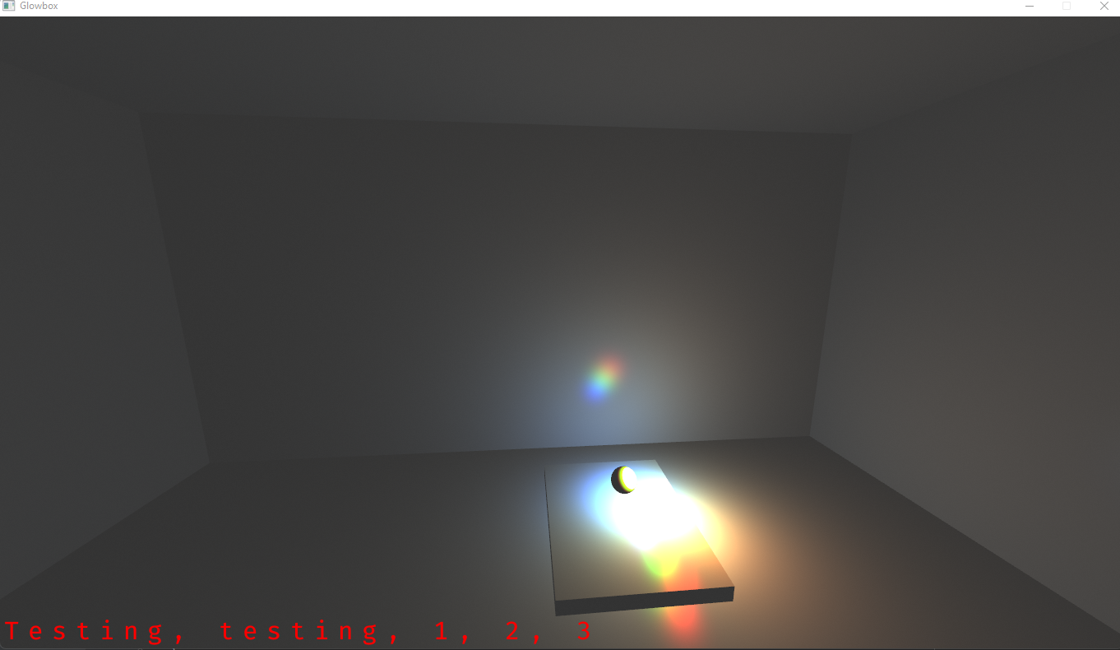

Forgot to activate the shader before sending the ball and camera position, so there where no shadows when I took the picture.

Task 2

1. Interpolation is non-linear because we use a perspective projection. When doing this the ratios between objects are distorted. This is because in a perspective projection matrix the coordinates are divided by z. So, the smaller value of z the closer to the camera the object is and vice versa.
   1. A displacement map is used to change the position of the vertices in a mesh. In our assignment the walls do not have enough vertices for this.
   2. By increasing the number of vertices.
2. When zooming out the mipmaps used for the triangles becomes smaller and smaller. At some point the sampling rate for creating the mipmaps is to low and the red and the green will start to overlap.

Task 3

f)

j)

