I suggest you use IE11 test.

1. First you need use Local computer to access this link:

http://localhost:8080/#/peer7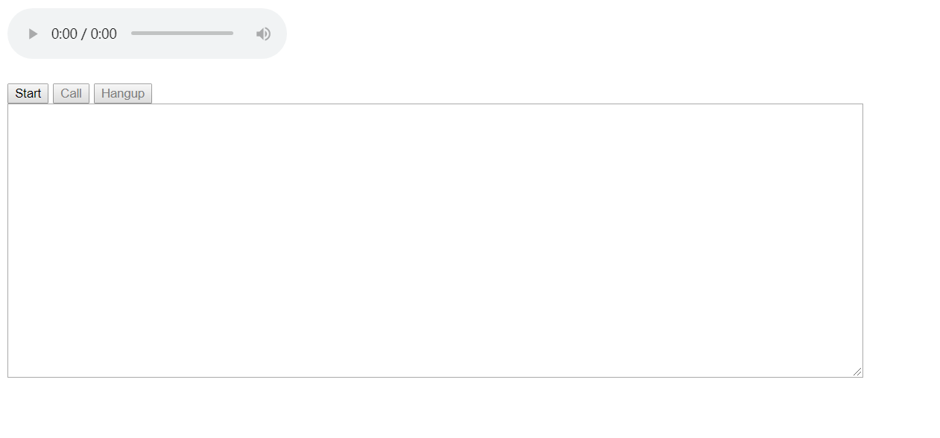

1. Then you open the chrome:

http://localhost:8080/#/peer8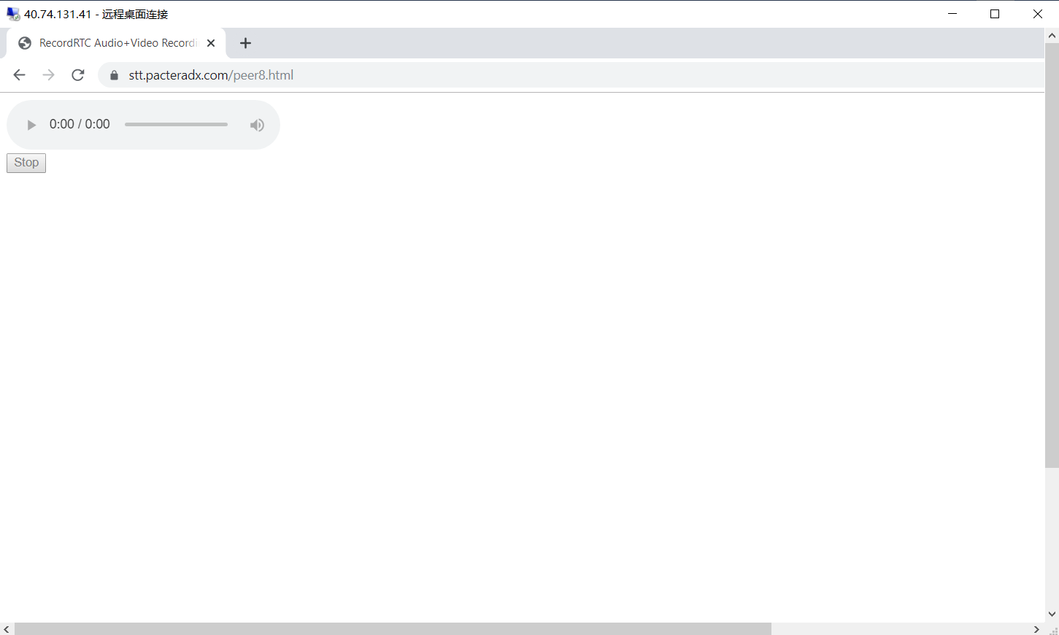

1. Notice: Before testing this demo, you must click on the space of the player first, otherwise the test will fail.

Or you can run this command with administrator:

chrome.exe --disable-features=PreloadMediaEngagementData,AutoplayIgnoreWebAudio,MediaEngagementBypassAutoplayPolicies

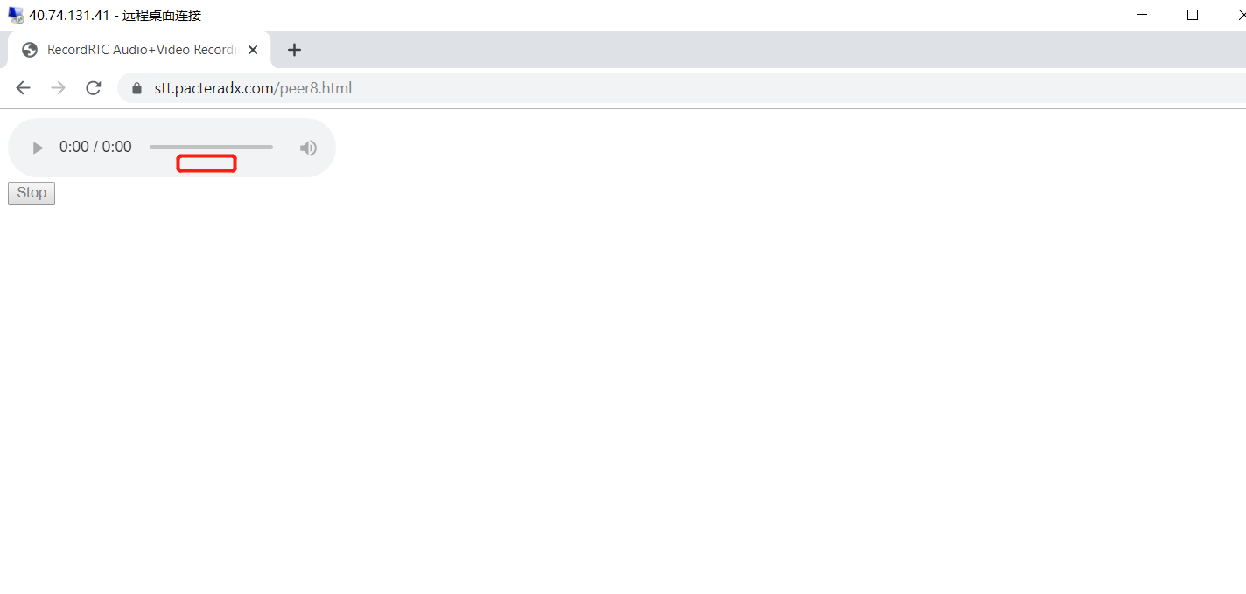

1. Click the “start”button on the peer7.

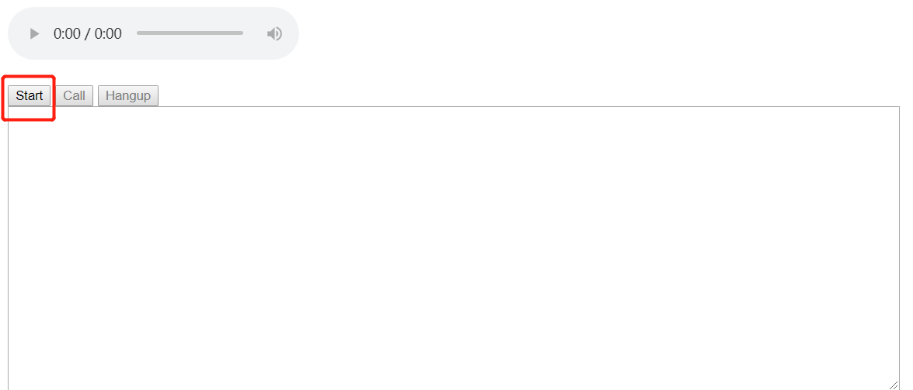

1. Then click the “call”button on the peer7.

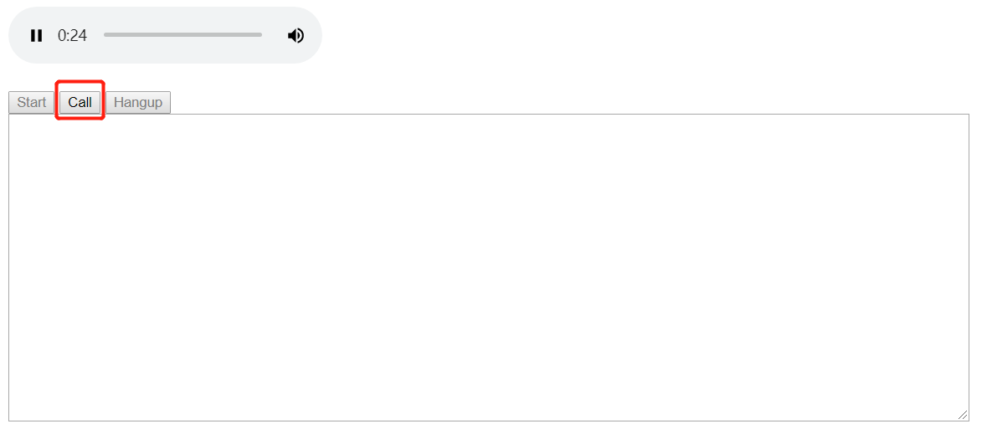

1. You can talk to test.

