About Me

My name is J. Sai Ganesh, and I am a Computer Science and Engineering student specializing in robotics at VIT Amaravati. Since my school days, I have been passionate about exploring new technologies. This interest led me to become the president of the science club, where I explored and showcased various technologies such as drones, robotics, and floating islands.

I have completed several courses and projects in robotics, web applications, and marketing. Notably, I led a team in developing a self-driving robot prototype for a project called ECS. I am proficient in programming languages like Python and Java, as well as web technologies such as HTML, CSS, JavaScript, and PHP.

I want to do this internship to develop myself in various fields and apply the knowledge effectively when needed. My long-term goal is to excel as a software engineer and entrepreneur, leveraging my technical skills and innovative mind-set to solve real-world challenges.

About Project

This project focuses on the critical aspects of a business's supply chain by analyzing a wide range of data tables related to various operations. The goal is to extract meaningful insights from the data and present them in a structured manner using a Power BI dashboard. The dashboard will provide a multi-faceted view of the supply chain's performance, helping stakeholders identify opportunities for improvement and make data-driven decisions.

Key Data Points:

The project will consider data from multiple areas of the supply chain, including but not limited to:

Product Information: Types, SKUs (Stock Keeping Units), and pricing details.

Inventory and Stock: Availability, stock levels, and lead times.

Sales and Revenue: Total revenue, total products sold, and customer demographics.

Logistics and Shipping: Shipping details, costs, and transportation modes.

Production and Quality: Production volumes and defect rates.

Supplier Metrics: Supplier details and their performance metrics.

Objectives:

The primary objectives of the project are to:

Assess Revenue Performance: Analyze total revenue, identify top-performing products, and understand customer purchasing patterns.

Optimize Manufacturing and Inventory: Calculate average manufacturing costs, evaluate stock levels, and identify inefficiencies in production or supply.

Improve Supply Chain Metrics: Examine shipping costs, lead times, and defect rates to enhance overall supply chain performance.

Power BI Dashboard:

A visually engaging Power BI dashboard will be developed with three pages, each focusing on a specific dimension of the supply chain:

Revenue Analysis: Highlight total revenue, most selling products, and customer trends.

Supply Chain Performance: Showcase metrics like stock levels, lead times, shipping costs, and supplier performance.

Defect and Quality Analysis: Present defect rates, their impact on performance, and ways to reduce quality issues.

By combining robust data analysis with intuitive visualizations, this project aims to deliver actionable insights for optimizing the supply chain. Stakeholders will gain a clear understanding of the current performance and areas for enhancement, paving the way for increased efficiency and profitability. Let's dive deeper to explore the specific aspects and tools involved in this project.

Learning Objectives

By the end of this activity, students will understand:

- Basics of data analytics, Power BI, and key related concepts.

- Insights from a case study on Sustainable Supply Chain Performance.

- How to analyse:

- Total revenue by product type and SKU.

- Average defect rates by product type.

- Revenue generated by suppliers and carriers.

- Percentage of sales and total price by transportation mode.

- Total products sold by shipping carriers.

Power BI

Power BI is a powerful business analytics tool developed by Microsoft that allows users to connect to various data sources, transform raw data into meaningful insights, and create interactive visualizations and reports. It supports real-time data monitoring and enables easy sharing of dashboards across teams.

In this project, Power BI is used to analyze supply chain data, identify key performance metrics like revenue, defect rates, and shipping costs, and present the insights through an interactive three-page dashboard. This enables stakeholders to make data-driven decisions for optimizing supply chain performance.

In **Power BI**, the tools for data handling include:

* **ETL (Extract, Transform, Load)**: A process to prepare data for analysis.
  + **Extract**: Import data from various sources like databases, files, or APIs.
  + **Transform**: Clean and reshape data (e.g., removing duplicates, changing formats) using Power Query.
  + **Load**: Save the processed data into Power BI for visualization and analysis.

These tools streamline data preparation, ensuring accurate and efficient reporting.

overview of the key features and buttons in Power BI:

**1. Home Tab**

* **Get Data**: Import data from multiple sources.
* **Transform Data**: Open Power Query for cleaning and shaping data.
* **Publish**: Share reports to the Power BI Service.

**2. View Tab**

* **Bookmarks**: Save report views for navigation.
* **Sync Slicers**: Synchronize slicers across pages.
* **Themes**: Apply visual themes to reports.

**3. Insert Tab**

* **Visualizations**: Add charts, tables, maps, and custom visuals.
* **Text Box/Shapes/Images**: Include text, images, or shapes.
* **Buttons**: Add interactive navigation buttons.

**4. Modeling Tab**

* **New Measure/Column/Table**: Create calculated fields or tables.
* **Manage Relationships**: Define relationships between tables.
* **Formatting Options**: Adjust data type and formatting.

**5. Data Pane**

* View and explore imported data tables and fields.

**6. Report Pane**

* Design and visualize interactive reports and dashboards.

**7. Visualizations Pane**

* Add or modify visual elements (e.g., charts, slicers).

**8. Filters Pane**

* Apply filters at visual, page, or report levels.

**9. Power Query Editor**

* **Query Editor**: Clean, combine, and transform data.
* **Applied Steps**: Track and edit transformation steps.

**10. File Menu**

* Save, export, or open files and manage settings.

These features enable data import, transformation, visualization, and sharing in Power BI.

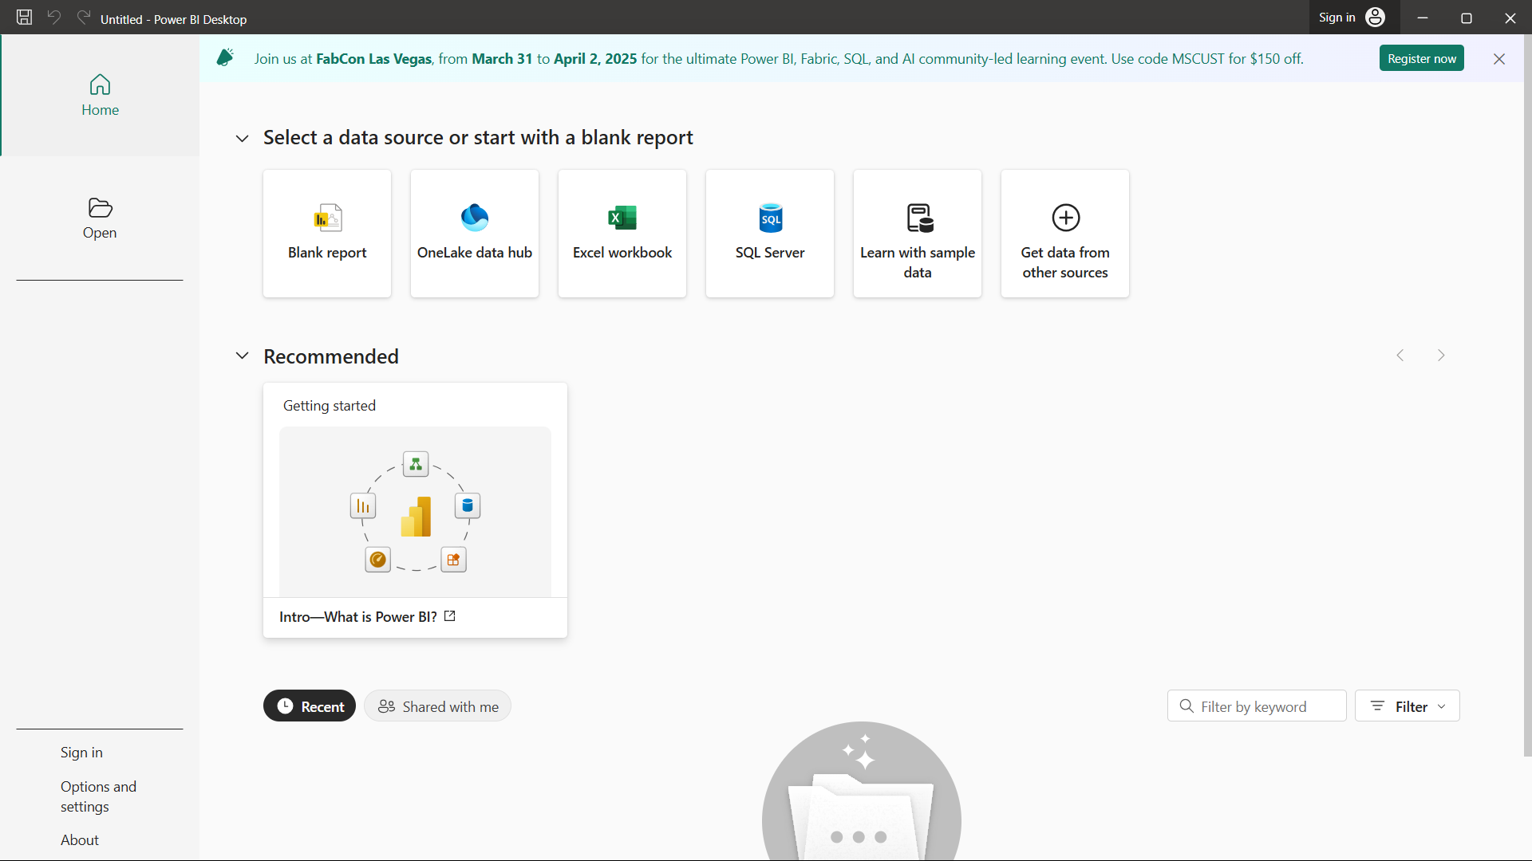

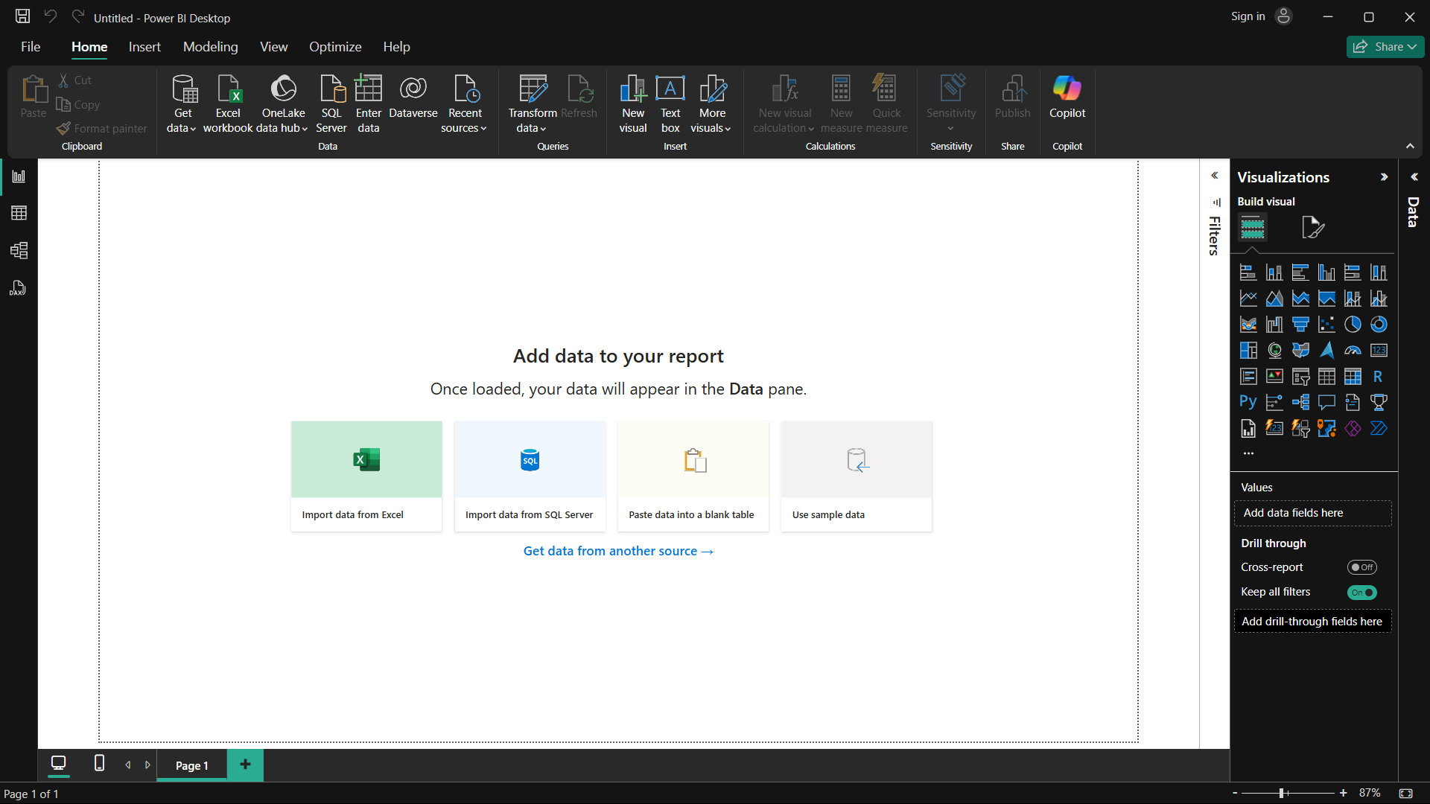

Lets Load data in Power BI

Steps to load a CSV file in Power BI:

1. Click on **"Home"** > **"Get Data"** > **"Text/CSV"**.
2. Browse and select your CSV file.
3. Preview the data in the dialog box and click **"Load"**.
4. The data is now added to Power BI for analysis.

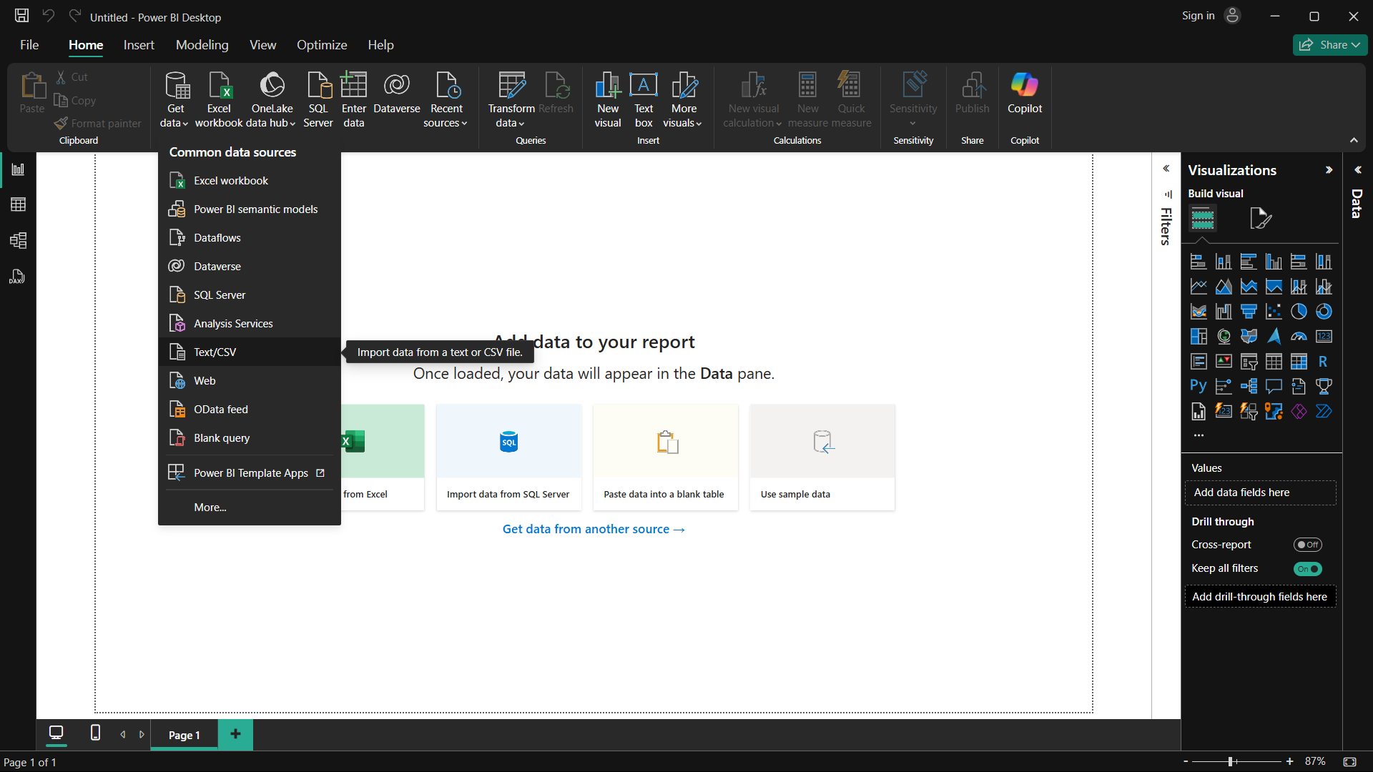

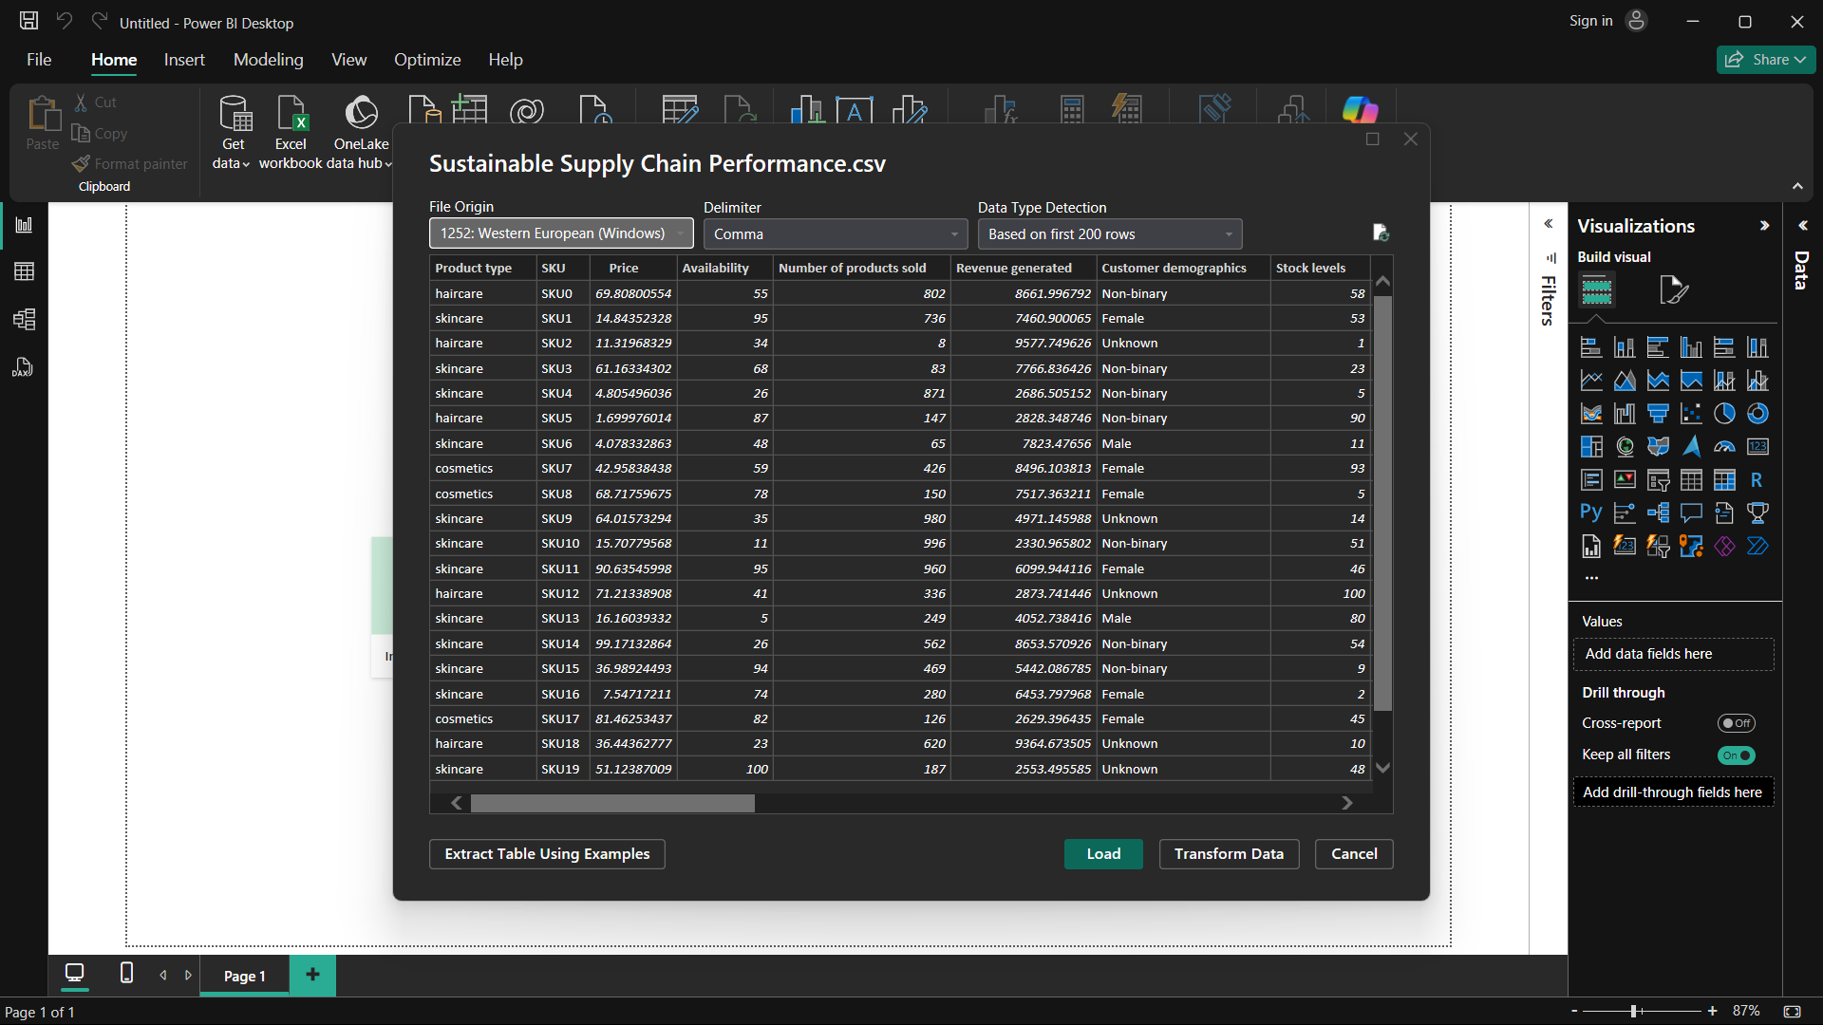

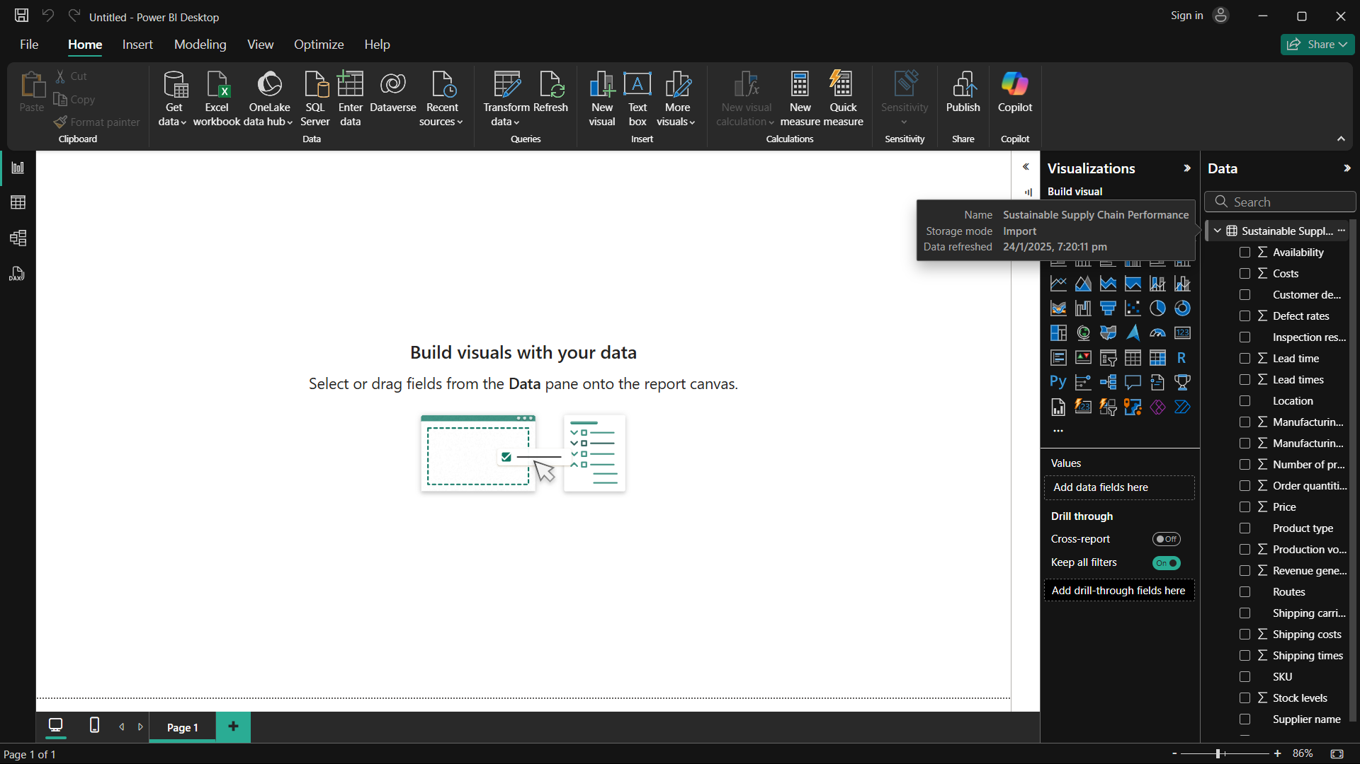

Table view

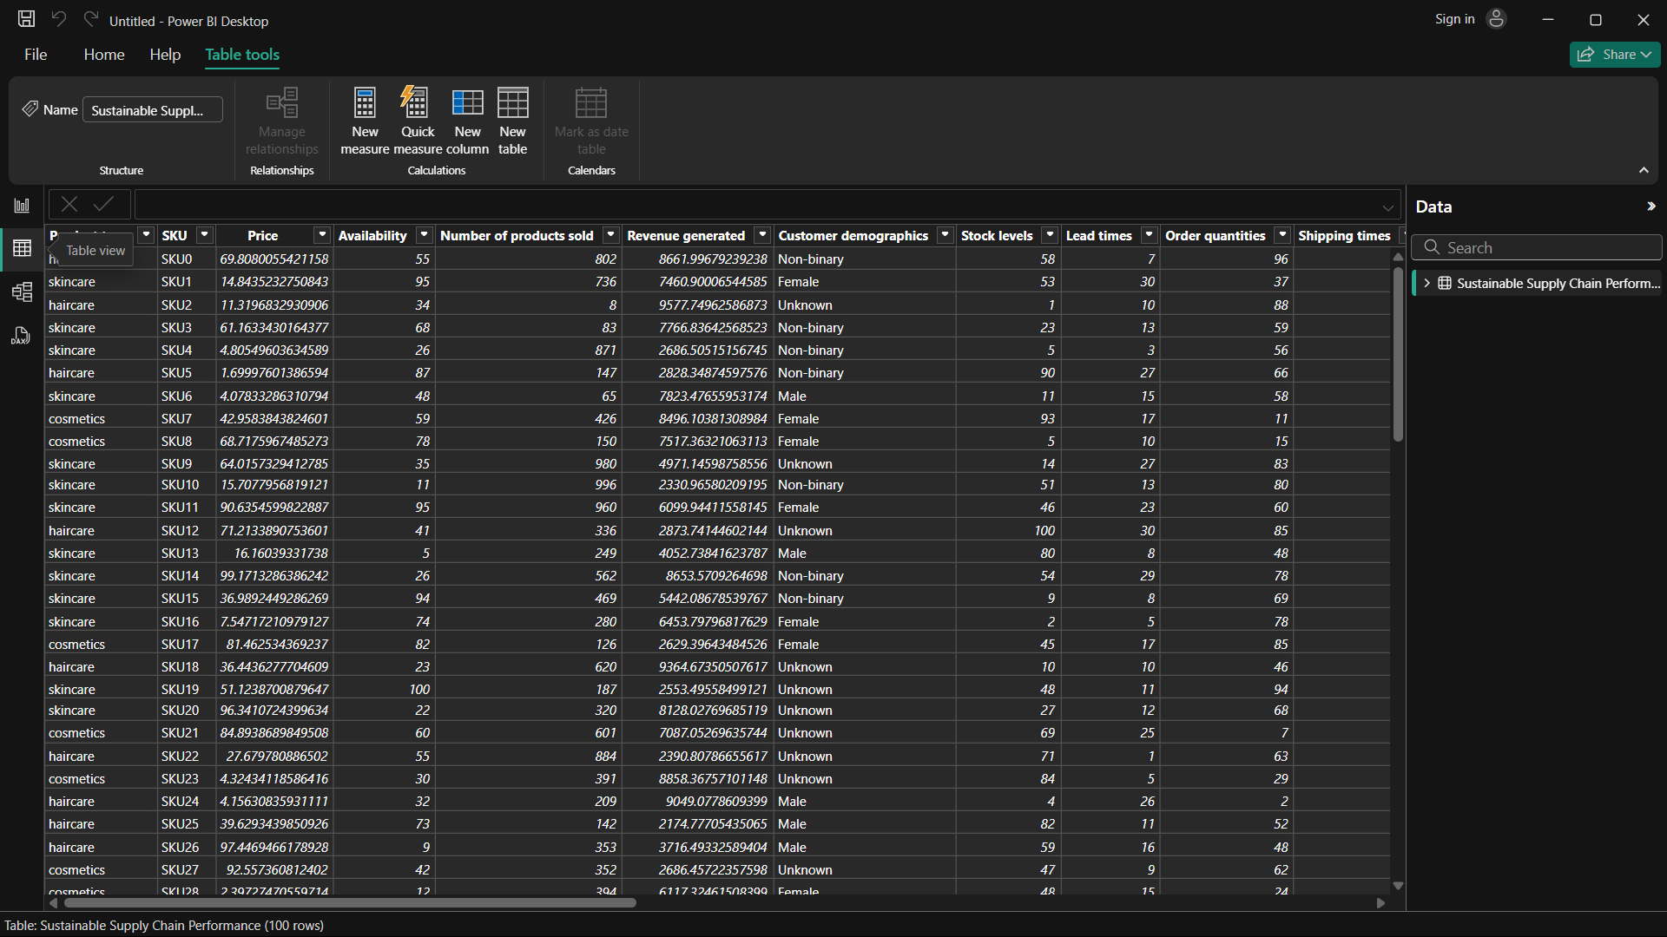

Model View

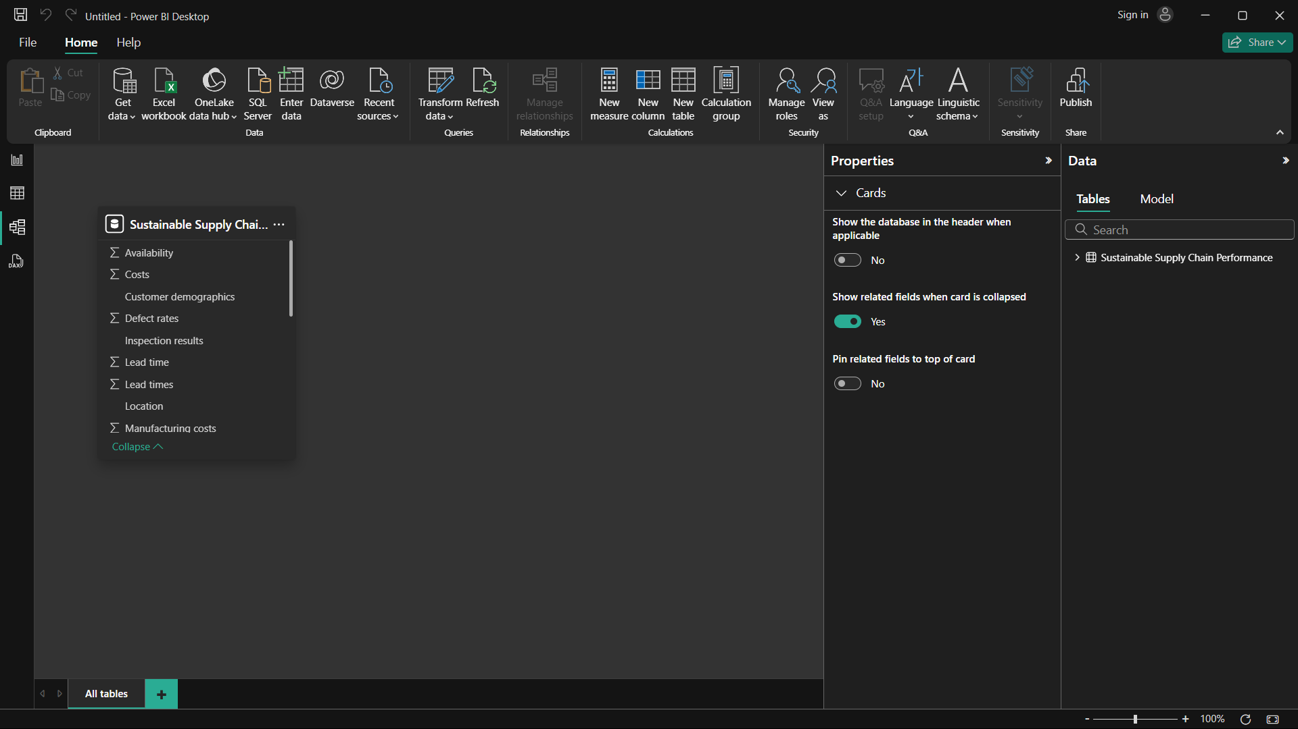

After creating all the tables

