­­­

**National University of Singapore**

**ES2531/ES1531 Critical Thinking and Writing**

**Assignment 2**

**2020/2021 Semester 2**

Renewable and Sustainable Energy in Singapore:

Enhancing Solar Energy Capabilities to Meet High Energy Demands

Wang Zizhen (A0201496H)

Yeo Rhi Khin (A0200764M)

See Hak Guan, Alfred (A0199642N)

Goh Kheng Xi, Jevan (A0199806L)

**Declaration**

We declare that we have taken the plagiarism quiz, understand what plagiarism is and have ensured that this assignment is our own work and does not involve plagiarism. The sources of other people’s work have been appropriately acknowledged.

**Signatures**

WZZ, YRK, SHGA, GKXJ

**Date:** 19 March 2021

ARGUMENT FRAMEWORK

|  |  |  |  |
| --- | --- | --- | --- |
| **MAIN/OVERALL CLAIM: The use of solar energy as a renewable energy source in Singapore is currently inadequate to meet the increasing local demand for energy. Hence, there is a need to develop sustainable methods to provide solar energy more efficiently.** | | | |
| **KEY ARGUMENT 1**  **(PROBLEM)** | **KEY ARGUMENT 2**  **(CAUSES)** | **KEY ARGUMENT 3**  **(CURRENT MEASURES)** | **KEY ARGUMENT 4**  **(PROPOSED SOLUTION)** |
| Claim:  Singapore has a high energy consumption, and renewable energy sources, including solar energy is currently inadequate and unsustainable in Singapore. | 1. Space Constraints      1. Intermittence generation | Criterion 1: power generated per unit area    Criterion 2: Reliability of power generated     1. EDB and PUB’s floating photovoltaic project to pilot solar panel installations on water      1. Smart grid system for efficient energy distribution.      1. Import of solar energy from Australia (Sun Cable) | 1. Single-axis and double-axis tracking systems  * Allows photovoltaic panels to track the sun, increasing energy output and improving intermittency  1. Installing of Non-Tracking Planar Concentrators (Mirrors)  * Redirect solar energy * More space efficient * -Improves intermittency      1. Photovoltaic cells on current infrastructures (roads and railrway tracks) |
| Premises:    In 2020, the energy consumption per capita is 7,680 kWh. [High energy compared to the global average of 3000kWh per capita in 2017]. However, the power produced by renewable sources is only 350 MWp in 2020.    Singapore is heavily reliant on imported energy (fossil fuel, natural gas), as Singapore has no natural resources.    Other renewable sources in Singapore apart from solar energy is currently not feasible due to land constraints (no space for wind turbines, bioenergy), lack of rivers and narrow tidal range (for hydropower / wave and tidal energy), and dense population (unsafe for nuclear risks)    However, solar energy only contributes 0.05% of Singapore’s energy consumption (2019).    Although Singapore is a small country, it is ranked 27th globally in per capita emissions [High contributor to global greenhouse gas emissions → Global warming?]    In 2019, renewable sources only contribute 0.24% of our energy consumption,   * Solar energy (0.05%) - largest renewable source in Sg. * Other renewables (total 0.19%) include ~~nuclear, hydropower, wind~~, geothermal, wave and tidal and bioenergy   while non-renewable sources (fossil fuels) contribute 99.76%   * Oil (86.10%) * Gas (12.92%) * Coal (0.74%)     The burning of fossil fuels for non-renewable energy is a problem:   * Top contributor (~75%) of global greenhouse gas emissions, which adds to global warming. * Major source of air pollution, leading to over five million premature deaths globally every year. | Premises     1. Cost of land in Singapore is expensive, and only 40km square is deployable for solar energy.      1. Energy output is not consistent due to cloudy weather. Urban landscapes also undermine the ability for solar panel installation. Type of building affects the deployment of solar panels, as the roof might not be suitable for installation. | Premises:     1. Does not use land space, however, it requires a large water space which can also affect our maritime activities.      1. Smart grid allows for two-way communication between energy produced and energy used. This allows for better integration of renewable energy.      1. Importing energy is not sustainable and is just a temporary solution. It Does not require any land space but is neither sustainable nor reliable. | Premises:     1. Single axis tracking systems produces approximately generates 19% more energy than fixed photovoltaic systems 2. Non-tracking planar concentrators (which requires less space than solar panels) can be deployed around Singapore to increase the solar energy output. According to a Bi-Directional Reflectance Function (BDRF) Based Modelling done by Queen’s University and Michigan Technological University, installation of non-tracking planar concentrators can increase photovoltaic system performance by up to 30%. Installation of the concentrators also requires a much lesser space compared to installation of solar panels.      1. Roads in Singapore currently occupy 12% of our land. By using solar panels as the road’s surface, no additional land space is required. A 70-meter-long bicycle path in the Netherlands was paved with solar panels and currently generating 3000kWh. |

Renewable and Sustainable Energy in Singapore:

Enhancing Solar Energy Capabilities to Meet High Energy Demands

Wang Zizhen, Yeo Rhi Khin, See Hak Guan Alfred, and Goh Kheng Xi Jevan

# Introduction

From household appliances to our complex train system, Singapore is a highly technologically advanced nation. A large magnitude of energy is then required for the heavy reliance on technology. While sourcing out energy production is important, it is also necessary to recognise and reduce any negative consequences in energy generation. One way to do this is through solar power exploitation. Unlike using fossil fuels, nuclear energy, and biomass geothermal, solar power exploitation generates energy while minimising any environmental concerns such as greenhouse gases. It is commonly known that in Singapore, there are more days with sunshine than not, which highly suitable for solar power generation. Therefore, my group and I propose to maximise both the area of solar panel deployment in Singapore and the energy generation from each solar panel in order to sustain a large amount of energy the country requires while minimising any environmental concerns.

# Problems

In an extensive study, petroleum and natural gases have been excessively used to produce energy in recent decades, and renewable energy such as solar energy is only being consumed below 0.1% in Singapore.

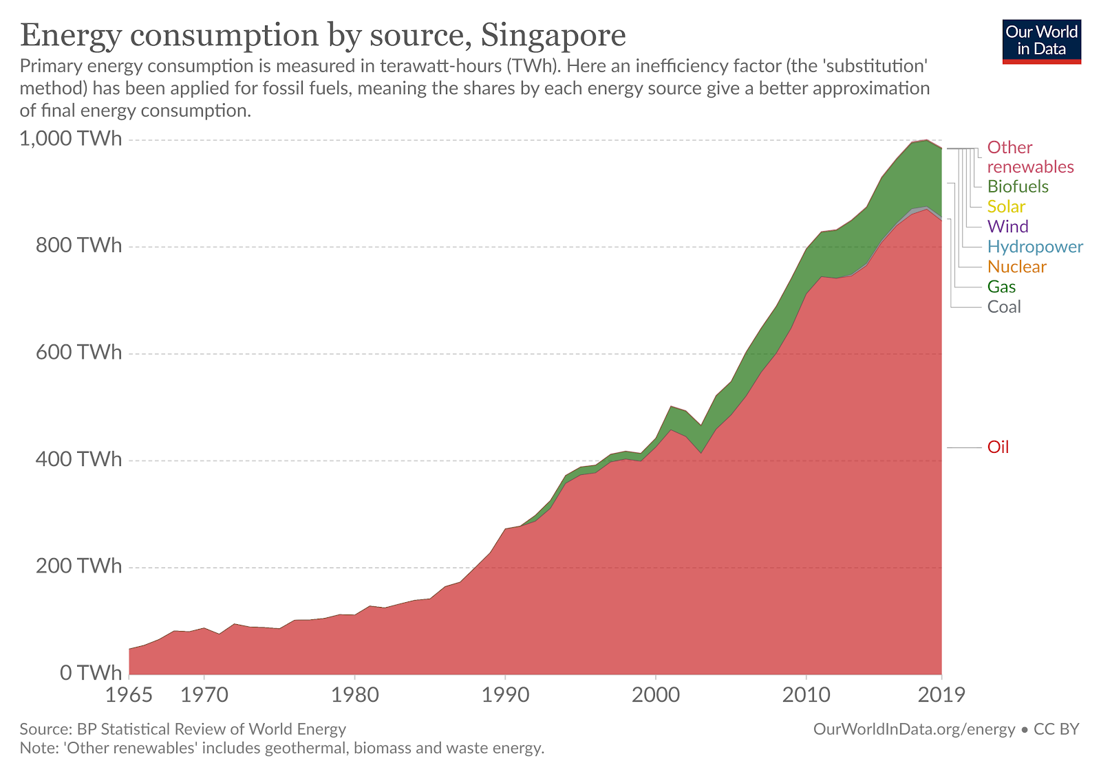

With Singapore being one of the sunniest countries [1], the use of our excessive sunny weather should be highly optimised in the production of energy through solar energy exploitation. To maximise collaborative effort in global sustainability, renewable energy such as solar power needs to be more prominent. If the rate of consumption of natural resources remains unchanged, these resources including oil, coal, and gas will deplete approximately 35, 107, and 37 years, respectively [2] and even faster in countries that are moving towards a technological nation. The lack of resources will affect the overall human survivability in the future and be unable to support the current lifestyle and technological developments. Apart from the resource crisis, energy generation creates 33.1% of carbon dioxide emission [3] which worsens the effects of global warming. In turn, this creates a domino effect starting with more natural disasters, such as floods and forest fires. This then leads to the extinction of animals, due to the destruction of habitats and food resources, and the melting of ice in the north pole [4]. The heavy reliance on technology in Singapore results in high energy consumption of 7680kWh per capita [5] as compared to a global average of 3000 kWh [6], which potentially creates concerning consequences to Singapore and in turn the world. Energy production through solar power should then be implemented in response to the high need for energy in Singapore as well as an effort to lower overall greenhouse gas emission. It will also help Singapore to be more self-reliant, as the main energies were imported [7].

|  |
| --- |
| [1] A. Doyle, "World's sunniest spots hint at energy bonanza," OSLO (Reuters), 28 November 2007. [Online]. Available: <https://www.reuters.com/article/environment-climate-solar-dc-idUKL237687620071128?edition-redirect=uk>. [Accessed 19 March 2021]. |

[2] S. Shafiee, "When will fossil fuel reserves be diminished?," *Energy Policy,* vol. 37, no. 1, pp. Pages 181-189, 2009.

[3] IEA (International Energy Agency) (2019), Global Energy & CO2 Status Report 2019, IEA, Paris <https://www.iea.org/reports/global-energy-co2-status-report-2019> [Online].

[4] M. Denchak, "Are the Effects of Global Warming Really that Bad?," NRDC (Natural Resources Defense Council), 15 March 2016. [Online]. Available: <https://www.nrdc.org/stories/are-effects-global-warming-really-bad>.

[5] CIA world factbook, "Electricity consumption per capita - World," Indexmundi, 1 January 2020. [Online]. Available: <https://www.indexmundi.com/map/?v=81000>.

[6] A. Kahan, "Global electricity consumption continues to rise faster than population," Energy Information Administration (EIA), 15 June 2020. [Online]. Available: <https://www.eia.gov/todayinenergy/detail.php?id=44095>.

[7] "Energy Supply," Energy Market Authority (EMA), 2019. [Online]. Available: <https://www.ema.gov.sg/singapore-energy-statistics/Ch01/index1>.

# Causes

The causes of not fully utilizing the solar energy as the main power supply in Singapore are:

**Insufficient vast open spaces for solar PV installation due to land scarcity.**

To generate electricity effectively by using light energy, the photovoltaic modules need to be placed at vast open spaces under the sun directly. However, Singapore lacks vast open spaces to build large solar arrays as most of the land is occupied by buildings, roads and protected green spaces. According to Singapore Energy Market Authority, at least 158km2 of panel surface area is required to generate 97% of Singapore’s current electricity need while the total land of Singapore is 710km2 [1]. However, it is unrealizable to use such a large area for solar PV installation, as the land is needed to build buildings, road, and protected green spaces.

The solar PV systems are commonly installed on the rooftop area in commercial, industrial public residential buildings, and private residential buildings. According to the analysis done by Singapore Land Authority (SLA), it is estimated that a total HDB rooftop area of 6,337,360 m2 to 7,779,890 m2 is available for solar PV installations [2]. Based on the Solar Repository data for crystalline technology, the solar PV systems have an average conversion efficiency of 14% - 15%, hence generating approximately 856 MW to 1050 MW solar capacity, accounting for 8.9% to 11.7% of Singapore’s total installed power generating capacity as of 31st March 2011 [2]. This data indicates that it is not achievable for Singapore to fully rely on solar energy due to insufficient solar PV systems installation spaces

**Solar PV systems are intermittence generation**

The solar PV is a weather conditions dependent energy source, so the desired output might not be able to be achieved all the time. The output of solar PV is mainly dependent of the weather conditions such as the intensity of sunlight and the amount of cloud [3]. For example, during the raining seasons, the solar PV is not able to generate large amount of electricity due to insufficient sunlight, hence resulted in blackouts. On cloudy and rainy days, the solar PV panels are able to generate approximately 10-25 % of their optimal capacity, depending on how the bad the weather condition is [4]. The “wet phase” of the Northeast Monsoon, which is on December and January, witnesses continuous moderate to heavy rainfall in the afternoons, therefore greatly affects the output of solar PV systems. Apart from that, the output of the solar PV systems is not consistent due to inconsistency of position of the sun on a typical day [5]. Hence, the solar photovoltaic panels are only able to generate electricity during a certain period which during daytime. 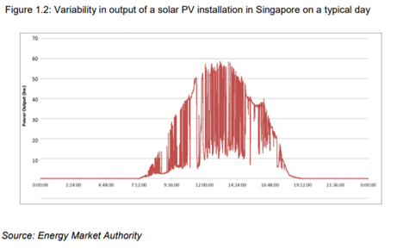

While the position of the sun is not fixed throughout the year, the optimal angle of the photovoltaic panels for the system changes. Consequently, the efficiency of the photovoltaic panels is not maximized all the time throughout the year [6].

**References**

[1] A. Quek, A. Ee, A. Ng, and T. Y. Wah, “Challenges in Environmental Sustainability of renewable energy options in Singapore,” *Energy Policy*, vol. 122, no. August, pp. 388–394, 2018.

[2] T. K. Doshi, N. Sebastian D’Souza, L. Nguyen, H. G. Teo, and N. Bin Zahur, “The Economics of Solar PV in Singapore,” *GSTF J. Eng. Technol.*, vol. 2, no. 1, 2013.

[3] D. S. Energy, “Deploying Solar Energy in Singapore Facilitating the Entry of Solar Energy into Singapore,” *Energy Mark. Singapore*, pp. 10–12.

[4] Palmetto Solar, “Solar Panel Efficiency in the Rain - Renewable Energy World.” 2016.

[5] Energy Market Authority, “Enhancements To the Regulatory Framework for Intermittent Generation Sources in the National Electricity Market of Singapore,” no. February, pp. 1–16, 2014.

[6] “This Is How The Sun Moves In The Sky Throughout The Year.” 2019.

# Current Measures

**Solar panel installation on water**

Acknowledging Singapore’s limited land and the large amount of open space needed for solar PV installation, Singapore’s national water agency – Public Utilities Board (PUB) along with Sembcorp Industries has begun the construction of a floating solar farm consisting over 32 hectares of double-glass solar PV modules at Tengeh Reservoir. [1] This solar system is expected to provide 60-megawatt peak (MWp) of clean energy. Additionally, smaller 1.5 MWp solar PV systems has also been installed at other reservoirs in Singapore such as Bedok reservoir and Lower Seletar Reservoir [1]. While this figure is claimed to have the potential to generate power equivalent to 16,000 four-room HDB flats and offset 32 kilotons of carbon emissions which amounts to around 7,000 cars yearly [2], it is far from Singapore’s renewable energy plan to hit a 1.5 gigawatt-peak (GWp) solar energy deployment by 2025 [3]. The system also has limited reliability as it does not address the problem of intermittence generation. In addition to weather conditions reducing the intensity of sunlight available, the location where the solar system is being installed is accessible to wildlife, and various animals such as birds and sea otters have been found to be resting on the solar panels [4], further reducing the amount of sunlight captured and consequently the solar energy generated.

**Energy storage systems**

To address solar intermittency, energy storage systems (ESS) has been implemented to store energy for later use. An ESS works by converting the electrical power generated from solar energy into chemical energy using an electrochemical battery typically made of lithium ion or lithium-iron-phosphate [5], and then storing the chemical energy in the battery. This energy may then be converted and discharged as electrical power at a later desired time. This allows the solar PV systems to capture solar energy and store the energy when not in use or when demand for electricity is lower such as during daylight. Subsequently, when the solar systems are unable to capture steady sunlight due to weather conditions, the ESS which already has solar energy stored may be activated to discharge its energy for usage. As ESS are Deployed in 2020, Singapore’s first utility-scale ESS has a capacity of 2.4MWh which enables the powering of around 200 four-room HDB flats daily [6]. While ESS tackles the solar intermittency issue by providing a system to store and draw energy when needed, it does not address the core problem of capturing less solar energy during undesirable weather conditions. With Singapore’s current low generation of solar power, solar energy may not even be stored in the first place as it would be rapidly consumed. Additionally, ESS batteries have limited storage capacities, and a large ESS cell will be required to have significant storage capacity [7]. This however requires big deployment spaces, which may instead be used to install more solar PV systems, and puts further pressure on the land scarcity problem that Singapore is facing.

**Import of solar energy from Australia**

The final measure that Singapore currently has in plan is to import solar power from Australia. Sun Cable, the leading company for this project, plans to build a 10 GWp solar farm in Tennant Creek, Australia, and transmit the power generated from this solar farm to Singapore via a 4,500km network of subsea high voltage, direct current (HVDC) cables [8]. The massive deployment area of 150km2­ [9] would already amount to the panel surface area needed in Singapore to generate 92% of its current electricity demands. The deployment location also has a high solar insolation level of an average 6.25 kWh per square metre per day, approximately 1.5 times higher than Singapore, increasing solar output and reliability. Hence, Tennant Creek’s solar farm’s ideal conditions and the import of energy from Tennant Creek effectively tackles both the land scarcity problem and solar intermittency problem that Singapore currently faces. However, this measure presents considerable challenges. For one, the subsea HVDC cable transporting the energy will be one of the longest ever subsea cable constructed, which makes deep-water installation and maintenance very costly and time consuming. The earliest projected date for the implementation phase to commence is at least a decade later. The subsea cable will also be exposed to man-made hazards such as hooks from heavy fishing activities and existing cables along the congested seabed, and natural stresses and strains from deep water pressure that may compromise its structural integrity. Additionally, a solution that relies on import can be questionable in the long run, as it may lead to dependency on other countries. This measure has a parallel to the Singapore-Malaysia water agreements, where Singapore was reliant on imported water from Malaysia to meet about half of its water demands from 1961 to 2011. However, bilateral relations between the two countries were affected when agreements could not be met, and subsequently, the 1961 Water Agreement was not renewed, leaving Singapore to find other self-sufficient methods to meet its water demands. Therefore, imports should only be a temporary solution, and while importing solar energy may help to meet solar energy demands in the short run (albeit only once it has been implemented), it should merely supplement Singapore’s solar energy generation and not be Singapore’s key method of resolving its high solar energy demands.

**References**

[1] Public Utilities Board, “Annual Report 2019/2020: Make Every Drop Count,” Singapore, 2020.

[2] J. Lim, “One of world's largest floating solar farms coming up in Tuas,” The Straits Times, Singapore, 2020.

[3] Singapore Green Plan, “Introducing the Green Plan,” 19 March 2021. [Online]. Available: https://www.greenplan.gov.sg/.

[4] Z. Zheng and S. Thiagarajan, “Floating solar systems in S'pore provide clean energy but impacts on wildlife have to be considered,” Mothership, Singapore, 2021.

[5] B. Sanchez, “How does an Energy Storage System (ESS) work?,” Electriq Power, 27 July 2020. [Online]. Available: https://electriqpower.com/2020/07/how-does-an-energy-storage-system-ess-work/#:~:text=The%20most%20common%20source%20of,the%20commercial%20and%20residential%20sectors..

[6] Energy Market Authority, “Energy Storage Solutions Deployed in Singapore For a More Sustainable Future,” 22 October 2020. [Online]. Available: https://www.ema.gov.sg/media_release.aspx?news_sid=20201021tjiKAqWWba6H.

[7] Energy Market Authority, “Handbook for Energy Storage Systems,” n.d.. [Online]. Available: https://www.ema.gov.sg/cmsmedia/Industry-Partners/ESS/Handbook-for-Energy-Storage-Systems.pdf.

[8] S.-A. Tan, “$20b plan to supply solar power from Australia to Singapore,” The Straits Times, Singapore, 2019.

[9] Energy Matters, “Australia could power Singapore via world’s largest solar farm in Northern Territory,” 2019.

# Proposed Solutions

**Tracking system**

Mentioned in the “Causes” section of the report, the position of the sun affects the amount of solar energy harvested by photovoltaic cells. As the position of the sun changes throughout the day and the year, the optimal angle of the photovoltaic panels for maximum exposure to solar energy also changes. Hence, a tracking system is one of our proposed solutions to increase the efficiency of the photovoltaic panels. A single axis tracking system allows the photovoltaic panels to adjust its angle to account for the changes in the sun’s position due to the Earth’s rotation throughout the day. According to a study done by a team of researchers, single axis tracking systems produces approximately generates 19% more energy than fixed photovoltaic systems [1]. As the additional energy produced is due to the resolving of reduction in harvested energy as a result of changes in the sun’s position, the tracking system also improves the consistency of energy provided by the photovoltaic cells.

The dual-axis tracking system is an upgrade to the single-axis tracking system that also allows the photovoltaic panels to adjust its angle to account for the changes in the sun’s position due to the Earth’s revolution around the sun throughout the year in addition to the single-axis's current features. However, as Singapore is near the equator, the changes in the Sun’s position due to the Earth’s revolution around the sun is insignificant and hence, a single axis tracking system, which only accounts for the Earth’s rotation throughout the day, is more appropriate as it requires lesser power compared to the dual-axis system. According to the same study, dual-axis systems produce only 4% more energy than their single-axis counterparts [1]. Moreover, it is also more complicated and costly to install and maintain. Hence, until the dual-axis tracking technology is further developed to achieve better energy efficiency, the single-axis tracking system can be deployed to achieve greater energy output without occupying additional space.

**Concentrators(mirrors)**

Our second proposed solution is the installation of non-tracking planar concentrators which act as mirrors to redirect solar energy onto specific areas with photovoltaic panels installed. As some areas have consistent and good exposure to the sun, but the restricted space due to urban infrastructure impedes the installation of photovoltaic panels, planar concentrators which require lesser space (and cost) than the photovoltaic panels can be installed. These concentrators resolve the intermittency in solar generation by redirecting solar energy from these consistently high sunlight exposed areas with limited panels installation space onto locations with lower or inconsistent sunlight exposure but with available space for photovoltaic panels installations. According to a report by Solar Energy Research Institute of Singapore (SERIS), photovoltaic cell can only be installed in the upper part of high-rise buildings due to mutual shading [2]. In addition, photovoltaic cells can only be installed at places out of reach of the residents or homeowners as they might sabotage the photovoltaic cells due to the unappealing hetics [2]. Hence, as these concentrators are smaller in size and less impactful to the overall aesthetic of the location, they can be installed at these areas while photovoltaic cells can be installed at areas affected by mutual shading of the buildings, thereby redirecting the sunlight from the region within reach of saboteurs onto areas with limited sunlight exposure due to mutual shading. Since these concentrators requires lesser space to install, they are also able to boost the energy output of the photovoltaic cells more space efficiently. According to a Bi-Directional Reflectance Function (BDRF) Based Modelling done by Queen’s University and Michigan Technological University, installation of non-tracking planar concentrators can increase photovoltaic system performance by up to 30%[3]. This means that these concentrators can increase the energy output while occupying relatively lesser space than installing additional photovoltaic panels.

**Photovoltaic cells on current infrastructure**

Our third proposed solution is the placing of photovoltaic cells on current infrastructure such as roads and railway tracks. Roads currently take up 12% of Singapore’s land [4] which can be used to install solar cells, thus generating solar energy without occupying additional land. However, most of current real-world applications of solar road, such as the 1 kilometer solar road in the small French town of Tourouvre-au-Peche and the one in Wattway, have proven to be failures [5]. The solar panels were either not strong and durable enough to handle the weight of the road traffic or unable to produce meaningful amounts of energy or both. Moreover, these solar roads were also costly to produce. However, a 70m bicycle path in Netherlands have been paved with solar panels coated in glass and its performance have exceeded expectations, generating enough energy to power a small household [6]. Hence, this technology can be applied to the Park Connector Network (PCN) paths in Singapore which spans a total length of 300km [7]. Since the solar panels are to be built onto existing infrastructures, there will be no additional land occupied and the only resources required are the installation and maintenance cost.

**References:**

[1] Alkaff, S.A., Shamdasania, N.H., Ii, G.Y. *et al.* A Study on Implementation of PV Tracking for Sites Proximate and Away from the Equator. *Process Integr Optim Sustain* **3,** 375–382 (2019). <https://doi.org/10.1007/s41660-019-00086-7>

[2] P. J. LUTHER and D. T. REINDL, “Solar Photovoltaic (PV) Roadmap for Singapore (A Summary),” 2013.

[Online]. Available: <https://www.nccs.gov.sg/docs/default-source/default-document-library/solar-photovoltaic->

roadmap-for-singapore-a-summary.pdf. [Accessed: 28-Mar-2021].

[3] Rob W. Andrews, Andrew Pollard and Joshua M. Pearce. Photovoltaic System Performance Enhancement With Non-Tracking Planar Concentrators: Experimental Results and Bi-Directional Reflectance Function (BDRF) Based Modelling. IEEE Journal of Photovoltaics (in press). DOI: 10.1109/JPHOTOV.2015.2478064

[4] Budget Direct Insurance, “Car Ownership Singapore 2021,” *Budget Direct Insurance*, 19-Jan-2020.

[Online]. Available: https://www.budgetdirect.com.sg/car-insurance/research/car-ownership-

singapore#:~:text=Roads%20take%20up%2012%25%20of,costs%20around%20%2499%2C000%20in%20Sin

gapore. [Accessed: 19-Mar-2021].

[5] M. Colagrossi, “Moving forward with other solar projects,” *Big Think*, 21-Aug-2019. [Online]. Available:

<https://bigthink.com/>technology-innovation/france-solar-roadrebelltitem=2#rebelltitem2.[Accessed: 19-Mar

2021].

[6] F. MacDonald, “The Solar Road in The Netherlands Is Working Even Better Than Expected,” *ScienceAlert*.

[Online]. Available: <https://www.sciencealert.com/solar-roads-in-the-netherlands-are-working-even-better-than>

-expected. [Accessed: 19-Mar-2021].

[7] “Community gathers to celebrate 25 years of the Park Connector Network,” *National Parks Board*, 09-Jul-

2018. [Online]. Available: <https://www.nparks.gov.sg/news/2015/9/community-gathers-to-celebrate-25-years->

of-the-park-connector-network. [Accessed: 19-Mar-2021].

**Conclusion**

In conclusion, electricity generation of Singapore is highly dependent on fossil fuels which is environmentally unsustainable. Solar energy is the most effective renewable resources due to high average annual solar irradiation. However, there are some challenges when deploying solar energy on large scale in Singapore such as land scarcity and intermittence generation due to weather conditions.

**Word Count:***(from Intro to Conclusion)*

# References

# Annotated Bibliography

# Appendix A