Taylor’s theorem



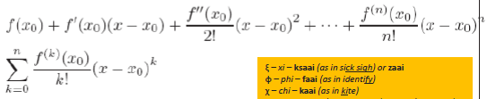



Second Taylor polynomial for $f\left(x\right)=e^{x}cosx$ about $x_{0}=0$

Remainder term (upper bound)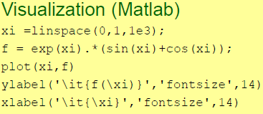

Error propagation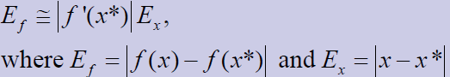

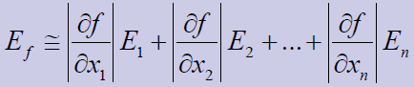

Solutions of one variable equations

Bisection method

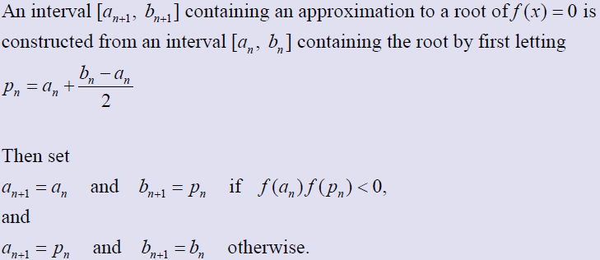

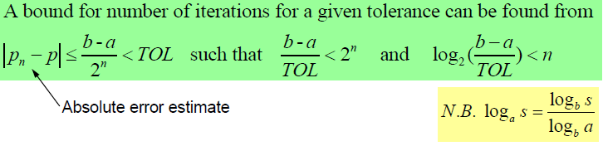

Pseudocode

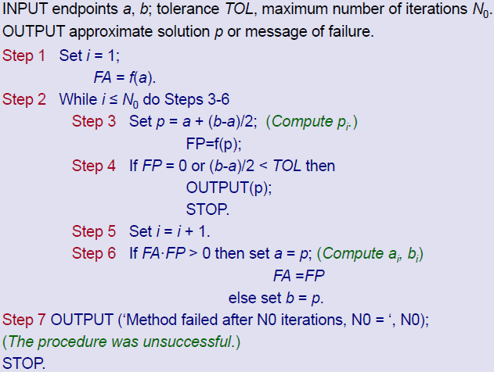

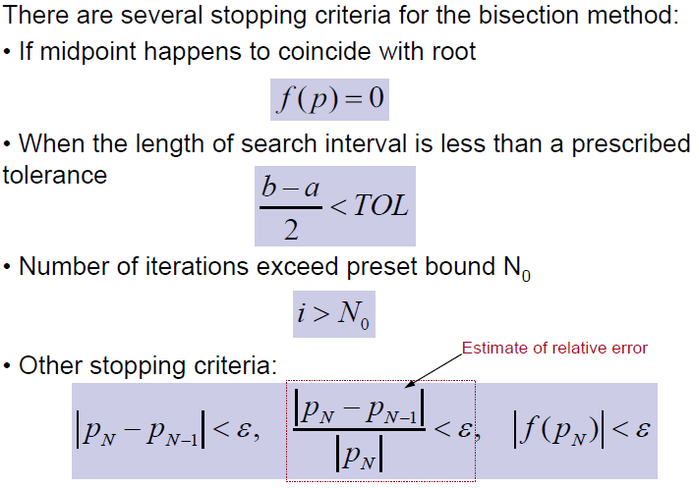

Newton-Raphson

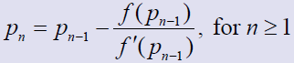

Pseudocode

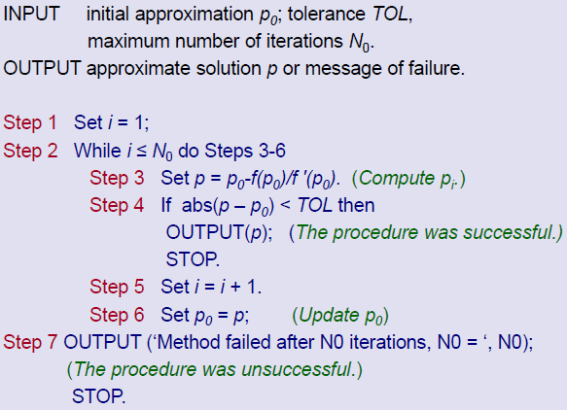

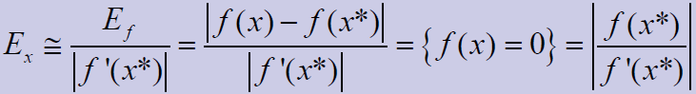

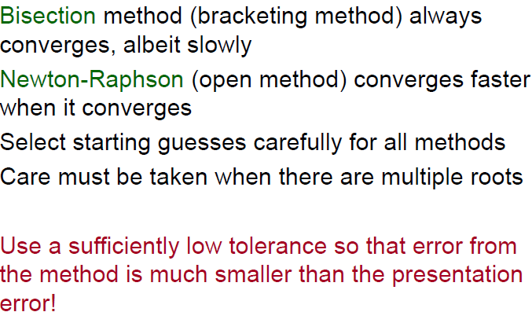

Interpolation and poly approximation

Lagrange polynomial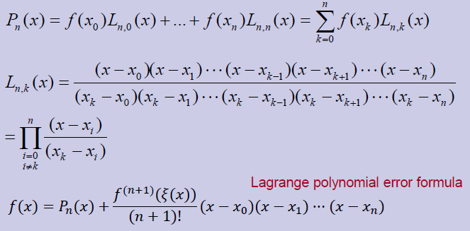Hermite interpolation (n+2)

- derivatives (gives 2n+1 degrees)

Spline Interpolation

- need high degree

Integration

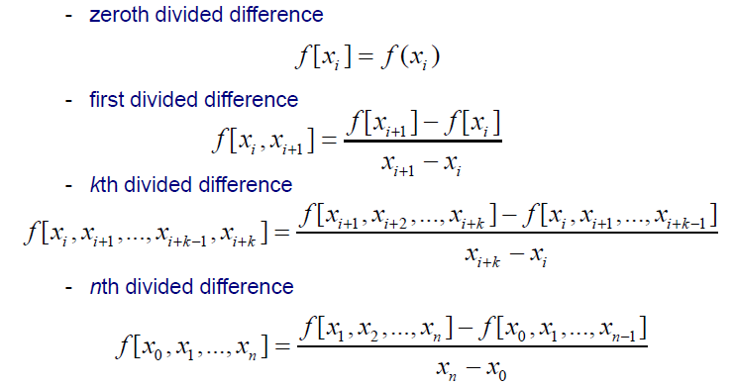

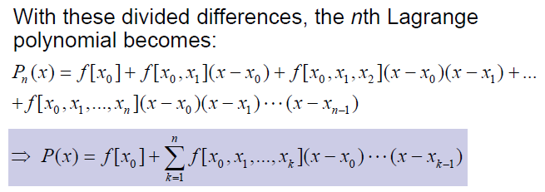

Midpoint rule

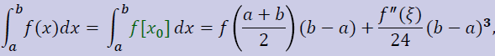

Trapezoidal rule

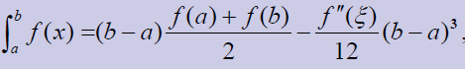

Simpson’s rule

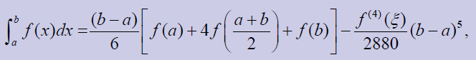

Composite simpson’s rule

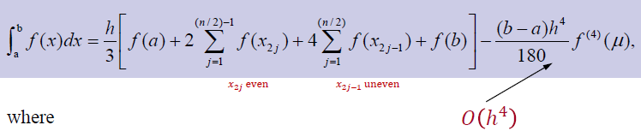

Pseudocode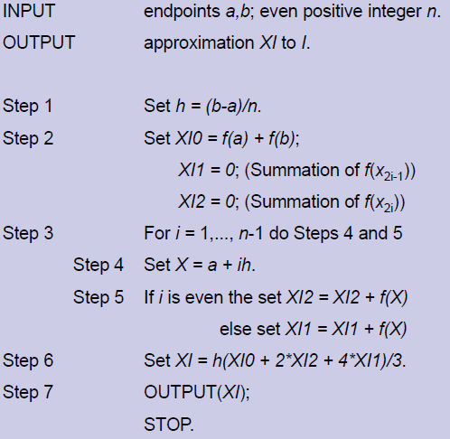

Bisection

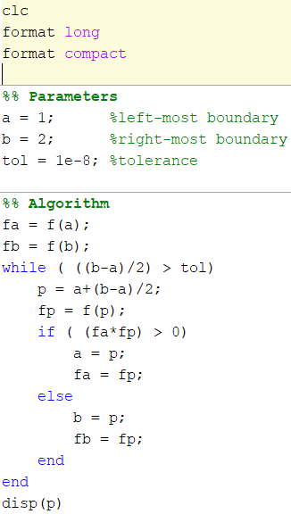vvvvvvvvvvvvvvvvvvvvvv

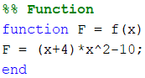

Composite simpson method

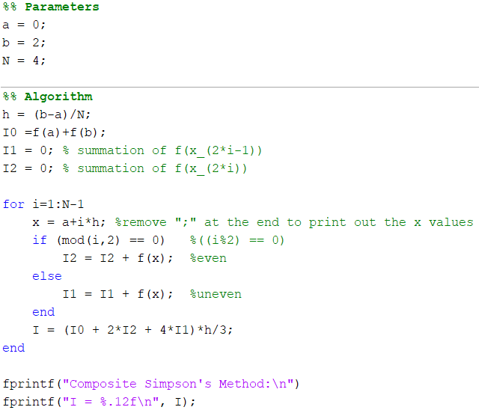

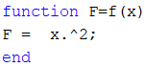

Interpolation

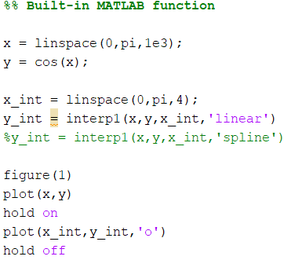

Newton Raphson

