Case Study: Gaidouromantra microgrid in Kynthos island

# 1. Main features

1. System is permanently islanded (no physical connection with the public utility)
2. Main electricity generators are PVs
3. Consumption profile deviates from normal household profiles as houses only used in holidays and are equipped with high efficiency loads

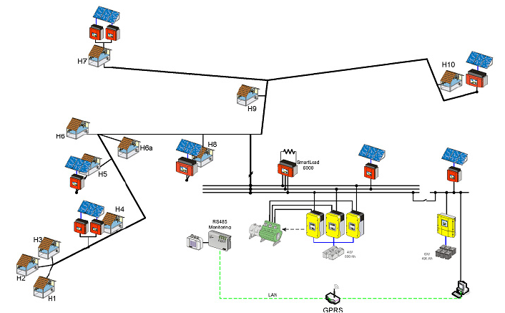

# 2. Problems faced

This section describes the main problems faced by the microgrid.

## 2.1 Battery

During the last 2 years the previous battery bank operating life, the electrolyte consumption was significantly increased, requiring frequent filling (every 2-3months) with distilled water.

## 2.2 Diesel generator

Scarce use of the diesel generator increased its wear and the recent breakdown is considered to be due to insufficient cooling as it was summer time whenever it was operating and the settlement was mostly populated and ambient temperatures were high.

## 2.3 Lack of standards for power quality monitoring

Development of microgrid specific standards for power quality monitoring, especially for islanded operation

## 2.4 Agent based intelligent load controller

Not efficient enough for large number of houses?

# 3. Improvements to consider

Development of required safety, protection measures, communication and control of a smart active (bi-directional) low voltage to medium voltage transformer