# Typical components of a microgrid

1. Energy source

2. Feeder

3. Microgrid controller

4. Inverter

5. Energy storage system

6. Point of common coupling

7. Load

# Challenges faced by current microgrids

Goals of modern microgrids and their typical problems.

Power quality is an important issue in a microgrid due to intermittent nature of the integrated distributed renewable energy sources within the microgrid,

the transition between grid‐tied and islanded modes of microgrid, nonlinear loads, injected current harmonics by power electronic devices, and loads with considerable reactive power demand.

Energy storage, filtering, and proper control schemes are three main categories utilized by scholars to improve the power quality of a microgrid.

Microgrid control strategies, power management and optimization

Stability reliability, and protection

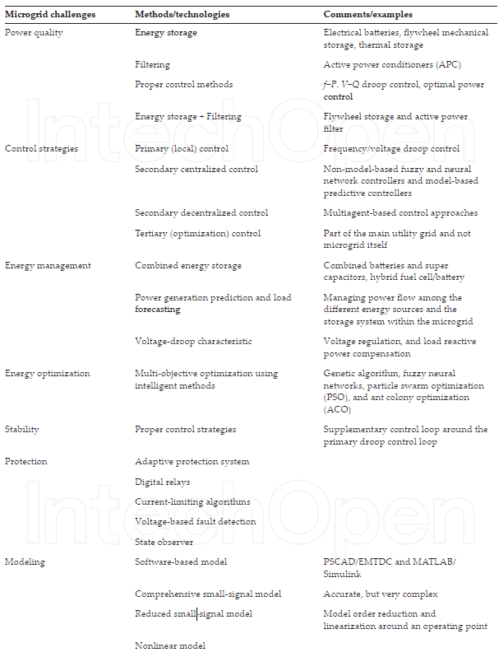

# Case study

Case study 1: Avista’s shared energy project

Problem 1

Extreme care must be taken in designing a network for a critical infrastructure such as an MCS [1]. Designs involving a flat network reduce the number of switches and routers on the network, but they have drawbacks including poor security and lack of scalability. A segmented network approach was followed in designing the network for the MCS in this project. It is best to segment a network that follows the security principle that devices should communicate only with other devices that have a need to share data. Network segmentation allows for fewer end points in a subnet, making it easier to set up end points for each type of multicast traffic. In addition, any broadcast traffic that is not filtered is much easier for devices to handle in a segmented network.

Problem 2

The MCS communicates with the smart switchgear to collect breaker status indications and voltage and current measurements to detect the loss of a utility tie. Although possible, seamless islanding of a microgrid was not applied for this use case. Automatic decoupling schemes using frequency, rate-of-change of frequency, and directional power elements were investigated and can be enabled in future stages of this project. These types of decoupling schemes are required to prevent damage to the microgrid components during a disturbance on the main utility grid.

Problem 3

The goal of the DER optimization concept is to demonstrate that a collection of DERs and other assets can be optimized to more effectively create value than individual DERs. Examples include operating buildings to use excess local PV generation when available and optimizing battery storage for local needs. Solar optimization includes proactively operating buildings to predict and respond to available solar generation, which allows for system efficiencies and better long-term economics for solar energy. Strategies within the buildings, such as precooling or controlling processes.

Python program timeline:

|  |  |
| --- | --- |
| Task | Deadline |
| CBAv5 Technical | Done |
| CBAv5 Financial | Done |
| CBAv5 Scenario Summary | 18th September |
| CBAv5 GUI | 30th September |
|  |  |
|  |  |
|  |  |

Fyp proposal:

So far of all the cases I have read, I realised controller is the key component in the microgrid. Instability of the grid are predominantly caused by the intermittent nature of solar PV and the dynamic loads cause instability in the grid. With a robust and responsive controller, instability in the microgrid can be resolved before they cause bigger problems in the grid in addition to a more efficient microgrid. Hence, I would like to propose a FYP to further study current implementations of microgrid controllers, their effectiveness and propose better solutions.

Goals:

- Look into the current types of controllers used today and find case studies

1. Multi-agent

2. PID controller

3. ANN controller

4. Hardware in the loop (HIL – CHIL, PHIL)

- Find a metric to measure performance of controllers

- Find microgrid models to simulate

- Propose a more effective controller method

- Simulate and show results

Case study 1: Hitachi Energy’s Johannesburg facility

Problem 1: high energy cost due to frequent islanding

Since 2009, four back-up diesel generators (two rated at 600 kVA and two rated at 800 kVA) had been feeding the different parts of the network via conventional transfer switches. Whenever one of the frequent utility power outages or short-term voltage variations that affect the site occurred, these generators would island and provide backup power.

On average, the facility had to be isolated from the grid up to 10 times a month. As a result, its total energy cost in 2015, including utility fees and diesel fuel, was US$630,000.

To address this challenge, Hitachi Energy has transformed the existing generator backup system into an innovative microgrid solution. Now, only two 600 kVA diesel generators are required, with the support of a 1 MVA/ 380 kWh PowerStore™ Battery Energy Storage System based on lithium-ion (Li-ion) technology and a Microgrid Plus Control System as well as a 750 kWp rooftop solar PV (photovoltaic) system.

Problem 2:

Prior to installing the microgrid the facility suffered from an average of 10 voltage dips per month, negatively impacting production. The compact and versatile PowerStore battery energy storage system (BESS) stabilize the power system against fluctuations in frequency and voltage.