Technoeconomic Study on Electric Vehicles Charging (EVs)

Goh Kheng Xi, Jevan (A0199806L)

Department of Engineering Science, National University of Singapore

Abstract – The rapid proliferation of Electric Vehicles (EVs) sees microgrids struggling to adapt to the new load as the market races to prove the economic feasibility of the technology. This project is a continuation of a previous study done by J.J. Yeoh whose aim is to model the technoeconomic assessment of EV charging strategies. A technoeconomic model will be designed as a python software, complete with Graphical User Interface (GUI) using Yeoh’s research. The software will help charging service operators to make informed decisions and provide a smoother onboarding of EVs infrastructure into the current economy.

Index Terms – Electric Vehicles, electric vehicle charging, technoeconomic, energy storage systems

I. INTRODUCTION

In the recent years, societies have recognised and acknowledged the detrimental effects of climate change because of human activities. As societies transitions to cleaner forms of energy, new technological revolutions such as microgrids and EVs are introduced due to this adaptation. Microgrids serve as a more resilient, robust and effective method of incorporating renewable energy into electrical grids, whereas EVs produce lesser pollutants then their internal combustion engine (ICE) counterparts. However, the advent of EVs see microgrids struggle to adapt to the new demand.

The lack of accurate modelling of EVs contributes to the challenge of EV integration into the market as businesses are unable to

accurately assess the risk involved as well as the optimal strategies to employ.

*A. Microgrids*

According to the U.S. Department of Energy, a microgrid is a group of interconnected loads and distributed energy resources (DER) within distinct electrical boundaries, acting as a single control entity that can connect or disconnect from the main grid. This study is concerned with solar microgrids with EV charging loads and the following are the components of a solar microgrid instrumental to this project:

1. Solar Photovoltaics (PVs)
2. Energy Storage System (ESS)
3. Inverters
4. Converters

Solar Photovoltaics (PVs) are semiconductors that convert incident light radiation from the sun into electrical energy. However, irregular solar irradiance due to the natural movement of the causes irregular power output. As such, ESS is typically integrated into the microgrid to even out peak loads.

Moreover, as the grid is typically using Alternating Current (AC) power but power output from the solar PVs is Direct Current (DC), hence, inverters are incorporated into the system to convert DC output from the solar PVs to useable AC to be used in the grid.

Additionally, EV chargers operate in DC and hence, converters are required to convert the AC power from the grid to DC power output.

*B. Yinson Green Technology*

Yinson Green Technologies (YGT) is the green technologies division of Malaysia-based Yinson Holdings Berhad listed on Malaysia’s stock exchange. (https://www.businesstimes.com.sg/international/asean/malaysias-yinson-green-technologies-expand-ev-charging-business-singapore)

Yinson Green Technologies is headquartered in Singapore. It aims to provide a clean, integrated and technological ecosystem in different industries including marine, mobility, energy and digital sectors. Currently, it operates an EV charging station at Ayer Keroh’s Rest & Relaxation (R&R) facility along Malaysia’s North-South highway.

*C. Scope and Objectives*

This project is a continuation of the previous work done by J.J. Yeoh where the technoeconomic factors of the EV charging at Ayer Keroh’s R&R facility are studied. Using J.J Yeoh’s paper and information provided by Yinson, this project aims to design and recreate Yeoh’s model in the form of a python program, complete with a Graphical User Interface (GUI) for the end users to interact with.

This technoeconomic python model aims to aid EV charging providers in making technical decisions to achieve the better financial performance.

II. LITERATURE REVIEW

Yeoh’s technoeconomic model have the following objectives:

1. Finding optimal level of grid involvement in ESS charging strategies.
2. Predict availability of charging station according to demand.
3. Determine optimal energy storage system (ESS) sizing for an EV charging station, according to technical and financial parameters.
4. Scenario analysis for according to different demand and sensitivity analysis of minimum charging price to demand. Diagram

   Description automatically generated

Figure x above shows a block diagram of the electrical flow of the EV charging site.

The model split into 3 sections:

1. Solar Power Generation
2. Energy Storage System (ESS)
3. DC charging points

*A. Solar Power Generation*

According to values given by Yinson, the solar power generation capacity installed at the Ayer Keroh R&R is 27kWp. The lower bound specific PV conditions is 3.58 kWh/hWp per day at the Melaka region and the boost inverter was assumed to be at 90% efficiency. Thus, the average energy generated per day was calculated with this estimation:

Figure x above shows the hourly generation profile of Ayer Keroh at coordinates 2.3982N, 102.2219E in 2019.

*B. ESS*

Yeoh studied 2 different ESS charging strategies. Strategy 1 involves charging the ESS predominantly during off-peak hours and when the ESS reached its state of charge (SOC) limits during peak hours.

Equation 1 calculates the energy stored in the ESS when it is charging from the grid while equation 2 calculates the energy stored in the ESS when it is discharging (i.e. charging EV).

Strategy 2 involves charging the ESS during off-peak hours and discharging of the energy stored in the ESS when the supply from the grid is insufficient during peak hours.

Where represents the energy supplied by the main grid during peak hour at time t.

*C. DC Charger*

According to the information provided by Yinson, the Ayer Keroh R&R is installed with a 180kW DC charger with two 90kW charging guns. The battery capacity of the EV customers is assumed to be 54kWh with a 20% SOC at entry and 80% SOC on exit. Hence, each customer is estimated to require 32.4 kWh in 1C charging.

*D. Study Variables*

In the study performed by Yeoh, the daily number of EV charging station customers and charging price in RM/kWh are studied.

Figure 1 and 2 captures the Functional Principal Component Analysis (FPCA) results for the EV charging usage performed by Chen. The blue curves represent the average occupancy of the charging stations involved in Chen’s study, green curves represent the function after adding a functional component to the average curve and red curves represent the function after subtracting one functional component from the average curve.

FPC1 results mainly focuses on the variance between 7 am and 5 pm and FPC2 results focuses on the variability from 6 pm to 6 am. Hence, in the study, EV charging demand is assumed to start from 9A.M.

III. METHODOLOGY

To create the real-time model in python, the QT 6 Framework is used with python bindings, packaged as a python package (pyside6).

Model-View-Controller (MVC) software design pattern is observed where model represents the underlying data, view is responsible for the GUI display and the controller act as a coordinator between the model and the controller. In this python program, the model are the actual values of the parameters and are python files stored in the model directory. The view related codes are stored in a separate directory and is responsible for the user interface as shown in the figures in the results section. The controller is the equations governing the relationships between each parameter.

The model is split into 4 different sections:

1. Hourly Solar Power Generation
2. Hourly Charging Demand
3. Technical
4. Financial

*A. Hourly Solar Power Generation*

Hourly solar power generation is responsible for the hourly solar energy generation profile. Using the daily solar generation value of 86.99 kWh estimated by Yeoh, and the hourly solar irradiance profile at the Ayer Keroh site, the hourly profile for the solar energy generation is generated. Daily values are obtained from the technical section.

*B. Hourly Charging Demand*

Hourly charging demand allows user to set the daily number of customers. An hourly profile of the EV charging users will then be generated, filling up the peak hours first.

*C. Technical*

The technical section itself is comprised of 3 sections:

1. Solar power generation which allows the user to set the installed capacity of the solar power generation, the Ayer Keroh site solar daily conditions and boost inverter efficiency, thus obtaining the estimated daily energy output.
2. Charging and demand which is responsible for the charging specifications such as the power rating and the number of chargers. This subsection also allows the changing of the EV characteristics to estimate the load required per customer.
3. Battery storage where ESS specifications are adjusted such as the installed capacity, depth of discharge (DoD), nameplate lifecycle. Discharge power and the electricity required from the grid are also contained in this subsection. Most importantly, the ESS charging strategies suggested by Yeoh are implemented in this section.

*D. Financial*

The financial section also involves 3 subsections:

1. Capital expenditure which includes the prices of the facilities in the technical section and their depreciation costs.
2. Operating expenditure which involves the operational and maintenance (O&M) costs.
3. Revenue where the tariff assumptions can be set and thus, showing the revenue required to breakeven and thus the EV charging price to pass on to the consumers.

IV. RESULTS

This section shows presents the

IV. RESULTS

A stable and presentable version of the program is shown in the figures below.

Figure 1. shows the hourly solar generation section, where there is a row to set the hourly profile of the solar generation. The values in the figure above are set in accordance with the solar profile referenced in Yeoh’s research.

Figure 2 above shows the customer profile, prioritising the peak hours first followed by the non-peak hours as indicated by Chen’s study on EV charging behavioural pattern.

Figure 3 and 4 shows the technical section where the user can adjust the parameters. Values in the figures above are provided by Yinson.

Figures 5 shows the financial section and the values in the figure are also provided by Yinson.

Using the parameter values of the Ayer Keroh R&R facility provided by Yinson, the model estimated the price required to breakeven with the cost for that year to be 1.65 R.M

IV. ONGOING AND FUTURE WORKS

The model presented in the results section is a stable version but with limited features. The current model at the time of writing has vast improvements and better features than the model presented in the results section but is unstable and has incomplete features.

*A. Five-Years Analysis*

Yeoh proposed a five-years analysis to evaluate technical strategies. Current efforts towards this five-year analysis are ongoing but is unstable and incomplete.

Figure 1 and 2 shows the five year analysis in the hourly charging demand section where the daily number of customers increases per year according to the additional number of customers set by the user in the input text field.

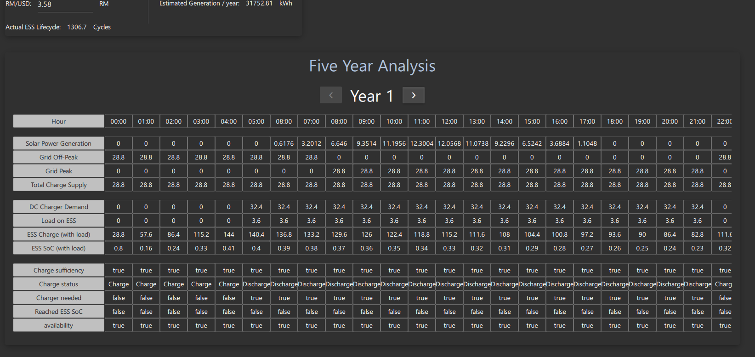

Figure 3 above shows a year selector for the five-years analysis component in the technical section, allowing the user to view the hourly breakdown for the year selected.

*B. Vehicle-to-Grid (V2G)*

V2G refers to the technology that allows EVs to serve as a power source for the electrical grid through bidirectional charging technology. With this technology, EVs act as distributed mobile energy storages that can aid in peak-shaving and load-shifting.

However, V2G is still a developing technology that charging service operators are still uncertain of its integration into the market it faces many adversaries such as increase battery degradation due to more discharge cycles in addition to the extra capital and maintenance cost of the more complex bidirectional chargers themselves.

This python model will look to integrate V2G technoeconomic analysis and provide more insights into the feasibility of V2G.

# 5. Conclusions

The results are constantly reviewed by Yinson; however, it is difficult to validate them as EV is still a new industry and thus, there are insufficient data. Despite this, technical values are verified with data provided by Yinson.

The source code for the project is hosted publicly on GitHub, a remote repository hosting site.

*A. Schedule for Semester*

# 2. Technical Study of Microgrids

“Decentralize, decarbonize and democratize” are popular trends in modern electrical systems and often termed as the “three Ds” (<https://www.sciencedirect.com/science/article/pii/S136403211830128X>). Microgrids are the results of these trends and they serve as a smaller unit of control compared to the traditional macro-sized grids.

## 2.1 Purposes and advantages of microgrid

Traditional power grids are uni-directional and centralized, thus, they are more susceptible to failures (<https://www.sageautomation.com/blog/traditional-grids-vs-smart-grids-why-were-making-the-shift#:~:text=Traditional%20power%20grids%20are%20uni,the%20electricity%20demanded%20by%20customers>.) . By splitting the electrical grid into smaller unit of controls, microgrids are more resilient to failures and can handle dynamic loads and supply. This also makes them an attractive platform to integrate renewable energy.

## 2.2 Components

The figure above shows a typical microgrid diagram.

### 2.2.1 Solar Photovoltaics (PVs)

Solar PVs are semiconductors that convert incident light radiation from the sun into electrical energy. Solar energy is a form of green and renewable energy and thus, is more environmentally friendly than fossil fuels.

However, solar PVs are met with many challenges. Irregular solar irradiance due to the natural movement of the sun causes irregular power output. As such, MPPT (Maximum power point tracking) controllers are employed to track the maximum power point by adjusting the output voltage. Additionally, an energy storage system is typically integrated into the microgrid to even out peak loads.

Another major challenge of solar PVs is difference in the type of power output from the solar PVs and the power used in the microgrid. Solar PVs produce direct current (DC) power while microgrids typically employ alternating current (AC) output. Hence, an inverter is commonly used for this application to convert the DC output from the Solar PVs into AC output.

### 2.2.2 Inverters

* MPPT (Maximum power point tracking) controllers tracks the maximum power point using a series of buck and boost converters.
* When solar PV output is lower voltage than the ESS voltage: boost converter

# (bidirectional convert, rectifier)

* Inverter will convert DC from solar PV to AC to feed to the microgrid
* Sine wave (best), modified sine wave, square wave (worst)

# ESS can have a buck boost converter but solar pv only uses boost converter

# MPPT will have their own control for the MPP

Buck converter

Buck converter is a DC-DC converter that lowers the input voltage.

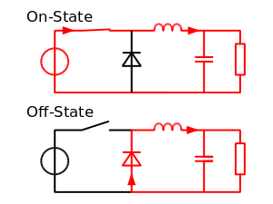

When the switch (transister) is turned on, current flows through the inductor and the capacitor to the load. This charges the inductor and hence, the current in the load and the charge C1 increases gradually. No current flows through the diode as it is reverse biased.

When the switch is turned off, the energy stored in the inductor is supplied back into the circuit. The voltage across the inductor is now in the reverse polarity and the energy stored during the “on” state is sufficient to supply the load while the switch is turned off.

Boost Converter (<https://components101.com/articles/boost-converter-basics-working-design#:~:text=A%20boost%20converter%20is%20one,a%20diode%2C%20and%20a%20capacitor>.)

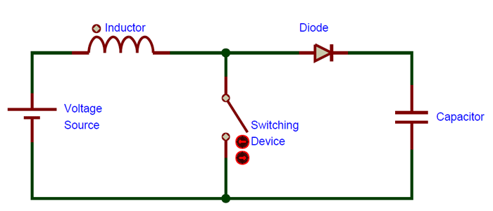

Boost converter is a DC-DC converter that increases the input voltage. When the switch is turned on, current flows through the inductor, diode and the capacitor, charging the inductor and the capacitor. The capacitor cannot discharge due to the reverse bias of the diode and hence, it remains charged. When the switch is turned off, the inductor’s polarity is reversed and it releases the stored energy back into the circuit. As the inductor is seen as another voltage source in series with the actual voltage source, the input voltage is “boosted”.

## 2.2.2 Inverters

Since most DER generates DC output, there is a need to convert the DC output to AC. Inverters are a type of power electronics that is commonly used in microgrids to perform this function. (<https://www.energy.gov/eere/solar/solar-integration-inverters-and-grid-services-basics#:~:text=Inverters%20are%20just%20one%20example,input%20becomes%20an%20AC%20output>.)

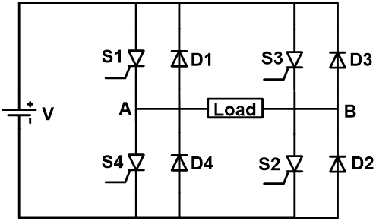

This is a simple single-phase inverter circuit. Inverters typically incorporates switches such as IGBTs (Insulated-gate bipolar transistors) and MOSFETs (Metal-oxide Semiconductor Field-Effect Transistor).

When S1 and S2 are switched on, S3 and S4 are switched off. This causes current to flow through the load in the positive direction and generates the positive half cycle of the AC output. On the other hand, When S3 and S4 are switched on, S1 and S2 are switched off. This causes current to flow through the load in the negative direction and generates the negative half cycle of the AC output. This combined effect generates the AC output as shown in the graph below. (https://www.electrical4u.com/power-inverter/#:~:text=The%20inverter%20uses%20the%20power,inverter%20to%20understand%20the%20working.)

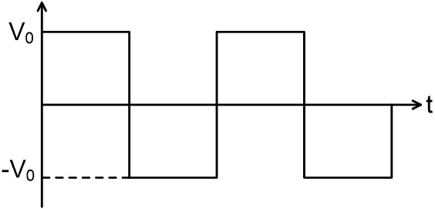

As the output of the inverter is a square wave, they are often filtered to generate a sine wave. The figure below shows an example of LC filter.

When the input frequency is high, impedance of inductor is high while the impedance of capacitor is low, hence the current supplied to the load is attenuated. On the other hand, when the input frequency is low, impedance of inductor is low while the impedance of capacitor is high, hence, current is allowed to flow to the load. Therefore, the higher harmonics signal is filtered. (<https://blog.mbedded.ninja/electronics/circuit-design/how-to-create-sine-waves-from-square-waves-and-rc-filters/>)

# 3. Power control and management

Islanding:

In Islanding mode, droop control is used for power sharing. Droop control is the controlling of output voltage and frequency of the voltage source inverter as the output power varies. Each DER is seen as being connected in parallel and all of them are sharing the same load. (<https://www.sciencedirect.com/topics/engineering/droop-speed-control#:~:text=Droop%20control%20refers%20to%20a,inverters%20are%20connected%20in%20parallel>.)

It works by setting each DER reference point to be lower than the actual required frequency/voltage. Droop is defined as the ratio of the difference between no load speed and full load speed to the no load speed (refer to equation below).

Frequency droop control is use for controlling real power and voltage is for controlling reactive power.

Grid-connected:

* Supply real power to main grid: microgrid leading voltage
* Supply reactive power to main grid: microgrid higher voltage

General strategies

* Supply more than demand: excess will charge ESS to a certain level using droop control (ESS become load)
* Supply more than demand and ESS is fully charged: return excess supply back to main utility grid
* Demand more than supply: Draw from ESS using droop control
* Demand more than supply and ESS below minimum SOC: Draw from main utility grid

# 3. Technical Study V2G

V2G

## 3.1 Bidirectional Charging