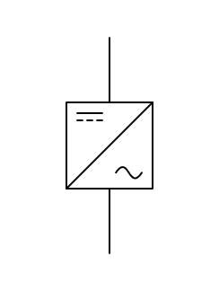

ESS



MGCC

|  |  |
| --- | --- |
| Symbol | Meaning |
|  | Utility Grid |
|  | Transformer |
|  | Point of Common Coupling (PCC) |
|  | Microgrid Central Controller (MGCC) |
|  | Local Controller |
|  | Solar PV |
|  | Energy Storage System (ESS) |
|  | Load |

|  |  |
| --- | --- |
|  | AC Feeder line |
|  | Communication line |
|  | Boost Inverter |
|  | Power converter |

# 1. Purpose and advantages of microgrid

* Able to connect (grid-connected) and disconnect (islanding) from the main grid
* More resilient as it can handle dynamic supply and load
* Hence able to integrate renewable sources of energy

Define Islanding, grid tied mode here

#Microgrid diagram incomplete, DC-DC converter separate from the local control

# 2. Components

## 2.1 Solar PV

Solar PV converts the incident light radiation from the sun into electrical energy.

* Irregular voltage and current output due to irregular irradiance
* MPPT (Maximum power point tracking) controllers tracks the maximum power point using a series of buck and boost converters.
* When solar PV output is lower voltage than the ESS voltage: boost converter

# (bidirectional convert, rectifier)

* Inverter will convert DC from solar PV to AC to feed to the microgrid
* Sine wave (best), modified sine wave, square wave (worst)

# ESS can have a buck boost converter but solar pv only uses boost converter

# MPPT will have their own control for the MPP

Buck converter

Buck converter is a DC-DC converter that lowers the input voltage.

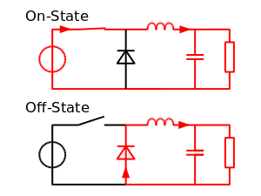

When the switch (transister) is turned on, current flows through the inductor and the capacitor to the load. This charges the inductor and hence, the current in the load and the charge C1 increases gradually. No current flows through the diode as it is reverse biased.

When the switch is turned off, the energy stored in the inductor is supplied back into the circuit. The voltage across the inductor is now in the reverse polarity and the energy stored during the “on” state is sufficient to supply the load while the switch is turned off.

Boost Converter (<https://components101.com/articles/boost-converter-basics-working-design#:~:text=A%20boost%20converter%20is%20one,a%20diode%2C%20and%20a%20capacitor>.)

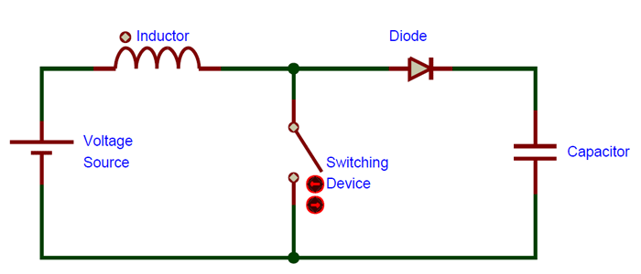

Boost converter is a DC-DC converter that increases the input voltage. When the switch is turned on, current flows through the inductor, diode and the capacitor, charging the inductor and the capacitor. The capacitor cannot discharge due to the reverse bias of the diode and hence, it remains charged. When the switch is turned off, the inductor’s polarity is reversed and it releases the stored energy back into the circuit. As the inductor is seen as another voltage source in series with the actual voltage source, the input voltage is “boosted”.

## 2.2 Inverters

Since most DER generates DC output, there is a need to convert the DC output to AC. Inverters are a type of power electronics that is commonly used in microgrids to perform this function. (<https://www.energy.gov/eere/solar/solar-integration-inverters-and-grid-services-basics#:~:text=Inverters%20are%20just%20one%20example,input%20becomes%20an%20AC%20output>.)

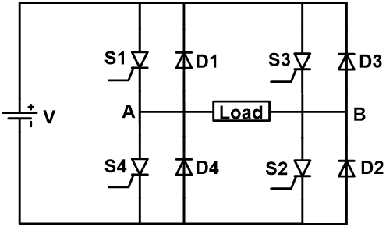

This is a simple single-phase inverter circuit. Inverters typically incorporates switches such as IGBTs (Insulated-gate bipolar transistors) and MOSFETs (Metal-oxide Semiconductor Field-Effect Transistor).

When S1 and S2 are switched on, S3 and S4 are switched off. This causes current to flow through the load in the positive direction and generates the positive half cycle of the AC output. On the other hand, When S3 and S4 are switched on, S1 and S2 are switched off. This causes current to flow through the load in the negative direction and generates the negative half cycle of the AC output. This combined effect generates the AC output as shown in the graph below. (https://www.electrical4u.com/power-inverter/#:~:text=The%20inverter%20uses%20the%20power,inverter%20to%20understand%20the%20working.)

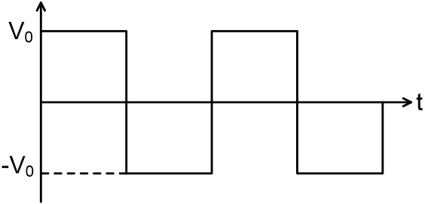

As the output of the inverter is a square wave, they are often filtered to generate a sine wave. The figure below shows an example of LC filter.

When the input frequency is high, impedance of inductor is high while the impedance of capacitor is low, hence the current supplied to the load is attenuated. On the other hand, when the input frequency is low, impedance of inductor is low while the impedance of capacitor is high, hence, current is allowed to flow to the load. Therefore, the higher harmonics signal is filtered. (https://blog.mbedded.ninja/electronics/circuit-design/how-to-create-sine-waves-from-square-waves-and-rc-filters/)

# 3. Power control and management

Islanding:

In Islanding mode, droop control is used for power sharing. Droop control is the controlling of output voltage and frequency of the voltage source inverter as the output power varies. Each DER is seen as being connected in parallel and all of them are sharing the same load. (<https://www.sciencedirect.com/topics/engineering/droop-speed-control#:~:text=Droop%20control%20refers%20to%20a,inverters%20are%20connected%20in%20parallel>.)

It works by setting each DER reference point to be lower than the actual required frequency/voltage. Droop is defined as the ratio of the difference between no load speed and full load speed to the no load speed (refer to equation below).

$$Droop =\frac{No load speed-full load speed }{No load speed}$$

Frequency droop control is use for controlling real power and voltage is for controlling reactive power.

Grid-connected:

* Supply real power to main grid: microgrid leading voltage
* Supply reactive power to main grid: microgrid higher voltage

General strategies

* Supply more than demand: excess will charge ESS to a certain level using droop control (ESS become load)
* Supply more than demand and ESS is fully charged: return excess supply back to main utility grid
* Demand more than supply: Draw from ESS using droop control
* Demand more than supply and ESS below minimum SOC: Draw from main utility grid

Solar PV side

Grid-forming inverters?

// this inverter will form the parameters for the grid.

// if islanding/isolated should be grid-forming

Grid-following inverters?

// grid following, there is a main grid, the battery and inverter is following the parameters of the main grid.

//if tied to the grid, it should be a grid-following

Microgrid protection

# Battery Energy Storage System (BESS)

# 

Reference diagrams

