# 1. Vehicle to grid (V2G)

With the rapid proliferation of Electric Vehicles (EV) technology, microgrids are struggling to adapt to the new load, sparking a new wave of interest in integrating EV technology into microgrids. One such technology is vehicle-to-grid (V2G), which refers to the technology that allows electric vehicles to serve as a power source for the electrical grid.

## Bidirectional charging

Bidirectional charging refers to the bidirectional power flow between the electrical grid and the load, and it is the key behind V2G. Reference: https://blog.wallbox.com/en-sg/why-bidirectional-charging-is-the-next-big-thing-for-ev-owners/#:~:text=Bidirectional%20EV%20charging%20is%20exactly,electricity%20can%20flow%20both%20ways.

The figure above shows an example of a bidirectional two-stage converter.

/*

Incomplete

*/

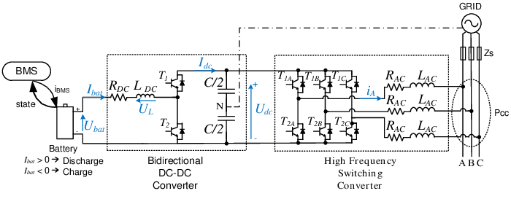

https://www.researchgate.net/figure/General-electric-diagram-of-the-bidirectional-charger_fig5_224245113

# 2 Economy of V2G

## 2.1 Parameters for modelling

1. Number of users reverse charging

2. Reverse charging speed (about 10kW)

3. Hourly user profile (similar to hourly solar generation)

- a charger can only be charging or reverse-charging at any point of time, not both

- the V2G users acts as extra energy capacity

When an EV is charged, AC power from the grid is converted to DC

But how does this work? Well, when an EV is charged, AC (alternating current) electricity from the grid is converted to DC (direct current) electricity, the kind that can be used by a car. This conversion is carried out by [either the car’s own converter or a converter located in the charger](https://wallbox.com/en_sg/faqs-difference-ac-dc). Then, when you want to use that energy stored in the EV’s battery for a house or send it back to the grid, the DC electricity used in the car logically has to be converted back to AC electricity. Although currently there aren’t many bidirectional EV chargers out there, all contain internal converters. This means that they can handle the electrical conversion back from DC to AC. They can even control the amount of power supplied to and from the battery.

GPT promps

Vehicle-to-grid, or V2G, refers to the technology that allows electric vehicles (EVs) to be used as a source of power for the electrical grid. This is made possible by the bi-directional flow of electricity between EVs and the grid, which allows excess electricity stored in the vehicle's battery to be transferred back to the grid.

One of the key benefits of V2G technology is that it can help to balance out fluctuations in demand for electricity. For example, during periods of high demand, EVs can provide a source of additional power to the grid. On the other hand, during periods of low demand, the grid can provide power to recharge the batteries of EVs. This can help to ensure that the grid operates more efficiently and can also reduce the need for power plants that only operate during peak times.

In addition to improving the efficiency of the electrical grid, V2G technology also has the potential to provide a source of renewable energy. Many EVs are powered by electricity generated from renewable sources, such as solar or wind power. By allowing excess electricity from EVs to be transferred back to the grid, V2G technology can help to increase the amount of renewable energy that is available for use.

Despite these potential benefits, V2G technology is still in the early stages of development. There are many challenges that must be overcome in order to make it more widely adopted. For example, V2G requires specialized equipment, such as bi-directional charging stations, and it also requires a high level of coordination between EVs and the grid. Additionally, there are concerns about the potential impact of V2G on the batteries of EVs, as transferring power back and forth between the grid and the vehicle's battery can cause wear and tear.

Overall, while V2G technology has the potential to revolutionize the way that electricity is generated and distributed, it is still in the early stages of development. In order for V2G to become more widely adopted, further research and development is needed to address the challenges that currently limit its use.

Vehicle-to-grid (V2G) technology is important for several reasons. One of the key benefits of V2G is that it can help to improve the efficiency of the electrical grid. By allowing EVs to provide power to the grid during periods of high demand and to recharge from the grid during periods of low demand, V2G can help to balance out fluctuations in electricity demand and reduce the need for power plants that only operate during peak times.

Another reason why V2G is important is that it has the potential to provide a source of renewable energy. Many EVs are powered by electricity generated from renewable sources, such as solar or wind power. By allowing excess electricity from EVs to be transferred back to the grid, V2G can help to increase the amount of renewable energy that is available for use.

Additionally, V2G technology can also help to reduce greenhouse gas emissions. By allowing EVs to provide power to the grid, V2G can help to reduce the need for power plants that burn fossil fuels, which are a major source of greenhouse gas emissions.

Overall, V2G technology has the potential to play a significant role in the transition to a more sustainable and efficient energy system. It can help to improve the efficiency of the electrical grid, increase the use of renewable energy, and reduce greenhouse gas emissions.