Two-Dimensional Mass and Momentum Transport Modeling for PEM Fuel Cells
Chunmei Wang, Po-Fu Shih
Abstract
Based on Maxwell-Stefan diffusion and convection equations and Darcy’s law mass transport and momentum transport of gas fuels in a PEMFC were modeled using the COMSOL program. Hydrogen would accumulate at the outlet of the anode due to the electro-osmotic drag of water. Oxygen would be consumed along the flow at the cathode. The velocity of gases would increase around the corners of electrochemical reactions. The model was validated through comparing the modeling results with literature report. And the effect of water transport on gases transport would be discussed.

- Introduction

Since the first oil crisis of 1973 the world energy prospective seeks a sustainable energy source. Also more and more significantly an environmental benign energy source is needed [1]. The widespread use of hydrogen can meet these needs. It can reduce the dependence on oil and benefit environment by reducing greenhouse gas emissions and pollutant emissions. In 2003, President George W. Bush announced the Hydrogen Fuel Initiative to accelerate the research and development of hydrogen and fuel cell technologies [2]. Fuel cells generate electricity energy from hydrogen with high efficiency, in which proton exchange membrane fuel cells (PEMFCs) are promising with prototype efficiency of up to 64% [3] and with high energy density [4, 5].

Proton conductivity membranes play a key role in PEMFC [6]. There are different types of membranes: polymer membrane [7, 8], solid acid membrane [9, 10], and composite membrane [11, 12]. In PEMFCs protons are generated at anode and pass through membranes to the cathode, while electrolyzed electrons flow through an external circuit to generate electrical power. At the cathode water will be generate when oxygen is reduced reacting with protons [13]. Water is the proton carrier in the membranes. Liquid water transport or liquid/gas transport is one of major concerns in the fuel cell modeling [14].

Nowadays, many of the transport phenomena inside a fuel cell or electrolytic cell still cannot be observed or measured directly. Therefore, mathematical modeling will be an effective tool to understand these transport phenomena. The one-dimensional models by Verbrugge and Hill [15, 16], Bernardi and Verbrugge [17, 18], and Springer et al. [19] laid a good foundation for PEMFC modeling. Springer et al. presented empirical relations for such parameters as water diffusion coefficient, electro-osmotic drag coefficient, water adsorption isotherms, and membrane conductivities, etc. Gurau et al. [20] developed a two-dimensional PEMFC model that included fluid flow, mass transfer and the electro-kinetics and introduced the computational fluid dynamics into fuel cell modeling. Wang et al. [21] and You and Liu [22, 23] developed PEMFC models that applied two-phase flow model for the cathode of the PEMFC.

In this project, our work will be to construct a computer model using the COMSOL program. The objective of this model is to simulate two-dimensional mass and momentum transport of fuel gases in a PEMFC with considering convection and diffusion effects.

- Governing Equations

Referenced from Sun etc [24] and Liu etc [14], a two-dimensional PEMFC model was constructed to modeling species mass transfer and electro-kinetics in the cell. The schematic of the PEMFC model was shown in Fig 1 (GDL is gas diffusion layer).

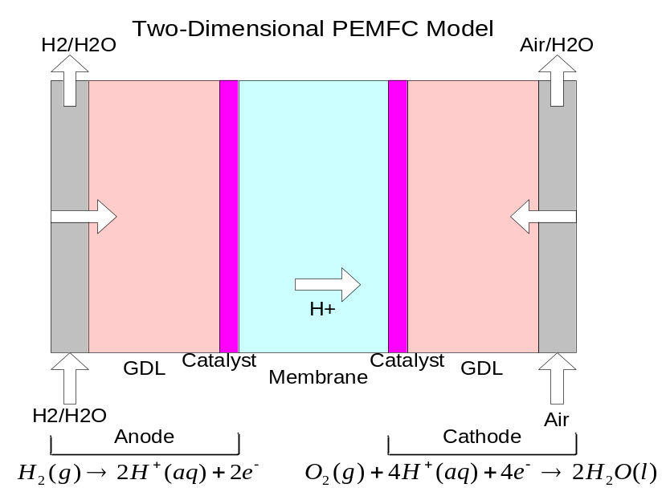
Figure 1. Two dimensional PEMFC model.
There were some assumptions applied for the model:
- Catalyst layer was assumed to be an ultra-thin layer as integrate parts of the system;
- Water would not condense in the flow channels;
- Oxygen and hydrogen would not dissolve in water

Model equations are:
1. The continuity equation is
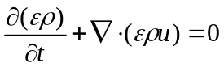 (1)
2. For the two-phase mixture in the gas channel, the Maxwell-Stefan mass transport equation was used
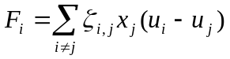 (2)
Where, F_{i} is the driving force on i, at a given T and p, 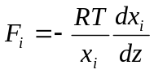, ζ_{i,j} is the friction coefficient between i and j, x_{j} is mole fraction of j. u is velocity.
3. For the multiphase mixture flow in the GDL, Darcy’s Law was used for momentum transport modeling
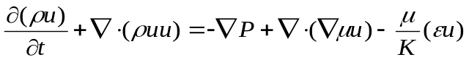 (3)
4. The species conservation equation for the multiphase mixture is
(4)

Boundary and initial conditions at the interface between the membrane and the cathode are:
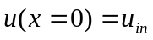, 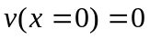, 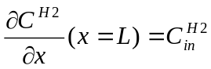, 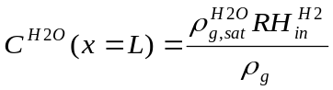.
- Solution

Using the COMSOL program mass transport and momentum transport of gas fuels in a PEMFC were modeled at constant temperature of 80 °C. Three domains were considered: an anode, a proton exchange membrane, and a cathode. The mass contour and velocity field were shown in Figs 2 & 3.

Feed gases (humidified hydrogen and air) treated as ideal gases were transported through diffusion and convection. Their momentums were modeled with Darcy’s law, in which velocities were governed by the continuity equations. Mass transport of gases (H₂ at the anode, and O₂ and N₂ at the cathode) were modeled with Maxwell-Stefan equations.

Considering boundary settings, at inlet of each electrode mass fractions of gases were specified (at inlet of the anode 0.1 of weight fraction of H₂ was used, and at the inlet of the cathode 0.21 of weight fraction of O₂ and 0.79 N₂ were put). At outlets, convective flux boundary conditions were applied. At the electrode-membrane boundaries mass flux of H₂ and O₂ were determined by electrochemical reactions.

For other constants their values were put as reference recommended. For example, 0.09 S/cm of conductivity of membrane was used, 1⁻¹³ m² of electrodes permeability was used, Faraday’s constant is 96485 C/mol, water drag coefficient was 3, the referenced pressure is air pressure 1.013⁵ Pa, and H₂ and air inlet pressure were set as 1.1 time of reference pressure.

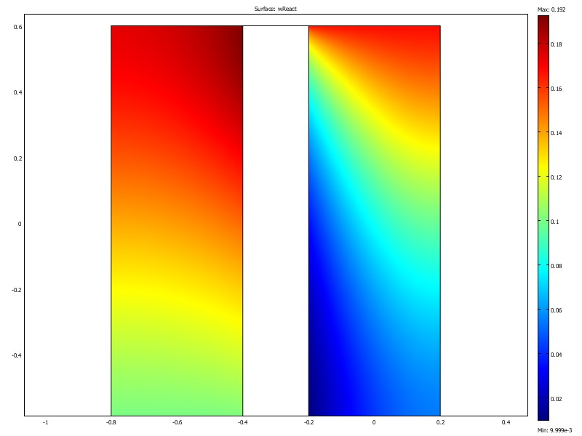
Figure 2. Mass distribution in the PEMFC.
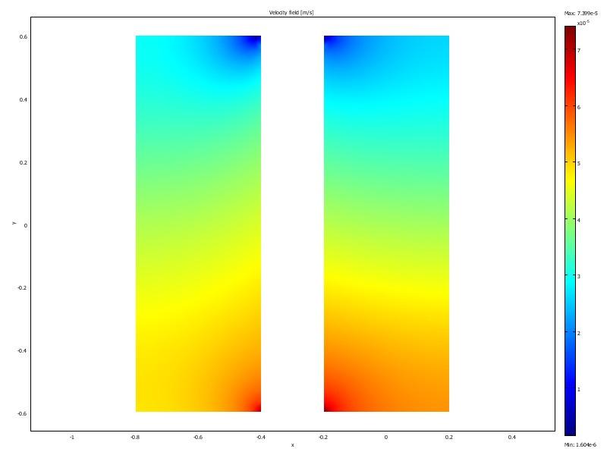
Figure 3. Velocity field of the PEMFC.

- Validation

The modeling results of pressure drop and velocity distribution using our COMSOL model were compared with literature report [25]. From literature result (Figure 5), the pressure near inlet and outlet were shown to keep constant and the pressure along the inlet was higher than that along the outlet. The pressure dropped to the fairly constant level at the outlet rapidly. Our pressure drop modeling was shown in Figure 4. The trend was the same with that in Figure 5, but there was no constant pressure along the inlet and outlet.
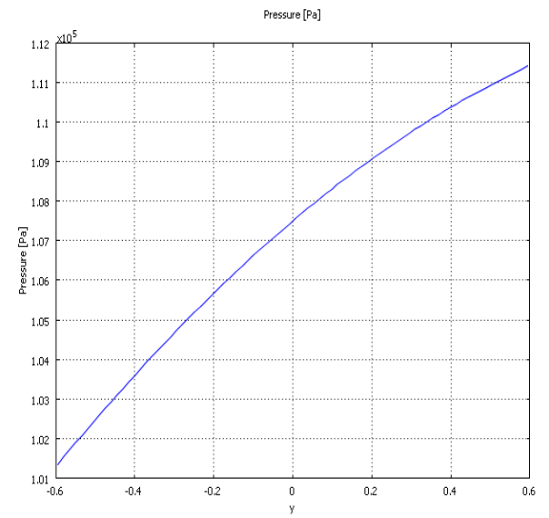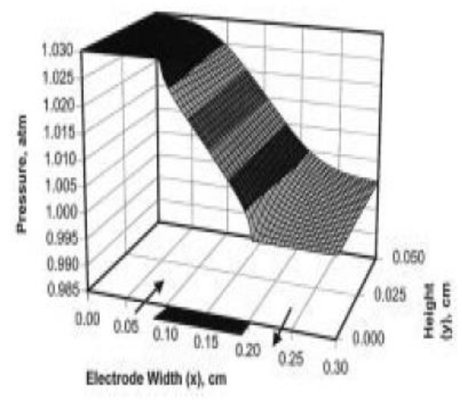
Figure 4. Pressure versus y-orientation (COMSOL Model) Figure 5. Pressure versus y-orientation (Yi and Nguyen)

The velocity distributions of COMSOL modeling results were also compared with those from literature. Comparing the relationship between Y-direction velocity and y-orientation in Figure 6 with that in Figure 7, we found that the results from COMSOL modeling matched precisely with those from Yi and Nguyen modeling. Also, the magnitudes calculated from our model were comparable to those given in the Yi and Nguyen’s paper [25].
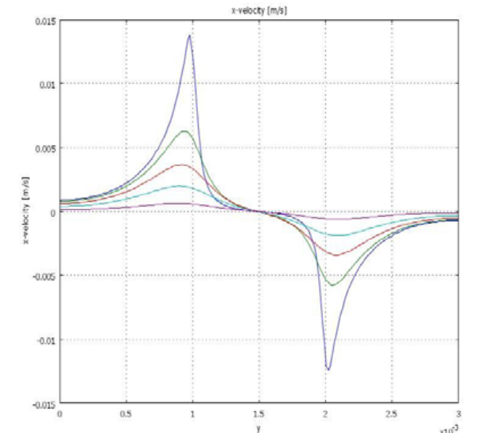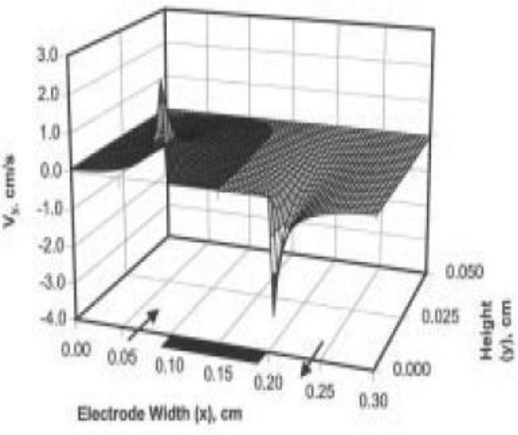
Figure 6. Y-direction velocity versus y-orientation Figure 7. Y-direction velocity versus y-orientation
(COMSOL Model) (Yi and Nguyen)
- Parametric Study

There are many parameters that affect the gas (hydrogen, the oxygen stream or air) flow and performance of a PEMFC, such as, conductivity of the membrane, fuel cell operation temperature, relative humidity of the cell, fuel concentration, gas diffusivity, porosity of electrode, effectiveness of catalyst etc. Feed supply with pure oxygen or with air is a factor which affects the performance of a PEMFC greatly. A fuel cell will generate a power density of 380 mW/cm² with oxygen feed, while only generate a 260 mW/cm² with air feed. The ratio of oxygen to hydrogen inside the cathode also must be optimized. If the ratio is too low, the lack of oxygen reactant will reduce the reaction rate and the output power within the cathode. If the ratio is too high, the gas will cause the polymer membrane to dry out. Another key parameter will be humidity of the cell. To obtain desirable current with optimum mass and momentum transport, proton conductive membrane has to be maintained at high relative humidity. This humidification can be realized with wet hydrogen feed or with water generated at the cathode. Thus, the effect of water mass and momentum transport on the modeling results will be preferable to be discussed.

The velocity distribution of flow gases without water included was shown in Figure 8. Without water transport hydrogen and oxygen in the cell were almost stagnant, which diminished the fuel cell performance. Compared with Figure 3, it can be concluded that water transport is important for fuel gases flowing in the cell.
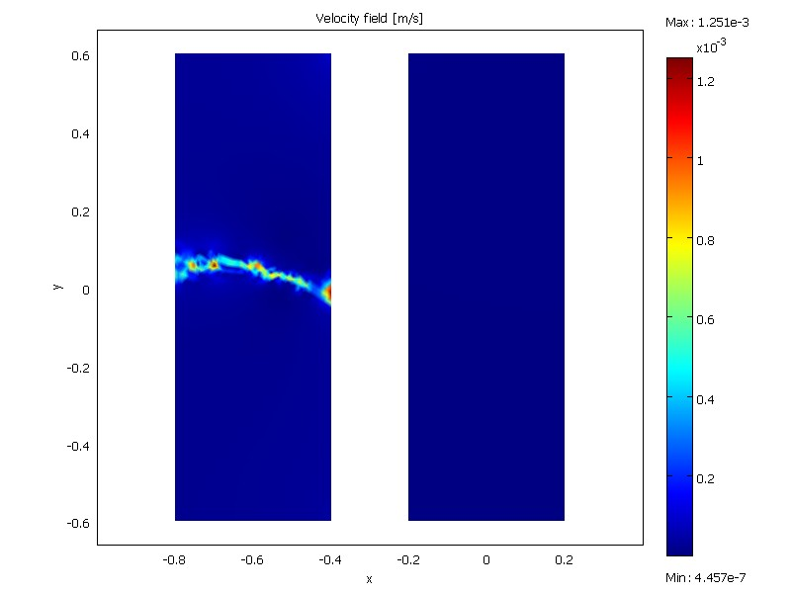
Figure 8. Velocity distribution of flow gases in a PEMFC without water species.

- Conclusions

Based on Darcy’s law and Maxwell-Stefan diffusion and convection equations momentum transport and mass transport of gas fuels in a PEMFC were modeled at constant temperature of 80°C. From the mass distribution modeling results we found that hydrogen mass fraction at the anode increased as flux flowed towards the outlet. This was the result of the electro-osmotic drag of water through the membrane. So, water is important in realizing the correct modeling. At the cathode, oxygen content decreased with the flow. The velocity of gases reached at highest value at the corners of electrochemical reactions. Our results of pressure and velocity modeling were compared with those from literatures. It was shown that the results from our COMSOL modeling matched with literature ones.

References
1. Blomen, L.J.M.J. and M.N. Mugerwa, Fuel Cell Systems. 1993: Springer.
2. Hydrogen and Our Energy Future, U.S.D.O.E.H. Program, Editor.
3. Hogarth, W.H.J., J.C. Diniz da Costa, and G.Q. Lu, Solid acid membranes for high temperature (> 120 °C) proton exchange membrane fuel cells. Journal of Power Sources, 2005. 142(1-2): p. 223-237.
4. Emery, M., et al., The Development of New Membranes for Proton Exchange Membrane Fuel Cells. The Electrochemical Society (ECS) Transactions 2007. 11(1): p. 3-14.
5. Hamrock, S.J. and M.A. Yandrasits, Proton Exchange Membranes for Fuel Cell Applications. Journal of Macromolecular Science, Part C: Polymer Reviews, 2006. 46: p. 219-244.
6. Kreuer, K.-D., Proton Conductivity: Materials and Applications. Chemistry of Materials, 1996. 8: p. 610-641.
7. Alberti, G., et al., Polymeric proton conducting membranes for medium temperature fuel cells (110-160 °C). Journal of Membrane Science, 2001. 185(1): p. 73-81.
8. Kim, Y.S., et al., Multiblock Copolymers for Low Relative Humidity Fuel Cell Operation. ECS Transactions, 2007. 11(1): p. 49-54.
9. Alberti, G. and M. Casciola, Solid state protonic conductors, present main applications and future prospects. Solid State Ionics, 2001. 145(1-4): p. 3-16.
10. Matsuda, A., et al., Proton conductivities of sol-gel derived phosphosilicate gels in medium temperature range with low humidity. Solid State Ionics, 2002. 154-155: p. 687-692.
11. Alberti, G. and M. Casciola, Composite Membrane for Medium-Temperature PEM Fuel Cells. Annual Review of Material Research, 2003. 33: p. 129-154.
12. Adjemian, K.T., et al., Investigation of PEMFC operation above 100 [degree sign]C employing perfluorosulfonic acid silicon oxide composite membranes. Journal of Power Sources, 2002. 109(2): p. 356-364.
13. Larminie, J. and A. Dicks, Fuel Cell Systems Explained. 2003, West Sussex: John Wiley & Sons Ltd.
14. Liu, Z., Z. Mao, and C. Wang, A two dimensional partial flooding model for PEMFC. Journal of Power Sources, 2006. 158(2): p. 1229-1239.
15. Verbrugge, M.W. and R.F. Hill, Ion and Solvent Transport in Ion-Exchange Membranes. Journal of The Electrochemical Society, 1990. 137(3): p. 886-893.
16. Verbrugge, M.W. and R.F. Hill, Analysis of Promising Perfluorosulfonic Acid Membranes for Fuel-Cell Electrolytes. Journal of The Electrochemical Society, 1990. 137(12): p. 3770-3777.
17. Bernadi, D.M. and M.W. Vergrugge, Mathematical model of a gas diffusion electrode bonded to a polymer electrolyte. American Institute of Chemical Engineers (AIChE) Journal, 1991. 37: p. 1151-1163.
18. Bernardi, D.M. and M.W. Verbrugge, A Mathematical Model of the Solid-Polymer-Electrolyte Fuel Cell. Journal of The Electrochemical Society, 1992. 139(9): p. 2477-2491
19. Springer, T.E., T.A. Zawodzinski, and S. Gottesfeld, Polymer Electrolyte Fuel Cell Model. Journal of The Electrochemical Society, 1991. 138(8): p. 2334-2342
20. Gurau, V., H. Liu, and S. Kakac, Two-dimensional model for proton exchange membrane fuel cells. AIChE Journal, 1998. 44(11): p. 2410-2422.
21. Wang, Z.H., C.Y. Wang, and K.S. Chen, Two-phase flow and transport in the air cathode of proton exchange membrane fuel cells. Journal of Power Sources, 2001. 94(1): p. 40-50.
22. You, L. and H. Liu, A two-phase flow and transport model for the cathode of PEM fuel cells. International Journal of Heat and Mass Transfer, 2002. 45(11): p. 2277-2287.
23. You, L. and H. Liu, A two-phase flow and transport model for PEM fuel cells. Journal of Power Sources, 2006. 155(2): p. 219-230.
24. Sun, H., H. Liu, and L.-J. Guo, PEM fuel cell performance and its two-phase mass transport. Journal of Power Sources, 2005. 143(1-2): p. 125-135.
25. Yi, J.S. and T.V. Nguyen, An Along-the-Channel Model for Proton Exchange Membrane Fuel Cells. Journal of Electrochemical Society, 1998. 145(4): p. 1149-1159.

