**Mobility with doping and temperature**

- For higher doping, the carrier mobilities systematically decrease with doping

- In the lowest doped samples, carrier mobility monotonically decreases with increase in temperature

**Dominant scattering mechanisms in doped materials:**

**Holes**



**Drift velocity**

- When an electric field, E, is applied to a semiconductor

- carriers will not accelerate indefinitely due to scattering

- will have an averaged velocity called the drift velocity

**Carrier Scattering**

**Others**

- Deflection by ionized impurity atoms

**Carrier-carrier scattering**

- deflection due to coulombic force between carriers

- only significant at high carrier concentrations

**Lattice/phonon scattering**

- random thermal motion of electrons and atoms

- electrons frequently collides with vibrating atoms

- increases with increasing temperature

**Total Drift Current**

**Holes**





**Drift Current Density**

- current = charge per unit time

- current density = current per unit area $(\frac{amp}{cm^{3}})$

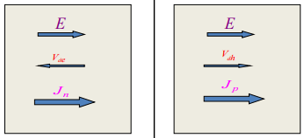

**Electrons**





$$V_{de}$$

$$V_{dh}$$

**Electrons**



**-** Negative sign indicates electrons move in opposite direction to E

**Carrier drift**



Where E is the applied electric field

**Mechanisms**

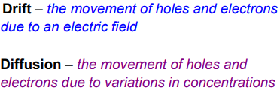

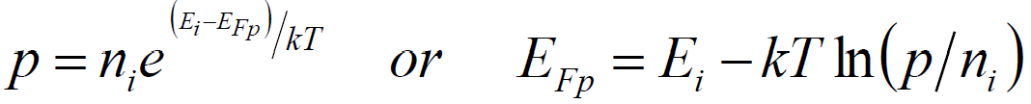



**Einstein Relation**



**Electrons & hole currents: Quasi Fermi Levels**

- Related to non-equilibrium carrier concentration the same way $E_{i}$ is to equilibrium carrier concentration

**Equilibrium conditions**

**Non-equilibrium conditions**

Diffusion constant

**Total Current: Steady State**

**Total**

**holes**

**electrons**

**Diffusion Current Density**

**Carrier Diffusion**

-> Thermally induced random motion

-> mobile carriers move from high concentration to low concentration

-> produce a flux of carriers

-> produce current

-> known as diffusion current

- Does not need external electric field

**n-type**

**p-type**

**Resistivity**

**Conductivity**

**In both cases, force arises from a compositional gradient**

**Charge Separation**

- In crystalline semiconductors a junction between two electronically different materials provides electrostatic force

- In photosynthesis, excited electrons are driven across the photosynthetic membrane by differences in free energy of molecular acceptors

**Work Function (**

- work function of a material is the energy required to remove the least tightly bound electron from Fermi level too vacuum level



**Electron Affinity $(χ)$**

**-** electron affinity is the energy required to remove electron from CB



**Note**

- Work function of a material is strongly dependent on surface preparation

- Work function of metal is always equal to electron affinity, but semiconductor depends on doping

**Determination of $E_{f}$ (doped semiconductor)**

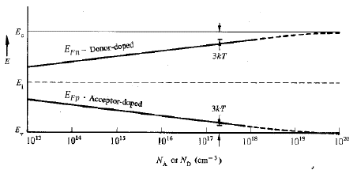

Fermi level systematically moves upward in energy from $E_{i}$ with increasing donor doping, and systematically downward in energy from $E_{i}$ with increasing acceptor doping

Figure above refers to exact positioning of $E_{f}$ in Si at room temperature as a function of doping concentration.

**Charge Separation: Types of Junctions**

- key step in photovoltaic energy conversion

- requires some kind of driving force, which should be built in the device

- driving force is electric field which effectively separates charge carriers and drives them in opposite directions

- in solar cells, a junction between 2 electronically different materials provides necessary driving force

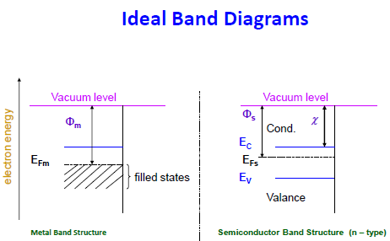



**Schottky Barrier (in dark)**

- When two materials isolated from each other, fermi levels are independent

- When brought into contact, electrons flow from semiconductor into the metal until Fermi energies of both solids are equal

- Upon electrons leaving the semiconductor, a layer of fixed positive charge left behind and a negative surface charge layer on metal appear

- This creates depletion region in semiconductor and hence, a built-in electric field which prevents further electron flow

- Since electron affinity and band gap are invariant in semiconductor, hence, $E_{vac}$ changes by a certain amount, so conduction and valence band energies must vary, by the same amount (band bending)

- Band bending energy, $qV_{bi}$, is equal to gradient in vacuum level (or difference in work functions)

- The greater the difference in work functions, larger the bending and higher the $V_{bi}$

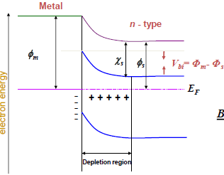

**Schottky Barrier**

- Formed between metal and a n- or p- semiconductor when are brough into contact

- $ϕ_{m}>ϕ_{s}$

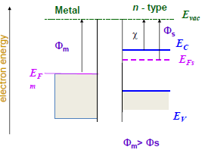

**Metal-Semiconductor Junction**

- Simple photovoltaic junction

- charge separating field is established due to difference in work functions of metal and semiconductor

**Types**

1. Schottky barrier

2. Ohmic contact

**Types of Junctions**

- Electrostatic field can be established at the junction between any two regions of different work functions due to vacuum level gradient

**Homo Junction**

- two layers of same semiconductor with different levels of doping

- most widely used technique in solar cells for establishing the charge separating field

**Hetero Junction**

- a semiconductor and a metal or

- two semiconductor of different work functions

**Origin of Photovoltaic Action**

- In photovoltaic device, light produces a pair of charges which are then separated

- that charge separation then gives rise to a photocurrent (short circuit) or photo-voltage (open circuit)

- photovoltaic action arises from the driving force separating charges

**Schottky Barrier (upon illumination)**

**Under illumination at open circuit**

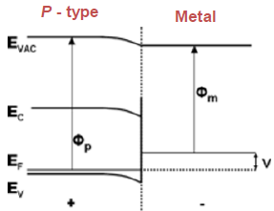

**Equilibrium**

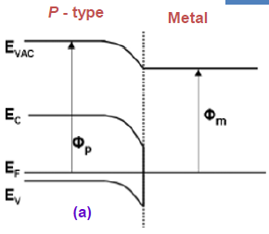

**Schottky Barrier (upon illumination)**

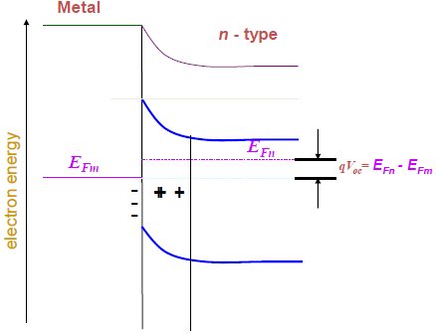

- When semiconductor is illuminated with photons of energy greater than band gap

-> built-in electric field will cause EHP generated in semiconductor to be separated

-> electrons accumulate in semiconductor and holes in metal

-> electron quasi fermi level in semiconductor moves up

-> become higher than it was dark and higher than the fermi level in metal $\left(E_{fm}\right)$

-> generates voltage called photo voltage

- Magnitude of phot voltage is equal to difference in fermi levels of semiconductor and metal

- Ability to sustain a difference in quasi fermi levels under illumination – key requirement in PV energy conversion

**Schottky Barrier**

Concentration profile

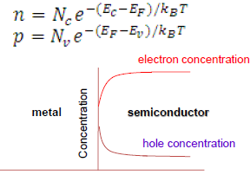

- When metal and semiconductor join -> electric field in layer close to interface

- Electric field drive electrons and holes in opposite direction – separation

- Contacts present lower resistance path for holes than electrons, from semiconductor to metals – this type of junction is an example for Schottky barrier

**p-type**

**- $ϕ_{m}>ϕ_{p}$**

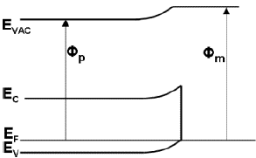

**n-type**

**- $ϕ_{m}<ϕ_{n}$**

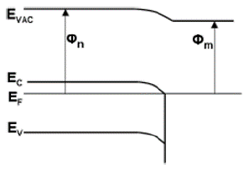

**p-n Junction**

- Formation:

-> p-n junction is established when layer of p-type semiconductor and layer of n-type material are brought together

-> when p-n junction formed, majority carriers diffuse across junction

-> leave behind layer of fixed charge on either side due to ionized impurity atoms

-> this space charge sets up an electrostatic field which opposes further diffusion of carriers across junction

-> when diffusion of majority carriers across junction is balanced by drift of minority carriers back across junction in the built-in field, equilibrium is established

-> fermi levels of p-type and n-type semiconductors are now equal

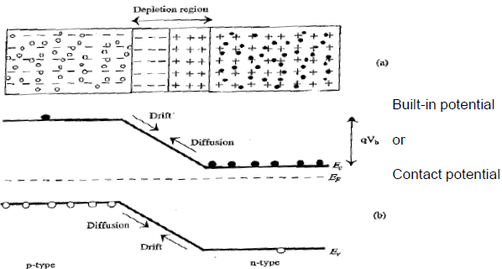

**Ohmic contacts**

- When n-type semiconductor-metal are brought into contact

-> the semiconductor bands bend

-> such that it encourages transport of majority carriers across the junction and inhibits only flow of minority carriers

-> Majority carriers accumulate near interface to establish necessary potential difference and junction is rich with carriers

-> this means it can pass current easily in either direction

-> so have a low contact resistance for majority carriers usually an Ohmic contact.

-> the difference in work function between two layers causes build-up of majority carriers near the interface

-> under illumination, the charges separated at the junction pass across the junction relatively easily

-> resultant photovoltage is negligible – mechanism which gives rise to photovoltage in a barrier junction – selective removal of minority carriers is absent

**p-n junction (in dark)**

**Band profile of p-n junction in equilibrium in the dark**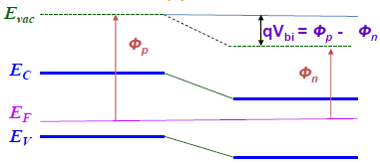

**Band profiles of p-type and n-type semiconductor in isolation**

**n-type**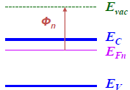

**p-type**

