# Setting up MEAN

### Introduction:

MEAN is short for a full-stack application that uses **M**ongoDB as a database, **E**xpress for a robust HTTP API, **A**ngularJS for the front-end, and **N**ode.js as a back-end framework.

## MongoDB

1. Go to <https://www.mongodb.com/download-center>, click on **Community Server** in the navigation bar and select the download for your operating system.

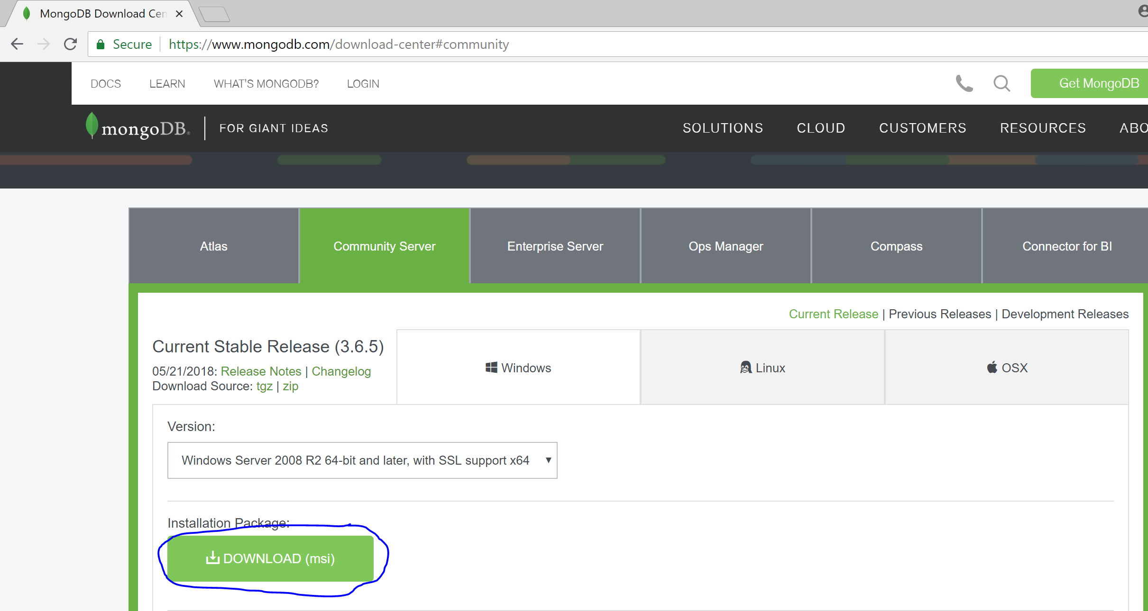

1. Run the MongoDB installer, making sure to select **Complete** instead of Custom, and to un-select **Install MongoDB Compass**.

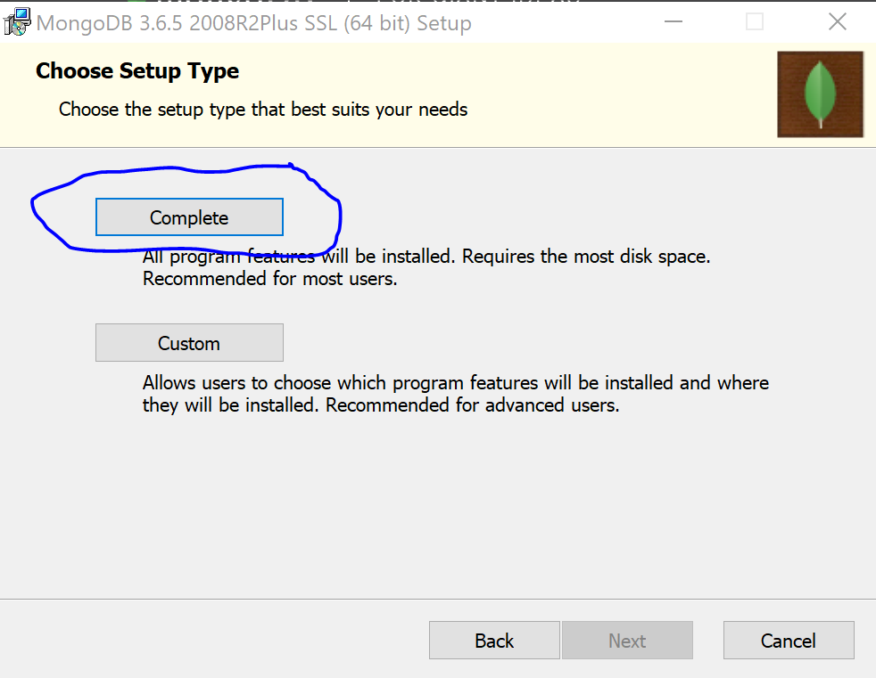

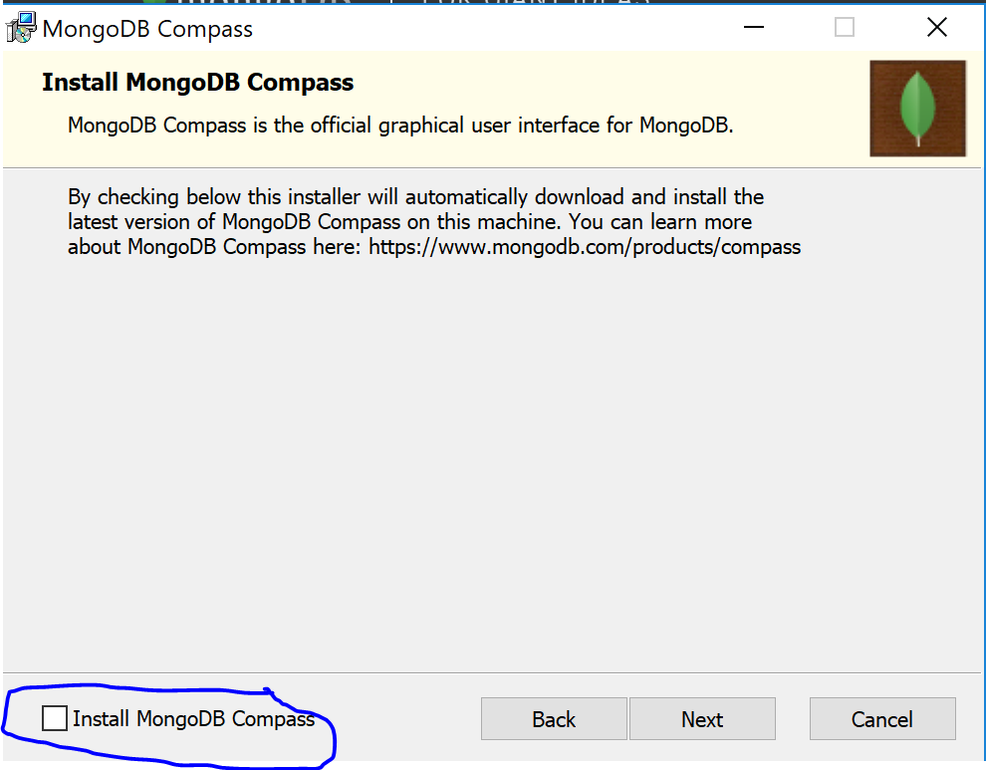

1. Create the directory C:\data, and C:\data\db. C:\data\db is a directory where MongoDB will store the contents of the database.

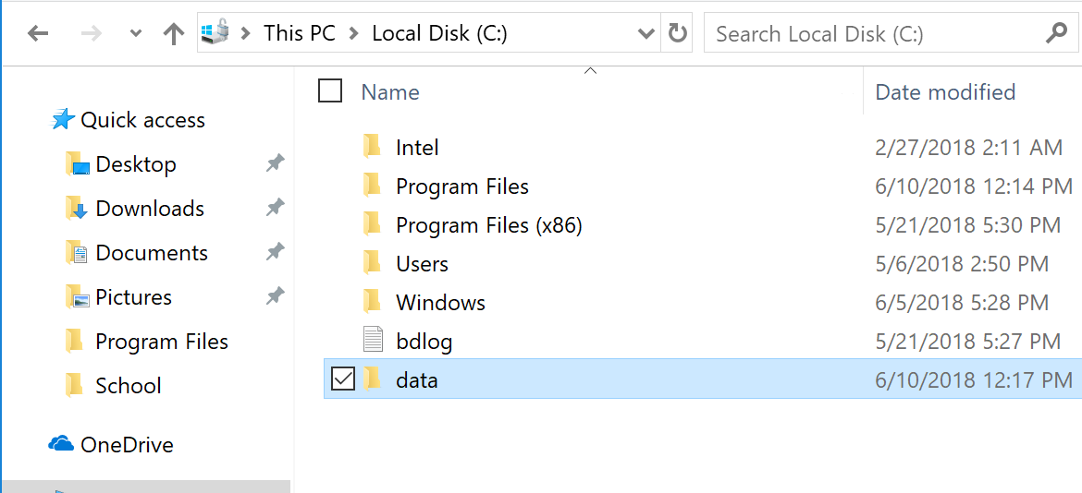

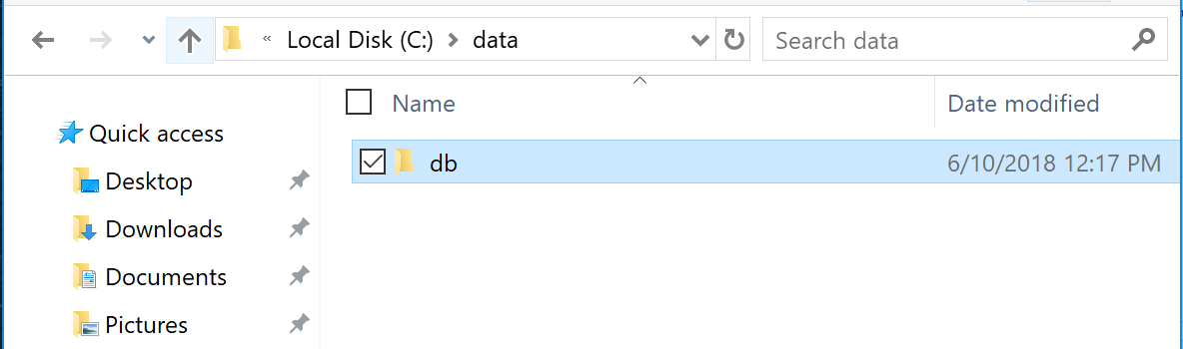

## Node.js

1. Go to <https://nodejs.org/en/download/> and select the appropriate LTS installation for your operating system.

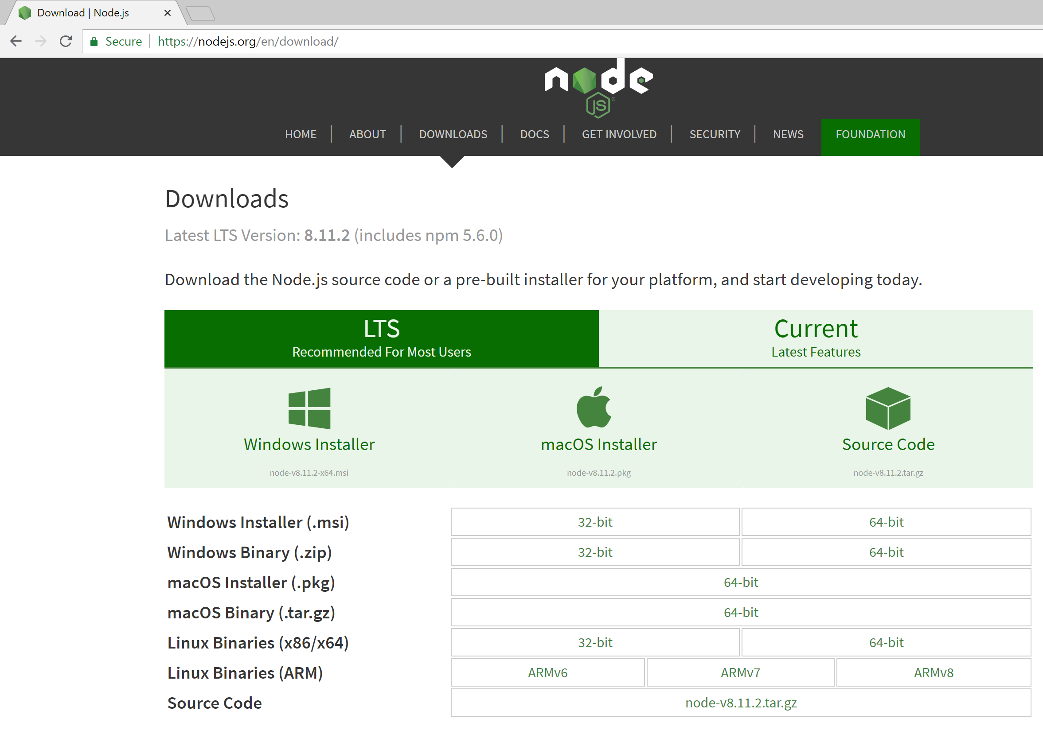

1. Run the installer, accepting all default options.