Howard University
College of Engineering and Architecture
Department of Electrical Engineering & Computer Science

Large Scale Programming
Fall 2024

Midterm Exam – Part I
October 17, 2024

Part I: 50 pts. (essay questions)

Instructions:
- Submit completed exam to your github repository under package org.howard.edu.lsp.midterm

Verify that the commit(s) completed successfully

- OPEN BOOK, OPEN NOTES. THERE IS NO COLLABORATION ON THIS EXAM
- Site any and ALL references for anything obtained off the internet.

Sources Used
Inheritance: https://www.geeksforgeeks.org/object-oriented-programming-in-cpp/
Encapsulation: https://www.geeksforgeeks.org/encapsulation-in-java/
Polymorphism: https://www.geeksforgeeks.org/polymorphism-in-java/
Single Responsibility Principle (SRP): https://en.wikipedia.org/wiki/Single-responsibility_principle
Encapsulation Principle: https://en.wikipedia.org/wiki/Encapsulation_%28computer_programming%29

Question 1. (10 pts.)

You are reviewing the following class in a Fitness Tracking System. The class is intended to manage various aspects of a user’s fitness activities.

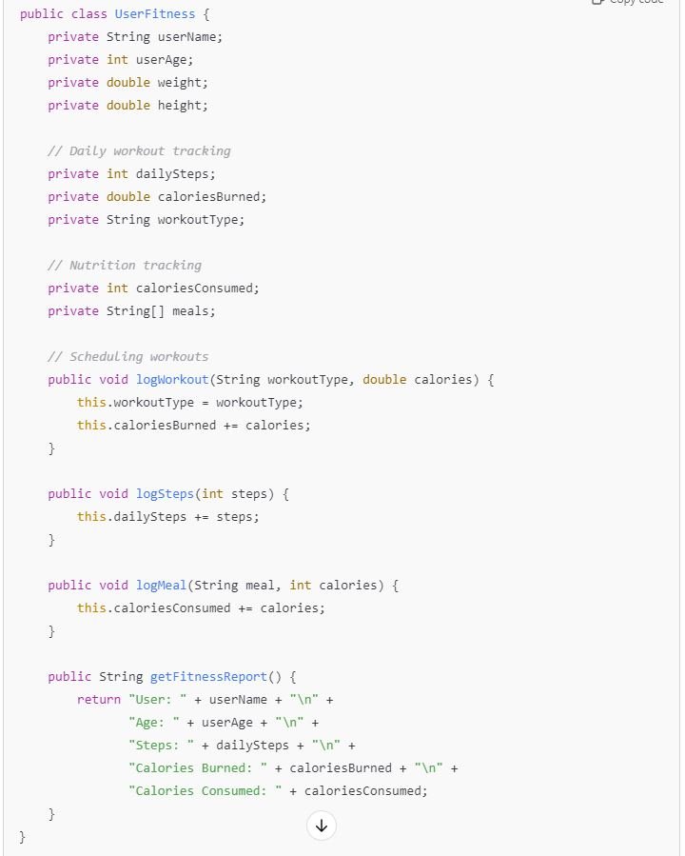

Tasks:
- Analyze the UserFitness class. Explain why this class has low cohesion. (5 pts.)

This class has low cohesion since it combines divergent yet similar processes/ responsibilities that have been implemented throughout the code rather than having them occur independently.

User_Profile ( each users unique persona/ profile) - > userName, age, and weight
WorkoutTrack_>logworkout , logSteps
NutritionTrack-> logMeal

- Describe, in general, how you would split the UserFitness class into more cohesive classes. Your answer should not be a complete design. (5 pts.)

I would split the UserFitness class into more cohesive classes by creating and implementing smaller trackers aimed at addressing smaller target processes.

User_Profile ( each users unique persona/ profile) - > userName, age, and weight

General user information for the application and user unique information

WorkoutTrack_>logworkout , logSteps

Keep a log of workouts and steps taken by user

NutritionTrack-> logMeal

Track user consumption effectively and accordingly

Question 2. (5 pts.)
Given the following, answer the below questions.

A university manages its students using a program that has a class Student with subclasses FirstYear, SecondYear, and ThirdYear for year-specific state and behaviors. The program has a List that contains all Students.

Should Student be a class, an abstract class or an interface? Explain your answer

Student should be an abstract class rather than an interface due to several factors. For example, students have somewhat alike behaviors when considering the likes of GPA (0.0 -4.0) , year to year course requirements/considerations such as year specific examinations or class requirements. Also, as we have logic that shifts within this context year to year, abstract is a more ideal choice.

- At the end of each year, the third-year students graduate and must be removed. This is done by passing the list to the following method:

void removeThirdYears(List<Students> students) {
for (Student student : students) {
try {
ThirdYear = (ThirdYear) student;
students.remove(thirdyear);
}
}
}

Why is the above method flawed? Hint: Another Arthur Riel heuristic (5 pts.)

The above method is flawed due to it being dependent on “ThirdYear”. As such, when adding a new student from another year outside of third, we have to keep adjusting if the particular parameter / year isn’t properly reflected in our line of code. In other terms, Open-Closed-Principle is not being properly nor effectively executed here.

Question 3. (5 pts.)
Given the following, answer the below questions.

public class BankAccount {
public String accountHolderName;
public String accountNumber;
public double balance;
public double interestRate;

public BankAccount(
String accountHolderName,
String accountNumber,
double initialDeposit,
double interestRate) {
this.accountHolderName = accountHolderName;
this.accountNumber = accountNumber;
this.balance = initialDeposit;
this.interestRate = interestRate;
}

// Exposed implementation for adding interest
public void addInterest() {
double interest = balance * (interestRate / 100);
balance += interest;
}

// Exposed implementation for deposits
public void deposit(double amount) {
balance += amount;
}

// Exposed implementation for withdrawals
public void withdraw(double amount) {
balance -= amount;
}
}

- Is BankAccount well-encapsulated? Why or why not? If so, describe what changes you would make to the class. Otherwise, state nothing. (5 pts.)

BankAccount is not well-encapsulated as it reveals several pieces of important information being : the interest( addInterest) , deposit, and withdraw methods directly into our implementation details. As such, this leads to security concerns and vulnerabilities.

Question 4. (10 pts.)
Given the following, answer the below questions.

Given:
A car manufacturer uses Java software to track current vehicles being built. The UML diagram below shows an excerpt of the current software structure. You should assume the presence of other appropriate fields and methods

Car
getTrimLevel()
Engine
accelerate()
getFuelLevel()
Base
Sports
Luxury
Electric
Petrol

Each car can be built to one of three trim levels: Base, Luxury or Sport. They can also be configured with an electric or petrol engine. At various points in the manufacturing process the customer can choose to change the trim level.

Task:
- Explain in detail why the current structure does not support this. (5 pts.)

The current structure does not support this as a byproduct of inheritance and tight coupling. As such, once a car is placed on a unique trim ,it cannot be altered without breaching the inheritance. On the other hand, the car is linked to unique trim levels hence, it’s not able to function without modifications of the initial trim

- Describe how to refactor the structure to allow trim-level change for a car to dynamically change. Hint: How would you modify Car to use composition to solve the problem? (5 pts.)

To address these issues, we need to implement a unique TrimLevel interface and establish instances for each trim. As such, the Car class should then be linked to a TrimLevel object.

Question 5. (5 pts.)
Suppose you are about to code a particular class and find that you have written another class with nearly the functionality that you now are developing. This means that the two classes in large parts contain the same code, but in smaller parts have different code. Explain in detail why this may be a problem and how to solve it. Give your answer in terms of Arthur Riel’s design heuristics.

This may be a issue as duplicated code can lead to constant adjustments across your block of code and makes your code possibly harder to follow, and future adjustments are drastically harder to implement. In terms of Arthur Riel’s design heuristics (Commonalities, Classes, Interface): we should look to adjust the dependence amongst classes, assign one unique responsibility per class, and eliminate duplicated code that can lead to future errors.

Question 6. (5 pts.)
Suppose we need to store instances of the classes Car and BankAccount in a database. To obtain low coupling it may seem as if the functionality to save an instance should be in precisely those classes, since they have the information that shall be saved. Why is it unwise to place the database calls there?

It’s unwise to place the database calls there since it violates several principles and considerations. Foremost, it creates tight coupling, code is being duplicated, and we are increasing the time complexity. As such, the data should just be put into a separate class to assist with the general flow.

Question 7. (5 pts.)
Given a set of requirements, what conditions must be met to make it appropriate to create a new class hierarchy using inheritance? Neither superclass nor subclass exist before, the question is about designing a new class hierarchy.

The conditions that must be met to make it appropriate to create a new class hierarchy using inheritance are as follows :

Commonalities: The classes shares several common attributes and behaviors.

Is-A Relationship: One class is a specialized version of another.

No Circular Dependencies: Avoid circular dependencies between classes, where classes are merged and code becomes over complicated

Question 8. (2.5 pts.)
Describe the difference between inheritance and composition why would you choose one over the other.

Inheritance ( “is-a”) occurs when a subclass takes on the attributes and behaviors of a superclass. As such it is best suited for hierarchical relationships. On the other hand, Composition("has-a") occurs when one class contains instances or references of another class as members. As such, it is best suited for part-whole relationships. We can choose which is best to use based on the flexibility you which to have such as, is-a vs has-a or a functional requirement.

Question 9. (2.5 pts.)
Explain the meaning of cohesion and describe whether low or high cohesion is better.

Cohesion is when elements such as a class or function are connected/ focused on the same task. As such, high cohesion is well-focused and performs a unique and well-established task. Accordingly, this leads to improved code functionality vs low cohesion. As such for low cohesion, multiple unrelated tasks or busy work within the code occurs, making it drastically more complicated and difficult to manipulate

