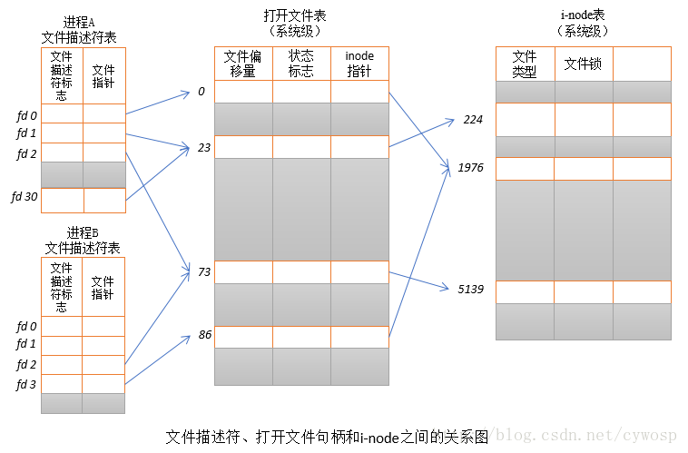

详细见https://blog.csdn.net/cywosp/article/details/38965239