| ETEC2110 Homework 1 Points: **20** |
| --- |

*“Homework” assignments are usually short assignments meant to ensure you were following along with lecture. Lab assignments are generally longer and task you with writing code.*

For this homework assignment, use a document editor (MS Word, LibreOffice, Google Docs, etc.). Open this file in that program and put your answer beneath the ques�ons (replacing the red text). Turn in this document on blackboard (you can either leave it as a doc/docx file or convert to pdf)

Some ques�ons about you

1. Your name

Jevin

2. Your Student ID#:

303385

3. Major(s)

Computer Engineering Technologies

4. A picture of yourself (this is just so I can associate names and faces – I won’t ever post this anywhere public) I had a hard time uploading a picture from my phone.

5. Hometown

Ewa Beach, Hawaii

6. Describe what you hope to learn from this class.

I hope to learn and get comfortable enough with C when I can focus on the problem and not on “how to write this program”

7. What programming language(s) [if any] have you used. For each, give a ranking of your comfort-level (0 = I’ve heard of it; 5 = I understand the basics; 10 = I’m ready for an entry-level job using)

MathPiper: 3.5

Java: 3.5

Some ques�ons pertaining to the syllabus

8. What are student learning outcomes and why should you care about them?

They are what the students are expected to know by the end of the course. We should care about them because we probably would have a hard time in the future if we don’t meet them.

9. When is our final exam?

Thursday, Dec 7 at 8am-9:50am

10. If I have a problem with a homework or lab, what should I do?

Ask the professor, SI, or classmates for help

11. Paraphrase the academic honesty policy

No copying other classmates work, work found online, or work generated by AI

Some ques�ons rela�ng to the content of the class

12. Why should I care about C (if you *don’t* think you should care about C, make that point instead)? Because a lot of jobs ask about your proficiency in the language and it’s faster than most other languages.

13. What do the ANSI C11, C89, C17, etc. mean?

They’re the version update for C

14. If I have a foo.c file in d:\labs\etec2110 (in windows) and I start a command prompt to c:\Users\Me, what are the command-line commands necessary to build a foo.exe using the gnu toolchain?

gcc -c foo.c

gcc -o foo.exe foo.o

gcc -o foo.exe foo.c

15. Write a complete C program where the main uses exactly 3 prin� statements where the second prints just your name, show how to make your name inside a pyramid like this. If your name is an even number of leters, cap your pyramid with /\ instead of /-\:

/-\

/”””\

/”””””\

|Jason|

\”””””/

\”””/

\-/

Include a comment at the top with your name and Lab number (#1) (do this for every file you create in this class)

**16. Turn in your document (doc, docx, or pdf format) and a zip of your project folder on blackboard on/before the due date**

If you’re not sure how to create a zip file, read on:

A zip file is a compressed folder. It contains one or more files and sub-folders (directories). Generally, you’ll have a directory (or sub-directory) for your work for that lab. For this assignment, you’ll probably want one folder that contains your two documents from Module01, Module02, and the python file for this module. In a Windows 10 file browser, this would look like this:

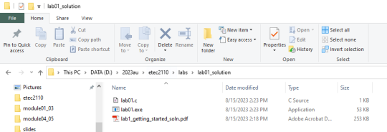To compress it, go to the containing folder (by clicking on the up arrow icon)…

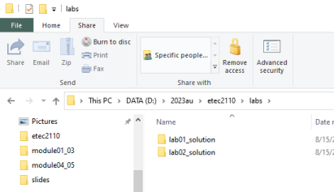(lab02_solu�on are from labs we’ll do later – they’re not part of this assignment)

Now, we have a couple of op�ons to compress this folder:

1. Use the built-in tools:

a. **Windows 10/11**: Right click on the lab01_solu�on folder, and select Send To => Compressed (zip) folder. You can op�onally rename the created zip file. This is what you’ll turn in.

b. **MacOS**: Control-click the folder in the finder (or tap it with two fingers if your keyboard doesn’t have a control key) and pick “Compress” from the shortcut menu.

c. **Linux**: (if you’re using linux, you probably don’t need my help here; **tar** is probably the command you want)

2. Use another program

a. I personally use a program called **7-zip** (htps://www.7-zip.org/) – you right-click on a folder in a file browser to add everything to a zip file. 7zip compression is slightly beter than standard compression. b. **WinRar** is an old (but s�ll widely used) program. It’s shareware meaning you can use it, but will be “pestered” to buy the commercial version.