Analysis

1. User base

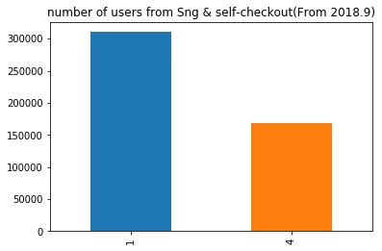

1. Repeated pattern
2. Average basket size

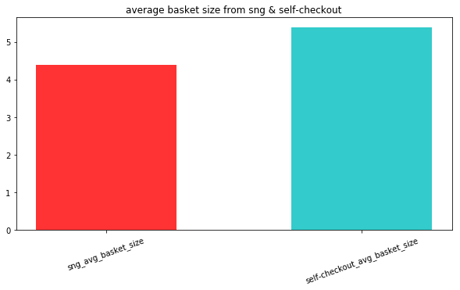

1. Peak order time