**Bagares, Christine Jhoy**

**BSIT-NS-3B**

**Activity 5**

**Views and Triggers**

1. **Views**
2. **Create a table called website_session using structure of cvs files**

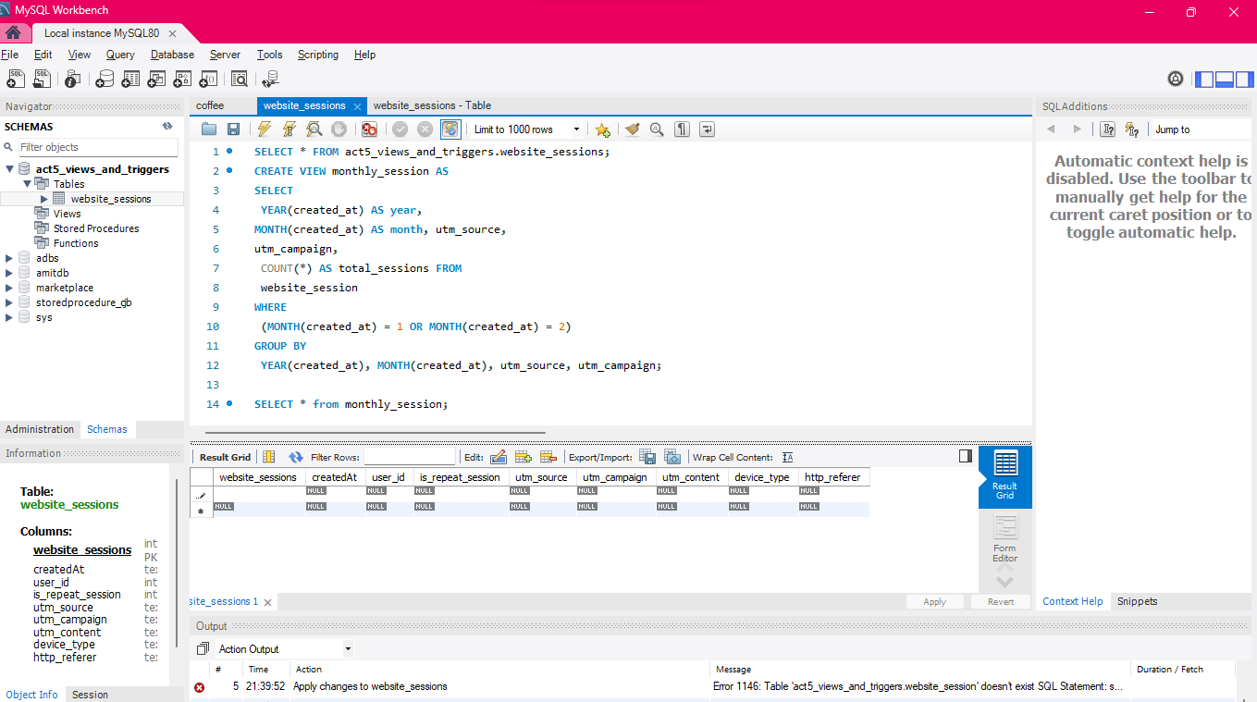

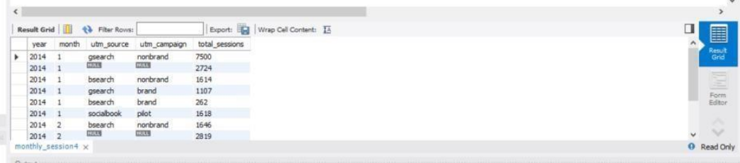

**VIEW**SELECT * FROM act5_views_and_triggers.website_sessions;

CREATE VIEW monthly_session AS

SELECT

YEAR(created_at) AS year,

MONTH(created_at) AS month, utm_source,

utm_campaign,

COUNT(*) AS total_sessions FROM

website_session

WHERE

(MONTH(created_at) = 1 OR MONTH(created_at) = 2)

GROUP BY

YEAR(created_at), MONTH(created_at), utm_source, utm_campaign;

SELECT * from monthly_session;

SELECT * from monthly_session;

1. **Create a view summarizing performance for January and February: Display the number of sessions sliced by year, month, utm_source, and utm_campaign if possible.**

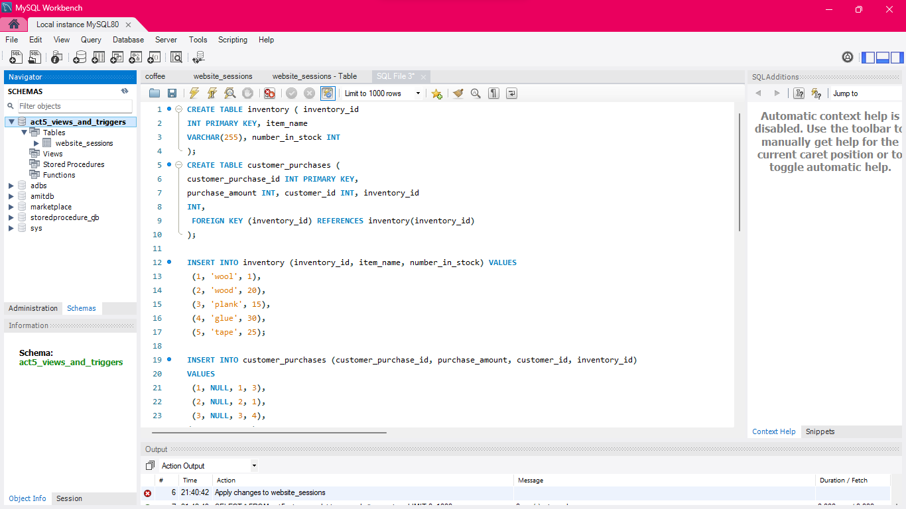

**TRIGGERS**

CREATE TABLE inventory ( inventory_id

INT PRIMARY KEY, item_name

VARCHAR(255), number_in_stock INT

);

CREATE TABLE customer_purchases (

customer_purchase_id INT PRIMARY KEY,

purchase_amount INT, customer_id INT, inventory_id

INT,

FOREIGN KEY (inventory_id) REFERENCES inventory(inventory_id)

);

INSERT INTO inventory (inventory_id, item_name, number_in_stock) VALUES

(1, 'wool', 1),

(2, 'wood', 20),

(3, 'plank', 15),

(4, 'glue', 30),

(5, 'tape', 25);

INSERT INTO customer_purchases (customer_purchase_id, purchase_amount, customer_id, inventory_id)

VALUES

(1, NULL, 1, 3),

(2, NULL, 2, 1),

(3, NULL, 3, 4),

(4, NULL, 4, 2);

DELIMITER //

CREATE TRIGGER purchase_Update_Inventory

AFTER INSERT ON customer_purchases FOR EACH ROW

BEGIN

UPDATE inventory

SET number_in_stock = number_in_stock - 1

WHERE inventory_id = NEW. inventory_id;

END;

//

DELIMITER ;

INSERT INTO customer_purchases (customer_purchase_id, purchase_amount, customer_id, inventory_id)

VALUES (5, 1, 1, 3),

(6, NULL, NULL, 4);

DELIMITER //

CREATE TRIGGER purchase_Update_Inventory

AFTER INSERT ON customer_purchases FOR EACH ROW

BEGIN

DECLARE new_stock INT;

SET new_stock = (SELECT number_in_stock - 1 FROM inventory WHERE inventory_id =

NEW.inventory_id);

UPDATE inventory SET number_in_stock = GREATEST(new_stock, 0) WHERE inventory_id =

NEW.inventory_id;

IF new_stock <= 0 THEN

SIGNAL SQLSTATE '45000'

SET MESSAGE_TEXT = 'Error: Insufficient stock.'; END IF;

END;

DELIMITER ;

INSERT INTO customer_purchases (customer_purchase_id, purchase_amount, customer_id, inventory_id)

VALUES (7, 1, 5, 1); select * from inventory;