To create a new blank workbook:

1. Select the **File** tab. **Backstage view** will appear.

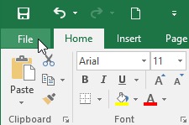

1. Select **New**, then click **Blank workbook**.

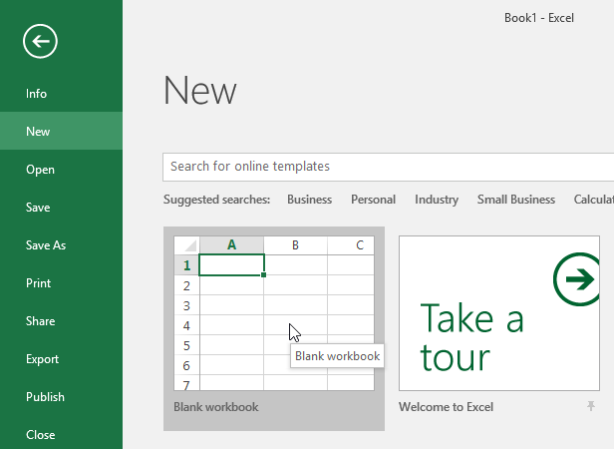

1. A new blank workbook will appear.

To open an existing workbook:

In addition to creating new workbooks, you'll often need to open a workbook that was previously saved. To learn more about saving workbooks, visit our lesson on [**Saving and Sharing Workbooks**](http://www.gcflearnfree.org/excel2016/saving-and-sharing-workbooks/1/).

1. Navigate to **Backstage view**, then click **Open**.

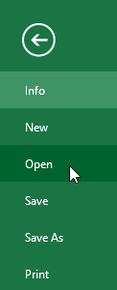

1. Select **Computer**, then click **Browse**. Alternatively, you can choose **OneDrive** to open files stored on your **OneDrive**.

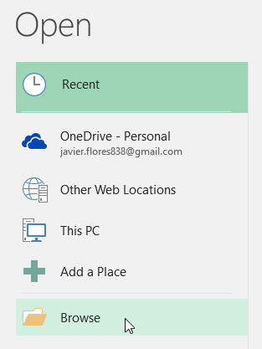

1. The **Open** dialog box will appear. Locate and select your **workbook,** then click **Open**.

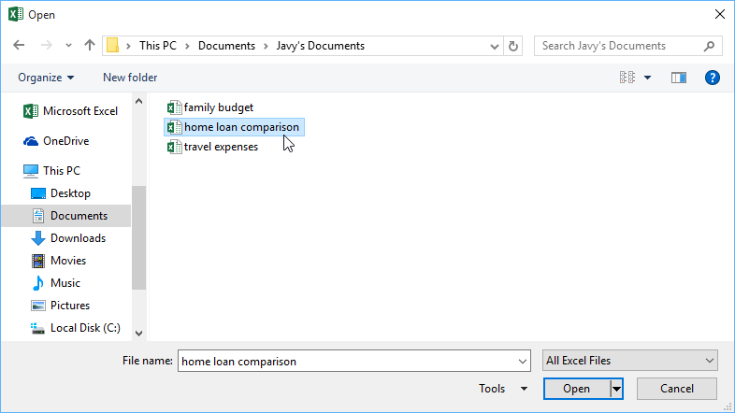

If you've opened the desired workbook recently, you can browse your **Recent Workbooks** rather than search for the file.

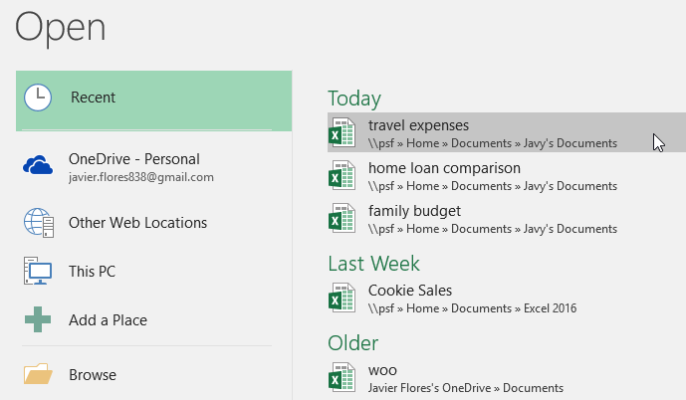

To pin a workbook:

If you frequently work with the **same workbook**, you can**pin it**to Backstage view for faster access.

1. Navigate to **Backstage** **view**, then click **Open**. Your **recently edited workbooks** will appear.

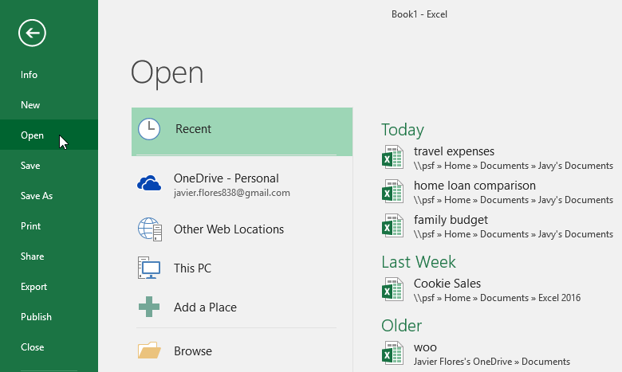

1. Hover the mouse over the **workbook**you want to pin. A **pushpin** **icon** will appear next to the workbook. Click the **pushpin icon**.

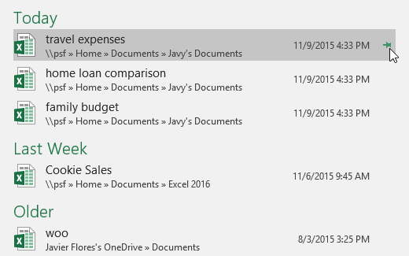

1. The workbook will stay in Recent Workbooks. To **unpin** a workbook, simply click the pushpin icon again.

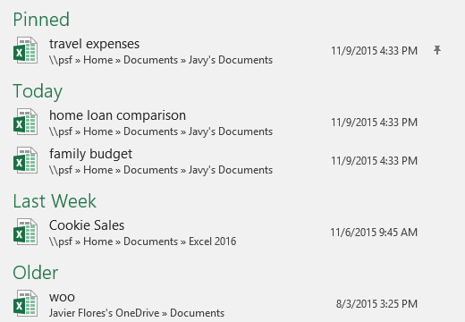

Using templates

A **template** is a **predesigned spreadsheet** you can use to create a new workbook quickly. Templates often include **custom** **formatting** and **predefined** **formulas**, so they can save you a lot of time and effort when starting a new project.

To create a new workbook from a template:

1. Click the **File** tab to access **Backstage** **view**.



1. Select **New**. Several templates will appear below the **Blank workbook**option.
2. Select a **template** to review it.

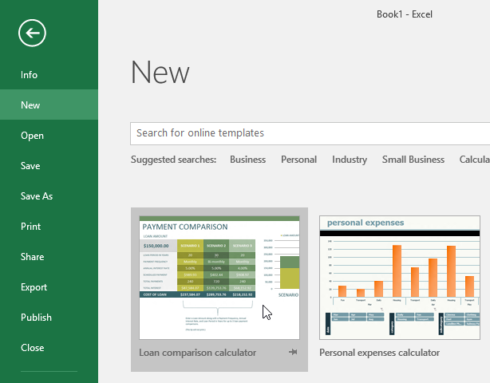

1. A **preview** of the template will appear, along with **additional** **information**on how the template can be used.
2. Click **Create**to use the selected template.

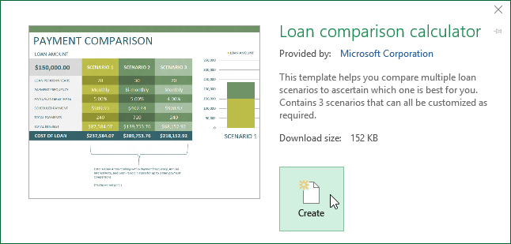

1. A new workbook will appear with the **selected** **template**.

You can also browse templates by **category** or use the **search bar**to find something more specific.

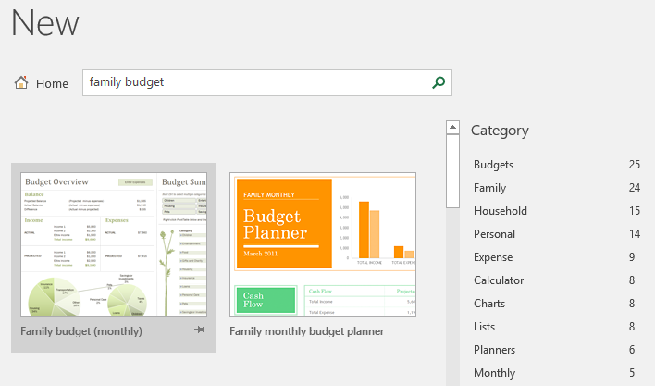

It's important to note that not all templates are created by Microsoft. Many are created by third-party providers and even individual users, so some templates may work better than others.

Compatibility Mode

Sometimes you may need to work with workbooks that were created in earlier versions of Microsoft Excel, such as Excel 2003 or Excel 2000. When you open these types of workbooks, they will appear in **Compatibility Mode**.

Compatibility Mode **disables** certain features, so you'll only be able to access commands found in the program that was used to create the workbook. For example, if you open a workbook created in Excel 2003, you can only use tabs and commands found in Excel 2003.

In the image below, you can see that the workbook is in Compatibility Mode, which is indicated at the top of the window to the right of the file name. This will disable some Excel 2016 features, and they will be grayed out on the Ribbon.

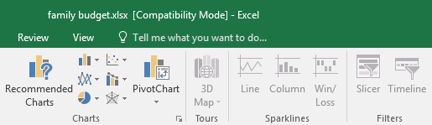

In order to exit Compatibility Mode, you'll need to **convert**the workbook to the current version type. However, if you're collaborating with others who only have access to an earlier version of Excel, it's best to leave the workbook in Compatibility Mode so the format will not change.

To convert a workbook:

If you want access to all of the Excel 2016 features, you can **convert** the workbook to the 2016 file format.

Note that converting a file may cause some changes to the **original layout**of the workbook.

1. Click the **File** tab to access Backstage view.



1. Locate and select **Convert** command.

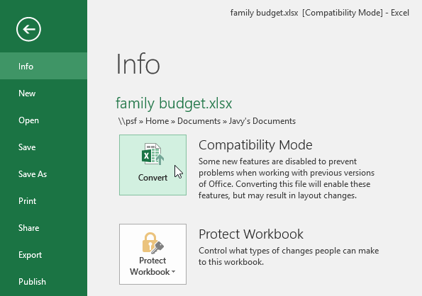

1. The **Save As** dialog box will appear. Select the **location** where you want to save the workbook, enter a **file name** for the workbook, and click **Save**.

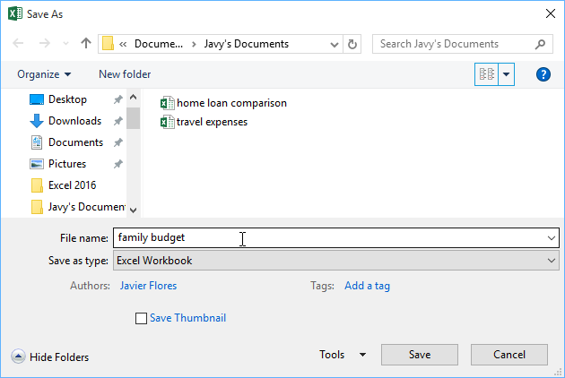

1. The workbook will be converted to the newest file type.