Getting to know Excel

If you've previously used Excel 2010 or Excel 2013, then Excel 2016 should feel familiar. If you are new to Excel or have more experience with older versions, you should first take some time to become familiar with the **Excel interface**.

The Excel interface

When you open Excel 2016 for the first time, the **Excel Start Screen** will appear. From here, you'll be able to create a **new workbook**, choose a **template**, and access your **recently** **edited** **workbooks**.

* From the **Excel Start Screen**, locate and select**Blank workbook**to access the Excel interface.

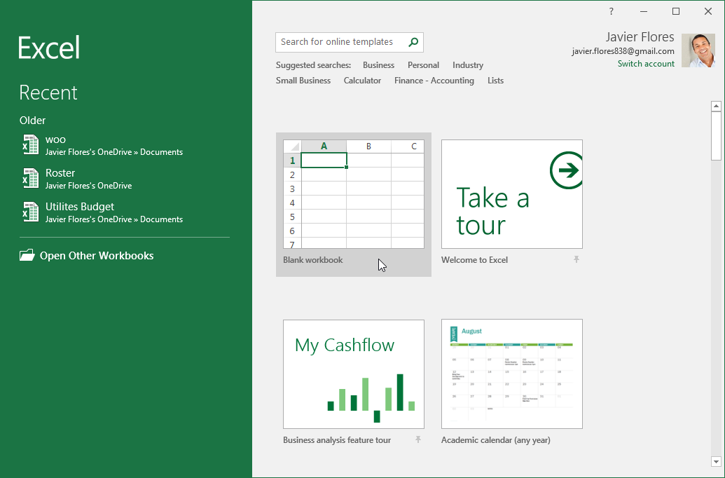

Click the buttons in the interactive below to become familiar with the Excel interface.

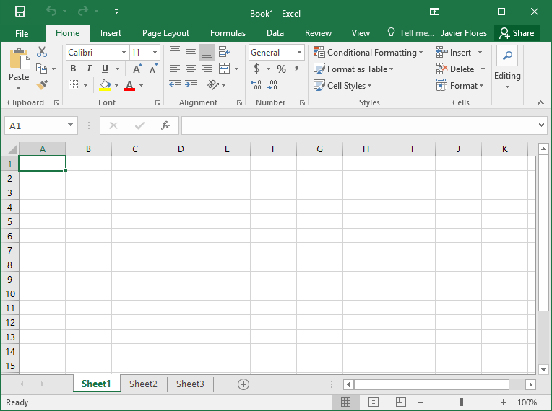

Working with the Excel environment

The **Ribbon** and **Quick Access Toolbar** are where you will find the commands to perform common tasks in Excel. The **Backstage view** gives you various options for saving, opening a file, printing, and sharing your document.

The Ribbon

Excel 2016 uses a **tabbed Ribbon system**instead of traditional menus. **The Ribbon**contains **multiple tabs**, each with several **groups** **of commands**. You will use these tabs to perform the most **common tasks** in Excel.

* Each tab will have one or more groups.

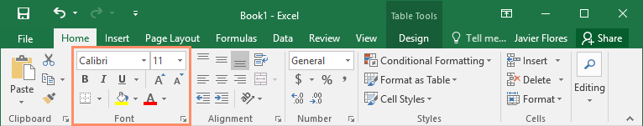

* Some groups will have an arrow you can click for more options.

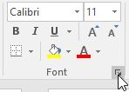

* Click a tab to see more commands.

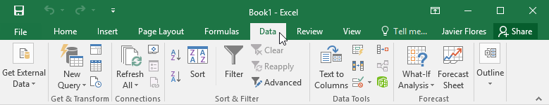

* You can adjust how the Ribbon is displayed with the Ribbon Display Options.

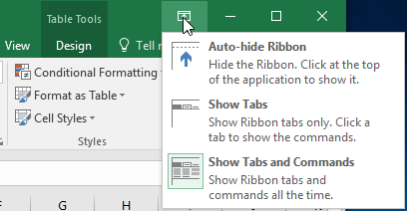

Certain programs, such as **Adobe Acrobat Reader**, may install additional tabs to the Ribbon. These tabs are called **add-ins**.

To change the Ribbon Display Options:

The Ribbon is designed to respond to your current task, but you can choose to **minimize**it if you find that it takes up too much screen space. Click the **Ribbon Display Options**arrow in the upper-right corner of the Ribbon to display the drop-down menu.



There are three modes in the Ribbon Display Options menu:

* **Auto-hide Ribbon:** Auto-hide displays your workbook in full-screen mode and completely hides the Ribbon. To **show the Ribbon**, click the **Expand Ribbon** command at the top of screen.

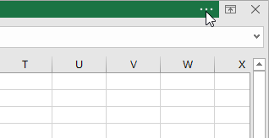

* **Show Tabs:**This option hides all command groups when they're not in use, but **tabs** will remain visible. To **show the Ribbon**, simply click a tab.

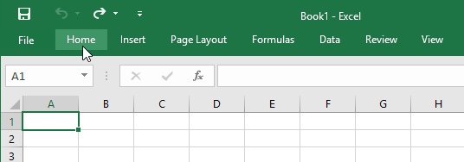

* **Show Tabs and Commands:** This option maximizes the Ribbon. All of the tabs and commands will be visible. This option is selected by default when you open Excel for the first time.

The Quick Access Toolbar

Located just above the Ribbon, the **Quick Access Toolbar** lets you access common commands no matter which tab is selected. By default, it includes the **Save**, **Undo**, and **Repeat** commands. You can add other commands depending on your preference.

To add commands to the Quick Access Toolbar:

1. Click the **drop-down arrow** to the right of the **Quick Access Toolbar**.
2. Select the **command** you want to add from the drop-down menu. To choose from more commands, select **More Commands**.

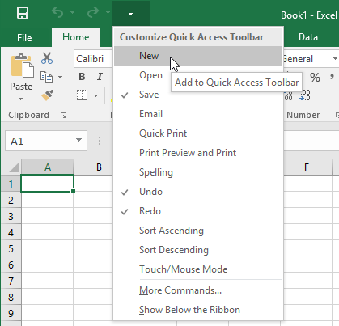

1. The command will be **added** to the Quick Access Toolbar.

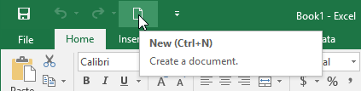

How to use Tell me:

The **Tell me** box works like a search bar to help you quickly find tools or commands you want to use.

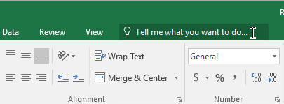

1. Type in your own words what you want to do.

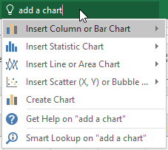

1. The results will give you a few relevant options. To use one, click it like you would a command on the Ribbon.

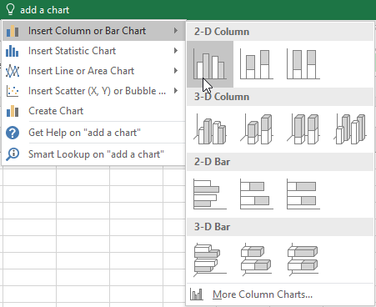

Worksheet views

Excel 2016 has a variety of viewing options that change how your workbook is displayed. These views can be useful for various tasks, especially if you're planning to **print** the spreadsheet. To **change worksheet views**, locate the commands in the bottom-right corner of the Excel window and select **Normal view**,**Page Layout view**, or**Page Break view**.

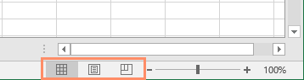

* **Normal view** is the default view for all worksheets in Excel.

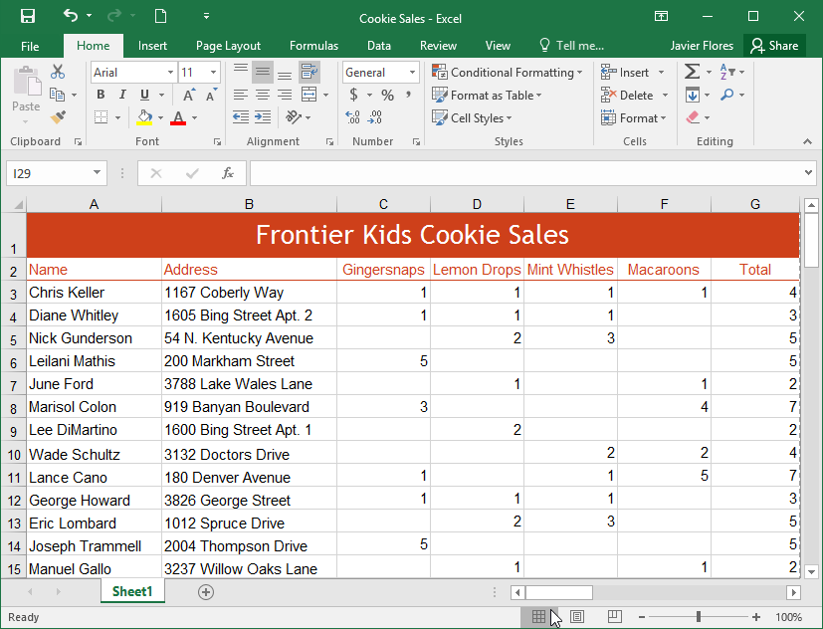

* **Page Layout view** displays how your worksheets will appear when printed. You can also add headers and footers in this view.

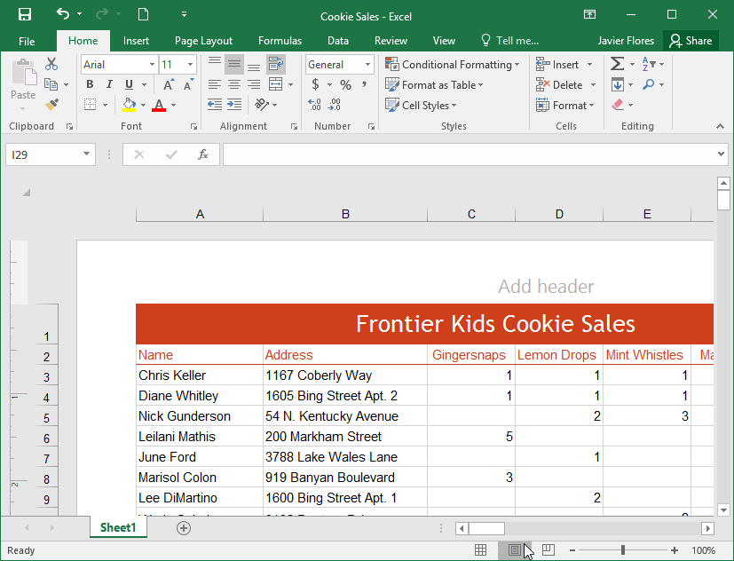

* **Page Break view** allows you to change the location of page breaks, which is especially helpful when printing a lot of data from Excel.

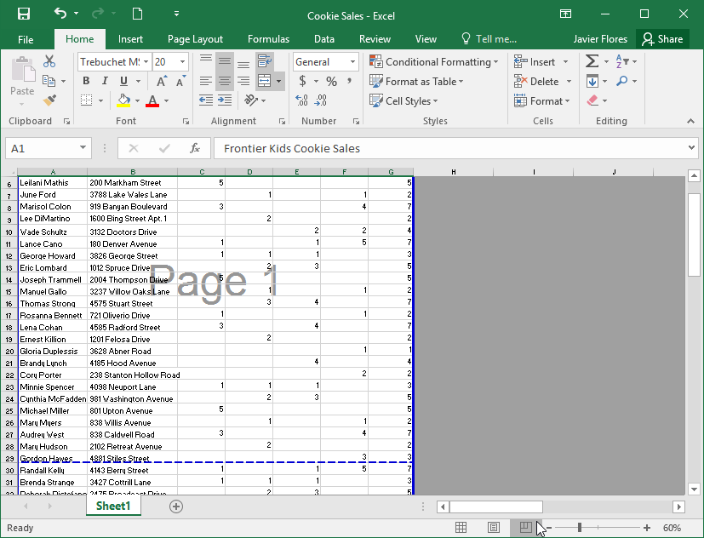

Backstage view

**Backstage view** gives you various options for saving, opening a file, printing, and sharing your workbooks.

To access Backstage view:

1. Click the **File** tab on the**Ribbon**. **Backstage view** will appear.

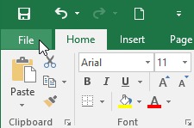

Click the buttons in the interactive below to learn more about using Backstage view.

