To modify column width:

In our example below, column C is too narrow to display all of the content in these cells. We can make all of this content visible by changing the **width** of column C.

1. Position the mouse over the **column line** in the **column heading** so thecursor becomes a **double arrow**.

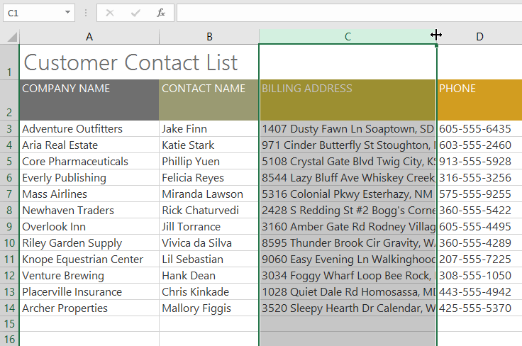

1. Click and drag the mouse to **increase** or **decrease** the column width.

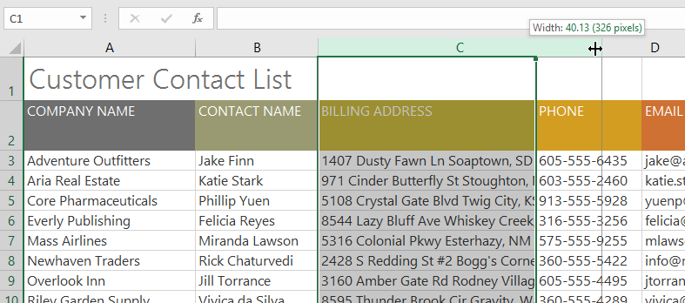

1. Release the mouse. The **column width** will be changed.

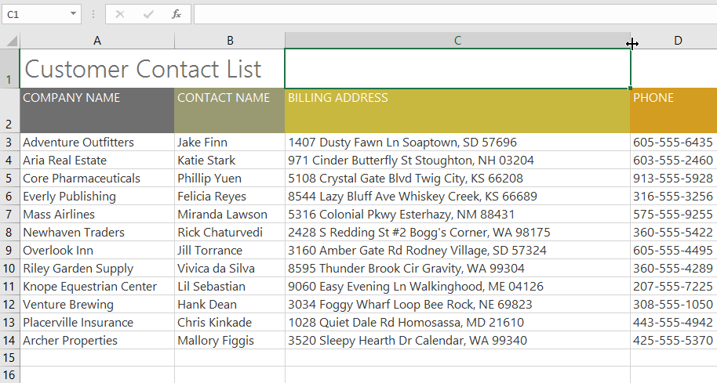

With numerical data, the cell will display **pound signs** (#######) if the column is too narrow. Simply **increase the column width** to make the data visible.

To AutoFit column width:

The **AutoFit** feature will allow you to set a column's width to fit its content **automatically**.

1. Position the mouse over the **column line** in the **column heading**so the cursor becomes a **double arrow**.

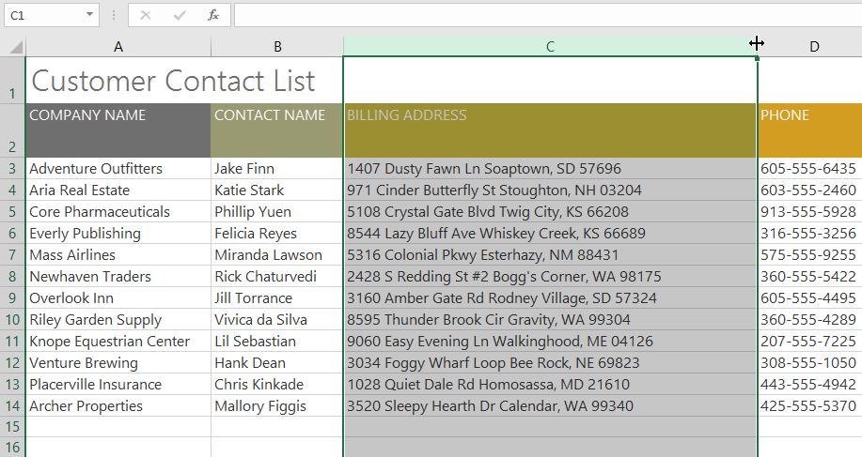

1. Double-click the mouse. The **column width** will be changed automatically to fit the content.

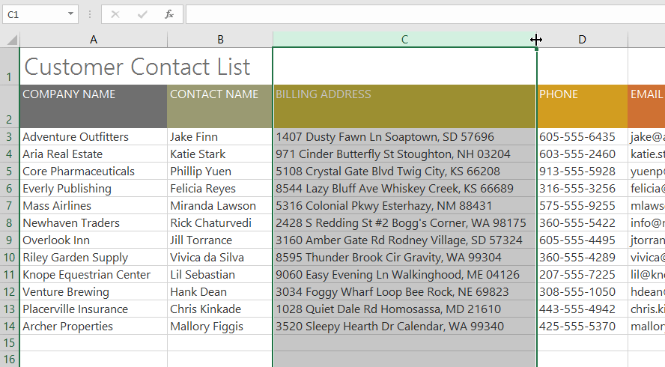

You can also AutoFit the width for several columns at the same time. Simply select the columns you want to AutoFit, then select the **AutoFit Column Width** command from the **Format** drop-down menu on the **Home** tab. This method can also be used for **row height**.

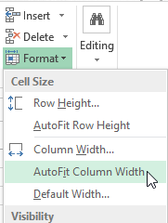

To modify row height:

1. Position the **cursor** over the **row line**so the cursor becomes a **double arrow**.

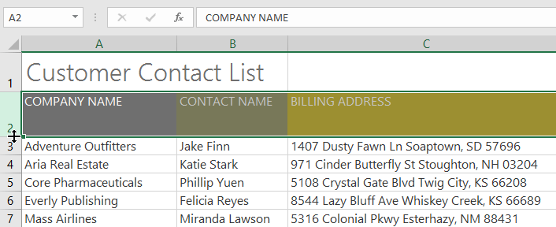

1. Click and drag the mouse to **increase** or **decrease** the row height.

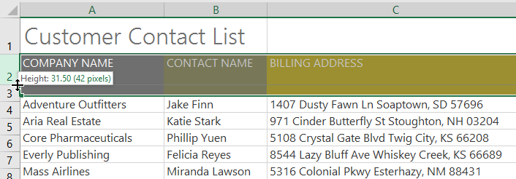

1. Release the mouse. The **height** of the selected row will be changed.

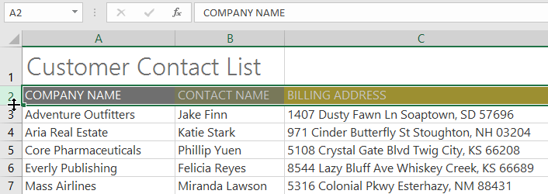

To modify all rows or columns:

Instead of resizing rows and columns individually, you can modify the height and width of every row and column at the same time. This method allows you to set a **uniform size**for every row and column in your worksheet. In our example, we will set a **uniform row height**.

1. Locate and click the **Select All**button just below the**name box** to select every cell in the worksheet.

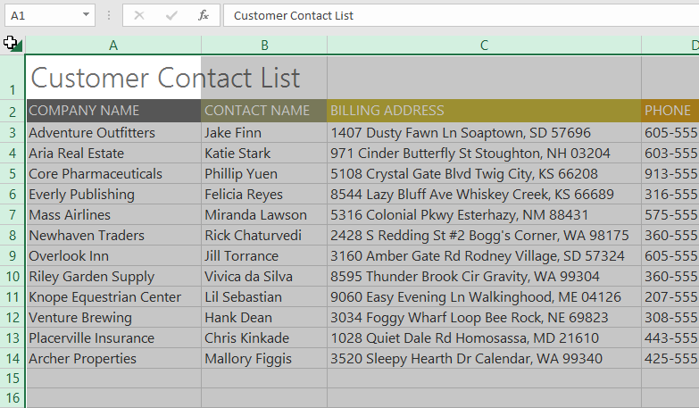

1. Position the mouse over a **row line** so the cursor becomes a **double arrow**.
2. Click and drag the mouse to **increase** or **decrease** the row height, then release the mouse when you are satisfied. The row height will be changed for the entire worksheet.

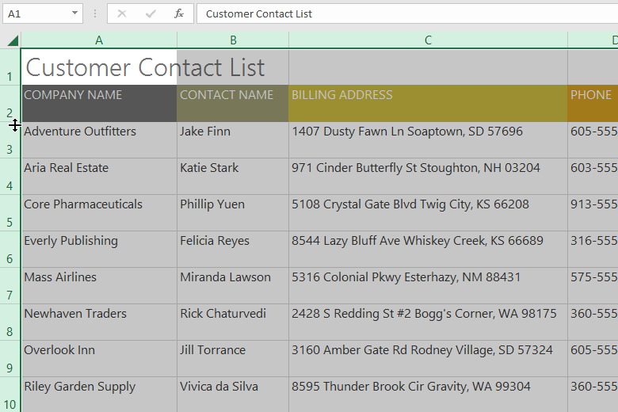

Inserting, deleting, moving, and hiding

After you've been working with a workbook for a while, you may find that you want to **insert new**columns or rows, **delete** certain rows or columns, **move** them to a different location in the worksheet, or even **hide** them.

To insert rows:

1. Select the **row** **heading** below where you want the new row to appear. In this example, we want to insert a row between rows 4 and 5, so we'll select **row 5**.

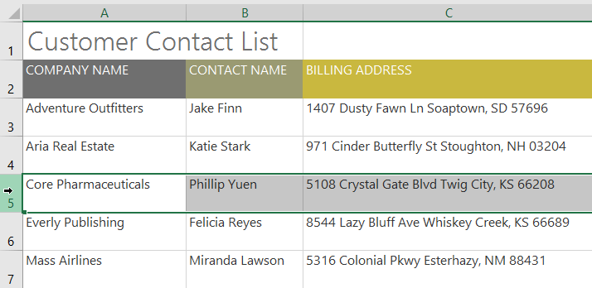

1. Click the **Insert** command on the **Home** tab.

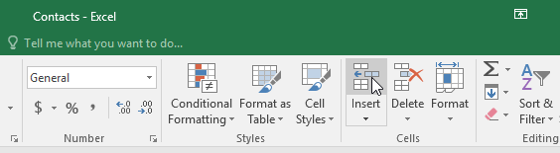

1. The **new row** will appear **above** the selected row.

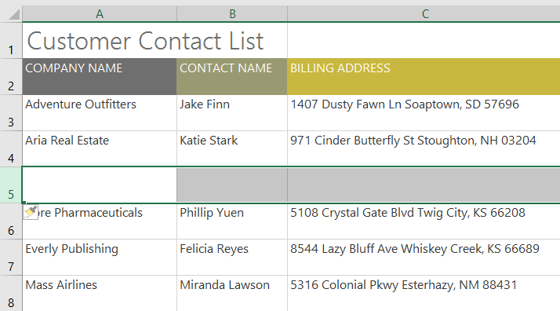

When inserting new rows, columns, or cells, you will see a **paintbrush icon**next to the inserted cells. This button allows you to choose how Excel formats these cells. By default, Excel formats inserted rows with the same formatting as the cells in the row above. To access more options, hover your mouse over the icon, then click the**drop-down arrow**.

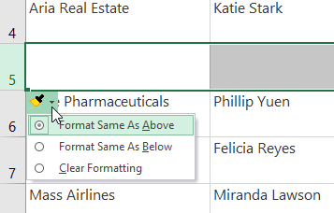

To insert columns:

1. Select the **column** **heading** to the right of where you want the new column to appear. For example, if you want to insert a column between columns D and E, select **column E**.

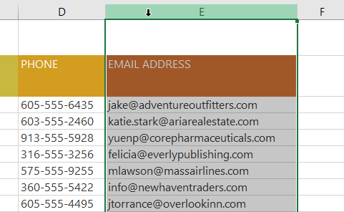

1. Click the **Insert** command on the **Home** tab.

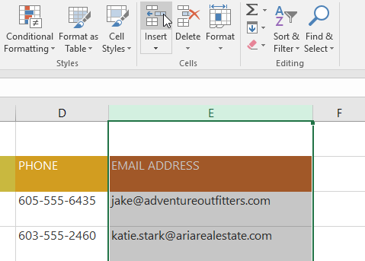

1. The **new column** will appear **to the left** of the selected column.

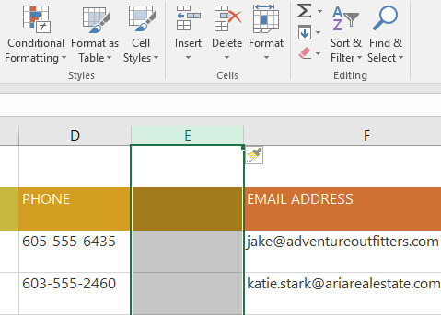

When inserting rows and columns, make sure you select the entire row or column by clicking the **heading.** If you select only a cell in the row or column, the **Insert** command will only insert a new cell.

To delete a row or column:

It's easy to delete a row or column that you no longer need. In our example we'll delete a row, but you can delete a column the same way.

1. Select the **row**you want to delete. In our example, we'll select **row 9**.

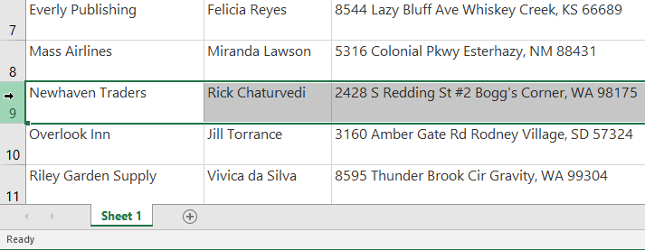

1. Click the **Delete** command on the **Home** tab.

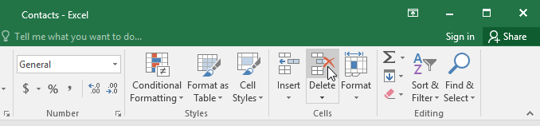

1. The **selected row** will be deleted, and those around it will **shift**. In our example, **row** **10** has moved up, so it's now **row 9**.

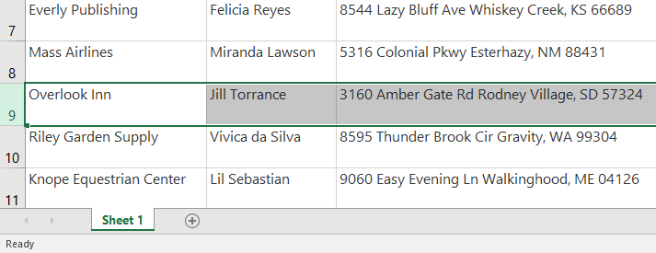

It's important to understand the difference between **deleting** a row or column and simply **clearing** **its contents**. If you want to remove the **content** from a row or column without causing others to shift, **right-click a heading**, then select **Clear Contents** from the drop-down menu.

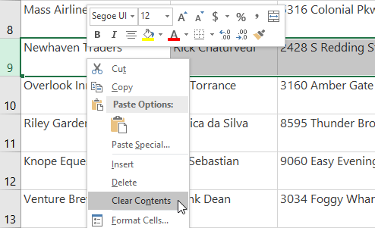

To move a row or column:

Sometimes you may want to **move** a column or row to rearrange the content of your worksheet. In our example we'll move a column, but you can move a row in the same way.

1. Select the desired **column heading** for the column you want to move.

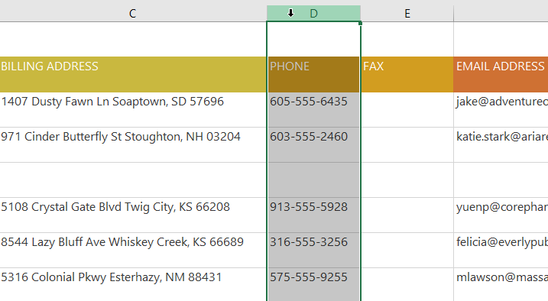

1. Click the **Cut** command on the **Home** tab, or press **Ctrl+X** on your keyboard.

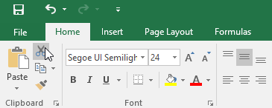

1. Select the **column** **heading** to the right of where you want to move the column. For example, if you want to move a column between columns E and F, select**column F**.

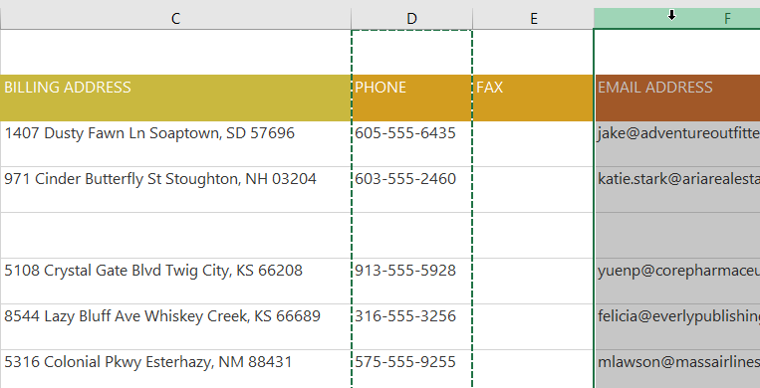

1. Click the **Insert** command on the **Home** tab, then select **Insert Cut Cells**from the drop-down menu.

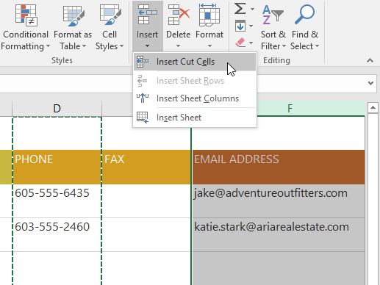

1. The column will be **moved** to the selected location, and the columns around it will shift.

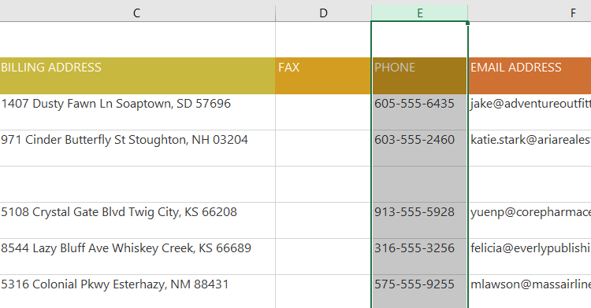

You can also access the **Cut** and **Insert** commands by right-clicking the mouse and selecting the **desired** **commands** from the drop-down menu.

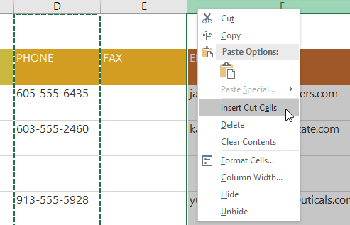

To hide and unhide a row or column:

At times, you may want to **compare** certain rows or columns without changing the organization of your worksheet. To do this, Excel allows you to **hide** rows and columns as needed. In our example we'll hide a few columns, but you can hide rows in the same way.

1. Select the **columns** you want to **hide**, right-click the mouse, then select **Hide** from the **formatting** menu. In our example, we'll hide columns C, D, and E.

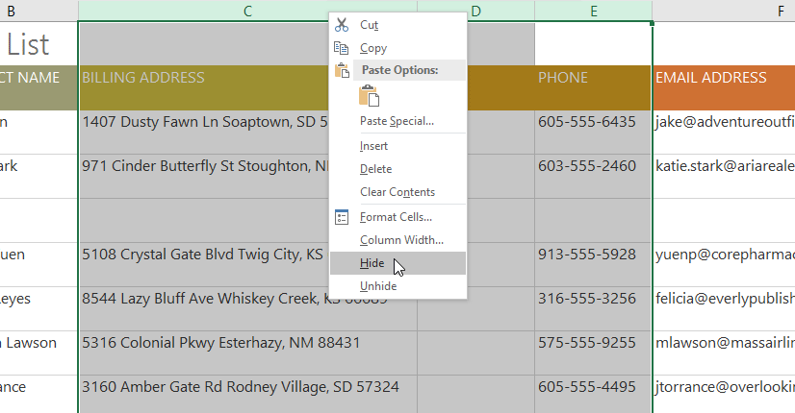

1. The columns will be **hidden**. The**green column line** indicates the location of the hidden columns.

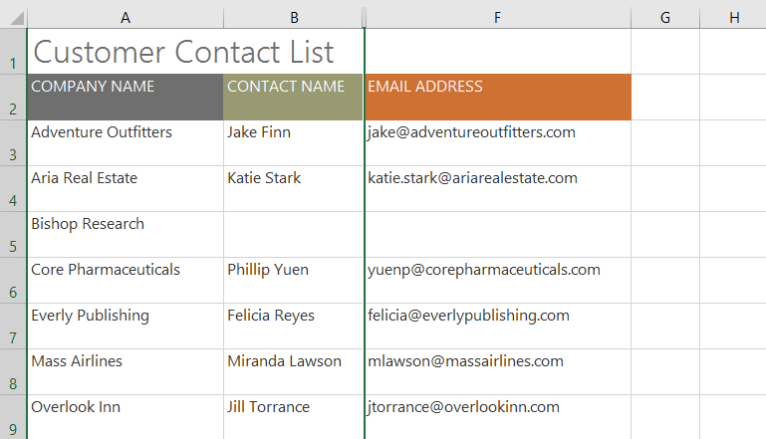

1. To **unhide** the columns, select the columns on **both** **sides** of the hidden columns. In our example, we'll select columns **B** and **F**. Then right-click the mouse and select **Unhide** from the **formatting**menu.

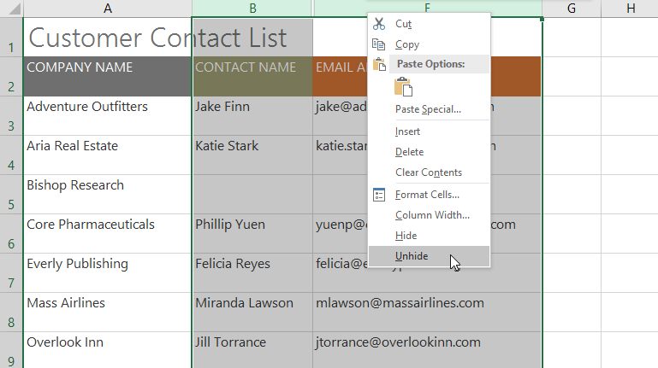

1. The hidden columns will reappear.

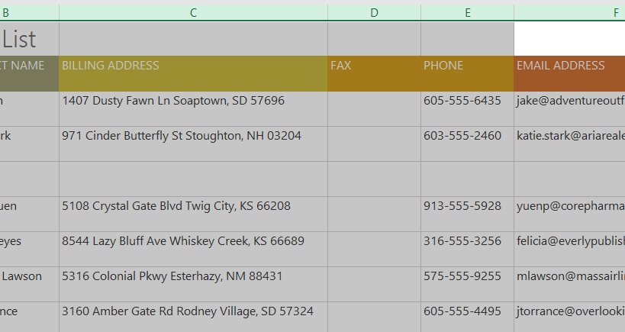

Wrapping text and merging cells

Whenever you have too much cell content to be displayed in a single cell, you may decide to **wrap the text** or **merge**the cell rather than resize a column. Wrapping the text will automatically modify a cell's **row height**, allowing cell contents to be displayed **on multiple lines**. Merging allows you to combine a cell with adjacent empty cells to create **one large cell**.

To wrap text in cells:

1. Select the cells you want to wrap. In this example, we'll select the cells in **column C**.
2. Click the **Wrap Text** command on the **Home** tab.

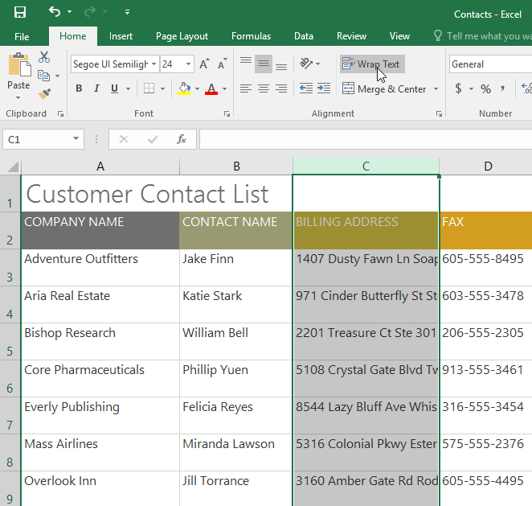

1. The text in the selected cells will be **wrapped**.

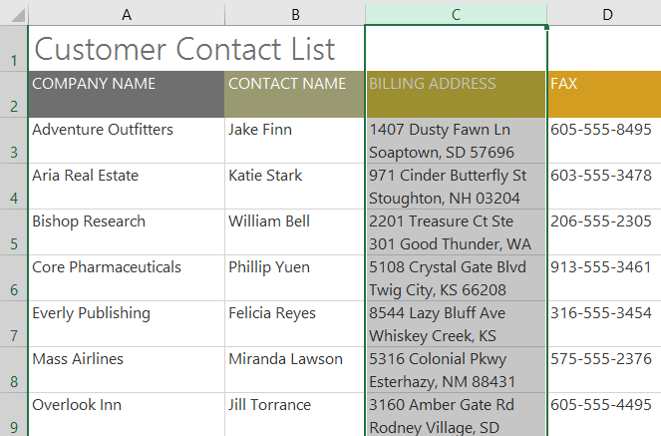

Click the **Wrap Text** command again to **unwrap** the text.

To merge cells using the Merge & Center command:

1. Select the **cell range** you want to merge. In our example, we'll select **A1:F1**.
2. Click the **Merge & Center** command on the **Home** tab. In our example, we'll select the cell range **A1:F1**.

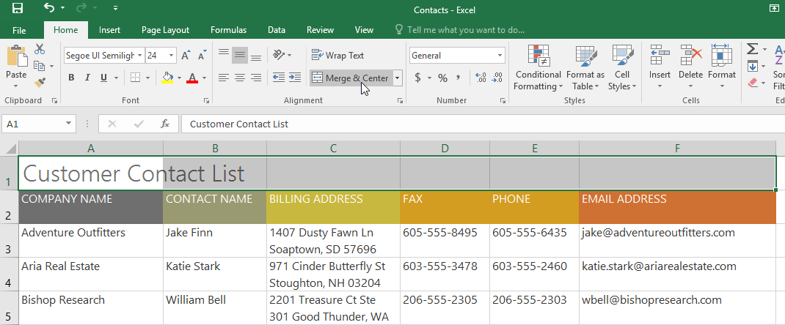

1. The selected cells will be **merged**, and the text will be **centered**.

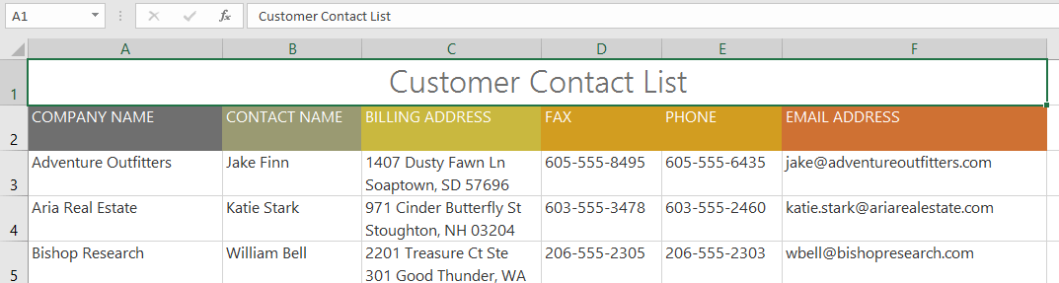

To access more merge options:

If you click the drop-down arrow next to the **Merge & Center** command on the **Home**tab, the **Merge** drop-down menu will appear.

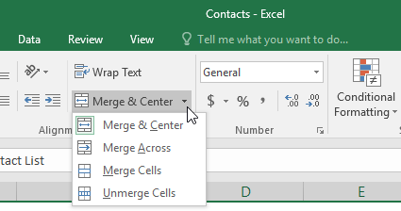

From here, you can choose to:

* **Merge & Center**: merges the selected cells into **one cell** and **centers** the text
* **Merge Across**: merges the selected cells into **larger cells** while keeping each **row** separate
* **Merge Cells**: merges the selected cells into one cell but **does not cente**r the text
* **Unmerge Cells**: unmerges selected cells

You'll want to be careful when using this feature. If you merge multiple cells that all contain data, Excel will keep only the contents of the upper-left cell and discard everything else.

To center across selection:

Merging can be useful for organizing your data, but it can also create problems later on. For example, it can be difficult to move, copy, and paste content from merged cells. A good alternative to merging is **Center Across Selection**, which creates a similar effect without actually combining cells.