What are number formats?

Whenever you're working with a spreadsheet, it's a good idea to use appropriate **number formats** for your data. Number formats tell your spreadsheet exactly what type of data you're using, like percentages (%), currency ($), times, dates, and so on.

#### **Why use number formats?**

Number formats don't just make your spreadsheet easier to read—they also make it easier to use. When you apply a number format, you're telling your spreadsheet exactly **what types of values** are stored in a cell. For example, the **date**format tells the spreadsheet that you're entering **specific calendar dates**. This allows the spreadsheet to better understand your data, which can help ensure that your data remains consistent and that your formulas are calculated correctly.

If you don't need to use a specific number format, the spreadsheet will usually apply the **general** number format by default. However, the general format may apply some small formatting changes to your data.

#### **Applying number formats**

Just like other types of formatting, such as changing the font color, you'll apply number formats by selecting cells and choosing the desired formatting option. There are two main ways to choose a number format:

* Go to the **Home** tab, click the **Number Format** drop-down menu in the **Number** group, and select the desired format.

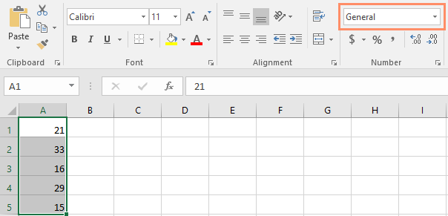

* You can also click one of the quick number-formatting commands below the drop-down menu.

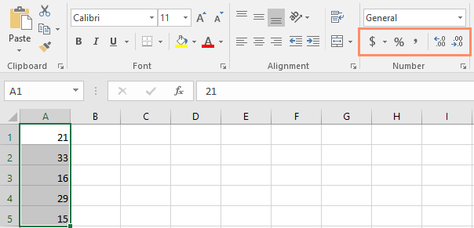

You can also select the desired cells and press **Ctrl+1** on your keyboard to access more number-formatting options.

In this example, we've applied the **Currency** number format, which adds currency symbols ($) and displays two decimal places for any numerical values.

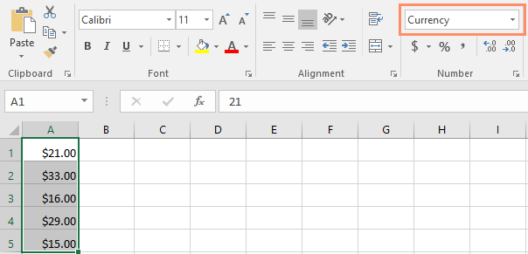

If you select any cells with number formatting, you can see the **actual value** of the cell in the formula bar. The spreadsheet will use this value for formulas and other calculations.

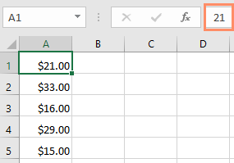

### Using number formats correctly

There's more to number formatting than selecting cells and applying a format. Spreadsheets can actually apply a lot of number formatting **automatically** based on the way you enter data. This means you'll need to enter data in a way the program can understand, and then ensure that those cells are using the proper number format. For example, the image below shows how to use number formats correctly for dates, percentages, and times:

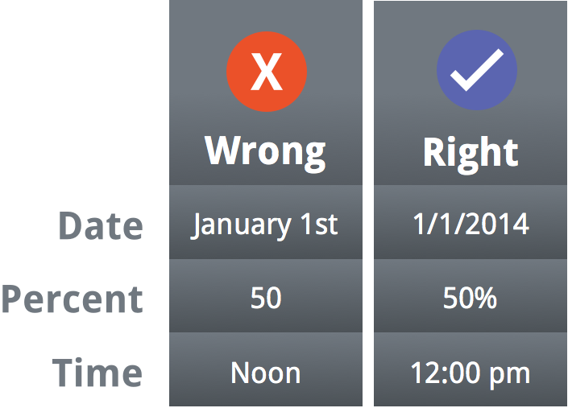

Now that you know more about how number formats work, we'll look at a few different number formats in action.

### Percentage formats

One of the most helpful number formats is the **percentage** (%) format. It displays values as percentages, such as **20%** or **55%**. This is especially helpful when calculating things like the cost of sales tax or a tip. When you type a percent sign (%) after a number, the percentage number format will be be applied to that cell **automatically**.

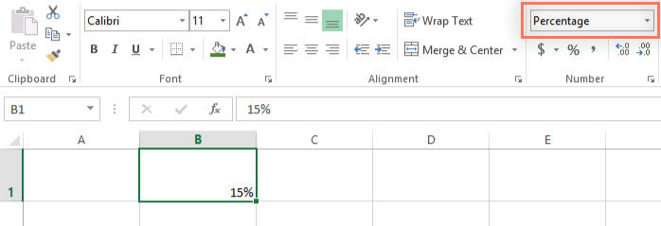

As you may remember from math class, a percentage can also be written as a **decimal**. So 15% is the same thing as 0.15, 7.5% is 0.075, 20% is 0.20, 55% is 0.55, and so on. You can review [**this lesson**](http://www.gcflearnfree.org/percents/converting-percentages-decimals-and-fractions/1/) from our [**Math tutorials**](http://www.gcflearnfree.org/topics/math) to learn more about converting percentages to decimals.

There are many times when percentage formatting will be useful. For example, in the images below, notice how the **sales tax rate** is formatted differently for each spreadsheet (5, 5%, and 0.05):

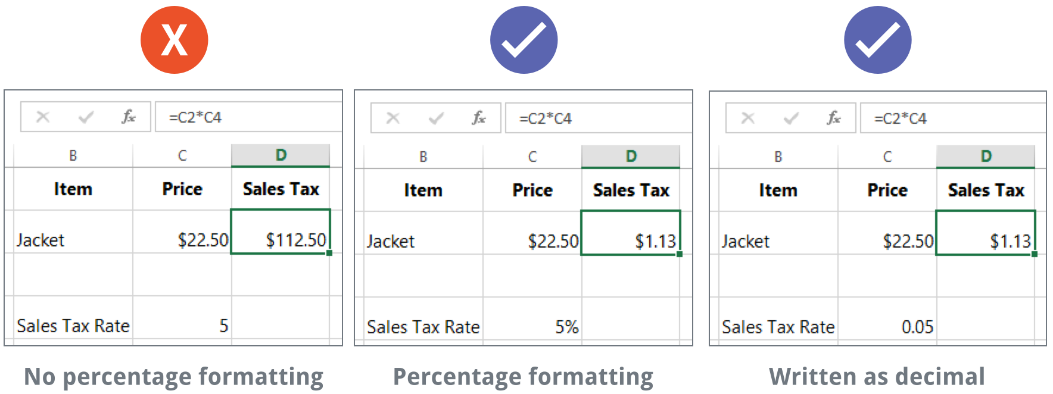

As you can see, the calculation in the spreadsheet on the left didn't work correctly. Without the percentage number format, our spreadsheet thinks we want to multiply $22.50 by 5, not 5%. And while the spreadsheet on the right still works without percentage formatting, the spreadsheet in the middle is easier to read.

### Date formats

Whenever you're working with **dates**, you'll want to use a date format to tell the spreadsheet that you're referring to **specific calendar dates**, such as July 15, 2014. Date formats also allow you to work with a powerful set of date functions that use time and date information to calculate an answer.

Spreadsheets don't understand information the same way a person would. For instance, if you type **October** into a cell, the spreadsheet won't know you're entering a date so it will treat it like any other text. Instead, when you enter a date, you'll need to use a **specific format** your spreadsheet understands, such as **month/day/year** (or **day/month/year** depending on which country you're in). In the example below, we'll type **10/12/2014** for October 12, 2014. Our spreadsheet will then automatically apply the date number format for the cell.

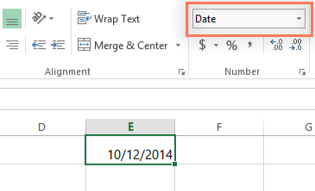

Now that we have our date correctly formatted, we can do many different things with this data. For example, we could use the fill handle to continue the dates through the column, so a different day appears in each cell:

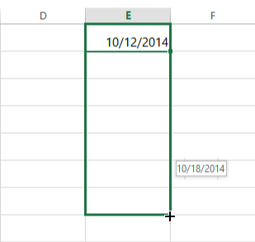

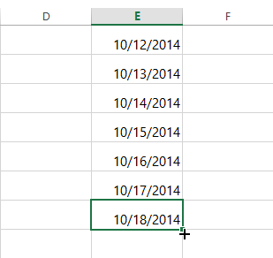

If the date formatting isn't applied automatically, it means the spreadsheet did not understand the data you entered. In the example below, we've typed **March 15th**. The spreadsheet did not understand that we were referring to a date, so this cell is still using the **general** number format.

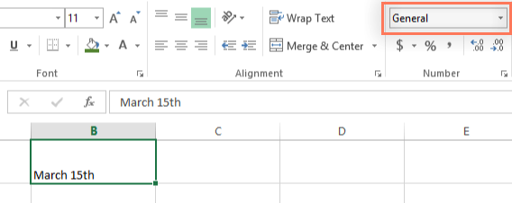

On the other hand, if we type **March 15** (without the "th"), the spreadsheet **will**recognize it as a date. Because it doesn't include a year, the spreadsheet will automatically add the current year so the date will have all of the necessary information. We could also type the date several other ways, such as **3/15**, **3/15/2014**, or **March 15 2014**, and the spreadsheet would still recognize it as a date.

Try entering the dates below into a spreadsheet and see if the date format is applied automatically:

* 10/12
* October
* October 12
* October 2016
* 10/12/2016
* October 12, 2016
* 2016
* October 12th

If you want to add the current date to a cell, you can use the **Ctrl+;** shortcut,

#### **Other date formatting options**

To access other date formatting options, select the **Number Format** drop-down menu and choose **More Number Formats**. These are options to display the date differently, like including the day of the week or omitting the year.

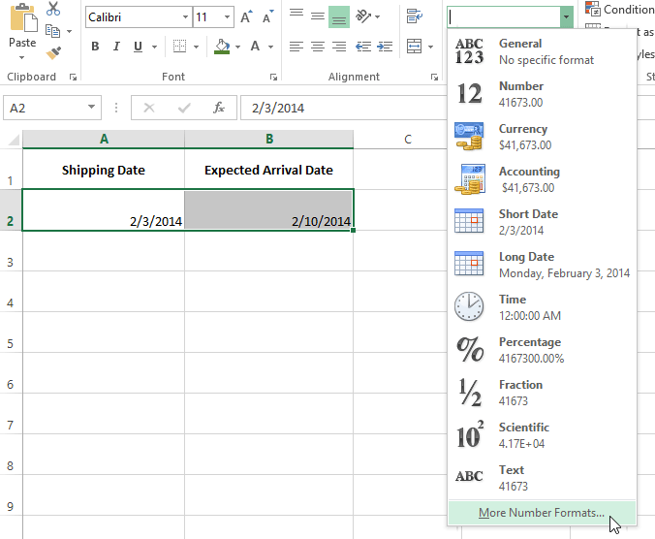

The **Format Cells** dialog box will appear. From here, you can choose the desired date formatting option.

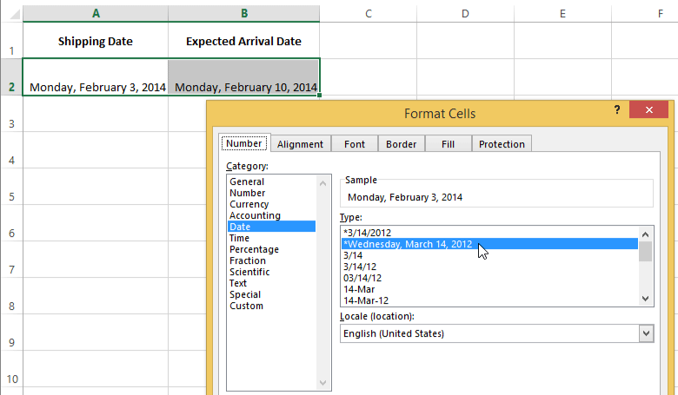

As you can see in the formula bar, a custom date format doesn't change the actual date in our cell—it just changes the way it's displayed.

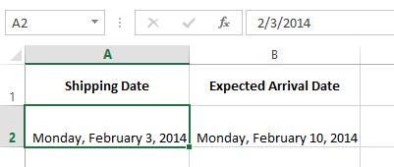

### Number formatting tips

Here are a few tips for getting the best results with number formatting:

* **Apply number formatting to an entire column**: If you're planning to use one column for a certain type of data, like dates or percentages, you may find it easiest to select the entire column by clicking the column letter and applying the desired number formatting. This way, any data you add to this column in the future will already have the correct number format. Note that the header row usually won't be affected by number formatting.

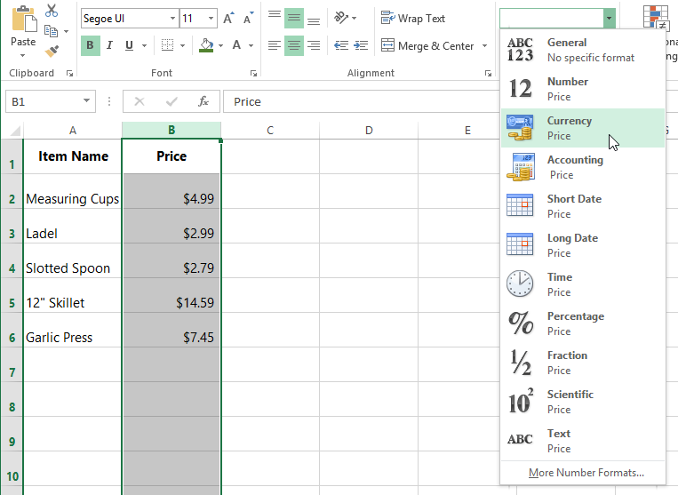

* **Double-check your values after applying number formatting**: If you apply number formatting to existing data, you may have unexpected results. For example, applying **percentage** (%) formatting to a cell with a value of 5 will give you 500%, not 5%. In this case, you'd need to retype the values correctly in each cell.

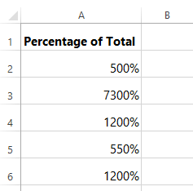

* If you reference a cell with number formatting in a formula, the spreadsheet may automatically apply the same number formatting to the new cell. For example, if you use a value with currency formatting in a formula, the calculated value will also use the currency number format.

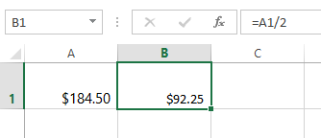

* If you want your data to appear **exactly as entered,** you'll need to use the **text** number format. This format is especially good for numbers you don't want to perform calculations with, such as phone numbers, zip codes, or numbers that begin with 0, like **02415**. For best results, you may want to apply the text number format before entering data into these cells.

#### **Increase and Decrease Decimal**

The **Increase Decimal** and **Decrease Decimal** commands allow you to control how many decimal places are displayed in a cell. These commands don't change the value of the cell; instead, they display the value to a set number of decimal places.

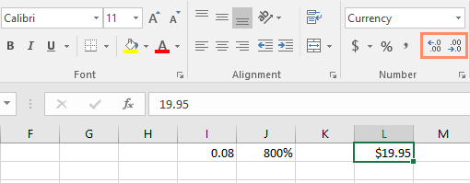

Decreasing the decimal will display the value rounded to that decimal place, but the actual value in the cell will still be displayed in the formula bar.

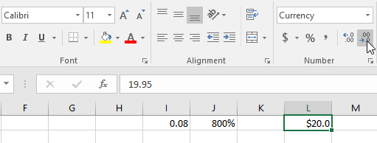

The **Increase/Decrease Decimal** commands don't work with some number formats, like **Date** and **Fraction**.