Understanding cells

Every worksheet is made up of thousands of rectangles, which are called **cells**. A cell is the **intersection** of a **row** and a **column**—in other words, where a row and column meet.

Columns are identified by **letters** **(A, B, C)**, while rows are identified by **numbers (1, 2, 3)**.Each cell has its own **name**—or **cell address**—based on its column and row. In the example below, the selected cell intersects **column C** and **row 5**, so the cell address is **C5**.

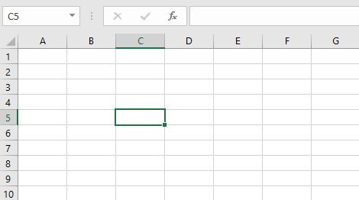

Note that the cell address also appears in the **Name box** in the top-left corner, and that a cell's **column** and **row headings** are **highlighted**when the cell is selected.

You can also select **multiple cells** at the same time. A group of cells is known as a **cell range**. Rather than a single cell address, you will refer to a cell range using the cell addresses of the **first**and **last** cells in the cell range, separated by a **colon**. For example, a cell range that included cells A1, A2, A3, A4, and A5 would be written as **A1:A5**. Take a look at the different cell ranges below:

* Cell range **A1:A8**

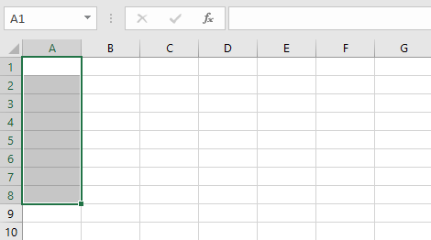

* Cell range **A1:F1**

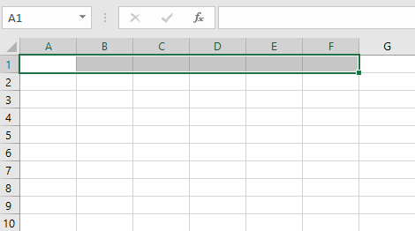

* Cell range **A1:F8**

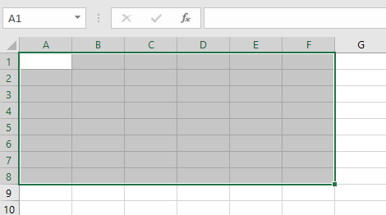

If the columns in your spreadsheet are labeled with numbers instead of letters, you'll need to change the default **reference style** for Excel. Review our Extra on [**What are Reference Styles?**](http://www.gcflearnfree.org/excel2016/what-are-reference-styles/1/) to learn how.

To select a cell:

To input or edit cell content, you'll first need to **select** the cell.

1. Click a **cell**to select it. In our example, we'll select cell **D9**.
2. A**border** will appear around the selected cell, and the **column heading** and **row heading** will be highlighted. The cell will remain selected until you click another cell in the worksheet.

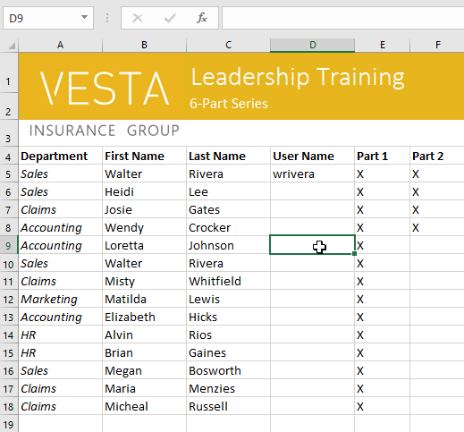

You can also select cells using the **arrow keys** on your keyboard.

To select a cell range:

Sometimes you may want to select a larger group of cells, or a **cell range**.

1. Click and drag the mouse until all of the **adjoining** **cells** you want to select are **highlighted**. In our example, we'll select the cell range **B5:C18**.
2. Release the mouse to **select** the desired cell range. The cells will remain selecteduntil you click another cell in the worksheet.

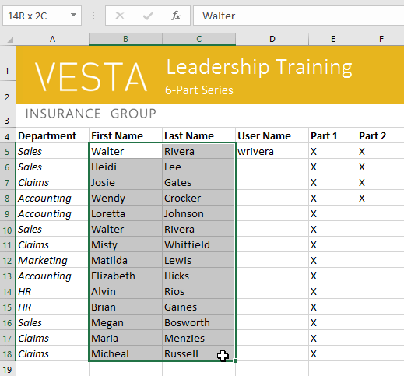

Cell content

Any information you enter into a spreadsheet will be stored in a cell. Each cell can contain different types of **content**, including **text**, **formatting**, **formulas**, and **functions**.

* **Text**:Cells can contain **text**, such as letters, numbers, and dates.

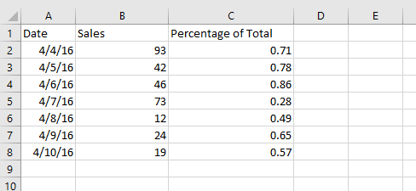

* **Formatting attributes**:Cells can contain **formatting attributes** that change the way letters, numbers, and dates are displayed. For example, percentages can appear as 0.15 or 15%. You can even change a cell's **text** or **background color**.

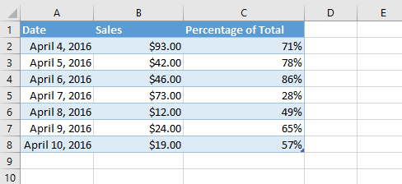

* **Formulas and functions**: Cells can contain **formulas** and **functions** that calculate cell values. In our example, **SUM(B2:B8)**adds the value of each cell in the cell range B2:B8 and displays the total in cell B9.

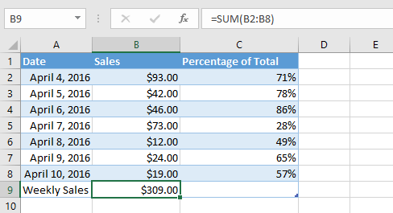

To insert content:

1. Click a **cell** to select it. In our example, we'll select cell **F9**.

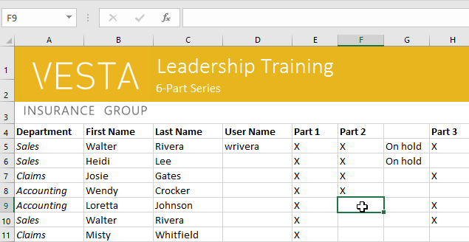

1. Type something into the selected cell, then press **Enter**on your keyboard. The content will appear in the **cell** and the **formula** **bar**. You can also input and edit cell content in the formula bar.

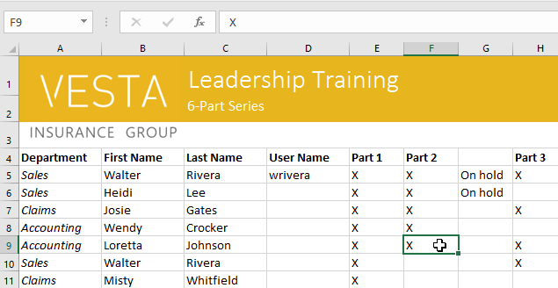

To delete (or clear) cell content:

1. Select the **cell(s)** with content you want to delete. In our example, we'll select the cell range **A10:H10**.

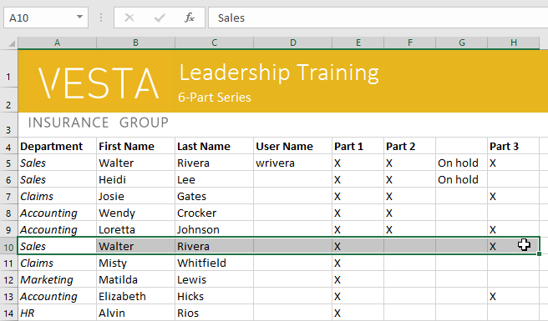

1. Select the **Clear** command on the **Home** tab, then click **Clear Contents**.

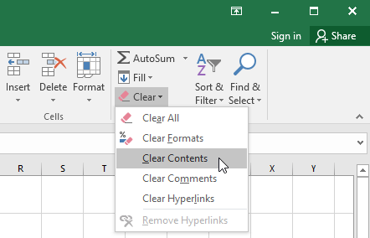

1. The cell contents will be deleted.

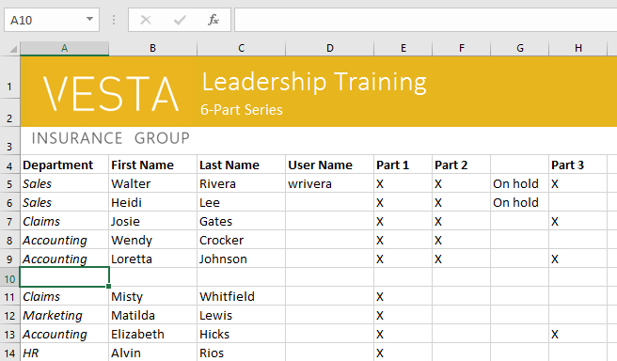

You can also use the **Delete** key on your keyboard to delete content from **multiple cells** at once. The **Backspace** key will only delete content from one cell at a time.

To delete cells:

There is an important difference between deleting the content of a cell and **deleting the cell itself**. If you delete the entire cell, the cells below it will **shift to fill in the gaps**and **replace** **the deleted cells**.

1. Select the**cell(s)** you want to delete. In our example, we'll select **A10:H10**.

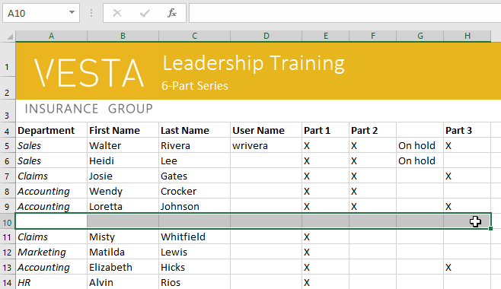

1. Select the **Delete** command from the **Home** tab on the **Ribbon**.

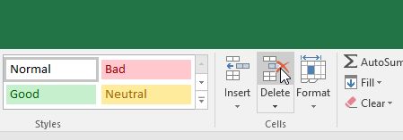

1. The cells below will **shift** **up** and **fill in the gaps**.

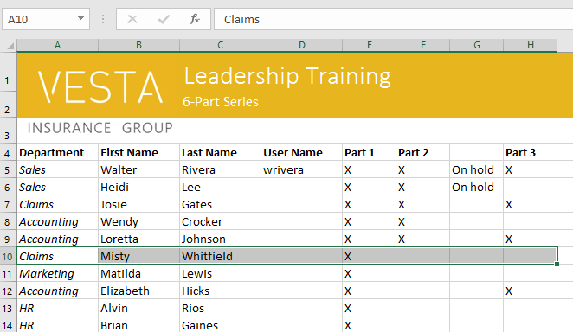

To copy and paste cell content:

Excel allows you to **copy** content that is already entered into your spreadsheet and **paste** that content to other cells, which can save you time and effort.

1. Select the **cell(s)** you want to **copy**. In our example, we'll select **F9**.

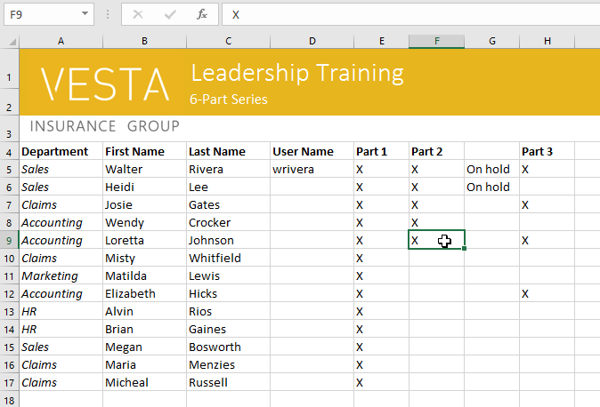

1. Click the **Copy** command on the **Home**tab, or press **Ctrl+C** on your keyboard.

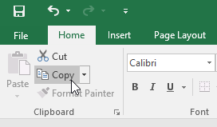

1. Select the **cell(s)**where you want to **paste** the content. In our example, we'll select **F12:F17**. The copied cell(s) will have a **dashed box** around them.

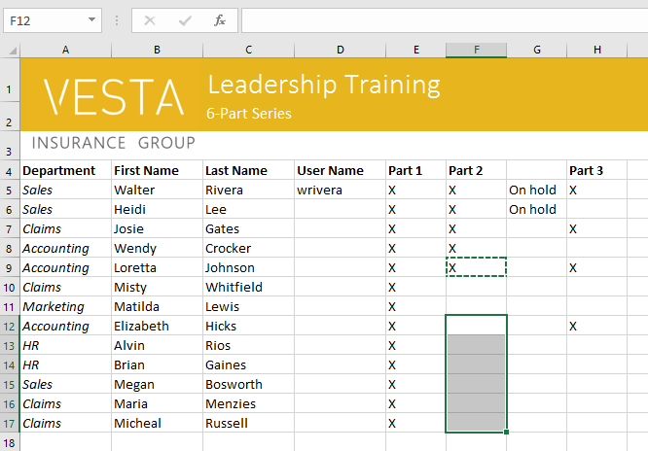

1. Click the **Paste** command on the **Home** tab, or press **Ctrl+V** on your keyboard.

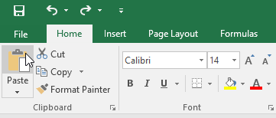

1. The content will be **pasted** into the selected cells.

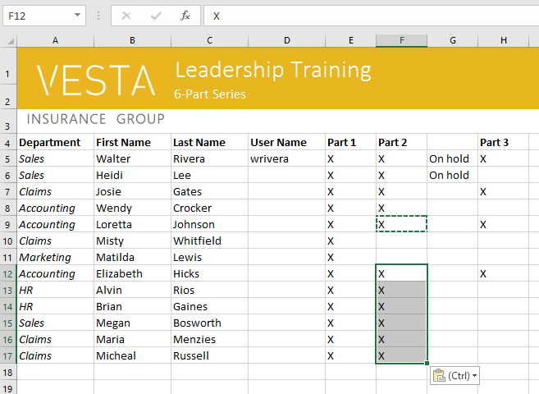

To access more paste options:

You can also access **additional paste options**, which are especially convenient when working with cells that contain**formulas**or**formatting**. Just click the**drop-down arrow**on the**Paste**command to see these options.

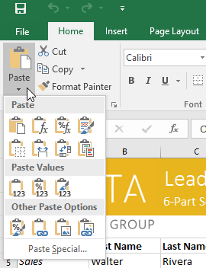

Instead of choosing commands from the Ribbon, you can access commands quickly by **right-clicking**. Simply select the**cell(s)** you want to **format**, then right-click the mouse. A **drop-down menu** will appear, where you'll find several **commands** that are also located on the Ribbon.

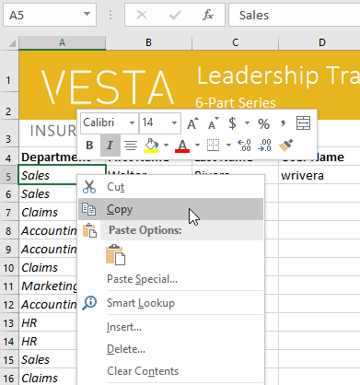

To cut and paste cell content:

Unlike copying and pasting, which **duplicates** cell content, **cutting** allows you to **move**content between cells.

1. Select the **cell(s)** you want to **cut**. In our example, we'll select **G5:G6**.
2. Right-click the mouse and select the **Cut** command. Alternatively, you can use the command on the **Home** tab, or press **Ctrl+X** on your keyboard.

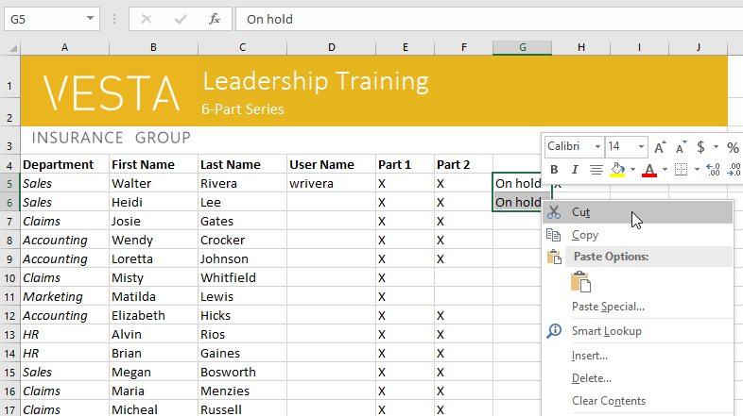

1. Select the cells where you want to **paste** the content. In our example, we'll select **F10:F11**. The cut cells will now have a **dashed box** around them.
2. Right-click the mouse and select the **Paste** command. Alternatively, you can use the command on the **Home** tab, or press **Ctrl+V** on your keyboard.

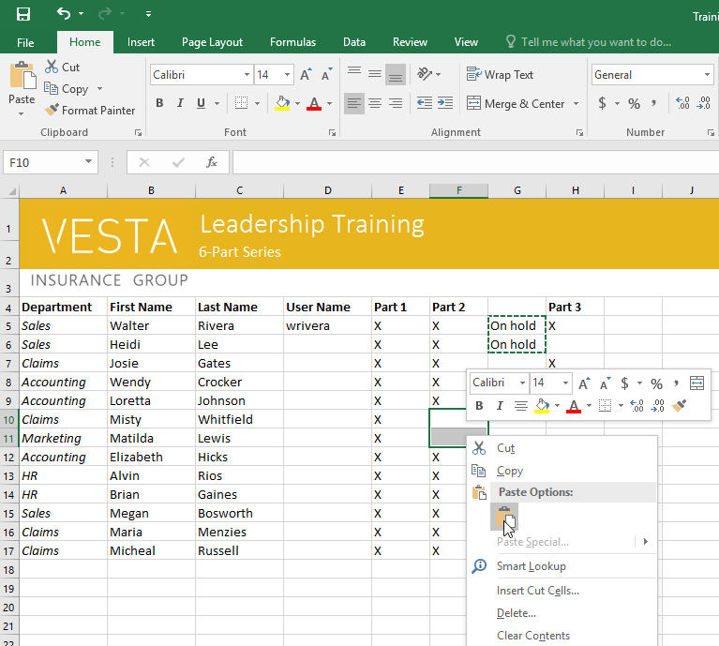

1. The cut content will be **removed** from the original cells and **pasted** into the selected cells.

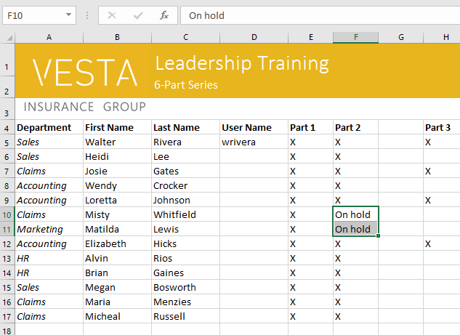

To drag and drop cells:

Instead of cutting, copying, and pasting, you can **drag and drop** cells to move their contents.

1. Select the **cell(s)** you want to **move**. In our example, we'll select **H4:H12**.
2. Hover the mouse over the **border**of the selected cell(s) until the mouse changes to a **pointer with four arrows**.

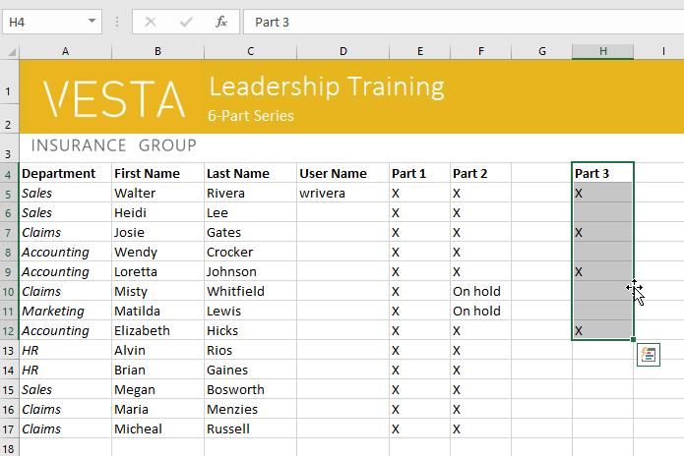

1. Click and drag the cells to the **desired** **location**. In our example, we'll move them to **G4:G12**.

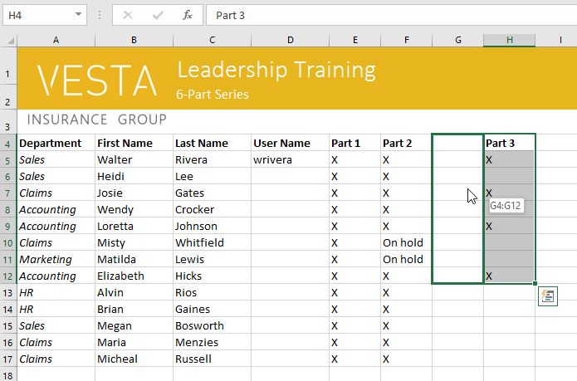

1. Release the mouse. The cells will be **dropped** in the selected location.

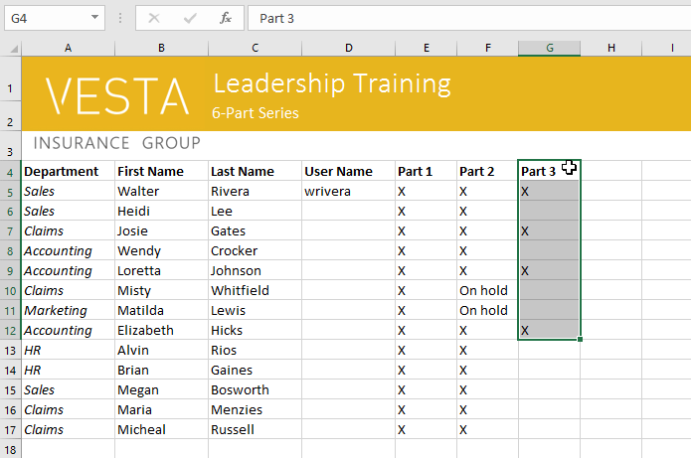

To use the fill handle:

If you're copying cell content to adjacent cells in the same row or column, the **fill handle**is a good alternative to the copy and paste commands.

1. Select the **cell(s)** containing the content you want to use, then hover the mouse over the lower-right corner of the cell so the **fill handle** appears.

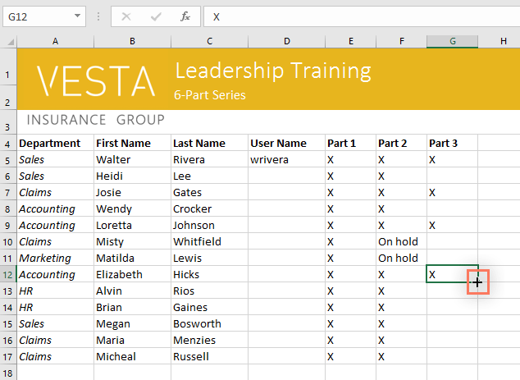

1. Click and drag the **fill handle** until all of the cells you want to fill are selected. In our example, we'll select **G13:G17**.

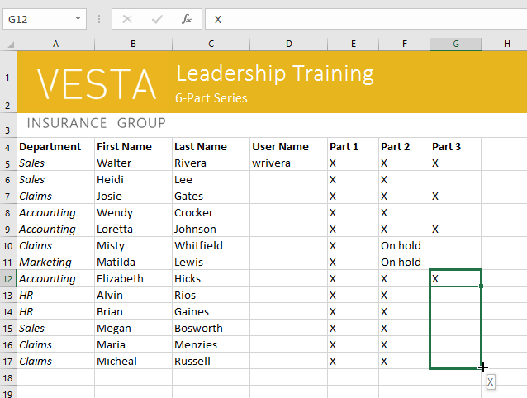

1. Release the mouse to **fill** the selected cells.

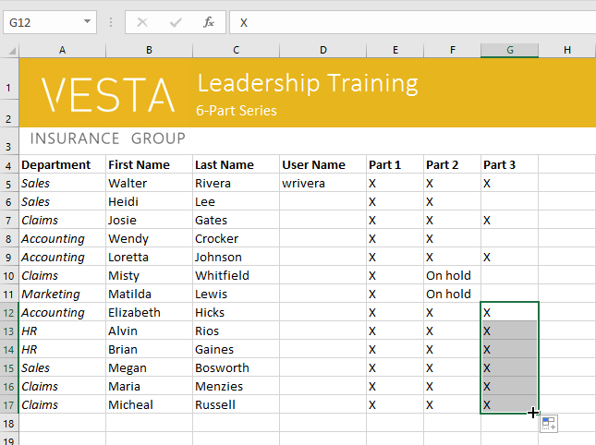

To continue a series with the fill handle:

The fill handle can also be used to **continue** **a series**. Whenever the content of a row or column follows a sequential order, like **numbers** **(1, 2, 3)** or **days** **(Monday, Tuesday, Wednesday)**, the fill handle can guess what should come next in the series. In most cases, you will need to select **multiple cells** before using the fill handle to help Excel determine the series order. Let's take a look at an example:

1. Select the cell range that contains the series you want to continue. In our example, we'll select**E4:G4**.
2. Click and drag the fill handle to continue the series.

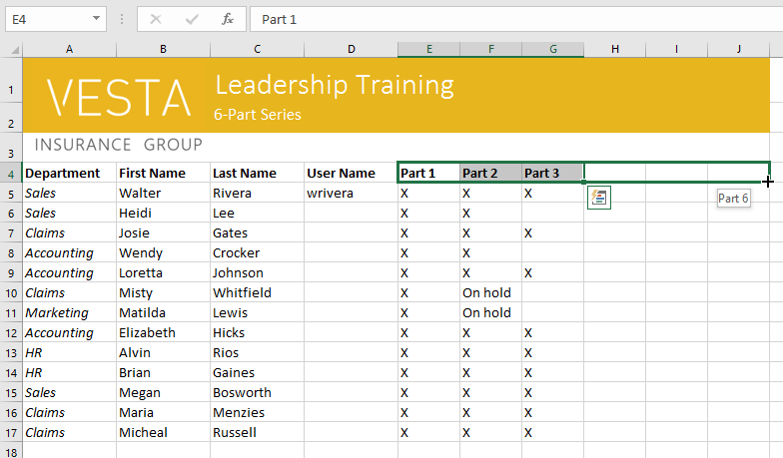

1. Release the mouse. If Excel understood the series, it will be continued in the selected cells. In our example, Excel added **Part 4**, **Part 5**, and **Part 6** to **H4:J4**.

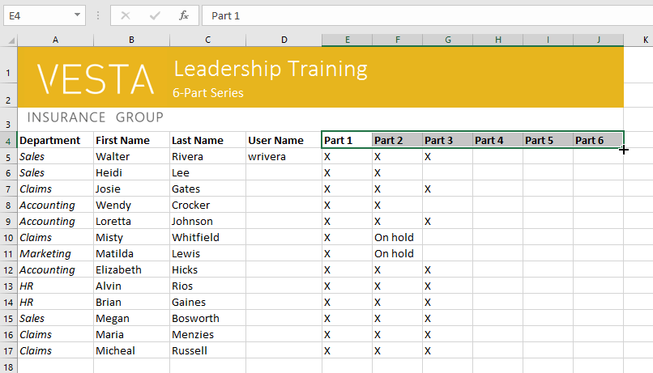

You can also **double-click** the fill handle instead of clicking and dragging. This can be useful with larger spreadsheets, where clicking and dragging may be awkward.