Introduction

Every workbook contains at least one **worksheet** by default. When working with a large amount of data, you can create **multiple worksheets** to help organize your workbook and make it easier to find content. You can also **group**worksheets to quickly add information to multiple worksheets at the same time.

#### **To insert a new worksheet:**

1. Locate and select the **New sheet** button near the bottom-right corner of the Excel window.

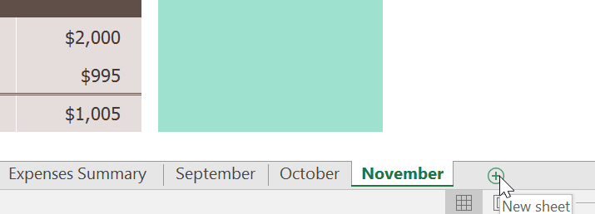

1. A **new blank worksheet** will appear.

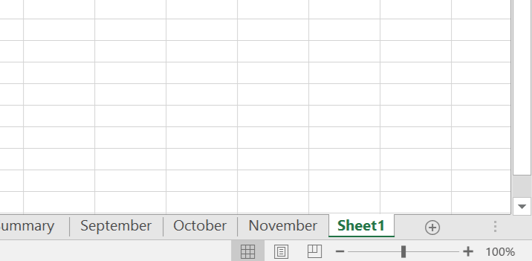

By default, any new workbook you create in Excel will contain one worksheet, called **Sheet1**. To change the **default number** of worksheets, navigate to **Backstage view**, click **Options**, then choose the desired number of worksheets to include in each new workbook.

#### **To copy a worksheet:**

If you need to **duplicate** the content of one worksheet to another, Excel allows you to **copy** an existing worksheet.

1. Right-click the worksheet you want to copy, then select **Move or Copy**from the worksheet menu.

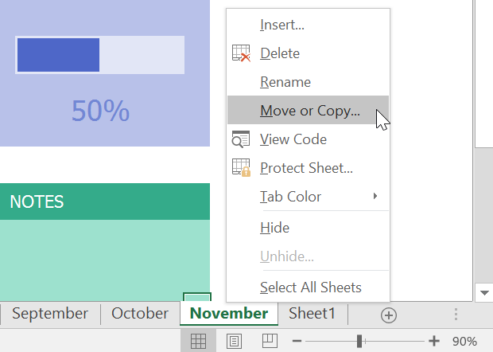

1. The **Move or Copy** dialog box will appear. Choose where the sheet will appear in the**Before sheet:**field. In our example, we'll choose**(move to end)** to place the worksheet to the right of the existing worksheet.
2. **Check the box** next to **Create a copy**, then click**OK**.

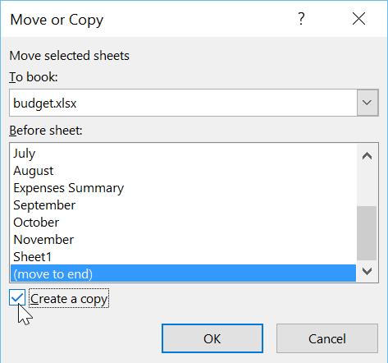

1. The worksheet will be **copied**. It will have the same title as the original worksheet, as well as a **version** **number**. In our example, we copied the **November** worksheet, so our new worksheet is named **November (2)**. All content from the November worksheet has also been copied to the new worksheet.

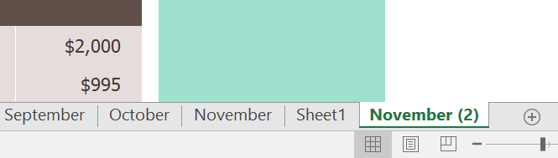

You can also copy a worksheet to an entirely different **workbook**. You can select any workbook that is currently open from the **To book:**drop-down menu.

#### **To rename a worksheet:**

1. Right-click the **worksheet**you want to rename, then select **Rename** from the worksheet menu.

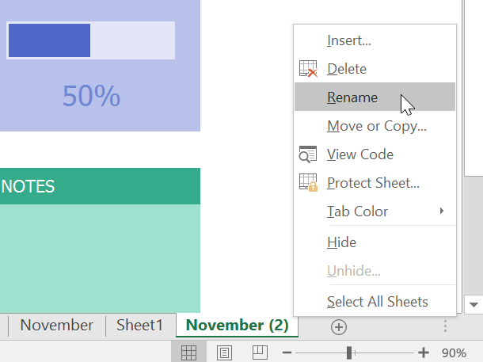

1. Type the **desired name** for the worksheet.
2. Click anywhere outside the worksheet tab, or press **Enter** on your keyboard. The worksheet will be **renamed**.



#### **To move a worksheet:**

1. Click and drag the worksheet you want to move until a **small black arrow**appears above the desired location.

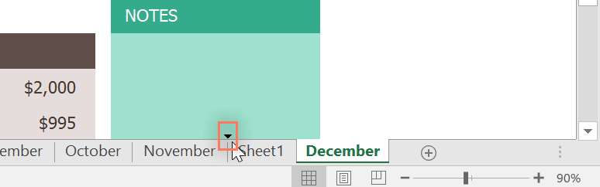

1. Release the mouse. The worksheet will be moved.

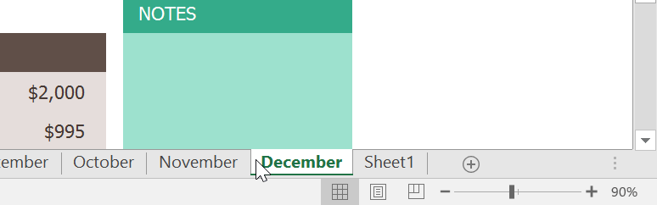

#### **To change the worksheet tab color:**

1. Right-click the desired worksheet tab, and hover the mouse over **Tab Color**. The **Color** menu will appear.
2. Select the desired **color**.

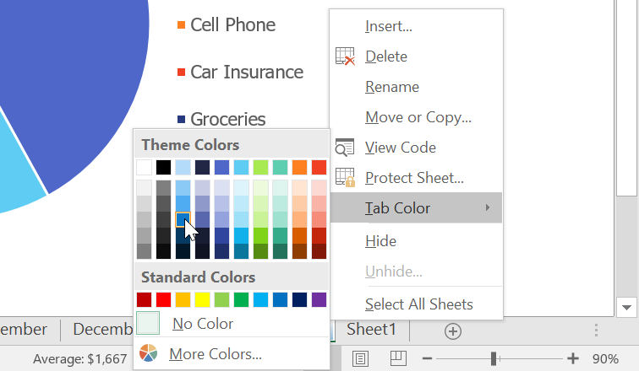

1. The worksheet tab color will be **changed**.

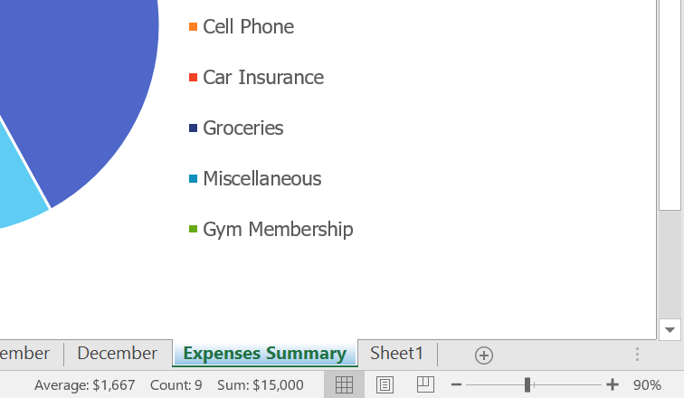

The worksheet tab color is considerably **less noticeable** when the worksheet is selected. Select another worksheet to see how the color will appear when the worksheet is not selected.

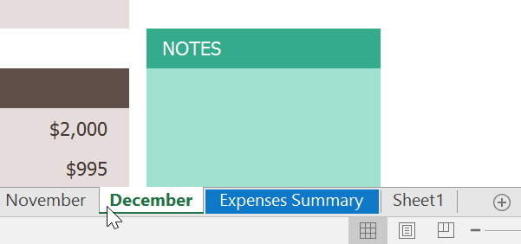

#### **To delete a worksheet:**

1. Right-click the **worksheet** you want to delete, then select **Delete** from the worksheet menu.

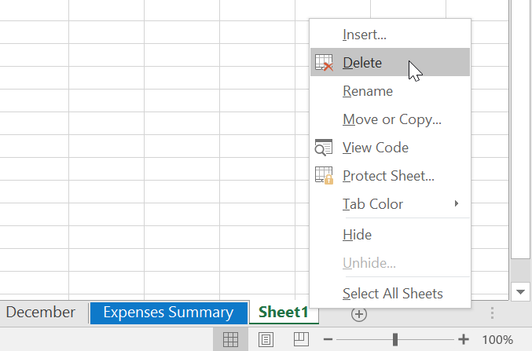

1. The worksheet will be **deleted** from your workbook.

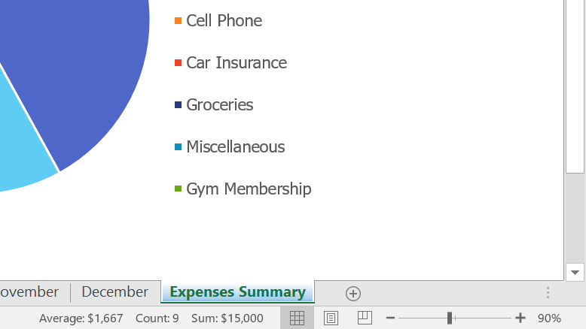

If you want to prevent specific worksheets from being edited or deleted, you can **protect** **them** by right-clicking the desired worksheetand selecting **Protect Sheet**from the worksheet menu.

#### **Switching between worksheets**

If you want to view a different worksheet, you can simply **click the tab** to switch to that worksheet. However, with larger workbooks this can sometimes become tedious, as it may require scrolling through all of the tabs to find the one you want. Instead, you can simply **right-click** the scroll arrows in the lower-left corner, as shown below.



A dialog box will appear with a list of all of the sheets in your workbook. You can then **double-click** the sheet you want to jump to.

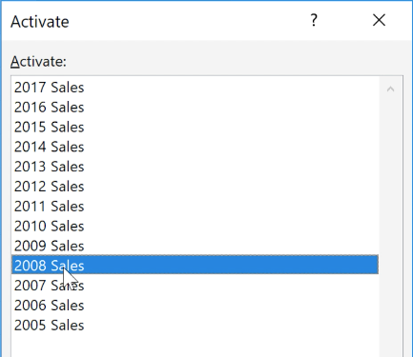

### Grouping and ungrouping worksheets

You can work with each worksheet **individually**, or you can work with multiple worksheets at the same time. Worksheets can be combined together into a **group**. Any changes made to one worksheet in a group will be made to **every worksheet** in the group.

#### **To group worksheets:**

1. Select the **first worksheet** you want to include in the **worksheet group**.

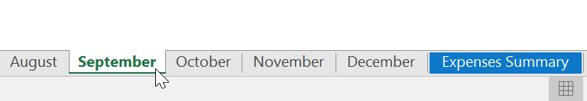

1. Press and hold the**Ctrl**key on your keyboard. Select the **next worksheet**you want in the group.

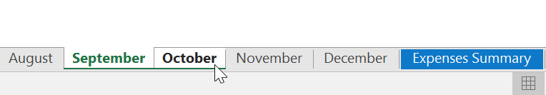

1. Continue to select worksheets until all of the worksheets you want to group are selected, then release the **Ctrl** key. The worksheets are now **grouped**.

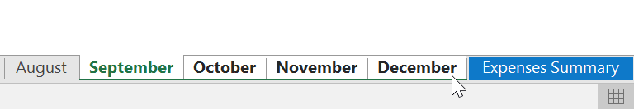

While worksheets are grouped, you can navigate to any worksheet within the group. Any **changes** made to one worksheet will appear on **everyworksheet** in the group. However, if you select a worksheet that is not in the group, all of your worksheets will become **ungrouped**.

#### **To ungroup worksheets:**

1. Right-click a worksheet in the group, then select **Ungroup** **Sheets** from the worksheetmenu.

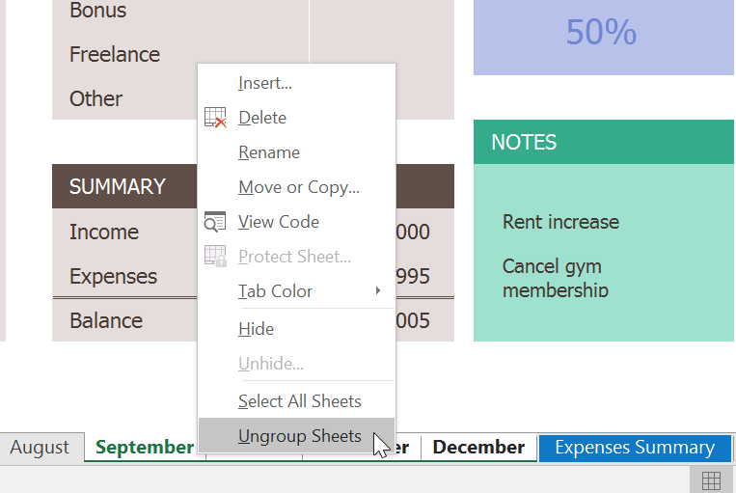

1. The worksheets will be **ungrouped**. Alternatively, you can simply click any worksheet not included in the group to **ungroup all worksheets**.

