**Multi-tiered strategy for large-scale wastewater detection of SARS-CoV-2 in low-case settings provides confidence for public health actions.**

A. R. Jexa,b, #,N. Johna,a,b, D. McCarthyc,k, S. Myersd, N. Johnb, N. Begued, C. Schangc, S. P. Ushere, L. Bakera, C. Kaucnerd, P. Monisf, L. M. Hartmana, B. Flynna, J. E. Merretta, D. Listerg, M. Herolda, A. Kueha, N. Chengg, J. Nolang, L. Calyh, J. Druceh, B. Thorleyh, P. J. Scalese, J. Schmidti, S. Sarkisg, N. Crosbiej, R. Poong and M. Nolang

a The Walter and Eliza Hall Institute of Medical Research, Parkville, Victoria, Australia, 3010

b Faculty of Science, The University of Melbourne, Parkville, Victoria, Australia, 3010

c Environmental and Public Health Microbiology Laboratory (EPHM Lab), Department of Civil Engineering, Monash University, Clayton, Victoria, Australia, 3800

d Australian Laboratory Services, Scoresby, Victoria, Australia, 3179

e Department of Chemical Engineering, The University of Melbourne, Parkville, Victoria, Australia, 3010

f Australian Water Quality Centre, SA Water, Adelaide, South Australia, Australia, 5000

g Department of Health, State Government of Victoria, Melbourne, Victoria, Australia, 3000

h Victorian Infectious Diseases Reference Laboratory, Peter Doherty Institute for Infection and Immunity, Parkville, Victoria, Australia, 3010

i South East Water Corporation, Frankston, Victoria, Australia, 3199

j Melbourne Water Corporation, Docklands, Victoria, Australia, 3001

k School of Civil and Environmental Engineering, Queensland University of Technology, Brisbane, Australia, 4000

# Corresponding author; [jex.a@wehi.eu.au](mailto:jex.a@wehi.eu.au)

**Supplementary Method 1**: Amplicon Sequencing protocol

The identity of each N or Orf1ab amplicon produced by the SARS-CoV-2 RT-qPCR assay was sequenced on an Illumina MINIseq (Illumina, USA) using a modified overhang-extension PCR amplicon sequencing protocol. Each amplicon was cleaned before sequencing using the ExoSAP-IT™ Express PCR Product Clean-up Kit (Applied Biosystems, USA) as per the manufacturer's protocol and extended using an overhang-extension PCR (Penington et al., 2018). Briefly, overhang primers were synthesised by a commercial service (Bioneer Pacific, Australia) using the published sequences for CCDC N and CCDC Orf1ab primer pairs (Kitajima et al., 2020). In addition, we added a universal oligonucleotide overhang, not found in the SARS-CoV-2 genome or related betacoronavirus sequences, at the 5' end of each primer (5' GTGACCTATGAACTCAGGAGTC for CCDC-N-Fwd and CCDC-Orf1ab-Fwd; 5' CTGAGACTTGCACATCGCAGC for CCDC-N-Rev and CCDC-Orf1ab-Rev). These overhang primers were used to support a two-phase PCR extension of each amplicon. In a 96-well PCR semi-skirted plate, a 20 µL phase one (overhang-PCR) reaction consisted of 1 µL of each ExoSAP-IT™ cleaned amplicon, 10 µL NEB 2x Taq enzyme mix (New England Biolabs, USA), 0.5 µL each of the appropriate forward and reverse overhang primer pair (at 10 µM master concentration) and 8 µL of nuclease-free water and amplified on a Bio-Rad T100™ thermal cycler using the following conditions: 95 oC for 3 minutes, followed by 10 cycles of 95 oC for 15 seconds, 60 oC for 30 seconds and 72 oC for 30 seconds, with a final extension at 72 oC for 7 minutes. PCR negative controls and extraction blanks (PBS) were also amplified and processed in parallel for each extension PCR run and carried through to amplicon sequencing and analysis.

Each overhang-PCR amplicon was cleaned using 30 µL (or 1.5x volume of overhang-PCR reaction) of NucleoMag (Macherey-Nagel, Germany) NGS beads with two rounds of ethanol (80%) washing, followed by elution in 40 µL nuclease-free water. Each cleaned overhang-PCR amplicon was used to introduce Illumina MiSeq adaptors and 8-mer dual index barcodes from the Illumina Nextera design. Index primers were added to each overhang-PCR amplicon using a second extension PCR reaction in duplicate. The second phase PCR mastermix included 10 µL of the cleaned overhang-PCR amplicon, 10 µL NEB 2x Taq enzyme mix (New England Biolabs, USA), and 0.5 µL each of a 10 µM forward and reverse index primer (with a unique forward and reverse index pairing used for each sample). This was denatured at 95 °C for 3 minutes, followed by 16 (replicate 1) and 20 (replicate 2) thermocycles of 95 °C for 15 seconds, 60 °C for 30 seconds and 72 °C for 30 seconds, with a final extension at 72 °C for 7 minutes. Index-PCR amplicons were pooled (5 µL from each well), cleaned using a 0.8x NucleoMag NGS bead kit (as above) and eluted in nuclease-free water. The indexed pooled library was further diluted to 8 pM and sequenced (300-cycle sequencing kit) on an Illumina Miseq (Illumina, USA). The paired sequencing was forward-biased to produce a 151 bp sequence in the forward direction (capturing the complete amplicon and forward barcode) and a 21 bp sequence in the reverse direction (capturing the reverse index for demultiplexing).

All reads were demultiplexed by sample using the paired F and R-index barcodes and filtered for a minimum Phred quality of 30 (1 error per 1000 bases) using Pipeline Pilot (Dassault Systèmes). All read data were analysed using a custom-designed pipeline developed for the Geneious Prime® (version.2020.2.2) software suite. Briefly, reads were uploaded into the Geneious Prime® suite in fastq format for each sample. Each read was trimmed for the forward primer adaptor and oligonucleotide extension sequence. The reverse read (which included the adaptor and R-index barcode only) was discarded. The forward read aligned to the N or Orf1ab locus in the SARS-CoV-2 Wuhan genomic reference sequence (GenBank accession ID: NC045512), requiring a minimum mapping error rate of <0.1%, a minimum alignment overlap equivalent to the complete amplicon length (99 and 119 bp for N and Orf1ab respectively), and a minimum sequence identity of 94%. Non-mapping reads within these amplicon sequence data were *de novo* assembled in Geneious Prime® and amplicons comprised of >100 reads were compared by a BLASTn search of the NCBI's (National Centre for Biotechnology Information, USA) non-redundant sequence database.

**Supplementary Method 2**: CRISPR DETECTR protocol

Before CRISPR identification, each RT-qPCR amplicon was cleaned of PCR reagents and amplicon fragments before testing. In optimising the clean-up process to maximise detection specificity, we tested (1) a Nucleospin® Gel and PCR Clean-up kit (Machery-Nagel, Germany), (2) the ExoSAP-IT™ Express PCR Product Clean-up Kit (Applied Biosystems, USA) and (3) NucleoSpin® Gel and PCR Clean-up kit followed by ExoSAP-IT™ Express PCR Product Clean-up Kit. Before setting up fluorescence read for ssDNA, appropriate reagents were prepared. Briefly, **(1)** 1X NEBuffer™ 2.1 was prepared from 10X NEBuffer™ 2.1 (New England BioLabs, USA), **(2)** Cas12a/Cpf1 enzyme [[custom made from Gene Universal, USA ] complex: A 1:4 Cpf1 complex was made from 16 µM stock solution (i.e., 1 µL of 16 µM Cpf1 + 3 µL of 1X NEBuffer™ 2.1), **(3)** Guide RNA: A 1:8 dilution of the respective guide RNA (1 µL of the 40 µM guide RNA + 7 µL of 1X NEBuffer™ 2.1) and **(4)** Cpf1/guide RNA complex for each sample consisting of 8 µL of the 1X NEBuffer™ 2.1 plus 1 µL of the 1:4 Cpf1 enzyme complex plus 1 µL of the 1:8 guide RNA. The Cpf1/guide complex was incubated at 37 oC for 5 mins before the fluorescence readout plate was set up. Following the preparation of reagents (as described above), a fluorescence readout ssDNAse activity was set up on a 96-well microplate (Cat# M33089, Invitrogen, USA). Each well consisted of 78 µL 1X NEBuffer™ 2.1, 2 µL of 80X FAM probe, 10 µL of Cpf1/guide complex (incubated at 37 oC for 5 mins) and 10 µL of the cleaned sample amplicon. A separate, complex-only well for each target gene was set up on the same 96-well plate by adding the above reagents with 10 µL of 1X NEBuffer™ 2.1 in place of the sample amplicon. Two blank wells, each consisting of 78 µL 1X NEBuffer™ 2.1 and 2 µL of 80X FAM probe, were also added to the 96-well plate and detected on a CLARIOstar® Plus multi-mode plate reader (BMG Labtech, Germany) using the following settings: excitation at 490-8 nm, dichroic at 505 nm and emission at 520-8 nm. The assays were run for 62 cycles with 60s cycle time with top optics and double orbital shake for five seconds before each cycle at 300 rpm. Results were analysed using CLARIOstar software, and graphs were plotted using Prism9 software.

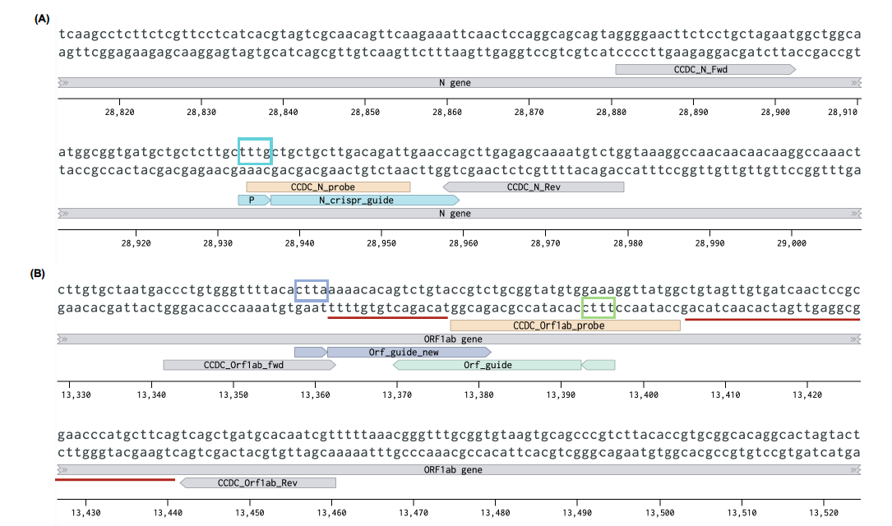

**Supplementary Figure 1**: Schematic representation of the binding regions of CCDC RT-qPCR primers/probes and CRISPR guide RNAs for N gene (**A**) and Orf1ab gene (**B**). The corresponding protospacer-adjacent motif (PAM) sites for each guide RNA are shown in coloured boxes. Red underline shows missing regions of the 'truncated/ambiguous' Orf1ab amplicons.



**Supplementary Figure 2**: Multiple aligned sequences (**A**) of Orf1ab' truncated/ambiguous' amplicons (Dashes represent missing regions of the 119 bp Orf1ab amplicon observed in sequencing. CCDC Orf1ab primers and probe binding sites are shown in grey arrows and orange box, respectively). Tapestation image (**B**) of the 'truncated/ambiguous' amplicons. NTC represents non-template control.

**Supplementary Figure 3**: Graphs showing CRISPR fluorescent readout for the 'truncated/ambiguous' amplicons tested using Orf1ab guide-RNA (**A**) and Orf1ab guide-RNA (redesigned) (**B**). Sample 6717215 was not tested using redesigned Orf1ab guide RNA as it was exhausted.