Binomial Dist..

2024-02-28

1. Let X represent the number of sixes in 10 rolls of a fair die. Simulate 50 runs of this probability experiment.
2. According to a recent survey 72% of Americans prefer dogs to cats. If 8 Americans are choosen at random, what is the probabilitythat 6 prefer dogs.That fewer than 6 do.
3. A weighted coin has a 42% chance of coming up heads. What is the expected number of heads in 5 tosses. The standard deviation? Consruct a probability histogram for X, the number of heads in 5 tosses.

rbinom(50, 10, 1/6)

## [1] 1 1 4 1 0 1 1 2 3 2 2 0 1 2 1 2 1 0 0 1 3 1 0 0 1 3 0 1 2 2 1 0 2 2 5 3 0 2  
## [39] 2 4 4 1 3 2 2 3 2 0 1 1

table(rbinom(50, 10, 1/6))

##   
## 0 1 2 3 4   
## 10 21 11 6 2

dbinom(6, 8, .72)

## [1] 0.3058222

pbinom(5, 8, .72)

## [1] 0.3972716

x <- 0:5  
x

## [1] 0 1 2 3 4 5

p <- dbinom(x, 5, .42)  
p

## [1] 0.06563568 0.23764642 0.34417757 0.24923203 0.09023918 0.01306912

sum(p)

## [1] 1

weighted.mean(x,p)

## [1] 2.1

weighted.mean((x-2.1)^2, p)

## [1] 1.218

weighted.mean((x-2.1)^2, p)^.5

## [1] 1.10363

library(tidyverse)

## ── Attaching core tidyverse packages ──────────────────────── tidyverse 2.0.0 ──  
## ✔ dplyr 1.1.4 ✔ readr 2.1.5  
## ✔ forcats 1.0.0 ✔ stringr 1.5.1  
## ✔ ggplot2 3.4.4 ✔ tibble 3.2.1  
## ✔ lubridate 1.9.3 ✔ tidyr 1.3.0  
## ✔ purrr 1.0.2   
## ── Conflicts ────────────────────────────────────────── tidyverse_conflicts() ──  
## ✖ dplyr::filter() masks stats::filter()  
## ✖ dplyr::lag() masks stats::lag()  
## ℹ Use the conflicted package (<http://conflicted.r-lib.org/>) to force all conflicts to become errors

qplot(x, weight=p, geom ="histogram", bins=6, col=I("black"))

## Warning: `qplot()` was deprecated in ggplot2 3.4.0.  
## This warning is displayed once every 8 hours.  
## Call `lifecycle::last_lifecycle_warnings()` to see where this warning was  
## generated.

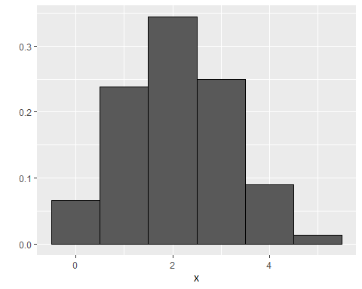

``{r}