## Requirement:

Rabobank Customer Statement Processor

Rabobank receives monthly deliveries of customer statement records. This information is delivered in two formats, CSV and XML. These records need to be validated.

Input

The format of the file is a simplified format of the MT940 format. The format is as follows:

| *Table 1. Record description* | |
| --- | --- |
| **Field** | **Description** |
| Transaction reference | A numeric value |
| Account number | An IBAN |
| Start Balance | The starting balance in Euros |
| Mutation | Either and addition (+) or a deducation (-) |
| Description | Free text |
| End Balance | The end balance in Euros |

Output

There are two validations:

* all transaction references should be unique
* the end balance needs to be validated

At the end of the processing, a report needs to be created which will display both the transaction reference and description of each of the failed records.

## Technical Specification:

|  |  |
| --- | --- |
| Java Version | 8 |
| Maven Version | 3.1 |
| Frameworks Used | Spring boot |

## URL:

<http://localhost:8090/validateTransReport>

## Test Reports:

**Case 1:**

**Input File**



Output:

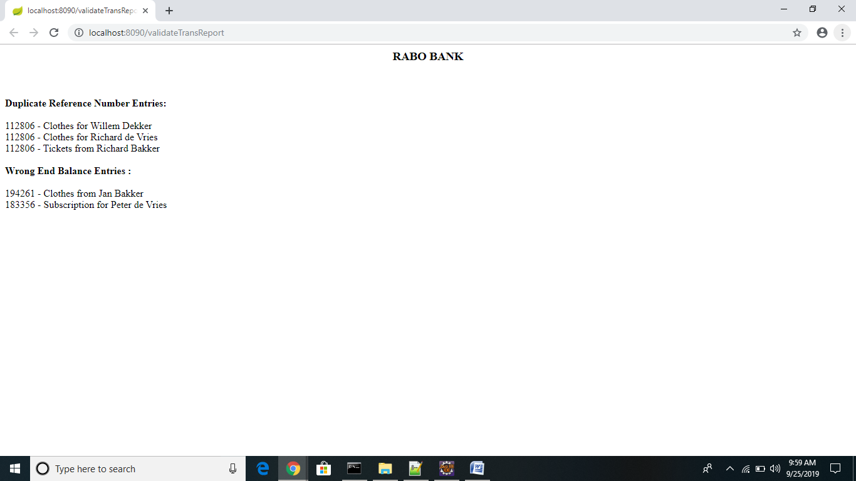

**Case 2:**

Input File :



Output:

