## Requirement:

Create an Angular app that is capable of importing the attached csv-file and visualize it on the screen

Keep in mind the following:

1. I should be able to select this file from my computer and see the results on screen

2. I should be able to filter the results based on minimal issue count

3. Act as if this code is meant to be production code for the Rabobank

## Technical Specification:

|  |  |
| --- | --- |
| UI Framework | Angular 7 |
| Browser Support | Chrome |

## URL:

http://localhost:4200

## Test Reports:

**Input File**



Output:

**Case 1:**

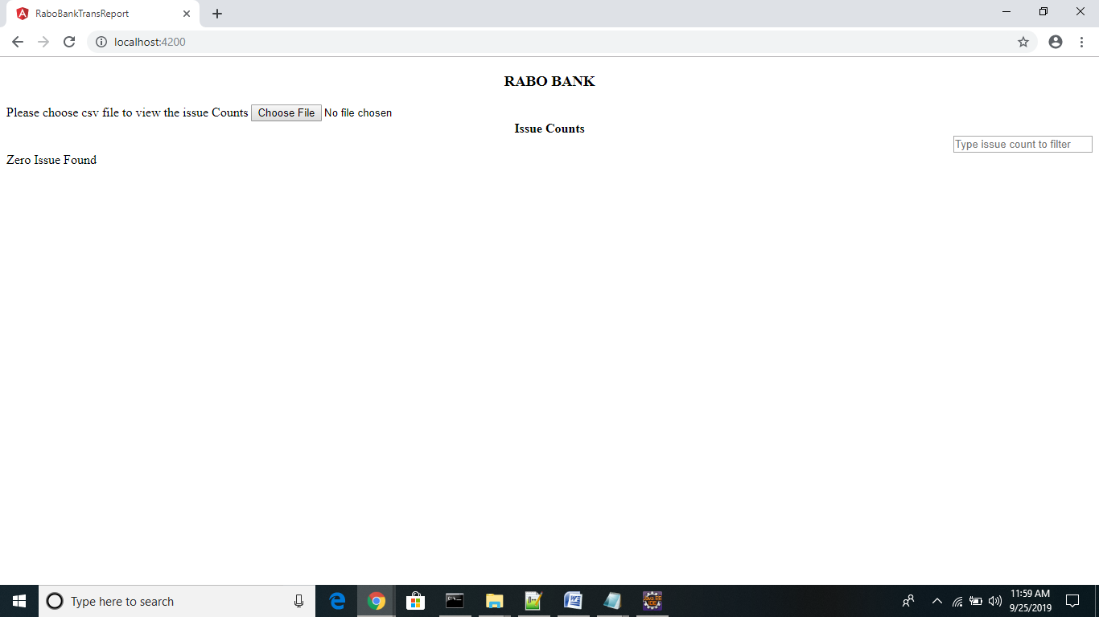

**Case 2:**

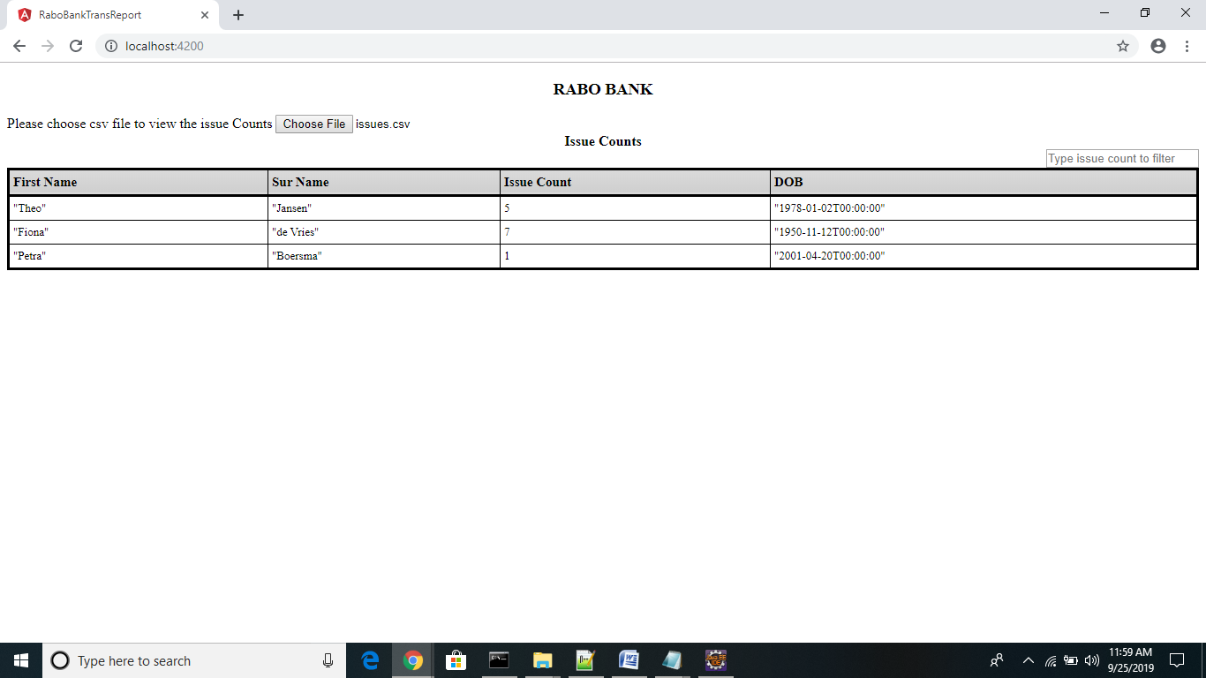

Case 3:

